

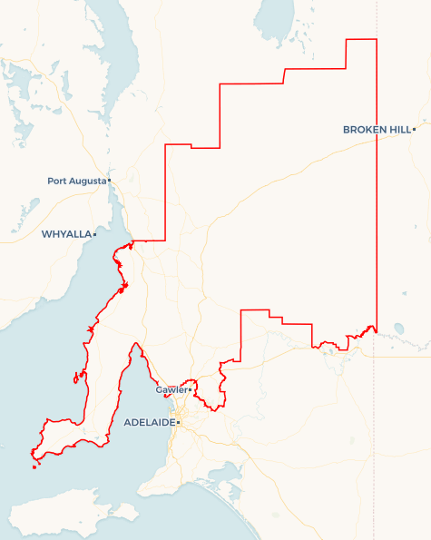Local Jobs Plan

Mid North SA ****Employment Region**** | SA | ****November 2024****

Workforce Australia Local Jobs (Local Jobs) is a program that supports tailored approaches to accelerate   
reskilling, upskilling and employment pathways in response to current and emerging local workforce needs.

## Local Jobs elements

### Local Jobs Plan

The Local Jobs Plan sets out the skills and employment challenges and priorities of the region, and associated strategies that will drive the design and implementation of activities to be implemented to address these challenges.

### Employment Facilitators

Employment Facilitators and Support Officers support the delivery of the program by bringing together key stakeholders including businesses, employment services providers, higher education and training organisations.

### Local Jobs and Skills Taskforce

Each Employment Region has its own Taskforce. Representatives include local stakeholders who have demonstrated experience in upskilling, reskilling, and an ability to represent, connect and collaborate with others in the region to meet labour market needs.

### Local Recovery and National Priority Funds

The Local Recovery Fund supports projects that meet the priorities identified in the Local Jobs Plan. The National Priority Fund provides funding for innovative local solutions to address structural barriers to employment.

Explore labour market insights for the   
[Mid North SA](https://www.jobsandskills.gov.au/work/employment-region-dashboards-and-profiles/monthly-labour-market-dashboards) Employment Region

## Local labour market challenges in the region

* Parts of the region face entrenched labour market and socio-economic challenges, including historically high unemployment levels, intergenerational unemployment, and high proportions of jobless families.
* Need for improved accesses to private and public transport and support for individuals to gain a driver’s licence.
* Low levels of Vocational Education and Training (VET) uptake and completion and the need for locally based trainers and training providers aligned to industry skill needs.
* Older population profile and ageing workforce presents opportunities to explore how to attract and retain mature aged people to address workforce shortages.
* Significant investment pipeline in renewables, resources and construction and unmet demand for entry level roles in health, aged and disability care, meat processing, horticulture, hospitality, and retail.
* Untapped labour market potential due to high levels of youth unemployment, high occurrence of part-time and casual work and significant number of people not in the labour force.

## Local jobs and skills priorities and strategies in the region

### Priority 1 – Maximise opportunities for local jobs to be filled by local job seekers, ensuring individuals are adequately skilled and supported to take up employment opportunities including traineeships and apprenticeships

#### What are our challenges and opportunities?

Parts of the region experience entrenched unemployment and high levels of socio-economic challenge. The challenges faced by individuals include work readiness, fitness for work, transport/driver’s licences and child care access.

#### How are we responding?

* Ensuring local employment initiatives include work readiness skills such as life skills, self-development, work hardening, work experience and work exposure activities.
* Supporting individuals to tap into the ‘hidden’ jobs market, including increasing awareness of local employers, job opportunities and career pathways.
* Supporting individuals to identify their qualities and transferrable skills and sell themselves to employers.
* Focussing on non-vocational challenges to employment such as drug and alcohol, fitness for work, transport and childcare access.
* Engaging with people not in the labour market and untapped labour potential within the region.
* Delivering initiatives that encourage and motivate employers to prioritise employment of local people.

### Priority 2 – Maximise opportunities for partnerships between local, state and federal governments to create pathways into growth and emerging industries and prepare for future of work changes

#### What are our challenges and opportunities?

The region has a significant investment pipeline including a range of new and emerging projects such as renewable energy, and significant demand in existing industries such as health care and social assistance, education and training, construction, and heavy industry. Workforce responses have historically been reactive, with more focus needed on planning and long-term solutions to support those impacted by intergenerational unemployment and jobless families, and to increase VET uptake and completion rates.

#### How are we responding?

* Partnering with regional bodies such as Regional Development Australia (RDA) and local government to support workforce needs of major projects, new industries and the Net Zero transition to maximise long-terms benefits for the region and local employment outcomes.
* Shared responsibility across government, employers, and industry in addressing local workforce challenges, including a focus on socially responsible recruitment and procurement and co-designed regional responses.
* Identifying current and emerging occupations and skills in demand, to better align local training, education and employment initiatives with industry needs.
* Delivering intel and ideas to government and other key organisations to address structural challenges impacting local workforce, employment and skilling outcomes.

### Priority 3 – Support young people to gain employment, addressing specific challenges to employment in the region, such as licences and transportation and other non-vocational challenges

#### What are our challenges and opportunities?

There is an opportunity to develop local initiatives that support people to gain their drivers licences and provide transport solutions within and between towns. Part time and casual employment in young people is high, with more focus needed on supporting people into full-time employment through the provision of independent, quality career education and guidance and strong industry connections.

#### How are we responding?

* Exploring non-traditional methods of engagement that align to the aspirations and interests of young people.
* Supporting initiatives that seek to address under-employment in young people and increase their ability to secure full-time employment.
* Championing initiatives that improve access to quality career education and guidance.
* Empowering young people to have a voice and co-design solutions that help increase participation in learning and earning activities.

### Priority 4 – Support older job seekers including support for reskilling and changing industries

#### What are our challenges and opportunities?

Mature-aged people bring a wealth of skills, knowledge and experience to the workforce. With an older population, the region is well positioned to capitalise on these skills and explore innovative solutions that will assist mature-aged to remain in the workforce or reconnect with employment that is suited to their capabilities. Many older people are not in the labour force and therefore not connected to support to explore work options, and there is an opportunity to support businesses to improve conditions and flexibility to accommodate older workers.

#### How are we responding?

* Identifying challenges that prevent older workers from fully participating in the labour market and develop solutions that will address these challenges.
* Increasing access to adult and community education programs, including support to increase digital and technical capability.
* Engaging with underutilised people within the community such as retired, semi-retired, underemployed and volunteers as a potential labour pool.

**Priority 5 – Support employers and industry in upskilling existing employees to increase capacity and to open opportunities for entry-level jobs for those looking for work**

#### What are our challenges and opportunities?

The Mid North region continues to see strong demand for entry level, skilled, trade and professional level roles and there is a strong focus on growing a local workforce and investing in the development and career progression of existing workers. Increasing the uptake of government programs, services and funding available to support local employers will assist small and medium business operators to develop a pipeline of workers and invest in retention and development.

#### How are we responding?

* Educating businesses on support available such as government programs, services and funding and better local promotion of support for business.
* Developing bespoke opportunities in partnership with business and industry that reflect the unique needs of employers and the region.
* Developing leadership and mentoring capability in industry to better support entry level workers entering the workforce.
* Sharing of personnel, resources, and specialists across the region/industry/business for shared local benefit.

### Priority 6 – Support the development of local organisations to increase their capability to respond to current and emerging employment, skills and workforce needs of the region

#### What are our challenges and opportunities?

* With a small number of locally based training providers and industry bodies within the region, there is an opportunity to develop the training capabilities of existing organisations and facilitate solutions Developing more qualified trainers in the region to increase access to quality, industry-relevant training.
* Maximising the use of local training facilities and identify gaps in local training infrastructure and delivery to ensure the region has access to high quality, locally based training.
* Supporting organisations to understand and access government programs, services, and funding.
* Supporting small organisations and businesses with limited management and human resource capability, to ensure they can maximise their involvement in local workforce initiatives and solutions.

## Want to know more?

* Contact: Lisa Brock, Mid North SA Employment Facilitator: [lisa@usgemployment.com.au](mailto:lisa@usgemployment.com.au)
* Visit: [Local Jobs](https://www.dewr.gov.au/local-jobs) or [Workforce Australia](https://www.workforceaustralia.gov.au/)