

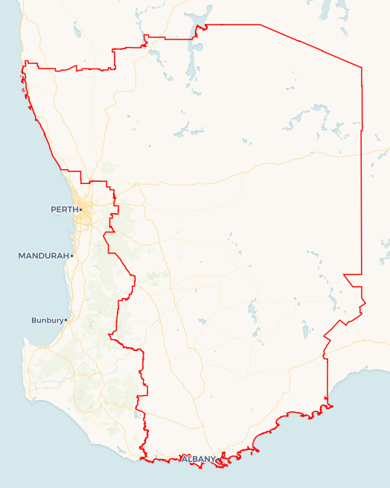Local Jobs Plan

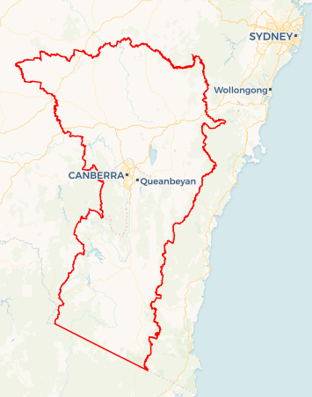

**SAMPLE MAP ONLY**

A map of your Employment Region and hyperlink will be added before publishing.

Great Southern Wheatbelt ****Employment Region**** | WA | ****August 2024****

Workforce Australia Local Jobs (Local Jobs) is a program that supports tailored approaches to accelerate   
reskilling, upskilling and employment pathways in response to current and emerging local workforce needs.

## Local Jobs elements

### Local Jobs Plan

The Local Jobs Plan sets out the skills and employment challenges and priorities of the region, and associated strategies that will drive the design and implementation of activities to be implemented to address these challenges.

### Employment Facilitators

Employment Facilitators and Support Officers support the delivery of the program by bringing together key stakeholders including businesses, employment services providers, higher education and training organisations.

### Local Jobs and Skills Taskforce

Each Employment Region has its own Taskforce. Representatives include local stakeholders who have demonstrated experience in upskilling, reskilling, and an ability to represent, connect and collaborate with others in the region to meet labour market needs.

### Local Recovery and National Priority Funds

The Local Recovery Fund supports projects that meet the priorities identified in the Local Jobs Plan. The National Priority Fund provides funding for innovative local solutions to address structural barriers to employment.

Explore labour market insights for   
[Great Southern Wheatbelt](https://www.jobsandskills.gov.au/work/employment-region-dashboards-and-profiles/monthly-labour-market-dashboards) Employment Region

## Local labour market challenges in the region

* A significant portion of Workforce Australia participants are experiencing periods of intermittent work due to seasonal and casual work, long-term unemployment, and/or inter-generational unemployment. Participants need tailored support to build work-ready skills over time and are not usually ready for ‘short, sharp’ training programs which are favoured by some training providers and other stakeholders.
* First Nations peoples, a significant cohort within our Workforce Australia participants, face multiple challenges when entering the workforce. Tailored delivery of employment services, customised mentoring supports and cultural awareness from employers all require further investment and effort from our community and our region’s various service providers.
* There are some persistent issues which hinder recruitment between employers and youth applicants. These include a mismatch between employer and candidate expectations for entry level roles, insufficient places available in pre-apprenticeship training and programs and lack of support and means to gain a driver’s license. This leaves a portion of the youth cohort disengaged from work and study.
* Changes to business operating conditions is leading to increasing redundancies in our region and existing businesses are conservative with their hiring plans. We anticipate support will be required both for retrenched workers and also in mapping key skills and job switching opportunities for these industries in the next twelve months.
* At the same time, emerging industries, such as clean energy and defence contracting, offer opportunities to our manufacturing and welding sectors to join the relevant supply chain and secure new sources of business. Small businesses need support to identify and prepare for these opportunities and local training organisations need market intelligence to connect the relevant training resources to support the existing and incoming workforce.
* Small business owners, who form the majority of our region’s employers, lack the time and resources to develop customised recruitment and onboarding programs to connect individuals with support needs and/or those who have been unemployed longer term. As a result, they are not well engaged with government funded employment support services and can overlook available candidates who may require work role adjustment or onboarding support.
* Our large geographical area and dispersed population make connecting training and government programs problematic. This is exacerbated by participants being split between differing government services which offer varying services and funding arrangements. Local training and employment support programs have the most success in the region when local service providers are consulted and included in program planning and promotion.

## Local jobs and skills priorities and strategies in the region

### Priority 1 – Improve support to individuals experiencing long term and/or inter-generational unemployment What are our challenges and opportunities?

#### A significant portion of Workforce Australia participants are experiencing periods of ongoing unemployment, including those who also experience inter-generational unemployment. They benefit from tailored support to build work-ready skills over a period of time. ‘Short, sharp’ training programs which are favoured by some training providers and other stakeholders can be unsuccessful in the region unless they are paired with pre and post program engagement and mentoring. How are we responding?

* We will collaborate with local provider networks to identify and support short and long-term programs to support job readiness and job pathway education.
* We will consider the needs of mature age participants in program design, including the need for programs delivered part time, digital skills coaching and customised job pathways.
* Where individuals are experiencing inter-generational unemployment, we will encourage program providers to consider the opportunity to involve and/or communicate with the participant’s family through the program.

### Priority 2 – Provide tailored support to First Nations peoples

#### What are our challenges and opportunities?

First Nations participants face multiple challenges when entering the workforce and need customised support and mentoring.

#### How are we responding?

* We will identify and connect with Indigenous owned and other culturally safe employers in the region and provide warm introductions between employment service providers and employers.
* We will identify and support opportunities to build the community services and mentoring workforce within our regions’ First Nations communities.
* We will advocate for First Nations staff members to be hired within our region’s employment services programs to support improved engagement and outcomes for our participants.
* We will support opportunities to build connections and cultural awareness within our communities and employer networks.

### Priority 3 – Improve connection and hiring success between local employers and candidates

#### What are our challenges and opportunities?

#### Small business owners, who form the majority of our region’s employers, lack the time and resources to develop customised recruitment and onboarding programs to connect to individuals with support needs and/or those who have been unemployed longer term. As a result, they are not well engaged with government funded employment support services and can overlook available candidates who may require work role adjustments or onboarding support. How are we responding?

* We will connect and educate employers, small business and larger corporate employers to widen their candidate pool and adjust their recruitment and onboarding process to meet the available labour market.
* We will advocate to connect and support more pre-apprenticeship training opportunities into the region, particularly in trades-based environments such as mechanical and construction services and in areas of emerging industries such as new energy, manufacturing automation and cyber security.

### Priority 4 – Map and connect emerging job pathways within the region What are our challenges and opportunities?

Our region is well positioned for opportunities in emerging sectors, including clean energy projects and advanced manufacturing opportunities in agriculture and defence industries. Educators and training organisations are keen to promote these career sectors. However, the related local job pathways are unclear and there is a risk of jobs being centralised to Perth, rather than established in the region.

**How are we responding?**

* Together with the taskforce, we will map existing and emerging regional employment pathways in emerging sectors, such as clean energy and advanced manufacturing.
* With our taskforce, we will identify supply chain pathway business opportunities related to emerging sectors and communicate these opportunities with our business sector.
* We will work together with key stakeholders to communicate local training and recruitment opportunities with key employers and advocate to bring these jobs into the region to benefit our local communities, rather than hiring from Perth.
* We will advocate for training providers and employers to consider appropriate support to increase participation from our female and First Nations participants in these emerging pathways.

### Priority 5 – Support delivery of local programs through collaboration between services

#### What are our challenges and opportunities? Our large geographical area and dispersed population can make connecting training and government programs challenging. Local training and employment support programs have the most success in the region when local service providers are consulted and included in program planning and promotions.

#### How are we responding?

* We will maintain and keep building strong networks within key regional centres, connecting service providers across multiple state and federal government funded services, Registered Training Organisations and Group Training Organisations, education providers, community support agencies and employer networks.
* We will partner with local organisations in our delivery of Local Initiative Fund activities to boost community ties and activity effectiveness and we will encourage Local Job Activity Hosts and other program providers to do the same.

## Want to know more?

* Contact: Emma Everett, Great Southern Wheatbelt Employment Facilitator: [emma.everett@gswlocaljobs.com.au](mailto:emma.everett@gswlocaljobs.com.au)
* Visit: [Local Jobs](https://www.dewr.gov.au/local-jobs) or [Workforce Australia](https://www.workforceaustralia.gov.au/)