

Understanding BAC and CAC Claim Periods

The Boosting Apprenticeship Commencements (BAC) wage subsidy supports employers to take on new or recommencing apprentices and trainees. After 12 months of this initial support, employers may be eligible to transition to the time-limited Completing Apprenticeship Commencements (CAC) wage subsidy for the following 24 months.

# BAC and CAC Claim Periods

BAC and CAC wage subsidy claims are separated into fixed three-month periods, with the first period commencing 5 October 2020 to 31 December 2020. Employers may submit a BAC or CAC claim in ADMS after each fixed three-month period (also referred to as a claim quarter). Claim applications will become available around the 15th of the month after the end of the previous period.

Employers may be eligible to claim wages paid to an apprentice or trainee for an entire BAC and CAC period or may only be eligible to claim wages paid to an apprentice or trainee for part of the period (a part period).

A part period is where the apprentice or trainee commences after the start of a BAC and CAC period, or an apprentice or trainee ends their Australian Apprenticeship prior to the end of a BAC and CAC period. This could be due to withdrawal from or cancellation/completion of the apprenticeship.

Employers are not eligible to claim the BAC and CAC wage subsidies for days where the apprentice or trainee is suspended, or where the Australian Apprenticeship has been cancelled or completed. In calculating your wage subsidy entitlement, ADMS will exclude any wage evidence that relates to work performed outside of the period you are eligible to claim.

Here are some examples of how BAC and CAC claims might occur within a claim period.

# Examples

In these examples, the claim period runs from 1 January 2022 to 31 March 2022.

## Apprenticeship commences during claim period

If an apprentice commences on 14 January 2022, the employer can claim the BAC wage subsidy for wages paid to the apprentice during the period 14 January 2022 to 31 March 2022.

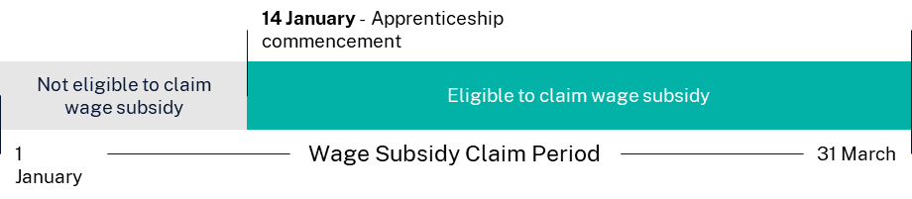

The claim application is available for completion in ADMS after the claim period ends, from 15 April.

## Apprenticeship commences and is suspended during claim period

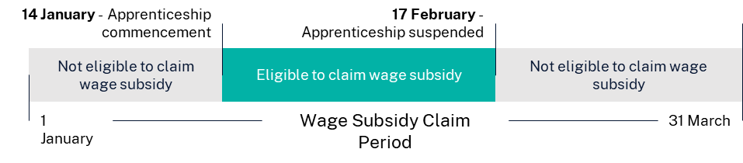If an apprentice commences on 10 January 2022 and has their apprenticeship cancelled on the 17 February 2022, their employer can claim the BAC wage subsidy for any wages paid to the apprentice during the period 10 January 2022 to 17 February 2022.

The claim application is available for completion in ADMS after the claim period ends.

# Support

For assistance with ADMS, contact the National Customer Service Line (NCSL) on **1800 020 108**.

For feedback on this Knowledge Article, contact [ADMSEngagement@dese.gov.au](mailto:ADMSEngagement@dese.gov.au).