

Using the AAPathways website to research your next career

*This fact sheet aims to help you navigate the* [*Australian Apprenticeships Pathways website*](http://www.aapathways.com.au/) *(www.aapathways.com.au) which provides career and training information for a range of occupations that offer apprenticeships and traineeships.*

# The Australian Apprenticeships Pathways website

The AAPathways website provides information and resources to support**apprentices, trainees and other job seekers.**

Besides hosting a range of information relevant to apprenticeships and traineeships, the AAPathways website also provides industry and occupation data, links to training and other services, as well as general career information.

# About this guide

This guide provides step by step instructions on how to use the AAPathways website to access career information, including career quizzes, day-in-the-life videos and training pathway information.

*Please note: The training requirements for apprenticeships and traineeships vary from one state or territory to another. You will need to choose the links for your state and territory to find the industry and training information that is relevant to you.*

# For more information

If you have any questions about the Australian Apprenticeships Pathways website you can contact them via the [Australian Apprenticeships Pathways website contact page](http://www.aapathways.com.au/Contact-Us) (www.aapathways.com.au/Contact-Us) or phone **1800 338 022** or **(03) 9326 5585.**

# How do I access career information, quizzes and job vacancies?

**1. Go to the** [**Australian Apprenticeships Pathways website**](http://www.aapathways.com.au/) **(www.aapathways.com.au).   
2. Select the ‘Career Resources’ tab from the home page.**

Pages in the ‘**Career Resources’** section provide general tools and information specifically designed to assist job seekers who aren’t sure what industry or job they are interested in.

**Click on the ‘Career Resources’ tab.**

**

**Click on the ‘Career Resources’ tab.**

**3. Click on the ‘Industry Career Information & Quizzes’ tab.**

## To access information on a range of occupations, click on Career Resources from the homepage, then Career Services, then Industry Career Information and Quizzes.

**Click on the ‘Industry Career Information & Quizzes’ to access information on a range of occupations.**

**4. Click on the field you are interested in (in this case ‘Building & Construction’) to access a list of occupation fields information, links and resources such as practice aptitude quizzes.**

## To access Industry Career Information and Quizzes, click on Career Resources from the homepage, then select the link on Industry Career Information and Quizzes.

**Click on ‘Quiz’ to test your aptitude for a particular occupation.**

**Click on ‘Job Hunting’ for job search tips and hints as well as links to job vacancies.**

**Click on ‘Useful Links’ for links to other information and support websites relevant to the selected occupation field.**

**Click on the ‘+’ to see the list of occupations.**

**Click on ‘Career Information’ for useful career and job information, including average weekly earnings.**

# How do I find apprenticeship and traineeship vacancies?

**1. From the website homepage (**[**www.aapathways.com.au**](http://www.aapathways.com.au/)**) click on the ‘Self Help’ tab to access information on preparing for and finding an apprenticeship or traineeship.**

**2. Click on Step 3 ‘Job Hunting’ for tips on finding an apprenticeship or traineeship.**

**Click on the ‘Step by Step Guide’ to access information on preparing for and finding an apprenticeship or traineeship.**

**Now Click on ‘Step 3 - Job Hunting’ to get tips on how and where to find an apprenticeship or traineeship.**

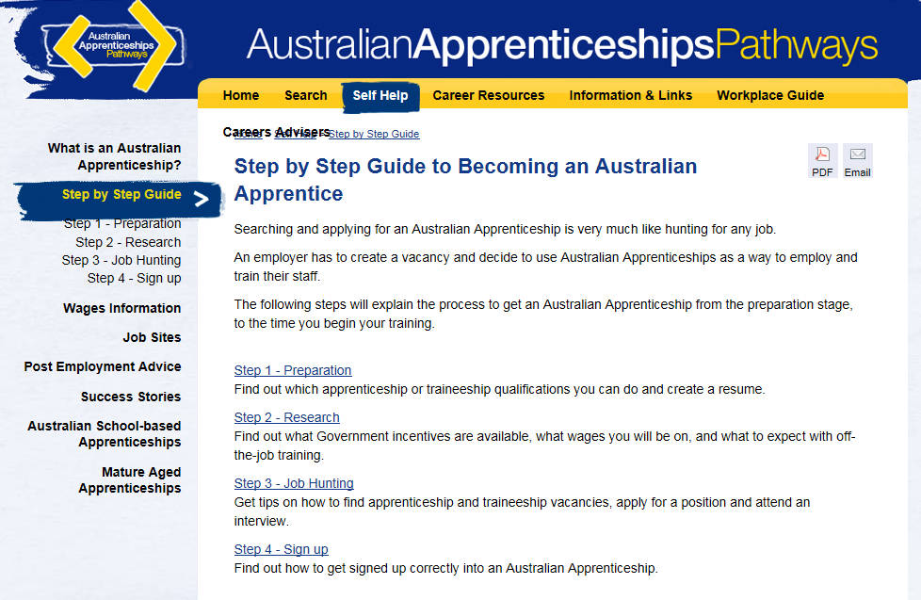

# How do I access career videos?

**1. Click on ‘Occupational Videos’ to access a range of day-in-the-life and job overview videos.**

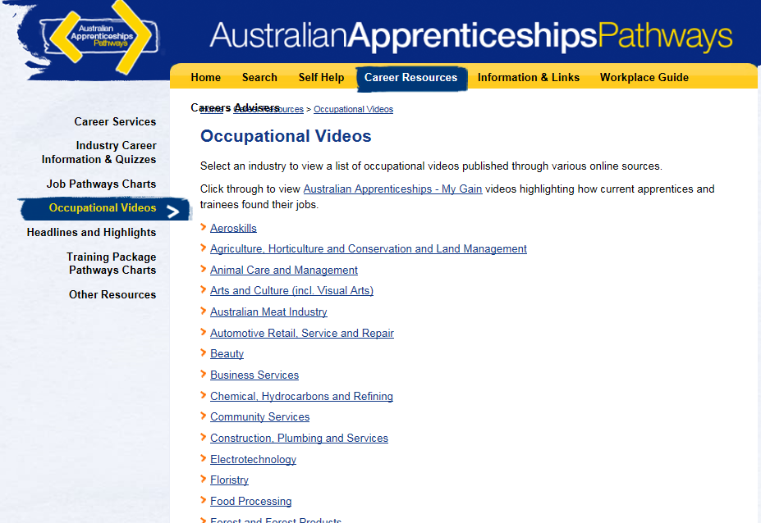

**Click on the relevant occupation grouping to access videos relevant to this industry or occupation.**

**Once you have viewed a video, click on the back button (the blue arrow) in the top left-hand corner of the screen to return to the ‘Occupational Videos’ page and view more videos.**

**Click on ‘Occupational Videos’ to view an alphabetical list of videos by occupation.**

**2. Select the industry or occupation you are interested in (in this case ‘Construction, Plumbing and Services’) to view a list of relevant videos from around the web. Clicking on these links will open the relevant video.**

**This section provides a list of general videos about this industry or occupation.**

**This section provides videos about the experiences of individual apprentices and trainees in this industry.**

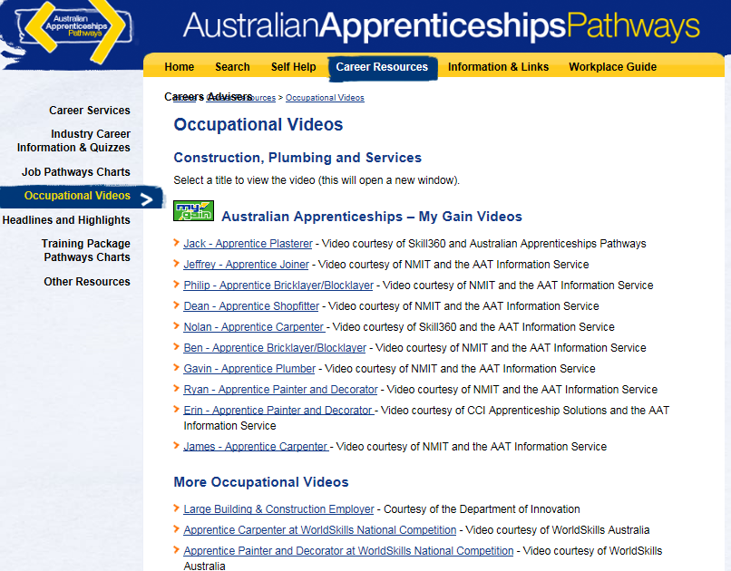

**Use your mouse to scroll down the page to access more videos.**