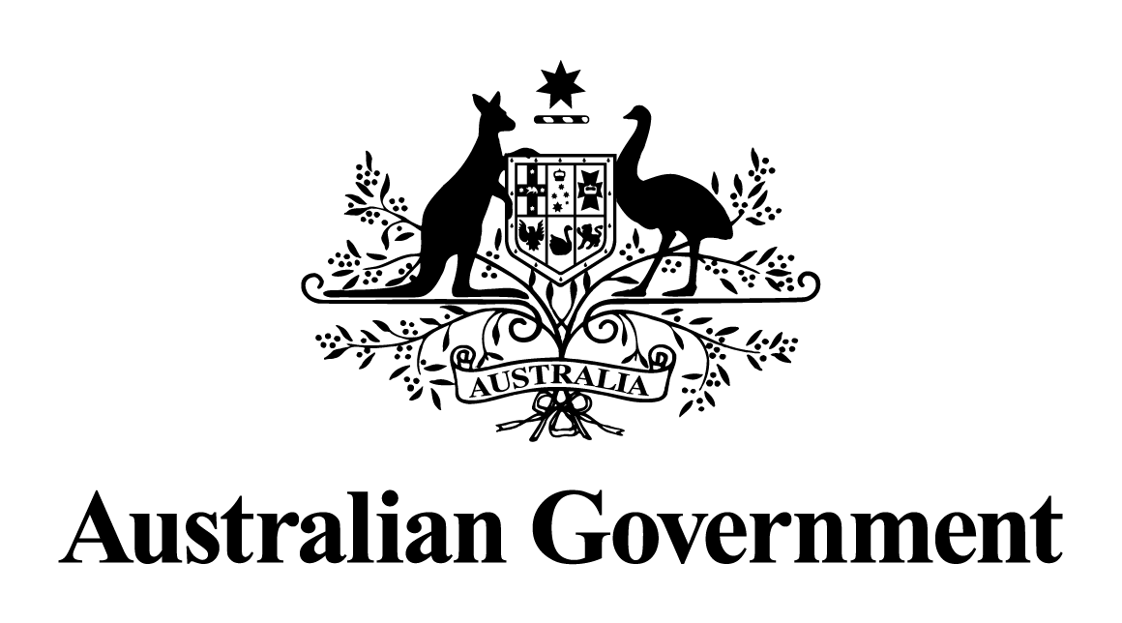

Australian Government response to the   
Senate Education and Employment References Committee report: Penalty Rates

January 2018

This work is licensed under the Creative Commons Attribution-NonCommercial-NoDerivs 3.0 Australia License.

Creative Commons graphic

The details of this licence are available on the Creative on the Creative Commons website: <http://creativecommons.org/licenses/by-nc-nd/3.0/au/>

The document must be attributed as the *Australian Government response to the   
Senate Education and Employment References Committee report: Penalty Rates*

# **Introduction**

On 19 June 2017, the Senate referred an inquiry into Penalty Rates to the Education and Employment References Committee (the Committee). The Committee’s Final Report was released on 4 October 2017.

Coalition Senators requested that an additional hearing be held for this inquiry in order to give Coalition Senators, the Australian Greens and NXT Senators the opportunity to seek further evidence and receive answers to remaining questions on notice.

Unfortunately, Labor Senators decided to use their numbers on the Committee to prematurely cut the inquiry short and deny further opportunity for additional witnesses to be heard or to ask additional questions.

The inquiry exposed that for many years, unions have signed enterprise agreements with large organisations that include cuts to Sunday penalty rates.

The former Department of Employment’s submission to the inquiry included an analysis of enterprise agreements with 200 or more employees (at the time they were lodged with the Fair Work Commission) that identified the Fast Food, Retail, Hospitality or Pharmacy modern awards as their parent award.

Of 108 agreements analysed, 70 (64.8 per cent) had a below-award hourly rate for hours worked on a Sunday. Of these 70 agreements, 55 covered at least one union, including the Shop Distributive and Allied Employees’ Association, the Australian Workers’ Union or United Voice.

This demonstrates that small businesses have been on an uneven playing field relative to large businesses when it comes to employing staff on Sundays.

On 5 June 2017, the independent Fair Work Commission decided that its changes to Sunday penalty rates for some workers under four awards in the retail and hospitality sectors would start on 1 July 2017, with either three or four annual instalments depending on the award.

The former Department of Employment estimates that the Fair Work Commission’s change to Sunday penalty rates will affect about three to four per cent of Australia’s workforce. That is, between 300,000 to 450,000 employees who at least sometimes work on a Sunday under the relevant award, may be affected by the Fair Work Commission’s decision on Sunday penalty rates.

The Fair Work Commission said its decision is expected to deliver an increase in the level and range of services in both retail and hospitality industries, with a consequent increase in employment – that is more hours of work for existing employees or the engagement of new employees.

## Committee Recommendation 1

The committee recommends that the government legislate to overturn the Fair Work Commission's decision to reduce Sunday penalty rates.

The Government rejects this recommendation.

The Government’s position on penalty rates has always been clear – setting pay and conditions of awards is the job of the independent Fair Work Commission. This is core business for the Commission.

In making its decision to reduce penalty rates for some workers in the hospitality and retail sectors, the Commission considered evidence over a two-year period. The Commission received almost 6,000 submissions, heard evidence from 143 witnesses and held 39 days of hearings. In a unanimous judgement, a five member Full Federal Court found that the Fair Work Commission had properly exercised its jurisdiction in the penalty rates case.

The Fair Work Commission said its decision is expected to deliver an increase in the level and range of services in both retail and hospitality industries, with a consequent increase in employment – that is more hours of work for existing employees or the engagement of new employees.

There has not been a level playing field on Sundays between small and large business. 4.3 per cent of all employees who work at a small business (with under 20 employees) are on an enterprise agreement, compared with 47.4 per cent of employees who work at a business with 20 or more employees (as at May 2016).

Around 65 per cent (70 out of 108) of a sample of large enterprise agreements covering 200 or more employees which identified the Fast Food, Retail, Hospitality or Pharmacy modern awards as their parent award already cut Sunday penalty rates for at least one group of workers (the former Department of Employment’s analysis looked at level 1 permanent adult employees).

## Australian Greens - Recommendation 1

The Fair Work Amendment (Pay Protection) Bill 2017 should pass in order to protect minimum employee standards such as penalty rates and overtime, and close loopholes that have allowed hundreds of thousands of employees to be paid less than the award.

The Government rejects this recommendation.

The Government agrees with Recommendation 1 of the Education and Employment Legislation Committee’s report: An inquiry into the Fair Work Amendment (Pay Protection) Bill 2017, that the Senate reject this Bill.

## Australian Greens - Recommendation 2

Establish a Royal Commission into Underpayment of Penalty Rates and Other Wage Theft to fully investigate the extent of wage theft and below-award payment in Australia and recommend appropriate recourse to compensate those affected.

The Government rejects this recommendation.

The Government has taken a strong approach to tackling allegations of fraud and exploitation in Australian workplaces. The *Fair Work (Protecting Vulnerable Workers) Act 2017* strengthens protections for vulnerable workers, including:

* introducing a higher scale of penalties (up to 10 times the current amount) for a new category of ‘serious contraventions’ of prescribed workplace laws;
* expressly prohibiting employers from unreasonably requiring employees to make payments (i.e. ‘cash-back’ arrangements);
* strengthening the evidence gathering powers of the Fair Work Ombudsman to ensure that the exploitation of vulnerable workers can be properly investigated; and
* introducing stronger provisions to make franchisors and holding companies responsible for breaches of the Fair Work Act in certain circumstances where they are culpable for the breaches.

These changes complement other measures by the Government to respond to worker exploitation—including increasing funding to the Fair Work Ombudsman by $20.1 million over four years and establishing the Migrant Workers’ Taskforce chaired by Professor Alan Fels.

## Australian Greens - Recommendation 3

Support the Committee’s recommendation that the government legislate to overturn the Fair Work Commission’s decision to reduce Sunday penalty rates.

The Government rejects this recommendation, consistent with the response to recommendation 1 of the Committee’s report.

## NXT Recommendation 1

That the *Fair Work Act 2009* be amended to ensure that enterprise agreements do not contain clauses that result in employees receiving penalty rates that are lower than the rates specified in the relevant Modern Award.

The Government rejects this recommendation.

Enterprise bargaining was introduced in part to drive productivity in the workplace by allowing employers to tailor the working conditions to their individual circumstances. Under the Fair Work Act, base rates of pay in an enterprise agreement cannot fall below the base rates of pay under a relevant modern award. Enterprise agreements also cannot exclude any part of the National Employment Standards (although it may increase the benefits under those provisions).

In applying the ‘better off overall’ test, the Fair Work Commission is required to compare all of the conditions, including pay, casual loading and penalty rates, that an employee would receive under the relevant award.

## NXT Recommendation 2

That pending the changes in Recommendation 1, the party who is seeking to deviate from the terms of a relevant Modern Award provide an additional statement to the Fair Work Commission, in the form of a statutory declaration, outlining the specific clauses in an enterprise agreement that deviate from the relevant Modern Award, and the reasons for this. Furthermore, employees should be provided with a copy of this additional statement prior to a vote occurring on a proposed enterprise agreement.

The Government notes this recommendation.

The Committee heard evidence from workers under union agreements that they were not informed—either by the company or the union—that their enterprise agreement included penalty rates that were lower than the award.

Employers are already required to provide an F17 form to the Fair Work Commission when they apply for approval of an enterprise agreement. The F17 form has the effect of a statutory declaration and requires employers to specify all terms of a proposed enterprise agreement that deviate from the relevant modern award and other sections of the Fair Work Act like the National Employment Standards.

The Government considers that employees must be properly informed about the impact of a proposed enterprise agreement on their pay and conditions, including penalty rates, prior to a vote occurring on any proposed enterprise agreement.

Currently, the Fair Work Act requires an employer to provide a copy of a proposed agreement to employees and to take all reasonable steps to ensure the terms of the proposed agreement – and the effect of those terms – are explained to employees, prior to asking them to vote on it.

The Government agrees that there is merit in considering further policy options to ensure employees understand what a proposed enterprise agreement has traded-off.

## NXT Recommendation 3

There should be greater transparency of payments made between unions and employers, and that employees should be provided full details of any such arrangements or proposed arrangements prior to a vote occurring on a proposed enterprise agreement.

The Government notes this recommendation.

The Committee received evidence of arrangements in which unions paid a share of members’ dues back to employers.

The *Fair Work (Corrupting Benefits) Amendment Act 2017* provides greater transparency over payments made between unions and employers through outlawing the payment and receipt of corrupting benefits and requiring registered organisations and employers to disclose direct and indirect financial benefits they receive in connection with a proposed enterprise agreement, before employees vote.

In addition, the Fair Work Laws (Proper Use of Worker Benefits) Bill 2017, if passed, would provide similar transparency for certain arrangements made between registered organisations and employers outside of the bargaining process by requiring organisations and employers to disclose the financial benefits they receive.

The Government agrees that there is merit in considering further policy options to improve the transparency of payments between unions and employers.