


Local Jobs Program - supporting workforce transition to a

net zero economy
  - Hunter Employment Region | NSW | April 2024

The Local Jobs Program is supporting tailored approaches to your region’s current and emerging workforce needs.

Australian Government Employment Facilitators
Australian Government Employment Facilitators are members of your local community. They care about local jobs and are providing support for workforces in the transition to net zero.
They are helping:
- employees to upskill and reskill
- new and existing businesses with their workforce needs
- and educational institutions to develop training solutions for the future.
They work with the existing Employment Facilitator in your region and are employees of the Department of Employment and Workplace Relations.
Please read this document in conjunction with the Hunter Employment Region Local Jobs Plan.

Our Australian Government Employment Facilitator teams will:
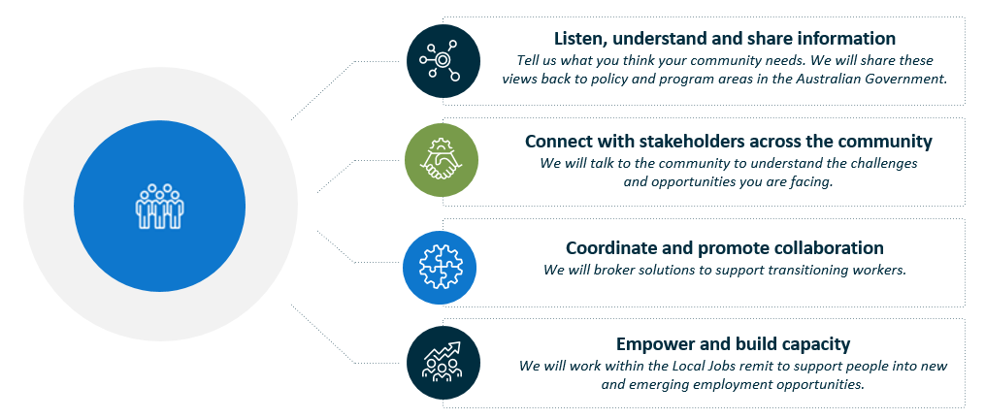
‘The net zero transformation presents an unprecedented opportunity to revitalise the Australian education and training sector, working with industry to develop a more diverse workforce and create sustainable employment for generations to come. This includes opportunities for our regional labour markets and industries that have long been in decline.
With the right investment we can offset the jobs at risk in areas like coal-fired power and ensure these workers and their communities are given the support they need to transition and find new opportunities.
However, the transformation also presents a major challenge. If we don’t fine tune our workforce pipelines, skill shortages could prevent us from reaching net zero by 2050, and opportunities to broaden our industrial base will be missed.
We also need to make sure that the jobs created are accessible and shared with all Australians, particularly underrepresented cohorts, and workers in transitioning sectors.’
Australian Government Jobs and Skills Australia (2023)
The Clean Energy Generation: workforce needs for a net zero economy

Priority 1 – Support an orderly and positive transition to net zero economy

What are our challenges and opportunities?
- Challenges for skills, training, and education sectors to anticipate emerging, in demand skills.
- Specialist skills required in some net zero sectors.
- Sharing the benefits of net zero investments with all community groups, including those that do not traditionally have high participation rates in the energy sector (e.g. Aboriginal and Torres Strait Islanders people, women, people with disability).
- Raising community awareness about emerging industries and job opportunities. Supporting impacted businesses and supply chains and assisting them to identify opportunities within the net zero local economy.

How are we responding?
- Consulting with groups to profile future employment opportunities in growth industries. Using data and insights from the clean energy sector and its supply chains to identify skills and training gaps for future in-demand opportunities.
- Connecting industry and educational institutions to develop training for future skills needs.
- Supporting the establishment of feedback loops so that we know what is working and where the gaps are.

Priority 2 – Listening to community and sharing views with Australian Government policy and program areas
Transition to a net zero economy requires community support. Our approach is inclusive and is developed in dialogue with all sections of the community. Our processes will draw on our local region’s experience and perspectives.

What are our challenges and opportunities?
- Policies and programs should be informed by local experience and work for the people they intend to assist.
- Providing the community with communication channels to government.

How are we responding?
- Providing the community with up-to-date labour market data to identify critical occupations that will support emerging and growth industries. Use data to inform employers and small and medium business to plan for their future workforce.
- Supporting engagement with net zero and community organisations and other groups to develop an understanding of current and emerging opportunities. Share this information with government policy and program areas.
- Collaborating on events and activities and promoting labour market opportunities.
- Raising community understanding about how the transition to net zero will impact them.
- Promoting government initiatives, funding, and submissions to support the labour market as it transitions to net zero.

Priority 3 – Support workers, business, and community through challenges. Take advantage of opportunities.
We coordinate labour market supports to manage change and embrace new employment opportunities. We work with community and emerging industries to support their labour market needs and impacted workers into new employment.

What are our challenges and opportunities?
- Securing adequately skilled workers in growth and demand sectors. Creating accessible entry level work.
- High unemployment and low participation rates of some groups and in some local government areas.
- The impact and opportunities that meeting net zero targets are creating for existing workers and communities.
- Skilled workers exiting the labour force versus those entering the labour force over the coming years.
- Timing and alignment of emissions-intensive industry closures and net zero projects coming online.
- Changing technology in emerging sectors, with higher skilling and training options critical to support these sectors.

How are we responding?
- Working collaboratively across all levels of government. Developing activities to support workers into emerging net zero industries. Supporting sector-based activities and connecting workers with supports and employment opportunities.
- Working as part of the Transition Support Network to guide employers through best practice retrenchment processes.
- Supporting business and impacted supply chains to understand the opportunities available in emerging industries.

Want to know more about Employment Facilitators or the Local Jobs Program?
- Contact: Grahame Irwin, Australian Government Employment Facilitator: HunterNSW.AGEF@dewr.gov.au
- Visit: Local Jobs or Workforce Australia for Business

