Quick Guide – Applications
This quick guide provides information on the application process for a VET Student Loan

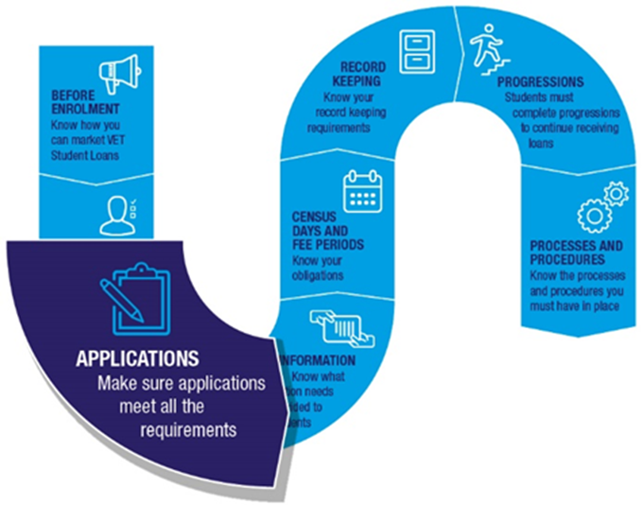

The VET Student Loan application process
To apply for a VET Student Loan a student must complete the following:
- After enrolling in a VET Student Loans approved course, a student informs you they want to access a VET Student Loan.
- You assess the student’s eligibility for a loan (refer to Quick Guide – Eligibility). If you have assessed the student as eligible you enter the student’s enrolment information into the electronic Commonwealth Assistance Form (eCAF) system. All approved course providers are required to use the eCAF as the student application form for a VET Student Loan.
- The eCAF system sends an email to the student with instructions on how to access their application.
- The student completes the pre-populated eCAF including providing their Tax File Number (TFN). For students aged under 18 additional information is required.
- A student cannot submit an eCAF earlier than 2 business days after the enrolment date in the eCAF system. This ensures that students have adequate time to consider their decision to take on a loan.
- The eCAF must be submitted on, or before, the census day for which they want the loan to apply.
- After submitting the eCAF the student receives a receipt via email with confirmation that the application has been approved. You can now view the student’s eCAF.
After these processes are complete the student will be able to access a VET Student Loan, paid to the provider, for any census days that occur after the eCAF submission date.

Students who are under 18
Students who are under 18 must submit a completed parental consent form as part of their application. This parental consent form needs to be signed by a responsible parent.
If the student does not submit a completed parental consent form, they will be unable to access a VET Student Loan unless they can prove that they are independent.
You can find the VET Student Loans Parental Consent Form on the Department of Employment and Workplace Relations website.

Student under 18 who is considered independent
A student under 18 years of age is considered independent if they have received Youth Allowance on the basis that they are independent. They will need to provide evidence of this to you. This evidence is best provided by the student’s Centrelink Income Statement that notes that they have been assessed as independent.
A student who is under 18 that can prove their independence does not need to submit a parental consent form as part of their application. If a student cannot show appropriate evidence of their independence, they will need to submit a signed parental consent form to access a VET Student Loan.

electronic Commonwealth Assistance Form (eCAF)
Applications for VET Student Loans are made through the electronic Commonwealth Assistance Form (eCAF) system.
To access the eCAF system, you must complete the eCAF System Access Request form for each individual officer requesting access to the system, and/or the eCAF API System Access Request form for a provider service account. The completed forms must be sent to VETStudentLoans@dewr.gov.au.
Answers to frequently asked questions can be found under the ‘Help’ tab in the eCAF system.
You must supply accurate student enrolment information in the eCAF. If there are inaccuracies students will be directed to you for correction.
You cannot delete an eCAF once it has been submitted by a student. However, you may delete an eCAF that has not been submitted by a student if the student no longer wishes to access a VET Student Loan.

Tax File Number (TFN)
To apply for a VET Student Loan a student needs to have a valid TFN.
If a student cannot remember their TFN they should call the Australian Taxation Office (ATO) on
13 28 61. You cannot request or obtain a student’s TFN directly from the ATO.
If a student does not have a TFN they will need a Certificate of Application for a Tax File Number to apply for a VET Student Loan. This is a certificate from the ATO that shows that a student has applied for a TFN. The student must attach a valid certificate to their eCAF before submitting it to us. A certificate of application for a TFN is only valid if it has been stamped by Australia Post to confirm the student has provided their documentation to a participating post office.

Once the student receives their TFN from the ATO they need to contact you immediately. You will need to re-open the eCAF to allow the student to update their TFN.
You can do this by putting the eCAF into ‘revision’ status. The student will receive an email telling them to update their eCAF record with their TFN. The student resubmits the eCAF after entering their TFN.
This process must be done within 6 weeks of the ‘First census day of the loan application’ in the eCAF. The student will not be able to use the loan to pay their fees without a TFN.
You will not be paid the loan amount without a TFN included in the eCAF. You cannot recover course fees from the student where those fees were indicated in the Statement of Covered Fees as being covered by a loan.
You can run an eCAF exception report to identify students who have only supplied a Certificate of Application for a Tax File Number but not yet supplied a TFN. The report is available on the eCAF dashboard. A report is also available in TCSI Analytics. The TFN needs to be verified in both eCAF and TCSI. You may also access and search for eCAFs without TFNs directly in the eCAF system or via the API links from your student management systems. Refer to the eCAF User Guide for more information.

Required documentation
You must retain all required information and documentation collected in relation to a VET Student Loan application for 5 years. You must be able to produce this evidence and documentation on request.

Further information
For further information on applications, refer to the following resources.
- VET Student Loans Manual for Providers (see Chapter 4.7 Student Administration and Chapter 4.8 Processes and Procedures)
- VET Student Loans Information Booklet
For the legislation relating to application requirements, please see sections 10, 17 and 51-52 of the VET Student Loans Act 2016, and sections 10, 85, 105 and 152 of the VET Student Loans Rules 2016.
If you need assistance with the eCAF system please contact VETStudentLoans@dewr.gov.au.

