

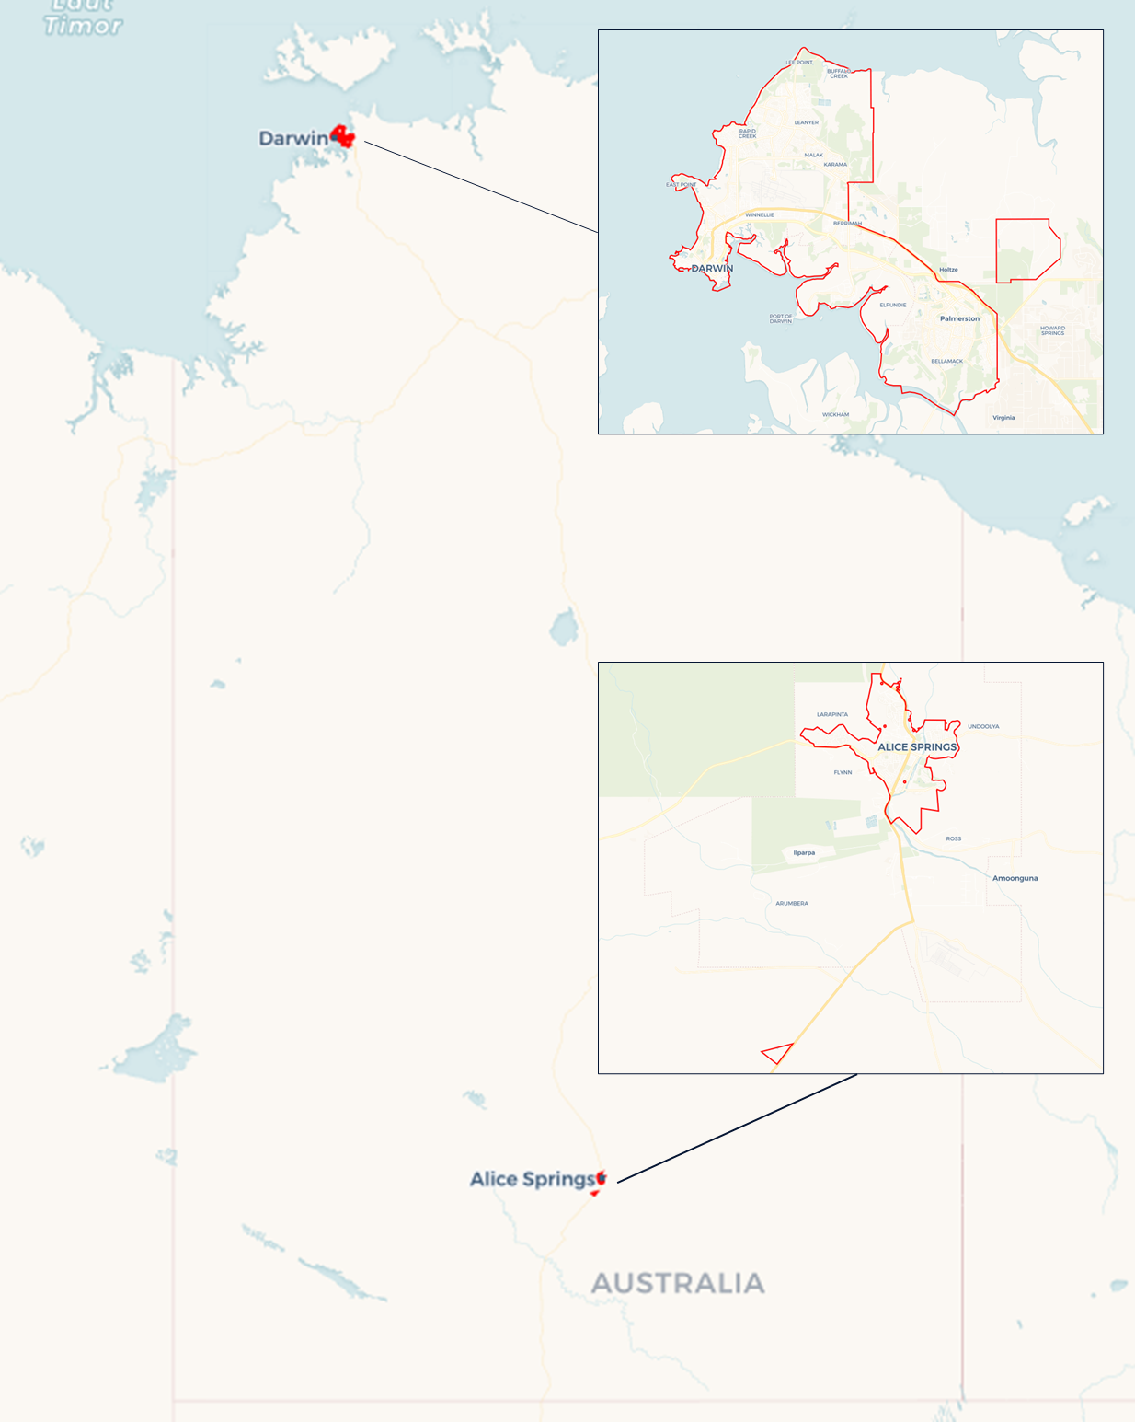Local Jobs Plan

Darwin (including Alice Springs) ****Employment Region**** | NT | September ****2024****

Workforce Australia Local Jobs (Local Jobs) is a program that supports tailored approaches to accelerate   
reskilling, upskilling and employment pathways in response to current and emerging local workforce needs.

## Local Jobs elements

### Local Jobs Plan

The Local Jobs Plan sets out the skills and employment challenges and priorities of the region, and associated strategies that will drive the design and implementation of activities to be implemented to address these challenges.

### Employment Facilitators

Employment Facilitators and Support Officers support the delivery of the program by bringing together key stakeholders including businesses, employment services providers, higher education and training organisations.

### Local Jobs and Skills Taskforce

Each Employment Region has its own Taskforce. Representatives include local stakeholders who have demonstrated experience in upskilling, reskilling, and an ability to represent, connect and collaborate with others in the region to meet labour market needs.

### Local Recovery and National Priority Funds

The Local Recovery Fund supports projects that meet the priorities identified in the Local Jobs Plan. The National Priority Fund provides funding for innovative local solutions to address structural barriers to employment.

Explore labour market insights for the   
[Darwin (including Alice Springs)](https://www.jobsandskills.gov.au/work/employment-region-dashboards-and-profiles/monthly-labour-market-dashboards) Employment Region

## Local labour market challenges in the region

* The Northern Territory (NT) faces workforce shortages across various skill levels and sectors, particularly healthcare and social assistance, construction, mining, retail, public administration, and hospitality.
* The region faces high levels of socioeconomic disadvantage, intergenerational unemployment, and a high proportion of jobless families. Long-term unemployment remains high, especially among First Nations and Youth.
* Individuals seeking employment often face a range of challenges including low literacy, reading, and writing comprehension, language, digital literacy, criminal history, a lack of formal education, minimal or no work experience, and family or cultural obligations.
* Limited Public Transport Services makes it difficult for individuals without private vehicles to access employment, education, healthcare, and other essential services. This can be burdensome for individuals and families facing socioeconomic disadvantages and for those living away from key industrial growth centres.
* Housing challenges in the NT, particularly in First Nations communities, are multifaceted, including high level of transience from remote communities to regional centres. High living costs and lower incomes contribute to affordability concerns, exacerbated by a housing shortage leading to overcrowding. Homelessness is significant, affecting Youth and First Nations in both urban and rural areas and straining support services.

## Local jobs and skills priorities and strategies in the region

### Priority 1 - Collaborate with the business community to identify and broker solutions to current and emerging workforce and skills needs that will create opportunities for local individuals to move into ongoing sustainable employment

#### What are our challenges and opportunities?

Emerging industries including defence support, renewables, manufacturing and their related supply chains will add to current workforce shortages across various skill levels and sectors. There is an opportunity to address some of the needs by prioritising skill-building initiatives that foster cross-sectional relationships within the business community and employment service providers to bridge the gap and provide benefit to both job seekers and the business community.

#### How are we responding?

* Facilitating localised workforce development working groups in Darwin and Alice Springs that are solutions-focused to address local attraction, recruitment, and retention across healthcare, social assistance, construction, mining, retail, public administration, transport, hospitality, defence support, renewables, manufacturing, and related supply chains.
* Working with businesses and peak bodies to create opportunities for local individuals, enabling them to transition into sustainable employment.
* Promoting employment opportunities available, and the skills needed with employment services providers and other stakeholders.
* Strengthening connections between businesses, employment services providers, training organisations and other industry stakeholders by collaborating on major projects, employment and workforce forums, information sessions and expos.
* Providing labour market intelligence to stakeholders to support employment pathway initiatives to meet labour market demand.

### Priority 2 – Collaborate with the business community to build employer capacity to recruit, retain, and support a skilled workforce

#### What are our challenges and opportunities?

#### The workforce shortage in the NT presents an opportunity to implement localised attraction campaigns and skilling programs to tackle recruitment challenges and enhance job seeking and workforce capabilities. Successful workforce attraction campaigns need to include development and retention strategies which requires planning, collaboration, and knowledge sharing among all stakeholders and must include cultural understanding, professional mentorship, to ensure on going retention.

#### How are we responding?

* Supporting employers to review candidate packs and job descriptions to ensure fit for purpose, help streamline recruitment processes, identify gaps and opportunities for enhancement, and to facilitate initiatives such as cultural awareness, mentoring and employment placement support, for the employer and individual.
* Providing information that increases the awareness of local businesses to available grants/programs and place-based initiatives provided by the Australian and NT Governments to address workforce shortages, attraction, recruitment, and retention needs.
* Encouraging employers to consider internships, work experience, job sharing, casual to part-time or full-time employment to enable individuals to build capability and capacity over time.
* Promoting cultural mentorship to the business community and collaborating with key members of the community to provide informed advice to their organisation.

### Priority 3 – Enhance efforts to increase the Vocational Education and Training (VET) sector capabilities to respond to current and emerging employment, skills and workforce needs of the region

#### What are our challenges and opportunities?

#### VET organisations across the NT are experiencing critical shortages of trainers. These shortages pose significant challenges to delivering quality training and education to individuals to meet the workforce demand and job seeking skilling initiatives.

#### How are we responding?

* Conducting workshops to explore innovative solutions to address the demands in the VET industry and ensure training remains accessible.
* Working with the VET sector to identify innovative strategies and best practices for recruiting and retaining trainers in region.
* Collaborating with Industry peaks and Jobs and Skills councils in supporting RTOs to understand the demand and access government programs, services, and funding to deliver on the demand.
* Actively promoting employment pathways and opportunities in the sector.

### Priority 4 – Enhance efforts to identify, facilitate, and support skills development and employment opportunities for the job-seeking community

#### What are our challenges and opportunities?

#### Individuals seeking employment lack skills to successfully transition into the workforce. The implementation of upskilling or reskilling initiatives, tailored to meet current labour market demands, will assist job seekers in this process. The review of the employment landscape, including available opportunities, prerequisites, and potential challenges would benefit job seekers in enhancing their readiness for obtaining employment opportunities.

#### How are we responding?

* Connecting Workforce Australia Services, Community Development Program, and Disability Employment Services providers with businesses, and training organisations to facilitate the development of place-based initiatives that address skills in demand and provide individuals with pathways to employment.
* Encouraging employers to review expectations, job fit and employment options, work with individuals to build capacity, and ensure two-way communication.
* Facilitating collaboration between governments, peak bodies, and community to drive skills and employment initiatives that attract, train and prepare the labour force and employers to meet local employment requirements.
* Promoting the benefits of investment in language, literacy, numeracy, and digital skills of workers, with local employers and industry groups.
* Promoting the benefits of Australian Apprenticeships to meet local employment requirements.
* Promoting initiatives delivered by governments, peak bodies, training organisations and local employment providers that address labour market demands.

### Priority 5 – Facilitate and support the participation in training and employment opportunities, with a particular focus on First Nations, youth, and people with a disability

#### What are our challenges and opportunities?

#### Many individuals within the Darwin Employment Region encounter significant challenges to effective participation in training and employment. There is opportunity to ensure connection and advocacy of holistic support that addresses education, skills development, health, access to transport, accommodation, and other social needs.

#### How are we responding?

* Collaborate with local stakeholders to support the delivery of targeted place-based employment pathway programs through the utilisation of the Local Initiative Fund, Local Recovery Fund, National Priority Fund, and where appropriate, Australian and NT Government grants programs.
* Conducting workshops and information session on employment pathways, opportunities and supports available, aiming to increase workforce participation of cohorts facing complex challenges.
* Encouraging collaboration in the delivery of wrap-around supports and services, positioning individuals to successfully transition into sustainable employment.
* Maximising linkages between training and local employment opportunities to fill entry-level positions, including promotion of traineeships and apprenticeships.
* Working with local stakeholders to promote culturally safe workplaces and collaborating with key members of the community on delivery of appropriate training to individuals and the business sector.
* Collaborating with all levels of government, health, transport, and accommodation support services and to identify and address needs of the local community.
* Collaborating with leaders from various sectors to support and improve the employment participation of individuals facing complex challenges.

## Want to know more?

* Contact: Michelle Burgess, Employment Region Employment Facilitator: [mburgess@localjobsnt.com.au](mailto:mburgess@localjobsnt.com.au)
* Website: [Local Jobs](https://www.dewr.gov.au/local-jobs) or [Workforce Australia](https://www.workforceaustralia.gov.au/)