

Quick Reference Guide: How to confirm your identity in ADMS

To claim incentives in ADMS, Apprentices need to complete a **one-time confirmation** of their identity. This guide shows Apprentices how to confirm their identity.

1. Navigate to [ADMS](https://adms.australianapprenticeships.gov.au/adms/sign-in).
2. Click ‘Apprentice Login’.

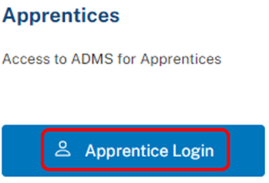

**RESULT:** The myGov sign in page will display.

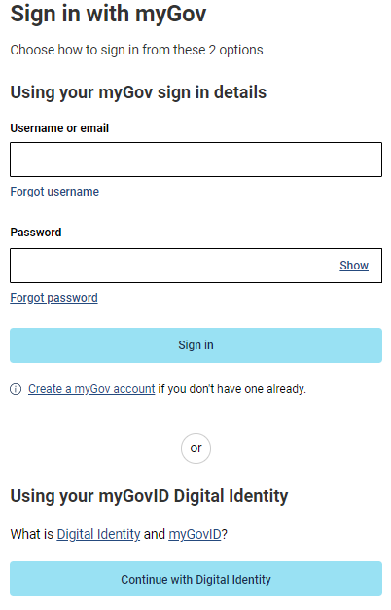

1. Sign in with either myGov or myGovID.

*NOTE: To sign in with myGov, you need an account that is linked to Medicare, Centrelink or the ATO.*

*To sign in with myGovID, you need a Standard Digital Identity strength* ***AND*** *a myGov account.*

**RESULT:** The ‘Welcome to ADMS’ page will display.

1. Complete the ‘privacy’ and ‘conditions of use’ declarations.
2. Select whether you’d like to activate your account with your Apprentice ID or Unique Student Identifier (USI).

*NOTE: Contact your Apprenticeship Network Provider if you don’t know your Apprentice ID.*

1. Enter your Apprentice ID or USI.
2. Enter your Date of Birth.
3. Complete the reCAPTCHA (if required).

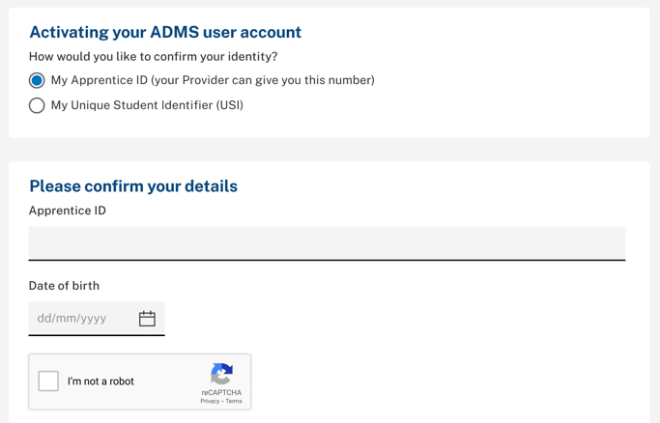

1. Click ‘Next’.

*NOTE: If your details on record don’t match your myGov account details, the confirmation will fail. If this occurs, contact your Apprenticeship Network Provider for assistance.*

**RESULT:** You will be prompted to confirm your account with an activation code.

*NOTE: If your email and phone number are not on record, please contact your Apprenticeship Network Provider for assistance.*

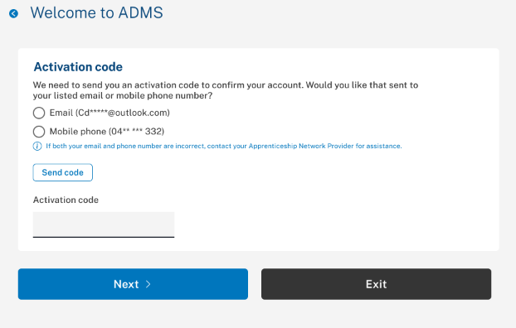

1. Choose to receive your activation code via email or SMS.
2. Click ‘Send code’.
3. Enter your activation code.
4. Click ‘Next’.

**RESULT:** You have now completed your one-time confirmation of your identity and can use ADMS.

*NOTE: If you are unable to successfully confirm your identity, contact your Apprenticeship Network Provider for assistance.*

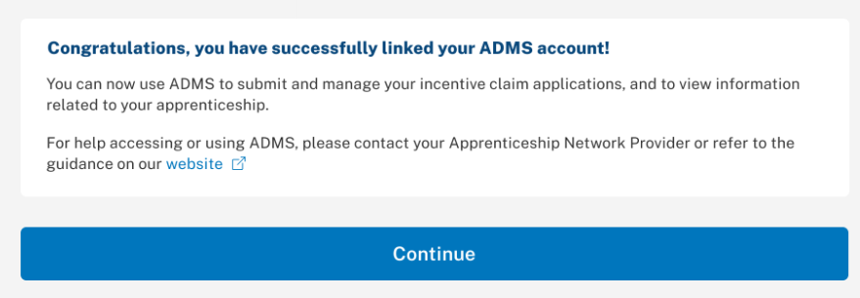

# Support

For assistance with ADMS, contact your Australian Apprenticeship Support Network (AASN) provider. If you aren’t sure who your AASN provider is, please call 1800 020 108.

For feedback on this quick reference guide, contact [ADMSEngagement@dese.gov.au](mailto:ADMSEngagement@dese.gov.au).