

Quick Reference Guide: How to complete a Living Away From Home Allowance eligibility application

Australian Apprentices can use this guide to complete a Living Away From Home Allowance (LAFHA) eligibility application created for them by their Australian Apprenticeship Support Network (AASN) Provider. If you need to complete a LAFHA claim application, visit the [Australian Apprenticeships](https://www.australianapprenticeships.gov.au/claiming-apprentice-incentives-adms) website and read through the Quick reference guide on How to complete a Living Away from Home Allowance claim application.

1. Navigate to [ADMS](https://adms.australianapprenticeships.gov.au/adms/sign-in) and log in using the Apprentice login button.

*NOTE: If you are logging into ADMS for the first time, you will need to set up your ADMS access. Visit the* [*Claiming Apprentice Incentives page*](https://www.australianapprenticeships.gov.au/claiming-apprentice-incentives-adms) *on the Australian Apprenticeships website for further information.*

1. Click ‘View my LAFHA eligibility application’ from the Actions menu.

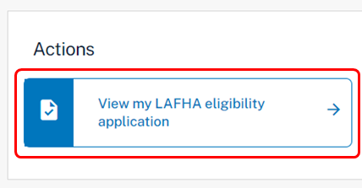

**RESULT:** Your LAFHA eligibility application is displayed.

1. Carefully read the Purpose of this application section.
2. Confirm that the pre-populated information on the application is correct.

*NOTE: Pre-populated information is taken from ADMS records. Contact your Australian Apprenticeship Network provider if you need to update any details.*

1. Complete the Eligibility details section.
2. Carefully read the Document evidence required section.
3. Click the ‘Choose file(s)’ button.
4. Locate your documents and click ‘Open’.

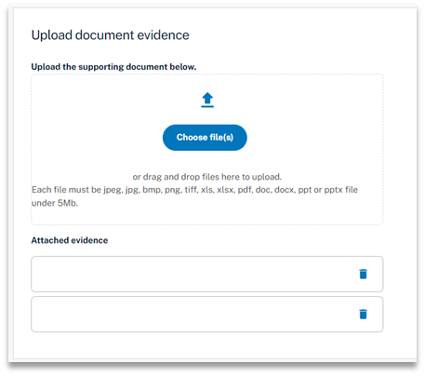

*NOTE: You can also drag and drop from your computer to upload your documents*.

**RESULT:** Your selected documents will be uploaded.

1. Click the ‘Next’ button at the bottom of the screen.
2. Select the checkbox after your have read and agreed to the information in the Apprentice declaration.
3. Click the ‘Submit’ button to finalise your application.

**RESULT:** Your LAFHA eligibility application will be submitted for assessment.

*NOTE: You can click the ‘View my LAFHA eligibility application’ from the ADMS home page to view your eligibility application.*

# Support

For assistance with ADMS, contact your Australian Apprenticeship Support Network (AASN) provider. If you aren’t sure who your AASN provider is, please call 1800 020 108.