Strategic Review of the Australian Apprenticeships Incentive System

Background Paper

June 2024

**Acknowledgement of Country**

The Department of Employment and Workplace Relations acknowledges the traditional owners of Country throughout Australia on which we gather, live, work and stand. We acknowledge all traditional custodians, their Elders past and present, and we pay our respects to their continuing connection to their culture, community, land, sea and water.

© Commonwealth of Australia 2024



With the exception of the Commonwealth Coat of Arms, the Department of Employment and Workplace Relations logo, any material protected by a trade mark and where otherwise noted, all material presented in this document is provided under a [Creative Commons Attribution 4.0 International licence](https://creativecommons.org/licenses/by/4.0/) (https://creativecommons.org/licenses/by/4.0).

The details of the relevant licence conditions are available on the Creative Commons website (accessible using the links provided), as is the full legal code for the [CC BY 4.0 International licence](https://creativecommons.org/licenses/by/4.0/legalcode) (https://creativecommons.org/licenses/by/4.0/legalcode).

The document must be attributed as the *Strategic Review of the Australian Apprenticeships Incentive System: Background Paper* by the Australian Government Department of Employment and Workplace Relations.

Contents

Abbreviations and acronyms iii

Introduction 1

Review goals 1

Review scope 2

Key contacts 2

Challenges facing the system 3

Australia’s emerging skills needs 3

Skills shortages 6

Gender segregation and skills shortages 9

A continuing decline in apprenticeship numbers 12

Barriers to entry and completion 17

Specific challenges and barriers faced by priority cohorts 28

Employer experiences of apprenticeships 31

Conclusion 33

Appendix A: Background on the Australian Apprenticeships Incentive System 34

Appendix B: Non-financial apprenticeship services and supports 37

Appendix C: Improving apprenticeship completions under the National Skills Agreement 40

References 41

**List of figures**

Figure 1: Review goals 1

Figure 2: Projected supply and demand in the electrician workforce, 2023 to 2030 4

Figure 3: Care and support sector employment, 1988 to 2023 5

Figure 4: Proportion of gender-imbalanced occupations in shortage on the Skills Priority List, 2021 to 2023 10

Figure 5: Top 10 priority occupations with highest proportion of male apprenticeship commencements, 2023 11

Figure 6: Top 10 priority occupations with highest proportion of female apprenticeship commencements, 2023 12

Figure 7: Commencements by existing worker status, 2010 to 2023 13

Figure 8: Completions by trade status, 2010 to 2023 14

Figure 9: Completion rates, by trade status, for the 2009 to 2018 commencing cohorts 15

Figure 10: Proportion of apprentices who observed bullying in the workplace, 2019 22

Figure 11: Number of apprentices in training, by priority cohort, 2023 28

Figure 12: Satisfaction with working conditions, trade occupations, 2019 29

Figure 13: Reasons for employing apprentices and for dissatisfaction, 2023 31

Figure 14: Summary of redesigned apprenticeship services and supports 39

**List of tables**

Table 1: Top 20 occupations in demand by shortage type, 2023 7

Table 2: Selected trade occupation completion rates, 2018 15

Table 3: Selected non-trade occupation completion rates, 2018 16

Table 4: Completion rates, by employer size and type, 2018 16

Table 5: Completion rates by key demographic group, 2018 17

Table 6: First main reasons why apprenticeships were discontinued, 2008, 2010 and 2023 20

Table 7: Incentives to labour force participation, women aged 25 to 39 years 29

# Abbreviations and acronyms

AAIP Australian Apprenticeships Incentives Program

AASN Australian Apprenticeship Support Network

ABS Australian Bureau of Statistics

ACCC Australian Competition and Consumer Commission

AHRC Australian Human Rights Commission

BAC Boosting Apprenticeship Commencements (wage subsidy)

CAC Completing Apprenticeship Commencements (wage subsidy)

DAAWS Disability Australian Apprentice Wage Support

DEWR Department of Employment and Workplace Relations (Australian Government)

ILO International Labour Organization

JSA Jobs and Skills Australia

NCVER National Centre for Vocational Education Research

NDIS National Disability Insurance Scheme

NSA National Skills Agreement

OECD Organisation for Economic Co-operation and Development

SAT Supporting Apprentices and Trainees (wage subsidy)

VET vocational education and training

# Introduction

On 19 February 2024, the Minister for Skills and Training, the Hon Brendan O’Connor MP, announced the establishment of the Strategic Review of the Australian Apprenticeships Incentive System (the review). The review is being led by the Honourable Iain Ross AO and Ms Lisa Paul AO PSM.

In establishing the review, the minister acknowledged the importance of apprentices and trainees in helping meet the current and emerging skills challenge, ensuring Australia’s economic growth and prosperity, and supporting the transition to a net zero economy (O’Connor 2024).

The review aims to inform future policy development for the apprenticeships system, through evidence-based research into the effectiveness of the current Commonwealth Incentive System in encouraging the take-up and completion of apprenticeships. The review will take a holistic view of the apprenticeships system and how different elements work together to influence apprentices and employers in apprenticeship attraction, retention and completions. This will include consideration of non-financial supports, apprentice workplace conditions and culture, and opportunities for lifelong learning, as well as identifying systemic impediments to the effective operation of the apprenticeships system.

Background on the Australian Apprenticeships Incentive System is at Appendix A.

**A note on language**

References in this paper to apprentices, apprenticeships and Australian Apprenticeships include trainees and traineeships, unless stated otherwise.

## Review goals

At the heart of the review is the goal of reducing skills shortages across the Australian economy. Four factors contribute to the reduction of skills shortages, as shown in Figure 1Figure 1Figure 1: Review goalsFigure 1Figure 1. This early framework will underpin research and consultation and help guide evidence-based recommendations.

Figure 1: Review goals

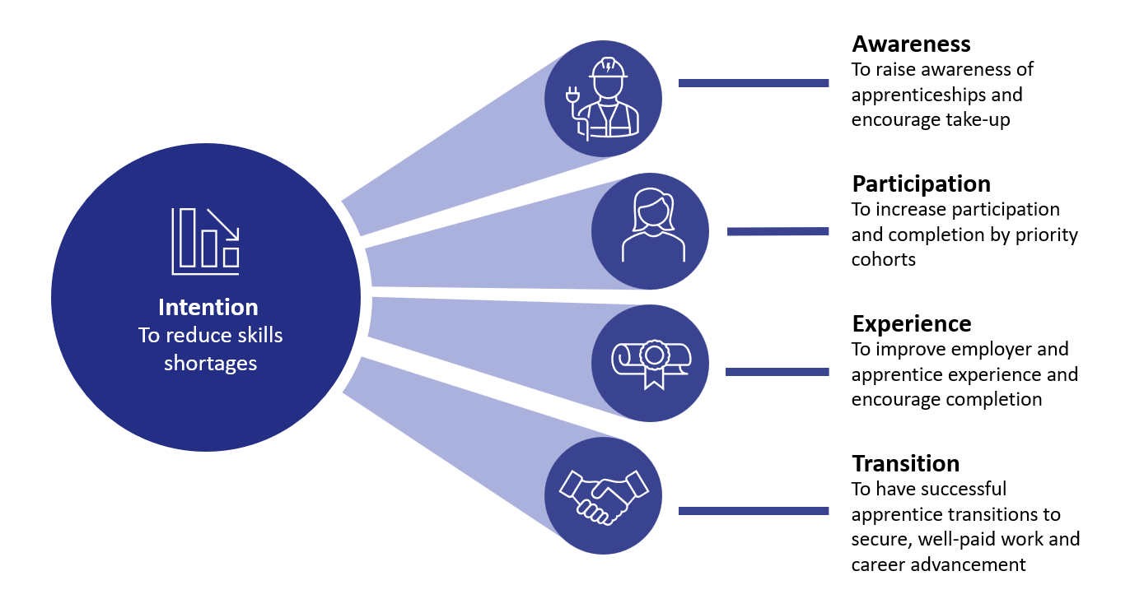

## Review scope

The [review’s terms of reference](https://www.dewr.gov.au/australian-apprenticeships/resources/terms-reference-app-incentive) have 5 key areas of focus:

* how the Australian Apprenticeships Incentive System and complementary services are performing in helping the take-up and completion of apprenticeships
* the effect that cost-of-living pressures are having on apprentices
* how the apprenticeships system can best support high-quality apprenticeships, including the roles of government support, workplace conditions and culture, and employers and supervisors
* if the current system is creating a training environment encouraging women, First Nations people, people with disability and people in regional, rural and remote communities into apprenticeships
* how the Incentive System can be aligned with the priorities in the 2023 Employment White Paper and the Australian Government’s broader economic objectives.

In 2022 and 2023, many people provided views on the non-financial services and supports available to apprentices (such as sign-up support, mentoring and pastoral care). These consultations informed changes to how these non-financial services and supports will be delivered from 1 July 2024 (see Appendix B for further information on the outcomes of that engagement). Due to the relationship between financial and non-financial supports, the review will take these earlier consultations into account and consider whether further changes in non-financial services and supports are required.

The review will also consider the commitment made under the National Skills Agreement to refresh the National Code of Good Practice for Australian Apprenticeships and collaborate on developing best-practice resources for employers (see Appendix C for more information).

The review’s scope aligns with the Quality Apprenticeships Recommendation, 2023 (No. 208), adopted at the General Conference of the International Labour Organization (ILO 2023). Areas of the recommendation relevant to the review include:

* the promotion of quality apprenticeships through vocational education and employment policies
* consultation with employer and union representatives around the suitability of apprenticeships to meet occupational needs
* the effectiveness of current policy in supporting members of vulnerable groups and in addressing gender equality within apprenticeships
* assessing current incentives and support services in relation to apprenticeships.

## Key contacts

|  |  |
| --- | --- |
| **Contact method** | **Details** |
| Email | [ApprenticeshipsReview@dewr.gov.au](mailto:ApprenticeshipsReview@dewr.gov.au?subject=Strategic%20Review%20-%20Discussion%20Paper%20query) |
| Post | Strategic Review of the Australian Apprenticeships Incentive System Department of Employment and Workplace Relations GPO Box 9880 Canberra ACT 2601 |
| Website | [dewr.gov.au/australian-apprenticeships/strategic-review-australian-apprenticeship-incentive-system](http://www.dewr.gov.au/australian-apprenticeships/strategic-review-australian-apprenticeship-incentive-system) |

# Challenges facing the system

The Australian labour market faces a number of challenges, now and into the future. This section discusses Australia’s emerging skills needs, including skills shortages; the contribution of the apprenticeships system in producing skilled workers, including analysis of the decline in apprenticeship numbers; barriers to entry and completion; and specific challenges faced by priority cohorts. It also examines employer experiences of apprenticeships.

## Australia’s emerging skills needs

Australia’s economy is undergoing a rapid transformation, with changing skills needs. The *Intergenerational Report 2023* identifies 5 forces shaping this transformation (Treasury 2023). These are an ageing population; technological and digital transformation; climate change and net zero goals; rising demand for care and support services; and geopolitical risk and fragmentation. These will all drive future skills needs, including skills to fill new occupations that do not yet exist or are only now emerging in the current economy.

### Climate change and net zero

In *Clean Energy Generation: Workforce needs for a net zero economy*, Jobs and Skills Australia (JSA) likens the transition to a clean energy economy to both the post-war industrial transformation and the digital transformation of the late 20th century, each of which saw the emergence of new jobs, qualifications, training pathways, technologies and industries (JSA 2023b).

Reaching the Australian Government’s net zero emissions target by 2050 will require a transformation of the workforce. For example, JSA’s modelling in its clean energy workforce capacity study indicates that Australia will likely need around 32,000 more electricians by 2030 (as shown in Figure 2) and around 85,000 more by 2050. Critically, JSA suggests that this represents 27% more than the projected supply of apprentices (JSA 2023b).

Figure 2: Projected supply and demand in the electrician workforce, 2023 to 2030

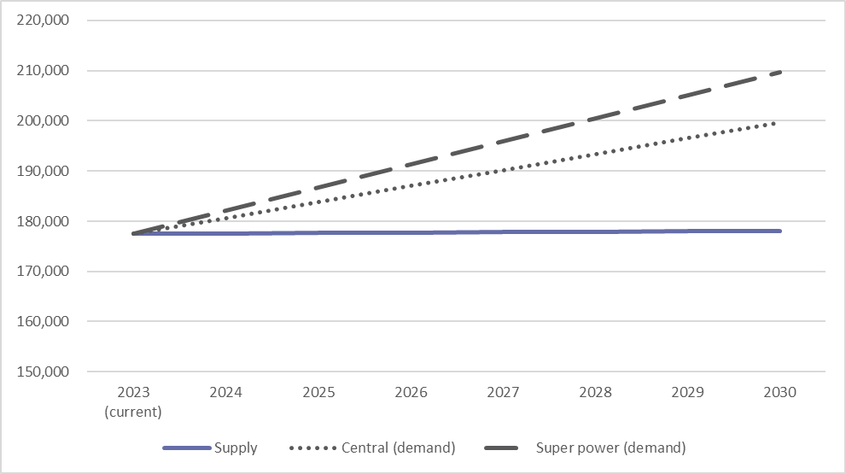

Note: The clean energy ‘super power’ scenario sees ambitious and coordinated government policy action that will give the national electricity system over 90% renewable energy by 2030. The assumptions underpinning this scenario are more ambitious than the measures outlined within current government policies. Those assumptions include 3 times more investment in low-emission technologies, more renewable energy capacity to support the export of green manufacturing (including iron), and a larger critical minerals mining and processing industry.

Source: JSA (2023b).

### Providing care and support

The ageing population and rising demand for care and support services will drive both increased and different needs in the care sector Figure 3. The National Disability Insurance Scheme (NDIS) review identified the need for a larger, more skilled workforce to meet the future demand for quality care. The challenge of creating a larger, more skilled workforce is compounded by the fact that, each year, 17 to 25% of NDIS support workers leave their job (NDIS Review 2023).

Figure 3 shows the increasing levels of employment in the care and support sector over the past 35 years.

Figure 3: Care and support sector employment, 1988 to 2023

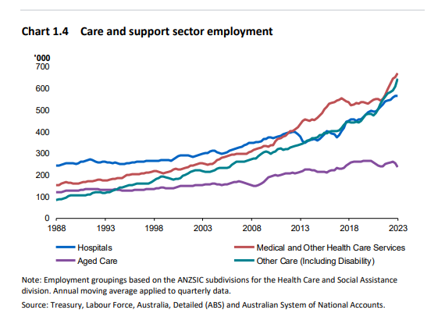

Note: Employment groupings based on the Australian and New Zealand Standard Industrial Classification subdivisions for the Health Care and Social Assistance division. Annual moving average applied to quarterly data.

Source: Treasury (2023).

In addition to the challenges in meeting the demand for care and support services, the demand for skilled workers in the childcare sector remains high. Analysis informing the Australian Competition and Consumer Commission’s (ACCC’s) 2023 Childcare Inquiry showed that that labour force shortages are affecting all childcare markets, in terms of both the supply of childcare services and the costs to supply these services (ACCC 2023b).

Key factors contributing to childcare workforce shortages include less attractive pay and conditions relative to other industries (particularly preschools and primary schools) and the need for staff to allocate (unpaid) personal time to study for required qualifications (also affected by current cost-of-living pressures). These issues can lead to burnout, with many staff leaving the industry and needing more time off due to illness (ACCC 2023a).

### Geopolitical risk and fragmentation

In response to changing geopolitics, Australia will need new and different skills in the defence sector. The defence industry requires many people with vocational education and training (VET) qualifications to fill job roles needed to deliver defence capability programs (Australian Government and Government of South Australia 2023).

Meeting the Australian Government’s commitments under the AUKUS agreement, including establishing a sovereign nuclear-powered submarine capability, will drive demand for engineering and operations workers from 2025 out to 2040. The South Australian defence industry workforce is predicted to grow from its current level of around 3,500 direct jobs to more than 8,500 direct jobs in the 2040s. Naval shipbuilding and sustainment are key drivers of this workforce demand, with many of the skills sets required in trade and technician roles (Australian Government and Government of South Australia 2023).

### Housing and manufacturing

Australia is also facing significant housing challenges, and delivering on the Australian Government’s commitment to address housing needs will also require a skilled workforce. National Cabinet has agreed to an ambitious new national target to build 1.2 million new, well-located homes over 5 years, from 1 July 2024 (Treasury n.d.).

The Housing Industry Association and Master Builders Australia report acute shortages of skilled tradespeople to meet Australia’s housing construction needs. BuildSkills Australia states that 90,000 extra skilled tradespeople are needed to deliver the National Housing Accord (Sobyra 2024), and it has recently been consulting on its first national workforce plan for the built environment. Further, Master Builders Australia (2023) estimates that to meet growth and replace workers who leave the industry, 486,000 workers need to enter the building and construction industry by the end of 2026.

Finally, the Manufacturing Industry Skills Alliance (2024) has highlighted the importance of strong vocational education and training to support a competitive manufacturing sector. It has raised concerns about decreasing apprentice completion rates across manufacturing and is undertaking a project to better understand the drivers of this and to develop strategies to increase the pipeline of apprentices.

## Skills shortages

Economic transformations provide opportunities and challenges. The objective of the review is to ensure that the Australian Apprenticeships Incentive System is fit for purpose to support these transformations.

At the present level of apprenticeship commencements and completions, Australia will not have enough skilled workers to meet these demands. There is also a significant risk that we will miss the opportunity to ensure that the jobs created are accessible and shared with all Australians, particularly among underrepresented cohorts and workers in transitioning sectors.

Australia faces a profound skills challenge. Table 1 shows the top 20 occupations in demand nationally, many of which use the apprenticeships system as a key pathway for bringing in and training new workers.

Table 1: Top 20 occupations in demand by shortage type, 2023

| **Classification of skills shortage** | **Top 20 occupations in demand** |
| --- | --- |
| **Longer training gap** Few qualified applicants per vacancy – bachelor degree, Certificate IV or apprenticeship required | * Early childhood (pre–primary school) teachers * Occupational therapists * Physiotherapists * Registered nurses * Solicitors * Social workers * Metal fitters and machinists * Electricians |
| **Shorter training gap** Few qualified applicants per vacancy – Certificate I to III or less required | * Retail managers |
| **Suitability gap** Many qualified applicants per vacancy, but few suitable applicants per qualified applicant | * Advertising, public relations and sales managers * Construction managers * Advertising and marketing professionals * Civil engineering professionals |
| **Retention gap** Above-average job mobility (below-average rates of retention), potentially reinforced by low number of total new applicants per vacancy | * Human resource professionals * Chefs * Child carers * Aged and disabled carers |

Note: The table includes 17 occupations. JSA notes there are 3 occupations in the top 20 occupations in demand (general practitioners and resident medical officers, software and applications programmers, and motor mechanics) that are yet to be classified – with additional analysis required – as they may fall into more than one skills shortage category.

Source: JSA (2023c:30).

Over the next 10 years, more than 90% of new jobs expected to be created will require a post-secondary qualification and around 44% of all new jobs created will require a VET qualification (Parliament of Australia 2024). JSA further projects demand of around 1.5 million new workers in the 60 occupational unit groups that form part of the Australian Apprenticeships Priority List over the next 5 years (DEWR 2024a).

### The apprenticeships system is a key pathway to fill skills needs

Apprenticeships are an important pathway for many Australians to gain the skills and qualifications required for secure, long-term employment. Apprentices represent 17% of all students enrolled in a training package qualification in 2020 (Stanwick et al. 2021).

Australian Government investment in this critical part of the VET system recognises the importance of apprenticeships in developing the skilled workforce Australia needs to support our ongoing economic sustainability and competitiveness. Since the 1960s, the Australian Government has provided a range of financial incentives and non-financial incentives and support for apprentices and employers. Currently, the Australian Apprenticeships Incentive System is the Australian Government’s primary financial assistance program providing incentives to both apprentices and employers, at around $1.1 billion per year in 2022–23 and 2023–24. See Appendix A for further information on past and current incentives.

While these measures have always been aimed at encouraging participation in apprenticeships, the range of incentives and supports available at any one time has altered to respond to shifting policy priorities, economic cycles, and emergency situations. The apprenticeships system must be flexible and responsive to ensure it can continue to effectively support employers and apprentices and address the barriers to entry that are impacting on commencement and completion rates. This includes ensuring the Incentive System supports apprentices who are managing cost-of-living pressures and who also have changing preferences for work, such as increased flexibility, support for mental health and wellbeing, and improved work-life balance.

### Role of the states and territories

State and territory governments have a key role in the apprenticeships system through the regulation of apprenticeships under state and territory legislation. This includes approving training contracts and overseeing employer–apprentice arrangements, deciding which qualifications and occupations can be undertaken as an apprenticeship or traineeship, registering group training organisations, and providing information and support to apprentices and employers throughout the apprenticeship process. Several recent reviews at the state level have sought to identify and address skills issues:

* Review of Skills, Training and Workforce Development in Western Australia (Driscoll et al. 2020)
* Skills for Victoria’s Growing Economy Review (Macklin 2020)
* Review of support provided to Queensland apprentices and trainees, with a focus on female apprentices in male-dominated occupations (Queensland Training Ombudsman 2022)
* National Vocational Education and Training Completions report (Skills SA 2023)
* NSW Vocational Education and Training Review interim report (Bruniges et al. 2023).

In addition to financial and non-financial supports delivered by the Australian Government, such as the Australian Apprenticeships Incentive System, state and territory governments employ a variety of approaches to alleviate skills shortages and advance workforce development. These approaches include subsidising some or all tuition fees associated with an apprenticeship or traineeship, and providing additional financial and non-financial supports. Some examples are outlined below, noting multiple jurisdictions may offer similar programs, tailored for local needs.

* The Western Australian Government delivers the Group Training Organisation Wage Subsidy Program, which assists small to medium-sized enterprises in the building and construction industry by providing a 100% wage subsidisation for 300 apprentices and trainees employed through group training organisations (Jobs and Skills WA 2023).
* Victoria’s Head Start program has been designed to help students kickstart their career by developing the hands-on skills and experiences that employers need. The program consists of one day a week paid employment in year 10, 2 days a week in year 11, and 3 days a week in year 12, and ensures that students are paid a training wage and complete a trade qualification or make significant progress towards that goal (Victorian Government 2024).
* The New South Wales Government delivers the Continuing Apprentices and Trainees Placement Service, which helps apprentices and trainees to secure employment and continue their training, along with providing employers with access to the Continuing Apprentice/Trainee Register to find suitable candidates (NSW Department of Education n.d.).
* The Queensland Government has released the Apprenticeships Info app, a free mobile phone app providing instant answers to apprenticeship questions, with further links to important contacts and services. The app complements Queensland’s Apprenticeships Info helpline, which fields concerns and complaints and offers end-to-end support and advice, tailored to the apprentice’s situation and location (Queensland Government n.d.).
* The South Australian Government’s Construction Industry Training Fund levy is collected on building and construction work to fund quality training and initiatives that attract and develop a highly skilled workforce within the building and construction industry. Initiatives include tool vouchers, funding for tradespeople to become qualified trainers and assessors, funding for driving lessons, and additional supports for First Nations apprentices, mature age apprentices and South Australian veterans (Construction Industry Training Board n.d.).
* In the Northern Territory, apprentices who need to travel more than 50 kilometres to attend off-the-job training at a registered training organisation can claim an apprenticeship travel and accommodation subsidy. The subsidy is a contribution towards the cost of travel and accommodation and can include intrastate and interstate road, bus and air travel, accommodation and transfers (Northern Territory Government n.d.)
* The New Apprenticeship Scholarship Program has been implemented to support eligible apprentices and trainees in North West Tasmania. The program includes grants of $2,000 for new workers aged over 18 years. Initial target industries include childcare, aged care, disability support, agriculture, forestry and fishing, and transport and logistics. The program is to support costs associated with fees, books and materials, transport, childcare or other services that will assist people to participate in an apprenticeship or traineeship (Skills Tasmania n.d.).
* In the Australian Capital Territory, the Head Start program is piloting tailored school-based apprenticeship and traineeship programs that match students’ job interests with local businesses in need of skilled workers. The program includes supported recruitment, pre-vocational training, a pathways plan supporting flexible school, work and training arrangements, and a dedicated mentoring team, including a career coach, industry coordinator, social worker and apprentice mentor (ACT Government n.d.).

## Gender segregation and skills shortages

Australia’s labour market is characterised by gender-segregated occupations. For example, in 2023 women comprised 7.9% of the workforce in male-dominated trades (unpublished DEWR data as at 31 March 2024).

The drivers for these disparities are many, but all have their roots in societal norms and expectations. A survey by Plan International Australia (2023) found that 58% of respondents agreed that some jobs are naturally suited to men, and some are naturally suited to women, 44% agreed that some areas of study are naturally suited to boys, and some are naturally suited to girls, and 25% agreed families function well and children are best supported when mothers do the caring and fathers earn the income.

It is generally accepted that women face uncertainties that men do not, in making career decisions associated with work interruption due to pregnancy and other family-related contingencies. These uncertainties include risk of income loss and skill depreciation, and missed opportunities for skills formation or consolidation. Time off work during the early years of a woman’s career interrupts and delays her skill acquisition, career progression and earning potential (Estévez-Abe 2005).

While work in male-dominated sectors and occupations offers better pay and career development opportunities, their work environments can make it difficult for women to enter and progress in these areas. For example, various formal and informal workplace practices, such as recruitment and promotion processes based on connections with men and cultures of long working hours and constant availability, restrict women’s ability to work and succeed in masculine workplaces (Galea et al. 2020).

Notably, gender imbalance exists in a number of industries experiencing significant skills shortages. In 2023, 54% of male-dominated occupations and 40% of female-dominated occupations were prone to labour shortages, compared to 25% for occupations with more balanced gender ratios (Figure 4). JSA classifies an occupation as gender-dominated when one gender comprises at least 80% of the workforce (JSA 2023a).

Figure 4: Proportion of gender-imbalanced occupations in shortage on the Skills Priority List, 2021 to 2023

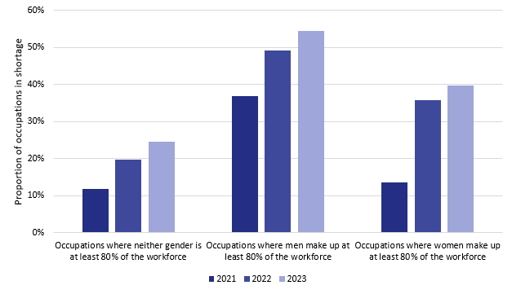

Source: JSA (2023a).

In the apprenticeships system, as of 30 June 2023, men dominate trade occupations like electricians, bricklayers, carpenters and joiners, while women are concentrated in occupations such as child carers, general clerks, sales assistants and personal carers (unpublished DEWR data as at 31 March 2024). In 2023, shortages grew among female-dominated community and personal service workers (JSA n.d.). These occupations all rely on apprenticeships as the key education and training pathway. Increasing apprenticeship participation and completion rates is therefore critical to meeting Australia’s skills needs.

The top 10 priority occupations with the highest proportions of male and female apprenticeship commencements are shown in Figure 5 and Figure 6.

Figure 5: Top 10 priority occupations with the highest proportion of male apprenticeship commencements

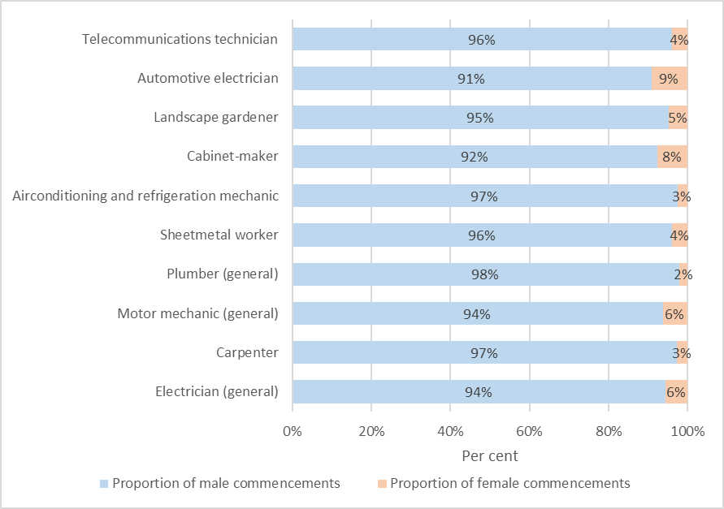

Source: DEWR analysis drawing on NCVER (2024a).

Figure 6: Top 10 priority occupations with the highest proportion of female apprenticeship commencements

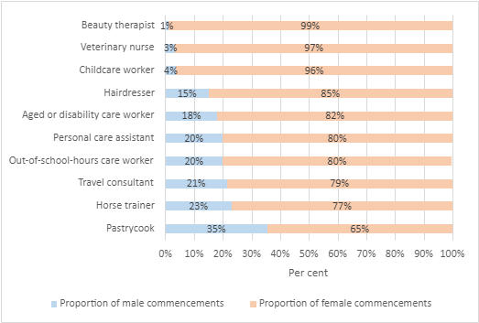  
Source: DEWR analysis drawing on NCVER (2024a).

This analysis suggests that encouraging greater gender balance across industries will be important to reducing skills shortages across the economy. If we are to meet our current and future skills needs, we must work to ensure the economic benefits of training and employment are equally accessible and attractive to men and women.

## A continuing decline in apprenticeship numbers

This section examines declining apprenticeship commencements and a decrease in completion rates.

### Commencements

‘Commencements’ refers to the number of people starting an apprenticeship in a given period. The decline in apprenticeship commencements started before the economic disruption of the COVID-19 pandemic. Between 2012 and 2019, annual apprentice commencements to 31 December fell by around 54%, from approximately 331,000 to 151,000 (NCVER 2023a).

As Figure 7 shows, 2012 saw a peak in apprentice commencements by existing worker status, immediately followed by a sharp decline. This decline was driven by a series of policy changes in 2012–2013, in response to recommendations made by the 2011 Expert Panel Review to redirect Australian Government employer incentives to support apprentices and their employers in occupations that are priorities for the Australian economy (McDowell et al. 2011). These changes tightened eligibility for incentives to address the rapid increase in existing worker apprenticeships, particularly in occupations that were not on the National Skills Needs List. ‘Existing worker’ refers to someone who has worked with an employer for more than 3 months (91 days) before starting their apprenticeship.

Further, the changes restricted other support for non-trade commencements in non-priority occupations. Therefore, they had the biggest impact on existing worker commencements, as access to incentives was focused on apprentices in trades and other priority occupations, such as the care sector. Prior to the 2012 changes, around 37% of all apprenticeship commencements came from existing workers, the majority of which were in non-trade occupations such as business administration, sales assistance and office management.

Figure 7: Commencements by existing worker status, 2010 to 2023

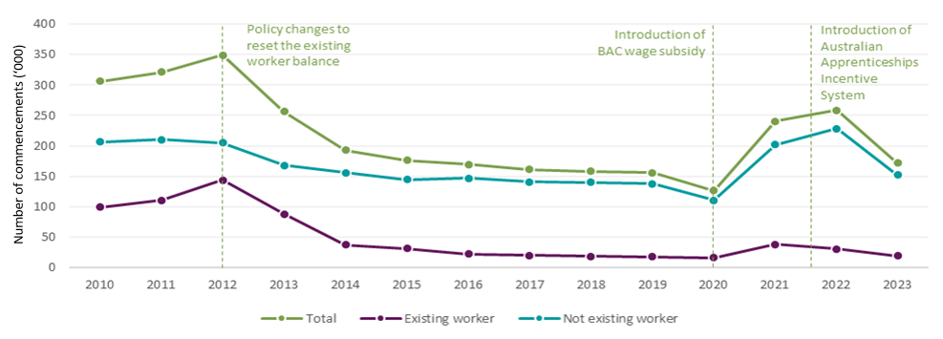

BAC = Boosting Apprenticeship Commencements

Note: Annual data based on 12-month period to 30 September.

Source: DEWR analysis based on NCVER (2024a).

While both trade and non-trade apprenticeship commencements have been declining since 2012, research shows the reduction in commencements is primarily due to a sharp decline in non-trade apprenticeships, while trade commencements have remained steady (see related data in Figure 8). This is partially explained by the removal of the employer incentives for existing worker apprenticeships.

These changes precipitated a steady year-on-year decline in commencements until the introduction of time-limited COVID-19 emergency response measures in 2020 and 2021 – the Boosting Apprenticeship Commencements (BAC) and Completing Apprenticeship Commencements (CAC) wage subsidies. With broad-based eligibility that was not limited to the National Skills Needs List, these measures provided high employer incentives through 50% wage subsidies, and were targeted to new apprentices, with numbers of existing workers capped under the program. State and territory COVID-19 response initiatives were also in operation at the same time, which – in some sectors such as construction at particular points in time – resulted in employers having almost a fully subsidised apprentice. While these measures did see a rapid increase in commencements for the duration of the measures, it did come at a significant cost of over $7.2 billion between 5 October 2020 and 31 December 2023.

The Department of Employment and Workplace Relations has engaged the Australian Centre for Evaluation to undertake an evaluation of the BAC and CAC wage subsidies. In particular, the evaluation will examine the extent to which these interventions increased apprenticeship commencements, increased apprenticeship retention and completion outcomes, and represented value for money for the Commonwealth. The Australian Centre for Evaluation will seek to make findings as to whether such interventions should be considered in future emergencies. Importantly, noting that any value-for-money findings will be highly relevant to the Strategic Review of the Australian Apprenticeships Incentive System, the evaluation report will be considered alongside the review.

Further information on the BAC and CAC wage subsidies is at Appendix A.

### Completions and the completion rate

Both the number of annual completions and the completion rate are important measures of the efficiency of the Australian Apprenticeships Incentive System in producing new skilled workers. Changes in annual completions are primarily a result of changes in the number of commencements in preceding years – as the number of commencements increases, so too will completions. The completion rate, however, refers to the proportion of a commencing cohort of individuals who complete their apprenticeship. Importantly, this rate may not necessarily move in the same direction as the number of completions. Completion rates vary according to demographics, employer size and occupation, with some sectors having particularly low (or high) completion rates. The impact of changing economic conditions, including COVID-19, also take time to flow through to the completion rate.

Changes in annual completions are affected by changes in commencements in preceding years.Figure 8shows the number of completions by trade status over time. A decline in commencements that began in 2012 can partly explain the decrease in the number of completions in subsequent years. However, the completion rate also decreased over this period, from 61.6% for those apprentices commencing in 2012 to 56.9% for those commencing in 2016. It is worth noting that there are differences between trade and non-trade completion rates, with the trade completion rates reducing from 59.6% for the 2012 commencing cohort to 57% for the 2016 commencing cohort, compared to 61% and 56.6% respectively for the same cohorts in the often shorter qualifications in non-trade apprenticeships.

Figure 8: Completions by trade status, 2010 to 2023

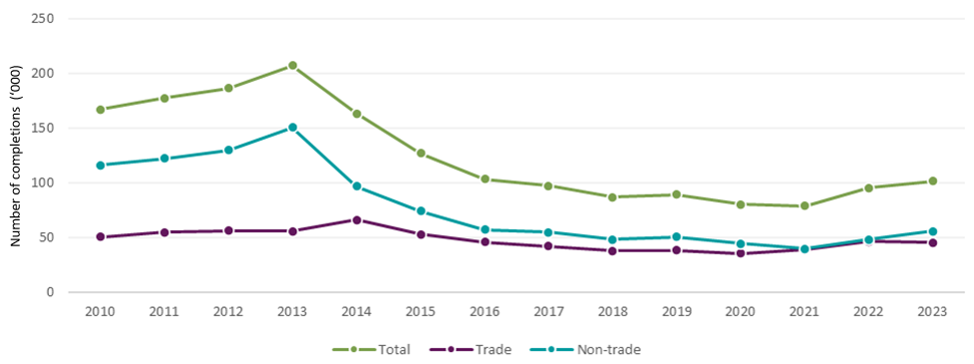

Note: Annual data based on 12-month period to 30 September.

Source: DEWR analysis based on NCVER (2024a).

Figure 9 shows completion rates by trade status for the cohorts of apprentices who commenced their training contracts between 2009 and 2018. The lower completion rates for the 2018 commencing cohort can be partly explained by the impact of COVID-19, particularly in the longer trade apprenticeships, which typically take 3 to 4 years. COVID-19 impacted apprenticeship completions in many ways, including delaying assessments and restricting access to on-the-job and off-the-job training.

The 2018 commencing cohort has a higher-than-usual proportion of apprentices remaining in training, as apprentices continue to complete the requirements of on-the-job and off-the-job training, which – for many apprentices – was paused or unavailable during the COVID-19 pandemic.

Figure 9: Completion rates, by trade status, for the 2009 to 2018 commencing cohorts

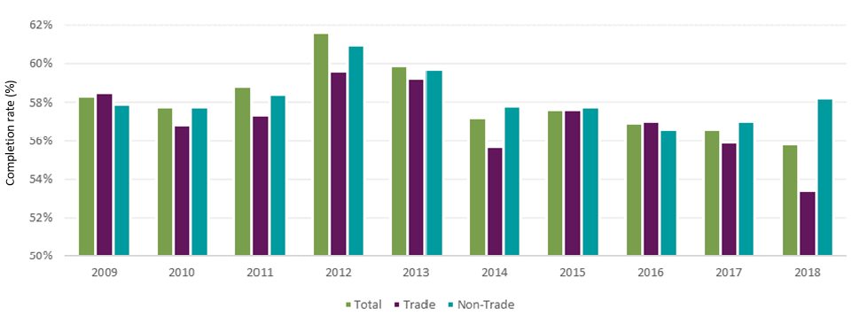

Source: DEWR analysis of NCVER *Completion and attrition rates for apprentices and trainees* publications, 2013 to 2022.

Lifting completion rates will substantially contribute to meeting Australia’s skills needs. Understanding what has contributed to the decline in the completion rate is important in identifying how the apprenticeships system can better support apprentice completions. However, in some occupations, lack of completion of a formal qualification does not prevent people from working in the industry. Chefs are one example. It is important to consider, however, that lack of completion may have implications for pay or career advancement. The key issue of interest is the likelihood of people transitioning from training, at whatever point, into employment in the relevant industry.

Table 2 to Table 4 compare completion rates for the 2018 commencing cohort by occupation (trade and non‑trade), and by employer size and type. For comparison, the overall completion rate was 55.8% (NCVER 2023a:20). Note that 2018 data has been used as it is the most recent stable option, with enough time passed that any delayed completion arising from COVID-19 has been resolved.

Table 2: Selected trade occupation completion rates, 2018

|  |  |
| --- | --- |
| **Trade occupations by ANZSCO sub-major group** | **Completion rate (%)\*** |
| **All trade occupations** | **53.4** |
| 31 Engineering, ICT and science technicians | 59.8 |
| 32 Automotive and engineering trades workers | 58.1 |
| 33 Construction trades workers | 51.9 |
| 34 Electrotechnology and telecommunications trades workers | 59.6 |
| 35 Food trades workers | 42.6 |

ANZSCO = Australian and New Zealand Standard Classification of Occupations; ICT = information and communications technology

* There is variation in completion rates of particular occupations within each category. For example, electricians have a high completion rate of 76% compared to the overall completion rate of 59.6% for electrotechnology and telecommunications trades workers.

Source: NCVER (2023a).

Table 3: Selected non-trade occupation completion rates, 2018

|  |  |
| --- | --- |
| **Non-trade occupations by ANZSCO sub-major group** | **Completion rate (%)** |
| **All non-trade occupations** | **58.2** |
| 42 Carers and aides | 68.7 |
| 62 Sales assistants and salespersons | 62.7 |
| 53 General clerical workers | 64.1 |
| 43 Hospitality workers | 49.8 |
| 51 Office managers and program administrators | 54.7 |

ANZSCO = Australian and New Zealand Standard Classification of Occupations

Source: NCVER (2023a).

Table 4: Completion rates, by employer size and type, 2018

|  |  |
| --- | --- |
| **Employer size/type** | **Completion rate (%)** |
| Small (1–19 employees) | 54.8 |
| Medium (20–199 employees) | 56.3 |
| Large (200+ employees) | 59.9 |
| Group training organisation | 62.0 |

Source: Unpublished DEWR data as at 31 March 2024.

The fact that small employers as a group tend to have lower completion rates than larger employers is particularly significant because about 2 in 5 apprentices work for small employers (NCVER 2023a; unpublished DEWR data as at 31 March 2024). A number of studies report that some small businesses may not have enough capacity to provide a high-quality training environment and support for their apprentices because of resource constraints and lack of mentoring expertise (Bednarz 2014; Dickie et al. 2011; O’Dwyer and Korbel 2019).

The type of apprenticeship engagement also matters. As shown in Table 4, apprentices employed through group training organisations tend to have completion rates 3 to 7 percentage points higher than those directly employed by small or medium-sized host employers, and 2 percentage points higher than large employers.

Table 5 shows completion rates for apprentices by key demographics.

Table 5: Completion rates by key demographic group, 2018

|  |  |  |  |
| --- | --- | --- | --- |
| **Key cohort** | **Completion rate (%)** | **Comparison cohort** | **Completion rate (%)** |
| Women | 58.7 | Men | 54.5 |
| Women in male-dominated trades | 50.3 | Men in male-dominated trades | 58.7 |
| First Nations | 48.7 | Not First Nations | 56.2 |
| Disability | 53.0 | Without a disability | 55.8 |
| Regional or remote* | 59.7 | Major cities* | 56.0 |
| Culturally and linguistically diverse | 50.7 | Not culturally and linguistically diverse | 56.3 |

* Based on [ABS Remoteness Areas](https://www.abs.gov.au/statistics/standards/australian-statistical-geography-standard-asgs-edition-3/jul2021-jun2026/remoteness-structure/remoteness-areas).

Source: DEWR analysis based on NCVER (2024a) and unpublished DEWR program data as at 31 March 2024.

Completion rates vary for apprentices with different characteristics; for example, completion rates for women are lower than for men in male-dominated trades, but higher than for men overall. Priority cohorts also have lower completions rates than their comparison groups, with the exception of apprentices from regional or remote areas who have a higher completion rate than apprentices from major cities.

Within trade apprenticeships, several groups typically have lower completion rates, including those aged below 19 years, people with disability, First Nations people, school-based apprentices, and those who had only completed year 9 or below (Productivity Commission 2020).

## Barriers to entry and completion

The long-term decline in apprentice commencements and completions suggests that there are various barriers to starting and completing apprenticeships.

### Why completion matters

As noted by the Productivity Commission (2020), there are significant costs associated with non-completion – for example:

* apprentices may become unemployed or receive a lower wage than if they had completed their training
* employers will have spent resources in supervising the apprentice and paying training costs (including time the apprentice spent at off-the-job training)
* governments will have subsidised training, provided employer incentives and incurred administrative costs.

Not all these costs are wasted. Non-completing apprentices are likely to have developed some skills to improve their productivity, and some will have developed sufficient skills to transition to full-time employment in their chosen career. The latter situation raises the question of whether the apprenticeship is fit for purpose, or if it could be shortened, if apprentices are able to effectively transition into work after completing only part of their apprenticeship.

Some level of non-completion is to be expected. Some apprentices change their minds about their career goals. Others may choose not to complete due to a change in their personal circumstances or if they feel they have gained the skills they need to transition to full-time employment (Productivity Commission 2020).

However, the aggregate costs of non-completion are significant. Deloitte Access Economics (2011) estimates that the cost of non-completion of ‘traditional trade apprenticeships’ in New South Wales in 2010 was around $348 million. Non-completion also limits an apprentice’s ability to work in some occupations, such as licensed trades (for example, electricians and plumbers).

Lifting completion rates will substantially contribute to meeting Australia’s skills needs. Indeed, lifting completions in the licensed trades is essential as completion is a prerequisite to securing a licence. Understanding what has contributed to the decline in the completion rate is important in identifying how the apprenticeships system can better support apprentice completions.

### Economic factors

The overall labour market, and perceptions about available jobs and actual job availability, affect participation. For example, the Organisation for Economic Co-operation and Development (OECD) has noted that timely and accurate insights into the labour market and career options impacts students’ career and educational choices in Australia (OECD 2016).

The retention of apprentices is also influenced by the tightness of the labour market. Neuenschwander (1999) finds that there are more apprenticeship terminations in fields where there are abundant opportunities for unskilled workers. Karmel and Misko (2009) observe that completion rates decreased when the labour market improved, and argue that this is due to apprentices having other opportunities. The authors also contend that the opposite result would be expected when opportunities decline, a contention supported by Knight (2008).

The economic environment within specific sectors of the economy can also influence commencements and completions. Trade apprenticeship training has been found to be particularly susceptible to changes in employment conditions. Atkinson and Stanwick (2016) point to a link between the overall numbers of trade apprentices in training and the unemployment rate – as the unemployment rate increases, trade apprentices in training, as a proportion of the trades labour force, decreases.

### Perceptions of apprenticeships

A young person’s decision to undertake an apprenticeship is subject to a range of social influences (Behavioural Insights Team 2020). A parent‘s area of study, line of work and views on desirable post-secondary pathways all have a significant influence on what pathway a young person will choose. If parents place more value on university pathways, they are more likely to discuss them with their children (Behavioural Insights Team 2020). These perceptions also vary by socioeconomic status. One study showed that young people in the lowest quartile of socioeconomic status were 4 times more likely to want to be technicians and trade workers than those in the highest quartile of socioeconomic status (Polesal et al. 2017).

School leavers are also influenced by peers and by how schools present post-secondary choices to young people. Often information about university courses is more accessible, and greater emphasis is placed on university at the expense of apprenticeships (Education Council 2020). Presenting university as the default pathway can result in young people pursuing a university pathway because it is the status quo, rather than whether it is the most appropriate pathway for them (Behavioural Insights Team 2020).

The House of Representatives Standing Committee on Employment, Education and Training found that schools need to promote vocational education and training (VET) as a viable post-school option with equal merit to university. While employers and industry view the sector positively, VET is often viewed as less intellectually demanding and inferior to university. There are misconceptions that VET pathways lead to a narrow range of careers and jobs that are lower paid, more physically demanding and not intellectually stimulating. The standing committee recommended implementing educational campaigns targeting stereotypes and negative attitudes (Parliament of Australia 2024).

### Lack of information about apprenticeship pathways

Where young people actively seek out information on apprenticeship pathways, career advice often leads them towards occupations based on traditional gender roles. Young women are streamed towards care and support, while young men are streamed towards male-dominated industries such as construction (DEWR 2023c). In deciding to pursue an apprenticeship, young people may prioritise short-term considerations (for example, the ease of finding alternative work) over longer-term considerations (for example, future earnings and job security). Careers information does not actively correct misperceptions about the financial outcomes of apprenticeships (Behavioural Insights Team 2020).

Some studies suggest careers advisers and teachers promote apprenticeships and traineeships as a career option only for low-achieving students. For example, Misko et al. (2007) note that a lack of encouragement from teachers and counsellors can act as a potential barrier to greater interest in trade apprenticeships among school students. Categorising students by their perceived ability levels, the authors found that teachers were more likely to suggest to students that were ‘performing not so well or not so well at all’ to undertake trade apprenticeships compared with students that were ‘performing at a very high level’. The authors identify a lack of information on apprenticeships as a key barrier, as ‘[a]pprentices and students both cited the lack of promotion of apprenticeships and information about apprenticeships as additional disincentives’ (Misko et al. 2007:21).

### Factors affecting non-completions

Identifying the specific factors that impact on non-completion is complex because many of the issues cited by apprentices (such as working conditions, pay, alternative job offers, personal reasons and career changes) interact with one another. Apprentices usually have more than one reason for not completing, so a multifaceted approach is needed to improve completions. No single solution will provide a complete solution to the problem.

The National Centre for Vocational Education Research (NCVER) publishes the annual *Apprentice and Trainee Outcomes* report, which includes information on apprentices’ and trainees’ reasons for non‑completion. Reasons relating to the employment experience are the most common reasons for leaving an apprenticeship. Table 6 ranks the main reasons why apprenticeships were discontinued, based on surveys conducted in 2008, 2010 and 2023.

Most of the reasons given for not completing an apprenticeship vary depending on how far an individual has progressed in their training contract. Karmel and Mlotkowski (2010) found that only the desire to do something different (such as study at university) or better (such as getting a better paid job) remains constant throughout the duration of the contract. Every other reason for non-completion either increases or decreases with duration.

Table 6: First main reasons why apprenticeships were discontinued, 2008, 2010 and 2023

|  |  |  |  |
| --- | --- | --- | --- |
| **Main reason** | **2008 (n=429) (%)** | **2010 (n=1,154) (%)** | **2023 (n=810) (%)** |
| Personal reasonsa | 10.0 | 15.7 | 19.6 |
| Got offered a better job | 3.3* | 2.2 | 13.7 |
| Left job/changed career | 9.4 | 12.5 | 10.2 |
| I didn’t get on with my boss or other people at work | 16.2 | 10.2 | 9.2 |
| The pay was too low | 8.7 | 4.7 | 8.8 |
| I didn’t like the type of work | 10.2 | 8.3 | 7.3 |
| Poor working conditions | 3.1* | 3.1 | 5.3 |
| I lost my job/was made redundant | 8.9 | 26.8 | 4.8 |
| I wasn’t happy with the on-the-job training | 5.4* | 1.9 | 4.5 |
| Apprenticeship/traineeship cancelled/discontinued | 3.2* | 3.8 | 3.5 |
| Other | 10.2 | 1.5* | 2.2 |
| I was not happy with the job prospects in the industry | 3.6* | 4.2 | 2.2 |
| I wasn’t happy with the off-the-job training | 1.4* | 1.6* | 2.0 |
| I found the study too difficult | 1.4* | 1.6* | 1.5* |
| Business closed/company went into liquidation | n/a | n/a | 1.4* |
| I transferred to another apprenticeship/traineeship | 3.1* | 1.1* | 1.2* |
| Studying elsewhere (university/school) | 1.9* | 0.8* | 1.1* |
| Wasn’t happy with the course, training or curriculum | n/a | n/a | 1.0* |
| Not able to use the skills I was learning at work | n/a | n/a | 0.6* |

a ‘Personal reasons’ includes the following: family reasons, illness, lack of time, moved, problems with travelling/transport.

* Estimate has a relative standard error greater than 25% and should therefore be used with caution.

**Notes**

The table is sorted by the main reason in 2023.

Comparisons between 2008 and 2010 results, and 2023 results, should be treated with some caution for the following reasons:

* The order and wording of the questions in the 2023 Student Outcomes Survey sometimes differed to the 2008 and 2010 surveys, which could affect responses.
* Using the Student Outcomes Survey to gather information from apprentices and trainees means that the survey responses are limited to apprentices and trainees who undertook off-the-job training during the previous year.

NCVER survey results from 2008 and 2010 were included as comparisons to the 2023 survey results. They are the only general surveys on reasons for discontinuing an apprenticeship prior to 2019. Figures in the table represent the proportion of weighted survey participants who selected the reason as their primary reason for discontinuing their apprenticeship. Each participant is only allowed to select one reason in their response.

Source: Bednarz (2014) and DEWR analysis of NCVER (2024b). We note the survey upon which the NCVER *Apprentice and Trainee Outcomes* report is based has been the subject of a number of methodological criticisms (Smith 2023).

Drop-out rates tend to be higher at the beginning – overall, around 10% of apprentices and trainees withdraw within the first 3 months and around 20% withdraw within the first 6 months (NCVER 2009:13). Workplace issues, such as poor working conditions, harassment and lack of support, have an immediate impact and are likely drivers of the high proportion of non-completions in the first 6 to 9 months (Karmel and Mlotkowski 2010). The fact that most terminations take place during an early stage of the apprenticeship also suggests matching problems (Stalder and Schmid 2006; Bessey and Backes-Gellner 2007).

### Impact of the employment experience

Apprentices, like any employee, want to feel valued. About 80% of cancellations are initiated by the apprentice (Productivity Commission 2020) and they commonly give reasons relating to the employment experience (see Table 6). This is perhaps unsurprising as an apprenticeship is, in essence, a job with a training component. The primary reason for the non-completion of apprenticeships across developed nations is the quality of the employment experience (Bednarz 2014).

Dickie et al. (2011) argue that the extent to which the apprentice regards their employment experience as representing a ‘fair deal’ is central to completion. To be considered a ‘fair deal’, apprentices expect varied work; good supervision and on-the-job training; a good boss; and a safe, contemporary workplace free from bullying. The authors suggest that if an apprentice does not think they are receiving a fair deal, then other factors start to matter more: not liking the work and pursuing other opportunities are secondary issues to the relationship with the employer:

Apprentices will put up with a lot, including low wages, if what they get in return is fair … If they don’t get a fair deal, then any aspect of the apprenticeship – like pay, repetitive work or a lack of workmates – can become a source of dissatisfaction and restlessness and impact on their commitment and likelihood of completion. (Dickie et al. 2011:13)

In relation to young trades apprentices, the authors found that a sense of fairness ‘is the tipping point for commitment’ (Dickie et al. 2011:13). If apprentices perceived the deal to be fair, they were more willing to trade off some of their current disadvantages, such as low pay, low status or repetitive work, for the long-term advantages they believed would be delivered by a valuable trade qualification, like higher wages. The psychological contract in apprenticeships and traineeships is also discussed in Walker et al. (2012).

Engagement with stakeholders on the government’s non-financial supports in 2022–23 also raised the importance of quality employer–apprentice relationships, and how strong relationships and good supervision support apprentices to complete their training. Several Australian studies also support the proposition that apprentices’ and trainees’ experiences of training and working conditions affect retention and completion rates.

McDowell et al. (2011), Karmel and Misko (2009), Cully and Curtain (2001), Callan (2001) and Dickie et al. (2011) find that it is most often the working conditions, and not training-related reasons, that primarily influence apprentices’ and trainees’ decisions to complete or terminate their training. A bad working environment, especially clashes with supervisors and/or work colleagues, ranks among the most frequently cited reasons for terminating an apprenticeship (Schöngen 2003; Neuenschwander et al. 1996; Stalder and Schmid 2006). Ainley and Corrigan (2005) found that dissatisfaction with their supervisor caused some apprentices and trainees to discontinue their training or change employers. People who were dissatisfied with supervisors commented that the supervisors were often criticising, too demanding, never gave positive feedback and treated them disrespectfully (Misko et al. 2007; Dickie et al. 2011).

In addition to interpersonal conflict with supervisors and co-workers, problematic or difficult working conditions also contribute to non-completions (Snell and Hart 2008; Karmel and Mlotkowski 2010; Huntly Consulting Group 2008). These problems included poor, unsafe or dangerous workplace practices and conditions, bullying, hours being cut or unreasonably extended, call-ins at short notice, pressure to work extra shifts, lack of appropriate supervision (Snell and Hart 2008), and apprentices reporting that their work was ‘boring’ and not engendering a sense of accomplishment (Huntly Consulting Group 2008).

Research by NCVER has found bullying is one of the reasons why apprentices may not complete their training. In one study (Stanwick et al. 2021), a quarter of apprentices had observed bullying. Further, a higher proportion of non-completers (35%) than completers (21%) reported observing bullying (Figure 10). Female non-completers were more likely to report observing bullying (45%), as well as non-completers in the food trades (55%).

Figure 10: Proportion of apprentices who observed bullying in the workplace, 2019

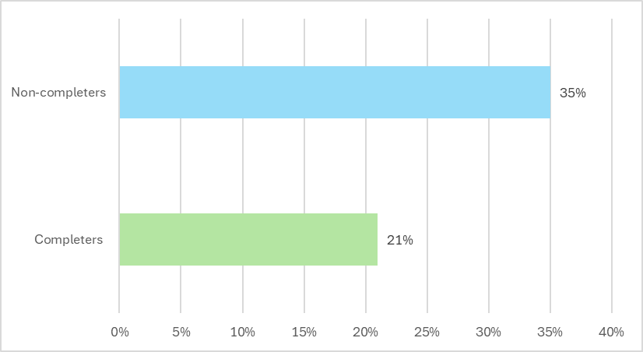

Source: Stanwick et al. (2021).

Research by Ross et al. (2020) showed that 27.3% of Queensland construction industry apprentices had experienced workplace bullying (with 20% reporting this bullying as ‘severe’).

Conversely, a positive workplace experience improves retention and completion. Dickie et al. (2011) note that employers who mentor apprentices in a positive way are more likely to retain them. Adequate workplace support for apprentices and trainees plays an important role in ensuring successful completion rates (Skills Australia 2010; Clarke and Lamb 2009; Karmel and Oliver 2011), particularly during the first 4 to 12 months of the employment arrangement when the apprentice or trainee is most at risk of dropping out (Snell and Hart 2008).

Supportive managers are a significant factor in retaining apprentices and trainees (Cocks and Thoresen 2013; Bednarz 2014; Misko et al. 2001). Dickie et al. (2011:39) note that ‘those who say their boss has a fair and positive attitude towards them are much more likely to get through to the end’.

Peer support and peer mentorship have also been found to be important in ensuring apprentices’ and trainees’ wellbeing and mental health (Buchanan et al. 2016), as well as enhancing their satisfaction with their training experience (Snell and Hart 2008). Many group training organisations have made an important contribution to providing such support for apprentices.

Dickie et al. (2011) note that workplace factors that positively contribute to completion include a good first placement, previous positive experience, a good supervisor, and participation in structured training. Despite not being particularly satisfied with aspects of their training, some surveyed apprentices and trainees in Snell and Hart’s (2008) study cited other factors influencing their retention, such as better-than-average pay or support in the current position, a desire to obtain a certificate for future employment opportunities, and a lack of being able to find other jobs.

Harris et al. (2001) argue that completion is more likely if the apprentice or trainee can develop and use a wide range of skills and knowledge; hours and demands of work are realistic and reasonable; physical conditions of work are not too onerous; interpersonal relationships are satisfying; and management and supervision are supportive.

In summary, several factors are linked to successful completions, including having access to a quality training experience, enjoying the job, experiencing a range of work tasks, feeling happy with the quality of training, having time to practise new skills, and experiencing a positive work environment. Social inclusion and integration into the workplace are also vital, particularly getting along with the ‘boss’ in an effective and positive relationship (Western Australian State Training Board 2017; Jobs Queensland 2016; Bednarz 2014).

### Low wages

The evidence on how wages impact apprenticeship commencements and completions is mixed. The evidence suggests that training wages are not the main reason why apprentices do not complete their training, but they are likely to be a significant factor. In 2023, only 8.8% of non-completers reported low training wages as the main reason why they did not complete their apprenticeship (Table 6); however, 35% were dissatisfied with their wage (NCVER 2019). It is conceivable that apprentices may have put up with other problems with their employment, had their wages been higher.

Snell and Hart (2008:62) found high levels of satisfaction among apprentices and trainees who had received a higher-than-average training wage, noting that:

apprentices working for larger companies with union representation and collective agreements rarely complained about their pay or conditions, they widely recognised that they were in a privileged position compared to many other apprentices and had little or no intention of leaving training.

Low wages may be a more important barrier to *entering* an apprenticeship (Misko and Wibrow 2020). This is a particular constraint for longer apprenticeships, some of which can take up to 4 years. For example, an 18-year-old apprentice who has completed year 12 will receive a training wage as a proportion of a qualified tradesperson: 55% in year 1; 65% in year 2; 75% in year 3 and 88% in year 4 (Fair Work Commission 2013).

Evidence indicates that some young people may pay particular attention to short-term considerations, such as jobs that pay better immediately after leaving school. For example, an apprentice mechanic earns a lower average wage than a casual hospitality worker or labourer, and an apprentice chef earns less than a casual kitchen hand. Similarly, mature age workers looking to make a career change can be deterred by low apprentice wages for up to 4 years and the lack of flexible learning options (Deloitte Access Economics 2012).

The training wage is part of a complex dynamic between training wages, future wages, and wages in alternative employment. Apprentice pay represents an opportunity cost in undertaking an apprenticeship as the training wage is lower than alternative employment.

The opportunity costs are balanced against the future premium that a qualified tradesperson receives relative to an unskilled worker (the wage premium) (Nechvoglod et al. 2009). The benefit to the apprentice is very sensitive to the premium attached to being a qualified tradesperson and the alternative to the apprenticeship. Nechvoglod et al. (2009:25) observe:

For a young person the pay-back period is short, and the apprenticeship appears to be a good investment. For an older person apprentice wages in the first and second year are low compared with the wage in an unskilled job. Therefore, the critical factor is the wage margin obtained by qualified tradespeople. Unless this is considerable, undertaking an apprenticeship is a poor investment for an older person.

Wage premiums vary extensively between industries and occupations, and tend to be higher for apprenticeships than traineeships. Using data from NCVER’s 2008 Apprentice and Trainee Destination Survey, Karmel and Rice (2011:16–17) reported that the sampled participants in the trades were foregoing annual earnings of $10,000 to $15,000, in the sense that they could have earned more in alternative, unskilled employment. In non-trade occupations, foregone earnings were between $5,000 and $10,000, with men on average foregoing slightly higher amounts than women.

Karmel and Mlotkowski (2011:34) found that for trade apprentices, the wage premium on completion is more likely to affect completion rates than the training wage. For trainees, the training wage matters more:

... completion rates decrease with increases in the difference between wages in alternative employment and training wages.

Low wages can impact on apprentices’ living conditions, ability to attend trade school and job sites, satisfaction, and ultimately attrition (Productivity Commission 2020; NCVER 2023a; Misko et al. 2007; Huntly Consulting Group 2008). Misko et al. (2007) reported that apprentices had difficulty meeting their needs and financial commitments on their apprentice wages and the higher comparative wages of their peers in other types of work caused dissatisfaction with their pay. A study by Karmel and Mlotkowski (2011) concurs that low pay is the most significant source of apprentice dissatisfaction.

Addressing issues associated with low apprenticeship wages is complicated. While increasing training wages may increase the potential supply of apprentices and aid retention and completion, it also raises employer costs.

Overall, it is likely that wages have some impact on the decision not to continue with an apprenticeship, but the effect is not consistent across all apprentices. The difference between wages on completion and wages in alternative employment is significant in the trades, but much less significant in non-trade traineeships.

### Dissatisfaction with training

Of employers dissatisfied with vocational qualifications, their main concerns were poor training quality, not teaching relevant skills, or not enough focus on practical skills (Joyce 2019).

While dissatisfaction with on- or off-the-job training does not rank highly in the NCVER outcomes listed in Table 6, other research suggests that a lack of adequate training is associated with apprentices and trainees terminating their training contracts (Huntly Consulting Group 2008; Cully and Curtain 2001; Dunn et al. 2011; Misko et al. 2001).

Harris et al. (2001) found that certain aspects of the training experience enhance retention and completion rates for apprentices and trainees:

* a high level of integration between the training program and the on-the-job environment, and linkages between different levels of qualifications providing a career or learning pathway
* trainers seen to be experienced, efficient and supportive
* all parties (apprentices/trainees, managers/supervisors, teachers/trainers) recognising and valuing the skills and knowledge developed during the training contract
* apprentices and trainees supported to develop persistence over the duration of training.

### Age and educational attainment

Age and educational attainment influence apprenticeship completion rates.

Ball and John (2005:6) found the highest level of school completed was one of the most important influences on completion rates: 54% for those who finished year 12 compared with 47% for those who only completed year 9. Similarly, Stromback and Mahendran (2010:73) found that the level of schooling had a large effect on the probability of an apprentice completing their apprenticeship, but a much smaller effect for trainees. Trainees who completed year 12 were associated with a 3.6-percentage-point higher probability of completing their traineeships than those who had completed year 11, but for apprentices this figure was 9.3 percentage points.

A number of other studies show that education level is an important determinant on the likelihood of completion (Ainley et al. 2010; Cully and Curtain 2001; *contra* Curtis 2008). Bessey and Backes-Gellner (2007:16) found that:

Apprentices with a higher level of schooling are significantly more likely to stay within the educational system, either as apprentices in another firm or as full-time students again. This could be due to lower costs of learning, but also to a higher level of awareness for the future consequences of dropping out.

Similarly, international studies consistently report that youths with a higher level of previous schooling are less likely to prematurely terminate their apprenticeship (Bessey and Backes-Gellner 2007).

While completion rates for younger apprentices are on the decline, the completion rates for adult apprentices have been steadily increasing. Adult apprentices (aged 25 to 64 years) are also more likely to be ‘undertaking training at a higher level … and more likely to complete ... in two years or fewer’ (Hargreaves et al. 2017:16). Woolcott Research (2016:41) also noted that age groups under 24 years may be less likely to complete their apprenticeship, while those over 45 years are more likely to complete their apprenticeship.

### Pre-apprenticeship programs

The Productivity Commission (2020:347) found that:

[i]n principle, pre-apprenticeship programs can increase the supply of apprentices and employer demand for apprentices by:

* shortening the commitment and removing the need to secure an employment position for trialling apprenticeship-type training and vocations
* providing skills for applicants to succeed in securing an apprenticeship, particularly applicants facing disadvantage. Indeed, Dumbrell and Smith (2007, p. 10) found that ‘about two-thirds of these students were doing the course either to get into an apprenticeship or because they had missed out on an apprenticeship and saw this option as the next best’
* signalling to employers that the apprentice is likely to be more productive at the outset
* lowering the cost to employers by shifting some of the training costs to the apprentice and government. Stromback (2012, p. 9) noted that: ‘In contrast to employer subsidies, it does this at the margin, by converting applicants below the cut-off mark to above the mark. In contrast, subsidies are payable for all apprentices, including those who would have been trained in the absence of subsidies.’

However, pre-apprenticeship programs vary in quality and across jurisdictions and occupations, and hence the evidence about the effectiveness of pre-apprenticeships on completion rates is limited and mixed. Karmel and Oliver (2011) found that pre-apprenticeships may increase the likelihood of apprenticeship completion in some occupations (construction, food and electrotechnology trades), but may reduce the likelihood of completion for others (hairdressers, and automotive and engineering trades). The authors also found that pre-apprenticeships had no significant effect on apprentice satisfaction (also see Stromback 2012; Toner and Lloyd 2012).

### Screening

Polesel et al. (2004) recommend close screening of students at enrolment and progressively reviewing student satisfaction during training to customise delivery and provide students with additional assistance. At-risk learners need additional services and support, including language, literacy and numeracy support and pastoral care, to maximise completions.

The Productivity Commission (2020:346) considered that there was a good in-principle case for screening apprentices to increase their prospects for completion:

Screening can improve completion rates by ensuring better matching of prospective apprentices and employers, as well as by identifying any need for support services. State and Territory governments should consider screening candidates before their apprenticeships commence (where this does not already occur). Screening could be extended to other VET students if found to be cost effective.

### Motivation

Some studies have concluded that a strong intention to complete is a powerful predictor of sustained enrolment, particularly in male-dominated trades. Dickie et al. (2011) concluded that trades apprentices who were more likely to complete their qualification possessed the following intrinsic motivations:

* had a real passion for the trade
* wanted to work with their hands, out of doors
* were not interested in another kind of job and are not just trying out the trade to see if they like it
* were very happy to identify as a ‘tradie’
* had lots of family and friends who work in trades.

Gow et al. (2008) found that, for surveyed male apprentices from Victoria and Queensland, intrinsic motivation and satisfaction were ’significant predictors’ of apprentices’ intention to continue their training to completion, while extrinsic motivation was not a significant predictor.

In New Zealand, Alkema and Dawson (2016) found that the intensity of motivation at the front end is influential both in the trainee’s decision to start and their ability to continue to completion (for example, students described themselves as ‘keen as’, ‘really keen, optimistic and motivated’).

Conversely, an Australian study involving 1,016 plumbing apprentices found that those who were initially indecisive about their occupational choice were 37% more likely to consider dropping out (Powers 2015).

### Support services

The available evidence suggests that support services are generally very effective at increasing completion rates.

An expert panel review of the Australian apprenticeships system (McDowell et al. 2011) found that mentoring and pastoral care are the most significant support strategies for boosting completion rates. An OECD study suggests that these supports are also more likely to improve completion rates than financial incentives (OECD 2018).

In 2009, the Victorian Government established the Apprenticeship Support Officer program to mentor first‑year apprentices aged under 25 years who were at risk of dropping out. A 2014 review by Deloitte Access Economics found that the program increased the first‑year retention rate by about 3 percentage points (Productivity Commission 2020).

The Australian Apprenticeship Mentoring Program, which ran from 2011 to 2015, funded 33 projects to support apprentices in their first year of training. An evaluation found that the average program participant had a 5‑percentage-point greater probability of retention than a comparable non‑participating apprentice (Deloitte Access Economics 2014:32).

The Productivity Commission (2020:350) noted that several organisations reported significantly higher completion rates arising from the Industry Specialist Mentoring for Australian Apprentices program, which ran from 2018 to 2019 and provided intensive support to apprentices in their first 2 years:

* [The program] delivered a 90% retention rate from 50% prior to the program for over 400 automotive apprentices in SA [Motor Trade Association of South Australia and Northern Territory]
* [The program achieved] an 81% retention rate in the Queensland automotive industry [Motor Trades Association of Queensland]
* Based on HIA’s [Housing Industry Association’s] final figures at the conclusion of the 2‑year mentoring period, an 84% retention rate was achieved for the 3,773 apprentices mentored.

The importance of support services is also supported by qualitative evidence (Billett et al. 2015).

### Lack of opportunities

Individuals may be limited by employer interest and demand when they do decide to take up an apprenticeship. While this is not actively tracked, a comparison of Australian Bureau of Statistics and NCVER data in 2017 showed that around 15% of those who applied for an apprenticeship were unsuccessful (Karmel 2017). While unemployment is currently low, JSA’s Recruitment Experiences and Outlook Survey for March 2024 identified that employers had slightly less difficulty filling vacancies for apprentices (46% recruitment difficulty rate) compared with 55% for all vacancies over 2021 to 2023 (JSA 2024).

## Specific challenges and barriers faced by priority cohorts

Certain cohorts face additional or specific barriers to both entering and completing apprenticeships. These priority cohorts include women in male-dominated trades, First Nations apprentices, apprentices with disability, and apprentices in regional, rural and remote locations.

Figure 11 shows the number of apprentices in training in priority cohorts in 2023.

Figure 11: Number of apprentices in training, by priority cohort, 2023

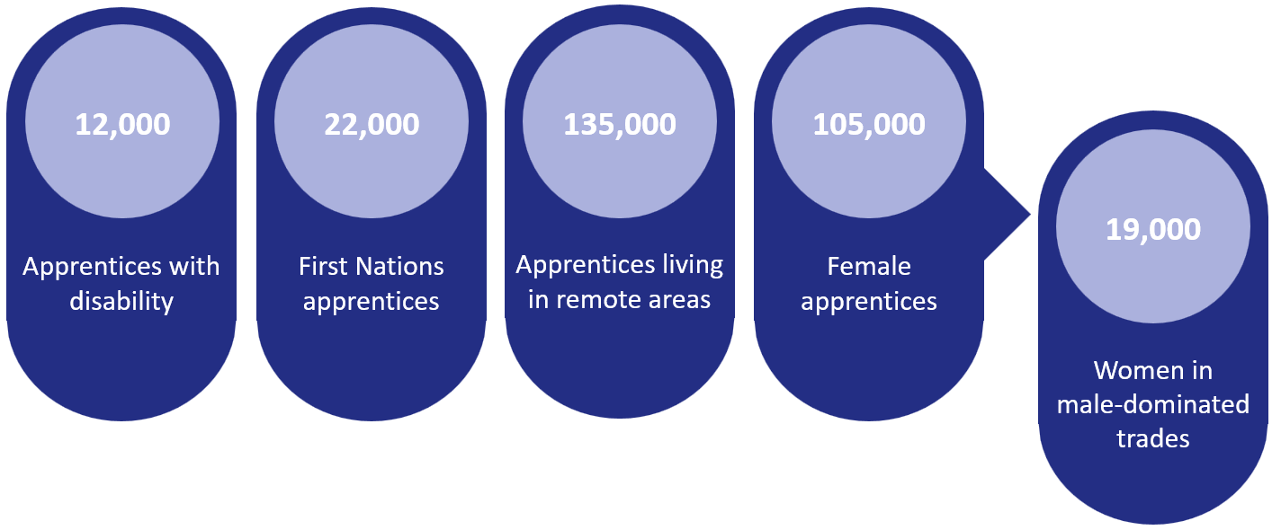

Source: Unpublished DEWR data.

### Women in male-dominated trades

Gender equality is a national priority under the National Skills Agreement. The 2022 Jobs and Skills Summit identified women’s economic participation and equality as an economic imperative (Treasury 2022:1).

Women face several barriers to entering and completing an apprenticeship, particularly in trade occupations in which there has been traditionally low take-up by women compared to men. Data from September 2023 shows women made up only 11.7% of trade-based apprentices currently in training (NCVER 2024a; unpublished DEWR data). Completion rates for this cohort are 50% compared to 58.7% for men in male-dominated trades.

Male-dominated workplaces have smaller proportions of part-time employees, and full-time employees tend to work longer hours – attributes that deter women with family and caring responsibilities (JSA 2022). The lack of flexibility of training and work hours and limited access to childcare places, especially care places available for the hours required in certain industries such as construction, are significant barriers to women’s participation. Table 7 shows the most important incentives for women aged 25 to 39 years to participate in the labour force.

Table 7: Incentives to labour force participation, women aged 25 to 39 years

|  |  |
| --- | --- |
| **Most important incentives** | **%** |
| Financial assistance with childcare | 55 |
| Ability to work part-time hours | 55 |
| Working a set number of hours on set days | 54 |
| Access to childcare | 52 |

Source: ABS (2023).

Societal norms and gender stereotypes are contributing to gender segregation across occupations, exacerbating labour shortages in heavily gendered industries. Around 65% of occupations experiencing workforce shortages have workforces with over 80% men or over 80% women (JSA 2022).

Cultural expectations and misconceptions about women’s capabilities to perform in trades can deter women from considering trade occupations as an attractive career (Bridges et al. 2021). Once women enter these types of apprenticeships, workplace culture, bullying and sexual harassment can contribute to non-completion. In 2018, 51% of women working in the construction industry reported having experienced sexual harassment, compared to 12% of men (AHRC 2020).

The NCVER Apprentice and Trainee Experience and Destinations Survey in 2019 found that around 19% of women in trade apprenticeships were either dissatisfied or very dissatisfied with their working conditions. This compares to around 9% of men in trade apprenticeships who reported the same levels of dissatisfaction.

Figure 12 shows satisfaction with working conditions for trade occupations by gender.

Figure 12: Satisfaction with working conditions, trade occupations, 2019

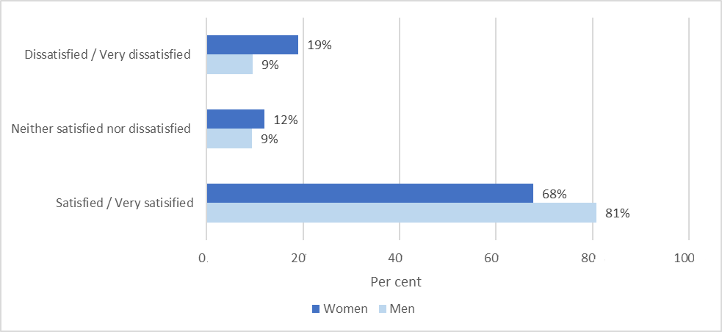Source: NCVER (2019).

Poor working conditions are the biggest single factor for women discontinuing their apprenticeship. Around 14% of women reported poor working conditions as the main reason for discontinuing their apprenticeship. This compares to only 6% of men discontinuing their apprenticeship for the same reason. The same survey also showed that women in trade occupations were almost twice as likely to observe bullying (43%) as men (23%).

Workplace sexual harassment continues to be an unacceptable feature of Australian workplaces. Between 2017 and 2022, 41% of women and 26% of men experienced sexual harassment at work (AHRC 2020).

On 12 December 2022, the [*Anti-Discrimination and* *Human Rights Legislation Amendment (Respect at Work) Act 2022*](https://www.legislation.gov.au/C2022A00085/asmade/text) (Cth) came into effect. The Act introduced a positive duty on employers and persons conducting a business or undertaking to take reasonable and proportionate measures to eliminate, as far as possible, certain discriminatory conduct, including sex discrimination and harassment and certain acts of victimisation in the workplace. The positive duty aims to prevent sexual harassment from occurring, rather than reacting after unlawful conduct occurs. This shifts the responsibility away from individual employees – enforcing their right to a safe and inclusive workplace – to employers, who now bear the responsibility to ensure the workplace is safe and inclusive for all employees. The aim is to achieve meaningful cultural change to create safer, inclusive and more respectful workplaces.

### First Nations apprentices

Consultations on non-financial apprenticeship supports in 2022 and 2023 revealed specific challenges to entry and completion for First Nations apprentices. These included isolation, a lack of cultural awareness of apprentice employers and training providers, and a lack of First Nations trainers in vocational education and training.

Intensive ongoing mentoring by First Nations community organisations was identified as a critical support for First Nations apprentices, particularly where apprentices may face additional disadvantage or be at risk of disengaging from their employers.

### Apprentices with disability

Apprenticeships are seen as a valuable pathway to support the transition from school to employment for students with disability (DEWR 2023b). To support this transition, advocacy groups acknowledge that apprentices with disability often need additional support, particularly prior to sign-up, to ensure they are matched with the right employer and have the necessary conditions to succeed. For apprentices with disability, ‘social exclusion, particularly harassment and bullying, were significant barriers’ (Cocks and Thoresen 2013:26).

Employers who want to employ and support apprentices with disability can find accessing supports an administratively difficult process, creating a barrier to commencements. Australia’s Disability Strategy 2021–2031 (Department of Social Services 2021) identifies employment and financial security as central to improving outcomes for people with disability. Apprenticeship supports must be accessible to help people with disability to achieve their full potential through education and learning.

### Apprentices located in remote Australia

Labour shortages are more pronounced in regional areas. Students located in remote Australia encounter various barriers associated with their geographic location when engaging with the VET system. These include distance and difficulty of travel (including from extreme weather); lack of infrastructure, services, resources and technology; limited local pathways and job opportunities; training not matched to local training needs; and trainer safety (due to social problems in some locations).

High location-based costs are also a significant barrier for apprentices in remote Australia, affecting the viability of training. This is particularly evident in thin markets, where training is expensive, and employers can be hesitant to employ an apprentice because of financial viability concerns (Productivity Commission 2020).

## Employer experiences of apprenticeships

Employers view apprenticeships as an opportunity to hire a relatively unskilled employee at a significant wage discount, and to train them to be increasingly skilled and productive. They report that the top reasons for employing apprentices are to obtain skilled staff, upskill existing staff, fill a specific role, or train to their own requirements. Many employers also report that they employ apprentices to give young people a head start and to support their industry (Productivity Commission 2020).

Figure 13 shows the results of an employer survey on the reasons for employing apprentices, and the main reason for employer dissatisfaction with apprentices.

Figure 13: Reasons for employing apprentices and for dissatisfaction, 2023

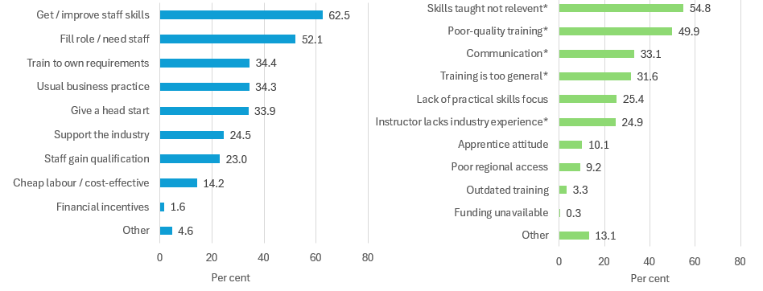* The estimate has a margin of error greater than or equal to 25% and should be used with caution.

Source: NCVER (2023b).

Supervision costs are often the most expensive costs for employers, aside from training wages, with higher upfront costs that decline over time as the apprentice requires less supervision. Nechvoglod et al. (2009) found, based on a small number of actual electrical and plumbing apprenticeships, that the apprenticeship model involves a substantial financial commitment from employers. The highest costs to employers are for supervision, as apprentice wages (including on-costs such as superannuation and leave) were more or less equal to their productivity. The authors also concluded that the effect of government incentives on employers’ decisions to train trade apprentices was minimal, as they do not represent a significant portion of the costs incurred.

The relative costs to the employer are higher if an apprentice does not complete their apprenticeship or changes employers. In such cases, the employer misses out on the apprentice’s greater productivity in the latter years of the apprenticeship.

This risk of non-completion can reduce an employer’s appetite to hire an apprentice, particularly for small and medium-sized enterprises (Behavioural Insights Team 2020), which employ more than half of all apprentices in Australia. In small businesses, establishing apprenticeships can be more challenging as the businesses often do not have dedicated human resources staff or experience in navigating the apprenticeships system; are less likely to have a sophisticated recruitment system; are less likely to attract the best apprentices; and do not have the economies of scale to reduce the cost of training across their workforce (Kuszera 2017).

Globally, there is a widespread view that employers of apprentices need more structured training in how to mentor, train and manage apprentices (Hensen 2014). In the Australian context, Huntly Consulting Group (2008) concluded, based on interviews with industry stakeholders, that almost everybody involved believed that the apprenticeships system was out of touch with young people, failing to understand the motivations and mindset of commencing apprentices.

The extent to which government subsidies and other financial incentives provided to employers are effective is contested. The Productivity Commission (2020:361, 363), in its report from the Review of the National Agreement for Skills and Workforce Development, cited findings that:

Employer incentives, as designed, are widely seen to have little effect on the decisions made by employers of trade apprentices, largely because they are modest relative to the cost of hiring and training …

Overall, modest employer incentives provided to all employers are only likely to change the behaviour of a small number at the margin …

Therefore, unless they make a sufficiently large proportion of employer costs or return on investment, employer incentives are not likely to be effective at achieving *additionality*.

The Productivity Commission (2020) also favoured the removal of employer completion incentive payments, noting that employers have strong incentives to avoid non-completions because their apprentices are likely to become more productive over time.

The Productivity Commission (2020:364) concluded:

Overall, given their limited effectiveness relative to scale, employer incentives do not appear to offer a good return on investment. Increasing the size of incentives is unlikely to be prudent. Further, it is important to recognise that employers benefit from engaging in apprenticeships and need to have ‘skin in the game’.

The importance of incentive size is shown by the pattern of traineeship commencements. The number of traineeship commencements reached a peak of about 280,000 in 2012, but fell by almost 70% by 2019. This sharp fall has been linked to changes in employer incentives. Prior to the 2012 policy change, incentives made up a significant portion of trainee wages – in some cases, up to 20% – because incentive payments were unrelated to duration and traineeships are generally of a shorter duration than trade apprenticeships (Karmel and Rice 2011). The Productivity Commission (2020:361) observed that ‘the acute sensitivity of traineeships to employer incentives suggests that the training itself had little real or perceived value for most employers’.

The impact of the COVID-19 apprenticeship wage subsidies also demonstrates the importance of incentive size. In its final report, the review will take into account the impact evaluation of the BAC and CAC wage subsidies currently being undertaken by the Australian Centre for Evaluation, within the Australian Treasury, detailed earlier in the paper.

# Conclusion

This paper has provided an overview of the current state of apprenticeships and the apprenticeships system from available data and research. It has drawn on previous government reports, publicly available data sources as well as internal program-level data, and academic research. There is a great volume of information to consider; however, we have found there are still questions that are difficult to answer, particularly about the real experiences of apprentices and what informs their decision-making about entering, cancelling and completing apprenticeships.

This paper is complemented by the consultation process already underway to gather perspectives from industry, employers and apprentices. The review will consider all sources of evidence to inform the final report to government.

# Appendix A: Background on the Australian Apprenticeships Incentive System

The Australian Government invests in the apprenticeships system through financial and non-financial incentives and support for apprentices and employers. This investment supports the development of the skilled workforce Australia needs to underpin our ongoing economic sustainability and competitiveness. States and territories also provide various forms of financial assistance (such as tax rebates or reductions, direct payments or subsidies, and discounts or waivers on government services such as vehicle registration), as well as non-financial support services to apprentices and their employers. The common goal of these supports is to improve the apprenticeship experience and encourage apprentices to remain in training through to completion.

**Australian Apprenticeships Incentives Program**

The precursor to the Australian Apprenticeships Incentive System was the Australian Apprenticeships Incentives Program (AAIP). Introduced in 1998, the AAIP was aimed at increasing apprenticeship commencement and completion rates. The AAIP provided a standard set of incentives, as well as additional incentives for specific cohorts such as women in traditionally male-dominated occupations, and apprentices with disability. Incentives were delivered through a combination of wage subsidies, flat rate payments, vouchers, loans and rebates.

However, over time a range of adjustments and incremental changes were made to the AAIP, resulting in a complex and difficult-to-understand program, with over 30 individual payment types primarily targeting employers rather than apprentices.

The AAIP contained various one-off, small-value payments for employers. The bulk of the more broadly available incentives comprised a lower value of $750 to $2,000 and were predominantly anchored to commencements and completions.

Prior to the transition to the current Australian Apprenticeships Incentive System on 1 July 2022, and not including COVID-19 response measures, employers were required to navigate, determine their eligibility for, and make claims against a complex system of AAIP payments. This included up to 19 payments ranging from $750 to $3,000.

The AAIP saw the introduction of 3 wage subsidies as COVID-19 economic response measures operating between early 2020 and mid-2022.

* The Supporting Apprentices and Trainees (SAT) subsidy, introduced in March 2020, was designed to protect the employment of existing apprentices during the early stages of the pandemic. SAT provided a 50% wage subsidy as a retention payment for existing apprentices to eligible employers of up to $7,000 per quarter, per apprentice.
* The Boosting Apprenticeship Commencements (BAC) subsidy, introduced in October 2020, was a response to the rapid decline in commencements in mid-2020. BAC was targeted at encouraging apprenticeship commencements during the economic uncertainty of COVID-19 and provided a 50% wage subsidy of apprentice or trainee wages, paid in arrears based on actual wages paid to eligible employers of up to $7,000 per quarter, per apprentice. Initially designed as a capped program that was expected to end in early 2021, BAC was uncapped and extended several times. It finally closed to new entrants on 30 June 2022.
* The Completing Apprenticeship Commencements (CAC) subsidy, introduced in October 2021, was designed to provide transitional support for BAC-eligible employers to retain apprentices into their second and third year to complete their qualifications. In the second year of an eligible apprenticeship, CAC provided a 10% wage subsidy to eligible employers of up to $1,500 per quarter, per apprentice. In the third year of an eligible apprenticeship, CAC provided a 5% wage subsidy to eligible employers of up to $750 per quarter, per apprentice.

While these temporary measures played a role in influencing employer behaviour and protecting the employment of apprentices during Australia’s economic recovery from the initial impacts of the pandemic, they came at a high cost and were not fiscally sustainable in the long term. Between 5 October 2020 and 31 December 2023, over $7.2 billion in BAC and CAC wage subsidies were paid to 114,610 employers of 407,130 eligible apprentices.

**Introduction of the Australian Apprenticeships Incentive System**

Introduced on 1 July 2022 and replacing the AAIP, the current Australian Apprenticeships Incentive System was designed to transition away from the short-term COVID-19 response measures towards a more sustainable level of payments, while also making the program easier for users to understand by simplifying the incentive structure. The Incentive System is designed to encourage take-up of apprenticeships in high-demand occupations that are relevant to the Australian economy now and into the future by focusing support for qualifications and occupations listed on the Australian Apprenticeships Priority List (DEWR 2023a).

Released annually, the priority list is a point-in-time assessment of in-demand occupations where an apprenticeship is a required or preferred training pathway.The priority list is based on demand ratings and includes occupations that have been:

* assessed by Jobs and Skills Australia (JSA) as being in national shortage
* classified by the Australian Bureau of Statistics (ABS) under the Australian and New Zealand Standard Classification of Occupations (ANZSCO) as Major Group 3 – Trades and Technicians, and Major Group 4 – Community and Personal Care Workers.

The sources used to create the priority list are developed by the ABS, JSA and the National Register of Vocational Education and Training to ensure data is consistent, independent and transparent. Since its inception in July 2022, 2 updates have been published – in January 2023 and January 2024.

The cost of the Incentive System under the higher levels of subsidies provided in 2022–23 and 2023–24 is around $1.1 billion per year. This includes incentive payments to apprentices and employers in each year. Further, while the AAIP measures are no longer available to new starters, AAIP payments will continue under grandfathering arrangements until 30 June 2027 (noting these payments are declining year on year as apprentices progress through their apprenticeships), with an estimated cost of $338.4 million from 2024–25 to 2027–28 (DEWR 2024b:40).

**Payments for apprentices**

The Australian Apprenticeships Incentive System currently includes 2 payments for eligible apprentices. These are designed to encourage apprentices to take up an apprenticeship in priority occupations, and to assist them with the cost of living and training, particularly in the early years when training wages are lowest.

* Eligible apprentices in priority occupations on the Australian Apprenticeships Priority List may claim the Australian Apprentice Training Support Payment (AATSP) of up to $5,000 over 2 years.
* To encourage people to take up apprenticeships in the clean energy sector, from January 2023, eligible apprentices training in identified clean energy occupations on the priority list subset are eligible to claim the New Energy Apprentice Support Payment of up to $10,000 over 4 years. From 1 June 2024, eligibility was expanded to assist more apprentices and trainees skilling up in occupations with exposure to clean energy. The eligibility changes capture the sector’s growth and incorporate feedback received from industry. An employer must demonstrate that their business engages and operates in the clean energy sector and that the apprentice will be provided with meaningful exposure, experience and work in the sector that is appropriate to their skill level, and/or off-the-job training.

Complementary to the Incentive System, apprentices in priority occupations can also access an interest-free Australian Apprenticeship Support Loan (AASL). In 2023–24, the maximum loan value is $24,493. The loan does not become repayable until the apprentice is earning above a minimum threshold (currently $51,500 per year).

In addition, apprentices who are required to move away to complete their apprenticeship may be eligible for a Living Away From Home Allowance (LAFHA) – a weekly payment that reduces over the first 3 years of training ($77.17 per week in year 1, $38.59 per week in year 2 and $25 per week in year 3).

**Payments for employers**

The streamlined incentive structure includes 2 payments for eligible employers. These are designed to assist with the cost of taking on, supervising and training an apprentice, especially in the early years when supervision requirements are high and apprentice productivity is lower, and to encourage employers to consider the priority occupations in particular.

* Eligible employers of apprentices in priority occupations may claim the Priority Wage Subsidy (PWS), which reimburses 10% of the apprentice’s wage in years 1 and 2 and 5% in year 3, to a maximum amount of $15,000 over the 3 years.
* Employers of apprentices not in priority occupations may claim a hiring incentive of up to $3,500, paid in 2 instalments at 6 and 12 months after commencement.
* Employers of apprentices who meet prescribed disability eligibility criteria may claim the Disability Australian Apprentice Wage Support (DAAWS) payment of $104.30 per week. This payment is available where an apprentice is living with long-term or permanent disability, or for the term of a temporary disability. The purpose of DAAWS is to encourage employers to provide apprenticeships to people living with disability who can participate in open employment with suitable hiring, training and support.

From 1 July 2024, payments for employers will change.

* Employers of apprentices in priority occupations may claim a hiring incentive of up to $5,000 paid in 2 instalments ($2,000 at 6 months and $3,000 at 12 months after commencement).
* Employers of apprentices not in priority occupations will not receive any financial support.
* The DAAWS payment will remain available.

# Appendix B: Non-financial apprenticeship services and supports

In addition to financial incentives, the Australian Government funds a range of non-financial supports delivered through the Australian Apprenticeship Support Network (AASN). Designed to complement state and territory services, the key goal of the AASN is to make it easier for employers to recruit, train and retain apprentices, and to support apprentices to stay in their apprenticeship through to completion.

Seven AASN providers are currently contracted by the Australian Government across Australia. These AASN providers are responsible for the sign-up of every apprentice across the country. As part of the sign-up process, AASN providers are responsible for ensuring the apprenticeship arrangement is genuine and appropriate, and that both the employer and apprentice understand their roles and responsibilities in accordance with legislative and other requirements in the relevant jurisdiction. This includes selecting an appropriate qualification and training provider best suited to the location and circumstances of the apprentice and employer. AASN providers also offer training support for apprentices and employers that can include mentoring, counselling and pastoral care.

**Redesign of apprenticeship services and supports**

At the Jobs and Skills Summit held in September 2022, the Australian Government committed to exploring options to improve the apprenticeship support system and drive up apprenticeship completions (Treasury 2022).

In November 2022, the Department of Employment and Workplace Relations (DEWR) released a discussion paper on Australian apprenticeship services and supports (DEWR 2022). The discussion paper tracked the journey of an apprentice and sought views on how the government could address key issues at each stage of the apprenticeship lifecycle, focusing on non-financial supports. The government engaged closely with a broad range of organisations and key stakeholders, including apprentices, employers, state and territory governments, unions, registered training organisations, group training organisations, AASN providers and advocacy groups.

Feedback was consistent that the key apprenticeship services should be retained but refocused. Stakeholders recommended reducing the complexity of services for apprentices and employers across governments and investing in personalised and appropriate support for diverse cohorts. Stakeholders also highlighted the critical role of employers and supervisors in building strong working relationships with their apprentices, and the role of these relationships in the delivery of quality apprenticeships.

In April 2023, DEWR published findings and an outline of the government’s proposed new model in the *Future Directions for Australian Apprenticeship Support Services Consultation Paper* (DEWR 2023b). The consultation paper provided further opportunity for stakeholders to share feedback on the government’s proposed intentions for the redesign of the apprenticeship services and supports program. The paper highlighted opportunities to strengthen and better target the support provided to apprentices to ensure that they finish their training and find secure, well-paid work. Engagement focused on how a new apprenticeship support model could:

* better support apprentices and employers throughout the duration of the apprenticeship
* address the specific needs of priority cohort apprentices – women in male-dominated trade apprenticeships, First Nations apprentices, apprentices with disability and apprentices working in remote locations
* enhance non-financial supports to ensure the system continues to deliver a secure, skilled workforce that industry needs.

Feedback from the 2 rounds of consultations informed the finalisation of the government’s proposed new model for apprenticeship services and supports, which will be introduced from 1 July 2024. This new model, and the consultation that informed its design, is outlined in Figure 14.

The new model has been designed to lift completions and better support apprentices and their employers, with a particular focus on those apprentices who experience additional barriers to completion (O’Connor 2023). It will:

* provide improved wraparound support and mentoring for key client groups, including First Nations apprentices, apprentices with disability, those who live remotely, and women in male-dominated trades, while continuing to support all apprentices – and their employers – who experience additional barriers to completing their apprenticeship
* provide better support and mentoring to employers to help them better understand their role in supporting their apprentice, including ensuring a safe and respectful workplace, free from harassment, and connecting employers to support services and training to improve their capacity to effectively supervise and support their apprentices in the workplace
* look to introduce specialist providers to provide expert support to certain cohorts of apprentices, including women in male-dominated trades, First Nations apprentices, and apprentices working towards clean energy occupations
* leverage improved technology to increase and better target communications, and streamline program administration to free up service providers to spend more time supporting apprentices
* improve the transparency of apprenticeship services and supports to improve the quality of service delivery and drive apprenticeship service provider performance.

Figure 14: Summary of redesigned apprenticeship services and supports

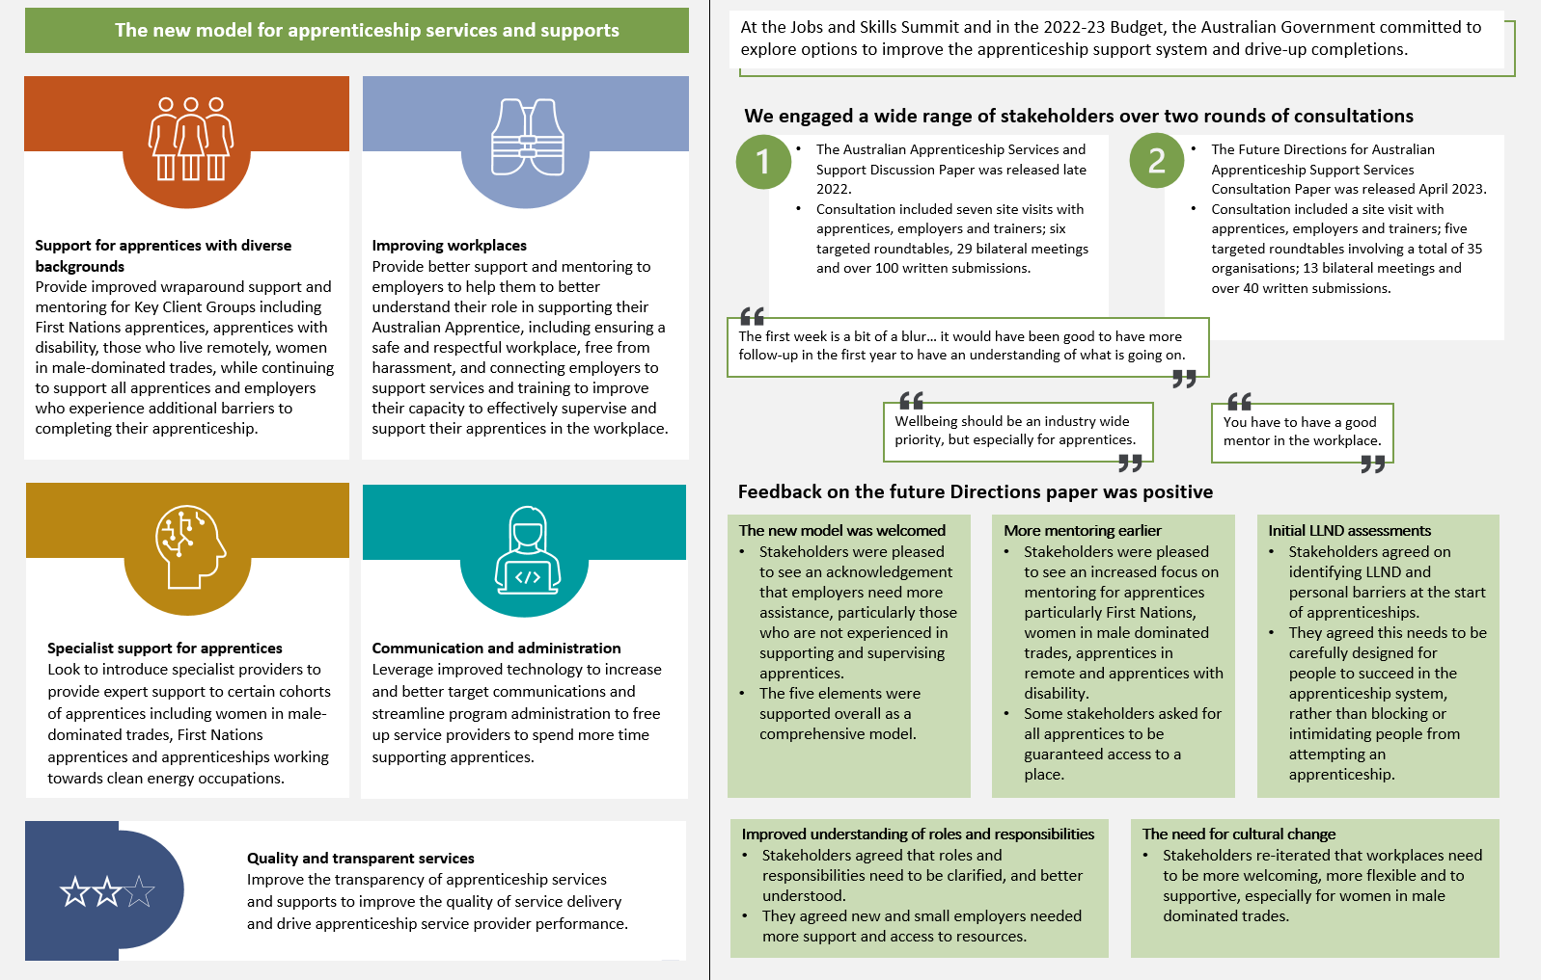

# Appendix C: Improving apprenticeship completions under the National Skills Agreement

The new 5-year National Skills Agreement (NSA), which commenced on 1 January 2024, includes a policy initiative aimed at improving student outcomes, with a specific action to support apprenticeship completions.

Through the NSA, the Australian Government and state and territory governments committed to jointly refresh and update the National Code of Good Practice for Australian Apprenticeships, in consultation with employers and supervisors, unions, apprentices and other stakeholders, to better clarify the roles and responsibilities of employers and promote quality, best-practice learning and employment arrangements for apprentices.

Additionally, the development of best-practice guidance and resources for employers of apprentices will support employers and supervisors to understand their roles and responsibilities to ensure safe and inclusive workplaces and high-quality apprenticeships.

Refreshing the National Code in collaboration with stakeholders will provide the opportunity to ensure the document and any supporting resources reflect the current apprenticeship environment in a way that is useful for employers and apprentices. It is also an opportunity to consider recent and emerging work from Australian Government and state and territory government reviews, consultation activities and apprenticeship taskforces, such as the Skills SA–led National Vocational Education and Training Completions Taskforce report (Skills SA 2023), the Victorian Apprenticeships Taskforce to improve workplace safety, and the NSW Vocational Education and Training Review.

# References

ABS (Australian Bureau of Statistics) (December 2023) [*Barriers and Incentives to Labour Force Participation, Australia*](https://www.abs.gov.au/statistics/labour/employment-and-unemployment/barriers-and-incentives-labour-force-participation-australia/latest-release), ABS website, accessed 14 May 2024.

ACCC (Australian Competition and Consumer Commission) (2023a) [*Childcare inquiry: interim report*](https://www.accc.gov.au/inquiries-and-consultations/childcare-inquiry-2023/september-2023-interim-report), ACCC.

ACCC (2023b) [*Childcare inquiry: final report*](https://www.accc.gov.au/inquiries-and-consultations/childcare-inquiry-2023/december-2023-final-report), ACCC.

ACT Government (n.d.) [*Head Start*](https://www.education.act.gov.au/public-school-life/transitions-careers/vet-and-australian-school-based-apprenticeships/head-start), ACT Education Directorate website, accessed 8 May 2024.

AHRC (Australian Human Rights Commission) (2020) [*Respect@Work: Sexual Harassment National Inquiry report*](https://humanrights.gov.au/our-work/sex-discrimination/publications/respectwork-sexual-harassment-national-inquiry-report-2020), AHRC.

Ainley J and Corrigan M (2005) [*Participation in and progress through new apprenticeships*](https://research.acer.edu.au/lsay_research/48/), Australian Council for Educational Research.

Ainley J, Holden S and Rothman S (2010) [*Apprenticeships and traineeships: participation, progress and completion*](https://research.acer.edu.au/lsay_briefs/19/), Australian Council for Educational Research.

Alkema A and Dawson A (2016) [*Why do trainees ‘drop out’ and what can we do about it?*](https://www.voced.edu.au/content/ngv%3A73650), NCVER.

Atkinson G and Stanwick J (2016) [*Trends in VET: policy and participation*](https://www.ncver.edu.au/research-and-statistics/publications/all-publications/trends-in-vet-policy-and-participation), NCVER.

Australian Government and Government of South Australia (2023) [*South Australian Defence Industry Workforce and Skills Report*](https://www.defence.gov.au/about/reviews-inquiries/south-australian-defence-industry-workforce-skills-report), report of the South Australian Defence Industry Workforce and Skills Taskforce.

Ball K and John D (2005) [*Apprentice and trainee completion rates*](https://www.voced.edu.au/content/ngv%3A2519), NCVER.

Bednarz A (2014) [*Understanding the non-completion of apprentices*](https://www.ncver.edu.au/research-and-statistics/publications/all-publications/understanding-the-non-completion-of-apprentices), NCVER.

Behavioural Insights Team (2020) [*Perceptions of apprenticeships: behavioural insights evidence review*](https://www.education.gov.au/quality-schools-package/resources/perceptions-apprenticeships-behavioural-insights-evidence-review-february-2020), Australian Government Department of Education, Skills and Employment.

Bessey D and Backes-Gellner U (2007) ‘[Premature apprenticeship terminations: an economic analysis](https://ideas.repec.org/p/iso/educat/0002.html)’, *Economics of Education Working Paper Series 0002*, University of Zurich, Department of Business Administration.

Billett S, Choy S, Dymock D, Smith R, Henderson A, Tyler M and Kelly A (2015) [*Towards more effective continuing education and training for Australian workers*](https://ncver.edu.au/research-and-statistics/publications/all-publications/towards-more-effective-continuing-education-and-training-for-australian-workers), NCVER.

Bridges D, Bamberry L, Wulff E and Krivokapic-Skoko B (2021) ‘[”A trade of one’s own”: the role of social and cultural capital in the success of women in male-dominated occupations](https://onlinelibrary.wiley.com/doi/10.1111/gwao.12764)’, *Gender, Work and Organization*, 29(2):371–387, https://doi.org/10.1111/gwao.12764.

Bruniges M, Ardler J and Firth V (2023) [*NSW VET review: interim report*](https://education.nsw.gov.au/about-us/strategies-and-reports/our-reports-and-reviews/nsw-vocational-education-and-training-review), NSW Department of Education.

Buchanan J, Raffaele C, Glozier N and Kanagaratnam A (2016) [*Beyond mentoring: social support structures for young Australian carpentry apprentices*](https://ncver.edu.au/research-and-statistics/publications/all-publications/beyond-mentoring-social-support-structures-for-young-australian-carpentry-apprentices), NCVER.

Callan V (2001) [*Report on apprenticeship and traineeship completions*](https://www.voced.edu.au/content/ngv%3A36364), University of Queensland and Queensland Department of Employment, Training and Industrial Relations.

Clarke K and Lamb S (2009) *Provision of pastoral care in apprenticeships* [unpublished report].

Cocks E and Thoresen SH (2013) [*Barriers and facilitators affecting course completions by apprentices and trainees with disabilities*](https://www.voced.edu.au/content/ngv%3A55705), NCVER.

Construction Industry Training Board (CITB) (n.d.) [*Construction Industry Training Board*](https://citb.org.au/) [website], accessed 20 May 2024.

Cully M and Curtain R (2001) [*Reasons for new apprentices’ non-completions*](https://ncver.edu.au/research-and-statistics/publications/all-publications/reasons-for-new-apprentices-non-completions), NCVER.

Curtis D (2008) [*VET pathways taken by school leavers*](https://research.acer.edu.au/lsay_research/2/), Longitudinal Surveys of Australian Youth research report no. 52, Australian Council for Educational Research.

Deloitte Access Economics (2011) [*The cost of apprenticeship non-completion in NSW*](https://www.voced.edu.au/content/ngv%3A48913), report to the NSW Board of Vocational Education and Training, Deloitte Access Economics.

Deloitte Access Economics (2012) [*Econometric analysis of the Australian Apprenticeships Incentives Program*](https://www.voced.edu.au/content/ngv%3A64341), report to the Australian Government Department of Education, Employment and Workplace Relations, Deloitte Access Economics.

Deloitte Access Economics (2014) *Australian Apprenticeship Mentoring Package: interim evaluation*, report to the Australian Government Department of Industry, Deloitte Access Economics.

Department of Social Services (2021) [*Australia’s Disability Strategy 2021–2031*](https://www.disabilitygateway.gov.au/document/3106), Australian Government.

DEWR (Department of Employment and Workplace Relations) (2022)[*Australian apprenticeship services and supports discussion paper*](https://www.dewr.gov.au/australian-apprenticeships/resources/australian-apprenticeship-services-and-supports-discussion-paper), DEWR.

DEWR (2023a) [*Australian Apprenticeships Incentive System: program guidelines*](https://www.dewr.gov.au/skills-support-individuals/resources/australian-apprenticeships-incentive-system-guidelines), DEWR.

DEWR (2023b) [*Future directions for Australian apprenticeship support services consultation paper*](https://www.dewr.gov.au/australian-apprenticeships/resources/future-directions-australian-apprenticeship-support-services-consultation-paper), DEWR.

DEWR (2023c) [*Supporting women to achieve VET-based careers: discussion paper*](https://consultations.dewr.gov.au/supporting-women-to-achieve-vet-based-careers), DEWR.

DEWR (2024a) [*Australian Apprenticeships Priority List: for commencements from 1 January 2024*](https://www.dewr.gov.au/skills-support-individuals/resources/appendix-australian-apprenticeship-priority-list-1-january-2024), DEWR.

DEWR (2024b) [*Portfolio Budget Statements 2024–25: Employment and Workplace Relations portfolio*](https://www.dewr.gov.au/about-department/resources/employment-and-workplace-relations-2024-25-portfolio-budget-statements), Budget related paper no. 1.6, Australian Government.

Dickie M, McDonald R and Pedic F (2011) [*A fair deal: apprentices and their employers in NSW: integrated research report*](https://www.voced.edu.au/content/ngv%3A48917), report to the NSW Board of Vocational Education and Training.

Driscoll A, Hoad M and Durant T (2020) [*Report on the review of skills, training and workforce development*](https://www.voced.edu.au/content/ngv%3A87305), Department of Training and Workforce Development, Western Australian Government.

Dumbrell T and Smith E (2007) [*Pre-apprenticeships in three key trades*](https://www.voced.edu.au/content/ngv%3A7458), NCVER.

Dunn A, Rozenbes D, Maltman K, Leung E, Pung A, Waugh B, Dixon C, Cagorski T, Linehan A and Tisseverasinghe R (2011) [*Australian apprentice minimum wages in the national system*](https://www.fwc.gov.au/documents/sites/wagereview2011/research/research_report_6-2011.pdf), Research Report 6/2011, Fair Work Australia.

Education Council (2020) [*Looking to the future: report of the review of senior secondary pathways into work, further education and training*](https://www.education.gov.au/quality-schools-package/resources/looking-future-report-review-senior-secondary-pathways-work-further-education-and-training), Australian Government Department of Education, Skills and Employment.

Estévez-Abe M (2005) ‘[Gender bias in skills and social policies: the varieties of capitalism perspective on sex segregation](https://academic.oup.com/sp/article-abstract/12/2/180/1685509)’, *Social Politics: International Studies in Gender, State and Society*, 12(2):180–215, https://doi.org/10.1093/sp/jxi011.

Fair Work Commission (2013) [*Transitional review of modern awards – apprentices, trainees and juniors: common claims*](https://www.fwc.gov.au/documents/summaries/2013fwcfb5411_summary.pdf), summary of decision, Fair Work Commission.

Galea N, Powell A, Loosemore M and Chappell L (2020) ‘[The gendered dimensions of informal institutions in the Australian construction industry](https://onlinelibrary.wiley.com/doi/10.1111/gwao.12458)’*,* *Gender, Work and Organization*, 27(6):1214–1231, https://doi.org/10.1111/gwao.12458.

Gow K, Warren C, Anthony D and Hinschen C (2008) ‘[Retention and intentions to quit among Australian male apprentices](https://www.emerald.com/insight/content/doi/10.1108/00400910810873991/full/html)’, *Education and Training*, 50(3):216–230, https://doi.org/10.1108/00400910810873991.

Hargreaves J, Stanwick J and Skujins P (2017) [*The changing nature of apprenticeships: 1996–2016*](https://www.ncver.edu.au/research-and-statistics/publications/all-publications/the-changing-nature-of-apprenticeships-1996-2016), NCVER.

Harris R, Simons M, Bridge K, Bone J, Symons H, Clayton B, Pope B, Cummins G and Blom K (2001) [*Factors that contribute to retention and completion for apprentices and trainees*](https://www.ncver.edu.au/research-and-statistics/publications/all-publications/factors-that-contribute-to-retention-and-completion-for-apprentices-and-trainees), NCVER.

Hensen K (2014) [*Early leaving from vocational education and training: Germany*](https://www.refernet.de/dokumente/pdf/Artikel_DE_Early_leaving_from_VET.pdf), Bundesinstitut für Berufsbildung [Federal Institute for Vocational Education and Training].

Huntly Consulting Group (2008) *Exit from the trades: research into attrition from the trades*, research report commissioned by the Australian Government Department of Education, Employment and Workplace Relations.

ILO (International Labour Organization) (2023) [*Recommendation concerning quality apprenticeships*](https://www.ilo.org/resource/ilc/111/recommendation-concerning-quality-apprenticeships), Recommendation No. 208 of International Labour Conference – 111th session, ILO.

Jobs Queensland (2016) [*Positive futures: apprenticeships and traineeships in Queensland: discussion paper*](https://jobsqueensland.qld.gov.au/projects/positive-futures/), Jobs Queensland.

Jobs and Skills WA (2023) ‘[Incentives and wage subsidies for employers of apprentices and trainees](https://www.jobsandskills.wa.gov.au/employer-incentives)’, fact sheet, Department of Training and Workforce Development, Western Australian Government, accessed 10 May 2024.

Joyce S (2019) [*Strengthening skills: expert review of Australia’s vocational education and training system*](https://www.pmc.gov.au/publications/strengthening-skills-expert-review-australias-vocational-education-and-training-system), Department of the Prime Minister and Cabinet.

JSA (Jobs and Skills Australia) (n.d.) [*Current skills shortages*](https://www.jobsandskills.gov.au/publications/towards-national-jobs-and-skills-roadmap-summary/current-skills-shortages), JSA website, accessed 10 May 2024.

JSA (2022) ‘[Could a more even gender and age composition of a workforce help with skill shortages?](https://www.jobsandskills.gov.au/sites/default/files/2023-01/australian_labour_market_research_workshop.pdf)’ [workshop presentation], *Australian Labour Market Research Workshop*, accessed 10 May 2024.

JSA (2023a) [*2023 Skills Priority List: key findings report*](https://www.jobsandskills.gov.au/publications/skills-priority-list-key-findings-report-2023), JSA.

JSA (2023b) [*The clean energy generation: workforce needs for a net zero economy*](https://www.jobsandskills.gov.au/publications/the-clean-energy-generation), JSA.

JSA (2023c) [*Labour market update: December 2023*](https://www.jobsandskills.gov.au/publications/labour-market-update-december-2023), JSA website, accessed 30 May 2024.

JSA (11 April 2024) [*REOS spotlight: employers’ experiences of recruiting apprentices*](https://www.jobsandskills.gov.au/news/reos-spotlight-employers-experiences-recruiting-apprentices), JSA.

Karmel T (2017) [*Factors affecting apprenticeships and traineeships*](https://www.fwc.gov.au/documents/sites/wagereview2017/research/apprenticetrainee.pdf), research report 3/2017, Part II, Fair Work Commission.

Karmel T and Misko J (2009) [*Apprenticeships and traineeships in the downturn*](https://www.ncver.edu.au/research-and-statistics/publications/all-publications/apprenticeships-and-traineeships-in-the-downturn), NCVER.

Karmel T and Mlotkowski P (2010) [*The impact of wages on the probability of completing an apprenticeship or traineeship*](https://www.ncver.edu.au/research-and-statistics/publications/all-publications/the-impact-of-wages-on-the-probability-of-completing-an-apprenticeship-or-traineeship), NCVER.

Karmel T and Mlotkowski P (2011) [*The impact of wages and the likelihood of employment on the probability of completing an apprenticeship or traineeship*](https://www.ncver.edu.au/research-and-statistics/publications/all-publications/the-impact-of-wages-and-the-likelihood-of-employment-on-the-probability-of-completing-an-apprenticeship-or-traineeship), NCVER.

Karmel T and Oliver D (2011) [*Pre-apprenticeships and their impact on apprenticeship completion and satisfaction*](https://www.ncver.edu.au/research-and-statistics/publications/all-publications/pre-apprenticeships-and-their-impact-on-apprenticeship-completion-and-satisfaction), NCVER.

Karmel T and Rice J (2011) [*The economics of apprenticeships and traineeships*](https://www.voced.edu.au/content/ngv%3A45659), NCVER.

Knight B (2008) ‘Insights into traditional apprenticeship completions: spin-offs from a National Training Statistics Committee project’ [conference presentation], *No Frills 2008: 17th National Vocational Education and Training Research Conference*, University of Tasmania, Launceston, 9–11 July 2008.

Kuszera M (2017) ‘[Incentives for apprenticeship](https://www.oecd-ilibrary.org/education/incentives-for-apprenticeship_55bb556d-en)’, *OECD Education Working Papers*, no. 152, OECD, https://doi.org/10.1787/55bb556d-en.

Macklin J (2020) [*Future skills for Victoria: driving collaboration and innovation in post-secondary education and training*](https://www.vic.gov.au/skills-victorias-growing-economy), Victorian Government.

Manufacturing Industry Skills Alliance (26 March 2024) [*Workforce projects*](https://manufacturingalliance.org.au/workforce-projects/), Manufacturing Industry Skills Alliance website, accessed 10 May 2024.

Master Builders Australia (21 April 2023) [*Builders nail plan for half a million workers by 2026*](https://masterbuilders.com.au/builders-nail-plan-for-half-a-million-workers-by-2026/) [media release], Master Builders Australia website, accessed 10 May 2024.

McDowell J, Oliver D, Persson M, Fairbrother R, Wetzlar S, Buchanan J and Shipstone T (2011) [*A shared responsibility: apprenticeships for the 21st century*](https://www.voced.edu.au/content/ngv%3A45663), report to the Australian Government Department of Education, Employment and Workplace Relations.

Misko J, Nguyen N and Saunders J (2007) [*Doing an apprenticeship: what young people think*](https://www.ncver.edu.au/research-and-statistics/publications/all-publications/doing-an-apprenticeship-what-young-people-think), NCVER.

Misko J, Patterson J and Markotic R (2001) ‘The value of on-the-job traineeships’, in Smart N (ed) [*Australian apprenticeships: research readings*](https://www.ncver.edu.au/research-and-statistics/publications/all-publications/australian-apprenticeships-research-readings), NCVER.

Misko J and Wibrow B (2020) [*Traditional trade apprenticeships: learnings from the field*](https://www.ncver.edu.au/research-and-statistics/publications/all-publications/traditional-trade-apprenticeships-learnings-from-the-field), NCVER.

NCVER (National Centre for Vocational Education Research) (2009) [*Australian vocational education and training statistics: Apprentices and trainees, 2008 – annual*](https://www.voced.edu.au/content/ngv%3A1621), NCVER.

NCVER (2019) [*Apprentice and trainee experience and destinations 2019*](https://www.ncver.edu.au/research-and-statistics/publications/all-publications/apprentice-and-trainee-experience-and-destinations-2019), NCVER.

NCVER (2023a) [*Completion and attrition rates for apprentices and trainees 2022*](https://www.ncver.edu.au/research-and-statistics/publications/all-publications/completion-and-attrition-rates-for-apprentices-and-trainees-2022), NCVER.

NCVER (2023b) [*Employers’ use and views of the VET system 2023: data tables*](https://www.ncver.edu.au/research-and-statistics/publications/all-publications/employers-use-and-views-of-the-vet-system-2023), NCVER.

NCVER (2024a) [*Apprentices and trainees 2023: September quarter*](https://www.ncver.edu.au/research-and-statistics/publications/all-publications/apprentices-and-trainees-2023-september-quarter), NCVER.

NCVER (2024b) [*Apprentice and trainee outcomes 2023*](https://ncver.edu.au/research-and-statistics/publications/all-publications/apprentice-and-trainee-outcomes-2023), NCVER

NDIS Review (2023) [*New ways to attract, train and keep disability support workers*](https://www.ndisreview.gov.au/resources/fact-sheet/disability-support-workers), fact sheet 10, Australian Government.

Nechvoglod L, Karmel T and Saunders J (2009) [*The cost of training apprentices*](https://ncver.edu.au/research-and-statistics/publications/all-publications/the-cost-of-training-apprentices), NCVER.

Neuenschwander MP (1999) *Lehrvertragsauflösungen im Kanton Zürich: Schlussbericht* [*Terminations of apprenticeship contracts in the canton of Zurich: final report*], 1st edn, Impulse, Zurich.

Neuenschwander MP, Stalder B and Süss D (1996) [*Berufswahl und Lehrvertragsaulösungen im Kanton Bern: Resultate einer empirischen Studie*](https://digitalcollection.zhaw.ch/handle/11475/4289) [*Career choice and termination of apprenticeship contracts in the canton of Bern: results of an empirical study*], Universität Bern, Institut für Psychologie und Amt für Bildungsforschung [Institute of Psychology and Office for Educational Research].

Northern Territory Government (n.d.) [*Apprenticeship travel and accommodation subsidy scheme*](https://nt.gov.au/employ/apprenticeships-and-traineeships/support-for-apprentices/apprenticeship-travel-and-accommodation-help), Northern Territory Government website, accessed 20 May 2024.

NSW Department of Education (n.d.) [*Continuing Apprentices and Trainees Placement Service (CAPS)*](https://education.nsw.gov.au/skills-nsw/apprentices-and-trainees/support-with-your-apprenticeship-or-traineeship/continuing-apprentices-trainees-placement-service-caps), NSW Department of Education website, accessed 10 May 2024.

O’Connor B (27 April 2023) [*Setting apprentices up to succeed*](https://ministers.dewr.gov.au/oconnor/setting-apprentices-succeed) [media release], Ministers’ Media Centre: Ministers of the Employment and Workplace Relations portfolio, accessed 10 May 2024.

O’Connor B (19 February 2024) [*Australian Apprenticeships Incentive System Strategic Review*](https://ministers.dewr.gov.au/oconnor/australian-apprenticeships-incentive-system-strategic-review) [media release], Ministers’ Media Centre: Ministers of the Employment and Workplace Relations portfolio, accessed 10 May 2024.

O’Dwyer L and Korbel P (2019) [*Completion rates for group training organisations and direct employers: how do they compare?*](https://www.ncver.edu.au/research-and-statistics/publications/all-publications/completion-rates-for-group-training-organisations-and-direct-employers-how-do-they-compare), NCVER.

OECD (Organisation for Economic Co-operation and Development) (2016) [*Skills matter: further results from the survey of adult skills*](https://www.oecd.org/skills/skills-matter-9789264258051-en.htm), OECD.

OECD (2018) [*Seven questions about apprenticeships: answers from international experience*](https://www.oecd.org/publications/seven-questions-about-apprenticeships-9789264306486-en.htm), OECD.

Parliament of Australia (2024) [*Shared vision, equal pathways: Inquiry into the perceptions and status of vocational education and training*](https://www.aph.gov.au/Parliamentary_Business/Committees/House/Employment_Education_and_Training/VETInquiry/Final_Report), report of the House of Representatives Standing Committee on Employment, Education and Training, Parliament of Australia.

Plan International Australia (2023) [*Gender Compass: a segmentation of Australia’s views on gender equality*](https://www.plan.org.au/our-work/gender-compass/)*,* Plan International Australia.

Polesel J, Davies M and Teese R (2004) [*Course completion and instructional experience in TAFE*](https://www.ncver.edu.au/research-and-statistics/publications/all-publications/course-completion-and-instructional-experience-in-tafe), NCVER.

Polesel J, Leahy M and Gillis S (2017) ‘[Educational inequality and transitions to university in Australia: aspirations, agency and constraints](https://www.tandfonline.com/doi/full/10.1080/01425692.2017.1409101)’, *British Journal of Sociology of Education*, 39(6):793–810, https://doi.org/10.1080/01425692.2017.1409101.

Powers T (2015) ‘[Predicting apprenticeship retention: not all trades are the same](https://www.voced.edu.au/content/ngv%3A68264)’, in Griffin T (ed) *2014 postgraduate research papers: a compendium*, NCVER.

Productivity Commission (2020) [*National Agreement for Skills and Workforce Development review*](https://www.pc.gov.au/inquiries/completed/skills-workforce-agreement/report), study report, Productivity Commission.

Queensland Government (n.d.) [*Apprenticeships Info app*](https://www.qld.gov.au/education/apprenticeships/for-apprentices/support/helpline/app), Queensland Government website, accessed 20 May 2024.

Queensland Training Ombudsman (2022) [*Review of support provided to Queensland apprentices and trainees, with a focus on female apprentices in male-dominated occupations*](https://trainingombudsman.qld.gov.au/reports/), Queensland Training Ombudsman.

Ross V, Wardhani R and Kolves K (2020) [*The impact of workplace bullying on mental health and suicidality in Queensland construction industry apprentices*](https://mates.org.au/apprentice-report), Australian Institute for Suicide Research and Prevention, Griffith University.

Schöngen K (2003) [*Lösung von Ausbildungsverträgen – shon Ausbildungsabbruch?: Ergebnisse einer Befragung des Bundesinstituts für Berufsbildung*](https://lit.bibb.de/vufind/Record/DS-123784/Preview) [*Termination of training contracts – already dropped out of training?: results of a survey by the Federal Institute for Vocational Training*], Bundesinstitut für Berufsbildung [Federal Institute for Vocational Training].

Skills Australia (2010) [*Creating a future direction for Australian vocational education and training: a discussion paper on the future of the VET system*](https://www.voced.edu.au/content/ngv%3A43224), Skills Australia.

Skills SA (2023) [*National vocational education and training completions*](https://skills.sa.gov.au/national-vet-completions), Skills SA and Secretariat of the National Vocational Education and Training Completions Taskforce.

Skills Tasmania (n.d.) [*New Apprenticeship Scholarship Program*](https://skills.tas.gov.au/funding/other_programs/tiles/new_apprenticeship_scholarship_program), Skills Tasmania website, accessed 8 May 2024.

Smith E (2023)‘[Apprenticeships: the problem of attractiveness and the hindrance of heterogeneity](https://onlinelibrary.wiley.com/doi/10.1111/ijtd.12281)’, *International Journal of Training and Development*, 27(1):18–38, https://doi.org/10.1111/ijtd.12281.

Snell D and Hart A (2008) ‘[Reasons for non-completion and dissatisfaction among apprentices and trainees: a regional case study](https://www.tandfonline.com/doi/abs/10.5172/ijtr.6.1.44)’, *International Journal of Training Research*, 6(1):44–73, https://doi.org/10.5172/ijtr.6.1.44.

Sobyra R (24 March 2024) ‘[90,000 extra tradies needed to deliver Housing Accord](https://buildskills.com.au/news/90-000-extra-tradies-needed-to-deliver-housing-accord)’, *BuildSkills Australia news*, accessed 10 May 2024.

Stalder B and Schmid E (2006) [*Lehrvertragsauflösungen, ihre Ursachen und Konsequenzen: Ergebnisse aus dem Projekt LEVA*](https://edudoc.ch/record/3892) [*Terminations of apprenticeship contracts, their causes and consequences: results from the LEVA project*], Erziehungsdirektion des Kantons Bern [Education Directorate of the Canton of Bern].

Stanwick J, Ackehurst M and Frazer K (2021) [*Issues in apprenticeships and traineeships – a research synthesis*](https://www.ncver.edu.au/research-and-statistics/publications/all-publications/issues-in-apprenticeships-and-traineeships-a-research-synthesis), NCVER.

Stromback T (2012) [*The effect of a pre-apprenticeship on getting an apprenticeship*](https://ncver.edu.au/research-and-statistics/publications/all-publications/the-effect-of-a-pre-apprenticeship-on-getting-an-apprenticeship) [technical paper], NCVER.

Stromback T and Mahendran A (2010) ‘[Analysis of factors contributing to apprenticeship and traineeship completion](https://www.tandfonline.com/doi/abs/10.5172/ijtr.8.1.63)’, *International Journal of Training Research*, 8(1):63–79, https://doi.org/10.5172/ijtr.8.1.63.

Toner P and Lloyd C (2012) [*A study into pre-apprenticeship delivery models and their labour market outcomes*](https://www.voced.edu.au/content/ngv%3A52912), Group Training Australia.

Treasury (n.d.) [*Delivering the National Housing Accord*](https://treasury.gov.au/housing-policy/accord), Australian Government Department of the Treasury website, accessed 10 May 2024.

Treasury (2022) [*Jobs and Skills Summit: outcomes*](https://treasury.gov.au/employment-whitepaper/jobs-summit), Australian Government Department of the Treasury.

Treasury (2023) [*Intergenerational Report 2023: Australia’s future to 2063*](https://treasury.gov.au/publication/2023-intergenerational-report), Australian Government Department of the Treasury.

Victorian Government (2024) [*Head Start apprenticeships and traineeships*](https://www.vic.gov.au/head-start-apprenticeships-and-traineeships), Victorian Government website, accessed 27 May 2024.

Walker A, Smith E and Brennan Kemmis R (2012) ‘[The psychological contract in apprenticeships and traineeships: comparing the perceptions of employees and employers](https://www.researchgate.net/publication/325168589_The_psychological_contract_in_apprenticeships_and_traineeships_Comparing_the_perceptions_of_employees_and_employers)’, *International Employment Relations Review*, 18(1):66–81.

Western Australian State Training Board (2017) [*Growing apprenticeships and traineeships: consultation paper*](https://www.stb.wa.gov.au/our-work), State Training Board, Western Australian Government.

Woolcott Research (2016) [*VET participation and completion – trends, decision-drivers, key questions and hypotheses:* *Phase 1 report – literature review, landscape analysis and enviroscan*](https://www.voced.edu.au/content/ngv%3A92088), report for the NSW Department of Industry, Woolcott Research.