Decision about stopping Centrelink money

People not doing activities

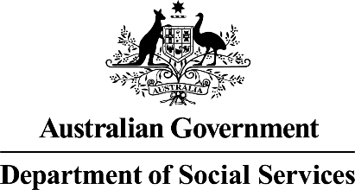  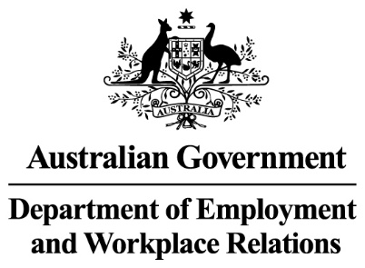 | The Australian Government  - Department of Social Services wrote this.  We say DSS for short.  - Department of Employment and Workplace Relations  We say DEWR for short.  When you see the word we it means DSS and DEWR.
 | We wrote this in an easy to read way.  We use pictures to explain some ideas.
 | We have some words in bold.  This means the letters are thicker and darker.  These are important words.
 | This is an Easy Read summary of another document.  This means it has the most important ideas.
 | You can ask for help to read this document.  You can ask  - A friend  - Family members  - A support person.

Contents

What is mutual obligation failure | 5
Decisions we have made | 7
Why we made this decision | 10
Who will be affected | 11
What you need to do | 15
Past decisions | 17
About the review | 19
Support | 21
Other decisions that are stopped for now | 22
What is next | 23

What is mutual obligation failure

 | We have laws for  - People who get Centrelink money for not having a job  We call this job seeker.
 | - The things they need to do to get their Centrelink money.  We call these activities.  Laws are rules for how we live.
 | You can read about the different activities on our website.  www.dewr.gov.au/resources/assuring-integrity-targeted-compliance-framework  It is in Easy Read.
 | It is called mutual obligation failure if you do not do them
 | If you do not do them we can  - Make changes to  - Stop  Your Centrelink money.  The law says we can do this.

Decisions we have made

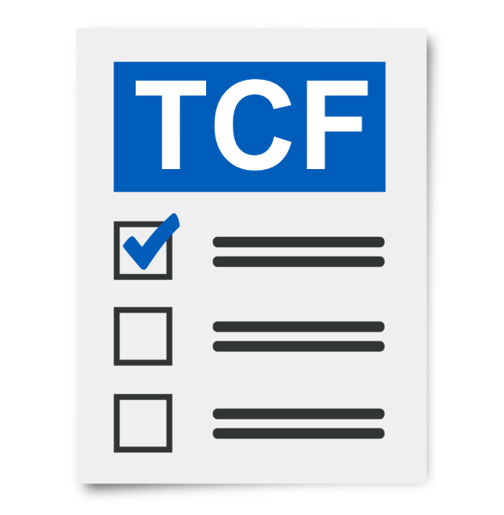 | The Targeted Compliance Framework is the rules we have for people who do not do their activities without a good reason.  We call it TCF for short.
You can read about some of the good reasons for not doing your activities on our website.

www.dewr.gov.au/resources/assuring-integrity-targeted-compliance-framework

It is in Easy Read.
 | If people do not do their activities they can have their Centrelink money  - Stopped  - Changed.
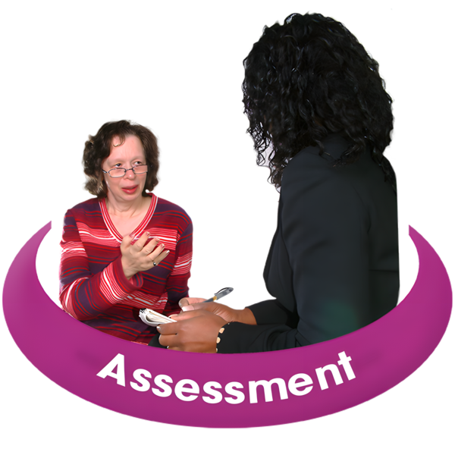 | 2 people do an assessment to see if people are not doing their activities.  Assessments help us work out if you are following the rules.
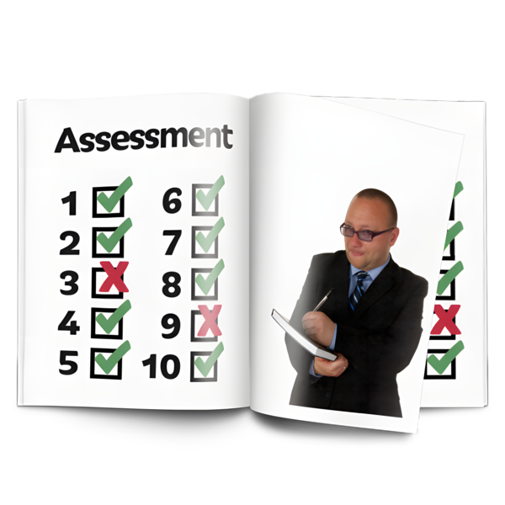 | An assessment will be done by  - Your employment provider  - Services Australia.
Most of the time if people do not do their activities 8 times they can have their Centrelink money stopped.

The law says we can stop your Centrelink money after this time.
 | The only time you will not have your Centrelink money stopped for not doing activities is if you have a good reason.
 | You need to apply for your Centrelink payments again if they are stopped.  Apply means you send in information to Services Australia about  - Who you are  - What payments you need.
 | You will have to wait for 4 weeks before you get money from Centrelink.
 | In July 2024 we stopped for now cancelling Centrelink money for people who do not do the activities.

Why we made this decision

 | In July 2024 we think some of the decisions to stop Centrelink money might not have been right.
 | We are checking that the way we do things  - Are fair  - Follow the law.
 | We have stopped these decisions while we make changes.

Who will be affected

 | Some people had their Centrelink money stopped for not doing their activities.
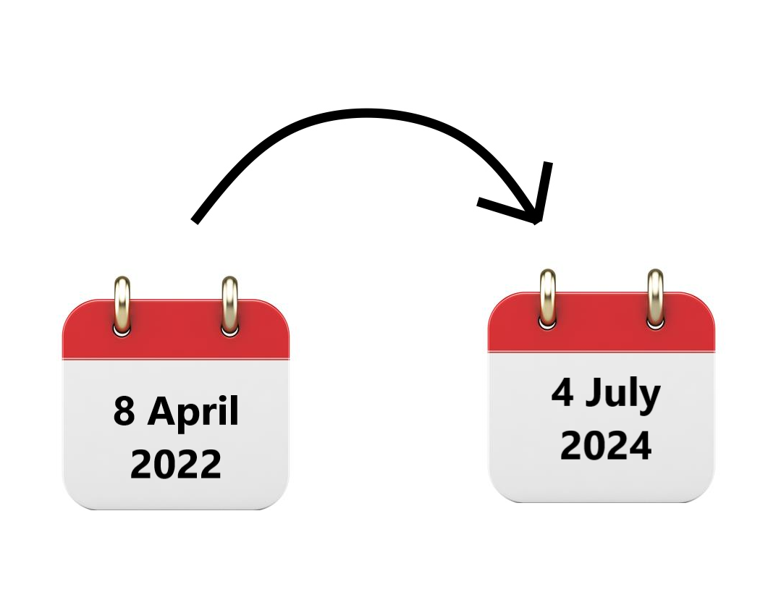 | We have looked at the payments that were stopped between  - 8 April 2022  - 4 July 2024.
 | If you were 1 of the people you can read more about what  - To do  - Will happen next  On our website.  www.dewr.gov.au/resources/assuring-integrity-targeted-compliance-framework  It is Easy Read.
 | Some of the people who were affected got Centrelink money for  - Job seeker
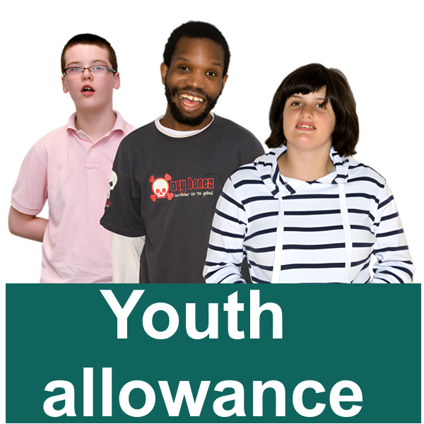 | - Youth allowance other
 | - Parenting payment single  After your youngest child is 6 years old.
 | - Special benefit for nominated visa holders.  This is for people from overseas working here.
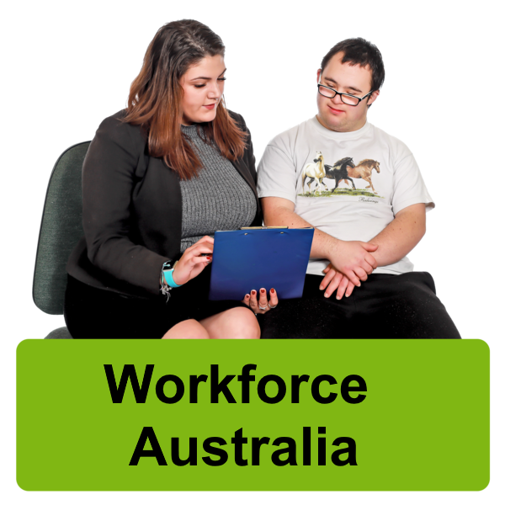 | It could also be anyone who took part in  - Workforce Australia
 | - Disability Employment Services  We call it DES for short.
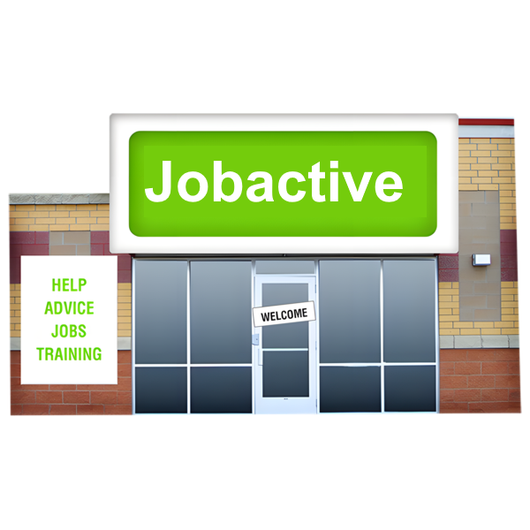 | - The Jobactive program
 | - Parents Next Program.
 | It does not affect anyone who was in the Community Development Program.
 | This program supports people who live in remote areas to get  - Fair money for work they do  - Jobs that help the community.

What you need to do

 | You do not need to do anything at the moment.
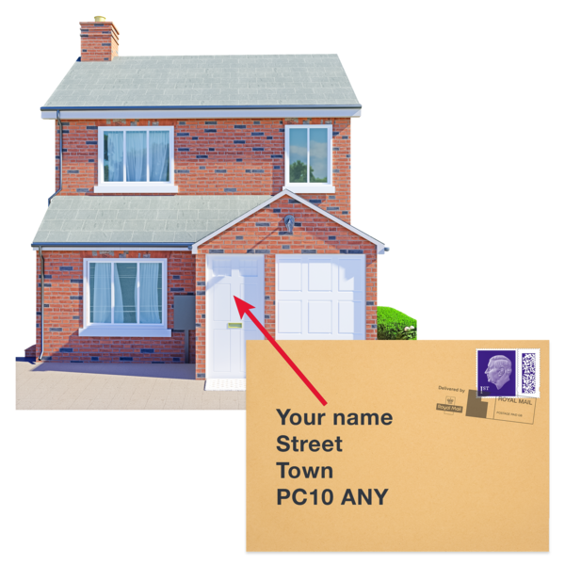 | You will get a letter in the mail in the next few weeks.  It will explain what will happen next.
 | We will look at the reasons why you did not do your activities.
 | This will help us find out if the decision was  - Right  - Wrong.
 | You need to keep doing your activities.
 | Talk to  - Your employment provider
 | - The Digital Services Contact Centre  1800 314 677  To make sure your activities are right for you.

Past decisions

We will review all the decisions to stop Centrelink money between

- 8 April 2022
- 4 July 2024.
 | We will do the review following the rules for the Compensation for Detriment caused by Defective Administration.  We call it CDDA for short.
You can read more about CDDA on the website.

www.finance.gov.au/cdda-scheme

It is not Easy Read.
You do not need to do anything.

We will let people know in the next few weeks.
You can read more about how we will do the review on our website.

www.finance.gov.au/cdda-scheme

It is not Easy Read.
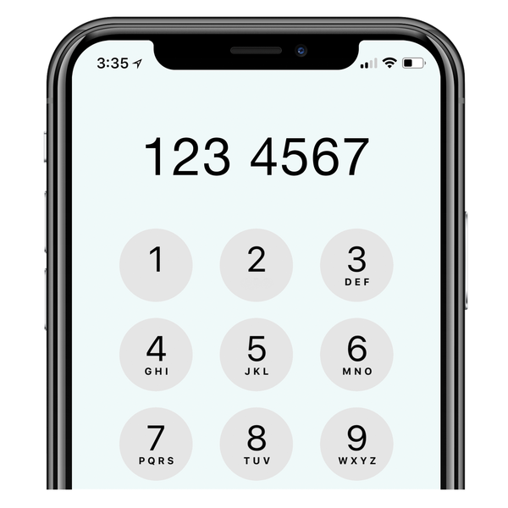 | If you have questions you can call the DEWR National Customer Service Line  1800 805 260
We will look at all decisions to stop Centrelink money between

- April 2022
- July 2024.
 | We might decide that the decision was not right.  We might pay you  - The money you should have got  - Money for your payments stopping when they should not have.  This is called compensation.

About the review

 | CDDA will do the review in 2 parts.
Part 1

CDDA will look at information about the decisions when they were made.
 | The information could be stored with  - DEWR  - Employment providers  - Services Australia.
 | If the decision did not look at all the information we will  - Let you know  - Pay you back the money.
 | Part 2  We might need to ask you more questions.
 | We will let you know if we  - Need more information from you
 | - Think the decision was right.
You might have another chance to tell us the reasons you could not do your activities.

You can look at our website to see some of the reasons you could not do your activities.

www.dewr.gov.au/resources/assuring-integrity-targeted-compliance-framework

It is in Easy Read.

Support

You might

- Have questions
 | - Be worried
 | - Want to make a complaint.  Complaints are when you tell someone they have not done a good job.  Everyone has the right to make a complaint.
You can call the DEWR National Customer Service Line

1800 805 260

Other decisions that are stopped for now

There are other decisions that have been stopped for now.
You can go to our website to read about the other decisions we have stopped for now.

www.dewr.gov.au/resources/assuring-integrity-targeted-compliance-framework

It is in Easy Read.

What is next

 | We have updated our computer systems.  They will not stop Centrelink payments for anyone that does not do their activities.
 | We will keep working to make sure the decisions  - Follow the law  - Are fair.
We are doing a review of this law.

A review is when you check what

- Works
- Needs to change.

 | We have made sure the review is  - Done in a fair way  - Following the law.
 | We have an independent person checking our computer systems.  Independent means separate to the government.
 | This means we are checking if our computer systems are following the rules.
If we do not believe the decisions

- Follow the law
- Are fair

We will stop them right away.
 | We need to make sure that any changes to  - The way we do things
 | - Our computer systems
- The law

Are done in the right way.
 | We are working on this.
 | We will let you know when we make more decisions.

Images in this Easy Read must not be used or copied without permission

