Reasons to not do activities

Without getting in trouble

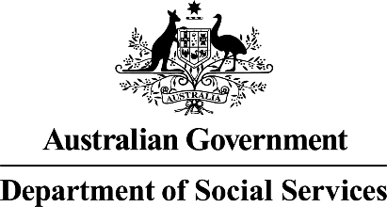  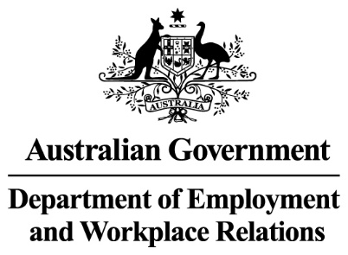 | The Australian Government  - Department of Social Services wrote this.  We say DSS for short.  - Department of Employment and Workplace Relations  We say DEWR for short.  When you see the word we it means DSS and DEWR.
 | We wrote this in an easy to read way.  We use pictures to explain some ideas.
 | We have some words in bold.  This means the letters are thicker and darker.  These are important words.
 | This is an Easy Read summary of another document.  This means it has the most important ideas.
 | You can ask for help to read this document.  You can ask  - A friend  - Family members  - A support person.
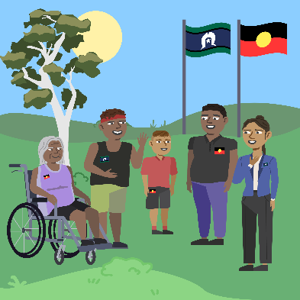 | We recognise Aboriginal and Torres Strait Islander people as the Traditional Owners of the land we live on.
 | They were the first people to live on and use the  - Land  - Waters.

Contents

What is mutual obligation failure | 5
Reasons you could not do your activities | 7
What you need to do | 10
Support | 11
More information | 12

What is mutual obligation failure

 | We have laws for  - People who get Centrelink money for not having a job  We call this job seeker.
 | - The things they need to do to get their Centrelink money.  We call these activities.  Laws are rules for how we live.
 | You can read about the different activities on our website.  www.dewr.gov.au/resources/assuring-integrity-targeted-compliance-framework  It is in Easy Read.
 | It is called mutual obligation failure if you do not do them
 | If you do not do them we can  - Make changes to  - Stop  Your Centrelink money.  The law says we can do this.

Reasons you could not do your activities

 | Sometimes there are good reasons you could not do your activities.  They could be you
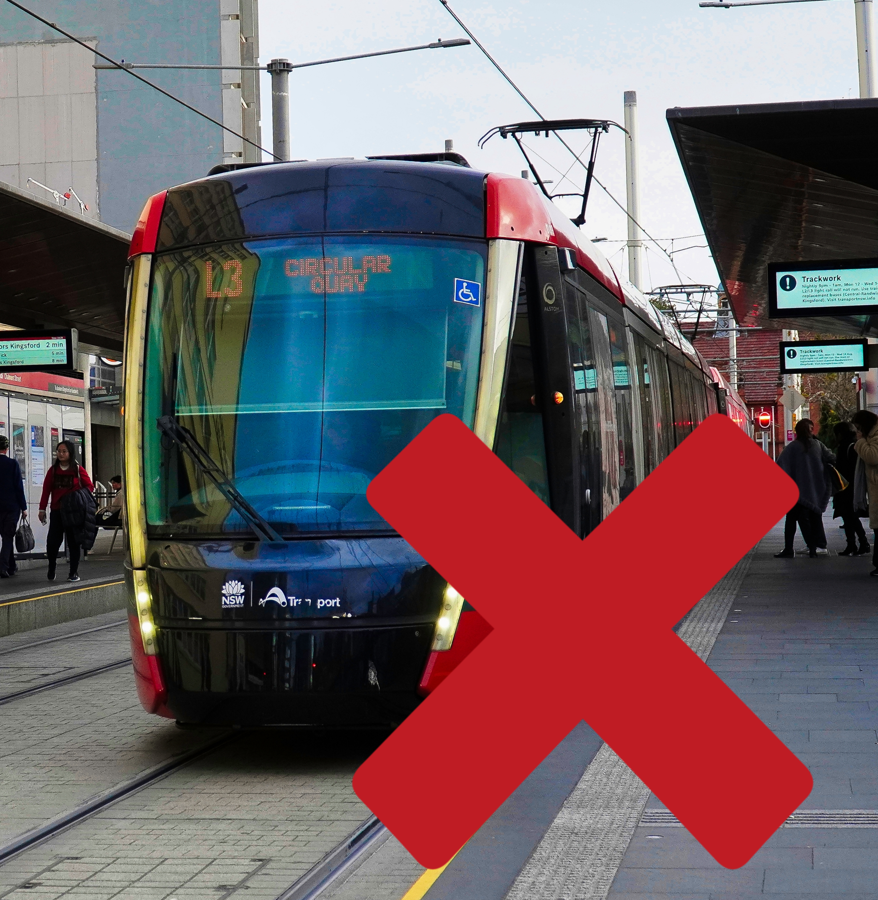 | - Could not get to the activities
 | - Were sick
 | - Were looking after someone who was sick
 | - Could not tell your employment provider
 | - Could not tell Services Australia
 | - Were experiencing violence  Violence is when someone hurts you.  It can also be called Domestic and Family Violence.
 | - Did not have a stable home  A stable home is when you have somewhere safe to live.  You can choose how long you can stay there.
 | - Were having a hard time which made it so you could not do your activities

What you need to do

 | You need to keep doing your activities.
 | Talk to  - Your employment provider
 | - The Digital Services Contact Centre  1800 314 677  To make sure your activities are right for you.

Support

 | You might  - Have questions
 | - Be worried
 | - Want to make a complaint.  Complaints are when you tell someone they have not done a good job.  Everyone has the right to make a complaint.
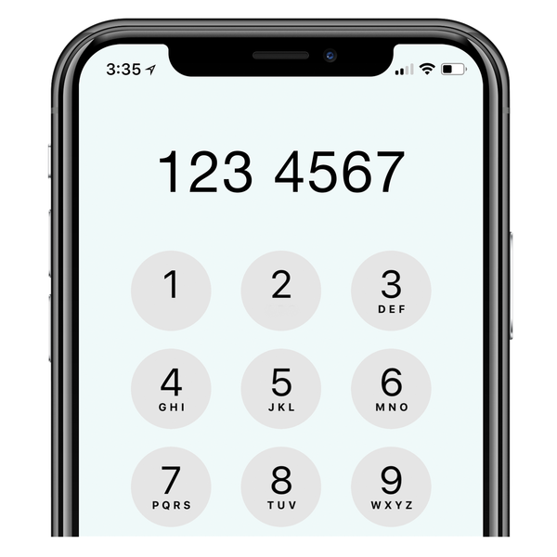 | You can call the DEWR National Customer Service Line  1800 805 260

More information

You can go to our website to read more information.

www.dewr.gov.au/resources/assuring-integrity-targeted-compliance-framework

It is in Easy Read.

Images in this Easy Read must not be used or copied without permission

