Decision about changes to Centrelink money

People not doing activities

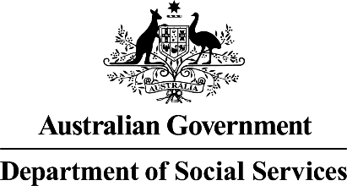  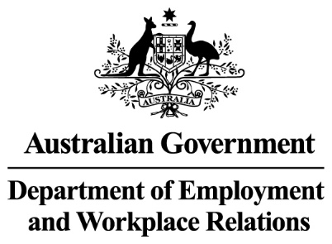 | The Australian Government  - Department of Social Services wrote this.  We say DSS for short.  - Department of Employment and Workplace Relations  We say DEWR for short.  When you see the word we it means DSS and DEWR.
 | We wrote this in an easy to read way.  We use pictures to explain some ideas.
 | We have some words in bold.  This means the letters are thicker and darker.  These are important words.
 | This is an Easy Read summary of another document.  This means it has the most important ideas.
 | You can ask for help to read this document.  You can ask  - A friend  - Family members  - A support person.

Contents

What is mutual obligation failure | 5
Decisions we have made | 7
Why we made this decision | 9
Who will be affected | 11
What you need to do | 14
Past decisions | 15
Support | 18
Other decisions that are stopped for now | 19
What is next | 20

What is mutual obligation failure

 | We have laws for  - People who get Centrelink money for not having a job
 | - The things they need to do to get their Centrelink money.  We call these activities.  Laws are rules for how we live.
 | You can read about the different activities on our website.  www.dewr.gov.au/resources/assuring-integrity-targeted-compliance-framework  It is in Easy Read.
 | It is called mutual obligation failure if you do not do the activities.
 | If you do not do them we can  - Make changes to  - Stop  Your Centrelink money.  The law says we can do this.

Decisions we have made

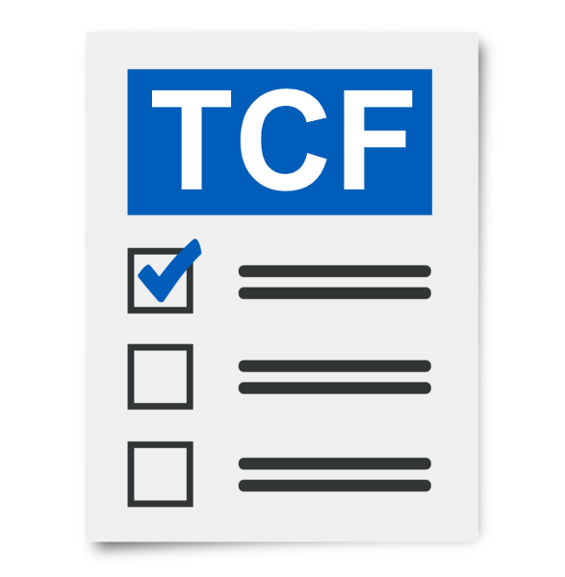 | The Targeted Compliance Framework is the rules we have for people who do not do their activities without a good reason.  We call it TCF for short.
 | If people do not do their activities they can have their Centrelink money  - Stopped  - Changed.
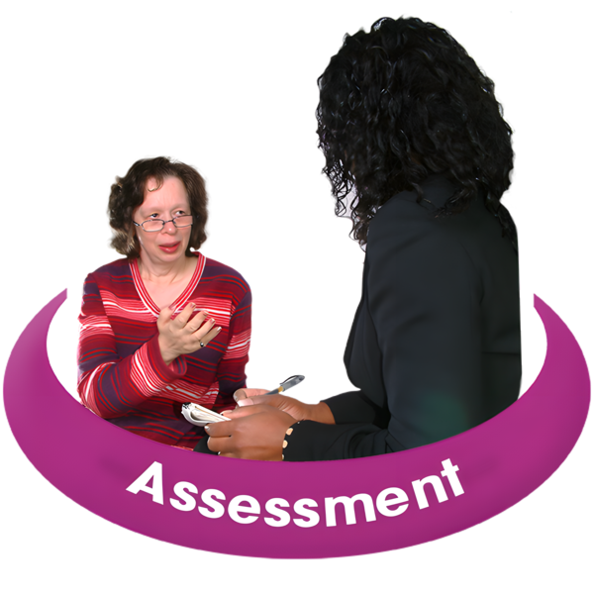 | 2 people do an assessment to see if people are not doing their activities.  Assessments help us work out if you are following the rules.
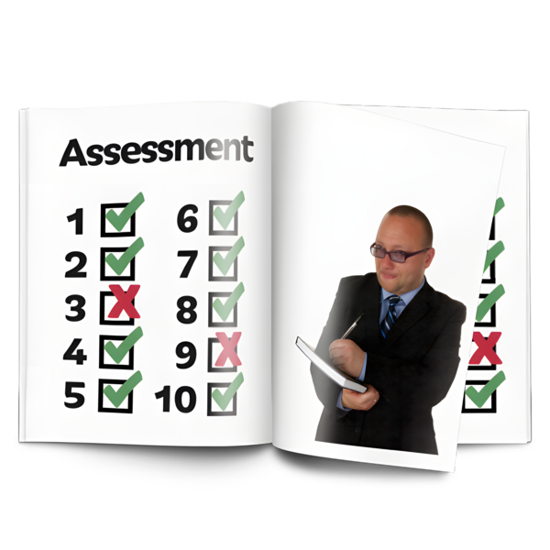 | An assessment will be done by  - Your employment provider  - Services Australia.
 | We can make your Centrelink money less if they both find that you are not doing your activities.  The law says when we can do this.
 | On 6 March 2025 we stopped for now changes to Centrelink money if people do not do the activities.

Why we made this decision

 | We want to make sure we are following the rules.
 | We do not think the decisions  - Are wrong  - Have hurt people.
 | We are stopping the decisions for now to make sure decisions are following the rules.  This will make sure no one has a decision made that is wrong.
 | We will keep the decision stopped while we make changes to the way we do things.
 | Anyone who gets job seeker for Centrelink will not have less money if they do not do their activities while we have stopped.
You can have a look at our website for more information.

www.dewr.gov.au/assuring-integrity-targeted-compliance-framework/decision-pause-reductions-peoples-social-security-participation-payments-due-persistent-mutual/information-jobseekers

It is Easy Read.
 | We are thinking about what to do about decisions that have been made already.

Who will be affected

 | The people who will have less Centrelink money if they do not do their activities are people who get  - Job seeker
 | - Youth allowance other
 | - Parenting payment single  After your youngest child is 6 years old.
 | - Special benefit for nominated visa holders.  This is for people from overseas working here.
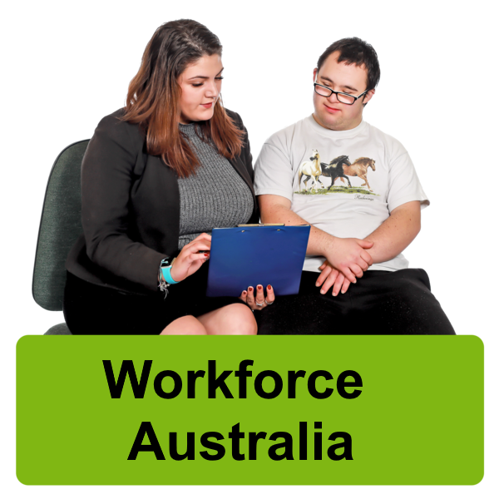 | It will also affect anyone who must take part in  - Workforce Australia
 | - Disability Employment Services  We call it DES for short.
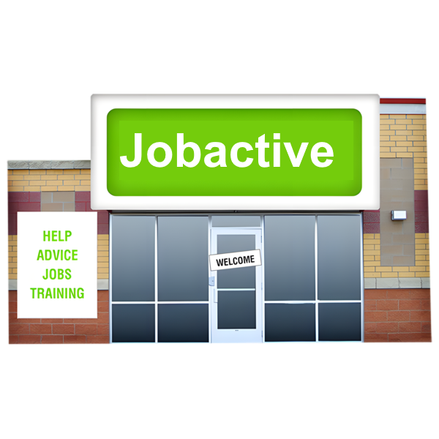 | - The Jobactive program
 | - Parents Next Program.
 | It does not affect anyone who is volunteering.  Volunteering is helping someone but not getting paid.

What you need to do

 | You do not need to do anything at the moment.
 | You need to keep doing your activities.
 | Talk to  - Your employment provider
 | - The Digital Services Contact Centre  1800 314 677  To make sure your activities are right for you.

Past decisions

 | If you think a decision we have made is not right you can ask us to  - Look at it again  - Explain our reasons for the decision.
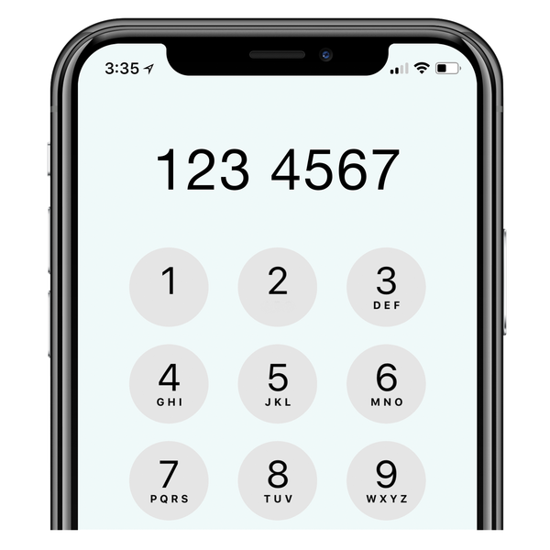 | You can do this by  - Calling Services Australia
 | - Going to a Services Australia centre
 | - Filling out a form online.  www.servicesaustralia.gov.au/ss351
If you do not agree with our decision you can ask us to look at it again.

You can ask Services Australia to have an Authorised Review Officer look at the decision.
 | If you still do not agree with our decision you can have it looked at by the Administrative Review Tribunal.  We call it ART for short.
 | It is important to ask for a review by ART before 13 weeks have passed.  If it is longer than 13 weeks and the decision is changed it will not be for the whole time.
You can go to the ART website to read more information.

www.art.gov.au/
You can call ART

1800 228 333
 | It will not cost you any money for ART to look at the decision.
 | When you ask for ART to review the decision Service Australia will be told.  Services Australia will send documents to you about the decision.
 | You can also get help from the Commonwealth Ombudsman  www.ombudsman.gov.au/  If you can not fill the form out online you can call them  1300 362 072

Support

 | You might  - Have questions
 | - Be worried
 | - Want to make a complaint.  Complaints are when you tell someone they have not done a good job.  Everyone has the right to make a complaint.
You can call the DEWR National Customer Service Line

1800 805 260

Other decisions that are stopped for now

There are other decisions that have been stopped for now.
You can go to our website to read about the other decisions we have stopped for now.

www.dewr.gov.au/resources/assuring-integrity-targeted-compliance-framework

It is in Easy Read.

What is next

 | We have updated our computer systems.  They will not change Centrelink payments for anyone that does not do their activities.
 | We will keep working to make sure the decisions  - Follow the law  - Are fair.
 | We are doing a review of this law.  A review is when you check what  - Works  - Needs to change.
 | We have made sure the review is  - Done in a fair way  - Following the law.
 | We have an independent person checking our computer systems.  Independent means separate to the government.
 | This means we are checking if our computer systems are following the rules.
If we do not believe the decisions

- Follow the law
- Are fair

We will stop them right away.
 | We need to make sure that any changes to  - The way we do things
 | - Our computer systems
- The law

Are done in the right way.
 | We are working on this.
 | We will let you know when we make more decisions.

Images in this Easy Read must not be used or copied without permission

