Australian Government Department of Employment logo

# Slide 1 Department of Employment North Western Melbourne Priority Employment Area presentation September 2013

Presentation given by Ivan Neville Branch Manager, Labour Market Research and Analysis Branch based on survey undertaken in September 2013 of the North Western Melbourne Priority Employment Area.

# Slide 2 Map of North Western Melbourne Priority Employment Area

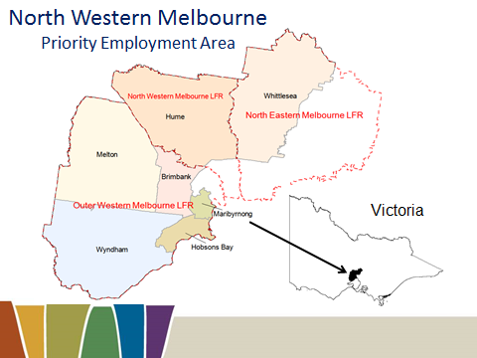

This map shows the Local Governments Areas (LGAs) that make up the North Western Melbourne Priority Employment Area (PEA).

The region consists of seven LGAs and 16 Statistical Local Areas (SLAs).

378 employers were surveyed in the PEA in June 2013. The region was previously surveyed in March 2012, February 2010 and May 2009.

Labour Force Regions (LFRs) and LGAs included in the North Western Melbourne PEA:

LFR *Outer Western Melbourne*

LGA Melton

Wyndham

Brimbank

Hobsons Bay

Maribyrnong

83% of LFR’s working age population is in the PEA

LFR accounts for 66% of PEA’s working age population

LFR *North Western Melbourne*

LGA Hume

52% of LFR’s working age population is in the PEA

LFR accounts for 18% of PEA’s working age population

LFR *North Eastern Melbourne*

LGA Whittlesea

29% of LFR’s working age population is in the PEA

LFR accounts for 16% of PEA’s working age population

SLAs included in the North Western Melbourne PEA

Brimbank (C) - Keilor

Brimbank (C) - Sunshine

Hobsons Bay (C) – Altona

Hobsons Bay (C) - Williamstown

Hume (C) - Broadmeadows

Hume (C) - Craigieburn

Hume (C) - Sunbury

Maribyrnong (C)

Melton (S) - East

Melton (S) Bal

Whittlesea (C) - North

Whittlesea (C) - South-East

Whittlesea (C) - South-West

Wyndham (C) - North

Wyndham (C) - South

Wyndham (C) - West

# Slide 3 What has Changed? (since last survey, March 2012)

|  |  |
| --- | --- |
| Unemployment rate | Steady |
| Employment | Up |
| Population growth | Up |
| Youth participation rate | Down |
| Recruitment Activity | Down |
| Competition for vacancies | Up |
| Future recruitment expectations | Steady |
| Overall labour market conditions for the LGA | Steady |

*Source: ABS, Census of Population and Housing, 2011 and 2006; ABS, Labour Force Survey, May & July 2013; DEEWR, Small Area Labour Market, June 2013; DEEWR, Survey of Employers’ Recruitment Experiences, North Western Melbourne PEA, March 2012 and June 2013*

* Labour market conditions in the North Western Melbourne PEA have moderated since 2012 and results from the June 2013 survey suggest further softening in the future.
* The unemployment rate in the North Western Melbourne PEA decreased slightly to 7.9% in June 2013 from 8.0% in June 2012 (DEEWR, SALM, June 2013).
* Employment increased by 13,300 jobs in the year to July 2013. But, there was a structural shift in employment across the major industries (ABS LFS, May Quarter 2013).
* Adult population growth between 2006 and 2011 was 21% (ABS Census 2006 and 2011).
* The youth participation rate for the Northern-North West Labour Force Region and Outer Western Melbourne LFR dropped from 70% in July 2011 to 65% in July 2013 (ABS LFS, July 2013).
* Competition for vacancies increased substantially.
* The survey showed a decrease in recruitment activity but expectations of future recruitment were encouraging.

# Slide 4 Strong population growth

|  |  |  |  |  |
| --- | --- | --- | --- | --- |
| Region | Adult Population 2011 (15+) | Growth 2006 to 2011 (15+) | Participation rate (Working Age Population) 2011 | Median Age 2011 |
| Hume LGA | 129,480 | 16% | 69.1% | 33 |
| Brimbank LGA | 147,930 | 11% | 69.0% | 35 |
| Hobsons Bay LGA | 68,660 | 5% | 75.7% | 38 |
| Maribyrnong LGA | 59,770 | 13% | 76.0% | 34 |
| Melton LGA | 82,260 | 38% | 74.7% | 32 |
| Whittlesea LGA | 122,670 | 26% | 73.4% | 34 |
| Wyndham LGA | 123,250 | 44% | 76.0% | 32 |
| North Western  Melbourne PEA | 734,020 | 21% | 72.8% | 33 |
| Victoria | 4,355,250 | 9% | 75.6% | 37 |
| Australia | 17,363,690 | 9% | 75.8% | 37 |

*Source: ABS Census of Population and Housing, 2006 and 2011*

The adult population (15 years+) for the North Western Melbourne PEA at the time of 2011 Census was 734,020, an increase of 21% from the 2006 Census. Population growth over this period for Victoria and Australia was lower, both 9%

Some 31% of the total growth in the PEA was in the 20 to 34 year age group. The 20 to 24 years cohort grew by 22%, the 25 to 29 years cohort grew by 35% and the 30 to 34 year cohort increased by 24%. However, there was also large growth in the 60 to 65 year group (increased by 41%).

The Wyndham LGA had the largest adult population growth (44%) of all the LGAs in the area. The age cohorts with the largest growth in the Wyndham LGA were the 25-29 (60%) and 60-64 (62%). The Melton and Whittlesea LGAs also experienced considerable growth in the adult population (38% and 26% respectively).

# Slide 5 Age Distribution

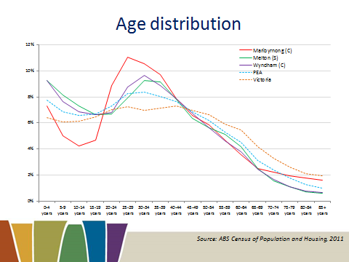

*Source: ABS Census of Population and Housing, 2011*

The age distribution in the North Western Melbourne PEA shows that in some LGAs, in particular Melton, Maribyrnong and Wyndham, the adult population is considerably younger.

# Slide 6 Migration Over Five Years (persons of working age in 2011)

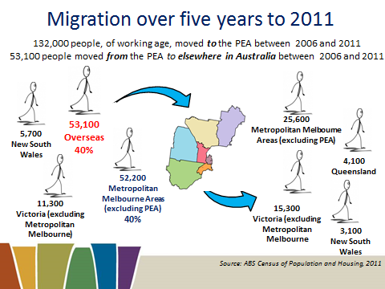

*Source: ABS Census of Population and Housing, 2011*

132,000 people of working age in 2011 in the North Western Melbourne PEA had moved to the PEA over the previous five years (18%).* Over the same period, 53,100 people (of working age in 2011) had moved from the PEA to elsewhere in Australia.

By far the most common origin was overseas (53,100 persons of working age in 2011), with the two main destinations for those coming from overseas being Wyndham (11,900) and Brimbank (11,500).

*Note: These figures include only those who reported and adequately defined their location in 2006 during the 2011 Census.

The majority of people came from the following localities:

|  |  |  |  |
| --- | --- | --- | --- |
| Region | WAP | | % of WAP who moved to the PEA |
| Overseas | 53,100 | | 40% |
| Metropolitan Melbourne (excluding PEA) | 52,200 | | 40% |
| The rest of Victoria | 11,300 | | 9% |
| New South Wales | 5,700 | | 4% |
| Region | WAP | % of WAP who moved away from the PEA | |
| Metropolitan Melbourne (excluding PEA) | 52,200 | 48% | |
| The rest of Victoria | 11,300 | 29% | |
| Queensland | 4,100 | 8% | |
| New South Wales | 3,100 | 6% | |

# Slide 7 Unemployment Rates

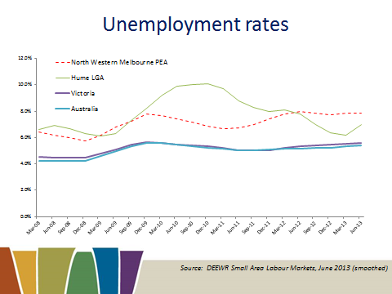

*Source: DEEWR Small Area Labour Markets, June 2013 (smoothed)*

The PEA unemployment rate has consistently remained above the state and national unemployment rate.

The North Western Melbourne PEA unemployment rate stood at 7.9% in June 2013 compared with 5.7 per cent for Victoria and 5.8 per cent for Australia (seasonally adjusted, August).

# Slide 8 Unemployment rate increasing most in areas with high population growth

|  |  |  |  |
| --- | --- | --- | --- |
| Region | Unemployment Rate | | Annual Change |
| June 2012 | June 2013 |
| Hume LGA | 7.8% | 7.0% | -0.8% pts |
| Brimbank LGA | 8.9% | 8.9% | 0.0% pts |
| Hobsons Bay LGA | 5.5% | 5.2% | -0.3% pts |
| Maribyrnong LGA | 8.0% | 7.8% | -0.2% pts |
| Melton LGA | 8.9% | 9.0% | 0.1% pts |
| Whittlesea LGA | 7.3% | 8.0% | 0.7% pts |
| Wyndham LGA | 8.5% | 8.7% | 0.2% pts |
| North Western Melbourne PEA | 8.0% | 7.9% | -0.1% pts |
| Victoria (August, seasonally adjusted) | 5.6% | 5.7% | 0.1% pts |
| Australia (August, seasonally adjusted) | 5.1% | 5.8% | 0.7% pts |

*Source: DEEWR Small Area Labour Markets, June 2013 (smoothed); ABS Labour Force, August 2013 (seasonally adjusted)*

The unemployment rate for the North Western Melbourne PEA decreased by 0.1 percentage points over the 12 months to June 2013 to stand at 7.9%.

There were large disparities in the unemployment rate across the LGAs. The Melton LGA had the highest unemployment rate (9.0%) followed by the Brimbank LGA (8.9%). Increases in the unemployment rate were generally experienced in regions with the highest adult population growth. The Whittlesea LGA had the biggest increase in the unemployment rate, up 0.7 of a percentage point to 8.0%.

The Hume LGA had the largest fall in the unemployment rate, down 0.8 of a percentage points to 7.0%. The lowest unemployment rate in the North Western Melbourne PEA was 5.2% for the Hobsons Bay LGA.

# Slide 9 Largest Employing Industries

Largest employing industries, North Western Melbourne LFR/ Outer Western Melbourne LFR/ Victoria
 
Health Care and Social Assistance 12%/10%/12%
Manufacturing 12%/10%/10%
Retail Trade 10%/10%/11%
Transport, Postal and Warehousing 6%/11%/5%
Construction 10%/7%/8%
Professional, Scientific and Technical Services 8%/8%/9%
Education and Training 8%/7%/8%
Accommodation and Food Services 7%/7%/6%




*Source: ABS Labour Force, May 2013 (4 quarter averages)*

For those living inthe North Western Melbourne LFR, the Health Care and Social Assistance and Manufacturing industries are the largest employing industries (both 12%). The North Western Melbourne LFR also has a large proportion of people working in the Retail Trade industry (10%), although this figure is slightly smaller than the proportion for Victoria (11%).

In the Outer Western Melbourne LFR, Transport, Postal and Warehousing industry is the largest employer (11%) and employs a far larger proportion of the workforce in the LFR than in Victoria (5%). The Health Care and Social Assistance; Manufacturing; and Retail Trade industries are also major employers (all 10%).

# Slide 10 Shift in employment over past 5 years – 5 years to May 2013

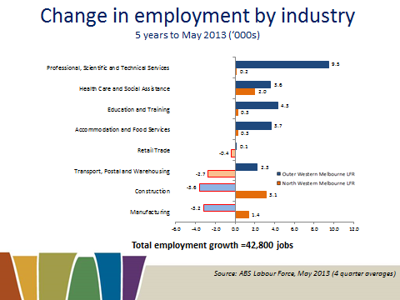

*Source: ABS Labour Force, May 2013 (4 quarter averages)*

Over the five years to May 2013, employment for those living in the Outer Western Melbourne LFR increased by 26,200 jobs (7%). Employment growth was strongest in the Professional, Scientific and Technical Service industry, which grew by 9,500 jobs, and Education and Training (4,300). However, there were large falls in employment in the Construction industry (-3,600) and Manufacturing Industry (-3,200).

Over the same period, employment in the North Western Melbourne LFR increased by 16,600 (13%). Employment growth was strongest in the Construction industry, which grew by 3,100, followed by the Health Care and Social Assistance industry (2,000). Losses in employment were experienced by the Transport, Postal and Warehousing industry (-2,700) and Retail Trade industry (-400).

Overall, employment across both LFRs increased by 42,800 jobs. Increases were greatest in the Professional, Scientific and Technical Service industry (9,700) and Health Care and Social Assistance industry (5,600). Declines in employment were largest in the Manufacturing Industry (-1,800) and Construction (-500)

Over the last year, employment grew by 13,300 jobs across the two LFRs.

# Slide 11 Structural change in Industry employment

Structural change in industry May quarter 2008 to May quarter 2013 (percentage of total employment)

Manufacturing 18% to 10%
Retail trade 13% to 9%
Education and training 7% to 7%
Construction 8% to 9%
Accomodation and food services 6% to 8%
Transport, postal and warehousing 8% to 10%
Professional, scientific and technical services 5% to 8%
Health care and social assistance 6% to 10%

*Source: ABS Labour Force, May 2013 and May 2003*

Over the ten years to 2013 there has been a structural change in industry employment in the Outer Western Melbourne and North Western Melbourne LFRs. Major traditional employers like Manufacturing and Retail Trade have experienced substantial declines in their share of total employment, while major service industries such as Health Care and Social Assistance and Professional, Scientific and Technical Services have seen large increases in their share of total employment.

# Slide 12 Employment growth faltering for lower skilled occupations – 5 years to May 2013

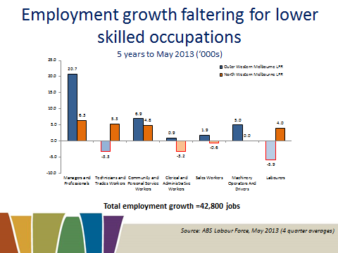

*Source: ABS Labour Force, May 2013 (4 quarter averages)*

Over the five years to May 2013, employment for those *living in* the Outer Western Melbourne LFR also increased by 26,200 (7%). Over the same period, employment in the North Western Melbourne LFR increased by 16,600 (13%). Nevertheless, there were considerable disparities between growth numbers when comparing occupation groups. High and medium skill occupation groups experienced growth of 38,500 jobs (17%), whereas lower skilled occupations, experienced a net growth of 4,300 jobs (4%). By and large, there was a large increase in employment for higher skilled occupations such as Managers and Professionals. For medium skilled occupations, such as and Technicians and Trades Workers and Community and Personal Service Workers, there were moderate gains in employment, although there was an overall decline of employment for Clerical and Administrative Workers. For lower skilled occupations overall, there was only a small net increase in employment across the LFRs. For Sales Workers and Labourers, there were overall declines in employment across the combined LFRs.

# Slide 13 Melbourne internet vacancies decreasing 12 months to July 2013

|  |  |  |  |
| --- | --- | --- | --- |
| Region | Index  (May '10 = 100) | Yearly  % change | Number of vacancies |
| Melbourne | 77.3 | -15.4% | 35,070 |
| Rest of Victoria | 94.6 | -12.2% | 4,096 |
| Australia | 80.6 | -20.9% | 162,688 |

*Source: DEEWR Vacancy Report, July 2013 (three month moving average)*

Internet vacancies have dropped considerably for Melbourne over the 12 months to July 2013 (down 15.4%). Nevertheless, the fall in vacancies is well below that for Australia overall (down 20.9%).

# Slide 14 The PEA is a net exporter of skilled labour

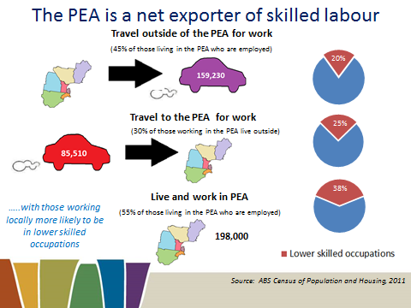

*Source: ABS Census of Population and Housing, 2011*

The PEA is a net exporter of skilled labour. At the time of the 2011 Census, 198,000 people who lived in the PEA reported their place of work as being in the North Western Melbourne PEA.* Almost as many, 159,230 (45% of employed people living in the PEA) travelled outside the PEA for work. In contrast, only 85,510 of those who reported their place of work as being in the North Western Melbourne PEA lived outside the PEA (30% of total population who worked in the PEA).

*Note: 15% of employed people living in the PEA (63,900 people) did not state or inadequately described their place of work.

**People who work in the PEA 283,500**

- and live in the PEA 198,000 70%

- and live outside the PEA 85,500 30%

**Employed people who live in the PEA** **357,200**

- and work in the PEA 198,000 55%

- and work outside the PEA 159,200 45%

# Slide 15 Long-term Unemployment

|  |  |  |  |
| --- | --- | --- | --- |
| Region | Long-term unemployed July 2013 (52 weeks or more) | | Average duration of unemployment |
| Persons | % of all unemployed |
| North Western Melbourne LFR | 1,500 | 15% | 28 weeks |
| Outer Western Melbourne LFR | 6,000 | 22% | 39 weeks |
| Victoria | 29,400 | 17% | 33 weeks |
| Australia | 125,900 | 19% | 37 weeks |

*Source: ABS labour Force, July 2013 (12 month averages)*

The average duration of unemployment in the Outer Western Melbourne LFR was 39 weeks whilst the North Western Melbourne LFR was 28 weeks.

The average duration of unemployment for the Outer Western Melbourne LFR is 6 weeks longer than for Victoria.

Overall, in the Outer Western Melbourne LFR 22% of all unemployed persons are unemployed for over 52 weeks. This is higher than the North Western Melbourne LFR (15%) and Victoria (17%).

# Slide 16 Teenagers looking for full-time work – Persons aged 15-19 years

|  |  |  |  |
| --- | --- | --- | --- |
| Region | Long-term unemployed  July 2013  (52 weeks or more) | | Average duration of unemployment |
| Persons | % of all unemployed |
| North Western Melbourne LFR | 1,500 | 15% | 28 weeks |
| Outer Western Melbourne LFR | 6,000 | 22% | 39 weeks |
| Victoria | 29,400 | 17% | 33 weeks |
| Australia | 125,900 | 19% | 37 weeks |

*Source:* *ABS Labour Force, July 2013 (12 month average); ABS Census of Population and Housing, 2011*

Due to their lack of skills and experience, teenagers in the full-time labour market can be particularly vulnerable during a labour market downturn. The teenage full-time unemployment rate is based on people aged 15 – 19 years old who are searching for full-time employment.

In July 2013, the teenage full-time unemployment rate for the Outer Western Melbourne LFR was 39%. This was higher than the rates for both Victoria and Australia (26% and 25% respectively). The North Western Melbourne LFR had a slightly lower unemployment rate (31%), however, still higher than Victoria.

The teenage full-time unemployment to population ratio of 5% for the Outer Western Melbourne LFR was larger than the figures for the North Wester Melbourne LFR (3%) and for Victoria and Australia (3% and 4% respectively)

At the time of the 2011 Census, 7% of 15 to 19 year olds in the North Western Melbourne PEA were neither studying nor working, on a par with the national average.

# Slide 17 Youth labour force participation falling but participation in education increasing

|  |  |  |  |  |
| --- | --- | --- | --- | --- |
| Age Group | Youth participation rate  (labour force) *Combined  North Western Melbourne LFR and  Outer Western Melbourne LFR* | | Youth participation  in education *North Western Melbourne PEA* | |
| July 2013 | Change over  2 years | 2011 | 2006 |
| 15 to 19 years | 47% | -7% | 83% | 80% |
| 20 to 24 years | 78% | -4% | 38% | 33% |
| 25 to 34 years | 79% | -2% | 12% | 10% |
| 15 to 64 years (WAP) | 75% | 0% | 18% | 16% |

*Source: ABS Labour Force, July 2013 (12 month average); Source: ABS Census of Population and Housing, 2006 and 2011*

The participation rate in the North Western Melbourne and Outer Western Melbourne LFRs has remained constant over the past 2 years from July 2011 and stands at 75%. The participation rate, however, varies greatly across different age cohorts of the area.

The 15 to 19 year group has seen a drop in participation of 7 percentage points. This trend continues in the 20 to 24 age group with a drop of 5 percentage points. This trend is also evident across both Victoria and Australia but to a lesser extent (-1 percentage points and   
-2 percentage points in Victoria and -1 percentage points for both groups in Australia).

Accompanying this decrease in labour force participation for youth has been an increase in participation in education.

# Slide 18 What are youth doing?

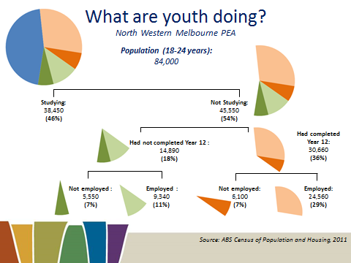

*Source: ABS, Census of Population and Housing, 2011*

According to the 2011 Census 54% (84,000) of 18 to 24 years olds in the North Western Melbourne PEA, were not studying and may experience difficulty entering or staying in the labour market, particularly those who have not completed Year 12.

In particular, 14% (11,650 people) of youth aged 18 to 24 are not studying and not employed and 5,550 of these (7% of youth aged 15 to 19) had not completed Year 12. These figures are higher compared with Victoria, where 11% of youth aged 15 to 19 were not studying and not employed and 5% had also not completed Year 12. This group are especially at risk given their lack of Year 12 Certificate and level of disengagement within the labour market.

Note: Not stated records for FT/PT Student Status, Labour Force Status and Highest Year of School Completed have not been included.

# Slide 19 Educational Attainment – Persons aged 25-34 years

|  |  |  |  |  |
| --- | --- | --- | --- | --- |
| Region | Completed Year 12 | | Highest Non-School Qualification Attained | |
| 2011 | 2006 | Advanced Diploma, Diploma or Certificate III & IV Level | Bachelor Degree or Higher |
| Hume LGA | 70% | 62% | 30% | 23% |
| Brimbank LGA | 79% | 69% | 28% | 31% |
| Hobsons Bay LGA | 82% | 73% | 27% | 41% |
| Maribyrnong LGA | 89% | 83% | 22% | 52% |
| Melton LGA | 73% | 66% | 34% | 25% |
| Whittlesea LGA | 78% | 69% | 33% | 29% |
| Wyndham LGA | 78% | 67% | 29% | 37% |
| North Western Melbourne PEA | 77% | 69% | 29% | 33% |
| Victoria | 79% | 73% | 29% | 40% |
| Australia | 75% | 69% | 30% | 35% |

*Source: ABS Census of Population and Housing, 2011*

Educational attainment is strongly linked with labour market performance. Accordingly, regions with relatively low levels of educational attainment tend to be more vulnerable to economic slowdowns and face greater labour market difficulties.

At the time of the 2011 Census, the proportion of 25 to 34 year olds in the North Western Melbourne PEA who had completed Year 12 or equivalent was 77%, smaller than Victoria (79%) but larger than for Australia. This varied across regions, with the Hume LGA having the smallest Year 12 attainment level (70%), while the Maribyrnong LGA had the largest (89%). Overall across the PEA for this age group, Year 12 attainment had increased by 8 percentage points since 2006.

Job seekers who have not completed Year 12 and have limited experience in the workforce are likely to lack many basic employability skills that employers value and look for in applicants, particularly for lower skilled vacancies and entry level positions such as apprenticeships and traineeships.

At the time of the 2011 Census, the proportion of 25 to 34 year olds who had attained an Advanced Diploma, Diploma or a Certificate III or IV in the North Western Melbourne PEA (29%) was on a par with state and national averages (29% and 30% respectively), while the proportion who had attained a Bachelor Degree or higher (33%) was lower than the state and national averages (40% and 35% respectively).

# Slide 20 Educational Attainment and Labour Market Outcomes

Educational attainment and labour market outcomes for persons aged 25 - 34 years.

Unemployment / participation rate
Bachelor degree or higher 4.3%/87.4%
Advanced diploma and diploma level 4.8%/85.2%
Certificate III & IV level 4.5%/87.3%
Year 12 or equivalent 7.1%/76.7%
Certificate I & II level 15%/67%
Below year 12 12.8%/64.1%

*Source: ABS Census of Population and Housing, 2011*

There is a strong relationship between educational attainment and employment outcomes. For those aged 25 to 34 years in the North Western Melbourne PEA who had not completed Year 12 there was a low participation rate (64.1%) and a high unemployment rate (12.8%). Although the participation rate was marginally higher for those who had not completed year 12 but had attained a Certificate Levels I or II qualification, the unemployment rate was even higher (15.0%).

Unemployment rates are considerably lower for those who have completed Year 12. They are even better for those who have attained a Certificate Levels III or IV, or completed a tertiary education at the Advanced Diploma and Diploma Level or Bachelor Degree or higher level. This emphasises the importance of post-school education in gaining employment.

# Slide 21 Jobless Families with children aged less than 15 years

|  |  |  |  |  |
| --- | --- | --- | --- | --- |
| Region | Number of jobless  families | Proportion of all families  that are  jobless | Proportion of couple families that are  jobless | Proportion of lone parent families that are jobless |
| Hume LGA | 3,990 | 21% | 13% | 52% |
| Brimbank LGA | 3,980 | 22% | 11% | 56% |
| Hobsons Bay LGA | 1,050 | 13% | 6% | 43% |
| Maribyrnong LGA | 1,010 | 15% | 8% | 45% |
| Melton LGA | 1,930 | 14% | 5% | 48% |
| Whittlesea LGA | 2,460 | 14% | 7% | 45% |
| Wyndham LGA | 2,650 | 13% | 5% | 46% |
| North Western Melbourne PEA | 17,070 | 17% | 8% | 49% |
| Victoria | 66,720 | 13% | 5% | 43% |
| Australia | 294,880 | 14% | 5% | 44% |

*Source: ABS Census of Population and Housing, 2011*

At the time of the 2011 Census, almost one in five (17%) families with children (under 15 years of age) in the North Western Melbourne PEA did not have an employed parent, a figure larger than that for Victoria and Australia.

However, there was disparity across the region. Some 22% of families with children in the Brimbank LGA were jobless. This differed from the Hobson Bay and Wyndham LGAs, where 13% of families with children were jobless, on par with Victoria.

# Slide 22 Higher intake of Humanitarian Migrants in the PEA – Settlers aged 18-64 years over the past 5 years

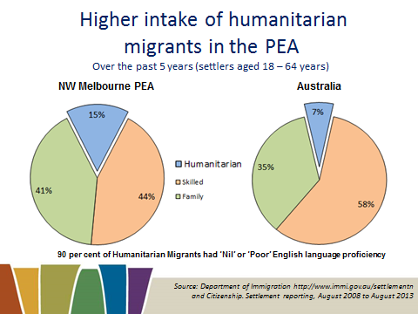

*Source: Department of Immigration http://www.immi.gov.au/settlementn and Citizenship. Settlement reporting, August 2008 to August 2013*

There have been over 39,840 migrants (aged 18-64 years) settle in the North Western Melbourne PEA over the past 5 years:

* 44% (17,460 migrants) settled under the skilled migration stream, compared with 58% for Australia.
* 41% (16,350 migrants) settled under the family migration stream, compared with 35% for Australia.
* 15% (6,030 migrants) settled under the humanitarian migration stream, compared with 7% for Australia.
* 90% of Humanitarian migrants had ‘nil’ or ‘poor’ English language proficiency.

Of all Humanitarian migrants aged 18-64 who settled in Australia over the past 5 years, 13% settled in the North Western Melbourne PEA. This is notably high considering only 4% of Australia’s working age population live in the PEA.

# Slide 23 OTMESC Recent Arrivals More Likely to be in Lower Skilled Employment — Persons of working age in 2011

OMESC workers 61% in higher/medium skilled occupations and 39% in Lower skilled occupations

Mesc workers 77% in higherr/medium skilled occupations and 23% in Lower skilled occupations

In the PEA 26% of working aged people have a Bachelor degree  or higher compared to16% of MESC working aged people.

*Source: ABS Census of Population and Housing, 2011*

|  |  |  |
| --- | --- | --- |
|  | OTMESC | MESC |
| Managers and Professionals | 23% | 40% |
| Technicians and Trades Workers | 15% | 14% |
| Community and Personal Service Workers | 12% | 7% |
| Clerical and Administrative Workers | 11% | 15% |
| Sales Workers | 8% | 8% |
| Machinery Operators and Drivers | 11% | 8% |
| Labourers | 21% | 8% |

# Slide 24 OTMESC migrants take longer to enter the workforce (labour force status at 2011)

Comparison of OTMESC and MESC unemployment rates for the following year of arrivals 
2000-2004, 7.8% OTMESC, 4.8% MESC
2005-2009, 9.4% OTMESC, 6.0% MESC
2010-2011, 28.6% OTMESC, 14.4% MESC

Comparison of OTMESC and MESC participation rates for the following year of arrivals
2000-2004, 70.9% OTMESC, 81.4% MESC
2005-2009, 68.6% OTMESC, 82.2% MESC
2010-2011, 48.3% OTMESC, 80.0% MESC


*Source: ABS, Census of Population and Housing, 2011*

OTMESC migrants in the North Western Melbourne PEA who have recently arrived in Australia have a far higher unemployment rate than those who have been in Australia for longer. They also are far less likely to be participating in the labour market.

At the time of the 2011 Census, the unemployment rate for OTMESC migrants who had arrived in 2010 and 2011 was 28.6% compared with 14.4% for MESC migrants. The participation rate for recently arrived OTMESC migrants (48.3%) was also well below recently arrived MESC migrants (80.0%).

# Slide 25 English Language Skills and Labour Market Outcomes – For persons (working age) who speak a language other than English

The following is a comparison to the level of english language skills and labour market outcomes for people of working age that speak another language.
For those that speek only english 5.4%/78.1%
For those that speak other language and speak english very well 7.3%/73.8%
For those that speak another language and speak english well 9.0%/63.3%
For those that speak another language and speak english not well 16.3%/42.3%
For those that speak another language and speak english not at all 26.5%/25.7%

*Source: ABS Census of Population and Housing, 2011*

At the time of the 2011 Census, persons in the North Western Melbourne PEA with lower levels of English proficiency were less likely to be successful in the labour market. People with low English proficiency are far more likely to be unemployed or not participating in the labour market.

People who speak other languages but still speak English well are also more likely to have poorer labour force outcomes than those who only speak English.

In the North Western Melbourne PEA, the unemployment rate for working age persons without any English proficiency was 26.5% and the participation rate was only 25.7%. For working age persons who only spoke English, the unemployment rate (5.4%) and participation rate (78.1%) were considerably better.

# Slide 26 Young OTMESC people not working or studying – Persons aged 20-24 years

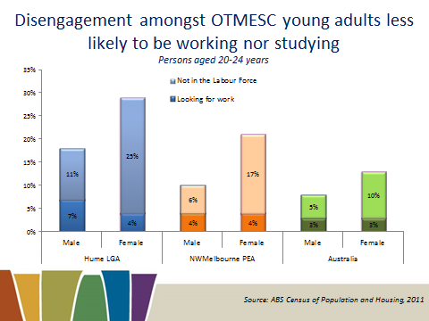

*Source: ABS Census of Population and Housing, 2011*

At the time of the 2011 census, 15% of OTMESC young adult 20-24 year olds in the North Western Melbourne PEA were neither employed nor studying, compared with 11% for Australia. For young adult OTMESC males, there were higher levels of engagement than those from Main English Speaking Countries. Yet for OTMESC 20-24 year old females, engagement was lower, largely due to a higher proportion not being in the labour force.

In the Hume LGA, the level of disengagement amongst OTMESC 20-24 year olds was considerably higher (23%) and was higher than their MESC counterparts (15%). OTMESC young adult females in the Hume LGA were far more likely to be disengaged from studying and participating in the labour force (23%).

# Slide 27 Survey Results - Recruitment Experiences 12 Months Preceding the Survey for the North Western Melbourne Priority Employment Area

## Recruitment activity has softened

### Recruitment experiences in the 12 months before the survey

378 employers were surveyed in the North Western Melbourne PEA in June 2013.

* The recruitment rate (number of vacancies per 100 staff) was 12.6%, compared with 14.7 per cent when region was last surveyed in March 2012.
  + The recruitment rate was 14.4% for the Hume LGA
* The rate of unfilled vacancies (2.9 per cent) was lower than in March 2012 (6.6 per cent).
  + The Hume LGA had only 1.7 per cent of vacancies left unfilled
* More than one quarter of the employers surveyed reported a reduction in staff (26 per cent), higher compared with the previous survey (16 per cent).
* 27 per cent of employers in the Hume LGA had reduced staff

*Source: DEEWR, Survey of Employers’ Recruitment Experiences, North Western Melbourne Priority Employment Area June 2013 and March 2012, and all regions surveyed in the 12 months to March 2013.*

# Slide 28 Many businesses in key industries have increased staff

Businesses in the North Melbourne Pea that increased staff in the past 12 months
Health care and social assistance 34%
Transport, postal and warehousing 32%
Accomodation and food services 21%
Construction 21%
Manufacturing 16%
Retail trade 13% 
North Western Melbourne PEA 2013 22%
Hume LGA 2013 21%


Professional, scientific and technical services 5% to 8%


*Source: DEEWR, Survey of Employers’ Recruitment Experiences North Western Melbourne Priority Employment Area, June 2013 and March 2012.*

Despite the softer recruitment activity, almost a quarter of businesses (22%) had increased staff in the 12 months preceding the survey. The Hume LGA recorded a similar proportion of businesses that had increased staff (21%).

The proportion of businesses that had undertaken staff increases varied considerably across the major industries. Increases were more prevalent in the Health Care and Social Assistance industry (34%) and the Transport, Postal and Warehousing industry (32%). Employers in the Retail Trade and Manufacturing industry were less likely to have increased staff over this period (13% and 16% respectively).

# Slide 29 Competition for vacancies

Competition for vacancies
Average number of applicants / average number of applicants interviewed.
Managers and professionals 13.6/2.8
Technicians and trade workers 15.3/2.5
Community and personal service workers 8.2/2.9
Clerical and administrative workers 71.9/4.0
Sales workers 11.5/3.9

On average 81% of applicants were not considered for an interview. The main reason applicants not considered was lack of experience.
Machinery operators and drivers 12.3/1.3
Labourers 29.3/5.7
Hume LGA 28.1/4.6
North Western Melbourne PEA 2013 18.2/3.4
North Western Melbourne PEA 2012 8.6

*Source: DEEWR, Survey of Employers’ Recruitment Experiences, North Western Melbourne Priority Employment Area June 2013.*

There was, on average, more competition for vacancies in the North Western Melbourne PEA (18.2 applicants per vacancy) compared with the last time the area was surveyed (8.6 applicants per vacancy).

There was a high level of competition for Clerical and Administrative Workers vacancies, with an average of 71.9 applicants per vacancy.

Community and Personal Service Workers had the least level of competition with 8.2 applicants per position.

The competition for employment in the Hume LGA is even tighter with an average of 28.1 applicant per vacancy of which an average of 4.6 applicants were interviewed.

# Slide 30 Most Employers Recruited Formally

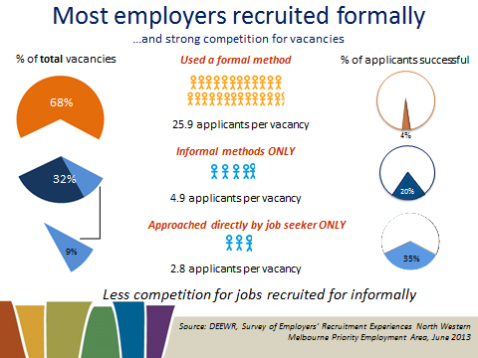

*Source: DEEWR, Survey of Employers’ Recruitment Experiences North Western Melbourne Priority Employment Area, June 2013*

68 per cent of vacancies in the North Western Melbourne PEA were recruited for through formal methods of recruitment (such as the Internet or Newspapers), receiving an average of 25.9 applicants per vacancy.

By contrast, one third (32 per cent) of vacancies were recruited for through informal methods only (such as word of mouth or approached by job seeker), receiving an average of just 4.9 applicants per vacancy.

Employers for some 9 per cent of vacancies relied solely on being approached directly by job seekers. For these vacancies there was an average of 2.8 applicants of whom 35 per cent were successful.

# Slide 31 Recruitment difficulty persisting

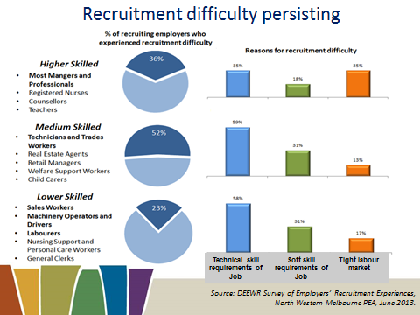

Source: DEEWR Survey of Employers’ Recruitment Experiences, North Western Melbourne PEA, June 2013.

Despite the strong competition for vacancies in the North Western PEA, almost one third of recruiting employers (31%) experienced recruitment difficulty.

For employers recruiting for higher skilled occupations, some 36% experienced recruitment difficulty. Finding applicants with the relevant technical skills (35%) and lack of applicants (35%) were the main reasons given for the difficulty in this category.

Employers recruiting for medium skilled occupations were most likely to experience recruitment difficulty (52% of recruiting employers). The main difficulty was finding applicants with the relevant technical skills (59%), although a lack of applicants with soft skills was also a common cause of difficulty (31%).

For employers recruiting for lower skilled occupations, while difficulty was less common, almost one quarter (23%) still experienced difficulty. Again, the main difficulties were finding applicants with the relevant technical skills (58%) and a lack of applicants with soft skills (31%).

# Slide 32 Expectations of staff increases persist across some industries

Expectations as to future recruitment, increase/decrease staff

Accomodation and food services 48%/1%
Health care and social assistance 32%/0%
Transport, postal and warehousing 21%/11%
Wholesale trade 20%/11%
Manufacturing 19%/22%
Hume LGA 20%/14%
North Western Melbourne PEA 22%/10%

*Source: DEEWR, Survey of Employers’ Recruitment Experiences, North Western Melbourne PEA, June 2013.*

Expectations for staff increases over the 12 months following the survey are encouraging in the North Western Melbourne PEA (22% of employers). Even though expectations have decreased since the March 2012 survey (34%), they demonstrate that employment opportunities will arise in some major industries. Expectations are strongest for the Accommodation and Food Services industry (48%) and the Health Care and Social Assistance industry (32%). In the Hume LGA future recruitment expectations are slightly lower (20%).

# Slide 33 Occupations employers commonly expect to recruit (in the 12 months following the survey)

|  |  |
| --- | --- |
| Higher (Bachelor or Higher) & Medium Skill Level(Certificate III to Associate Degree ) | |
| Registered Nurses | Enrolled and Mothercraft Nurses |
| Motor Mechanics | Child Carers |
| Lower Skill Level (Compulsory Secondary Education to Certificate II) | |
| Nursing Support and Personal Care Workers | |
| Bus and Coach Drivers | Aged and Disabled Carers |
| Kitchenhands | Bar Attendants and Baristas |
| Checkout Operator & Office Cashiers | Sales Assistants (General) |

*Source: DEEWR, Survey of Employers’ Recruitment Experiences, North Western Melbourne Priority Employment Area June 2013*

This slide shows the vacancies that employers most commonly expected to recruit for in the North Western Melbourne PEA in the 12 months following the survey.

Higher Skill Level (1) – Bachelor or Higher

Registered Nurses

Medium Skill Level (2 & 3) – Certificate IV to Associate Degree

Enrolled and Mothercraft Nurses

Motor Mechanics

Child Carers

Lower Skill Level (4 & 5) – Compulsory Secondary Education to Certificate III

Nursing Support and Personal Care Workers

Aged and Disabled Carers

Bus and Coach Drivers

Kitchenhands

Bar Attendants and Baristas

Checkout Operator & Office Cashiers

Sales Assistants

# Slide 34 Greatest concerns for the future (in the 12 months following the survey)

Greatest future concerns
Demand/ economy 49%
Other 21%
No concern 15%
Recruitment or retrenchment difficulty/ skills shortage 9%
Competition (including high Australian dollar) 6%

*Source: DEEWR, Survey of Employers’ Recruitment Experiences, North Western Melbourne Priority Employment Area June 2013*

By far the greatest future concern for employers was a downturn in the economy and demand for their services/products (49% of employers). Recruitment or retention difficulty/skill shortages were concerns for 9% of employers.

# Slide 35 Conclusion

* Labour market is subdued
  + Unemployment rate has remained steady over the last 12 months, but remains high
  + Decline in employment for some of the largest employing industries
  + Recruitment activity has decreased marginally
* What are the issues?
* Very strong population growth
* High intake of humanitarian migrants, and underutilisation of migrants more generally
* Local workforce more reliant on lower skilled employment but a decline in lower skilled jobs
* Opportunities
* Employment still growing in major employing industries such as Health and Education
* Recruitment difficulty persists with demand for some occupations still strong.
* Greater employment success if job seekers approach employers
* Employment across the broader Melbourne labour market
* Job seekers need to be job ready
* Experience
* Education/training
* Employability skills
* English proficiency

Collaboration amongst all key stakeholders and Local Employment Coordinator

# Slide 36 Further Information

**Please note – this presentation was produced in September 2013 by the former Department of Education, Employment and Workplace Relations (DEEWR). However, all links below are current and, where appropriate, will direct you to the new Department of Employment.**

If you have any questions about the presentation please contact the Employer Surveys Section or Recruitment Analysis Section on:

Tel: 1800 059 439 or

[Email](mailto:recruitmentsurveys@employment.gov.au): recruitmentsurveys@employment.gov.au

More information on labour market conditions and other research on small areas can be found on these web sites

[LMIP](http://www.employment.gov.au/LMIP): www.employment.gov.au/LMIP

[Skills Shortages](http://www.employment.gov.au/SkillShortages): www.employment.gov.au/SkillShortages

[Regional Reports](http://www.employment.gov.au/RegionalReports): www.employment.gov.au/RegionalReports

[Australian Jobs](http://www.employment.gov.au/australianjobs): www.employment.gov.au/australianjobs

[Job Outlook](http://www.joboutlook.gov.au/): www.joboutlook.gov.au

