# Australian Government Department of Employment logoLabour Market Conditions in Geelong

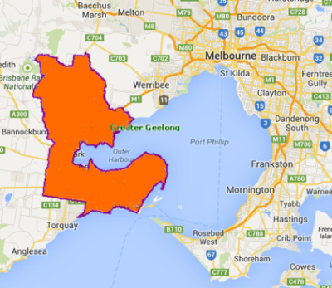Employment levels have been declining in Geelong over the past 12 months and the outlook remains uncertain with large scale redundancies announced at Alcoa and Ford.

* Total employment in Geelong has decreased by 3.2 per cent (3,800) in the past year.[1]
* The unemployment rate for Geelong currently stands at 8.4 per cent[2] compared with 6.4 per cent for Australia. [3]
* The participation rate has fallen from 59.5 per cent to 57.8 per cent in the past year suggesting that some job seekers have become discouraged and have given up looking for work. [4]

# What employers are telling us[5]

The survey results reflect the subdued and uncertain labour market conditions in Geelong. Nevertheless, the majority of surveyed employers had recruited in the 12 months prior to the survey, indicating that there are still opportunities available.

* Some 59 per cent of surveyed employers had recruited in the 12 months prior to the survey, which was in line with all regions (60 per cent). The annual vacancy rate (14.6 vacancies per 100 staff) was slightly lower than the average for all regions (16.0 vacancies per 100 staff).
* Only 2.0 per cent of vacancies remained unfilled, and fewer than one in three recruiting employers reported recruitment difficulty.
* Competition for vacancies advertised on the internet or in a newspaper was high (14.5 applicants per vacancy) and had increased slightly since the region was last surveyed (13.5 applicants per vacancy). The majority of applicants (75 per cent) did not get an interview, with employers citing a lack of relevant experience and insufficient qualifications or training as the most common reasons.
* Many employers reported a degree of uncertainty about their recruitment outlook with slightly more than half of employers (52 per cent) citing the ‘economy’ as being their single greatest future concern.

|  |  |  |  |
| --- | --- | --- | --- |
|  | June 2014 | September 2013 | All regions surveyed[6] |
| Annual vacancies per 100 staff | 14.6 | 13.4 | 16.0 |
| Unfilled vacancy rate (most recent recruitment round) | 2.0% | 2.6% | 3.7% |
| Recruitment difficulty (most recent recruitment round) | 31% | 31% | 35% |
| Average applicants per formally advertised vacancy [7] | 14.5 | 13.5 | 17 |

# Where are the opportunities?

* Despite the subdued labour market conditions, opportunities are still available in industries where recruitment activity is relatively high, such as Health Care and Social Assistance, Accommodation and Food Services and Retail Trade. Over the next 12 months many employers expect to continue to recruit for Waiters, Bar Attendants and Baristas, Chefs, Gaming Workers, General Clerks, Sales Assistants, Truck Drivers, Storepersons, Registered Nurses, Housekeepers, and Nursing Support and Personal Care Workers.

1. ABS, Labour Force Survey, July 2014 (3 month averages of original data)
2. ABS, Labour Force Survey, July 2014 (3 month averages of original data), Geelong SA4 (The Greater Geelong Local Government Area fits wholly within the Geelong SA4 and comprises 84 per cent of its Working Age Population)
3. ABS, Labour Force Survey, July 2014 (Seasonally adjusted)
4. ABS, Labour Force Survey, July 2014 (3 month averages of original data), Geelong SA4 (The Greater Geelong Local Government Area fits wholly within the Geelong SA4 and comprises 84 per cent of its Working Age Population)
5. Based on 408 responses from the Geelong *Survey of Employers’ Recruitment Experiences* undertaken in June 2014
6. Survey of Employers’ Recruitment Experiences, All regions surveyed in the 12 months to March 2014
7. For the purpose of this report a formally advertised vacancy is a vacancy advertised in a newspaper or on the internet.