# Australian Government Department of Employment logoLabour Market Conditions in the Pilbara

The Pilbara region, and Western Australia more generally, is transitioning rapidly from a construction phase in the Mining industry to a less labour-intensive production and export phase. To gain some insight into the impact of this transition on the labour market in the Pilbara region, the Department of Employment, as part of its *Surveys of Employers’ Recruitment Experiences,* interviewed 200 employers in April 2015. The survey results show that recruitment activity has slowed significantly since the region was surveyed in 2010.

Key findings
• Recruitment activity in the region has halved since 2010 with all industries affected
• Employers are now having considerably less difficulty filling vacancies
• Recruitment expectations for the year following the survey are subdued


## Mining investment and employment is falling

Over the past decade, economic and employment growth in the Pilbara region has been dominated by Mining investment, with projects valued at more than $100 billion completed, or nearing completion.[1] However, Mining investment across Australia fell by 19.6 per cent between 2012-13 and 2014-15 and is expected to fall a further 28.9 per cent in 2015-16 (see Chart 1).**[2]**

Chart 1: Mining investment in Australia ($billion – current prices)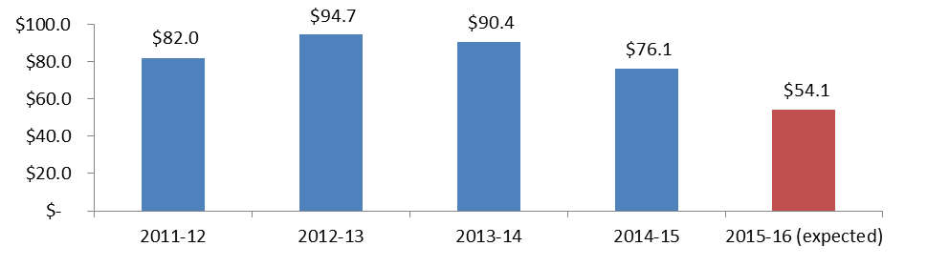

At the time of the 2011 Census, half of the jobs in the Pilbara region were in the Mining and Construction industries, an increase of more than 15,000 (or 136 per cent) compared with the 2006 Census (see Chart 2). Fly in-fly out (FIFO) arrangements were also common, with almost half of all people working in Mining and Construction in the Pilbara living outside of the region, and most of those residing in Greater Perth.[3]

### Chart 2: Employment by industry, Pilbara (place of work), 2006 and 2011

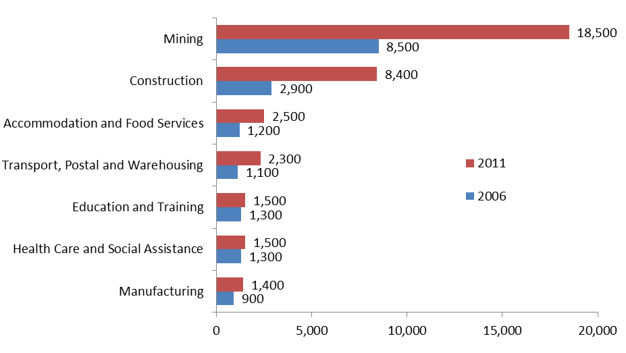

In the past 12 months, employment in the Mining industry has fallen by 4,200 in Western Australia Outback[4] and by 7,400 across Western Australia.[5] Employment in Mining is also projected to decrease by 6,000 in Western Australia Outback over the five years to November 2019.[6]

The decline in Mining investment has already impacted on the Pilbara region with the unemployment rate rising from 1.5 per cent to 3.1 per cent in the three years to June 2015.[7] While the unemployment rate in the Pilbara is still relatively low, the unemployment rate for Western Australia overall has increased from 3.5 per cent in June 2012 to 6.6 per cent in November 2015, suggesting that many ex-FIFO and Mining workers may now be contributing to higher unemployment in other parts of Western Australia.[8]

## Mining is a large employer of Indigenous residents

At the time of the 2011 Census, Mining was by far the largest employer of Indigenous residents in the Pilbara (43 per cent of all employed people). The current downturn in Mining investment and employment may limit the employment opportunities for Indigenous people entering the jobs market and, as a result, job seekers may need to look for opportunities in other industries, such as Health Care and Social Assistance.[9]

## Recruitment activity has halved since 2010[10]

The recruitment rate in the 12 months prior to the 2010 Pilbara survey was 79 vacancies per 100 staff. However, the recruitment rate has halved and in the 2015 survey stood at 39.

Recruitment activity has slowed across all industries (see Chart 3), with the largest decrease in demand for labour experienced by employers in the Construction industry (falling from 149 vacancies per 100 staff to 10 vacancies per 100 staff). Large falls in recruitment activity were also recorded for Wholesale Trade and Rental, Hiring and Real Estate Services (separate information is not available for the Mining industry).

### Chart 3: Annual vacancies per 100 staff (selected industries)

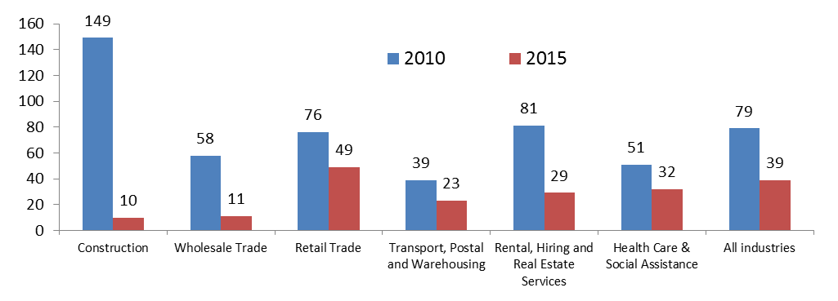

The proportion of employers surveyed in 2015 who had decreased staff in the previous 12 months (41 per cent) was more than four times higher than those who had increased staff (9 per cent).

* The Manufacturing and Construction industries had the highest proportions of employers who had decreased staff numbers in the past 12 months (70 per cent and 64 per cent respectively).

### Chart 4: Proportion of employers who increased and decreased staff in the past 12 months

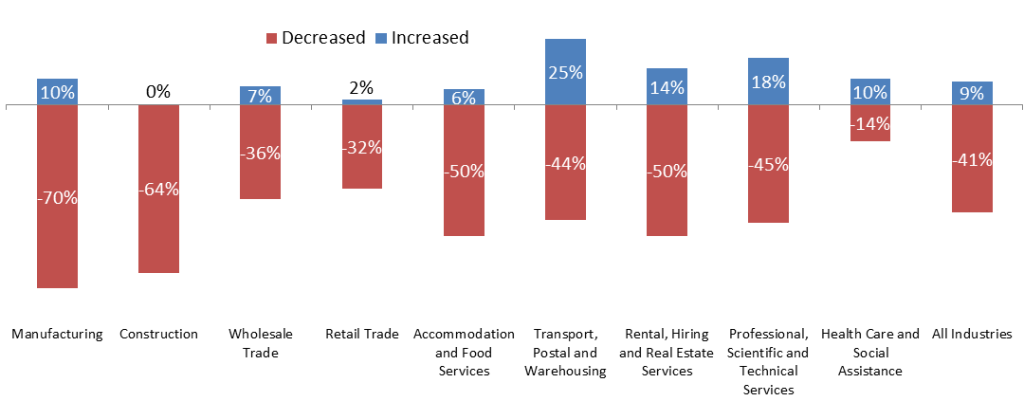

## Vacancies being filled more easily

Consistent with the decline in recruitment, the average number of applicants per vacancy has nearly doubled from 5 applicants per vacancy in 2010 to 9 applicants in 2015, while the proportion of employers reporting recruitment difficulty has fallen from 61 per cent to 31 per cent. In addition, only 2.4 per cent of vacancies remained unfilled in 2015 compared with 11.7 per cent in 2010.

## Table 1: Recruitment experiences in Pilbara

|  |  |  |  |
| --- | --- | --- | --- |
|  | Recruitment difficulty | Unfilled vacancy rate | Average no. of applicantsper vacancy |
| 2010 | 61% | 11.7% | 5 |
| 2013 | 43% | 6.4% | 6 |
| 2015 | 31% | 2.4% | 9 |

## Future recruitment expectations are subdued

Future recruitment expectations have softened considerably since 2010, with the proportion of employers expecting to recruit in the 12 months following the survey decreasing from 69 per cent in 2010 to 36 per cent in 2015.

* Some 20 per cent of employers expected to decrease staff numbers in the following 12 months, compared with only 2 per cent in 2010.
* The proportion of employers who were concerned about future skill shortages and recruitment difficulties decreased from 38 per cent in 2010 to 8 per cent in 2015.
* In the most recent survey, more than two thirds of employers reported that their greatest future concern was the economy.

## What does this mean for the Pilbara region?

While Mining production and export will remain an important part of the economy in the Pilbara and Western Australia more generally, significantly lower demand for labour in the Mining industry may result in labour market conditions easing further in the region. This may result in:

* A further reduction in job opportunities and increased competition for vacancies in the Pilbara region.
* A potential reduction in employment opportunities for Indigenous job seekers in the Pilbara region, which could have flow on effects to the communities in which they live.
* Ex-FIFO workers who are unemployed requiring assistance with finding employment and accessing training opportunities.

1. Deloitte Access Economics, *Investment Monitor, March 2013*
2. ABS, *Private New Capital Expenditure and Expected Expenditure*, June 2015
3. ABS, *Census of Population and Housing*, 2006 and 2011
4. Western Australia Outback region includes all of Western Australia except Greater Perth, Bunbury and Wheat Belt.
5. ABS, *Labour Force Survey,* August 2015 (4 quarter average of original data)
6. Department of Employment, *Employment projections for five years to November 2019*
7. Department of Employment, *Small Area Labour Markets,* June 2015
8. ABS, *Labour Force Survey,* November 2015 (Seasonally adjusted)
9. ABS, *Census of Population and Housing*, 2011
10. Based on responses from the Pilbara *Survey of Employers’ Recruitment Experiences* undertaken in August 2010, November 2013 and April 2015