



Evaluation of jobactive

Interim Report

**Evaluation Team**

James Backhouse

Lixin Cai

Robin Collins

Justin Connor

Joanne Evans

Anthony Flint

Akash Halder

Patrick Hamshere

Stephen Howe

Christina Jankovic

Bethany Jones

Mark Jones

Yusuf Muharram

Mai Pham

Robyn Shannon

Zlatko Spralja

Emily Wu

ISBN

978-1-76051-856-1 [PDF]

978-1-76051-857-8 [DOCX]

Creative Commons

With the exception of the Commonwealth Coat of Arms, the Department’s logo, any material protected by a trade mark and where otherwise noted all material presented in this document is provided under a [Creative Commons Attribution 3.0 Australia](http://creativecommons.org/licenses/by/3.0/au/) (http://creativecommons.org/licenses/by/3.0/au/) licence.

The details of the relevant licence conditions are available on the Creative Commons website (accessible using the links provided) as is the full legal code for the [CC BY 3.0 AU licence](http://creativecommons.org/licenses/by/3.0/au/legalcode) (http://creativecommons.org/licenses/by/3.0/au/legalcode).

The document must be attributed as *Evaluation of* *jobactive Interim Report*.

Contents

List of figures 5

List of acronyms 6

Executive summary 7

Background 7

Evaluation approach 7

Improved job seeker activation, due to a stronger compliance framework 8

Labour market outcomes for job seekers are mixed 9

Regulatory and administrative burden reduced 12

Conclusion 12

1. Introduction 14

1.1 Government-funded employment services in Australia 14

1.2 jobactive objectives 15

1.3 The jobactive service model: key features and differences from JSA 2012 17

1.4 Labour market conditions were slightly weaker in the jobactive study period than the JSA 2012 study period 26

1.5 Evaluation approach and methodology 28

1.6 Report structure 31

2. Job seekers are more engaged under jobactive 32

2.1 The relationship between the number of unemployed, and new entrant and caseload job seekers in employment programs 33

2.2 Job seekers were generally quicker to commence under jobactive 34

2.3 Changes to Mutual Obligation Requirements and the compliance framework have affected job seeker behaviour 37

2.4 Job seeker servicing 48

3. Effectiveness of jobactive at assisting job seekers to achieve labour market outcomes 53

3.1 Outcome measures and job seeker populations used in this evaluation 54

3.2 Results on the effectiveness of jobactive for new entrants are mixed 57

3.3 jobactive is more effective than JSA 2012 for caseload (longer term unemployed) job seekers 61

3.4 jobactive Work for the Dole phase is more effective than the comparable JSA 2012 phase at assisting job seekers to achieve labour market outcomes 66

4. Regulatory and administrative burden and provider collaboration 74

4.1 Regulatory and administrative burden in employment services 74

4.2 Estimated regulatory and administrative burden decreases from JSA to jobactive 75

4.3 Provider perceptions of regulatory and administrative burden largely correspond with the estimations 77

4.4 Findings on regulatory and administrative burden have policy and program implications 80

4.5 Providers are sceptical of collaboration in a competitive market 81

5. Conclusion 82

5.1 Job seeker engagement has improved under jobactive, when compared with JSA 2012 82

5.2 At the program level, the effectiveness of jobactive in achieving labour market outcomes was mixed 82

5.3 Regulatory and administrative burden reduced, but still perceived to be high 83

5.4 Summary 83

5.5 Further research 84

References 85

Appendix A Statistical tables 87

Appendix B Phases in jobactive and JSA 2012 96

Appendix C Administration fees in jobactive and JSA 2012 97

Appendix D Construction of comparison job seeker groups — methodology 98

Appendix E Placements and outcomes under JSA 2012 and jobactive 99

Appendix F Methodology used in analysing effectiveness of jobactive 100

Appendix G Effectiveness of jobactive at assisting job seekers to achieve labour market outcomes — raw (unadjusted) rates compared with adjusted rates 101

Appendix H New entrant program exit results, when not applying the additional exclusion criteria 108

Appendix I Indigenous Outcomes Targets 110

Appendix J Propensity-matched job seeker analyses in the jobactive Work for the Dole phase 112

List of tables

Table 1.1: Other Employment portfolio programs 16

Table 1.2: Full outcome payments and job placement payments for employment in non-regional locations 22

Table 1.3: Summary of main changes between jobactive and JSA 2012 24

Table 2.1: Time from registration to service commencement for caseload population 37

Table 2.2: Attendance rates by appointment type in the six months after caseload dates (1 October 2012 for JSA 2012 and 1 October 2015 for jobactive) 41

Table 2.3: Job seeker participation in activities in the six months after caseload dates (1 October 2012 for JSA 2012 and 1 October 2015 for jobactive) 45

Table 2.4: Job seeker perceptions of job search requirements by actual job search requirement 47

Table 3.1: Stream distribution of jobactive new entrant job seekers 57

Table 3.2: Percentage of new entrant job seekers who exited within six months of commencement (adjusted) 59

Table 3.3: Difference in the average adjusted income support dependency rate at six months from commencement 60

Table 3.4: Caseload study population total numbers and by stream 61

Table 3.5: Percentage of job seekers who exited within six months of the caseload snapshot date (adjusted) 63

Table 3.6: Difference in the average adjusted income support dependency rate at six months from caseload date 66

Table 3.7: Job seeker requirements in the Work Experience phase of JSA 2012 and the Work for the Dole phase of jobactive during the interim report analysis period 68

Table 3.8: Work for the Dole phase and Work Experience phase study population characteristics 69

Table 3.9: Percentage of job seekers who exited within six months of the caseload snapshot date — Work Experience and Work for the Dole phases 72

Table 3.10: Difference in the average adjusted income support rate at six months from caseload date — Work for the Dole phase versus Work Experience phase 73

Table 4.1: Annual compliance cost estimates under each contract by activity 75

Table A1: New entrant study population characteristics 88

Table A2: Caseload study population characteristics 91

Table A3: Work for the Dole phase and Work Experience phase study population characteristics 93

Table C1: Administration fees of jobactive 97

Table C2: Service fees in JSA 2012 97

Table E1: Placements and outcomes under JSA and jobactive 99

Table G1: Percentage of new entrant job seekers who exited within six months of commencement 103

Table G2: Percentage of job seekers who exited within six months of the caseload snapshot date 105

Table G3: Percentage of job seekers who exited within six months of the caseload snapshot date — Work Experience and Work for the Dole phases 107

Table H1: Percentage of new entrant job seekers who exited within six months of commencement, including job seekers not on income support. 109

Table I1: Indigenous Outcomes Targets 1 July 2015 – 31 December 2015: Performance Period 1 111

Table I2: Indigenous Outcomes Targets 1 January 2016 – 30 June 2016: Performance Period 2 111

# List of figures

Figure 1.1: Unemployment and participation rates in Australia (seasonally adjusted) 27

Figure 1.2: Internet job advertisements and job placements by employment services 28

Figure 2.1: Size of the caseload and new entrant population and the number of unemployed people 33

Figure 2.2: Time from registration to commencement for caseload populations 36

Figure 2.3: Non-attendance without a valid reason by appointment type in the six months after caseload dates (1 October 2012 for JSA 2012 and 1 October 2015 for jobactive) 42

Figure 2.4: Re-engagement after non-attendance of an appointment without a valid reason in the six months after caseload dates (1 October 2012 for JSA 2012 and 1 October 2015 for jobactive) 43

Figure 2.5: Job seeker improvements (self-reported) — most recent activity 46

Figure 2.6: Providers perceived benefits of Service Delivery Plans 49

Figure 2.7: Three statements which best describe how job seekers are serviced by stream 50

Figure 2.8: Site specialist staff roles as a proportion of all specialist staff 52

Figure 3.1: Monthly numbers of placements, program and income support exits (rolling three-month average) 55

Figure 3.2: Cumulative exit rates for new entrant job seekers 58

Figure 3.3: Cumulative exit rates — caseload 62

Figure 3.4: Cumulative exit rates — Work for the Dole phase and Work Experience phase 70

Figure 4.1: Annual compliance cost estimates under each contract by activity 77

Figure 4.2: Net agreement by providers on administrative activities being unnecessarily complex, time consuming and repetitive 78

Figure G1: Cumulative exit rates for new entrant job seekers 102

Figure G2: Cumulative exit rates — caseload 103

Figure G3: Cumulative exit rates — Work for the Dole phase and Work Experience phase 106

Figure H1: Cumulative exit rates for new entrant job seekers, including job seekers not on income support 108

# List of acronyms

|  |  |
| --- | --- |
| ABS | Australian Bureau of Statistics |
| CoB | Country of birth |
| DEEWR | Department of Education, Employment and Workplace Relations |
| DHS | Department of Human Services |
| DSP | Disability Support Pension |
| EF | Employment Fund General Account |
| EPF | Employment Pathway Fund |
| ESA | Employment Services Area |
| ESAt | Employment Services Assessment |
| ESS | Employment Services System |
| JCA | Job Capacity Assessment |
| JSA | Job Services Australia |
| JSA 2009 | JSA contract period from 1 July 2009 to 30 June 2012 |
| JSA 2012 | JSA contract period from 1 July 2012 to 30 June 2015 |
| JSCI | Job Seeker Classification Instrument |
| MOR | Mutual Obligation Requirement |
| NAR | Non-Attendance Report |
| NSA | Newstart Allowance |
| OBPR | Office of Best Practice Regulation |
| PAR | Provider Appointment Report |
| TtW | Transition to Work  W |
| YA(O) | Youth Allowance (Other) |

# Executive summary

This interim evaluation provides evidence on the effectiveness of the jobactive program during its first year of operation. The analyses of the early results suggest that jobactive has improved job seekers’ engagement as measured by the time taken from registration to commencement in services, attendance at appointments and reconnection to services after missing an appointment. The evidence suggests that for the most disadvantaged job seekers (e.g. the long-term unemployed or Stream B and C job seekers) jobactive is more effective in helping them achieve labour market outcomes than was its predecessor Job Services Australia (JSA) 2012. Further analysis is required to confirm whether this pattern of results holds true when more data becomes available.

## Background

The jobactive program is an Australian Government-funded labour market program that commenced on 1 July 2015. Replacing the previous JSA program, jobactive is part of the Government’s commitment to promote stronger workforce participation among people of working age, and to help more job seekers move from welfare to work. In order to fulfil this commitment, jobactive was designed to (Department of Employment 2015a):

* ensure that job seekers better meet the needs of employers
* increase job seeker engagement by introducing stronger Mutual Obligation Requirements (MORs)
* increase job outcomes for unemployed Australians
* reduce prescription and red tape for service providers.

This interim evaluation report is intended to provide an assessment of the program’s early effectiveness by examining:

1. job seekers’ activation through engagement in services and activities
2. labour market outcomes of job seekers
3. reduction in regulatory and administrative burden experienced by jobactive providers.

This interim evaluation does not attempt to assess comprehensively the performance of jobactive because of limitations of the data available at the time it was conducted. Subsequent jobactive evaluation reports will take advantage of the availability of more data and will provide more detailed analysis on the performance of the program.

## Evaluation approach

The evaluation approach taken in the report involved a comparison of jobactive with its predecessor employment services model, JSA 2012. Due to the universal nature of the program, it was not possible to evaluate the effect of jobactive in an absolute sense, such as by a net impact analysis.

The **comparative approach** was based on two complementary study populations of job seekers from JSA 2012 and jobactive, a new entrant population and a caseload population from each program. Data was drawn from administrative data from the Department of Employment (the Department)[1]. The **new entrant populations** consisted of job seekers who were new to employment services or who had commenced a new period of service between 1 October 2012 and 31 December 2012 for JSA 2012, and between 1 October 2015 and 31 December 2015 for jobactive. The **caseload populations** consisted of all job seekers in those employment services on 1 October 2012 for JSA 2012 and 1 October 2015 for jobactive. The analyses examined outcomes that were achieved over a six-month period from a job seeker’s commencement with either jobactive or JSA 2012 (in the case of the new entrant population) or from the caseload snapshot date (in the case of the caseload population).

For the purpose of analysing for program effects, it is preferable to study new entrant populations as their outcomes can be attributed more confidently to the effects of the current program. However, by definition new entrants are short-term unemployed job seekers (examined for their first six months in services) so, in order to examine the effectiveness of jobactive at supporting longer term unemployed job seekers into the labour market, caseload populations were also used.

When assessing the effectiveness of jobactive, statistical techniques have been used to calculate ‘adjusted’ measures that take into account differences between the two programs in job seeker characteristics and the unemployment rate as a measure of labour market conditions.

The evaluation has also drawn on surveys and qualitative fieldwork conducted with job seekers and providers and designed to assess their experiences and perspectives of jobactive. The Job Seeker Experiences of Employment Services (JSEES) survey, conducted in February 2016, explored the experience of job seekers in the early jobactive period. Qualitative and quantitative research was undertaken with jobactive providers between November 2015 and June 2016. Many of the issues raised in these pieces of research typify those encountered when transitioning from one employment services model to another. A number of these issues have been addressed by subsequent policy and operational changes. Employer opinions and experiences with jobactive will be analysed in future reporting.

## Improved job seeker activation, due to a stronger compliance framework

Several aspects of job seeker engagement appeared to perform more strongly under jobactive, compared to JSA 2012.

The time from registration to commencement in services for most job seekers was reduced in jobactive relative to JSA 2012. The majority of job seekers commenced in jobactive and JSA 2012 through RapidConnect, which is designed to streamline the commencement process for job-ready job seekers[2]. When compared with JSA 2012, job seekers in jobactive who were eligible for RapidConnect were slightly quicker to commence in employment services. Job seekers who were not eligible for RapidConnect took longer to commence under jobactive.

The appointment attendance rate increased under jobactive. Fewer job seekers failed to attend an appointment without a valid reason, and job seekers reconnected to services more quickly after missing an appointment. This indicates that the more stringent compliance framework applying to the jobactive cohort, as compared to that applying to the JSA 2012 cohort, may be impacting job seekers’ behaviour.

A higher number and proportion of the jobactive caseload were participating in an activity compared to the JSA 2012 caseload, reflecting increased activity requirements. Forty-four per cent of the jobactive caseload was participating in an activity, compared 34 per cent for JSA 2012. There was a substantial increase in participation in activities including Work for the Dole, employment and work experience in jobactive compared to JSA 2012.

A smaller proportion of job seekers participating in an activity undertook education or training in jobactive compared with JSA 2012. This reflected tighter rules for the funding of training and education for job seekers under jobactive than under JSA 2012.[3] These tighter training and education rules may have contributed to the difficulties experienced by the 45 per cent of respondents in the Provider Survey. This group agreed that addressing job seeker barriers was harder under jobactive than it was under JSA 2012.

Providers were largely supportive of the jobactive compliance framework and felt it provided them with more opportunity to reinforce MORs with participants. While the vast majority of job seekers surveyed felt well informed about what they needed to do to satisfy their MORs, about 40 per cent reported having had their income support suspended at some time.[4]

There is evidence of changes in servicing models from JSA 2012, with a shift away from case management to ‘rainbow’ servicing[5] and more group-based and open-plan servicing of job seekers. While the majority of job seekers (70 per cent) were satisfied with the services they received from jobactive providers, those who met in a group environment, or in open or shared spaces, were more likely to report being dissatisfied.

## Labour market outcomes for job seekers are mixed

Over the first financial year of operation, about 1.35 million job seekers were referred to the jobactive program and there were just over 346,000 job placements. For the first financial year of JSA 2012 about 1.42 million job seekers were referred and there were just over 355,000 job placements in total.

Three measures were used in this interim evaluation as proxies to assess the relative effectiveness of jobactive in assisting job seekers to achieve labour market outcomes: exit from income support; exit from employment service programs, and reduction in income support dependency.[6]

At the program level the results for the effectiveness of jobactive depended on the study populations used.

### The effectiveness of jobactive for new entrant job seekers is mixed compared to JSA 2012

Results from the analysis of new entrant job seekers show that jobactive was less effective overall at supporting job seekers to achieve labour market outcomes than was JSA 2012. This largely reflects a reduction in effectiveness for Stream A job seekers, who made up over 85 per cent of the new entrant populations. The adjusted income support exit rate and program exit rate are 2.8 percentage points and 1.0 percentage points lower respectively, and income support dependency is 2.4 percentage points higher for jobactive job seekers than for JSA 2012 job seekers.

When broken down by streams, jobactive was shown to have achieved higher exits from both program and income support for Stream B and C job seekers (more disadvantaged job seekers), but lower exit rates for Stream A job seekers.[7]

Results are mixed for other categories of new entrant job seekers examined (e.g. comparing outcomes for Indigenous with non-Indigenous job seekers, male with female job seekers, or job seekers under 25 years of age with those over 50).

### jobactive is more effective than JSA 2012 for the caseload (longer term unemployed) job seekers

For caseload job seekers, jobactive was more effective than JSA 2012 in helping achieve labour market outcomes for all of the following indicators: income support exits, program exits and income support dependency. It should be noted that the majority of caseload job seekers were transitioned from the preceding program. The adjusted rates of exits from income support and from the employment service program were 1.7 percentage points and 4 percentage points higher for jobactive than for JSA 2012. The income support dependency rate at the end of the six-month period was 1.5 percentage points lower under jobactive than under JSA 2012.

When broken down by streams, jobactive was most effective for Stream A caseload job seekers, followed by Stream C, compared to JSA 2012. While jobactive was more effective than JSA 2012 for all key job seeker categories (i.e. gender, age and Indigenous status), for all three indicators, the relative improvement varies across different categories of job seekers.

Compared with JSA 2012, the incentive structure under jobactive provides more rewards for employment outcomes overall, and makes the highest payments for employment outcomes for the most disadvantaged job seekers (as defined by stream and length of unemployment). There are no longer payments for job placements. This could, at least to some extent, explain why jobactive was more effective than JSA 2012 for the caseload job seeker populations which consisted mainly of long-term unemployed people. It could also explain why, for the new entrant populations, jobactive was more effective than JSA 2012 for Stream B and C job seekers, but less effective for Stream A job seekers.

Another factor that could have influenced the positive outcomes of jobactive for the caseload job seekers is differences in transition from the respective previous contracts. Job seekers were required to complete a new Job Plan when transitioning from JSA 2012 to jobactive, which was not required of job seekers transitioning from JSA 2009 to JSA 2012. Additionally, fewer providers continued from JSA 2012 to jobactive, when compared with the transition from JSA 2009 to JSA 2012, meaning more job seekers were required to transfer to a new provider. These changes, and a renewed focus on getting work, could have increased the exit rates for jobactive.

A new Job Seeker Classification Instrument (JSCI) point structure was introduced with jobactive and restreaming of job seekers was necessary because the number of streams was reduced from four (under JSA) to three (under jobactive). In jobactive Stream A is for more job-ready job seekers, who in JSA would have either been in Stream 1 or Stream 2. Stream B is for less job-ready job seekers, who in JSA would have either been in Stream 2 or Stream 3. Stream C is for job seekers with multiple complex barriers to work who would have been allocated to Stream 4 in JSA.

In order to compare job seeker populations for analysis used in this report, the evaluators determined the jobactive equivalent stream of job seekers who were in JSA 2012. Some job seekers who were in Streams 2 and 3 in JSA 2012 would have been streamed to Stream A had they been assessed under the jobactive model. Stream 2 and 3 job seekers under JSA 2012 attracted higher outcome payments and administrative fees than are paid for Stream A job seekers in jobactive. Providers were therefore better incentivised to service these particular job seekers under JSA 2012. This could be another reason why jobactive is less effective than was JSA 2012 for new entrant Stream A job seekers.

Under jobactive providers can claim paid outcomes for Stream A job seekers significantly earlier (i.e. when job seekers are placed in a job after having been in services for at least three months) than they could under JSA 2012 (i.e. when job seekers were place in a job after having been in services for at least 12 months). It might therefore be expected that jobactive would show more positive results for Stream A job seekers. While this is evident for the caseload job seekers, jobactive does not appear to be more effective for new entrant job seekers in Stream A. Therefore, further investigation is required to explain these inconsistent patterns of results.

Fieldwork research results show that jobactive providers in general support the principle of outcome-based funding, although they do have concerns about the long-term viability of the model. They also have concerns regarding job seeker streaming for certain categories of job seekers, particularly ex-offenders / pre-release prisoners; long-term / very long-term unemployed; job seekers with low English proficiency; and Aboriginal and Torres Strait Islander job seekers.

### jobactive achieves higher labour market outcomes for the activity phase than JSA 2012

The effectiveness of the Work for the Dole phase of jobactive was evaluated by comparing income support exit rates, program exit rates and income support dependency rates with those achieved under the Work Experience phase, the most comparable program element of JSA 2012. Despite differences in design and implementation, both phases of the programs entailed compulsory activities of an extended duration and intensity designed to increase work skills and, as a result, were comparable.

The analysis indicated that the Work for the Dole phase of jobactive was more effective overall in assisting job seekers to obtain employment outcomes than was the Work Experience phase of JSA 2012. In particular, the adjusted exit rates from income support and the programs were 1.6 percentage points and 3.9 percentage points higher respectively in jobactive’s Work for the Dole phase than in JSA 2012’s Work Experience phase.

The relative effectiveness of the general caseload population and jobactive’s Work for the Dole phase was largest for more job-ready (Stream A) job seekers but varied among other job seeker categories.

At the time of this study, the jobactive Work for the Dole phase started after six months in services for Stream A job seekers and for Stronger Participation Incentives (SPI) job seekers in Stream B, in contrast to 12 months for JSA 2012 job seekers. It is possible that jobactive’s Work for the Dole phase included a larger group of shorter term unemployed, who had the capacity to leave services more easily by either finding work and/or declaring income, than did the JSA 2012 Work Experience phase. However, when the long-term and very long-term unemployed were analysed separately the patterns of results are similar, suggesting that the effectiveness of the Work for the Dole phase was not driven by there being more short-term unemployed job seekers in the Work for the Dole phase than in the Work Experience phase.

## Regulatory and administrative burden reduced

New system tools and a less prescriptive employment services model, involving provider-designed bespoke Service Delivery Plans, were introduced with jobactive. The objectives of this were twofold: to reduce the regulatory and administrative burden for providers and to enhance the flexibility and adaptability of providers’ service provision. Balancing accountability with the need to lower the administrative burden on providers and other stakeholders as far as possible is a management challenge within jobactive.

Research shows that the estimated cost of regulatory and administrative burden has declined by 24.0 per cent between JSA 2012 ($259.3 million) and jobactive ($197.1 million). This reduction has affected providers principally, with an estimated annual regulatory and administrative burden cost to them declining from $219.2 million (JSA 2012) to $143.9 million (jobactive). The regulatory and administrative burden for employers, however, increased from $30.4 million to $49.1 million. This was primarily due to changes requiring Work for the Dole Host organisations and employers to provide updates on job seeker participation in activities.

Despite reductions in the overall estimated regulatory and administrative burden under jobactive, the burden in employment services overall remains significant. In the Employment Services Providers Survey 2017 and qualitative fieldwork, providers claimed that organising Work for the Dole activities and administering the Annual Activity Requirements were unnecessarily complex, time consuming and repetitive administrative activities.[8] The administrative burden imposed by the Department may be overstated, however, as providers may merge departmental administrative requirements with their own administrative demands.

## Conclusion

The interim evaluation of the first year of operation of jobactive suggests that the program was more effective than was its predecessor JSA 2012 at improving a job seeker’s engagement in services and in helping the most disadvantaged job seekers (that is, the long-term unemployed or Stream B and C job seekers) achieve labour market outcomes.

Due to the limitations of the data available for this interim evaluation, care should be taken in interpreting the results. The interim evaluation was based on relatively short study periods, making the identification of patterns in program effectiveness difficult to identify with a high degree of confidence. The final evaluation will examine overall program outcomes, including sustainability of achieved outcomes and the impact of program components.

# Introduction

## Government-funded employment services in Australia

Since 1946, successive government agencies (i.e. the Commonwealth Employment Service and its successors) have administered employment services programs on behalf of the Government, targeted primarily at job seekers receiving income support payments. This arrangement was changed with the introduction of the Job Network model in May 1998 when the delivery of employment services was outsourced to government-funded non-government organisations and private businesses. This arrangement remains a defining element of the current employment services program, jobactive.

The Job Network was a national arrangement of community and private organisations contracted to work with eligible job seekers to help them obtain employment. On 1 July 2003, as part of the Job Network contract, the Active Participation Model was introduced to provide a continuum of assistance to ensure that job seekers had uninterrupted employment services. It replaced the previous arrangements where a job seeker was often referred to different Job Network members for each phase of assistance with a model where job seekers were serviced by a single provider throughout their period of unemployment. In addition, it defined a set of services which increased in intensity as the duration of unemployment increased. The model aimed to provide a more flexible framework for the delivery of employment assistance and extended employment services to a broader range of job seekers.

A review of employment services undertaken by the former Department of Education, Employment and Workplace Relations in 2008 (DEEWR 2008) found that the Job Network was unsuccessful in providing job seekers with adequate servicing and was not addressing the gap between job seeker skills and employer needs. On 1 July 2009, the Job Services Australia (JSA 2009) model was introduced by the Government in order to provide better tailored, individual services in line with assessed job seekers’ level of disadvantage, as well as skills and training appropriate for the labour market. On 1 July 2012, the JSA model was extended to 30 June 2015 by a second contract (JSA 2012).

In 2013 DEEWR called for public submissions on the operation of JSA 2009 (DEEWR 2013). Feedback from employment service providers, job seekers, employers and other stakeholders highlighted a number of areas where employment services could be improved. Responses indicated that JSA:

* was unnecessarily complex and prescriptive
* no longer met the expectations of employers, job seekers or the community
* needed to be more responsive, flexible and focused on achieving employment outcomes.

In addition, the survey data collected by DEEWR showed that the proportion of employers using JSA providers had dropped from 18 per cent in 2007 to around 7 per cent in 2012[9]. Employers in general indicated that they were discouraged by the lack of skills and work-readiness of job seekers referred to them by JSA providers. The amount of ‘red tape’ (i.e. regulatory and administrative burden) involved discouraged employers from using JSA providers to source workers. This feedback from stakeholders was instrumental in the design of a new employment services model, jobactive.

## jobactive objectives

The jobactive program was introduced on 1 July 2015. According to the Request for Tender for Employment Services 2015–2020 (Department of Employment 2014a), jobactive is designed to:

* ensure that job seekers are job-ready and better meet the needs of employers
* introduce stronger Mutual Obligation Requirements (MORs) to encourage a work-like culture for job seekers
* increase job outcomes for unemployed Australians, including specific targets for Indigenous job seekers
* reduce service prescription and minimise red tape for stakeholders.

Under jobactive, providers deliver services according to the jobactive deed and their own Service Delivery Plan, with flexibility to respond to the needs of individual job seekers.

The Government indicated it would invest around $6.3 billion over four years from 1 July 2015 in jobactive. The five components of services that are delivered are:

* jobactive providers to assist eligible job seekers to find and keep a job and ensure that employers are provided with job seekers who meet their business needs
* Work for the Dole Coordinators to source suitable Work for the Dole activities in not‑for‑profit and government organisations to help prepare job seekers for the work environment[10]
* the New Enterprise Incentive Scheme to assist eligible job seekers to start and run their own small business
* Harvest Labour Services to help growers supplement local labour with out-of-area workers
* National Harvest Labour Information Service to provide national coordination and dissemination of information regarding harvest-related work opportunities across Australia.[11]

Other employment services programs and initiatives, administered by the Department, are complementary to jobactive and are designed to assist a wide range of targeted job seekers, especially the most disadvantaged groups of job seekers. Table 1.1 below shows some of these other complementary programs.

While these complementary programs are the subject of separate evaluations, and are out of the scope for this evaluation, they are likely to interact with jobactive and consequently impact on the performance of jobactive.

Table 1.1: Other Employment portfolio programs

| **Incentives and schemes** | **Implementation timeframe** | **Targeted group** |
| --- | --- | --- |
| Relocation Assistance to Take up a Job Program | 1 July 2014 – Current | To encourage labour mobility by assisting long-term unemployed people to relocate to take up ongoing work. |
| Job Commitment Bonus | 1 July 2014 – 31 December 2016 | To encourage long-term unemployed young Australians to find and keep a job by offering a payment for remaining in work and off income support. |
| Tasmanian Jobs Programme | 1 January 2014 – 30 June 2016 | To provide financial incentive to any Tasmanian business that employs eligible job seekers for a period of at least six months. |
| National Work Experience Programme | 1 October 2015 – Current | To allow job seekers aged 18 years and over to undertake unpaid work experience where there is a likelihood of employment. |
| Transition to Work (TtW) | February 2016 – 30 June 20201 | Providing intensive and pre-employment support to help young people aged 15–21 to improve their work‑readiness and help them into work or education. |
| Empowering YOUth Initiatives | April 2016 – April 20192 | Initiatives to support new, innovative approaches to help unemployed young people aged 15–24 to improve their skills and move toward sustainable employment. |
| ParentsNext | 4 April 2016 – Current3 | To help parents of young children to identify their education and employment goals, develop a pathway to achieve their goals and link them to activities and services in the local community. |
| Youth Jobs PaTH | 1 April 2017 – 30 June 20204 | To support young people under the age of 25 years to gain the employability skills and real work experience they need to get and keep a job, and provide incentives for employers to take them on, including providing employability skills training, internship placement and a youth wage subsidy. |
| Career Transition Assistance | 2 July 2018 to Current5 | To provide practical assistance for mature-age job seekers to help them gain the contemporary skills they need to move into ongoing employment. Eligible job seekers will be referred to Tailored Career Assistance, Functional Digital Literacy, or both, depending on their needs. |

**Notes:**

1. The Transition to Work (TtW) services commenced from February 2016 in seven employment regions, with rolling commencements in the remaining employment regions up until April 2016. TtW Deeds operate to 26 June 2020, with an option to extend for a further two years to 24 June 2022.
2. The Empowering YOUth Initiative comprises two rounds. The first round commenced in April 2016 and the second round commenced in April 2017. Both rounds are two years in duration.
3. ParentsNext operated in 10 locations from April 2016 to 30 June 2018. It expanded nationally from 2 July 2018.
4. Youth Jobs PaTH has three components: Employability Skills Training (commenced April 2017), Internship Placements (commenced April 2017) and a Youth Bonus Wage Subsidy (commenced January 2017).
5. Career Transition Assistance became available under trial arrangements in five Employment Regions across Australia from July 2018. It will be available nationally from July 2019.

## The jobactive service model: key features and differences from JSA 2012

#### This subsection explains key features of the jobactive service model as it operated from 1 July 2015 to 30 June 2016, and, where applicable, how these compare with the JSA 2012 model. Table 1.3 (located at the end of this subsection) summarises the key differences between the models.

#### Job seeker eligibility

Job seekers eligible for the full range of jobactive provider services are:

* people who are subject to MORs and are receiving Newstart Allowance (NSA), Youth Allowance (Other) (YA(O)), Special Benefit (specific cohorts) or Parenting Payment. Recipients of these payments who are principal carer parents and people with a partial capacity to work have reduced MORs.
* Disability Support Pension (DSP) recipients aged under 35 years with a work capacity of eight or more hours per week (without a youngest child under six years) with compulsory participation requirements
* other categories of eligible job seekers, including New Zealand non-protected Special Category Visa holders eligible for NSA or YA(O); pre-release prisoners; and job seekers affected by industry restructuring under a Labour Adjustment Package (LAP) or Structural Adjustment Package (SAP).

To promote labour market participation, job seekers not eligible for the full range of services can volunteer into service. These job seekers receive once only time-limited services of up to six months. jobactive providers assist volunteer job seekers as if they were Stream A participants to improve their employability skills by helping them understand the skills and attributes local employers need, build their résumé and look for jobs, and showing them how to access self-help facilities. Eligible volunteer job seekers include those who are:

* on income support and do not have compulsory MORs (e.g. Parenting Payment recipients with a youngest child aged under six, Carer Payment recipients, Age Pensioners or Disability Support Pension recipients without participation requirements), or
* full-time students seeking an Apprenticeship or Traineeship, or
* not on any type of income support and who are not:
  + full-time students
  + working in paid employment for 15 hours or more per week
  + overseas visitors on working holiday visas or overseas students studying in Australia
  + prohibited by law from working in Australia.

Volunteers are out of the scope of this evaluation.

#### Streaming of job seekers

Under jobactive, job seekers are placed into one of three streams (Stream A, B or C) based on their relative level of disadvantage in gaining and maintaining employment. This is determined using the Job Seeker Classification Instrument (JSCI) and the identification of any serious non-vocational issues that a job seeker may have (as indicated by an Employment Services Assessment (ESAt)).

Job seekers are assigned ‘points’ according to their answers to the questions in the JSCI questionnaire. The questions relate to factors that correlate with disadvantage in the labour market. The JSCI assessment also indicates if the job seeker has disclosed multiple and/or complex barriers to employment that may require further assessment through an ESAt.

The ESAt is used to identify an individual’s barriers to finding and maintaining employment, work capacity and interventions or assistance that may be of benefit to improve work capacity. The ESAt process ensures that disadvantaged job seekers are referred to the most appropriate assistance.

Stream A is for the most competitive job seekers, who require minimal assistance to find work. Stream B is for job seekers who have vocational issues and need assistance to become work-ready. Stream C is for the most disadvantaged job seekers, who may have a combination of vocational and non-vocational barriers to employment. Job seekers are allocated to Stream A or B based on their JSCI scores. ESAt assessments determine whether a job seeker is allocated to Stream C (Department of Employment 2016a).

The main difference in job seeker streaming between jobactive and JSA 2012 is the number of streams; there were four streams in JSA 2012 (Streams 1–4) compared to three streams in jobactive (Streams A–C). The lower number of streams under jobactive was designed to reduce the complexity of the system for providers and to reduce administrative burden (Department of Employment 2016c). In addition, a new JSCI point structure was introduced with jobactive to reflect changes to program design and the labour market environment.

#### Mutual Obligation Requirements

MORs are included in the jobactive model with the intention of helping job seekers find work, move off income support and give something back to the community that supports them. There are consequences for job seekers who do not meet their MORs (see *Compliance Framework* below). MORs include three elements:

* genuine job search efforts, comprising minimum requirements on the number of job applications per month, attendance at interviews and acceptance of appropriate jobs
* requirements that job seekers attend appointments with their jobactive provider
* a job seeker’s Annual Activity Requirement (AAR), which sets out the minimum number of hours for which a job seeker must participate in an approved work-like activity each week during the six-month Work for the Dole phase. There are a range of activities that job seekers can participate in to meet their AAR, with a Work for the Dole activity as the default activity if no other activities are identified and agreed.

The number of hours that job seekers are required to participate to meet their AAR varies in accordance with their age and work capacity. Activities can include:

* Work for the Dole
* unpaid work experience
* voluntary work
* part-time work
* part-time study or training
* accredited language and literacy courses
* Defence Force Reserves
* NEIS training
* other government programs
* the Green Army program (to 30 June 2018).

Undertaking Work for the Dole or other approved activities such as unpaid work experience or voluntary work is intended to help job seekers gain real work experience and skills by placing them in work-like settings.

Job seekers are generally required to undertake 20 job searches per month under jobactive. This too varies with their age and work capacity. The job search requirement can also be varied by providers if they feel this is appropriate with regard to job seekers’ circumstances and local labour market conditions (Department of Employment 2014a). Under JSA 2012, job seekers were also required to search for jobs but the minimum number of job searches was determined by providers.

Job seeker appointments are used to establish a relationship between the job seeker and provider, as well as to develop and monitor Job Plans, job search techniques and participation in activities.

#### The compliance framework

The jobactive model is driven by a strong emphasis on MORs that is intended to encourage a work-like culture among job seekers. This is supported by the Job Seeker Compliance Framework.[12] The key elements of the compliance framework are:[13]

* a ‘no show, no pay’ approach under which job seekers can lose a day’s payment for each day they fail to participate in an activity or attend a job interview
* immediate suspension of income support payment for non-attendance at appointments with jobactive providers
* eight-week non-payment penalties for serious failures, such as refusal of a job offer and persistent non-compliance, and for job seekers who are voluntarily unemployed or who have been dismissed due to misconduct.

jobactive providers monitor job seeker participation and report non-compliance with mandatory requirements where appropriate to the Department of Human Services (DHS) for investigation and decision.

The new Targeted Compliance Framework replaced the previous system on 1 July 2018 for jobactive job seekers with MORs.

#### Service phases in jobactive

There are three service phases of jobactive: the Self Service and Job Activity phase; the Case Management phase and the Work for the Dole phase (Department of Employment 2015b). In the Self Service and Job Activity phase, jobactive providers assist with job referrals and may provide access to computers and phones to assist job seekers with their job search. This is the phase in which job seekers are expected to use the resources provided to help themselves, with limited further assistance from providers.

In the Case Management phase, jobactive providers assist job seekers by providing advice on their job search activities, résumé and job applications at regular appointments and by referring them to suitable jobs. Providers also review whether there have been any changes in job seekers’ circumstances that may affect their obligations to find work, including changes in family situation and health conditions. Job seekers in this phase also receive assistance to address their vocational and non-vocational barriers.

In the Work for the Dole phase, job seekers participate in Work for the Dole or another approved activity in addition to undertaking job search. Providers of jobactive monitor and manage job seekers’ participation in these activities, as well as helping with job search and job referrals. After six months in the Work for the Dole phase, job seekers alternate between the Case Management phase and the Work for the Dole phase.

Stream A job seekers who are not Stronger Participation Incentive (SPI) participants (see the SPI section below for more details) commence in the Self Service and Job Activity phase. Until 1 October 2016, these job seekers generally moved to the Work for the Dole phase, before alternating between the Case Management and Work for the Dole phases. After 1 October 2016, these job seekers generally move to the Case Management phase before alternating between the Work for the Dole phase and the Case Management phase.

All other jobactive job seekers commenced in the Case Management phase. Until 1 October 2016, Stream A and B job seekers who were SPI participants generally moved to the Work for the Dole phase after six months, before alternating between the Case Management phase and the Work for the Dole phase, while Stream B and C job seekers who were not SPI participants did this after 12 months. From 1 October 2016, both of these groups of job seekers generally move to the Work for the Dole phase after 12 months, before alternating between the Case Management phase and the Work for the Dole phase.

Table 3.7 in Section 3 explains the differences between the jobactive Work for the Dole phase and the most comparable phase in JSA 2012 — the Work Experience phase. In addition, *Appendix B Phases in jobactive and JSA 2012* compares the timing of the phases between jobactive and JSA 2012.

#### Stronger Participation Incentives (SPI) for young job seekers

The SPI measure was introduced in the 2014–15 Budget and aimed to strengthen the participation requirements for young job seekers aged between 18 years and 30 years. From the commencement of jobactive, additional services were provided to job seekers who were SPI participants, such as mandated monthly contact with jobactive providers to discuss job searches and to obtain referrals to jobs.

The SPI criteria were changed in the 2015–16 Midyear Economic and Fiscal Outlook. From 1 July 2016, only new job seekers aged between 18 years and 25 years in Stream A became SPI participants. This meant that new Stream A job seekers aged 25–29 years and Stream B job seekers under 30 years no longer became SPI participants. Existing job seekers receiving intensive services as at 30 June 2016 continued under ‘grandfathering’ arrangements.

#### jobactive payment structure

Providers of jobactive employment services receive administration fees and outcome fees from the Government. Compared to previous employment services programs, for most job seekers outcome fees are generally larger under jobactive (see Table 1.2) and administration fees are smaller (see *Appendix C Administration fees in jobactive and JSA 2012*). There are also no job placement fees for providers under jobactive, unlike JSA 2012. The objective of this change to the fee and outcome payment structure was to encourage providers to focus on achieving more sustained employment outcomes.

Employment outcome payments are structured to reflect a job seeker’s stream, their duration of unemployment and whether they live in a regional or non-regional location. Full outcome payments are paid from the outcome start date at four, 12 and 26 weeks. Disadvantaged job seekers (that is, job seekers in higher streams or with a longer duration of unemployment) generally attract larger outcome payments under jobactive compared to JSA 2012 (see Table 1.2). Partial outcomes are paid at four and 12 weeks only where a job seeker has a job which partially reduces their income support.[14] Providers servicing job seekers in regional locations are entitled to claim a regional loading of 25 per cent on both administration and outcome fees.

Table 1.2: Full outcome payments and job placement payments for employment in non-regional locations

| **jobactive** | **Period of unemployment less than 24 months** | **Period of unemployment   24–59 months** | **Period of unemployment 60 months or more** |
| --- | --- | --- | --- |
| Stream A/volunteers: 4 Week | $400 | $500 | $600 |
| Stream A/volunteers: 12 Week | $500 | $1,000 | $1,250 |
| Stream A/volunteers: 26 Week | $650 | $1,250 | $1,550 |
| Stream B: 4 Week | $750 | $1,000 | $1,250 |
| Stream B: 12 Week | $1,500 | $2,000 | $2,500 |
| Stream B: 26 Week | $1,900 | $2,500 | $3,150 |
| Stream C: 4 Week | $1,000 | $1,500 | $2,000 |
| Stream C: 12 Week | $2,000 | $3,000 | $4,000 |
| Stream C: 26 Week | $2,500 | $3,750 | $5,000 |

| **JSA 2012** | **Period of unemployment less than 24 months** | **Period of unemployment**  **24–59 months** | **Period of unemployment 60 months or more** |
| --- | --- | --- | --- |
| Stream 1: Job Placement PWC2,3 | $385 | $385 | $385 |
| Stream 1: Job Placement non-PWC2,4 | $440 | $440 | $440 |
| Stream 1: 13 Week | $0 | $629 | $629 |
| Stream 1: 26 Week | $0 | $629 | $629 |
| Stream 2: Job Placement PWC3 | $385 | $385 | $385 |
| Stream 2: Job Placement non-PWC4 | $550 | $550 | $550 |
| Stream 2: 13 Week | $743 | $1,032 | $1,032 |
| Stream 2: 26 Week | $743 | $1,032 | $1,032 |
| Stream 3: Job Placement PWC3 | $385 | $385 | $385 |
| Stream 3: Job Placement non-PWC4 | $550 | $550 | $550 |
| Stream 3: 13 Week | $1,560 | $2,228 | $2,940 |
| Stream 3: 26 Week | $1,560 | $2,228 | $2,940 |
| Stream 4: Job Placement PWC3 | $385 | $385 | $385 |
| Stream 4: Job Placement non-PWC4 | $550 | $550 | $550 |
| Stream 4: 13 Week | $,1560 | $2,228 | $2,940 |
| Stream 4: 26 Week | $,1560 | $2,228 | $2,940 |

**Sources:** Department of Employment 2015b and Department of Employment 2014b.

**Note:** 1.Job placement payments were paid under JSA, but not jobactive.

2. Job placement payments for Stream 1 participants were only payable after 3 months in service.

3. PWC: Partial Capacity to Work Participant completes between 15 to 49 hours of paid work in a Placement within 10 Consecutive Working Days.

4. non-PWC:Where an Eligible Placement Participant completes a minimum of 50 hours of paid work in a Placement within 10 Consecutive Working Days

#### Employment Fund

The Employment Fund (EF) is a pool of money that can be accessed by jobactive providers to help job seekers build experience and skills to meet employers’ needs and get a job. The EF may be used for a range of purposes, the largest of which include education and training, professional services (counselling and allied health services), clothing and presentation, and work-related licensing and items. Compared to the equivalent fund of JSA (known as the Employment Pathway Fund), the use of the Employment Fund under jobactive is more restrictive for non-accredited training (Department of Employment 2017).[15]

#### Wage subsidies

A range of wage subsidies can be used by providers to encourage employers to hire job seekers from groups traditionally regarded as less job-ready. This includes the Restart wage subsidy for mature‑age job seekers, the Youth wage subsidy,[16] the Parents wage subsidy (for principal carer parents) and the Long-Term Unemployed and Indigenous wage subsidies.[17]

The re-designed wage subsidies under jobactive are demand driven and aim to provide assistance for jobactive providers and employers to respond to changes in employer demand (Australian Government 2015). Also, unlike under JSA 2012, employment services providers are unable to use Employment Fund general account credits to provide wage subsidies.

#### Collaboration focus and incentives

Providers under jobactive are expected to work with industry and local employers to understand their needs and identify employment opportunities for job seekers. They are also required to work and collaborate with other jobactive providers and stakeholders, such as vocational training providers, social services providers and other organisations that play a role in moving job seekers into work. Until December 2017, the jobactive model also featured a Collaboration Bonus in the Star Ratings based on the proportion of 12 Week outcomes achieved for placements of job seekers on the caseload of other jobactive providers. From January 2018 onwards, the Collaboration Bonus no longer featured in the calculation of Star Ratings.

#### Performance framework

The Department primarily assesses the performance of jobactive providers via the Star Rating system and the new Quality Assurance Framework certification requirement. Star Ratings continue to be used to assess jobactive providers’ efficiency (Key Performance Indicator 1) and effectiveness (Key Performance Indicator 2) in placing job seekers into sustainable work, relative to other jobactive providers. Until 31 December 2017 the performance framework incorporated Indigenous Outcomes Targets, with the intention of increasing jobactive providers’ focus on outcomes for Indigenous job seekers. From 1 January 2018 the Indigenous Outcomes Targets were replaced by Indigenous Outcomes Incentives, which are included in the Star Ratings model.

Certifications under a Quality Assurance Framework, compliance with the Deed as measured by the Compliance Indicator and assessments of performance against Service Guarantees and Delivery Plans indicate a provider’s quality assurance (Key Performance Indicator 3) (Department of Employment 2014a).

Additionally, departmental account managers give providers feedback every six months focusing on areas of strong performance and where performance can be improved. Lower performing providers may be subject to business reallocation after 18 months and 36 months of jobactive.

Table 1.3: Summary of main changes between jobactive and JSA 2012

| **Change** | | **jobactive compared to JSA** | **Rationale and expected impacts** |
| --- | --- | --- | --- |
| Contract length | The jobactive contract runs for five years; the JSA contract ran for three years (with a three-year extension). | | A longer contract under jobactive is intended to promote business viability, facilitate more effective business planning and reduce costs for jobactive providers. |
| Number of streams | Under jobactive there are three streams compared to JSA’s four streams. In addition, a new JSCI point structure was introduced with jobactive. | | Fewer streams are intended to reduced complexity of the system for providers and to reduce administrative burden (Department of Employment 2016c).  The JSCI point structure was updated to more accurately reflect the labour market disadvantage of job seekers. |
| Eligibility of volunteers[18] | Under jobactive, job seekers without a MOR are each eligible for one six-month period of assistance, with servicing equivalent to a Stream A job seeker. Under JSA, these job seekers received assistance as Stream 1 (Limited) participants, with no set limit on how long they could receive assistance. | | This is intended to achieve savings to Government while still providing assistance to volunteer job seekers without a MOR. |
| Mutual Obligation Requirements (MORs) | Annual Activity Requirements became more focused on work experience relative to training under jobactive (see Table 4.1 in Section 4 for details).  Most job seekers are expected to undertake 20 job searches per month under jobactive (as described in the text above), while in JSA 2012 the job search requirement was determined by providers. | | The changes are intended to help improve job seeker activation/engagement and labour market outcomes. |
| Service phases | Some job seekers enter the Work for Dole phase earlier in jobactive compared to a comparable phase in JSA 2012.[19] | | The changes are intended to help improve job seeker activation/engagement and labour market outcomes. |
| Stronger Participation Incentive (SPI) | The SPI was introduced as part of jobactive. SPI eligible job seekers have mandated monthly contact with jobactive providers (to discuss job searches and to obtain referrals to jobs). The SPI also changed the timing of entry into the Work for the Dole phase for eligible job seekers in Stream B (see Appendix B). | | The SPI is expected to help improve job seeker engagement and labour market outcomes for young job seekers. |
| Red tape reduction | jobactive was designed to have less service prescription. Also, administration fees are standardised compared to JSA. | | Red tape is expected to be reduced. |
| Payment structure | Compared to JSA, the ratio between administration fees and outcome payments places more emphasis on outcome payments. There are no fees for job placements. In addition, disadvantaged job seekers are linked to larger outcome payments under jobactive compared to JSA 2012. | | This is expected to increase the incentives for providers to focus on placing job seekers into sustained employment, especially disadvantaged job seekers. |
| Employment Fund | Compared to JSA, job seekers who undertake training in jobactive are required to take courses which teach skills that better meet the needs of employers.[20] | | Under jobactive, training is intended to better meet the needs of both employers and job seekers. |
| Wage subsidies | A wider variety of demand driven wage subsidies are available under jobactive. Providers may no longer use Employment Fund credits to fund wage subsidies at their discretion. | | The re-designed wage subsidies under jobactive aim to increase their take up, reduce their complexity and encourage employers to offer more ongoing employment to young, mature-age, long-term unemployed, Indigenous and Principal Carer Parent job seekers. The restriction on the use of Employment Fund credits may lead to wage subsidies being better targeted. |
| Level of collaboration among jobactive providers | | jobactive introduced a Collaboration Bonus in the Star Rating calculations. A provider can receive the bonus when a vacancy is filled by a job seeker from another provider.[21] | The Collaboration Bonus is intended to increase the level of collaboration among jobactive providers. |
| Maximum Time Transfers | | Job seekers who have not achieved an employment outcome after two years (for Stream, As) or three years (for Streams B and C) in jobactive may be transferred with their business share to another provider. | Some job seekers remain unemployed and receiving services from the one provider for extended periods without achieving an employment outcome. Maximum Time Transfer arrangements move job seekers to a new provider so they can experience different servicing and aims to improve the job seekers’ prospects of getting a job. |
| Employment regions | | There are 51 larger employment regions under jobactive with up to seven providers in each region, compared to 110 smaller Employment Services Areas under JSA. | This change is expected to reduce the complexity of the system and reduce red tape. |
| Indigenous employment | | For the first time jobactive introduced specific measures for incentivising Indigenous employment outcomes that form part of jobactive providers’ ongoing performance assessment. JSA had alternative methods to encourage Indigenous employment, for example mentoring.[22] | These targets are intended to increase employment outcomes for Indigenous Australians. |
| Work for the Dole Coordinators | | The jobactive model introduced Work for the Dole Coordinators.  The Work for the Dole Coordinators engaged with jobactive providers and sourced Work for the Dole places and projects with not-for-profit organisations and charities. | This was intended to assist with the operation of the Work for the Dole component of jobactive. |

## Labour market conditions were slightly weaker in the jobactive study period than the JSA 2012 study period

The performance of employment services programs is subject to the macroeconomic fundamentals that shape the labour market. Labour market conditions therefore need to be taken into account when evaluating employment outcomes of the employment services system (see Section 3). This subsection provides the broad economic and labour market context for this interim evaluation.

Labour market conditions were slightly weaker in the jobactive study period than the JSA 2012 study period. For example, the unemployment rate for the jobactive caseload study period (between December quarter 2015 and March quarter 2016) averaged 5.8 per cent compared to 5.4 per cent in the JSA 2012 caseload study period (Figure 1.1). The labour force participation rate was slightly lower in the jobactive caseload study period (64.9 per cent) than in the JSA 2012 caseload study period (65.1 per cent).[23] The slightly weaker labour market of the jobactive study period would be expected to reduce the employment rate of jobactive participants compared to JSA 2012 participants (see Section 3 for details).

Figure 1.1: Unemployment and participation rates in Australia (seasonally adjusted)

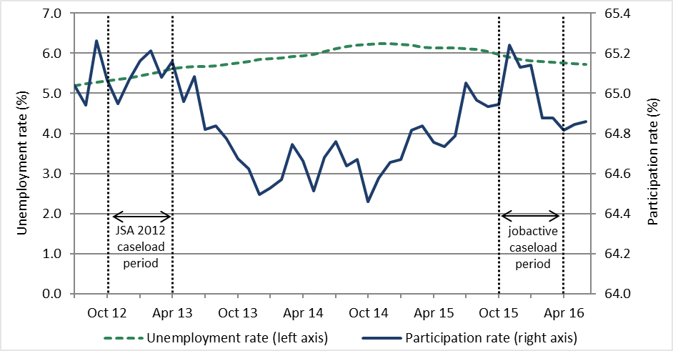

Source: Australian Bureau of Statistics, August 2016, Labour Force Australia, ‘Table 01. Labour force status by sex, Australia — trend, seasonally adjusted and original’, cat. no. 6202.0.

Since the global financial crisis there has been an increase in the growth of part-time employment relative to the growth of full-time employment and this has continued in recent years. For example, in the jobactive caseload study period, the share of employment that was part-time or casual was 31.1 per cent, while in the JSA 2012 study period it was 29.8 per cent (ABS 2017). The implication is that a higher proportion of employment outcomes under jobactive would be expected to be part-time or casual compared to JSA 2012. All else constant, this may lead to a relatively lower incidence of income support exits and a higher incidence of partial income support receipt under jobactive compared to JSA 2012 (see Section 3 for details).

The effect of macroeconomic conditions on the performance of employment services is demonstrated by the correlation between the monthly movements in the number of employment services job placements and the number of advertised jobs (Figure 1.2). From July 2012 to April 2016, the number of job placements in employment services was closely related to the number of job ads (except for a large drop-off in JSA placements in the final months of the operation of JSA which is explained in part by JSA provider behaviour and is consistent with what has happened at the end of previous employment services contracts). Given this, the impact of the macroeconomic context on the performance of employment services cannot be overlooked. For this reason, in the regression analysis undertaken to assess the outcomes of jobactive, adjustments are made to account for local labour market changes. Both adjusted and unadjusted figures are presented for comparison.

Figure 1.2: Internet job advertisements and job placements by employment services

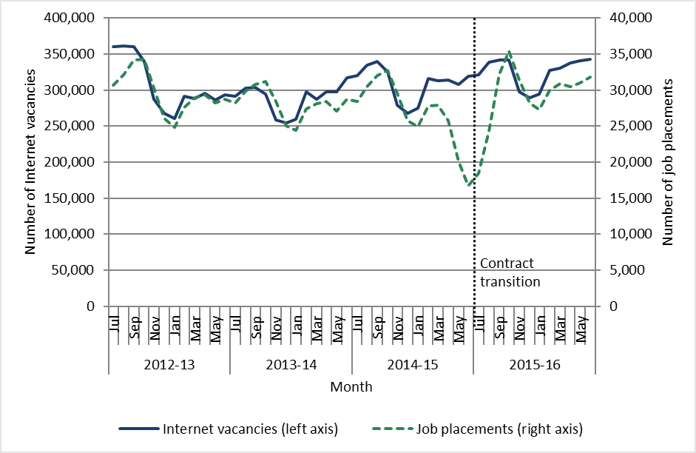

**Note:** Data displayed is the three-month average of original data.

Sources: Department of Employment 2016b and Department of Employment administrative data.

## Evaluation approach and methodology

### Effectiveness in job seeker engagement and achieving outcomes is the focus of the interim evaluation

As outlined in the *Evaluation Strategy for jobactive* (Department of Employment 2016a), this interim report aims to address several evaluation questions including:

* How effective and efficient is jobactive in engaging job seekers to participate in services and Annual Activity Requirements compared with predecessor programs?
* How effective is jobactive at assisting job seekers to obtain employment outcomes and reductions in their income support dependency[24] relative to the predecessor program JSA 2012?
* Does jobactive reduce administrative burden (‘red tape’) and service prescription for employment services providers?

This interim report focuses on evaluating the performance of the jobactive program as a whole. However, given its interim nature, this report does not unpack and evaluate all components of the jobactive program (such as the impact of wage subsidies and Employment Fund expenditure). The jobactive program and its components will be evaluated in more detail in the scheduled future evaluation reports.

### A comparative approach is taken for the interim report

This interim report provides a preliminary evaluation of the overall performance of the jobactive program and uses a comparative analysis of jobactive and the predecessor JSA 2012 where possible. The comparative approach utilised in this interim evaluation will help to identify those changes between the programs that affected job seeker engagement and outcomes. The report also identifies early and emerging trends and issues in the program’s operation that need further exploration as more data become available. Given the universal nature of the jobactive program, a comparison with JSA 2012 is used in the absence of a contemporary comparison group with the same characteristics and circumstances as jobactive job seekers. The analysis for this interim report focuses on job seeker engagement in services and program effectiveness in achieving employment outcomes, using descriptive statistics and regression modelling where appropriate.

Job seeker engagement in services is measured where possible by:

* commencement rate or the proportion of referrals which result in commencement
* rate of attendance at jobactive provider interviews
* proportion of job seekers undertaking an activity to meet their Annual Activity Requirement
* rates of non-compliance with the requirements of the compliance framework.

Key measures of program effectiveness analysed include:[25]

* exit rates from income support and exit rates from employment services[26] (proxies for job seekers obtaining sustained employment)
* reductions in income support payments received (a proxy for job seekers obtaining employment-related earnings, such as through temporary or seasonal work or self-employment — this is a particularly relevant measure of effectiveness for job seekers where obtaining full-time employment is not suitable).[27]

#### Constructing comparison groups

JSA 2012 job seekers were allocated to ‘Assessed Streams’ based on their level of labour market disadvantage using the re-estimated JSCI parameters now used to stream job seekers in jobactive. This enabled comparison of groups with similar levels of disadvantage in the labour market.

Job seekers in JSA 2012 had their jobactive equivalent stream calculated to enable comparison. This is discussed in more detail in *Appendix D Construction of comparison job seeker groups — methodology*.

### Various data sources are used for the evaluation

#### Administrative data

Administrative data is the key data source for the jobactive evaluation. The interim evaluation of jobactive is mainly based on two study populations of job seekers: a new entrant population and a caseload population. The new entrant population consists of job seekers who were new to employment services or commenced a new period of service, while the caseload consists of all job seekers in services at the caseload snapshot date.

* The jobactive **new entrant** study population is composed of job seekers who commenced jobactive services between 1 October 2015 and 31 December 2015 inclusive. The JSA 2012 comparison population consists of job seekers who commenced with a JSA provider between 1 October 2012 and 31 December 2012 inclusive. Job seekers who did not receive income support within 28 days of commencement were excluded. Job seekers were observed over six months from their commencement date.

The new entrant start date of 1 October 2015 was chosen because the jobactive program had been running for three months and the new entrant study population would therefore be less affected by the transition from JSA to the new jobactive arrangements. This is because the operation of employment services programs around ‘transition’ periods often does not reflect how the program performs over the longer term, once the new arrangements are ‘bedded in’. Section 3 analyses the new entrant study population.

* The jobactive **caseload** study population is composed of job seekers who were already in jobactive on 1 October 2015, the caseload snapshot date. The JSA 2012 comparison population consists of job seekers who were in JSA on 1 October 2012. These study populations were then observed over six months. Sections 2 and 3 analyse the caseload study population.

For analysis of program effects, it is preferable to study the new entrant study population. This is because new entrants have not been in employment services for at least three months prior to commencement and, as such, their outcomes can be more confidently attributed to the effect of the current program than any effects of servicing under previous programs. Additionally, relative to new entrant populations, caseload populations typically include job seekers with longer periods of unemployment and higher levels of disadvantage, potentially skewing analyses.

Some analyses in this report do, however, rely on caseload populations. For example, the effect of the Work for the Dole phase can only be analysed by the caseload population because no job seekers in the new entrant study population had entered the Work for the Dole phase when this interim evaluation was conducted. Similarly, by definition new entrants are short-term unemployed job seekers, so caseload populations are used to examine the effectiveness of jobactive at supporting longer term job seekers into the labour market.

The study populations are constructed from two administrative data sources:

* Department of Employment’s Employment Services System (ESS) data, which includes information on job seekers who have received employment services. Details include JSCI and ESAt assessments, types of assistance received, job placements and paid outcomes.
* The Research and Evaluation Database, which consists of unit record level data for customers receiving income support payments (excluding Department of Veterans’ Affairs pensions).

The administrative data are complemented by other data collections from providers and job seekers designed to gather information not available in the administrative data. The perspectives of employers will be included in future reporting.

#### Research with job seekers

The Department contracted the Social Research Centre (SRC) to conduct the Job Seeker Experiences of Employment Services (JSEES) survey in February 2016 to gauge job seeker experiences with jobactive. Data was collected from a survey (3004 participants, with two per cent completed in a language other than English) and in-depth interviews and focus groups with both job seekers who were new to jobactive and those who had transitioned from JSA.

Findings from this research are included in Section 2 of this report. Due to the timing of the research, job seeker experiences of jobactive were based on their experiences during the early stages of the program. Job seeker experiences may change as jobactive becomes more established. The experiences reported here will form a baseline for future analysis.

#### Research with jobactive providers

The Department regularly undertakes a survey of employment service providers which gathers information on providers’ views about various aspects of employment services and the quality of services provided by the Department. In the first year of the jobactive contract, two provider fieldwork projects were undertaken to inform this evaluation:

* a Survey of Employment Service Providers, with fieldwork conducted in June 2016
* a qualitative research project with jobactive providers and employment services peak bodies, with fieldwork conducted between November 2015 and February 2016.

Findings from this research are included in Sections 2 and 3 of this report.

## 1.6 Report structure

The remainder of this report is structured as follows. Section 2 evaluates job seeker activation and engagement with employment services. Section 3 evaluates the effectiveness of jobactive at assisting job seekers to obtain employment. Section 4 evaluates the objective to reduce regulatory and administrative burden. Section 5 provides conclusions and identifies areas that will be further investigated in future reports.

# Job seekers are more engaged under jobactive

|  |
| --- |
| **Key points**  Stronger Mutual Obligation Requirements (MORs) and the compliance framework under jobactive have led to better job seeker engagement with providers and activities compared to JSA 2012.   * The time from registration to commencement in services for most job seekers was reduced in jobactive relative to JSA 2012. * Under jobactive the attendance rate for appointments increased, fewer job seekers failed to attend an appointment without a valid reason, and job seekers reconnected more quickly in the event that they missed an appointment relative to JSA 2012. * Under jobactive, job seeker participation in Work for the Dole, employment and work experience activities increased, but participation in training and education activities decreased compared to JSA 2012. |

A core focus of the jobactive program is to give job seekers the support they need to obtain ongoing employment and reduce their welfare dependency. There are clear expectations for active participation by job seekers in this process. This section examines job seeker engagement with employment services. For the purpose of this analysis, ‘engagement’ is broadly defined to include time and activity related to a job seeker’s participation in employment services. Section 2.1 highlights the size of the job seeker caseload and the number of new entrant job seekers into employment services in order to provide context to job seeker engagement. Section 2.2 examines the time taken from registration to service commencement. Section 2.3 examines the effects of MORs on job seekers’ participation in activities and attendance at appointments. Section 2.4 examines job seeker servicing from both job seeker and provider perspectives.

While this analysis reflects evidence of the early stages of jobactive, the findings suggest that job seekers have stronger engagement with jobactive than with JSA 2012. For example, under jobactive, fewer job seekers missed appointments without a valid reason and job seekers re-engaged with providers faster when they did miss an appointment without a valid reason. This is likely due to changes made to the Job Seeker Compliance Framework in January 2015, prior to the start of jobactive. The stronger mutual obligation policy setting under jobactive also appears to be effective, with more job seekers participating in a Work for the Dole, employment, or work experience activity.

In this section, jobactive and JSA 2012 job seeker new entrant and caseload populations constructed from the Department’s ESS data, as described in Section 1.5, are used to try to establish if the policy changes have led to increased job seeker engagement. Results from the 2016 JSEES survey and qualitative fieldwork,[28] 2016 jobactive Provider Survey and 2015–16 provider qualitative fieldwork (also outlined in Section 1.5) are also incorporated to reflect perspectives from these stakeholders.

## The relationship between the number of unemployed, and new entrant and caseload job seekers in employment programs

Figure 2.1, below, shows the number of job seekers in the JSA 2012 and jobactive caseloads, the number of people unemployed in Australia according to the Australian Bureau of Statistics (ABS) and the number of people receiving either NSA or YA(O) between August 2012 and February 2016. The number of new entrants is also shown (right axis).

Figure 2.1: Size of the caseload and new entrant population and the number of unemployed people

The figure spans the period August 2012 until February 2016, and displays four curves. All four curves are clearly related, with peaks and troughs that roughly correspond, and are related to seasonal factors. The number of unemployed people fluctuates the most. While the caseload, the number of unemployed and the numer on allowances is increasing over time, the number of new entrants is tending to decrease over the period. Around July 2015 there is an apparent change in the pattern followed by the curves, with a clear drop, greater than would be expected from seasonal variation, in the caseload and the number of unemployed people, and a slight rise in the number of new entrants.

Introduction of jobactive, 1 July 2015

**Note:** It is important to note that each of these series measure different things. The ABS, for example, defines a person as employed if they work for at least one hour per week. A job seeker working one hour per week may, however, still be eligible for income support and employment services. Similarly, a person receiving NSA or YA(O) may be engaged in and meeting their MORs through a program other than jobactive such as Disability Employment Services, and hence may not appear in the jobactive caseload.

**Sources:** Caseload data is sourced from the Department’s administrative ESS data, NSA and YA(O) data is sourced from the Research and Evaluation Database, and unemployment data is sourced from Australian Bureau of Statistics, August 2016, Labour Force Australia, ‘Table 01. Labour force status by sex, Australia’, original data, cat. no. 6202.0.

While the number of job seekers on the employment services caseload fluctuated due to seasonal factors, the caseload increased over the course of the JSA 2012 contract. This was despite a decrease in the number of new entrants joining throughout the course of the program. Over the first few months of jobactive, the number of job seekers on the employment services caseload dropped notably. This is partly due to a coinciding seasonal reduction in the employment services caseload and partly due to the transition to jobactive.

During the transition from JSA to jobactive, volunteer job seekers were exited from JSA by default and were required to re-register with a jobactive provider if they wished to continue to receive services. As a result, the number of volunteer job seekers in employment services reduced substantially around the time of the transition and remained lower throughout the first six months of jobactive. There was also a general reduction in the number of new entrants to jobactive, compared with JSA.[29],[30]

The number of job seekers in the caseload was closely related to the number of unemployed people reported by the ABS. There was a higher proportion of NSA and YA(O) recipients in the jobactive caseload than in the JSA 2012 caseload. This is likely, at least in part, due to the removal of grandfathering provisions relating to changes made to Parenting Payment in 2006, which resulted in around 63,000 Parenting Payment recipients moving to NSA. Tightening of eligibility for Disability Support Pension between the caseload dates will have also had an impact.

## Job seekers were generally quicker to commence under jobactive

### Registration with employment services

Generally job seekers engage with employment services because they have applied for an activity-tested income support payment from DHS. Once job seekers register with DHS, DHS administers the JSCI to assess the job seeker’s level of labour market disadvantage and determine their service stream. The job seeker is then asked to choose from a list of local jobactive providers. If no choice is made, DHS randomly assigns the job seeker to a local provider with availability to provide service to them. The job seeker is then required to attend an initial appointment with the provider, where the provider assesses the job seeker’s circumstances, explains to the job seeker their obligations under social security law and, together with the job seeker, develops and agrees a Job Plan. The job seeker is then considered to have commenced in employment services.

If a job seeker directly approaches a provider, rather than first approaching DHS and subsequently being referred to a provider, the provider may, after determining their eligibility for employment services, register the job seeker directly and commence providing services. In some circumstances, for instance if the provider believes that the volunteer job seeker may be eligible for income support or the volunteer is in the Vulnerable Youth category, the provider may be required to commence servicing that job seeker and also refer them to DHS for further assessment.

### RapidConnect is a key process for referring job seekers to employment services

RapidConnect is a long-standing process for referring job seekers claiming either NSA or YA(O) to employment service providers as quickly as possible. Unless exempt from RapidConnect at the time of registration, DHS will create an appointment for the job seeker to attend with the selected provider.[31] This appointment will normally be within two business days and no more than 14 days from the initial registration.

Under RapidConnect rules, unless a waiting period applies, a job seeker will not be paid income support until they have attended their initial appointment. Arrangements in place during the evaluation study period provided that if the job seeker attended this appointment within 14 days, their income support payments were backdated to the date of registration.[32] If a job seeker attends this appointment between 15 and 28 days from the initial registration, income support will generally be paid from the date of the appointment. If a job seeker does not attend this interview within 28 days of initial registration, their application for income support will generally be rejected and they will be required to re-apply through DHS.

### Time to commencement varied by eligibility for RapidConnect and stream

Time to commencement is an important indicator of engagement because it determines how quickly assistance starts to be provided to those who need it. This subsection analyses the time taken from registration to commencement for job seekers in the JSA 2012 and jobactive new entrant study populations.

Under JSA 2012, around 215,000 job seekers registered during the study period, 82 per cent of whom were eligible for RapidConnect. Under jobactive, around 170,000 job seekers were registered and 84 per cent were eligible for RapidConnect. For both programs, RapidConnect eligible job seekers commence more quickly than non-RapidConnect eligible job seekers, as intended (Figure 2.2).

RapidConnect eligible job seekers commenced slightly more quickly under jobactive than for JSA 2012 (49 per cent of jobactive RapidConnect eligible job seekers were commenced within two days compared with 45 per cent for JSA 2012). This may simply reflect lower inflow numbers placing less demand on registration services in jobactive. For both programs, 98 per cent of RapidConnect eligible job seekers commenced within 14 days. In contrast, job seekers who were not eligible for RapidConnect took longer to commence under jobactive than JSA 2012. Around two-thirds of JSA 2012 job seekers who were not eligible for RapidConnect were commenced within 14 days, compared with half of jobactive job seekers.

Figure 2.2: Time from registration to commencement for caseload populations

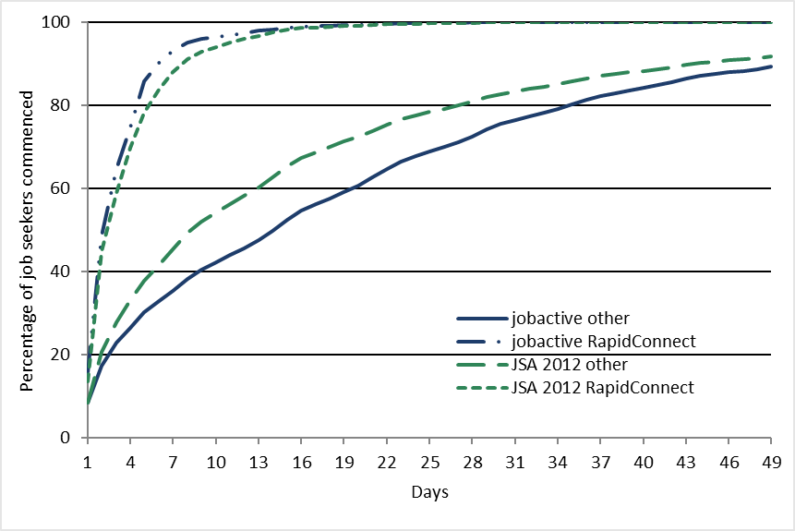

**Source:** Department of Employment administrative data.

Job seekers with an activity requirement (either full-time or part-time) commenced more quickly under jobactive, while volunteer job seekers (with no activity requirement) commenced more quickly under JSA 2012.[33] Stream C job seekers also took notably longer to commence under jobactive than comparable job seekers under JSA 2012 (Table 2.1). At this stage the reasons for Stream C and volunteer job seekers taking longer to commence under jobactive are not clear and require further monitoring and investigation. There do not appear to be any large differences in observable demographics between JSA 2012 and jobactive for these cohorts.

No notable difference is seen between jobactive and JSA 2012 regarding how quickly job seekers commenced based on age, gender or Indigenous status as shown in Table 2.1.

Table 2.1: Time from registration to service commencement for caseload population

| **Characteristics** | **JSA**  **0–2 days**  **(%)** | **JSA**  **3–14 days**  **(%)** | **JSA**  **> 14 days**  **(%)** | **jobactive**  **0–2 days**  **(%)** | **jobactive**  **3–14 days**  **(%)** | **jobactive**  **>14 days**  **(%)** |
| --- | --- | --- | --- | --- | --- | --- |
| Stream A | 34.4 | 49.5 | 16.1 | 38.1 | 44.3 | 17.6 |
| Stream B | 30.0 | 39.8 | 30.2 | 29.5 | 37.7 | 32.8 |
| Stream C | 26.4 | 26.8 | 46.8 | 20.9 | 23.6 | 55.5 |
| Age: Less than 30 years | 32.7 | 47.0 | 20.2 | 35.2 | 43.5 | 21.3 |
| Age: 30–54 years | 34.7 | 48.2 | 17.2 | 38.1 | 42.7 | 19.3 |
| Age: 55+ years | 34.9 | 49.3 | 15.8 | 40.1 | 43.1 | 16.8 |
| Female | 31.7 | 48.3 | 20.0 | 34.8 | 43.9 | 21.3 |
| Male | 35.2 | 47.2 | 17.6 | 38.5 | 42.5 | 19.0 |
| Indigenous | 31.3 | 38.4 | 30.4 | 32.1 | 36.2 | 31.7 |
| Non-Indigenous | 33.9 | 48.3 | 17.8 | 37.2 | 43.6 | 19.2 |
| Full-time activity requirement | 36.0 | 50.5 | 13.5 | 40.2 | 46.5 | 13.3 |
| Part-time activity requirement | 29.2 | 44.3 | 26.5 | 38.5 | 42.3 | 19.2 |
| Voluntary | 24.8 | 35.9 | 39.4 | 14.5 | 22.7 | 62.8 |
| Total | 33.7 | 47.7 | 18.6 | 36.8 | 43.1 | 20.0 |

**Note:** Includes job seekers who connected via RapidConnect and non-RapidConnect.

**Source:** Department of Employment administrative data.

## Changes to Mutual Obligation Requirements and the compliance framework have affected job seeker behaviour

### Changes to MORs and the compliance framework

MORs are set out in the *Social Security Act 1991* and administered by DHS. They ensure that unemployed people receiving an activity-tested income support payment, unless DHS has granted the job seeker an exemption from these requirements, are actively looking for work and/or are participating in activities that will help them into employment. A job seeker’s MORs are generally determined by their age, assessed work capacity and whether they have the primary responsibility for the care of a dependent child.

Under the Job Seeker Compliance Framework, which applied from 1 January, 2014, providers are expected to assist job seekers to fully understand and meet their MORs so that job seekers are aware at all times what social security law requires of them in return for receiving income support. The provider must develop an individual Job Plan with each job seeker detailing these requirements and providing a tailored approach to assist the job seeker to become work-ready and gain sustainable employment.

A job seeker’s compliance with their MORs is broadly determined by their engagement in three areas: their attendance at appointments both with their provider and with third parties; genuine job search efforts, including searching and applying for jobs, attending job interviews and accepting appropriate job offers; and for job seekers who have entered the activity phase, engagement in suitable activities to meet their Annual Activity Requirement (AAR), which sets out the minimum number of hours for which they are required to participate in an approved activity each week.

If a provider determines that a job seeker is not meeting their MORs, as identified in their Job Plan, the provider may deem it appropriate to notify DHS by completing a relevant compliance failure report. Completion of such a report is done at the provider’s discretion and may result in the imposition of sanctions by DHS, including the suspension or cancellation of income support payments. While the imposition of sanctions is determined by DHS, the submission of a compliance failure report by a provider is taken as a recommendation to impose sanctions.

The Job Seeker Compliance Framework was strengthened in January 2015 (the Strengthening the Job Seeker Compliance Framework) when JSA 2012 was still operating. It represented a significant change to the previous framework. [34] As a result of the changes and the selection of comparison periods for this report, variation in outcomes between the jobactive and JSA 2012 cohorts cannot be attributed to service model changes only.

The ultimate aim of the two compliance frameworks, however, was the same; namely to encourage job seeker engagement in employment services, broadly defined as attendance at appointments and participation in activities.

In this subsection, appointment and activity data are compared between jobactive and JSA 2012 job seeker caseload populations. Findings from the 2016 JSEES survey and qualitative fieldwork, 2016 jobactive Provider Survey and 2015–16 provider qualitative fieldwork are also incorporated where appropriate.

#### Job seekers are more aware of their obligations

jobactive providers commented during the 2015–16 provider qualitative fieldwork that they felt the compliance framework activated job seeker engagement with employment services. Providers felt that the program’s focus on employment and the changing nature of discussions with job seekers under jobactive, enabled them to give clearer messages to job seekers about MORs than they could under JSA. Some providers went on to attribute increased job seeker awareness of their MORs with the direct alignment of the jobactive Job Plan to requirements of the *Social Security Act 1991*.

This feedback is reinforced by data from the 2016 jobactive Provider Survey. Almost three-quarters of providers (71 per cent) agreed the compliance framework was useful in supporting their site to activate and engage job seekers. When asked whether job seekers were more aware of their MORs under the jobactive contract than under JSA, almost two-thirds of jobactive providers (61 per cent) indicated that they believed that job seekers were more aware. This sentiment was also reflected in the 2016 JSEES survey of job seekers, where 89 per cent of job seekers surveyed felt informed about what they were required to do to satisfy their MORs and maintain their payments.

Further, according to the 2016 jobactive Provider Survey:

* almost two-thirds of providers (61 per cent) agreed that the introduction of the Non-Attendance Report[35] (NAR) had encouraged better job seeker attendance at appointments
* three-quarters of providers agreed that the compliance framework is useful in assisting their site to re-engage job seekers following non-compliance
* almost three-quarters of providers (74 per cent) agreed that the compliance framework was useful in assisting their site to monitor job seeker MORs.

It is not surprising that providers reported that they were supportive of the new compliance framework. They felt that it gave them an opportunity to reinforce job seekers’ MORs including attending appointments, undertaking job search and fulfilling Work for the Dole requirements. Only a small proportion of providers reported that they felt it was difficult to have conversations with job seekers about the potential consequences of non-compliance.

### Despite high awareness of mutual obligations, one-third of job seekers report an income support suspension

As mentioned above, results from the 2016 JSEES survey found that most respondents (89 per cent) felt well informed about what they needed to do to satisfy their MORs. Despite this high awareness rate, four in 10 (40 per cent) job seekers also reported in the JSEES survey of having their income support suspended[36] due to a failure to meet their MORs or a failure to report earnings. This is consistent with administrative data on income support suspensions.[37]

Of all job seekers in the 2016 JSEES survey who reported having their income support suspended, around 70 per cent said the suspension was because of a failure to satisfy MORs, with this rate being slightly higher for job seekers who felt fully informed (70 per cent) than for job seekers who did not feel fully informed (60 per cent).

A number of factors may be influencing these figures. First, it may be that even though job seekers were fully informed of their obligations, they may not have fully appreciated the consequences of a failure to comply. Second, it may be that even though job seekers were fully informed of their obligations and fully appreciated the consequences of a failure to comply, they chose not to comply anyway. Third, it may be that job seekers who were not fully informed were not aware that the reason for their suspension was related to a breach of their MORs and therefore had not reported this in response to this survey. Fourth, it may be that job seekers who reported being fully aware only became fully informed once they experienced the consequent breaching their MORs. These issues notwithstanding, informing a job seeker of their MORs is a key role for jobactive providers, and this should be done at the initial appointment; therefore these numbers raise some questions about the extent to which job seekers were being informed of their MORs and the extent to which they comprehended these requirements. It could also be possible that regardless of being informed about their MORs there are job seekers whose personal circumstances make it difficult to comply.

Additionally, around one-quarter (23 per cent) of job seekers who had their payment suspended reported finding out about the suspension because they did not get paid their income support, rather than because their provider or DHS contacted them (24 per cent and 35 per cent respectively). As this finding was based on a survey of job seekers, and therefore self-reported, it was unclear if this was because contact was not attempted; contact was attempted, but was not successful; or, if contact was made, the respondent recalled incorrectly. Again, this points to the importance of having an effective relationship and communication between the job seeker and their jobactive provider.

Providers are required to attempt to contact a job seeker as soon as possible on the same business day where they become aware of a job seeker’s failure to comply with their MOR, which may lead to an income support suspension if the provider is not already aware that the job seeker has a valid reason for their failure to comply. This failure to comply might include failing to attend an appointment; failing to attend or participate in a compulsory activity; or failure to attend a job interview. Where an income support suspension results from something other than from a job seeker’s failure to comply with their MORs as detailed above, the provider is not required to contact the job seeker.

### Appointment attendance rates are higher under jobactive than under JSA 2012

As part of their MORs, job seekers are required to attend appointments with their provider. These appointments are used to establish a relationship between the job seeker and the provider, as well as to develop and monitor Job Plans, job search technique and participation in activities. If a job seeker fails to attend an appointment and does not have a reasonable excuse it may result in a compliance failure.

Appointments can be broken down into three categories: initial, contact and re-engagement. Job seekers are required to attend an initial appointment to begin engagement with a provider and commence in services. Usually this appointment is booked by DHS, after a job seeker applies for income support, and would occur shortly after the job seeker makes contact with DHS. A contact appointment is an appointment scheduled between the provider and the job seeker to provide updates on the job seeker’s progress and servicing requirements. A re-engagement appointment may be booked by either DHS or the provider if either party determines that a job seeker is failing to meet their MORs.

Overall there was an average of seven appointments per job seeker during the jobactive caseload study period, compared with six appointments per job seeker for JSA 2012. This increase was driven mainly by an increase in re-engagement appointments, which roughly doubled both in actual and in relative terms, and contact appointments, which increased by around one-third (Table 2.2).

The rate of attendance of all appointments increased by 4 percentage points in jobactive compared to JSA 2012 (from 53 per cent under JSA 2012 to 57 per cent under jobactive — Table 2.2). This takes into account non-attendance both with and without a valid reason. Breaking this data down by the appointment type shows that attendance at re-engagement appointments has changed the most between the two programs, increasing from 59 per cent under JSA 2012 to 84 per cent under jobactive.

Table 2.2: Attendance rates by appointment type in the six months after caseload dates (1 October 2012 for JSA 2012 and 1 October 2015 for jobactive)

| **JSA 2012**  **appointments** | **Number of job seekers** | **Number of appointments** | **Number of appointments attended** | **Proportion of appointments attended**  **(%)** |
| --- | --- | --- | --- | --- |
| **JSA 2012** |  |  |  |  |
| Initial |  | 148,875 | 60,357 | 40.5 |
| Contact |  | 3,637,618 | 1,920,385 | 52.8 |
| Re-engagement |  | 277,180 | 163,587 | 59.0 |
| Total | 649, 986 | 4,063,673 | 2,144,329 | 52.8 |

| **jobactive**  **appointments** | **Number of job seekers** | **Number of appointments** | **Number of appointments attended** | **Proportion of appointments attended**  **(%)** |
| --- | --- | --- | --- | --- |
| **jobactive** |  |  |  |  |
| Initial |  | 176,141 | 69,159 | 39.3 |
| Contact |  | 4,720,217 | 2,573,203 | 54.5 |
| Re-engagement |  | 580,761 | 488,789 | 84.2 |
| Total | 745, 403 | 5,477,119 | 3,131,151 | 57.2 |

**Notes:** Consistent with the evaluation approach identified in Section 1.5.3, these tables present appointment attendance rates for the six months after the JSA 2012 and jobactive caseload snapshot dates. The number of initial appointments is low as this analysis is based on the caseload study populations. It includes job seekers who were pending registration with employment services. It includes appointments that were attended, not attended with a valid reason and not attended without a valid reason.

**Source:** Department of Employment administrative data.

Further analysis shows that there was a slight decrease in the proportion of job seekers who did not attend appointments and did not have a valid reason, down from 17 per cent in JSA 2012 to 16 per cent in jobactive (Figure 2.3). This decrease was largely driven by a reduction in the failure to attend re-engagement appointments without a valid reason, which was down from 31 per cent under JSA 2012 to 10 per cent under jobactive.

Figure 2.3: Non-attendance without a valid reason by appointment type in the six months after caseload dates (1 October 2012 for JSA 2012 and 1 October 2015 for jobactive)

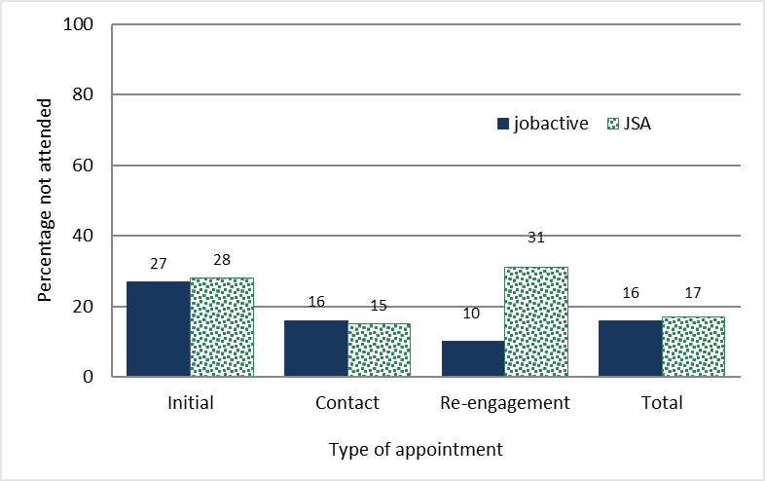

**Source:** Department of Employment administrative data.

In addition, under jobactive, job seekers who failed to attend an appointment without a valid reason reconnected more quickly. Figure 2.4 shows the number of days that elapsed between a job seeker failing to attend an appointment without a valid reason and the next appointment that they attended. Under jobactive, around 80 per cent of these job seekers attended an appointment within 14 days, compared with just under half of JSA 2012 job seekers.[38]

Figure 2.4: Re-engagement after non-attendance of an appointment without a valid reason in the six months after caseload dates (1 October 2012 for JSA 2012 and 1 October 2015 for jobactive)

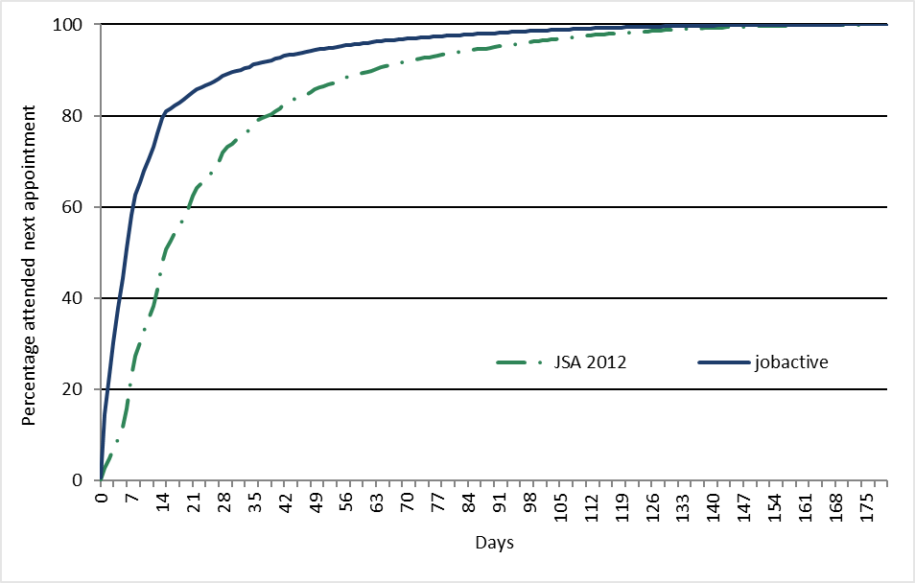

**Source:** Department of Employment administrative data.

Overall, analysis of appointments data suggests that job seeker engagement, as determined by attendance at appointments, was higher during the jobactive caseload study period than it was during the JSA 2012 caseload study period. The large increase in the attendance rate for re-engagement appointments, the large fall in the rate of failing to attend re-engagement appointments without a valid reason, and the increased re-engagement rate indicate that the more stringent compliance measures are having an impact on job seeker behaviour under jobactive.

### Changes in Mutual Obligation Requirement impact on job seeker participation in activities

In jobactive, job seekers with MORs are required to attend activities as identified in their Job Plan. Various activities are available to job seekers. These activities are intended to provide job seekers with the opportunity to increase their skills and capacity and improve their motivation and reliability so they can get and keep a job (Department of Employment 2016d).

Similarly in JSA 2012, job seekers with MORs were required to attend activities as identified in their Employment Pathway Plan (EPP), and there were a range of comparable activities available.

Job seekers without MORs could under JSA 2012, and still can under jobactive, negotiate with their provider to participate in activities.

For the purpose of this analysis, activities have been grouped into the following categories: education and training activities; intervention activities; employment or work experience activities; Work for the Dole activities; and other activities, as discussed in Section 1.

#### Changes to allowable activities between JSA 2012 and jobactive

The compliance framework under which jobactive operates[39] has more demanding MORs and more severe non-compliance measures than previous frameworks. Section 1.3 describes the compliance framework under which jobactive operates in more detail. Changes made to the Employment Fund have also had an impact on the nature of activities undertaken under jobactive.

Under JSA 2012, providers were able to access the Employment Pathway Fund (EPF) to, among other things, provide training and intervention activities to address a job seeker’s individual needs and barriers to employment, as identified in the job seeker’s EPP. For jobactive, the EPF was replaced with the Employment Fund General Account (EF). When compared with the EPF of JSA, the EF of jobactive was refined and streamlined. This included tighter rules for non-accredited training, with reimbursement for accredited training still available.[40]

#### Participation in Work for the Dole, employment or work experience activities has increased; participation in training activities has decreased

Analysis of job seeker participation in activities indicated that the stronger mutual obligation policy setting under jobactive, and the tightened requirements for training-related EF expenditure, appeared to have had an impact on activities undertaken by job seekers. While the caseload-based information considered in this analysis provides an indication of the early impact of these changes on participation in activities between the two programs, more thorough analysis of activities by job seeker phase using inflow data and data that is not impacted by transition arrangements will be included in future reporting.

As can be seen in Table 2.3, there has been an increase in both the number and proportion of job seekers participating in activities. Almost 44 per cent of the jobactive caseload participated in an activity compared with around 34 per cent for JSA 2012. There has been a substantial increase in the number of job seekers participating in a Work for the Dole activity under jobactive compared to JSA 2012. There was also a marked increase in the number of job seekers participating in employment and work experience activities. Fewer job seekers participated in an education or training activity under jobactive than under JSA 2012.

These observations are broadly consistent with the increased focus on MORs and activities that are directly linked to employment opportunities under jobactive. The increase in participation in activities stems from the fact that a higher proportion of the caseload is in a phase that requires participation in an activity and from the stronger emphasis on participation in an activity during the Work for the Dole phase under jobactive, when compared to the Work Experience and Compulsory Activity phases of JSA 2012.

Table 2.3: Job seeker participation in activities in the six months after caseload dates (1 October 2012 for JSA 2012 and 1 October 2015 for jobactive)

|  | **JSA 2012**  **Number** | **JSA 2012**  **%** | **jobactive**  **Number** | **jobactive**  **%** |
| --- | --- | --- | --- | --- |
| **Total job seekers** | **649,986** | **100.0** | **745,403** | **100.0** |
| **Participation in activities** |  |  |  |  |
| Job seeker with an activity | 223,831 | 34.4 | 326,789 | 43.8 |
| Job seeker without an activity | 426,155 | 65.6 | 418,614* | 56.2 |
| **Type of activities** |  |  |  |  |
| Education or training | 125,392 | 19.3 | 116,820 | 15.7 |
| Employment or work experience | 55,621 | 8.6 | 129,886 | 17.4 |
| Intervention | 21,568 | 3.3 | 14,826 | 2.0 |
| Work for the Dole | 23,386 | 3.6 | 118,250 | 15.9 |
| Other | 35,598 | 5.5 | 27,229 | 3.7 |
| None | 426,155 | 65.6 | 418,614 | 56.2 |

**Notes:** Consistent with the evaluation approach identified in Section 1.5.3, this table presents job seeker participation in activities over the six months after the JSA 2012 and jobactive caseload snapshot dates. This may include activities that started before the respective caseload snapshot dates.A job seeker may undertake activities in more than one activity group in a phase, and therefore the proportions of ‘type of activities’ may add to more than 100. Excludes JSA 2012 and jobactive job seekers with volunteer status at caseload date.

*Includes job seekers with a status of pending, suspended or meeting their activity requirement.

**Sources:** Department of Employment administrative data and the Research and Evaluation Database.

The introduction of the Work for the Dole phase is likely to have had two effects on job seekers. The primary effect is that more job seekers are now participating in a Work for the Dole activity due to the requirement that job seekers in the Work for the Dole phase do so, unless they meet their MORs by undertaking other approved activities. The second is that job seekers in the Work for the Dole phase who do not want to participate in Work for the Dole instead participate in an alternative activity, such as an employment or work experience activity. Work for the Dole metrics were also included in the calculation of a provider’s Star Ratings, which may incentivise providers to place job seekers in the Work for the Dole phase into activities.

Anecdotal evidence suggests that under JSA 2012, some job seekers might have been working, but either not declaring this to their provider and DHS, or under-declaring earned income. With increased emphasis on participating in an activity during jobactive’s Work for the Dole phase, it is likely that some of these job seekers are no longer be able to continue to both work and meet their MORs and are instead declaring their work as an employment activity to avoid participating in Work for the Dole.

This observation is supported by the evaluation of Work for the Dole 2014–15, which showed that job seekers reporting part-time/casual employment increased by 7 percentage points more in Work for the Dole 2014–15 areas than in other areas (Department of Employment 2015c). This will be investigated further in future reporting. This is likely to represent a combination of effects including job seekers gaining work in order to avoid participation in Work for the Dole activities or declaring previously undeclared income.

The reduction in education and training activities (from 19.3 per cent to 15.7 per cent) was broadly in line with the tightening of access to funding for non-accredited training activities under jobactive. This was also reflected in the 2016 JSEES survey, with only 47 per cent of respondents in the survey reporting having had a conversation with their jobactive provider regarding study or training. Of those who had had a conversation, just under 40 per cent had enrolled in or commenced study or training. Of the 60 per cent who had not enrolled in or commenced study or training, the main reason stated by almost a third (28 per cent) of this group was that their jobactive provider would not approve and or fund it. These results are based on data that predated the policy changes that permit greater usage of non-accredited training in specific circumstances, and this area is being monitored by the Department.

#### Non-Work for the Dole activities were perceived more favourably by job seekers

While the effects of participation in activities on job seekers’ employment outcomes will be analysed in future reporting, the 2016 JSEES survey provides job seekers’ views on participation.

Job seekers who participated in an activity were asked in the JSEES survey if they thought the most recent activity they had participated in either improved their chances of getting ongoing employment, improved their self-confidence, or helped them with broad work-related skills and behaviours (Figure 2.5). Between half (56 per cent) and three-quarters (71 per cent) of job seekers who had participated most recently in a Work for the Dole activity reported improvements across the measures assessed. However, a higher proportion of job seekers who most recently participated in a non-Work for the Dole activity reported improvements. This is consistent with the evaluation of Work for the Dole 2014–15, where job seekers reported an activity was a valuable experience more often for non-Work for the Dole activities (90 per cent) than for Work for the Dole activities (68 per cent) (Department of Employment 2015c).

Figure 2.5: Job seeker improvements (self-reported) — most recent activity

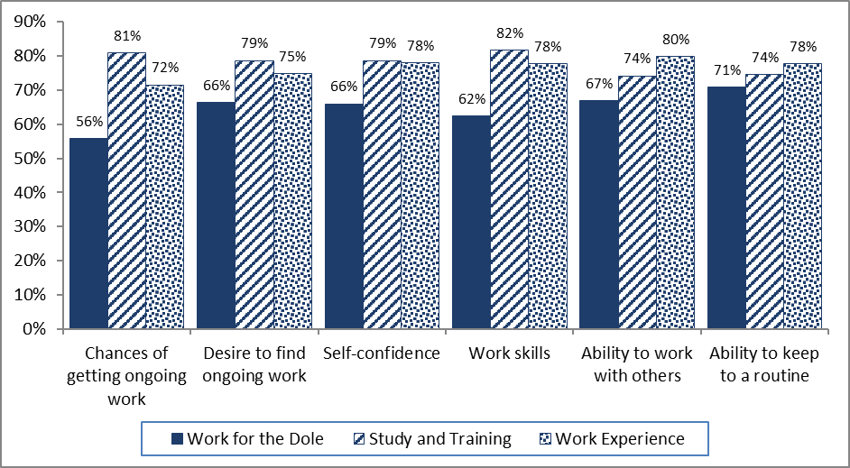

**Source:** JSEES Survey 2016.

The evaluation of Work for the Dole 2014–15 also showed that the willingness of a job seeker to actively engage with an activity depended on the extent to which they could choose an activity that suited them, the extent to which they enjoyed the activity and the extent to which they perceived it enhanced their work-related skills. The 2016 JSEES survey indicated that job seekers tend to prefer study and training activities over Work for the Dole or work experience activities. It is likely, therefore, that job seekers have a broad preference for activities other than Work for the Dole activities and reported more favourable outcomes for these activities. It is important to note that, being a survey, this is a self-reported metric.

### Job search requirements were about right for half of the job seekers, too high for some

2016 JSEES survey respondents who reported having a job search requirement were asked whether they thought their job search requirement was too high, too low or about right. These responses were linked back to the Department’s administrative data and broken down by the actual number of jobs they were required to search for each month. Administrative data showed that on average job seekers with a job search requirement needed to apply for 16 jobs per month.

Overall around half of respondents with a job search requirement thought that the number of jobs they were required to apply for was about right (50.9 per cent). Around two-fifths thought their job search requirement was too high, while only 7 per cent thought it was too low. Interestingly there was little variation by the number of jobs that job seekers were required to look for (Table 2.4). This suggests that job search requirements largely do not influence job seeker behaviour.

Feedback from both providers and employers during qualitative fieldwork suggests that some job seekers have developed systems for meeting their job search requirements through non-genuine job search efforts. As a result of these systems, it is likely that these job seekers would report that their requirement were ‘about right’. Job seekers who are genuinely motivated to find employment were likely to conduct appropriate job search irrespective of their job search requirement and were, therefore, also likely to agree, on aggregate, with job search requirements imposed upon them.

Most job seekers who thought their job search requirement was too high probably simply thought that there were not enough jobs in their area. Interestingly, the understanding that job seekers had of their job search requirements often varied from their actual requirements, as indicated by comparing responses in the JSEES survey with administrative data. Survey results showed that almost one in 10 (8 per cent) did not know what their correct job search requirement was, and 20 per cent of these were under the misunderstanding that they had no job search requirement.

Table 2.4: Job seeker perceptions of job search requirements by actual job search requirement

|  |  |  |  |  |  |  |  |  |
| --- | --- | --- | --- | --- | --- | --- | --- | --- |
| **Job searches per fortnight** | **Far too many or too many (Number)** | **Far too many or too many (%)** | **About right (Number)** | **About right (%)** | **Slightly too few or too few (Number)** | **Slightly too few or too few (%)** | **Total (Number)** | **Total (%)** |
| 1 to 9 | 72 | 43.9 | 77 | 47.0 | 15 | 9.1 | 164 | 100.0 |
| 10 to 19 | 190 | 40.6 | 235 | 50.2 | 43 | 9.2 | 468 | 100.0 |
| 20 | 452 | 42.4 | 555 | 51.8 | 65 | 6.1 | 1072 | 100.0 |
| Total | 714 | 41.9 | 867 | 50.9 | 123 | 7.2 | 1704 | 100.0 |

**Note:** Job seekers who responded Refused to answer / Don’t know (53) have been removed. Job seekers who did not have job search requirements in the Department’s administrative data at the time of the survey have also been removed (331).

**Source:** 2016 JSEES Survey and Department of Employment administrative data.

The JSEES survey also found that approximately half (45 per cent) of job seekers had spoken to their jobactive provider about specific job vacancies. Seventy per cent of these job seekers reported having applied for a job that their provider had found or recommended for them, although only one in eight (12 per cent) resulted in paid employment. Three-quarters of job seekers reported that they did not receive any feedback from their provider in the event that a job application was unsuccessful.

## Job seeker servicing

### 2.4.1 Job seekers were mostly satisfied with the services provided by their providers

Overall, 70 per cent of job seekers in the 2016 JSEES survey reported being either satisfied or very satisfied with the services provided to them by their jobactive provider. Those that were not satisfied reported the main reason for feeling that way was because of the provider not getting them a job (21 per cent); poor or inappropriate staff attitude (15 per cent); limited or inflexible services (13 per cent); or no or insufficient contact from their provider (11 per cent).

For job seekers previously assisted under JSA 2012, opinions seem to be mixed regarding the quality of services under jobactive compared with JSA 2012. Around half (48 per cent) reported that the quality of services was the same under both programs. Thirty per cent said that the service quality had improved a little or a lot under jobactive, while the remaining 22 per cent said that the service quality was a little or a lot worse under jobactive, compared with JSA 2012. Of the job seekers who thought services had deteriorated under jobactive, most cited interaction with staff (52 per cent) or communication with a provider (39 per cent) as the main reason for the deterioration.

It is likely that this deterioration has been caused by changes in service delivery between JSA 2012 and jobactive. Specifically, departmental analysis of Provider Survey data indicates the average number of staff at each site has decreased by around one-quarter between JSA 2012 and jobactive. Additionally, as detailed in Section 5.3, providers are increasingly using many-to-many servicing techniques, such as ‘rainbow’ servicing and group-based servicing.[41]

### 2.4.2 Most job seekers reported barriers to employment and discussed these barriers with their provider

Nine out of 10 job seekers (89 per cent) surveyed in the 2016 JSEES survey reported having barriers that made it difficult for them to find or stay in a job. The difficulty was usually due to a physical or mental health condition (18 per cent), insufficient jobs in the local labour market (16 per cent), caring responsibilities (10 per cent) or transport or location reasons (10 per cent). Less than one-fifth (18 per cent) of the Provider Survey respondents agreed that addressing job seeker’s barriers to work was easier under jobactive than it was under JSA 2012, and 45 per cent felt that it was more difficult to address job seekers’ barriers under the jobactive contract.

Stream A job seekers reported an insufficiency of jobs in the local labour market (23 per cent) or that they had no barriers to finding work (14 per cent) more frequently than those in other streams. Stream B job seekers reported caring requirements (18 per cent) most frequently and Stream C job seekers reported physical or mental health conditions (36 per cent) most frequently.

Most job seekers (72 per cent) reported discussing some, or all, of these barriers with their providers, although only around one-third of job seekers who reported discussing these barriers with their provider felt that anything was done to help address them. Providers most commonly helped with writing résumés and job search, counselling or external training, or spent additional time with the job seeker.

Of the young job seekers (under 22 years) surveyed, 17 per cent cited lack of work experience as the main factor stopping them from gaining employment.[42]

There was also an apparent disconnect between job seekers’ self-perceived barriers and development needs, and those identified by employers. When surveyed, employers indicated that job seekers typically lack work motivation or basic work skills. Job seekers, however, rarely identified these factors. While issues around attribution of barriers may drive job seekers’ self-reported barriers, this research nonetheless highlighted the importance of a provider being an intermediary between the job seeker and potential employers.

### 2.4.3 Flexibility of job seeker servicing is reflected in diverse servicing approaches

An essential component of jobactive is the capacity for providers to develop and deliver flexible servicing arrangements for job seekers and employers. Under jobactive, each provider has developed a Service Delivery Plan which outlines the services that job seekers can expect to receive. This provider-defined service delivery is in contrast to the prescriptive servicing model under JSA.

#### Service Delivery Plans are seen as useful by providers

The 2016 Provider Survey found that providers generally perceived that the Service Delivery Plans were beneficial in many aspects of servicing job seekers, as shown in Figure 2.6.

Figure 2.6: Providers perceived benefits of Service Delivery Plans

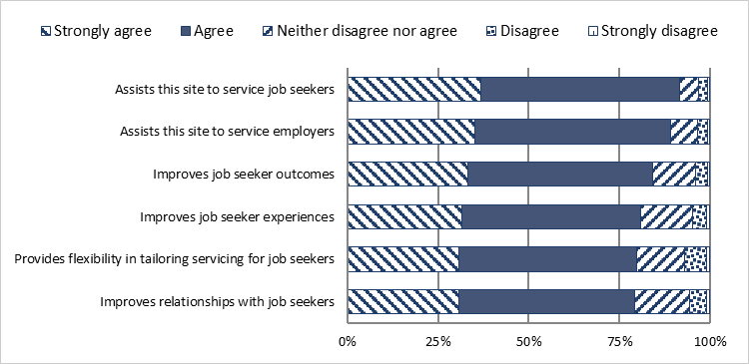

**Source:** 2016 jobactive Provider Survey.

The positive responses to the benefits of Service Delivery Plans in the Provider Survey were also reflected in the provider qualitative fieldwork undertaken in 2015–16. Site, regional and national managers surveyed or interviewed felt that the greater freedom and flexibility of servicing available under the jobactive contract would create a more innovative, flexible system of servicing job seekers.

While over three-quarters of providers reported that Service Delivery Plans provide flexibility in tailoring services for job seekers (see Figure 2.6), less than half of them (46 per cent) reported that jobactive gave them more flexibility in the way job seekers are serviced when compared with JSA.[43]

#### Methods of servicing differ by job seeker stream

Many providers interviewed as part of the provider qualitative fieldwork 2015–16 reported changes in the way they serviced job seekers, with a shift away from a traditional case management servicing model to ‘rainbow’ servicing, by which job seekers are seen and serviced by the next available employment consultant, and more group-based servicing of job seekers.

When asked in the 2016 Provider Survey to select three statements that best described how job seekers are serviced by stream, providers reported that while ‘individual servicing with the same consultant every time’ was dominant, particularly for Stream B and Stream C job seekers, group servicing, self service and servicing by telephone or teleconference featured significantly for Stream A job seekers (see Figure 2.7).

Figure 2.7: Three statements which best describe how job seekers are serviced by stream

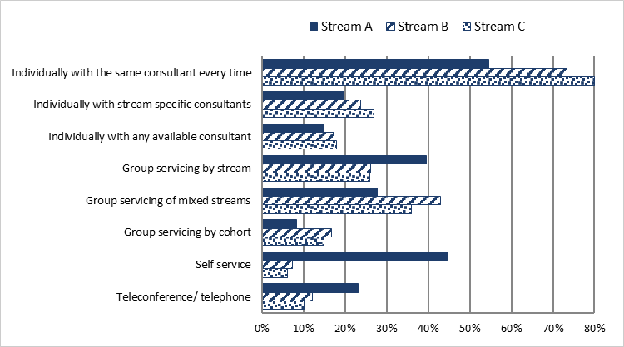

**Source:** 2016 jobactive Provider Survey.

#### There is evidence of changing job seeker servicing strategies since the transition to jobactive

In the 2016 jobactive Provider Survey, respondents who had worked in the employment services sector for more than 12 months, or had worked for their current employer for more than 12 months, were asked to select from a series of statements that compared job seeker servicing strategies that had changed since the transition from JSA 2012 to jobactive:

* almost two-thirds of providers (64 per cent) reported that there had been an increased focus on group servicing of job seekers since the transition to jobactive
* just under half (47 per cent) reported that the office configuration was more open-plan since the start of jobactive
* over a third of providers (37 per cent) indicated that job hubs are more frequently used and a mode of servicing in jobactive compared with JSA 2012
* over a quarter (28 per cent of providers) indicated that there were additional training rooms and 15 per cent indicated that there were additional interview rooms available at their site since the start of jobactive.

These findings reinforce those reported in the 2015–16 provider qualitative fieldwork, where providers indicated that group servicing of job seekers and open-plan office spaces were more prevalent in jobactive than they had been under the JSA contact.

While providers reported that there had been an increase in group servicing and job hub servicing since the transition to jobactive, more than half of providers (57 per cent) also reported that employment consultants had more job seekers on their caseload and less than one-fifth of providers (19 per cent) reported that employment consultants spent more time with job seekers since jobactive commenced.

These findings indicate that there may be less individualised servicing of job seekers, less time spent with individual job seekers and more group servicing of job seekers, with a higher job seeker to employment consultant ratios in jobactive compared to JSA.

#### Job seekers tend not to like group servicing and meeting with providers in open or shared spaces

Three-quarters of job seekers (73 per cent) in the 2016 JSEES survey reported that usually meetings with their jobactive provider were conducted one-on-one. A further 9 per cent reported that meetings were usually conducted in a group setting and for 17 per cent of them the meeting style varied. Job seekers who indicated they were dissatisfied with their current jobactive provider were more likely to meet in a group environment (14 per cent compared to 8 per cent of those who were satisfied with their provider).

For approximately two-thirds of job seekers (63 per cent) surveyed, meetings between them and their jobactive providers were conducted in open or shared spaces where other people might be present. A further 30 per cent reported that meetings were usually conducted in a private office and a further 7 per cent reported their meetings varied between open spaces and private offices. Again, those with higher levels of dissatisfaction with providers were more likely to report having meetings conducted in open, shared spaces (71 per cent, compared with 60 per cent of job seekers who expressed satisfaction with their provider) and less likely to report meetings taking place in private offices (22 per cent, compared with 32 per cent of job seekers who expressed satisfaction with their provider).

Change in the office configuration of jobactive providers was a concern raised frequently by participants in job seeker focus groups. These job seekers noted that desks were in close proximity to one another with the result that others could hear conversations they had with their employment consultant. This was raised, unprompted, in around half of the group discussions, with particular concerns expressed about the compromised privacy of the discussions, particularly when these were of a personal nature (regarding, for example, barriers to employment, personal health and wellbeing issues and so forth). While not explicitly covered in the survey, a common perception job seekers had of the jobactive staff was their evident frustration at seeing different case managers and having to constantly relay their ‘story’ and their circumstances.

#### Around half of jobactive sites have specialist service staff

The generalist/specialist[44] provider model, which featured in previous employment services models, has been discontinued in jobactive. In jobactive, all providers are encouraged to work with job seekers from across the range of client groups represented in each employment region.

According to the 2016 jobactive Provider Survey, over half of jobactive sites (53 per cent) have specialist staff to service job seekers. Specialist roles in jobactive provider sites are closely aligned to the specialist services as specified in the JSA contracts. The most common specialist staff roles in jobactive are displayed in Figure 2.8, with Mental Health / Allied Health / Psychologist being the most common site specialist role.

Figure 2.8: Site specialist staff roles as a proportion of all specialist staff

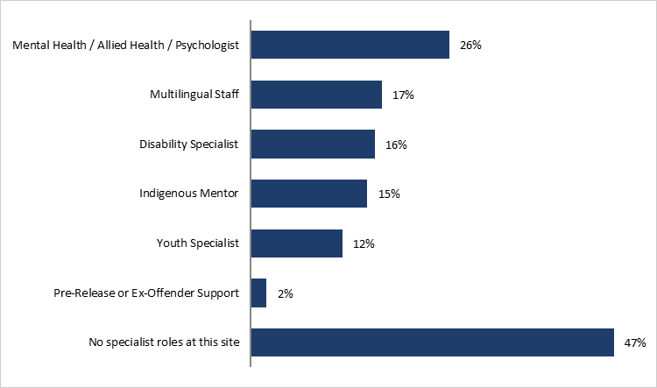

**Source:** 2016 jobactive Provider Survey.

# Effectiveness of jobactive at assisting job seekers to achieve labour market outcomes

|  |
| --- |
| **Key findings**   * There were mixed results on the extent to which jobactive was effective in helping job seekers achieve labour market outcomes over a six-month period early in the program’s implementation. * For new entrant job seekers * For Stream A job seekers, jobactive was less effective than JSA 2012 at supporting job seekers into the labour market. Some possible explanations are discussed below. * For Stream B and C job seekers, jobactive was more effective than JSA 2012. * For caseload job seekers * jobactive was more effective for all three streams, and Stream A job seekers showed the greatest positive effects. * The effect of jobactive was even larger for job seekers in the Work for the Dole phase. * The effect of jobactive varies by job seeker sub-group for both new entrant and caseload job seekers. |

This section of the report contains an assessment of the early effectiveness of jobactive in helping job seekers achieve labour market outcomes.[45] While the performance of jobactive could not be comprehensively assessed at this early stage, due to limited available data, the analysis points to areas of the program that require further examination in the final evaluation.

This section is structured as follows:

* Section 3.1 describes and discusses the outcome measures and population groups used in the analysis for this section.
* Sections 3.2, 3.3 and 3.4 present the results that use three different population groups in order to analyse different aspects of jobactive:
* Section 3.2 examines new entrant populations in order to enable attribution of any outcomes seen under jobactive to the jobactive program (by reducing any influence on outcomes caused by job seekers receiving services under a previous program), and to analyse the implications of the program design for short-term unemployed job seekers.
* Section 3.3 uses caseload populations to examine the effectiveness of jobactive for longer term unemployed job seekers.
* Section 3.4 uses caseload populations who are involved in the Work for the Dole phase of jobactive (or a comparison phase in JSA 2012) to examine the possible impact of an activity phase in the employment program.
* Section 3.5 presents providers’ views that relate to issues of effectiveness raised in this section.

## Outcome measures and job seeker populations used in this evaluation

The overall effectiveness of jobactive at supporting job seekers to achieve employment outcomes is evaluated by comparing income support exit rates, program exit rates and income support dependency rates with those achieved under JSA 2012. For this report, data availability dictated a relatively short-term analysis period of six months.

The labour market outcome measures used in this report are different from paid outcome measures for providers (e.g. 4 Week, 12 Week and 26 Week paid outcomes). The paid outcomes are conditional on job seekers becoming employed and are determined by how long job seekers keep their employment. As such, the paid outcome measures are measures of employment sustainability. This is out of scope for this interim report; however, the final report will include an analysis of the sustainability of job seekers’ employment outcomes.

During the first financial year of jobactive, about 1.35 million job seekers were referred to the program. There were just over 346,000 job placements. Just over 145,000 4 Week outcomes (full and partial) were achieved in jobactive, almost 102,000 12 Week outcomes and 40,000 26 Week outcomes. For the first financial year of JSA 2012, about 1.42 million job seekers were referred. There were just over 355,000 job placements in total. Just over 146,000 13 Week outcomes (full and partial) and 97,000 26 Week outcomes were achieved (see *Appendix E Placements and outcomes under JSA 2012 and jobactive*).

The composition of the characteristics of job seekers varies between JSA 2012 and jobactive — for example, the percentage of participants in an age cohort with reduced capacity to participate, or having part-time rather than full-time participation requirements.[46] Additionally, the national average unemployment rate during the jobactive study period was 5.8 per cent compared with 5.4 per cent in the JSA 2012 study period, reflecting the different labour market conditions operating during the two periods. Statistical techniques have been used to calculate ‘adjusted’ outcome measures that take into account these differences in job seeker characteristics and local unemployment rates. This enabled the results to be attributed to the jobactive program, rather than changes in job seeker characteristics or local labour market conditions (see *Appendix F Methodology used in analysing effectiveness of jobactive* for details). As a reference, and for completeness, raw (unadjusted) outcome rates directly calculated from the data are also provided in the appendix (see *Appendix G Effectiveness of jobactive at assisting job seekers to achieve labour market outcomes — raw (unadjusted) rates compared with adjusted rates*).

### The relationship between program exits, income support exits and job placements

The two exit rates considered in this evaluation are proxies for job seekers obtaining employment. To put these measures in context, Figure 3.1 shows the numbers of job seekers who exited from employment services and income support over the period from October 2012 to May 2016. While there were fluctuations over time, around 60,000 job seekers exited employment services or income support each month over the period. The two exits are not the same because some job seekers:

* left employment services by transferring to a non-activity-tested income support payment such as DSP
* exited employment services but remained on income support while fulfilling their MORs through part-time paid work or a combination of activities including part-time paid work.

The number of placements, also presented in Figure 3.1, is less than half of the exits from employment services or income support. There are at least three reasons for these lower placement numbers. First, not all job seekers who exit from employment services or income support go into employment. Second, many job seekers who find a job may not inform their provider or DHS. Third, providers may not record placements for job seekers who do not attract outcome payments (e.g. Stream A job seekers who have been in services for less than three months).

Figure 3.1: Monthly numbers of placements, program and income support exits (rolling three-month average)

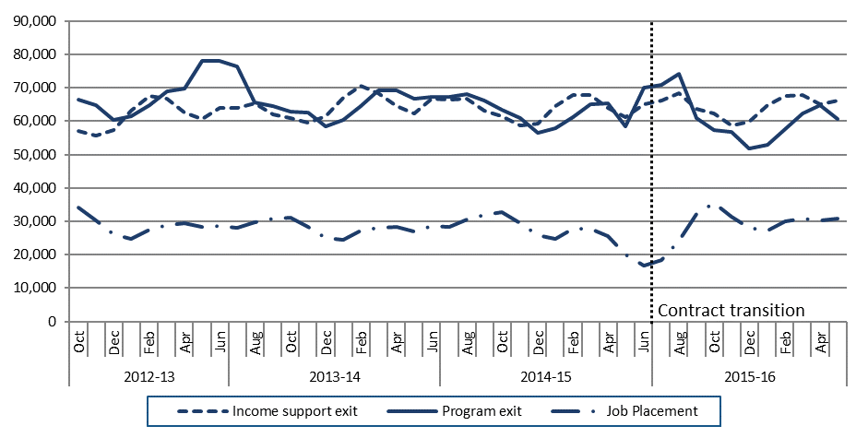

Source: Department of Employment administrative data.

### Income support dependency

Job seekers, including parents and people with disability with part-time participation requirements, can also earn some income while remaining in employment services and continuing to receive income support, subject to meeting income test requirements. Counts of exits from the program or income support, therefore, do not fully capture reductions in income support dependence. To address this, the income support dependency rate (the percentage of an allowance a job seeker is paid, excluding supplemental payments such as Rent Assistance) was also examined. Reductions in this rate can be a proxy for the increase in the proportion of job seekers obtaining employment-related earnings while remaining on income support, such as through temporary or seasonal work, part-time employment that meets participation requirements, or self-employment.[47]

### The study populations used in these analyses

The effectiveness of jobactive was evaluated by comparing outcomes for study populations from jobactive and JSA 2012 (as described in Section 1.5). Both new entrant populations and caseload populations were used for different analyses. These populations exclude those job seekers who did not have MORs[48] at their commencement date (for new entrants) or at the caseload date (for caseload job seekers). For new entrant job seekers, an additional exclusion criterion was applied[49] for job seekers who did have MORs and who were not receiving income support within 28 days of commencement (12.3 per cent of the JSA 2012 and 14.0 per cent of the jobactive new entrant populations).[50]

Job seekers who fell into this category left programs much faster than those receiving income support, and may never receive services. For caseload populations, this exclusion was only applied when analysing exits from income support (i.e. those not receiving income support were not included in the analysis of income support exits). The full dataset was used to analyse caseload exits from program to minimise differences between the study population and the actual caseload. There was only a 0.6 percentage point difference between JSA 2012 and jobactive regarding the number of people on caseload who were not receiving income support, so applying this exclusion is unlikely to affect results.

### Job seeker subgroups **specifically examined within** this analysis

Several sub-groups of job seekers with a particular focus in jobactive have been analysed. These include young job seekers who were targeted by measures such as the Stronger Participation Incentives, and Indigenous job seekers. Other subgroups analysed include job seekers by stream, gender, and length of unemployment, where appropriate.

Both jobactive and JSA 2012 have elements that focused on Indigenous outcomes. Until 31 December 2017, jobactive providers were expected to achieve outcomes in parity with the proportion of Indigenous job seekers on their caseloads, referred to as Indigenous Outcomes Targets.[51],[52] For example, if 5 per cent of the job seekers on a Stream B caseload identified as Indigenous then at least 5 per cent of the provider’s 4 Week, 12 Week and 26 Week outcomes in Stream B were expected to be for Indigenous job seekers. Providers have discretion as to how they service all job seekers, including Indigenous job seekers, so there are no particular strategies mandated for them to achieve these targets. As discussed earlier, since the paid outcome measures are sustainability measures and out of scope for this interim evaluation, this report does not provide an assessment on how providers have progressed against this target. *Appendix I Indigenous Outcomes Targets* provides some high-level analysis on this issue.

Indigenous-focused measures under JSA 2012 included provider produced and implemented Indigenous Employment Strategies and/or an Indigenous Training, Employment and Supplier Plan. An Indigenous Mentoring Pilot operated under JSA 2012 with the aim of providing culturally appropriate and intensive pre- and post-placement mentoring support to voluntarily participating Indigenous job seekers. Twelve JSA 2012 providers piloted the program in areas of high Indigenous job seeker population and employer demand.

## Results on the effectiveness of jobactive for new entrants are mixed

### The new entrant population in jobactive was smaller and slightly more disadvantaged than the corresponding JSA 2012 population

Fewer people commenced in jobactive between October 2015 and December 2015 compared with new entrants to JSA 2012 over the same three-month period in 2012. The jobactive new entrant population was also more disadvantaged, with a higher average JSCI score and a greater percentage of job seekers in Stream B and a smaller percentage in Stream A (see Table 3.1 for the distribution of streams in each program).

Table 3.1: Stream distribution of jobactive new entrant job seekers

|  | **JSA 2012**  **Number** | **JSA 2012**  **%** | **jobactive**  **Number** | **jobactive**  **%** |
| --- | --- | --- | --- | --- |
| **Total job seekers** | **71,211** | **100.0** | **55,648** | **100.0** |
| Stream A | 65,011 | 91.3 | 47,786 | 85.9 |
| Stream B | 4,209 | 5.9 | 7,062 | 12.7 |
| Stream C | 1,991 | 2.8 | 800 | 1.4 |

**Notes:** The characteristics of the new entrant populations were determined at their commencement in services. The above numbers exclude new entrants who did not have MORs at commencement and who did not begin income support within 28 days of commencement.

Source: Department of Employment administrative data.

Relative to JSA 2012, under jobactive there were increases in the proportion of new entrant job seekers who:

* were aged 50 years or over (14.3 per cent compared with 12.7 per cent in JSA 2012)
* were Indigenous (5.4 per cent versus 4.3 per cent in JSA 2012)
* had a reduced capacity to participate (11.1 per cent versus 8.1 per cent in JSA 2012)
* had part-time (12.3 per cent versus 5.4 per cent in JSA 2012) rather than full-time participation requirements.

Similarities between the two study populations of job seekers were found in location, education levels and recent paid full-time work experience. Over 90 per cent of job seekers in each of the programs were receiving NSA or YA(O) as their income support payment (see *Appendix A,* *Table A1* *New entrant study population characteristics*).

### For new entrant job seekers, there were lower overall income support and program exit rates under jobactive than under JSA 2012

Analysis indicates that jobactive was less effective overall than JSA 2012 for new entrant job seekers when using either income support exits or program exits as the outcome measure (see Figure 3.2).

* The adjusted program exit rate for the six-month observation period is 1.0 percentage point lower under jobactive than under JSA 2012.[53]
* The adjusted income support exit rate for the six-month observation period is 2.8 percentage points lower under jobactive than under JSA 2012.[54]

Figure 3.2: Cumulative exit rates for new entrant job seekers

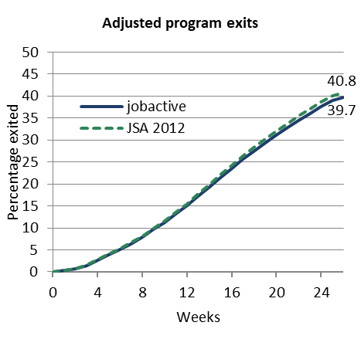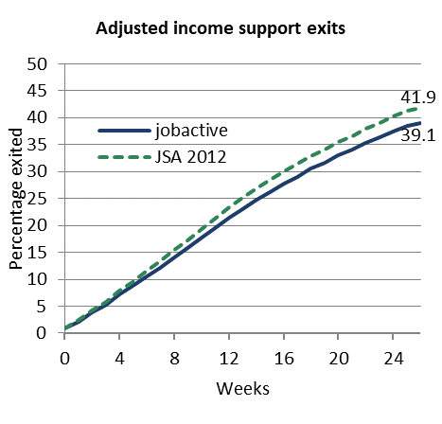

Source: Department of Employment administrative data and the Research and Evaluation Database.

Figure 3.2 shows that when using cumulative exit rates there is no obvious visual evidence of spikes in exits. This suggests that there were no particular events or changes in job seekers’ first six months in services which led to noticeable changes in exit rates. It might have been expected that a greater number of job seekers would exit the program and income support earlier, and the rate of exit would decrease as time passed. (This is the case when unadjusted rates are considered.) Those who needed little assistance to identify appropriate work opportunities could have been expected to leave earlier in their engagement with services, with it becoming more difficult for job seekers to move into work the longer they were unemployed. Figure 3.2, however, accounts for the differences in job seeker disadvantage and therefore no drop in exit rates would be expected.

As discussed in Section 3.1.1, exits from employment services do not necessarily mean exits from income support, and vice versa. For example, of new entrants who exit income support within six months of commencing an employment services program (jobactive or JSA 2012), only around 80 per cent also exit the program within the same time frame. The remaining approximately 20 per cent are still registered as active in services on the date of income support exit. These people are likely to have become volunteers in employment services or are no longer using employment services but have not yet been formally exited by a provider.

Similarly, about 8 per cent of all people who commence both income support and employment services have left employment services, but not income support, within six months. This might occur because job seekers move to an alternative income support program, or meet their MORs in an ongoing and sustainable way — for example, through a combination of part-time work and education. These people are no longer required to remain engaged with an employment services provider but may continue to receive income support payments.

#### jobactive is more effective for more disadvantaged new entrant job seekers as measured by stream, compared to JSA 2012

While jobactive is less effective for new entrants overall, analysis by stream shows that jobactive achieved higher exits for both income support and program than JSA 2012 for Stream B and C new entrant job seekers, and is less effective at achieving exits for Stream A job seekers (see Table 3.2). This suggests that for job seekers’ first six months in services, jobactive is more effective at assisting more disadvantaged job seekers than JSA 2012. This result could be due to the incentive structure embodied in the jobactive program where more disadvantaged job seekers, as defined by stream and length of unemployment, attract substantially higher outcome payments. Under both jobactive and JSA programs, higher streams attracted higher outcome payments, but the absolute value of these payments is substantially higher under jobactive than under JSA 2012 (see Table 1.2 in Section 1). As Stream A job seekers make up over 85 per cent of the total new entrant population for both jobactive and JSA 2012, lower Stream A outcomes for jobactive heavily influence the overall outcomes observed in the analysis.

Table 3.2: Percentage of new entrant job seekers who exited within six months of commencement (adjusted)

| **Category** | **Program exit**  **JSA 2012 (%)** | **Program exit jobactive**  **(%)** | **Program exit difference** | **Income support exit**  **JSA 2012**  **(%)** | **Income support exit**  **jobactive**  **(%)** | **Income support exit**  **difference** |
| --- | --- | --- | --- | --- | --- | --- |
| Overall | 40.8 | 39.7 | -1.0 | 41.9 | 39.1 | -2.8 |
| Stream A | 42.8 | 41.2 | -1.6 | 44.5 | 41.5 | -3.0 |
| Stream B | 22.2 | 26.3 | 4.1 | 16.1 | 16.3 | 0.2 |
| Stream C | 24.7 | 27.0 | 2.3 | 28.6 | 30.0 | 1.5 |
| Female | 40.1 | 40.5 | 0.4 | 38.3 | 36.5 | -1.9 |
| Male | 41.3 | 39.1 | -2.3 | 44.6 | 41.1 | -3.4 |
| Indigenous | 29.7 | 30.8 | 1.1 | 31.6 | 28.2 | -3.4 |
| Non-Indigenous | 41.3 | 40.2 | -1.1 | 42.4 | 39.6 | -2.8 |
| Age under 25 | 42.2 | 44.1 | 1.9 | 41.2 | 39.4 | -1.8 |
| Age 50 or above | 33.9 | 31.9 | -2.1 | 35.3 | 30.6 | -4.6 |

Notes: Results for different subpopulations of job seekers have been modelled separately in order to improve the estimate of the difference between the programs within subpopulations. Difference estimates presented here are subject to rounding error.

Source: Department of Employment administrative data and the Research and Evaluation Database.

#### Results are mixed for other categories of new entrant job seekers

jobactive is delivering better outcomes for some categories of new entrant job seekers than for others, and better outcomes for program exits than income support exits overall, as shown in Table 3.2. Specifically, jobactive is more effective than JSA 2012 at helping new entrant job seekers achieve program exits for:

* females compared to males
* Indigenous job seekers compared to non-Indigenous job seekers
* job seekers aged under 25 years compared to those over 50.

### New entrant job seekers have higher income support dependency under jobactive than JSA 2012

This section examines differences in the income support dependency rate (the percentage of a benefit a job seeker is paid) between JSA 2012 and jobactive. For this analysis, job seekers who were not on income support six months after commencement were allocated a zero rate of income support.

Adjusting for other factors (including initial income support rates), new entrant job seekers into jobactive had a higher dependency on income support six months after commencement compared to JSA 2012. On average, after six months jobactive participants had an adjusted income support dependency rate that was 2.4 percentage points higher than job seekers under JSA 2012 (see Table 3.3).

In particular, income support dependency rates were higher under jobactive for Stream A job seekers (compared with the other streams), Indigenous job seekers (compared with non-Indigenous job seekers), male job seekers (compared with female job seekers) and job seekers aged 50 years and older (compared with job seekers under 25). These results are consistent with the analysis using adjusted income support exit rates, except that the higher income support exit rate for Streams B and C did not result in a lower income support dependency rate for job seekers in those streams. The higher rate of income support dependency under jobactive was due in part to the lower exit rate from income support, because exiting income support was counted as having a 100 per cent reduction in dependency.

Table 3.3: Difference in the average adjusted income support dependency rate at six months from commencement

| **Category** | **Percentage points difference in income support rate**  **(rate under jobactive less rate under JSA 2012)** | |
| --- | --- | --- |
| Overall | 2.4 |
| Stream A | 2.7 |
| Stream B | 1.2 |
| Stream C | 1.0 |
| Indigenous | 3.5 |
| Non-Indigenous | 2.4 |
| Female | 1.9 |
| Male | 2.9 |
| Age under 25 | 1.1 |
| Age 50 or above | 5.3 |

**Note:** A positive percentage point difference indicates higher income support dependency rates under jobactive.

**Source:** Department of Employment administrative data and the Research and Evaluation Database.

## jobactive is more effective than JSA 2012 for caseload (longer term unemployed) job seekers

### Caseload job seeker populations were larger and less disadvantaged under jobactive

As discussed in Section 1.5, due to the short time window for the new entrant population for this interim evaluation, job seekers in the new entrant population tend to be short-term unemployed, and the effectiveness of jobactive for long-term unemployed cannot be examined by using the new entrant population. To address this, in this subsection the effectiveness of jobactive is analysed by using caseload job seekers. Full details of the caseload study population characteristics are contained in Table A2, Appendix A. A summary of key differences between the jobactive and JSA 2012 populations is provided below.

The jobactive caseload study population was 22.8 per cent larger than the equivalent JSA 2012 study population (Table 3.4). This corresponds with a higher number of people on NSA and YA(O) at the time of the jobactive caseload (see Figure 2.1). A greater proportion of the jobactive caseload study population belong to Stream A (51.8 per cent) compared to the JSA 2012 study population who would have been allocated to Stream A under jobactive streaming rules (47.2 per cent).

Table 3.4: Caseload study population total numbers and by stream

|  | **JSA 2012**  **Number** | **JSA 2012**  **%** | **jobactive**  **Number** | **jobactive**  **%** |
| --- | --- | --- | --- | --- |
| **Total job seekers** | **658,278** | **100.0** | **747,683** | **100.0** |
| Stream A | 310,496 | 47.2 | 386,966 | 51.8 |
| Stream B | 180,200 | 27.4 | 216,249 | 28.9 |
| Stream C | 142,668 | 21.7 | 129,735 | 17.4 |
| Volunteer and unknown | 24,914 | 3.8 | 14,733 | 2.0 |

**Source:** Department of Employment administrative data and the Research and Evaluation Database.

More job seekers in the JSA 2012 study population had personal factors likely to affect their job search and labour market performance (33.9 per cent in JSA 2012 and 27.0 per cent in jobactive). The presence and severity of the impact of these personal factors are identified for individual job seekers who have undertaken a Job Capacity Assessment (JCA) or ESAt. Examples of personal factors are caring responsibilities, anger management issues and insomnia. On the other hand, the jobactive caseload contained a higher proportion of older job seekers and a lower proportion of job seekers with full-time requirements, compared with the JSA 2012 caseload (see Appendix A, Table A2 *Caseload study population characteristics*). Furthermore, as noted earlier, the unemployment rate over the jobactive study period was higher than over the JSA 2012 study period.

Caseloads were similar in the geographic distribution of job seekers, Indigenous status, education levels and full-time work experience.

### For caseload populations, there are higher income support exits and program exits overall under jobactive compared to JSA 2012

The jobactive program is more effective for job seekers on the caseload compared to JSA 2012, with higher exits from both income support and the program at the end of the six-month observation period. The adjusted income support exit rate for the six-month observation period is 1.7 percentage points[55] higher under jobactive than under JSA 2012.[56] Using program exits as the outcome measure, the adjusted program exit rate is 4.0 percentage points higher under jobactive than under JSA 2012[57] (see Figure 3.3 and Table 3.4).

The improved effectiveness of jobactive compared to JSA 2012 could be due to the increased focus on outcome payments and/or the earlier timing of an annual activity phase for longer term unemployed job seekers in jobactive relative to JSA 2012. Indeed, the exit rates from caseload were even higher under jobactive than JSA 2012 when only job seekers in the Work for the Dole phase in jobactive and the most comparable phase in JSA 2012 — the Work Experience phase — were considered (see Section 3.4 ahead).

Figure 3.3: Cumulative exit rates — caseload

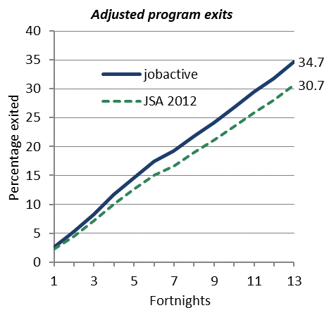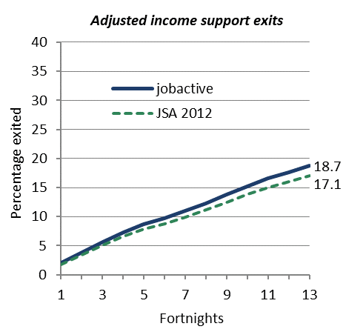

**Note:** The graphs start from the caseload snapshot date. Changes in exit rates may therefore reflect seasonal changes in the labour market.

**Source:** Department of Employment administrative data and the Research and Evaluation Database.

#### jobactive is most effective for Stream A caseload job seekers, followed by Stream C

The jobactive program is more effective than JSA 2012 for job seekers of all streams. When the adjusted income support exit rate at the end of six months is used as the outcome measure, the effectiveness of jobactive is higher for Stream A and C participants and smaller for Stream B participants (2.0, 1.9 and 0.7 percentage points respectively). A similar pattern appears when the adjusted program exit rate is used as the outcome measure — the difference is largest for Stream A participants (4.5 percentage points), followed by Stream C (3.7 percentage points) and Stream B participants (3.1 percentage points) (see Table 3.5).

Table 3.5: Percentage of job seekers who exited within six months of the caseload snapshot date (adjusted)

| **Category** | **Program exits**  **JSA 2012**  **(%)** | **Program exits**  **jobactive**  **(%)** | **Program exits**  **difference** | **Income support exits**  **JSA 2012**  **(%)** | **Income support exits**  **jobactive**  **(%)** | **Income support exits**  **difference** |
| --- | --- | --- | --- | --- | --- | --- |
| Overall | 30.7 | 34.7 | 4.0 | 17.1 | 18.7 | 1.7 |
| Stream A | 35.4 | 39.9 | 4.5 | 25.3 | 27.3 | 2.0 |
| Stream B | 24.8 | 27.9 | 3.1 | 8.6 | 9.3 | 0.7 |
| Stream C | 27.7 | 31.3 | 3.7 | 8.9 | 10.8 | 1.9 |
| Female | 28.4 | 32.4 | 4.0 | 13.9 | 14.7 | 0.8 |
| Male | 32.8 | 36.7 | 4.0 | 20.0 | 22.4 | 2.5 |
| Indigenous | 32.3 | 35.1 | 2.8 | 12.2 | 14.0 | 1.8 |
| Non-Indigenous | 30.6 | 34.7 | 4.1 | 17.5 | 19.2 | 1.7 |
| Age under 25 | 38.1 | 44.6 | 6.6 | 22.0 | 23.4 | 1.4 |
| Age 50 or over | 21.6 | 28.1 | 6.5 | 11.3 | 12.5 | 1.1 |
| Income support < 12 months | 40.6 | 44.9 | 4.4 | 28.5 | 31.4 | 2.9 |
| Income support  12–24 months | 30.4 | 35.4 | 5.0 | 16.8 | 18.6 | 1.8 |
| Income support > 24 months | 23.7 | 27.6 | 3.9 | 9.4 | 10.1 | 0.8 |

**Note:** Results are calculated for the ‘average’ job seeker within each category. Income support exits include only those job seekers who were on income support on the caseload date.

**Source:** Department of Employment administrative data and the Research and Evaluation Database.

#### Why might we be seeing these results?

Compared with JSA 2012, the incentive structure under jobactive provides more rewards for employment outcomes overall, and makes higher payments for employment outcomes for the most disadvantaged job seekers (as defined by stream and length of unemployment). This could, at least to some extent, explain why jobactive was more effective than JSA 2012 for the caseload job seeker populations, which consisted mainly of long-term unemployed people. It could also explain why for the new entrant populations jobactive was more effective than JSA 2012 for Stream B and C job seekers but less effective for Stream A job seekers.

Another factor that could have influenced the positive outcomes of jobactive for the caseload job seekers is the difference in transition from the respective previous contracts. Job seekers were required to complete a new Job Plan when transitioning from JSA 2012 to jobactive, which was not required of job seekers transitioning from JSA 2009 to JSA 2012. Additionally, fewer providers continued from JSA 2012 to jobactive, when compared with the transition from JSA 2009 to JSA 2012, meaning more job seekers were required to transfer to a new provider. These changes, and a renewed focus on getting work, could have increased the exit rates for jobactive.

A new Job Seeker Classification Instrument (JSCI) point structure was introduced with jobactive. There are three streams in jobactive, as opposed to four in JSA. In order to compare job seeker populations the evaluators determined the jobactive equivalent stream for job seekers in JSA 2012. Some job seekers who were in Streams 2 and 3 in JSA 2012 would have been streamed to Stream A had they been assessed under the jobactive model. Stream 2 and 3 job seekers under JSA 2012 attracted higher outcome payments and administrative fees than would be paid if they were in jobactive’s Stream A. Providers were therefore better incentivised to service these particular job seekers under JSA 2012. This could be another reason why jobactive was less effective than JSA 2012 for new entrant Stream A job seekers.

Under jobactive, providers can claim paid outcomes for Stream A job seekers significantly earlier (i.e. when job seekers are placed in a job after having been in services for at least three months) than they could under JSA 2012 (i.e. when job seekers were placed in a job after having been in services for at least 12 months). It might therefore be expected that jobactive would show more positive results for Stream A job seekers. While this is evident for the caseload job seekers, jobactive does not appear to be more effective for new entrant job seekers in Stream A.

#### Providers are concerned with job seeker streaming

It is worth noting that while jobactive is more effective at helping caseload job seekers achieve employment outcomes than JSA 2012, particularly for Streams A and C, providers expressed dissatisfaction with the way certain categories of job seekers are allocated to a stream in jobactive. In the jobactive Provider Survey 2016 almost two-thirds of providers (63 per cent) reported that they were dissatisfied with the way job seekers were allocated to a stream. Of the providers who were dissatisfied with the way job seekers are allocated to a stream, four-fifths reported that they had experienced unexpected streaming results. The four job seeker groups that providers reported most often as having unexpected streaming results were ex-offenders / pre-release prisoners; long‑term / very long-term unemployed; job seekers with low English proficiency; and Aboriginal and Torres Strait Islander job seekers. Note that these characteristics form only part of the set of factors taken into account in the stream allocation process (see Section 1.3 for details).

These findings were consistent with those reported in the 2015–16 provider qualitative fieldwork, where providers consistently reported dissatisfaction with streaming results for ex-offenders, job seekers with low English proficiency and job seekers with complex mental health and drug and alcohol issues.

#### Providers are supportive of the principle of the outcome-based funding model but have concerns about long-term viability

Providers involved in the qualitative research generally supported the principle of an outcome-related funding model, acknowledging that funding was directly related to the program objectives of jobactive. However, discussions with senior managers and peak body representatives revealed early concerns about the longer term viability of the jobactive funding model. This concern was twofold. First, providers perceived a much higher administrative burden in the jobactive model than had been anticipated, particularly associated with Work for the Dole. Second, they were concerned about their inability to achieve outcomes as large proportions of job seekers have significant labour market barriers. These barriers are present not only in Stream C but also increasingly in Stream A job seekers.

It should be noted that the provider research was conducted at an early stage of jobactive. The concerns over financial viability might reflect the lack of opportunity to receive outcome payments, particularly 26 Week outcome payments, in the early months of the jobactive contract. In an effort to address and alleviate provider concerns, the Department provided an initial advance of administrative fees on 1 July 2015 to assist with transition, and offered providers an advance payment of administration fees and an advance component of employment outcome fees in November 2015.

#### Effectiveness of jobactive varies for other categories of caseload job seekers

As can be seen in Table 3.5, among the other sub-groups of job seekers examined, jobactive appears to be delivering better outcomes for some categories of job seekers than others, and better outcomes for program exits than income support exits overall. Specifically, when compared with JSA 2012:

* jobactive is more effective for male job seekers, and only marginally more effective for female job seekers in terms of exiting income support. The relative effectiveness of jobactive in terms of exiting programs was the same for both females and males.
* The effectiveness of jobactive is similar for Indigenous and non-Indigenous job seekers when comparing income support exits. But jobactive is more effective in helping achieve program exits for non-Indigenous job seekers.
* jobactive is more effective for younger job seekers for exits from income support than older job seekers. This suggests SPI may be having an impact on young job seekers. This issue will be examined in future analyses.
* When job seekers are grouped by time on income support as a proxy for unemployment length at the caseload date, jobactive is shown to be more effective at moving the shorter term unemployed (i.e. less than 12 months) off income support, compared to the long-term unemployed (i.e. 12 to less than 24 months) and very long-term unemployed (i.e. 24 months or longer).
* jobactive appears to be most effective for the long-term unemployed, and least effective for the very long-term unemployed. Caution must be exercised in attributing higher outcomes to the jobactive program for long-term and very long-term unemployed job seekers, as these job seekers in jobactive would have also been influenced by their previous experience in JSA 2012.

### For caseload job seekers there is slightly lower income support dependency overall under jobactive compared to JSA 2012

Using income support dependency as an outcome measure, jobactive job seekers have, on average, an income support dependency rate that is 1.5 percentage points lower at the end of the observation period than JSA 2012 job seekers (Table 3.6). These results are consistent with the exit rate analysis in Section 3.3.2.

Again, the degree of improvement varies for different categories of job seekers (See Table 3.5):

* The reduction in income support dependency from JSA 2012 to jobactive is highest for Stream C. For Stream B participants the reduction in income support dependency is very small in magnitude.
* jobactive reduces income support dependency the most for the very long-term unemployed, followed by shorter term unemployed job seekers.
* jobactive reduces income support dependency relative to JSA 2012 for both Indigenous and non-Indigenous job seekers, by about the same degree.
* jobactive is more effective in reducing income support dependency for male job seekers than for female job seekers. To some extent this may be because a higher proportion of women than men were receiving Principal Carer Parent payments. Principal Carer Parent recipients do not have MORs prior to their youngest child turning six. They are also able to meet their activity requirements by part-time work once their youngest child turns six. Women who are parents are also more likely to be working part-time to meet their MORs, and therefore may not be looking for further work, even when their children are older.
* jobactive is more effective in reducing income support dependency for job seekers aged under 25) than for job seekers aged 50 and older.

The lower rate of income support payments under jobactive suggests that there are higher levels of employment-related earnings, seasonal or temporary employment, or self-employment under jobactive than under JSA 2012.

Table 3.6: Difference in the average adjusted income support dependency rate at six months from caseload date

| **Category** | **Percentage points difference in income support rate**  **(rate under jobactive less rate under JSA 2012)** | |
| --- | --- | --- |
| Overall | -1.5 |
| Stream A | -1.5 |
| Stream B | -0.1 |
| Stream C | -2.3 |
| Indigenous | -1.2 |
| Non-Indigenous | -1.5 |
| Female | -0.4 |
| Male | -2.5 |
| Age under 25 | -1.4 |
| Age 50 or above | -0.8 |
| Income support < 12 months | -1.2 |
| Income support 12–24 months | -0.9 |
| Income support > 24 months | -1.7 |

**Note:** A negative percentage point difference indicates lower income support dependency rates under jobactive.

**Source:** Department of Employment administrative data and the Research and Evaluation Database.

## jobactive Work for the Dole phase is more effective than the comparable JSA 2012 phase at assisting job seekers to achieve labour market outcomes

### Job seeker populations used for the Work for the Dole analysis

This subsection evaluates the effectiveness of one of the mutual obligation aspects of jobactive, the Work for the Dole phase. In the Work for the Dole phase job seekers are required to undertake activities as a means of improving their job prospects, including participation in a Work for the Dole activity or other approved activities, such as part-time work or unpaid work experience (see Table 3.7 for details). Depending on a job seeker’s circumstances, the initial policy settings provided for a job seeker to commence in the Work for the Dole phase after six or 12 months in services, (including time in JSA 2012 services for job seekers who transitioned from JSA 2012 to jobactive).[58]

The effectiveness of the Work for the Dole phase of jobactive was evaluated by comparing it with the most comparable phase in JSA 2012 — the Work Experience phase. This comparison is undertaken because both phases were designed to have compulsory activities of an extended duration and intensity for job seekers. However, there are notable differences between the two phases (see Table 3.7 for details). An important difference is that, for the period covered by this interim evaluation, the majority of new entrants in jobactive were expected to commence in the Work for the Dole phase after six months in services, compared to 12 months in services before entering the Work Experience phase in JSA 2012. A caseload population (rather than new entrant population) was used for this analysis because new entrant job seekers in jobactive had not had sufficient time to commence in the Work for the Dole phase during the observation period.

Job seekers are in the study population if they were in the Work Experience phase of JSA 2012 on 1 October 2012 (19 per cent of the JSA 2012 caseload), or in the Work for the Dole phase of jobactive on 1 October 2015 (28 per cent of the jobactive caseload). In other words, the study population of this section is a subset of the caseload study population described in Section 1.5 and used for Section 3.3. As a result of using the caseload job seekers for the analysis, job seekers in the jobactive Work for the Dole phase included many long-term unemployed who transitioned into jobactive from JSA. As the outcomes achieved by job seekers in the Work for the Dole phase will have been influenced by their previous experience in JSA, any outcomes achieved under jobactive cannot be attributed to jobactive alone, but provide information about possible trends to be examined further in later reporting.

The use of job seekers transitioning directly from JSA also makes it difficult to estimate the ‘threat effect’ of Work for the Dole (that is, people leaving services prior to commencing the Work for the Dole phase in order to avoid the activity),[59] as the analysis only included those people who were already in the phase. The ‘threat effect’ will be examined in future reporting when a larger new entrant dataset is available.

As in the previous subsection, effectiveness is measured by income support exit rates, program exit rates and income support dependency rates, adjusted for differences in job seeker characteristics and the local unemployment rate between the programs.

Table 3.7: Job seeker requirements in the Work Experience phase of JSA 2012 and the Work for the Dole phase of jobactive during the interim report analysis period

| JSA 2012 | jobactive |
| --- | --- |
| **Entry to phase**   * Job seekers in Streams 1 to 3 generally commenced the Work Experience phase after 12 months of stream services. * Job seekers in Stream 4 generally commenced the Work Experience phase after 12 or 18 months of stream services. * Job seekers outside the phase could choose to participate in activities voluntarily. | **Entry to phase (in general and not including volunteers)**   * Stream A and SPI participants enter the Work for the Dole phase after six months in services (SPI participants include job seekers aged less than 30 years in Stream A and some, more work-ready, Stream B job seekers). * Participants in jobactive who are not Stream A or SPI enter the Work for the Dole phase after 12 months in services. * Job seekers outside the phase can choose to participate in activities (including Work for the Dole activities) voluntarily. * For job seekers transitioning from JSA, time in program and job seeker characteristics (age and stream) were taken into account in the timing of when they entered the Work for the Dole phase. All job seekers in the Work for the Dole phase for this section’s analysis should be job seekers who transitioned from JSA 2012. |
| **Requirements in phase**   * Job seekers with a work experience activity requirement were required to participate in a work experience activity/activities over a 26‑week period when they were in the Work Experience phase. * This typically included job seekers aged 18 to 49. | **Requirements in phase**   * Most job seekers are required to undertake Work for the Dole or other approved activities for six continuous months each year to continue to receive income support. * The number of hours of activity participation per week that is required varies by age. |
| Choice of activity   * Job seekers and providers identified the activities to be undertaken during the Work Experience phase and included them in the Employment Pathway Plan. * Work Experience phase activities included vocational training, non-vocational training, part-time/casual employment, Work for the Dole, voluntary work, or other activities. | Choice of activity   * The default activity for the Work for the Dole phase is Work for the Dole. These Work for the Dole activities must focus on providing job seekers with work-like experiences. * Alternative activities in the Work for the Dole phase include unpaid work experience, voluntary work, part-time work, part-time study or training, accredited language and literacy courses, Defence Force Reserves, NEIS training, other government programs and the Green Army Program. * Placements should include skills that are in demand within the local labour market and provide training that is relevant to, or a pre-requisite for, the activity that is being undertaken. |

**Note:** Changes to the SPI criteria from 1 July 2016 have implications for requirements under Work for the Dole phase; however, this is beyond the study period considered in this section. From 1 October 2016, all job seekers will move to Work for the Dole after 12 months in services.

### The jobactive Work for the Dole phase population is less disadvantaged than the JSA 2012 Work Experience phase population

The jobactive study population for the Work for the Dole phase was almost double the size of the JSA 2012 Work Experience phase study population, in part because of the earlier entry into the Work for the Dole phase compared with entry into the Work Experience phase.[60]

Because of the earlier entry of job seekers into the jobactive Work for the Dole phase, it would be expected that the population in that phase should be less disadvantaged than the population in the JSA 2012 Work Experience phase. The distribution of job seekers by stream suggests this is the case, as can be seen in Table 3.8. In the Work for the Dole phase of jobactive around half of job seekers were in Stream A, and only about 20 per cent were in Stream C, while job seekers were more equally distributed across the three streams in JSA 2012.

Table 3.8: Work for the Dole phase and Work Experience phase study population characteristics

|  | **Work Experience phase** | | **Work for the Dole phase** | |
| --- | --- | --- | --- | --- |
|  | **Number** | **%** | **Number** | **%** |
| **Total job seekers** | **118,818** | **100.0** | **211,787** | **100.0** |
| **jobactive Stream** |  |  |  |  |
| Stream A | 38,822 | 32.7 | 104,022 | 49.1 |
| Stream B | 38,092 | 32.1 | 58,738 | 27.7 |
| Stream C | 38,262 | 32.2 | 46,136 | 21.8 |
| Volunteer and unknown | 3,642 | 3.1 | 2,891 | 1.4 |

**Source:** Department of Employment administrative data and the Research and Evaluation Database.

Other indicators of a slightly less disadvantaged group in the jobactive Work for the Dole phase include a higher proportion of job seekers with paid full-time work experience before having joined employment services (20 per cent compared with 14 per cent for JSA 2012 Work Experience phase) and a smaller proportion with high-impact personal factors that would affect job-readiness (16 per cent high-impact for jobactive Work for the Dole phase compared with 24 per cent for JSA 2012 Work Experience phase). There were also differences in the distribution of age groups and benefit types, with the jobactive Work for the Dole phase having more job seekers over 50 years and fewer under 25 years, and more job seekers on NSA (see Appendix A, Table A3 *Work for the Dole phase and Work Experience phase study population characteristics*).

Similarities between the two groups were found in the distribution of job seekers in terms of location, Indigenous status, education levels and participation requirements.

### Higher income support exits and program exits in the jobactive Work for the Dole phase than the JSA 2012 Work Experience phase

Using exits from employment services after six months as the outcome measure, the Work for the Dole phase of jobactive is more effective than the Work Experience phase of JSA 2012. The adjusted program exit rate for the six-month observation period was 3.9 percentage points higher in the Work for the Dole phase than in the Work Experience phase.[61] Similarly, using exits from income support as the outcome measure, the Work for the Dole phase was also more effective than the Work Experience phase. The adjusted income support exit rate for the six-month observation period was 1.6 percentage points higher in jobactive’s Work for the Dole phase than in JSA 2012’s Work Experience phase [62] (Figure 3.4).

Figure 3.4: Cumulative exit rates — Work for the Dole phase and Work Experience phase

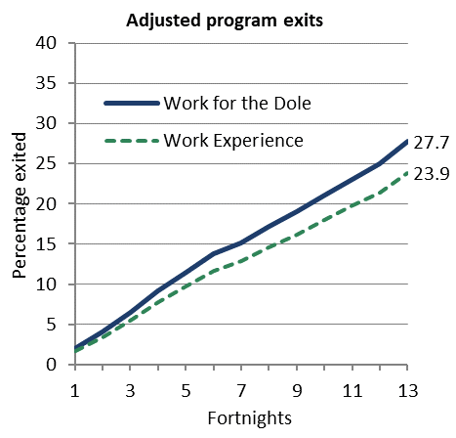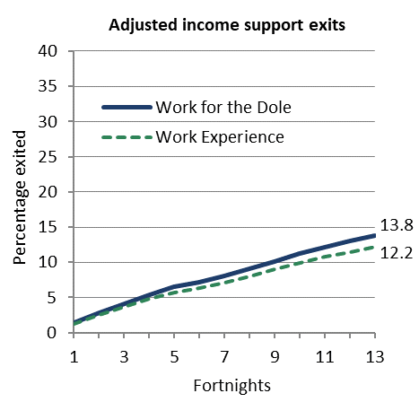

**Note:** The graphs show cumulative exits by fortnights since the caseload snapshot date.

**Source:** Department of Employment administrative data and the Research and Evaluation Database.

The higher exit rates in the Work for the Dole phase could be due to the more work-like nature of approved activities in the Work for the Dole phase relative to the Work Experience phase. When longer term data is available, analyses will compare specific activity types within jobactive to better understand the effects of activities on outcomes.

#### The relative effectiveness of the Work for the Dole phase is largest for Stream A job seekers

The Work for the Dole phase is more effective than the Work Experience phase in achieving both program and income support exits for job seekers of all streams, but the effectiveness of jobactive’s Work for the Dole phase relative to JSA 2012’s Work Experience phase in achieving both program and income support exits is largest for Stream A job seekers. Using the adjusted income support exit rates as the outcome measure, the difference in the exit rate between the two programs was 2.9 percentage points for Stream A job seekers, followed by small differences for Stream C (0.4 percentage points) and Stream B job seekers (0.3 percentage points)[63] (see Table 3.9).

#### The relative effectiveness of jobactive’s Work for the Dole phase varies for other job seeker characteristics

The Work for the Dole phase of jobactive is more effective for non-Indigenous job seekers. This is most pronounced for exits from the program.

The relative effectiveness of the Work for the Dole phase by age group varies depending on the outcome measure used. When exits from employment services are used, the Work for the Dole phase was slightly more effective relative to the Work Experience phase for mature-age job seekers than for younger job seekers. When exits from income support were used, jobactive’s Work for the Dole phase was slightly more effective relative to JSA 2012’s Work Experience phase for job seekers under 25 years than for job seekers aged 50 and older.

The relative effectiveness of the Work for the Dole phase by gender varied depending on the outcome measure used. The Work for the Dole phase under jobactive was slightly more effective for male job seekers than for female job seekers when using income support exits as the outcome measure, but slightly more effective for female job seekers than for male job seekers when using program exits as the outcome measure.

#### Length of unemployment does not appear to be the factor driving results.

The jobactive Work for the Dole phase started after six months in services for Stream A job seekers at the time of this study, as opposed to 12 months for JSA job seekers. As a result, the jobactive Work for the Dole study population had, on average, shorter duration of unemployment than the JSA 2012 study population (Table A.3). It is likely that higher exit rates under jobactive’s Work for the Dole phase are partly due to this fact.

To further investigate this issue,[64] job seekers were divided into three groups based on their time on income support at caseload start (as a proxy for unemployment length at caseload start), and the groups were analysed separately. The results show that when exits from income support are used as the outcome measure, the effectiveness of jobactive’s Work for the Dole relative to JSA 2012’s Work Experience is largest for the shorter term unemployed (i.e. less than 12 months unemployed) and smallest for the very long-term unemployed (i.e. 24 months or longer unemployed). Note that the very long-term unemployed in jobactive would already have experienced the Work Experience phase of JSA 2012.

When program exits are used as the outcome measure, the effectiveness of jobactive’s Work for the Dole phase relative to JSA 2012’s Work Experience phase is largest for the long-term unemployed, and is similar for the shorter term unemployed and the very long-term unemployed, (see Table 3.9).

Notwithstanding the variations, the results indicate that jobactive’s Work for the Dole phase achieves higher exit rates from both program and income support than JSA 2012’s Work Experience phase, for job seekers in all three categories of unemployment duration, suggesting that the effectiveness of the Work for the Dole phase was not driven by there being more short-term unemployed job seekers in the Work for the Dole phase than in the Work Experience phase.

Analysis using matching techniques produces similar results to those reported in Table 3.9 (see *Appendix J Propensity-matched job seeker analyses in the jobactive Work for the Dole phase* for details).

Table 3.9: Percentage of job seekers who exited within six months of the caseload snapshot date — Work Experience and Work for the Dole phases

|  |  |  |  |  |  |  |  |
| --- | --- | --- | --- | --- | --- | --- | --- |
| **Category** | **Program exits**  **JSA 2012**  **(%)** | **Program exits**  **jobactive**  **(%)** | **Program exits**  **difference** |  | **Income support exits**  **JSA 2012**  **(%)** | **Income support exits**  **jobactive**  **(%)** | **Income support exits**  **difference** |
| Overall | 23.9 | 27.7 | 3.9 |  | 12.2 | 13.8 | 1.6 |
| Stream A | 27.5 | 32.3 | 4.8 |  | 18.4 | 21.3 | 2.9 |
| Stream B | 19.4 | 22.8 | 3.3 |  | 7.7 | 8.0 | 0.3 |
| Stream C | 22.9 | 25.6 | 2.8 |  | 7.3 | 7.7 | 0.4 |
| Female | 21.9 | 26.0 | 4.1 |  | 10.3 | 11.3 | 1.0 |
| Male | 25.4 | 29.0 | 3.6 |  | 13.8 | 15.7 | 1.9 |
| Indigenous | 26.7 | 27.0 | 0.3 |  | 8.5 | 9.2 | 0.7 |
| Non-Indigenous | 23.6 | 27.8 | 4.2 |  | 12.7 | 14.3 | 1.7 |
| Age under 25 | 31.1 | 36.4 | 5.3 |  | 16.0 | 18.3 | 2.3 |
| Age 50 or over | 15.1 | 22.2 | 7.1 |  | 8.6 | 9.4 | 0.8 |
| Income support < 12 months | 37.3 | 40.5 | 3.2 |  | 20.7 | 26.6 | 5.9 |
| Income support 12–24 months | 27.2 | 33.6 | 6.4 |  | 18.3 | 21.2 | 2.9 |
| Income support > 24 months | 21.0 | 24.4 | 3.4 |  | 9.3 | 10.0 | 0.7 |

**Note:** The average of rows that taken together cover the population (e.g. Stream A, Stream B and Stream C) will not necessarily reflect the overall rate, as the ‘average’ person characteristics differ between rows.

**Source:** Department of Employment administrative data and the Research and Evaluation Database.

### Income support dependency is lower for Stream A and younger job seekers in the jobactive Work for the Dole phase than in the JSA 2012 Work Experience phase

Job seekers had similar dependency on income support at the end of the six-month observation period in the Work for the Dole phase compared to the Work Experience phase, when accounting for job seeker characteristics and local unemployment rates. Further analyses indicate that the job seekers in Stream A and aged under 25 had a lower income support dependency in the Work for the Dole phase at the end of the six-month observation period (Table 3.9) when compared to the Work Experience phase.

The lower income support dependency in the Work for the Dole phase for Stream A and young job seekers could suggest that there were higher levels of employment-related earnings, seasonal or temporary employment or self-employment in the Work for the Dole phase than in the Work Experience phase. It may also indicate that employment was being reported at higher rates by job seekers, rather than a real change in employment levels under jobactive’s Work for the Dole than under JSA 2012’s Work Experience. This is because job seekers who were already working some hours may have had a stronger incentive to report this in order to meet partially their required hours of activity in the Work for the Dole phase.

Table 3.10: Difference in the average adjusted income support rate at six months from caseload date — Work for the Dole phase versus Work Experience phase

| **Category** | **Percentage points difference in income support dependency rate**  **(rate under Work for the Dole phase less rate under Work Experience phase)** | |
| --- | --- | --- |
| Overall | -0.3 |
| Stream A | -1.0 |
| Stream B | 0.1 |
| Stream C | 0.8 |
| Indigenous | 0.6 |
| Non-Indigenous | -0.4 |
| Female | 0.0 |
| Male | -0.5 |
| Age under 25 | -1.2 |
| Age 50 or above | 0.2 |

**Source:** Department of Employment administrative data and the Research and Evaluation Database.

# Regulatory and administrative burden and provider collaboration

|  |
| --- |
| **Key points**   * The regulatory and administrative burden associated with reporting on service operations and outcomes has declined significantly in jobactive, and is concentrated in the assessment of whether job seekers are meeting their MORs. * Despite overall reductions in estimated regulatory and administrative costs under jobactive, the perceived level of regulatory and administrative burden in employment services remains significant. * Providers reported organising Work for the Dole activities and administering Annual Activity Requirements as being the most unnecessarily complex, time consuming and repetitive administrative activities. * Providers are sceptical of collaboration in a competitive market. |

## Regulatory and administrative burden in employment services

In employment services, regulations are imposed on providers, employers and job seekers to ensure appropriate risk management and accountability of public expenditure. A suitable balance is required to ensure the integrity of the program is maintained while allowing for the market to meet the objectives of the suite of employment programs.

New system tools and a less prescriptive employment services model, involving the design of bespoke Service Delivery Plans by providers, were introduced with jobactive. The objectives of this were twofold: to reduce the regulatory and administrative burden of providers, and to enhance the flexibility and adaptability of providers’ service provision.

### The definition of regulatory and administrative costs follows that of the Office of Best Practice Regulation

The Office of Best Practice Regulation (OBPR) defines the costs associated with regulatory and administrative burden as:

… *the costs incurred by regulated entities primarily to demonstrate compliance with the regulation.[65]*

For the purpose of this report, the regulatory and administrative burden is defined as additional costs to meet reporting requirements of government, beyond ‘business as usual’ or administrative costs associated with the contractual delivery of employment services. For example, maintaining a job seeker appointment register is not considered a regulatory and administrative burden as this is required for the everyday running of the business. However, requirements to report non-attendance at appointments or other processes that do not support standard business practices by the Department or DHS may be considered an administrative burden.

## Estimated regulatory and administrative burden decreases from JSA to jobactive

The Department has estimated the level of regulatory and administrative burden imposed on key stakeholders including providers, employers and job seekers, using guidance from the Regulatory Burden Measurement Framework provided by the OBPR. These estimates show the total estimated costs of complying with regulations for JSA 2009, JSA 2012 and jobactive. These estimates are also provided for each main component of the program, such as job seeker compliance and participation and stream services operations (Table 4.1).

Table 4.1: Annual compliance cost estimates under each contract by activity

| **Activity** | **JSA 2009** | **JSA 2012** | **jobactive** |
| --- | --- | --- | --- |
| Stream Services Operations | $93,736,252 | $37,914,555 | $1,123,446 |
| Outcomes | $87,622,278 | $77,931,819 | $16,833,506 |
| Job Seeker Compliance and Participation | $31,671,387 | $44,224,595 | $60,869,374 |
| JSA/jobactive Provider Operations | $30,039,786 | $30,039,786 | $13,629,856 |
| Employment Pathway Plans / Job Plans | $29,272,214 | $29,272,214 | $16,821,932 |
| Work Experience phase / Annual Activity Requirement | $17,414,174 | $18,745,699 | $64,729,082 |
| Employment Pathway Fund / Employment Fund | $13,268,562 | $13,809,435 | $9,885,504 |
| Registration and Assessments | $11,867,821 | $2,217,563 | $1,306,113 |
| Contract Management | $5,971,229 | $2,591,329 | $3,020,740 |
| Work for the Dole Coordinators | $0 | $0 | $8,103,261 |
| Indigenous Employment Strategy | $0 | $30,332 | $24,413 |
| Move to Work / Relocation Assistance | $0 | $123,419 | $70,553 |
| Wage Connect | $0 | $1,333,505 | $0 |
| Harvest Labour Services | $607,363 | $607,363 | $251,532 |
| Harvest Labour Information Services | $694 | $694 | $694 |
| New Enterprise Incentive Scheme | $413,870 | $413,870 | $459,902 |
| Total regulatory and administrative burden costs | $321,885,630 | $259,256,178 | $197,129,909 |

Note: Table 4.1 contains the current regulatory and administrative burden costs as provided to the Office of Best Practice Regulation (OBPR), as at 30 August 2016. JSA 2009 estimates were not provided to OBPR, but derived using the same methodology based on feedback from the relevant program areas.

Source: Department of Employment 2016c.

The estimates show that the cost of the regulatory and administrative burden associated with JSA declined significantly over the six years prior to the commencement of jobactive (Figure 4.1 and Table 4.1).[66]

This is demonstrated by:

* Estimated regulatory and administrative burden costs declined 19.5 per cent between JSA 2009 ($321.9 million) and JSA 2012 ($259.3 million). They declined a further 24.0 per cent between JSA 2012 ($259.3 million) and jobactive ($197.1 million).
* The reduction in regulatory and administrative burden has primarily affected providers, with estimated annual regulatory and administrative burden costs declining from $219.2 million (JSA 2012) to $143.9 million (jobactive). This reduction also resulted in a change of the proportion of regulatory and administrative burden costs attributable to providers from 84.5 per cent to 73.0 per cent.
* Regulatory and administrative burden for employers and host organisations increased from $30.4 million to $49.1 million. This was primarily due to changes in activity requirements requiring host organisations to provide updates on job seeker participation. The proportion of regulatory and administrative burden costs attributable to employers and host organisations increased from 11.7 per cent under JSA 2012 to 24.9 per cent under jobactive. The Regulatory Impact Statement which calculated the estimates above included Work for the Dole hosts in this category. It would be expected, given the design of jobactive, that much of the estimated increase in regulatory and administrative burden for this category related to Work for the Dole activities.
* Regulatory and administrative burden costs are concentrated in assessing whether job seekers are meeting MORs. The highest costs for jobactive are in the activities of job seeker compliance and participation and the Activity Requirement phase. This differs from JSA, where the higher cost areas were compliance and participation and outcome payment processing.
* Regulatory and administrative burden costs for outcomes reporting declined an estimated 78.4 per cent from JSA 2012 to jobactive. This was because providers were no longer required to collect documentary evidence for employment outcome claims directly from employers when it could be verified through DHS.
* Regulatory and administrative burden cost estimates for stream services operations declined 97.0 per cent. This is a result of the removal of requirements for documentary evidence relating to job seeker appointments and interviews.
* Regulatory and administrative burden costs for job seeker compliance and participation increased by 37.6 per cent due, primarily, to increased job search requirements. Most job seekers are now required to search for 20 jobs per month.
* Regulatory and administrative burden costs associated with the Work Experience / Work for the Dole phase increased an estimated 245.3 per cent. This is a result of the expansion of Work for the Dole and recording requirements for time spent placing a job seeker into an activity and participation in that activity.

Figure 4.1: Annual compliance cost estimates under each contract by activity

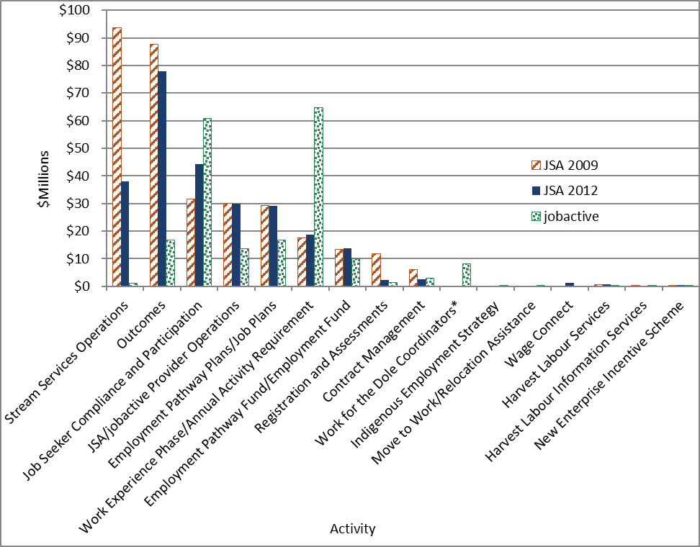

Source: Department of Employment 2016c.

Note: *This represents Work for the Dole Coordinators’ reported burden and employers’ reported burden when interacting with them.

Despite an overall decline in the regulatory and administrative burden, costs imposed on providers, employers and job seekers are still significant. With jobactive costing $1,022.5 million in 2015–16, annual regulatory and administrative burden costs of $196.4 million represent 19.3 per cent of total funding.[67] [68]

## Provider perceptions of regulatory and administrative burden largely correspond with the estimations

In the 2016 jobactive Provider Survey, a series of questions examined providers’ perceptions of the level of regulatory and administrative burden associated with the key activities that the OBPR estimates indicate impose the greatest regulatory and administrative burden on providers. Areas specifically covered include departmental requirements related to the compliance framework, Annual Activity Requirements, outcomes and the Employment Fund.

Providers were asked to provide their level of agreement to whether the key activities listed were unnecessarily complex, time consuming and repetitive. Net agreement to a statement was then derived by subtracting the percentage of ‘disagrees’ from the percentage of ‘agrees’ to a statement.[69]

It should be noted that the Advisory Panel on Employment Services Administration and Accountability Final Report (2012) noted that many providers maintain parallel data management systems, and that this creates an additional administrative burden, above that required by the Department.[70] While the report encouraged providers to examine and streamline their own systems, it is possible that parallel systems still remain. Respondents may have found it difficult to distinguish between the Department’s administration and that of their own provider organisations. Therefore the data quoted below may overstate the burden associated with the Department’s requirements.

Figure 4.2: Net agreement by providers on administrative activities being unnecessarily complex, time consuming and repetitive

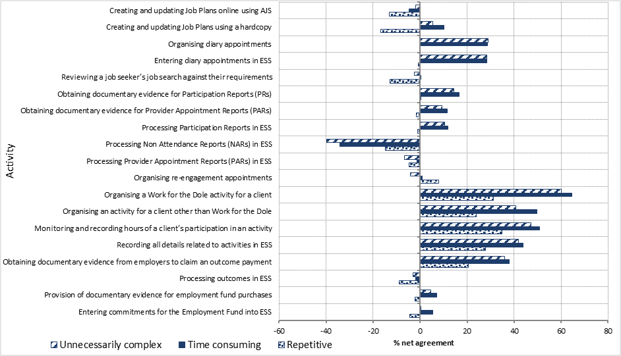

Source: 2016 jobactive Provider Survey.

Figure 4.2 shows net agreement to statements about the identified activities being unnecessarily complex, time consuming and repetitive. A negative net agreement figure (left of zero) to a statement would indicate that the activity was perceived as less burdensome than a positive net agreement (right of zero).

These perceptions were then compared to the OBPR costings in Figure 4.1 to see if the departmental estimates align with provider experiences under jobactive. Results show consistency with costings in the following areas.

#### Work for the Dole

The Annual Activity Requirements were perceived as considerably burdensome by providers. Organising Work for the Dole activities was rated as the most unnecessarily complex and time consuming and one of the most repetitive activities, with net agreement ratings of 60.3 per cent, 64.7 per cent and 31.2 per cent, respectively. Monitoring these activities was also perceived as unnecessarily complex, time consuming and, in particular, repetitive, with net agreement of 47.3 per cent, 50.8 per cent and 34.9 per cent, respectively.

#### Job seeker compliance and participation

Job seeker compliance and participation, identified as the second largest regulatory and administrative burden from OBPR costings, had mixed responses from providers as to whether it was unnecessarily complex, time consuming and repetitive.

Processing NARs and Provider Appointment Reports (PARs) and reviewing job search requirements were not considered burdensome by jobactive providers. These activities had an across the board negative agreement as to whether the activities were unnecessarily complex, time consuming or repetitive. For example, for NARs the ratings were -39.8 per cent, -34.1 per cent and -14.9 per cent for whether processing of NARs was unnecessarily complex, time consuming and repetitive, respectively. Other aspects of the compliance framework were considered more burdensome by providers, such as obtaining documentary evidence for PARs and Participation Reports. Yet, despite being the second highest administrative cost based on OBPR costings, these activities were perceived as less burdensome than other departmental requirements relating to Work for the Dole and outcome claims.

These results may reflect in part efforts made by the Department to simplify the implementation of the compliance framework and the provision of a range of material through the Department’s learning centre to assist providers. It could also be considered less burdensome as the compliance framework is considered by sites to add value to their operations.

The introduction of ESS Web with jobactive brought with it some changes to the way providers managed appointments, compared with the ESS under JSA 2012. Providers reported that these processes were unnecessarily complex and time consuming but, surprisingly, not repetitive. The Department has since streamlined the way appointments are able to be managed in ESS Web.

#### Outcomes

The Department made significant efforts to reduce the size of the regulatory and administrative burden in relation to claiming outcomes. Under jobactive, the Department’s IT systems capture information about a job seeker’s earnings and hours, and these are utilised to determine whether the requirements for a full or partial outcome have been met. In line with this change, providers reported processing outcomes in ESS Web less burdensome, with net agreement of unnecessarily complex (-3.1 per cent), time consuming (-2.0 per cent) and repetitive (-8.9 per cent).

Collecting documentary evidence to support an outcome claim remains problematic, with net agreement of 36.0 per cent, 38.1 per cent and 20.5 per cent that the activity is unnecessarily complex, time consuming and repetitive, respectively. In the period 1 July 2015 to 30 June 2016, Payslip Verified Outcomes represented only 14.0 per cent of all outcome payments (Department of Employment 2016 administrative data). This suggests that time spent verifying outcomes, while burdensome, might not have much of an impact on the overall time spent claiming outcomes. It might also understate the actual administrative burden of collecting documentary evidence, as the administrative burden involved may deter providers from making Payslip Verified Outcome claims.[71] There is some evidence from the 2016 jobactive Provider Survey to demonstrate that this may occur. However, the impact reported was small, with 8.1 per cent of sites stating that they did not claim an outcome payment they believed to be legitimate and to which they were entitled because it was too administratively burdensome.

#### Employment Fund

Providing documentary evidence for Employment Fund purchases and entering these details into ESS Web were only considered to be somewhat burdensome, with positive net agreement that activities were unnecessarily complex and time consuming and negative net rating for repetitiveness. Providing documentary evidence had a net agreement of 4.5 per cent, 7.1 per cent and -2.2 per cent that the activity is unnecessarily complex, time consuming and repetitive, respectively. Similarly, entering these details into ESS Web had a net agreement of 0.4 per cent, 5.3 per cent and ‑4.38 per cent that the activity is unnecessarily complex, time consuming and repetitive, respectively.

These findings align with OBPR costings that show that regulatory and administrative burden associated with the Employment Fund represents 5.0 per cent of total regulatory and administrative burden costs under jobactive. This is not surprising, as the documentary evidence requirements for General Account purchases relate to keeping a valid tax invoice or receipt that distinguishes between individual item costs.

## Findings on regulatory and administrative burden have policy and program implications

Despite reductions in the costs associated with the regulatory and administrative burden under jobactive, the level of regulatory and administrative burden in employment services generally remains significant. Under jobactive, annual regulatory and administrative burden estimates equate to approximately 19.3 per cent of program funding, compared to 20.9 per cent under JSA 2012. Conversely, the 2016 jobactive Provider Survey results indicate that providers spend the majority of their time on departmental administrative requirements (63.5 per cent on average). For some activities in particular, regulatory and administrative burden is perceived as unnecessarily complex, time consuming and repetitive. While these costs may be slightly overstated, these results indicate the need to continue to explore options to reduce regulatory and administrative burden costs, to allow providers to devote more resources to meeting job seeker needs and improve employment outcomes.

## Providers are sceptical of collaboration in a competitive market

In the jobactive model, providers are encouraged to work together by sharing vacancies with other jobactive providers and developing working relationships with the Work for the Dole Coordinator and Lead Providers. Until December 2017, the jobactive model also featured a Collaboration Bonus in the Star Ratings based on the proportion of 12 Week outcomes achieved for placements of job seekers on the caseload of other jobactive providers. From January 2018 onwards, the Collaboration Bonus no longer featured in the calculation of Star Ratings.

In March 2017 the Department established an Employer Mobilisation Strategy (the Strategy). Initially developed in response to low take up of Youth Jobs PaTH, the Strategy was devised to facilitate engagement between employers and jobactive providers, raise awareness of government employment programs, and provide more seamless access to employment services. The Strategy has evolved to increase focus on larger employers that have bulk recruitment needs, an area where a critical gap exists in employer servicing. These employers often cannot meet their recruitment needs through one provider and find it burdensome to engage with multiple providers. Employer Liaison Officers (ELOs) engaged by the Department to implement the Strategy support collaboration between providers by acting as a central point of contact between employers and providers within a region. An ELO can bring providers together to work on a recruitment project, facilitating the coordination of the project, troubleshooting any issues that may arise, acting as a conduit to the Department and acting as the central point of contact for the employer.[72]

The 2015-2016 provider qualitative fieldwork found that providers supported the concept of collaboration in principle but that most were sceptical about how realistic it would be to collaborate in the highly competitive employment services environment. Instead, they indicated a preference for concentrating on placing their own job seekers into vacancies and maintaining their own relationships with employers.

Survey results showed that some providers were unaware of the Collaboration Bonus and its effects, and were yet to share vacancies with other providers. Some providers reported they were not yet utilising the Collaboration Bonus for various reasons, including a lack of financial incentive and burdensome administrative processes.

Where providers were aware of the Collaboration Bonus in the Star Ratings, more than half (60 per cent) indicated that the Collaboration Bonus had not changed the way their site works with other jobactive providers.

Where providers indicated that they had not collaborated with other jobactive providers, just under half (48 per cent) reported that collaborating was contrary to the way the employment services market works; over a quarter (26 per cent) reported that there was too much red tape for the potential gain; and 22 per cent reported that there was not enough financial incentive to collaborate.

# Conclusion

This interim report provides an assessment of the early effectiveness of jobactive over its first year of operation. The evaluation was undertaken principally by comparing jobactive to its predecessor employment services model, JSA 2012. The main analysis was based on data collected by the Department as part of administering the program. It was supplemented by qualitative fieldwork and surveys of job seekers and employment services providers. Key findings of this interim evaluation are summarised below.

## Job seeker engagement has improved under jobactive, when compared with JSA 2012

The evidence presented in this interim report suggests that several aspects of job seeker engagement have improved under jobactive when compared to JSA 2012. This may reflect policy changes made to strengthen the compliance framework and MORs. Improvements under jobactive included:

* a reduction in the time from registration to commencement for most job seekers
* an increase in the appointment attendance rate
* a reduction in the number of job seekers who failed to attend an appointment without a valid reason
* quicker reconnection of job seekers who missed an appointment
* a greater proportion of the jobactive caseload participating in an activity, particularly employment, work experience and Work for the Dole activities
* a smaller proportion of job seekers undertaking an activity undertook education or training in jobactive.

There was evidence of changes in servicing models, with a shift away from case management to ‘rainbow’ servicing and more group-based and open-plan servicing of job seekers. While the majority of job seekers were satisfied with the service they received from jobactive providers, those who were dissatisfied were more likely to report the reason being meeting in a group environment or in open or shared spaces.

## At the program level, the effectiveness of jobactive in achieving labour market outcomes was mixed

When the new entrant job seeker populations were studied, jobactive was found to be less effective than JSA 2012 overall and less effective for Stream A job seekers, but more effective in supporting Stream B and C job seekers into the labour market. When the caseload job seeker populations were used, however, jobactive was found to be more effective than JSA 2012 in supporting job seekers to achieve labour market outcomes for all the three streams. Stream A job seekers showed the largest positive effect, while the smallest effect was seen for Stream B.

It might be expected that the incentive structure in jobactive — which more heavily rewards employment outcomes overall, and provides the highest payments for employment outcomes for the most disadvantaged and longer term job seekers, compared with JSA 2012 — would show positive results for the most job-ready (Stream A) job seekers and the most disadvantaged. While this was evident for the caseload job seekers, jobactive did not appear to be more effective for new entrants in Stream A. This difference may be explained by the job seeker reclassification method that was used to enable comparison between the JSA 2012 and jobactive populations. Further analysis is required to explain this pattern of results.

The effect of jobactive is even larger for job seekers in the compulsory activity phase. When compared with the Work Experience phase of JSA 2012, the Work for the Dole phase of jobactive was found to be more effective in assisting job seekers to obtain employment. The effectiveness of the Work for the Dole phase remained when short-term unemployed people were excluded from the analysis, suggesting that the effectiveness of the Work for the Dole phase was not driven by more short-term unemployed job seekers in the Work for the Dole phase than in the Work Experience phase.

Among the other sub-groups of job seekers examined (e.g. groups examined by gender, Indigenous status or age), jobactive appeared to be delivering mixed results compared to JSA 2012:

* For new entrant job seekers, jobactive was more effective than JSA 2012 at helping achieve program exits for those who were female, those who were Indigenous and those aged under 25 years. jobactive was less effective than JSA 2012 at helping achieve program exits for male, non-Indigenous, and older new entrant job seekers. For all of these subgroups, JSA 2012 was more effective than jobactive at achieving income support exits.
* For caseload job seekers, while all subgroups showed better outcomes under jobactive, jobactive was more effective for male (compared to female) and younger (compared to older) job seekers in terms of exiting income support. jobactive was also more effective at helping achieve program exits for non-Indigenous job seekers (compared to Indigenous job seekers) and was better overall at achieving exits from the program than from income support.
* While all subgroups showed better outcomes in the jobactive Work for the Dole phase than in the JSA 2012 Work Experience phase for both exit measures, relative outcomes varied between subgroup job seekers, depending on the outcome measure used. When using program exits as the measure jobactive’s Work for the Dole phase was more effective than the JSA Work Experience phase for mature-age (compared to younger) job seekers and for female (compared to male) job seekers. When exits from income support were used, jobactive’s Work for the Dole phase was more effective relative to JSA 2012’s Work Experience phase for younger (compared to older) and for male (compared to female) job seekers. jobactive’s Work for the Dole phase is more effective than the JSA Work Experience phase for non-Indigenous (compared to Indigenous) job seekers for both measures.

## Regulatory and administrative burden reduced, but still perceived to be high

Despite reductions in the estimated regulatory and administrative costs under jobactive, the perceived level of regulatory and administrative burden in employment services remains significant. Providers reported organising Work for the Dole activities and administering Annual Activity Requirements as the most unnecessarily complex, time consuming and repetitive administrative activities.

## Summary

While there were inconsistencies between various elements of the analysis in the interim report, overall there was evidence that jobactive was more effective than JSA 2012 in engaging job seekers in services and activity participation, and in assisting certain groups of job seekers to achieve labour market outcomes. It is important to note that these are preliminary findings based on the early stage of the program. These results are therefore indicative only. Subsequent jobactive evaluation reports will take advantage of the availability of more data and will provide more detailed analysis on the performance of the program.

## Further research

The final jobactive evaluation will utilise increased availability of data and will provide a more detailed analysis of the performance of the program. It will include, but not be limited to, the following:

* the effectiveness of jobactive in engaging, and meeting the needs of, employers
* the utilisation of a broader range of jobactive’s performance measures in terms of its effectiveness, efficiency, and sustainability of outcomes
* different types of effects of Work for the Dole, including the effects of various activities in the Work for the Dole phase
* the effects of elements of jobactive — such as wage subsidies, Employment Fund General Account, job seeker streaming, and the SPI — on job seekers’ outcomes
* the value for money and cost effectiveness of jobactive.

# References

Australian Bureau of Statistics, March 2017, Labour Force Australia, ‘Table 01. Labour force status by sex, Australia — trend, seasonally adjusted and original’, cat. no. 6202.0.

Australian Government 2016, ‘Budget Paper No. 2’, available at [budget.gov.au/2015-16/content/bp2/html/bp2_expense-10.htm](http://www.budget.gov.au/2015-16/content/bp2/html/bp2_expense-10.htm).

Card, D, Kluve, J, & Weber, A, 2015, ‘What works? A meta-analysis of recent active labor market program evaluations’. National Bureau of Economic Research, Working Paper 21431. Downloaded on 18 October 2016 from <http://www.nber.org/papers/>.

Connolly, G, and Trott, D, 2014, A New Look at the Determinants of the Female Full-time Participation Rate in the Australian Labour Force, Contributed Paper presented at the Australian Conference of Economists and the Econometric Society Australasian Meeting, Hobart, Tasmania, 1-4 July 2014.

Department of Education, Employment and Workplace Relations 2007, ‘Active Participation Model Evaluation July 2003-June 2006’, available at <https://www.jobs.gov.au/active-participation-model-evaluation>.

Department of Education, Employment and Workplace Relations 2008, ‘The future of employment services in Australia: a discussion paper’, available at <http://hdl.voced.edu.au/10707/168103>.

DEEWR 2013, ‘Employment Services – building on success: Issues Paper’, available at <http://hdl.voced.edu.au/10707/333516>.

Department of Employment 2014a, ‘Request for Tender for Employment Services 2015–2020’, available at <https://docs.jobs.gov.au/documents/request-tender-employment-services-2015-2020>.

Department of Employment 2014b, ‘Employment Services Deed 2012–2015’, available at  [https://docs.jobs.gov.au/system/files/doc/other/esd4_ss_-_clean_-_gdv_8_-_accessible_version.pdf.](%20https://docs.jobs.gov.au/system/files/doc/other/esd4_ss_-_clean_-_gdv_8_-_accessible_version.pdf.)

Department of Employment 2015a, ‘Department of Employment Annual Report 2014–15’, available at <https://docs.jobs.gov.au/documents/department-employment-annual-report-2014-2015> .

Department of Employment 2015b, ‘jobactive Deed’, available at <https://docs.jobs.gov.au/documents/final-jobactive-deed-2015-2020>.

Department of Employment 2015c, ‘Evaluation of Work for the Dole 2014–15’, available at <https://docs.jobs.gov.au/documents/work-dole-2014-15-evaluation-report>.

Department of Employment 2015d, ‘The Job Seeker Compliance Framework – Explanatory Notes’, available at <https://docs.jobs.gov.au/system/files/doc/other/the_job_seeker_compliance_framework_-_explanatory_notes_0.pdf>.

Department of Employment 2016a, ‘Evaluation Strategy for jobactive’, available at <https://www.jobs.gov.au/evaluation-strategy-jobactive>.

Department of Employment 2016b, ‘Department of Employment Vacancy Report’, available at [lmip.gov.au/default.aspx?LMIP/VacancyReport](http://lmip.gov.au/default.aspx?LMIP/VacancyReport).

Department of Employment 2016c, ‘Employment Services 2015 Regulation Impact Statement’, available at [ris.govspace.gov.au/files/2015/09/20150811-FINAL-ES2015-RIS.pdf](https://ris.govspace.gov.au/files/2015/09/20150811-FINAL-ES2015-RIS.pdf).

Department of Employment 2016d, ‘Activity Management Guideline’, available at <https://docs.jobs.gov.au/documents/activity-management-guideline>.

Department of Employment 2017, ‘Using the Employment Fund General Account’, available at <https://docs.jobs.gov.au/documents/employment-fund-general-account-guideline>.

Department of Human Services 2017, ‘Youth Jobs PaTH — Prepare – Trial – Hire’, available at [humanservices.gov.au/corporate/budget/budget-2016-17/job-seekers/youth-jobs-path-prepare-trial-hire](https://www.humanservices.gov.au/corporate/budget/budget-2016-17/job-seekers/youth-jobs-path-prepare-trial-hire).

Department of Social Services 2017a, ‘3.2.9.30 Job Search — Setting Job Search Requirements — General’, available at [guides.dss.gov.au/guide-social-security-law/3/2/9/30](http://guides.dss.gov.au/guide-social-security-law/3/2/9/30).

Department of Social Services 2017b, ‘3.1.13 Compliance Framework for Participation Payments’, available at [guides.dss.gov.au/guide-social-security-law/3/1/13](http://guides.dss.gov.au/guide-social-security-law/3/1/13).

Department of the Prime Minister and Cabinet 2014, ‘Regulatory Burden Measurement Framework: Guidance Note’, available at [dpmc.gov.au/sites/default/files/publications/005_Regulatory_Burden_Measurement_Framework.pdf](https://www.dpmc.gov.au/sites/default/files/publications/005_Regulatory_Burden_Measurement_Framework.pdf).

Jones, E, & Nisbett, R, 1970, ‘The Actor and the Observer: Divergent Perceptions of the Causes of Behavior’. General Learning Press.

Parsons, L, 2004, ‘Performing a 1:N Case-Control Match on Propensity Score’. Ovation Research Group, Seattle, Washington

Rosholm, M & Svarer, M, 2004, ‘Estimating the threat effect of active labour market programmes’. IZA Discussion Paper No. 1300, downloaded on 22 February 2017 from [ftp.iza.org/dp1300.pdf](ftp://ftp.iza.org/dp1300.pdf).

Social Research Centre 2015, ‘Evaluation of Work for the Dole 2014–15’, available at https://docs.jobs.gov.au/documents/work-dole-2014-15-evaluation-report.

# Appendix A Statistical tables

**List of tables**

Table A1: New entrant study population characteristics 88

Table A2 Caseload study population characteristics 88

Table A3 Work for the Dole and Work Experience study population characteristics 93

Table A1: New entrant study population characteristics

| **Selected variables** | **JSA 2012 (Number)** | **JSA 2012 (%)** | **jobactive (Number)** | **jobactive (%)** |
| --- | --- | --- | --- | --- |
| **Total job seekers** | **71,272** | **100.0** | **55,648** | **100.0** |
| **jobactive stream** |  |  |  |  |
| Stream A | 65,011 | 91.3 | 47,786 | 85.9 |
| Stream B | 4,209 | 5.9 | 7,062 | 12.7 |
| Stream C | 1,991 | 2.8 | 800 | 1.4 |
| **Geographical area** |  |  |  |  |
| Major Cities | 49,561 | 69.6 | 38,264 | 68.8 |
| Inner Regional | 14,627 | 20.5 | 11,456 | 20.6 |
| Outer Regional | 7,023 | 9.9 | 5,928 | 10.7 |
| **Activity requirement** |  |  |  |  |
| Full Time | 67,348 | 94.6 | 48,831 | 87.7 |
| Part Time | 3,863 | 5.4 | 6,817 | 12.3 |
| **Age grouping** |  |  |  |  |
| Under 25 | 26,986 | 37.9 | 20,760 | 36.8 |
| 25–29 | 11,127 | 15.6 | 8,187 | 14.7 |
| 30–49 | 24,020 | 33.7 | 18,741 | 33.7 |
| 50 or more | 9,078 | 12.7 | 7,960 | 14.3 |
| **Sex** |  |  |  |  |
| Male | 41,182 | 57.8 | 30,091 | 54.1 |
| Female | 30,029 | 42.2 | 25,557 | 45.9 |
| **Indigenous flag** |  |  |  |  |
| Missing | 555 | 0.8 | 1,754 | 3.2 |
| Not Indigenous | 67,572 | 94.9 | 50,894 | 91.5 |
| Indigenous | 3,084 | 4.3 | 3,000 | 5.4 |
| **Disability status** |  |  |  |  |
| No disability | 62,844 | 88.3 | 62,020 | 94.9 |
| JSCI assessed disability | 209 | 0.3 | 39 | 0.1 |
| JCA/ESAt assessed disability | 8,158 | 11.5 | 2,803 | 5.0 |
| **Work experience history** |  |  |  |  |
| Missing | 25 | 0.0 | 215 | 0.4 |
| 8+ hours work experience | 39,402 | 55.3 | 26,239 | 47.2 |
| <8/irregular work experience | 973 | 1.4 | 712 | 1.3 |
| Unpaid work | 361 | 0.5 | 305 | 0.5 |
| Not in labour force | 26,978 | 37.9 | 24,461 | 44.0 |
| Not working but looking for work | 3,472 | 4.9 | 3,716 | 6.7 |
| **English proficiency** |  |  |  |  |
| Missing | 25 | 0.0 | 215 | 0.4 |
| Good English proficiency | 68,303 | 95.9 | 53,100 | 95.4 |
| Mixed/Poor English proficiency | 2,883 | 4.0 | 2,333 | 4.2 |
| **Education level** |  |  |  |  |
| Missing | 25 | 0.0 | 215 | 0.4 |
| Less than Year 10 | 3,137 | 4.4 | 2,533 | 4.6 |
| Year 10 | 14,351 | 20.2 | 10,496 | 18.9 |
| Year 11/12 | 16,515 | 23.2 | 13,471 | 24.2 |
| TAFE/Diploma | 24,007 | 33.7 | 18,599 | 33.4 |
| Bachelor degree or above | 13,176 | 18.5 | 10,334 | 18.6 |
| **Country of birth — disadvantage** |  |  |  |  |
| Missing | 25 | 0.0 | 215 | 0.4 |
| Low Disadvantage CoB | 67,250 | 94.4 | 51,958 | 93.5 |
| Medium Disadvantage CoB | 2,122 | 3.1 | 1,722 | 3.1 |
| High Disadvantage CoB | 1,269 | 1.8 | 1,210 | 2.1 |
| Very High Disadvantage CoB | 545 | 0.8 | 543 | 1.0 |
| **Country of birth — language disadvantage** |  |  |  |  |
| Lowest CoB language disadvantage | 68,684 | 0.7 | 53,030 | 0.9 |
| Low CoB language disadvantage | 1,543 | 96.2 | 1,412 | 95.3 |
| Medium CoB language disadvantage | 530 | 2.4 | 567 | 2.6 |
| High CoB language disadvantage | 454 | 0.7 | 639 | 1.0 |
| **Vocational qualifications** |  |  |  |  |
| Missing | 25 | 0.0 | 215 | 0.4 |
| Useful vocational qualifications | 40,910 | 57.4 | 30,929 | 55.6 |
| Not useful vocational qualifications | 692 | 1.0 | 577 | 1.0 |
| No further qualifications | 29,584 | 41.5 | 23,927 | 43.0 |
| **Personal factors** |  |  |  |  |
| Missing | 18 | 0.0 | 586 | 1.1 |
| No impact | 68,523 | 96.2 | 54,011 | 97.1 |
| Low personal factor impact | 519 | 0.7 | 212 | 0.4 |
| Medium personal factor impact | 912 | 1.3 | 397 | 0.7 |
| High personal factor impact | 1,239 | 1.7 | 442 | 0.8 |
| **Geographic disadvantage** |  |  |  |  |
| Missing | 50 | 0.1 | 215 | 0.4 |
| Very Low ESA | 344 | 0.5 | 363 | 0.7 |
| Low/Low-Moderate ESA | 3,637 | 5.1 | 3,562 | 6.4 |
| Mod/Mod-High ESA | 38,586 | 54.2 | 29,851 | 53.6 |
| High/Very High ESA | 28,594 | 40.2 | 21,657 | 38.9 |
| **Transport availability** |  |  |  |  |
| Missing | 25 | 0.0 | 215 | 0.4 |
| Own transport | 43,116 | 60.5 | 34,408 | 61.8 |
| Other private transport | 5,752 | 8.1 | 4,457 | 8.0 |
| Public transport | 21,227 | 29.8 | 15,746 | 28.3 |
| No transport | 1,091 | 1.5 | 822 | 1.5 |
| **Phone availability** |  |  |  |  |
| Missing | 25 | 0.0 | 215 | 0.4 |
| Contactable by phone | 69,806 | 98.0 | 54,084 | 97.2 |
| Not contactable by phone | 1,380 | 1.9 | 1,349 | 2.4 |
| **Capacity to participate** |  |  |  |  |
| Full capacity to participate | 65,445 | 91.9 | 49,480 | 88.9 |
| Reduced capacity to participate | 5,766 | 8.1 | 6,168 | 11.1 |
| **Income support type** |  |  |  |  |
| NSA/YA(O) | 67,998 | 95.5 | 51,979 | 93.4 |
| Parenting Payment Single / Parenting Payment Partnered | 1,652 | 2.3 | 2,543 | 4.6 |
| Other benefit | 1,561 | 2.2 | 1,126 | 2.0 |
| **Income support history** |  |  |  |  |
| Missing | 25 | 0.0 | 215 | 0.4 |
| No support or up to 12 months | 62,139 | 87.3 | 48,588 | 87.3 |
| 12–23 months income support | 3,164 | 4.4 | 1,729 | 3.1 |
| 24+ months income support | 5,883 | 8.3 | 5,116 | 9.2 |
| **Single parent flag** |  |  |  |  |
| Missing | 25 | 0.0 | 206 | 0.4 |
| Not a lone parent | 68,102 | 95.6 | 51,238 | 92.1 |
| Lone parent | 3,084 | 4.3 | 4,204 | 7.6 |
| **Grandfathered Parenting Payment flag Recipient during observation period** |  |  |  |  |
| Not grandfathered parenting payment | 69,895 | 98.2 | 54,414 | 97.8 |
| Grandfathered parenting payment | 1,316 | 1.8 | 1,234 | 2.2 |
| **Ex-offender status** |  |  |  |  |
| Missing | 901 | 1.3 | 1,127 | 2.0 |
| Not an ex-offender | 67,011 | 94.1 | 52,156 | 93.7 |
| Ex-offender | 3,299 | 4.6 | 2,365 | 4.2 |
| **Homeless status** |  |  |  |  |
| Missing | 25 | 0.0 | 206 | 0.4 |
| Stable accommodation | 69,424 | 97.5 | 54,218 | 97.4 |
| Primary/secondary homeless | 1,762 | 2.5 | 1,224 | 2.2 |

**Source:** Department of Employment administrative data and the Research and Evaluation Database.

Table A2: Caseload study population characteristics

| **Selected variables** | **JSA 2012 (Number)** | **JSA 2012 (%)** | **jobactive (Number)** | **jobactive (%)** |
| --- | --- | --- | --- | --- |
| **Total job seekers** | **658,278** | **100.0** | **747,683** | **100.0** |
| **jobactive stream** |  |  |  |  |
| Stream A | 310,496 | 47.2 | 386,966 | 51.8 |
| Stream B | 180,200 | 27.4 | 216,249 | 28.9 |
| Stream C | 142,668 | 21.7 | 129,735 | 17.4 |
| Volunteer and unknown | 24,914 | 3.8 | 14,733 | 2.0 |
| **Geographical area** |  |  |  |  |
| Major Cities | 409,069 | 62.1 | 475,742 | 63.6 |
| Inner Regional / Outer Regional | 215,793 | 32.8 | 258,980 | 34.6 |
| Remote / Very Remote | 23,154 | 3.5 | 9,711 | 1.3 |
| Not defined | 10,262 | 1.6 | 3,250 | 0.4 |
| **Activity requirement** |  |  |  |  |
| Full Time | 496,751 | 75.5 | 519,095 | 69.4 |
| Part Time | 161,527 | 24.5 | 228,588 | 30.6 |
| **Age grouping** |  |  |  |  |
| Under 25 | 165,569 | 25.2 | 161,279 | 21.6 |
| 25–29 | 77,123 | 11.7 | 86,693 | 11.6 |
| 30–49 | 280,722 | 42.6 | 321,291 | 43.0 |
| 50 or more | 134,864 | 20.5 | 178,420 | 23.9 |
| **Sex** |  |  |  |  |
| Male | 352,628 | 53.6 | 390,787 | 52.3 |
| Female | 305,650 | 46.4 | 356,896 | 47.7 |
| **Indigenous flag** |  |  |  |  |
| Missing | 23,058 | 3.5 | 19,159 | 2.6 |
| Not Indigenous | 561,539 | 85.3 | 662,291 | 88.6 |
| Indigenous | 73,681 | 11.2 | 66,233 | 8.9 |
| **Disability status** |  |  |  |  |
| Missing | 16,622 | 2.5 | 4,811 | 0.6 |
| No disability | 471,645 | 71.6 | 537,173 | 71.8 |
| Disability | 170,011 | 25.8 | 205,699 | 27.5 |
| **Work experience history** |  |  |  |  |
| Missing | 16,622 | 2.5 | 4,814 | 0.6 |
| Paid Full Time | 152,533 | 23.2 | 178,105 | 23.8 |
| Paid Part Time | 117,807 | 17.9 | 125,811 | 16.8 |
| Unpaid/No Work Experience | 371,316 | 56.4 | 438,953 | 58.7 |
| **English proficiency** |  |  |  |  |
| Missing | 16,622 | 2.5 | 4,811 | 0.6 |
| Good English proficiency | 554,948 | 84.3 | 655,361 | 87.7 |
| Mixed/Poor English proficiency | 86,708 | 13.2 | 87,511 | 11.7 |
| **Education level** |  |  |  |  |
| Missing | 14,812 | 2.3 | 5,356 | 0.7 |
| Less than Year 10 | 87,851 | 13.3 | 83,044 | 11.1 |
| Year 10/11 | 197,115 | 29.9 | 212,584 | 28.4 |
| Year 12 | 98,349 | 14.9 | 133,044 | 17.8 |
| TAFE/Diploma | 208,016 | 31.6 | 252,713 | 33.8 |
| Bachelor degree or above | 52,135 | 7.9 | 60,942 | 8.2 |
|  |  |  |  |  |
| **Country of birth — disadvantage** |  |  |  |  |
| Missing | 16,622 | 2.5 | 4,811 | 0.6 |
| Low Disadvantage CoB | 599,642 | 91.1 | 692,437 | 92.6 |
| Medium Disadvantage CoB | 19,924 | 3.0 | 23,666 | 3.2 |
| High Disadvantage CoB | 16,124 | 2.4 | 19,681 | 2.6 |
| Very High Disadvantage CoB | 5,966 | 0.9 | 7,088 | 0.9 |
| **Personal factors** |  |  |  |  |
| Not assessed | 409,278 | 62.2 | 401,066 | 53.6 |
| No impact | 28,696 | 4.4 | 147,433 | 19.7 |
| Low personal factor impact | 31,963 | 4.9 | 28,446 | 3.8 |
| Medium personal factor impact | 72,790 | 11.1 | 66,854 | 8.9 |
| High personal factor impact | 115,551 | 17.6 | 103,884 | 13.9 |
| **Geographic disadvantage** |  |  |  |  |
| Missing | 16,622 | 2.5 | 4,811 | 0.6 |
| Very Low ESA | 205,832 | 31.3 | 223,164 | 29.8 |
| Low/Low-Moderate ESA | 28,778 | 4.4 | 42,038 | 5.6 |
| Mod/Mod-High ESA | 133,274 | 20.2 | 151,387 | 20.2 |
| High/Very High ESA | 176,459 | 26.8 | 203,784 | 27.3 |
| Extreme | 96,775 | 14.7 | 122,195 | 16.3 |
| Other | 538 | 0.1 | 304 | 0.0 |
| **Transport availability** |  |  |  |  |
| Missing | 16,622 | 2.5 | 4,811 | 0.6 |
| Public transport | 211,629 | 32.1 | 239,724 | 32.1 |
| Private transport | 388,778 | 59.1 | 465,091 | 62.2 |
| No transport | 41,249 | 6.3 | 38,057 | 5.1 |
| **Phone availability** |  |  |  |  |
| Missing | 16,622 | 2.5 | 4,811 | 0.6 |
| Contactable by phone | 601,196 | 91.3 | 716,447 | 95.8 |
| Not contactable by phone | 40,460 | 6.1 | 26,425 | 3.5 |
| **Capacity to participate** |  |  |  |  |
| Full capacity to participate | 511,650 | 77.7 | 632,912 | 84.6 |
| Reduced capacity to participate | 146,628 | 22.3 | 114,771 | 15.4 |
| **Income support type** |  |  |  |  |
| Newstart Allowance | 493,596 | 75.0 | 595,960 | 79.7 |
| Youth Allowance (Other) | 69,511 | 10.6 | 84,655 | 11.3 |
| Parenting Payment | 28,011 | 4.3 | 32,218 | 4.3 |
| Other benefit | 39,726 | 6.0 | 8,280 | 1.1 |
| No benefit | 27,434 | 4.2 | 26,570 | 3.6 |
| **Income support history** |  |  |  |  |
| Unknown | 51,108 | 7.8 | 36,647 | 4.9 |
| No support or up to 12 months | 206,532 | 31.4 | 215,486 | 28.8 |
| 12–23 months income support | 94,817 | 14.4 | 116,425 | 15.6 |
| 24+ months income support | 305,821 | 46.5 | 379,125 | 50.7 |
| **Ex-offender status** |  |  |  |  |
| Missing | 16,622 | 2.5 | 4,811 | 0.6 |
| No answer | 10,290 | 1.6 | 14,341 | 1.9 |
| Not an ex-offender | 553,844 | 84.1 | 646,276 | 86.4 |
| Ex-offender | 77,522 | 11.8 | 82,255 | 11.0 |
| **Homeless status** |  |  |  |  |
| Missing | 16,622 | 2.5 | 4,811 | 0.6 |
| Stable accommodation | 569,967 | 86.6 | 667,263 | 89.2 |
| Primary/secondary homeless | 71,689 | 10.9 | 75,609 | 10.1 |

**Source:** Department of Employment administrative data and the Research and Evaluation Database.

Table A3: Work for the Dole phase and Work Experience phase study population characteristics

| **Selected variables** | **Work Experience phase (Number)** | **Work Experience phase (%)** | **Work for the Dole phase (Number)** | **Work for the Dole phase (%)** |
| --- | --- | --- | --- | --- |
| **Total job seekers** | **118,818** | **100.0** | **211,787** | **100.0** |
| **jobactive stream** |  |  |  |  |
| Stream A | 38,822 | 32.7 | 104,022 | 49.1 |
| Stream B | 38,092 | 32.1 | 58,738 | 27.7 |
| Stream C | 38,262 | 32.2 | 46,136 | 21.8 |
| Volunteer and unknown | 3,642 | 3.1 | 2,891 | 1.4 |
| **Geographical area** |  |  |  |  |
| Major Cities | 72,854 | 61.3 | 129,684 | 61.2 |
| Inner Regional / Outer Regional | 44,010 | 37.0 | 78,145 | 36.9 |
| Remote / Very Remote | 1,367 | 1.2 | 3,054 | 1.4 |
| Not defined | 587 | 0.5 | 904 | 0.4 |
| **Activity requirement** |  |  |  |  |
| Full Time | 91,093 | 76.7 | 163,206 | 77.1 |
| Part Time | 27,725 | 23.3 | 48,581 | 22.9 |
| **Age grouping** |  |  |  |  |
| Under 25 | 28,706 | 24.2 | 42,483 | 20.1 |
| 25–29 | 13,758 | 11.6 | 26,057 | 12.3 |
| 30–49 | 52,379 | 44.1 | 90,764 | 42.9 |
| 50 or more | 23,975 | 20.2 | 52,483 | 24.8 |
| **Sex** |  |  |  |  |
| Male | 66,603 | 56.1 | 121,215 | 57.2 |
| Female | 52,215 | 43.9 | 90,572 | 42.8 |
| **Indigenous flag** |  |  |  |  |
| Missing | 3,621 | 3.0 | 3,582 | 1.7 |
| Not Indigenous | 102,939 | 86.6 | 186,609 | 88.1 |
| Indigenous | 12,258 | 10.3 | 21,596 | 10.2 |
| **Disability status** |  |  |  |  |
| Missing | 1,042 | 0.5 | 2,881 | 2.4 |
| No disability | 154,364 | 72.9 | 83,318 | 70.1 |
| Disability | 56,381 | 26.6 | 32,619 | 27.5 |
| **Work experience history** |  |  |  |  |
| Missing | 2,881 | 2.4 | 1,042 | 0.5 |
| Paid Full Time | 16,335 | 13.7 | 42,217 | 19.9 |
| Paid Part Time | 20,799 | 17.5 | 35,802 | 16.9 |
| Unpaid/No Work Experience | 78,803 | 66.3 | 132,726 | 62.7 |
| **English proficiency** |  |  |  |  |
| Missing | 2,881 | 2.4 | 1,042 | 0.5 |
| Good English proficiency | 98,496 | 82.9 | 181,967 | 85.9 |
| Mixed/Poor English proficiency | 17,441 | 14.7 | 28,778 | 13.6 |
| **Education level** |  |  |  |  |
| Missing | 2,647 | 2.2 | 1,666 | 0.8 |
| Less than Year 10 | 18,741 | 15.8 | 27,036 | 12.8 |
| Year 10/11 | 36,989 | 31.1 | 62,388 | 29.5 |
| Year 12 | 14,613 | 12.3 | 32,225 | 15.2 |
| TAFE/Diploma | 37,641 | 31.7 | 71,987 | 34.0 |
| Bachelor degree or above | 8,187 | 6.9 | 16,485 | 7.8 |
| **Country of birth — disadvantage** |  |  |  |  |
| Missing | 2,881 | 2.4 | 1,042 | 0.5 |
| Low Disadvantage CoB | 107,765 | 90.7 | 196,832 | 92.9 |
| Medium Disadvantage CoB | 3,890 | 3.3 | 6,861 | 3.2 |
| High Disadvantage CoB | 2,933 | 2.5 | 4,868 | 2.3 |
| Very High Disadvantage CoB | 1,349 | 1.1 | 2,184 | 1.0 |
| **Personal factors** |  |  |  |  |
| Not assessed | 58,347 | 49.1 | 137,072 | 64.7 |
| No impact | 6,326 | 5.3 | 14,695 | 6.9 |
| Low personal factor impact | 7,656 | 6.4 | 7,421 | 3.5 |
| Medium personal factor impact | 18,585 | 15.6 | 18,893 | 8.9 |
| High personal factor impact | 27,904 | 23.5 | 33,706 | 15.9 |
| **Geographic disadvantage** |  |  |  |  |
| Missing | 2,881 | 2.4 | 1,042 | 0.5 |
| Very Low ESA | 31,094 | 26.2 | 58,484 | 27.6 |
| Low/Low-Moderate ESA | 4,581 | 3.9 | 11,340 | 5.4 |
| Mod/Mod-High ESA | 23,764 | 20.0 | 41,663 | 19.7 |
| High/Very High ESA | 36,460 | 30.7 | 61,988 | 29.3 |
| Extreme | 19,994 | 16.8 | 37,188 | 17.6 |
| Other | 44 | 0.0 | 82 | 0.0 |
| **Transport availability** |  |  |  |  |
| Missing | 2,881 | 2.4 | 1,042 | 0.5 |
| Public transport | 41,684 | 35.1 | 74,637 | 35.2 |
| Private transport | 68,054 | 57.3 | 122,982 | 58.1 |
| No transport | 6,199 | 5.2 | 13,126 | 6.2 |
| **Phone availability** |  |  |  |  |
| Missing | 2,881 | 2.4 | 1,042 | 0.5 |
| Contactable by phone | 111,030 | 93.4 | 203,854 | 96.3 |
| Not contactable by phone | 4,907 | 4.1 | 6,891 | 3.3 |
| **Capacity to participate** |  |  |  |  |
| Full capacity to participate | 90,523 | 76.2 | 192,109 | 90.7 |
| Reduced capacity to participate | 28,295 | 23.8 | 19,678 | 9.3 |
| **Income support type** |  |  |  |  |
| Newstart Allowance | 96,535 | 81.2 | 182,326 | 86.1 |
| Youth Allowance (Other) | 11,330 | 9.5 | 19,854 | 9.4 |
| Parenting Payment | 2,634 | 2.2 | 2,765 | 1.3 |
| Other benefit | 5,710 | 4.8 | 1,590 | 0.8 |
| No benefit | 2,609 | 2.2 | 5,252 | 2.5 |
| **Income support history** |  |  |  |  |
| Unknown | 2,881 | 2.4 | 1,042 | 0.5 |
| No support or up to 12 months | 16,335 | 13.7 | 42,217 | 19.9 |
| 12–23 months income support | 20,799 | 17.5 | 35,802 | 16.9 |
| 24+ months income support | 78,803 | 66.3 | 132,726 | 62.7 |
| **Ex-offender status** |  |  |  |  |
| Missing | 2,881 | 2.4 | 1,042 | 0.5 |
| No answer | 1,541 | 1.3 | 3,314 | 1.6 |
| Not an ex-offender | 98,801 | 83.2 | 181,582 | 85.7 |
| Ex-offender | 15,595 | 13.1 | 25,849 | 12.2 |
| **Homeless status** |  |  |  |  |
| Missing | 2,881 | 2.4 | 1,042 | 0.5 |
| Stable accommodation | 100,376 | 84.5 | 185,871 | 87.8 |
| Primary/secondary homeless | 15,561 | 13.1 | 24,874 | 11.7 |

**Source:** Department of Employment administrative data and the Research and Evaluation Database.

# Appendix B Phases in jobactive and JSA 2012

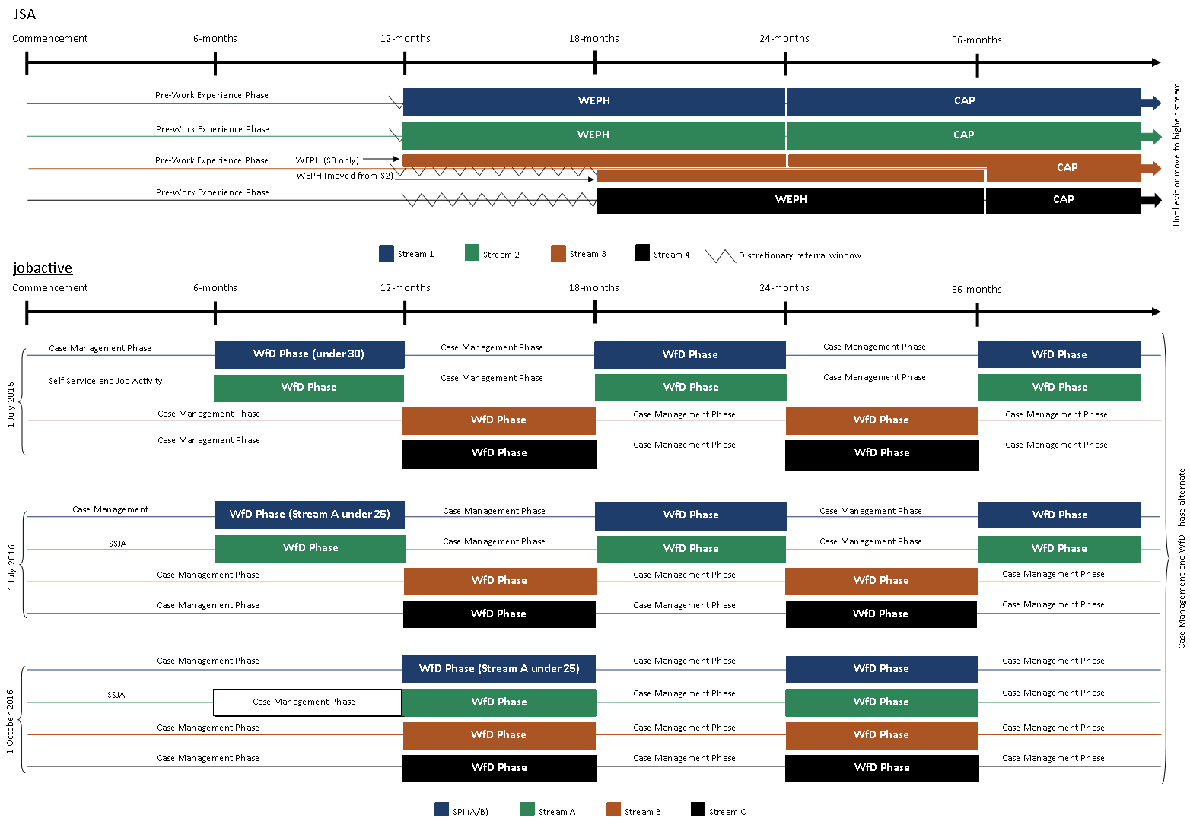

# Appendix C Administration fees in jobactive and JSA 2012

Providers of jobactive receive an administration fee every six months for each job seeker they continued to provide services to (Table C1). Under JSA 2012, the equivalent payment was known as a ‘service fee’. The service fee in JSA 2012 varied by stream and duration of unemployment (see Table C2).

Table C1: Administration fees of jobactive

|  |  |  |
| --- | --- | --- |
|  | **Fee** | **Fee with regional loading** |
| SPI participants | $350 | $438 |
| All other stream participants | $250 | $313 |

**Source:** Department of Employment 2015b.

Table C2: Service fees in JSA 2012

|  |  |
| --- | --- |
| **Stream and 13 week service fee period** | **Fee** |
| **Stream 1** |  |
| First 13 weeks | $63 |
| Second 13 weeks | $94 |
| Third 13 weeks | $328 |
| Fourth 13 weeks | $96 |
| Maximum for Stream 1 | $581 |
| **Stream 2** |  |
| First 13 weeks | $271 |
| Second 13 weeks | $208 |
| Third 13 weeks | $202 |
| Fourth 13 weeks | $204 |
| Maximum for Stream 2 | $885 |
| **Stream 3** |  |
| First 13 weeks | $332 |
| Second 13 weeks | $264 |
| Third 13 weeks | $257 |
| Fourth 13 weeks | $267 |
| Maximum for Stream 3 | $1,120 |
| **Stream 4** |  |
| First 13 weeks | $587 |
| Second 13 weeks | $512 |
| Third 13 weeks | $409 |
| Fourth 13 weeks | $411 |
| Fifth 13 weeks | $402 |
| Sixth 13 weeks | $415 |
| Maximum for Stream 4 | $2,736 |

**Source:** Department of Employment 2014b.

# Appendix D Construction of comparison job seeker groups — methodology

The Job Seeker Classification Instrument (JSCI) is an assessment tool developed by the Department of Employment and used by employment service providers and the Department of Human Services (DHS) to determine a job seeker’s relative labour market disadvantage. This tool scores a job seeker based on their responses to a range of questions, with a higher score indicating higher levels of labour market disadvantage and, therefore, a need for more intensive labour market assistance from an employment services provider. Under both JSA and jobactive, job seekers who are identified as requiring more intensive assistance are referred to a higher program stream. If complex or multiple barriers to employment are identified during a JSCI assessment, irrespective of the resulting score, a job seeker may be referred for a more thorough assessment, known as an Employment Services Assessment (ESAt), which will determine the job seeker’s overall capacity to work and recommend an appropriate program or stream.

The JSCI tool is periodically subject to a re-estimation process in order to ensure the factors considered and relative importance of these factors remain appropriate. A re-estimation of the JSCI occurred when jobactive was introduced.

Under JSA, a job seeker was allocated to one of Streams 1 to 3 based on their JSCI score. Job seekers could only be allocated to Stream 4 based on an ESAt. There is one fewer stream under jobactive, and the JSCI score thresholds used to allocate job seekers to different streams have been adjusted accordingly.

To enhance comparability of JSA and jobactive job seekers, given alterations made to both the JSCI and the employment services programs, JSA job seekers have been reallocated to the stream they would have been assigned to under jobactive using the re-estimated JSCI parameters. It should be noted that the correspondence between JSA 2012 and jobactive streams is not simple. Job seekers from multiple streams in JSA 2012 (with associated different service levels) have been assigned to a single jobactive stream-equivalent for comparison. Stream 4 job seekers under JSA 2012, whose stream was not determined by JSCI, were reallocated to Stream C.

# Appendix E Placements and outcomes under JSA 2012 and jobactive

Table E1: Placements and outcomes under JSA and jobactive

|  |  |
| --- | --- |
|  | **Number** |
| **JSA financial year 2012–13** |  |
| Unique job seekers referred1 | 1,421,947 |
| Job placements2 | 355,480 |
| Outcomes3 |  |
| 4 Week |  |
| Full | n/a |
| Partial | n/a |
| 13 Week |  |
| Full | 94,414 |
| Partial | 51,785 |
| 26 Week |  |
| Full | 76,459 |
| Partial | 20,919 |
|  |  |
| **jobactive financial year 2015–16** |  |
| Unique job seekers referred1 | 1,351,496 |
| Job placements2 | 346,324 |
| Outcomes4 |  |
| 4 Week |  |
| Full | 116,610 |
| Partial | 28,400 |
| 12 Week |  |
| Full | 69,934 |
| Partial | 31,849 |
| 26 Week |  |
| Full | 40,017 |

**Notes:** Placements and outcomes are not directly comparable as performance indicators between financial years.

1 The count of unique job seekers referred relates to the number of job seekers referred to the program with a stream placement date (they may or may not have commenced).

2 The count of job placements recorded for job seekers. An individual job seeker may have had more than one job placement. Job placements data as per Annual Reports.

3 The count of outcome payments made under the Job Services Australia contract. Outcomes include both full and partial 13 Week and 26 Week outcome claims. Claims are mapped to financial year based off the year that the outcome claim was created.

4 The count of employment outcome payments (excludes NEIS) made under the jobactive contract. Outcomes include both full and partial 4 Week, 12 Week and 26 Week outcome claims. Claims are mapped to financial year based off the year that the outcome claim was created. Under jobactive, 26 Week outcomes are only payable on a full outcome.

Source: Department of Employment administrative data.

# Appendix F Methodology used in analysing effectiveness of jobactive

Since evaluators are unable to accurately track the sustainability of employment outcomes after a job seeker leaves employment services, this report uses exits from income support and exits from the employment service program as proxies for employment. While the extent to which they represent good proxies is to some extent unknown, they are considered good measures for comparing the success of different employment services programs. This is because the degree to which these measures represent good proxies should not vary systematically between the programs.

The definition of exits from income support includes exit from all DHS-administered payments which help individuals meet basic living expenses. For example, this means that a movement from NSA to Disability Support Pension would not be counted as an exit from income support.

Exits from income support and exits from program were analysed using survival analysis techniques. Survival analysis is a class of statistical techniques that is used to analyse expected duration until a defined event occurs for a unit in a study population. Survival analysis has the feature that it enables the inclusion of information from those who have not yet exited by the end of the observation period, unlike a simple comparison of average duration to exit. Unadjusted analyses were based on observed exit outcomes while ‘adjusted’ results use predicted exit outcomes that are based on a regression (Cox regression) model to control for non-program differences between study populations such as job seeker characteristics and unemployment rate. Separate analyses were conducted for each of the major demographic groups of job seekers to assess whether the effectiveness of jobactive varies by job seeker groups.

The control variables were largely extracted from the Department of Employment’s administrative datasets. Job seeker characteristics are based mainly on individual level information collected for JSCI assessments. Unemployment rates are based on monthly ABS data, and are differentiated by job seekers’ age, sex and geographic location(s) (at the Australian Statistical Geographic region SA4 level).

The variables listed in Table A1 were used as controls for the new entrant population analysis (i.e. Section 3.2); those in Table A2 were for the overall caseload population analysis (i.e. Section 3.3); and those in Table A3 were for the analysis of the Work for the Dole caseload populations (i.e. Section 4).

Several interactions and other forms of variables were tested, but only a ‘sex by age’ interaction term was included, since it appears to be important in the regression model.

Exit income support with earnings was initially considered as another outcome measure, as it might be a clearer indication of job seekers finding employment than just employment services exit or income support exit. However, the data suggests a high rate of receipt of earnings for any given month, so income support exit with earnings does not seem to provide additional benefit. As a result, it was not used as an outcome measure in the analysis.

# Appendix G Effectiveness of jobactive at assisting job seekers to achieve labour market outcomes — raw (unadjusted) rates compared with adjusted rates

**List of tables**

Figure G1: Cumulative exit rates for new entrant job seekers

Table G1: Percentage of new entrant job seekers who exited within six months of commencement

Figure G2: Cumulative exit rates — caseload

Table G2: Percentage of job seekers who exited within six months of the caseload snapshot date

Figure G3: Cumulative exit rates — Work for the Dole phase and Work Experience phase

Table G3: Percentage of job seekers who exited within six months of the caseload snapshot date — Work Experience and Work for the Dole phases

Figure G1: Cumulative exit rates for new entrant job seekers

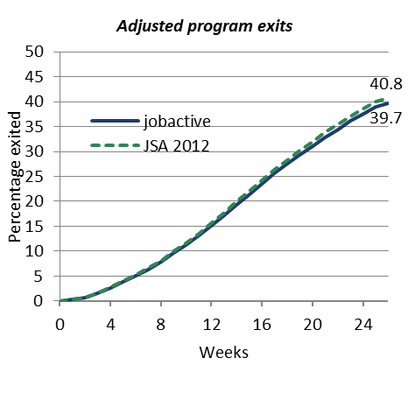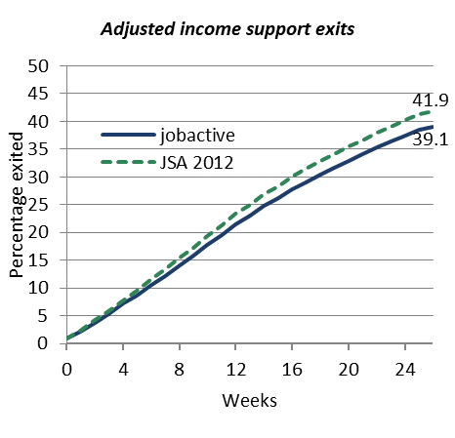

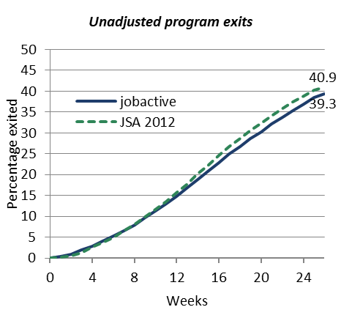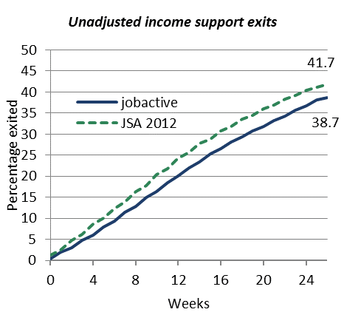

Note: The unadjusted graphs show the exit rate prior to statistical adjustments which remove non-program differences from the study populations.

Source: Department of Employment administrative data and the Research and Evaluation Database.

Table G1: Percentage of new entrant job seekers who exited within six months of commencement

|  |  |  |  |  |  |  |  |
| --- | --- | --- | --- | --- | --- | --- | --- |
| **Category** | **Program exit JSA 2012** | **Program exit jobactive** | **Program exit difference JSA 2012 and jobactive** |  | **Income support exit JSA 2012** | **Income support exit jobactive** | **Income support exit difference JSA 2012 and jobactive** |
| **(%)** | **(%)** |  | **(%)** | **(%)** |
| **Adjusted** | | | | | | | |
| Overall | 40.8 | 39.7 | -1.0 |  | 41.9 | 39.1 | -2.8 |
| Stream A | 42.8 | 41.2 | -1.6 |  | 44.5 | 41.5 | -3.0 |
| Stream B | 22.2 | 26.3 | 4.1 |  | 16.1 | 16.3 | 0.2 |
| Stream C | 24.7 | 27.0 | 2.3 |  | 28.6 | 30.0 | 1.5 |
| Female | 40.1 | 40.5 | 0.4 |  | 38.3 | 36.5 | -1.9 |
| Male | 41.3 | 39.1 | -2.3 |  | 44.6 | 41.1 | -3.4 |
| Indigenous | 29.7 | 30.8 | 1.1 |  | 31.6 | 28.2 | -3.4 |
| Non-Indigenous | 41.3 | 40.2 | -1.1 |  | 42.4 | 39.6 | -2.8 |
| Age under 25 | 42.2 | 44.1 | 1.9 |  | 41.2 | 39.4 | -1.8 |
| Age 50 or above | 33.9 | 31.9 | -2.1 |  | 35.3 | 30.6 | -4.6 |
| **Unadjusted** | | | | | | | |
| Overall | 40.9 | 39.3 | -1.5 |  | 41.7 | 38.7 | -3.0 |
| Stream A | 42.6 | 41.4 | -1.2 |  | 44.0 | 42.0 | -1.9 |
| Stream B | 21.3 | 27.1 | 5.9 |  | 13.3 | 17.7 | 4.4 |
| Stream C | 25.2 | 25.7 | 0.5 |  | 29.2 | 27.7 | -1.4 |
| Female | 40.8 | 39.2 | -1.6 |  | 38.7 | 35.4 | -3.3 |
| Male | 40.9 | 39.4 | -1.5 |  | 44.0 | 41.5 | -2.4 |
| Indigenous | 30.0 | 30.4 | 0.4 |  | 32.0 | 27.6 | -4.4 |
| Non-Indigenous | 41.4 | 39.8 | -1.5 |  | 42.2 | 39.4 | -2.8 |
| Age under 25 | 41.8 | 44.4 | 2.5 |  | 40.9 | 39.5 | -1.3 |
| Age 50 or above | 40.8 | 39.2 | -1.6 |  | 34.7 | 31.1 | -3.6 |

**Note:** Results for different subpopulations of job seekers have been modelled separately in order to improve the estimate of the difference between the programs within subpopulations. Difference estimates printed here are subject to rounding error.

**Source:** Department of Employment administrative data and the Research and Evaluation Database.

Figure G2: Cumulative exit rates — caseload

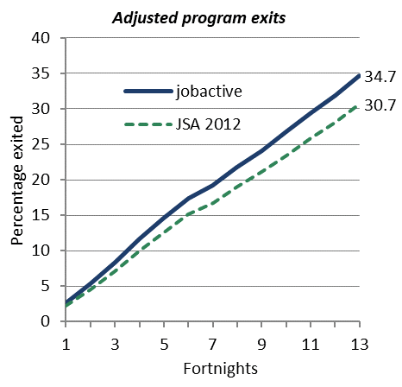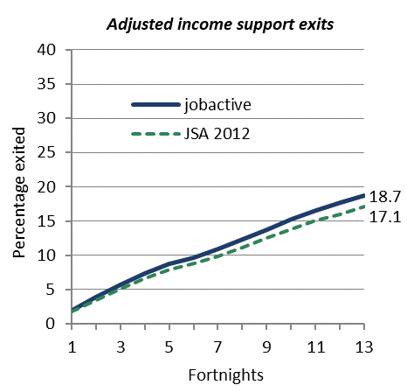

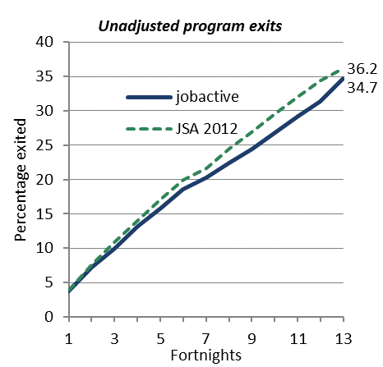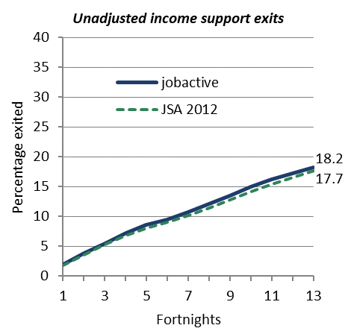

**Note:** The graphs start from the caseload snapshot date. Changes in exit rates may therefore reflect seasonal changes in the labour market. The unadjusted graphs show the exit rate prior to statistical adjustments which remove non-program differences from the study populations.

**Source:** Department of Employment administrative data and the Research and Evaluation Database.

Table G2: Percentage of job seekers who exited within six months of the caseload snapshot date

|  |  |  |  |  |  |  |  |
| --- | --- | --- | --- | --- | --- | --- | --- |
| **Category** | **Employment services exit JSA 2012**  **(%)** | **Employment services exit jobactive**  **(%)** | **Income support exit difference**  **JSA 2012 and jobactive** |  | **Income support exit JSA 2012**  **(%)** | **Income support exit jobactive**  **(%)** | **Income support exit difference JSA 2012 and jobactive** |
| **Adjusted** | | | | | | | |
| Overall | 30.7 | 34.7 | 4.0 |  | 17.1 | 18.7 | 1.7 |
| Stream A | 35.4 | 39.9 | 4.5 |  | 25.3 | 27.3 | 2.0 |
| Stream B | 24.8 | 27.9 | 3.1 |  | 8.6 | 9.3 | 0.7 |
| Stream C | 27.7 | 31.3 | 3.7 |  | 8.9 | 10.8 | 1.9 |
| Female | 28.4 | 32.4 | 4.0 |  | 13.9 | 14.7 | 0.8 |
| Male | 32.8 | 36.7 | 4.0 |  | 20.0 | 22.4 | 2.5 |
| Indigenous | 32.3 | 35.1 | 2.8 |  | 12.2 | 14.0 | 1.8 |
| Non-Indigenous | 30.6 | 34.7 | 4.1 |  | 17.5 | 19.2 | 1.7 |
| Age under 25 | 38.1 | 44.6 | 6.6 |  | 22.0 | 23.4 | 1.4 |
| Age 50 or over | 21.6 | 28.1 | 6.5 |  | 11.3 | 12.5 | 1.1 |
| Income support < 12 months | 40.6 | 44.9 | 4.4 |  | 28.5 | 31.4 | 2.9 |
| Income support 12–24 months | 30.4 | 35.4 | 5.0 |  | 16.8 | 18.6 | 1.8 |
| Income support > 24 months | 23.7 | 27.6 | 3.9 |  | 9.4 | 10.1 | 0.8 |
| **Unadjusted** | | | | | | | |
| Overall | 36.2 | 34.7 | -1.5 |  | 17.7 | 18.2 | 0.5 |
| Stream A | 42.4 | 40.6 | -1.8 |  | 26.1 | 26.6 | 0.5 |
| Stream B | 28.4 | 27.1 | -1.3 |  | 9.2 | 8.8 | -0.4 |
| Stream C | 31.6 | 29.8 | -1.8 |  | 9.8 | 9.8 | 0.0 |
| Female | 33.8 | 31.8 | -2.0 |  | 14.3 | 14.3 | 0.0 |
| Male | 38.3 | 37.4 | -0.9 |  | 20.6 | 21.9 | 1.2 |
| Indigenous | 36.9 | 34.7 | -2.2 |  | 12.8 | 13.6 | 0.8 |
| Non-Indigenous | 36.1 | 34.7 | -1.4 |  | 18.1 | 18.7 | 0.6 |
| Age under 25 | 44.1 | 44.7 | 0.5 |  | 21.3 | 24.3 | 2.9 |
| Age 50 or over | 27.2 | 27.2 | 0.0 |  | 11.9 | 11.9 | 0.0 |
| Income support < 12 months | 47.8 | 48.4 | 0.5 |  | 28.1 | 31.8 | 3.6 |
| Income support 12–24 months | 33.0 | 33.8 | 0.8 |  | 16.5 | 18.7 | 2.2 |
| Income support > 24 months | 26.6 | 25.8 | -0.7 |  | 9.5 | 10.0 | 0.5 |

**Note:** Adjusted results are calculated for the ‘average’ job seeker within each category. Income support exits include only those job seekers who were on income support on the caseload date.

**Source:** Department of Employment administrative data and the Research and Evaluation Database.

Figure G3: Cumulative exit rates — Work for the Dole phase and Work Experience phase

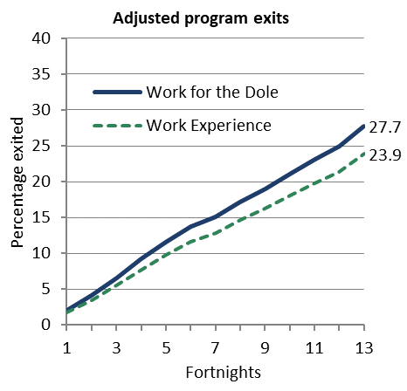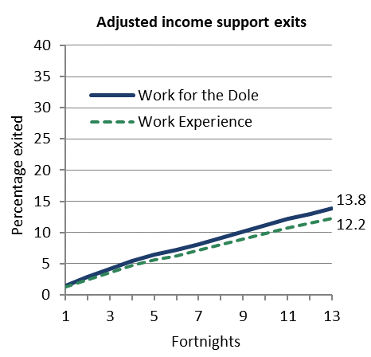

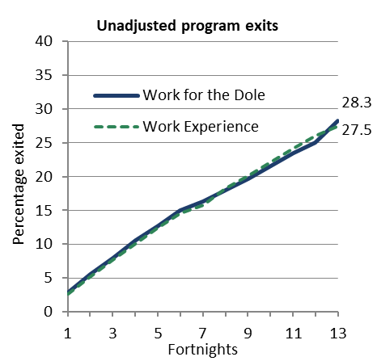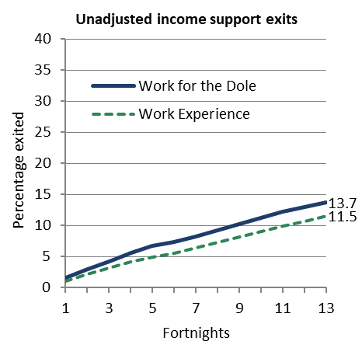

Note: The graphs show cumulative exits by fortnights since the caseload snapshot date. The unadjusted graphs show the exit rate prior to statistical adjustments which remove non-program differences from the study populations.

Source: Department of Employment administrative data and the Research and Evaluation Database.

Table G3: Percentage of job seekers who exited within six months of the caseload snapshot date — Work Experience and Work for the Dole phases

|  |  |  |  |  |  |  |  |
| --- | --- | --- | --- | --- | --- | --- | --- |
| **Category** | **Employment services exit JSA 2012**  **(%)** | **Employment services exit jobactive**  **(%)** | **Income support exit difference**  **JSA 2012 and jobactive** |  | **Income support exit JSA 2012**  **(%)** | **Income support exit jobactive**  **(%)** | **Income support exit difference JSA 2012 and jobactive** |
| **Adjusted** | | | | | | | |
| Overall | 23.9 | 27.7 | 3.9 |  | 12.2 | 13.8 | 1.6 |
| Stream A | 27.5 | 32.3 | 4.8 |  | 18.4 | 21.3 | 2.9 |
| Stream B | 19.4 | 22.8 | 3.3 |  | 7.7 | 8.0 | 0.3 |
| Stream C | 22.9 | 25.6 | 2.8 |  | 7.3 | 7.7 | 0.4 |
| Female | 21.9 | 26.0 | 4.1 |  | 10.3 | 11.3 | 1.0 |
| Male | 25.4 | 29.0 | 3.6 |  | 13.8 | 15.7 | 1.9 |
| Indigenous | 26.7 | 27.0 | 0.3 |  | 8.5 | 9.2 | 0.7 |
| Non-Indigenous | 23.6 | 27.8 | 4.2 |  | 12.7 | 14.3 | 1.7 |
| Age under 25 | 31.1 | 36.4 | 5.3 |  | 16.0 | 18.3 | 2.3 |
| Age 50 or over | 15.1 | 22.2 | 7.1 |  | 8.6 | 9.4 | 0.8 |
| Income support < 12 months | 37.3 | 40.5 | 3.2 |  | 20.7 | 26.6 | 5.9 |
| Income support 12–24 months | 27.2 | 33.6 | 6.4 |  | 18.3 | 21.2 | 2.9 |
| Income support > 24 months | 21.0 | 24.4 | 3.4 |  | 9.3 | 10.0 | 0.7 |
| **Unadjusted** | | | | | | | |
| Overall | 27.5 | 28.3 | 0.8 |  | 11.5 | 13.7 | 2.2 |
| Stream A | 32.7 | 33.8 | 1.1 |  | 18.7 | 20.0 | 1.3 |
| Stream B | 23.2 | 21.8 | -1.4 |  | 8.1 | 7.5 | -0.6 |
| Stream C | 26.6 | 24.2 | -2.4 |  | 7.6 | 7.2 | -0.4 |
| Female | 25.5 | 26.0 | 0.6 |  | 9.5 | 11.4 | 1.8 |
| Male | 29.1 | 30.0 | 0.9 |  | 13.1 | 15.4 | 2.4 |
| Indigenous | 30.6 | 26.5 | -4.1 |  | 8.4 | 9.1 | 0.6 |
| Non-Indigenous | 27.1 | 27.8 | 0.6 |  | 11.9 | 14.2 | 2.3 |
| Age under 25 | 35.3 | 37.1 | 1.8 |  | 14.4 | 18.5 | 4.0 |
| Age 50 or over | 19.4 | 21.8 | 2.4 |  | 8.1 | 9.4 | 1.3 |
| Income support < 12 months | 52.3 | 50.4 | -1.9 |  | 15.4 | 21.1 | 5.8 |
| Income support 12–24 months | 29.4 | 32.5 | 3.1 |  | 18.5 | 21.1 | 2.6 |
| Income support > 24 months | 23.6 | 23.1 | -0.5 |  | 9.0 | 10.1 | 1.1 |

Note: The average of rows that taken together cover the population (e.g. Stream A, Stream B and Stream C) will not necessarily reflect the overall rate, as the ‘average’ person characteristics differ between rows.

**Source:** Department of Employment administrative data and the Research and Evaluation Database.

# Appendix H New entrant program exit results, when not applying the additional exclusion criteria

Figure H1: Cumulative exit rates for new entrant job seekers, including job seekers not on income support

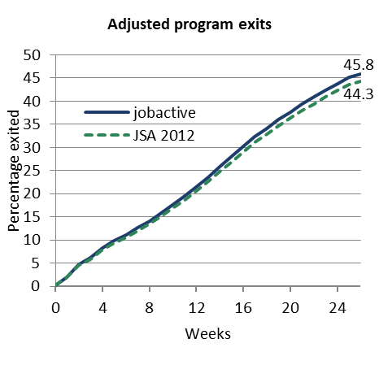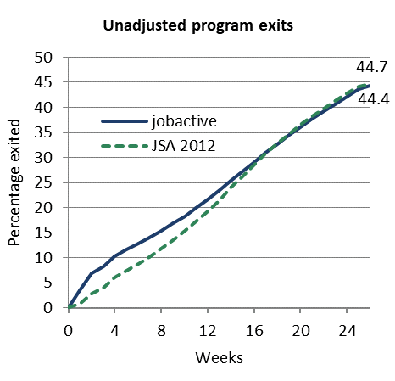

Notes: Includes job seekers who did not commence income support within 28 days.

The unadjusted graphs show the exit rate prior to statistical adjustments which remove non-program differences from the study populations.

Source: Department of Employment administrative data and the Research and Evaluation Database.

Table H1: Percentage of new entrant job seekers who exited within six months of commencement, including job seekers not on income support.

|  |  |  |  |
| --- | --- | --- | --- |
| **Category** | **Program exit JSA 2012 (%)** | **Program exit jobactive (%)** | **Program exit difference JSA 2012 and jobactive** |
| Overall | 44.3 | 45.8 | 1.5 |
| Stream A | 46.3 | 47.5 | 1.2 |
| Stream B | 24.7 | 29.5 | 4.8 |
| Stream C | 26.5 | 30.1 | 3.6 |
| Female | 43.2 | 46.0 | 2.8 |
| Male | 45.1 | 45.6 | 0.4 |
| Indigenous | 31.8 | 36.0 | 4.1 |
| Non-Indigenous | 44.9 | 46.3 | 1.4 |
| Age under 25 | 44.7 | 50.8 | 6.1 |
| Age 50 or above | 40.7 | 39.7 | -1.1 |
| Overall | 44.7 | 44.4 | -0.3 |
| Stream A | 46.4 | 46.5 | 0.1 |
| Stream B | 23.7 | 29.8 | 6.1 |
| Stream C | 26.9 | 28.0 | 1.1 |
| Female | 44.3 | 43.8 | -0.5 |
| Male | 45.0 | 44.9 | -0.1 |
| Indigenous | 32.5 | 34.3 | 1.8 |
| Non-Indigenous | 45.2 | 44.9 | -0.3 |
| Age under 25 | 45.5 | 49.1 | 3.7 |
| Age 50 or above | 40.4 | 38.9 | -1.6 |

Notes: Includes job seekers who did not commence income support within 28 days.

Results for different subpopulations of job seekers have been modelled separately in order to improve the estimate of the difference between the programs within subpopulations.

Source: Department of Employment administrative data and the Research and Evaluation Database.

# Appendix I Indigenous Outcomes Targets

As mentioned in Section 3.1, jobactive introduced Indigenous Outcomes Targets to incentivise parity of outcomes between Indigenous and non-Indigenous job seekers within the jobactive contract. From 1 January 2018, Indigenous Outcomes Targets were replaced by Indigenous Outcomes Incentives, which use regression analysis to predict the likelihood of a job seeker achieving outcomes, then assess a provider’s actual performance against that prediction to determine provider performance. Indigenous Outcomes Incentives are out of scope for this report.

Table I1 (1 July 2015 – 31 December 2015) and Table I2 (1 January 2016 – 30 June 2016) show the Indigenous Outcomes Targets results of the first two performance periods of the jobactive contract. The tables show the ‘Target’ (the average of each individual contract target) by stream and by outcome, at the overall level and the contract level. For example, Table 3.4 shows that in Performance Period 1, 17.9 per cent of the Stream B caseload was Indigenous (nationally), but Indigenous Stream B job seekers made up 14.1 per cent of all Stream B, 4 Week Outcomes, thus missing the target when all job seekers at all sites are considered. Table 3.4 also shows that 44 per cent of jobactive contracts met their Stream B, 4 Week Outcome target. Note that the figure of 17.9 per cent was a national average; individual jobactive providers’ targets were based on the percentage of their own caseloads that were Indigenous job seekers.

The tables broadly show that the Indigenous Outcomes Targets did not achieve parity of outcomes between Indigenous and non-Indigenous job seekers, and that parity of outcomes was harder to achieve in higher (more disadvantaged) streams. With the current data, however, it cannot be assessed whether Indigenous Outcomes Targets improved outcomes for Indigenous job seekers compared to JSA 2012. The data period covered in these tables does not include any outcomes after the business reallocation in mid-2017. Depending on provider circumstances and relative performance, providers may experience a reduction or increase in the proportion of new job seekers allocated to them. Therefore, the full effect of the Indigenous Outcomes Targets within the jobactive contract will not be known until results from both before and after the reallocation are assessed.

Table I1: Indigenous Outcomes Targets 1 July 2015 – 31 December 2015: Performance Period 1

|  |  |  |  |  |  |  |  |
| --- | --- | --- | --- | --- | --- | --- | --- |
|  | **National level targets** | | | | **Employment region numbers and proportion of total contracts** | | |
|  | **Target** | **Actual (and percentage of) target achieved** | | | **Contracts meeting targets**  **Number (and percentage)** | | |
| **Stream** | **(%)** | **4 Week** | **12 Week** | **26 Week** | **4 Week** | **12 Week** | **26 Week** |
| Stream A | 5.0 | 4.4 (88%) | 4.5 (90%) | n/a | 101 (50%) | 98 (49%) | n/a |  |
| Stream B | 17.9 | 14.1 (79%) | 13.9 (78%) | n/a | 88 (44%) | 76 (38%) | n/a |  |
| Stream C | 15.2 | 9.4 (62%) | 9.4 (62%) | n/a | 51 (25%) | 54 (27%) | n/a |  |

**Note:** Includes volunteers.

**Source:** Department of Employment administrative data.

Table I2: Indigenous Outcomes Targets 1 January 2016 – 30 June 2016: Performance Period 2

|  |  |  |  |  |  |  |  |
| --- | --- | --- | --- | --- | --- | --- | --- |
|  | **National level targets** | | | | **Employment region numbers and proportion of total contracts** | | |
|  | **Target** | **Actual (and percentage of) target achieved** | | | **Contracts meeting targets**  **Number (and percentage)** | | |
| **Stream** | **(%)** | **4 Week** | **12 Week** | **26 Week** | **4 Week** | **12 Week** | **26 Week** |
| Stream A | 5.2 | 4.5 (86%) | 4.2 (81%) | 4.1 (79%) | 73 (36%) | 61 (30%) | 63 (31%) |  |
| Stream B | 18.1 | 13.1 (72%) | 13.1 (72%) | 13.6 (75%) | 53 (26%) | 54 (27%) | 66 (33%) |  |
| Stream C | 15.5 | 9.8 (63%) | 9.2 (59%) | 8.7 (56%) | 39 (19%) | 37 (18%) | 42 (21%) |  |

**Note:** Includes volunteers.

**Source:** Department of Employment administrative data.

# Appendix J Propensity-matched job seeker analyses in the jobactive Work for the Dole phase

The regression-adjusted figures in Table 3.9 accounted for selected job seeker differences in characteristics and local unemployment rates between jobactive’s Work for the Dole phase and JSA 2012’s Work Experience phase. The robustness of this adjustment was tested by performing the same analyses on job seekers ‘matched’ for particular characteristics (age grouping, gender, participation requirement, and JSCI score). This ‘propensity matching’ technique[73] matched individual job seekers in the JSA 2012 Work Experience phase with a similar job seeker selected from the jobactive Work for the Dole phase. For example, a female job seeker with a full-time participation requirement and a JSCI score of 22 in the JSA 2012 Work Experience phase would be matched with a female job seeker with a full-time participation requirement and a JSCI score of 22 in the jobactive Work for the Dole phase (or nearest match if an exact match was not available). The technique resulted in 107,530 job seekers in the JSA 2012 Work Experience phase matched with 107,530 job seekers in the jobactive Work for the Dole phase.

When new survival analyses were carried out on the matched job seekers, results were broadly similar (but with the magnitude of the difference between programs generally slightly smaller) to the adjusted results detailed in Table 3.9. Although this alternative technique to control for non-program differences gave similar results, no statistical technique could fully account for the non-program differences between the groups in an observational study. Policy changes in the timing of and eligibility for the jobactive Work for the Dole phase have occurred during the course of the jobactive program. This provides an opportunity to evaluate the Work for the Dole phase with greater confidence in measuring effects isolated from other factors. A range of evaluation options are being developed for inclusion in the final report.

1. Now the Department of Employment, Skills, Small and Family Business
2. The 2017–18 Budget included the introduction of changes to RapidConnect so that from 1 July 2018 income support is generally payable from the date the job seeker attends the first appointment with their provider.
3. Under jobactive accredited training was always allowed to be funded through the Employment Fund (EF); however, non-accredited training was not. Changes were introduced in December 2015 to allow non-accredited employability and foundation skills training to also be paid from EF for Stream B and C job seekers.
4. The 2017–18 Budget included the introduction of a new targeted compliance framework that provides additional help for genuine job seekers to meet their requirements, while strengthening penalties for persistent and deliberate non-compliance. The Targeted Compliance Framework commenced on 1 July 2018.
5. Rainbow servicing refers to a situation where instead of being serviced by one particular employment consultant at a jobactive provider, a job seeker is instead serviced by the next available employment consultant, or serviced in group-based sessions.
6. Income support dependency is measured by the percentage of an allowance a job seeker is paid, excluding supplementary payments such as Rent Assistance.
7. To make comparison by stream possible, the evaluators determined the jobactive equivalent stream for job seekers in JSA 2012 (i.e. Streams A, B and C) based on the Job Seeker Classification Instrument (JSCI) rules under jobactive. Stream A is for the most competitive job seekers, who require minimal assistance to find work. Stream B is for job seekers who have vocational issues and need assistance to become work-ready. Stream C is for the most disadvantaged job seekers, who may have a combination of vocational and non-vocational barriers to employment.
8. This may also be influenced by coordination needed between providers and Work for the Dole Coordinators. Work for the Dole Coordinator services ceased from January 2018 (2017–18 Budget), which may reduce this issue to some degree.
9. Note: Comparable data on employer use of JSA was not collected for the 2014–15 period.
10. Under a 2017–18 Budget initiative Work for the Dole Coordinators ceased from 1 January 2018. Their responsibilities have been taken over by jobactive providers. The Work for the Dole Coordinators are, however, in scope for the final jobactive evaluation.
11. The New Enterprise Incentive Scheme, Harvest Labour Services and National Harvest Labour Information Service are out of scope for the jobactive evaluation.
12. The Job Seeker Compliance Framework is independent of the jobactive employment services system; that is, people receiving participation payments and in other programs are also subject to such requirements (Department of Social Services 2017b). In addition, the Job Seeker Compliance Framework straddles jobactive and JSA 2012 — for example, changes were made to strengthen the compliance framework on 1 July 2014, 1 January 2015 and 1 July 2015 (see Department of Employment 2015d for details).
13. The 2017–18 Budget identified changes to the compliance framework. From July 1 2018 a new targeted compliance framework has been introduced.
14. For a comprehensive description of outcome payments, refer to the Request for Tender for Employment Services 2015–2020 (Section 2.16.3).
15. As a result of consultations with jobactive providers on the EF, fund policy has been clarified and refined, and a number of changes have been made. These include the introduction of EF reimbursements for employability and foundation skills training for Stream B and C job seekers from December 2015. For the period 1 July 2015 – 31 March 2017, this item accounted for almost 10 per cent of EF funding disbursements (Department of Employment, 2017).
16. From 1 January 2017, the Youth Wage Subsidy 13-week suspension period allows job seekers to reconnect with income support without having to reclaim if their employment ends through no fault of their own (see Department of Human Services 2017 for details).
17. From 1 January 2017 changes were made to wage subsidies which included paying all wage subsidies to employers over six months instead of 12 months; paying wage subsidies as flat rates; simplifying the wage subsidy eligibility, agreement and payment processes; and lifting the minimum number of hours worked per week from 15 to 20 hours, averaged over the wage subsidy agreement.
18. Volunteers are not in scope for this evaluation and are excluded from results and analysis, unless otherwise stated.
19. This was only the case until 1 October 2016, when all job seekers entered the Work for the Dole phase after 12 months in services.
20. When compared with the EPF of JSA, the EF of jobactive was refined and streamlined, including tighter rules for non-accredited training, but still allowing accredited training. Micro-policy changes introduced in December 2015 now permit greater usage of non-accredited training in specific circumstances.
21. This was removed from Star Rating calculations from 1 January 2018.
22. From 1 January 2018, two new expenditure categories, Indigenous Training and Mentoring and Provider Indigenous Mentoring Capability, were introduced to the EF.
23. A number of factors might have caused a drop in the labour force participation rate in Australia over recent years, including the discouraged worker effect and the demographics of the working-age population. The discouraged worker effect arises when potential workers leave the labour force during recessions rather than continuing their search for work while job conditions are poor. In good economic times, potential workers join the labour force, giving rise to an encouraged worker effect (Connolly and Trott, 2014).
24. Income support dependency is measured by the percentage of an allowance a job seeker is paid, excluding supplementary payments such as Rent Assistance.
25. The jobactive program has a number of metrics that may be used to measure its performance (e.g. Key Performance Indicators and the number of paid job outcomes to jobactive providers). Departmental analysis of JSA outcome measures undertaken in 2014 suggests that exits from income support and the program are among the best proxies for job seekers obtaining employment. Moreover, unlike some other performance metrics, the data underlying these outcome measures in jobactive and JSA 2012 are comparable (an important feature given the comparative approach taken by this evaluation). See Appendix F for more detail.
26. The job seeker program exit rates presented in this interim report may be underestimated because of a technical issue in recording exits from the jobactive program. In particular, around 3700 job seeker program exits between 1 July 2015 and 23 March 2016 were not reflected in the data until 24 March 2016. For this reason, the relative performance of jobactive compared to JSA 2012 over this time period is better indicated using the income support exit rate.
27. Unlike the off-income-support measures, this measure will be influenced by reductions in a job seeker’s allowance due to a compliance penalty. Differences in the income support dependency rate between the programs will therefore reflect the penalty system in addition to the program’s effectiveness at assisting job seekers to obtain employment.
28. The target population for this study is job seekers engaged with a jobactive provider, as discussed in Section 1.5.
29. While volunteer job seekers are out of scope for this evaluation, they have been included in Sections 2.1 and 2.2 to provide a more complete picture of basic caseload and commencement data for each program.
30. The number of new entrant job seekers decreased over the course of the JSA 2012 contract. The number of new entrant job seekers has decreased at a faster rate since the introduction of jobactive.
31. A job seeker may be exempted from RapidConnect for a number of reasons. These reasons are listed in full in the Guide to the Social Security Law, paragraph 3.2.1.45. They include being exempted from MORs, being more suited to another program or service or because an immediate return to the workforce may be unsuitable.
32. Changes to Rapid Connect were announced in the 2017–18 Budget. Since July 2018, income support will usually start from the date job seekers attend their first appointment with their provider.
33. Refer to Appendix D for information on how JSA 2012 job seekers were re-assigned using jobactive streaming rules.
34. As discussed in a previous footnote, changes to the compliance framework are included in the 2017–18 Budget. From 1 July 2018 a more targeted approach was introduced (the Targeted Compliance Framework).
35. The Non-Attendance Report is an electronic report sent by the provider to DHS notifying of its assessment that a job seeker has failed to attend an appointment without a valid reason or reasonable excuse.
36. The 2017–18 Budget included the introduction of a new targeted compliance framework which started on 1 July 2018.
37. Analysis of administrative data suggests that the proportion of job seekers subject to an income support suspension was around 45 per cent in the first 12 months of jobactive. A job seeker subject to an income support suspension in administrative data, however, may not have had their income support payment reduced (e.g. if they reconnected within their income support payment fortnight), which may explain job seekers under-reporting in this instance.
38. It should be noted that this analysis does not take into account when the failure to attend and re-engagement occurred with respect to a job seeker’s DHS reporting fortnight. Whether the job seeker re-engages before the end of their DHS reporting fortnight can impact on whether DHS impose a suspension and/or financial penalty on the job seeker. Further analysis on re-engagement will be conducted in future reporting to track job seeker behaviour during the course of jobactive.
39. The framework was Introduced in January 2015 and operated for the last six months of JSA 2012.
40. Micro-policy changes introduced in December 2015 now permit greater usage of non-accredited training in specific circumstances. The data analysed in this report pre-dates this change.
41. Rainbow servicing refers to a situation where instead of being serviced by one particular employment consultant at a jobactive provider, a job seeker is instead serviced by the next available employment consultant, or serviced in group-based sessions.
42. Since this survey was conducted, the Government has introduced Transition to Work and Youth Jobs PaTH and enhanced the National Work Experience Programme. All of these are aimed at providing young people with opportunities to gain work experience.
43. This suggests jobactive staff may not have exploited the flexibility of jobactive in servicing job seekers.
44. Specialist providers delivered services for homeless, youth, people with disabilities, Indigenous job seekers, people from Culturally and Linguistically Diverse (CALD) backgrounds, and ex-offenders.
45. International literature suggests that ‘employment first’ schemes are prone to encouraging higher shorter term but lower longer term labour force outcomes. This interim evaluation does not have the data to examine such sustainability issues.
46. *Appendix A Statistical tables*.
47. This is not always the case as income support payments may be reduced by a partner’s income or asset tests.
48. This can include people on income support without MORs such as Parenting Payment recipients with their youngest child under six, Carer Payment recipients, Age Pensioners, and Disability Support Pensioners who choose to volunteer in an employment program. It can also include people who are not on a payment and are working fewer than 15 hours a week and not studying full-time.
49. For reference, the program exit results for new entrant populations when not applying the additional exclusion criteria are presented in *Appendix H New entrant program exit results, when not applying the additional exclusion criteria*.
50. This can happen when, for example, RapidConnect eligible job seekers commence in a stream while their support entitlement is still being determined, but do not qualify for or do not complete the process for obtaining an income support payment within 28 days.
51. The 2016–17 Budget included Closing the Gap – Employment Services measures to support progress on achieving parity in employment outcomes between Indigenous and non-Indigenous Australians.
52. From 1 January 2018, Indigenous Outcomes Targets were replaced by Indigenous Outcomes Incentives, which use regression analysis to predict the likelihood of a job seeker achieving outcomes, then assess a provider’s actual performance against that prediction to determine provider performance.
53. In unadjusted terms, the program exit rate for the six-month observation period is 1.5 percentage points lower under jobactive than under JSA 2012.
54. In unadjusted terms, the income support exit rate for the six-month observation period is 3.0 percentage points lower under jobactive than under JSA 2012.
55. All difference values in this section are based on unrounded values.
56. The unadjusted income support exit rate is 0.5 percentage points higher under jobactive than under JSA 2012.
57. In unadjusted terms, the program exit rate is 1.5 percentage points lower under jobactive than JSA 2012.
58. From 1 October 2016, this changed so that all job seekers enter the Work for the Dole phase after 12 months in services. Those who were already in the Work for the Dole phase on 1 October under the previous rules remained in the phase.
59. For more detail on ‘threat effects’ see Rosholm and Svarer (2004). The final evaluation report will contain an analysis of the size of the threat effect.
60. This may also have been the case in part because job seekers from the Case Management phase of JSA 2012 were transitioned into the Work for the Dole phase in jobactive.
61. In unadjusted terms, the program exit rate for the six-month observation period was 0.8 percentage points higher in the Work for the Dole phase than in the Work Experience phase.
62. In unadjusted terms, the income support exit rate for the six-month observation period was 2.2 percentage points higher in the Work for the Dole phase than in the Work Experience phase.
63. Using the unadjusted program exit rate as the outcome measure, the difference was 4.8 percentage points for Stream A job seekers, followed by Stream B job seekers (3.3 percentage points) and Stream C job seekers (2.8 percentage points).
64. Unemployment duration at caseload dates was used as a control in the analysis as previously described.
65. Some examples of compliance costs are: costs of making, keeping and providing records; costs of notifying the Government of certain activities; costs of conducting tests; costs of making an application; and compliance costs associated with financial costs, including the costs incurred in complying with government taxes, fees, charges and levies (excluding the actual amount paid) — for example, the time taken to pay a licence fee is a compliance cost. Compliance costs include the time taken to demonstrate compliance with the regulation as well as the associated travel costs (for instance, the costs of travelling to a particular location to submit a form or waiting in a queue in order to comply with a requirement) (DPMC 2014).
66. Some reductions in compliance costs that occurred under JSA have only been applied to the calculation of compliance costs under jobactive. This is because compliance costs for JSA were calculated for the year 2012–13. Reductions in compliance costs occurred primarily in 2014, such as the change in documentary evidence for outcome payments.
67. These figures include costs to employers and job seekers, though the greatest cost is to providers.
68. Departmental analysis estimates annual red tape costs in JSA 2012 equated to approximately 20.9 per cent of program funding.
69. It should be noted that respondents to the survey may not have been able to differentiate between the Department’s administrative requirements and those imposed by their own organisation.
70. Department of Education, Employment and Workplace Relations 2012, Advisory Panel on Employment Services Administration and Accountability final report, May, DEEWR, Canberra.
71. In mid 2015–16, after consultation with the sector, the Department expanded the documentary evidence options to support the submission of payslip verified outcomes.
72. As the Employer Mobilisation Strategy was introduced after the period of analysis chosen for the jobactive interim evaluation report, and will be evaluated as part of the Youth Jobs PaTH program, the Strategy is not considered in scope for this report.
73. See Parsons (2004).