

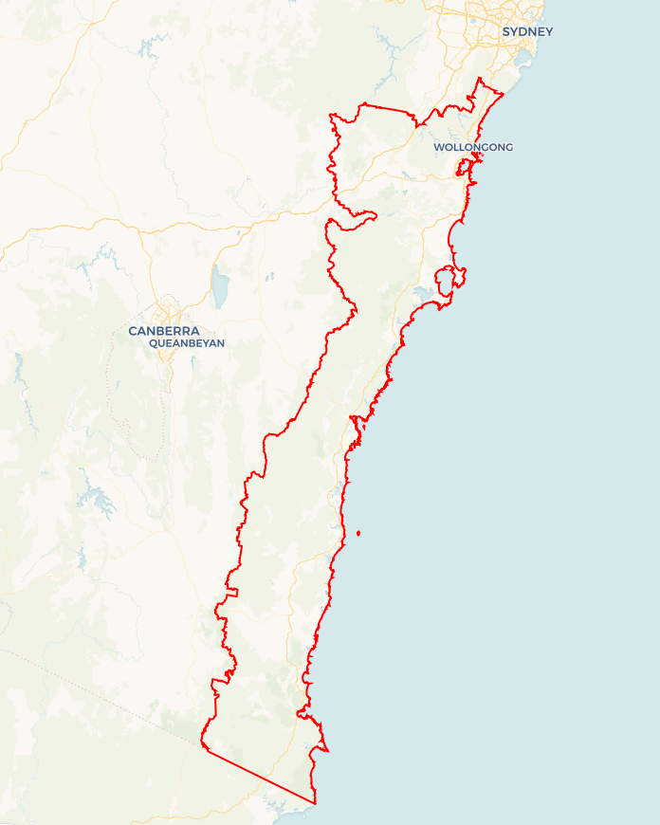Local Jobs Plan

****Illawarra South Coast**** Employment Region | NSW | ****March 2025****

Workforce Australia Local Jobs (Local Jobs) is a program that supports tailored approaches to accelerate   
reskilling, upskilling and employment pathways in response to current and emerging local workforce needs.

## Local Jobs elements

### Local Jobs Plan

The Local Jobs Plan sets out the skills and employment challenges and priorities of the region, and associated strategies that will drive the design and implementation of activities to be implemented to address these challenges.

### Employment Facilitators

Employment Facilitators and Support Officers support the delivery of the program by bringing together key stakeholders including businesses, employment services providers, higher education and training organisations.

### Local Jobs and Skills Taskforce

Each Employment Region has its own Taskforce. Representatives include local stakeholders who have demonstrated experience in upskilling, reskilling, and an ability to represent, connect and collaborate with others in the region to meet labour market needs.

### Local Recovery and National Priority Funds

The Local Recovery Fund supports projects that meet the priorities identified in the Local Jobs Plan. The National Priority Fund provides funding for innovative local solutions to address structural barriers to employment.

Explore labour market insights for the  
[Illawarra South Coast](https://www.jobsandskills.gov.au/data/employment-region-dashboards-and-profiles/monthly-labour-market-dashboards) Employment Region

## Local labour market challenges and opportunities in the region

* High youth unemployment in the 15-24 age group is a concern and is reflected in higher youth unemployment rates in the Illawarra South Coast. This will require an additional focus on support strategies.
* Limited public transport and barriers in obtaining a driver licence remains an issue. Additional Driver Licensing Access Program (DLAP) contracts and support programs are required for the Illawarra and Shoalhaven regions to increase access to sustainable employment.
* A collaborative approach with Workforce Australia Employment Services Providers (providers) for innovative and tailored services is required for First Nations, mature age, migrant, youth and long-term unemployed cohorts.
* Ongoing targeted training and employment support strategies for migrants and refugees are needed to increase job pathways.
* Partnerships with businesses are needed to support an improved understanding of the needs of a range of cohorts.
* The hospitality, tourism and retail industry are experiencing financial viability difficulties due to costs of living pressures and business closures. There are still demands for specialist roles such as chefs and front of house staff. Workforce needs for the Marine industry continue to increase on the Far South Coast.
* Ongoing innovative solutions to address workforce shortages for the care sector, in particular children’s services, aged care, disability services and childcare is required to increase meet workforce shortages.
* The significant growth in the defence, manufacturing, transport and logistics and clean energy industries as we move to a net zero and circular economy future in the Illawarra South Coast region, will have significant future workforce needs.
* Changes and uncertainty with Training Services Smart and Skilled funding, industry priorities and Registered Training Organisation (RTO) funding caps is causing uncertainty for RTOs in the region. The increase in fee for service courses reduces the accessibility of training for many people.
* Shortages of housing is restricting workforce capacity across the region. Strategies will need to be in place to manage essential worker housing needs including the hospital and large civil construction projects.

**Local jobs and skills priorities and strategies in the region**

### Priority 1 – Transport and driver licences

#### What are our challenges and opportunities?

The lack of public transport in the more remote parts of the region combined with inconsistent delivery of learner driver support services is reducing employment opportunities for a range of unemployed cohorts. Improved support particularly for youth, migrants, First Nations and long-term unemployed people is required to successfully gain a driver’s licence and pathway to sustainable employment.

#### How are we responding?

* Utilising the Transport Working Group membership to support new ‘Driver Mentoring Ls 2 Ps’ projects in the Illawarra, Shoalhaven and Bega Valley and working with DLAP providers funded by Transport NSW to ensure consistent access to driver licence support is provided across the Illawarra South Coast region.
* Utilising our Local Jobs and Skills Taskforce and Transport Working Group membership to advocate with Transport NSW and local NSW state members for increased access to bus services aligned to employment and skills opportunities to enable equitable access to skills and jobs.

### Priority 2 – Support education, employment and economic development for First Nations peoples

#### What are our challenges and opportunities?

Fostering skills and job opportunities to Increase sustainable employment opportunities for First Nations people in the Illawarra South Coast needs to be informed by effective community engagement, collaborative partnerships, innovative service delivery, project design and increased support for First Nations businesses.

#### How are we responding?

* Utilising the expertise and the commitment for collaboration of our Local Jobs and Skills Taskforce, working groups and key stakeholders including Workforce Australia, Department of Primary Industries and Regional Development, Regional Development Australia (RDA) Illawarra Shoalhaven and Southern NSW and ACT, the National Indigenous Australians Agency’s local First Nations communities and organisations to develop and implement innovative and culturally safe skills and employment activities to improve recruitment and retention of First Nations people.
* Working collaboratively across the region’s industry focused working groups and with our key stakeholders to increase pathways to employment by utilising Local Jobs Program funded activities, pre-employment, traineeship and apprenticeship and higher-level skills programs to offer tailored and integrated support, including cultural mentoring programs, for First Nations people.
* Supporting First Nations procurement partnerships, land management and growth of jobs by supporting First Nations businesses.

### Priority 3 – Supporting defence, manufacturing, energy, transport and logistics and their move to a net zero and circular economy future

#### What are our challenges and opportunities?

The expected extensive growth of these industries in the Illawarra South Coast regions requires a large pool of job-ready, skilled workers to successfully manage the planned project construction and business expansion phase over the next 2-5 years to ensure timely delivery of the new and existing projects.

#### How are we responding?

* Continuing to build stronger links with the regions key stakeholders including Jobs and Skills Councils, i3Net, Department of Primary Industries and Regional Development, RDA Illawarra Shoalhaven, RDA Southern NSW and ACT, Business Illawarra, University of Wollongong (UOW), Illawarra Shoalhaven Defence Industry Group, Bega Circulatory Centre, UOW Energy Futures Centre and TAFE Manufacturing Centre of Excellence to increase collaboration, skills and employment opportunities and minimise duplication to help build the workforce capacity of employers in the region.
* Working in partnership with working group members and industry stakeholders to develop innovative opportunities and an increased understanding of the needs of individual job seeker cohorts to maximise job opportunities in these industry areas.
* Supporting strategies that increase the understanding of individuals, school students and parents of the range of job roles, skills and career pathways through increased linkages with employers in these target industries to build skills, improve outcomes and gain sustainable employment.

### Priority 4 – The care sector

#### What are our challenges and opportunities?

The care sector which includes aged care, disability and children’s services is facing ongoing challenges to access a job ready, skilled workforce to meet current and future labour demands while at the same time needing to meet extensive compliance and regulatory requirements.

#### How are we responding?

* Working with strategic partners such as the Jobs and Skills Councils, Community Industry Group, Aged and Community Care Providers Association , NSW Health, the Department of Health and Aged Care and care providers to implement new initiatives that focus on building the capacity of the care workforce.
* Utilising the Local Jobs Care Sector working group members and industry stakeholders to develop campaigns that increase career opportunities in the sector.
* Trialling innovative recruitment strategies to increase pathways for a range of cohorts to maximise job opportunities in the sector.
* Support strategies that increase the understanding of individuals, school students and parents of the range of job roles, skills and career pathways through increased linkages with employers in these target industries to build skills, improve outcomes and gain sustainable employment.

### Priority 5 – Hospitality, tourism and small business

#### What are our challenges and opportunities?

The small business sector has experienced considerable difficulties over several years and are currently experiencing financial viability issues due to cost-of-living pressures. Skilled labour shortages are still a concern for the hospitality, tourism, accommodation and small business sectors including the marine industry to deliver services, maintain financial viability and manage the challenges of seasonality and the effect of the cost-of-living pressures.

#### How are we responding?

* Working collaboratively with employers, working group members and key industry stakeholders including Jobs and Skills Councils, the Shoalhaven Food Network, Destination NSW Sydney Surround South, SisterShip Training, Chambers of Commerce and industry stakeholders to raise awareness of employment opportunities, trial innovative recruitment strategies and seek to build the profile of the sector as a desirable career choice for a range of cohorts.

### Priority 6 – Collaborative jobs and skills activities aligned to regional economic and infrastructure development and workforce needs

#### What are our challenges and opportunities?

The Illawarra South Coast region includes a range of key stakeholders including the industry peak bodies, Jobs and Skills Council, Local Councils, Department of Primary Industries and Regional Development, RDA, Business Illawarra, Chambers of Commerce, UOW, TAFE NSW and private training providers and the Local Jobs Program that can benefit from working collaboratively to ensure skills and employment strategies align with the region’s economic and workforce needs.

#### How are we responding?

* Working collaboratively with the regions key stakeholder representatives to develop regular two-way sharing of key information about economic development and the large infrastructure and workforce capacity projects that will be implemented in the region to inform skills and employment projects to reduce duplication of resources and maximise outcomes for the Illawarra South Coast region.
* Working with Training Services NSW, UOW, providers, Australian Apprenticeship Support Centres, Group Training, Training Providers and schools to ensure school leaver pathways, pre-employment programs, traineeship and apprenticeship programs and higher-level skills align with the needs of current and emerging industries.
* Support strategies that increase the understanding of individuals, school students and parents of the range of job roles, skills and career pathways through increased linkages with employers in our target industries to build skills, improve outcomes and gain sustainable employment.

**Want to know more?**

* Contact: Andrew Wales, Illawarra South Coast Employment Facilitator: [andrew.wales@illawarrascjobs.com.au](mailto:andrew.wales@illawarrascjobs.com.au).
* Visit: [Local Jobs](https://www.dewr.gov.au/local-jobs) or [Workforce Australia](https://www.workforceaustralia.gov.au/)