

Local Jobs Plan

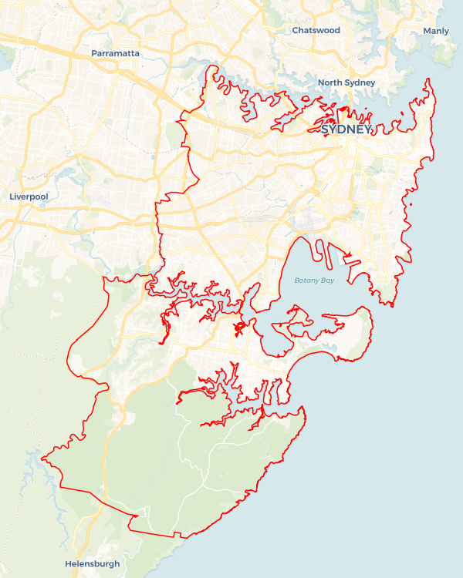

Explore labour market insights for the   
[Sydney East Metro](https://www.jobsandskills.gov.au/work/employment-region-dashboards-and-profiles/monthly-labour-market-dashboards)  Employment Region

Explore labour market insights for   
[[Employment Region Name](https://labourmarketinsights.gov.au/regions/employment-regions/)] Employment Region

Sydney East Metro ****Employment Region**** | NSW | ****September 2024****

Workforce Australia Local Jobs (Local Jobs) is a program that supports tailored approaches to accelerate   
reskilling, upskilling and employment pathways in response to current and emerging local workforce needs.

## Local Jobs elements

### Local Jobs Plan

The Local Jobs Plan sets out the skills and employment challenges and priorities of the region and associated strategies that will drive the design and implementation of activities to be implemented to address these challenges.

### Employment Facilitators

Employment Facilitators and Support Officers support the delivery of the program by bringing together key stakeholders including businesses, employment services providers and higher education and training organisations.

### Local Jobs and Skills Taskforce

Each Employment Region has its own Taskforce. Representatives include local stakeholders who have demonstrated experience in upskilling, reskilling and an ability to represent, connect and collaborate with others in the region to meet labour market needs.

### Local Recovery and National Priority Funds

The Local Recovery Fund supports projects that meet the priorities identified in the Local Jobs Plan. The National Priority Fund provides funding for innovative local solutions to address structural barriers to employment.

## Local labour market challenges and opportunities in the region

* There is high demand for entry-level workers in hospitality and tourism; healthcare and social assistance; construction and infrastructure; and retail.
* There are increasing skills shortages in these in-demand sectors in the region: manufacturing; wholesale trade; aged, disability and childcare; professional services; administrative support; accommodation and food services; information and communications technology and aviation.
* There has been a decrease in employer engagement with Workforce Australia Employment Services Providers. Organising activities like   
  pre-employment programs, targeted recruitment drives and working groups provide opportunities to restore relationships with employers.
* The completion rates for apprenticeships and traineeships have been a persistent challenge. In 2023, the completion rate for apprenticeships and traineeships in NSW stood at just 42%. Implementing strategies that effectively support both employers and learners can significantly boost completion rates, helping to address skill shortages and alleviate labour market gaps by improving retention.
* There are ongoing challenges for vulnerable cohorts, including Indigenous people, people from Culturally and Linguistically Diverse backgrounds and disengaged young people within the region. These include limited social support, sense of displacement, as well as stress and recovery from trauma or discrimination.

## Local jobs and skills priorities and strategies in the region

### Priority 1 – Employment pathways

#### What are our challenges and opportunities?

Long-term unemployed people face challenges to gain the skills required to enter or re-enter the workforce. These skills are often interpersonal skills, emotional intelligence, job-specific skills, job preparation skills (i.e., interviews and resume-writing), digital literacy and confidence. The Sydney East Metro Employment Region has a strong labour market demand in health care and social assistance, construction and infrastructure, retail and hospitality and tourism. Sydney East Metro will focus on building training pathways to employment that develop the skills required to prepare for entry-level roles in these in-demand industries.

#### How are we responding?

* We are collaborating with industry stakeholders to coordinate and link training and employment opportunities in the various sectors to prepare individuals for employment and match them with appropriate job opportunities. We endeavour to raise awareness of the many career pathways available in the industry while engaging directly with businesses in the Sydney East Metro Employment Region.
* We continue to work with local organisations to coordinate a range of training options from full qualifications, short courses, employer-specific bespoke and micro-credentials linked to current labour demand in the region to provide people with upskilling and reskilling opportunities.
* Our Local Jobs and Skills Taskforce (Taskforce) works to identify industry-specific recruitment models in areas across the region relating to skills shortages and job vacancies. These models are tailored to individual business needs and enable collaboration with employment services and training providers across the region.
* We look to support individuals and businesses to build entrepreneurial capability through Sydney East Metro network connections in response to new and emerging economic opportunities across all sectors identified.

### Priority 2 – Healthcare and social assistance

#### What are our challenges and opportunities?

Across all 51 employment regions nationally, we face the challenge of workforce shortages in the care sectors. Statistics estimate 1.2 million people will require care and assistance with daily living over the next 40 years, from basic to higher levels of care with complex medical conditions. The Sydney East Metro Employment Region will focus on supporting local businesses to fill their in-demand vacancies with suitable candidates.

#### How are we responding?

* We are coordinating a range of options from full qualification, short course and employer-specific bespoke and micro-credential training linked to current labour demand in the region to provide people with upskilling and reskilling opportunities.
* We are implementing initiatives such as recruitment drives and employment pathways and attending industry events that will facilitate significant, ongoing change to workforce attraction and retention by connecting key stakeholders.
* Our Taskforce is developing and implementing industry-specific recruitment models in areas of regional skills shortages (e.g. healthcare and social assistance) that enhance business and individual connections. These will be tailored to business needs and enable collaboration across the industry.
* We host a regular Working Group for industry stakeholders to support the sector through sharing ideas on initiatives to drive workforce attraction and retention in the care industries.

### Priority 3 – Construction and infrastructure workforce targets

#### What are our challenges and opportunities?

Several projects in the region are underway including the St George Hospital Redevelopment - Stage 3, Randwick Campus Redevelopment and the Moore Park Village Precinct. These projects continue to provide employment opportunities through all project phases. The Sydney East Metro Employment Region will focus on supporting construction and infrastructure businesses to fill in-demand vacancies and meet workforce targets. Challenges include consistent labour market fluctuations: the cyclical nature of construction projects can lead to labour shortages during peak times and underemployment during slow periods. The construction industry is male dominated, meaning the workplace environment can discourage women and people from underrepresented groups from participating in the industry.

#### How are we responding?

* Our Taskforce regularly discusses current and pending infrastructure and development projects to identify recruitment needs, required skills and timelines.
* We are working with employment services providers to align identified skills in demand with the skills profiles of individual participants in the region.
* We will develop and deliver recruitment solutions informed through engagement with stakeholders across the region. These may include direct recruitment; short course upskilling to support skills transferability into the construction industry; and pre-employment programs comprising employability and   
  industry-specific skills training as preparation for entry-level opportunities, apprenticeships and traineeships.
* A Construction and Infrastructure Working Group has been established to provide networking opportunities to increase awareness of activities and programs that support the industry.
* We aim to promote inclusivity for women and underrepresented groups through targeted recruitment and training programs.

### Priority 4 – Indigenous employment

#### What are our challenges and opportunities?

#### Indigenous unemployment is disproportionately higher than the mainstream unemployment rate. This is due to Indigenous people having unique challenges to employment, including limited access to relevant training and culturally safe workplaces. The Sydney East Metro Employment Region will focus on breaking down challenges to employment through developing appropriate training pathways with access to mentoring and opportunities for Indigenous people to meet with inclusive employers.

#### How are we responding?

* We are coordinating a range of options from full qualification, short course, employer bespoke and micro-credential training linked to current labour demand in the region to provide Indigenous people with opportunities to learn employability skills and apply for available job opportunities.
* We are undertaking stakeholder engagement in the development of industry-specific employment and training models relating to Indigenous people to better match them with suitable jobs.
* We are supporting Indigenous people to seek their desired career paths through training and job matching.
* We hold regular working group meetings to workshop ways to break down employment challenges for Indigenous people.

### Priority 5 – Youth

#### What are our challenges and opportunities?

In the current labour market, there are high numbers of youth who are not engaging in education or employment. For this reason, the focus for the Sydney East Metro Employment Region is to support young people to engage in education and training pathways linked to job opportunities. Youth are at the core of all the industry priorities in the region and regular engagement in activities and opportunities will assist local stakeholders in transitioning young people into employment. Supporting youth at the inception phase of their careers will ensure their future success in the workforce and contributes to the economic growth and development of the region.

#### How are we responding?

* We are connecting youth services to vocational programs that support young people towards job-readiness and consequential economic opportunities.
* We are working with local stakeholders to design and deliver pre-employment programs to support disengaged young people to develop the required skillset to take up an apprenticeship or traineeship in high growth industries.
* We are identifying opportunities and creating skills development pathways aligned with growth industries to support youth entrepreneurship.
* We are collaborating with local governments to support youth careers and employment expos, ensuring there are opportunities for young people to connect with industry stakeholders.
* We host regular Youth Working Group meetings to workshop ways to break down employment challenges for young people.

## Want to know more?

* Contact: Kelly Hayes, Sydney East Metro Employment Region Employment Facilitator: [Kelly.HayesSEM@localjobsfacilitator.com.au](mailto:Kelly.HayesSEM@localjobsfacilitator.com.au)
* Visit: [Local Jobs](https://www.dewr.gov.au/local-jobs) or [Workforce Australia](https://www.workforceaustralia.gov.au/)