Quick Guide – Progressions
  - This quick guide provides information on student engagement and progression requirements for VET Student Loans

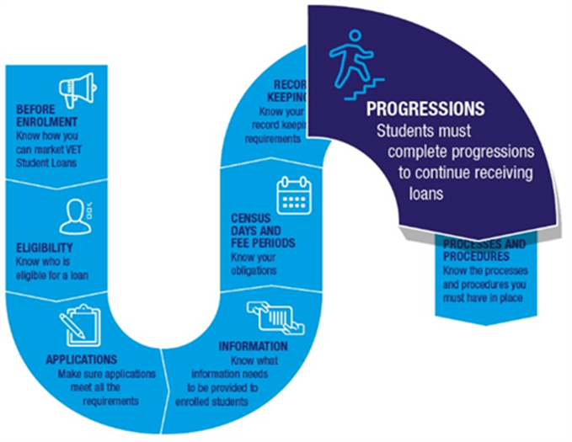

Purpose of progressions
Students must meet engagement and progression requirements to continue accessing a VET Student Loan. They do this by completing a Progression Form.
Progression Forms are used to verify that VET Student Loan students are ‘genuine’ and reasonably engaged in their course. The Department of Employment and Workplace Relations (the department) is not required to pay a VET Student Loan for students who are not considered genuine students.

Progression Form
Students are required to complete a Progression Form in the electronic Commonwealth Assistance Form (eCAF) system. Students must log into the eCAF system, complete and submit the form within 2 weeks of receiving the invitation email. The Progression Form is simple, quick and easy to complete. Students must answer brief questions and complete a short survey to confirm their active and legitimate enrolment in the course. Access to a VET Student Loan may be discontinued if a student does not complete their Progression Form at regular intervals.

Frequency
There are 3 fixed progression points throughout the year at 4-month intervals. Progression milestones are in February, June and October* (the exact date is at your discretion) or when a student returns from a break in their studies. For example, a full-time student commencing a 12-month course in January will have a minimum of 2 progression points, the first in June and the second in October. However, if a student returns from a break in their studies in August, a progression form must be triggered in August, and again in October.
Note: You may request that the fixed progression point milestones in HITS be changed for your organisation if relevant circumstances justify departure from the above timing arrangements. An example of this would be to better align progression points with your teaching and assessment cycle.
You should complete the online enquiry form on Provider Enquiries to request alternative progression point milestones in HELP IT System (HITS). You must include sufficient information in the request to support your case for varying the default progression points.
Students are required to indicate they are continuing to be a genuine student only after at least 4 months have elapsed since their eCAF application or their last Progression Form was submitted.
A student studying a course over multiple years is required to submit Progression Forms several times confirming their continuity as a genuine student over the entire period.
Students studying 2 or more courses covered by a VET Student Loan concurrently are required to complete progressions and surveys for each course.

Process
Milestones have been set up in HITS to remind you when the progression surveys are to be triggered for students. Your CEO or equivalent is required to confirm this has been completed. Once commenced the process is as follows:
- You initiate the progression. This can be done at the individual student-level from the student’s eCAF, by spreadsheet, or from your student management software.
- The eCAF system sends an invitation to the student containing their passkey. The email address will default to the personal email address from the previously submitted progression or eCAF but you can override this in the eCAF system if the student's email address has changed. Instructions on this process can be found in the eCAF User Guide.
- Students access the Progression Form by logging in to the eCAF system using the passkey provided then complete and submit the form.
- An email is then sent to the student acknowledging receipt of the form. It also provides a summary of their responses and reminds students that they are agreeing to a VET Student Loan being used to pay their tuition fees.
- Students have 2 weeks to complete and submit the form before it expires. If a student does not submit their Progression Form within the 2-week period, you will need to repeat the process.
You can see which students have completed the Progression Form and their intentions for study, but you do not have access to the survey responses.
You should ensure that students are aware of their loan obligations in completing Progression Forms. Progressions should be triggered for all VSL students, including those who have ceased study. This allows students to provide the most up to date status of their studies - continuing, deferred, withdrawn or completed.
When a student provides a completed status, the loan will be closed and the student is asked to complete a voluntary student satisfaction survey.
Obtaining a completed status and student survey results inform the re-approval process for providers.

Incorrect information
If a student informs you they have submitted an incorrect progression form, contact the department for further advice.

Failure to submit Progression Forms
Completion of Progression Forms by students is directly connected to the making of payments. Where a student fails to complete 2 consecutive Progression Forms, or where a student indicates they have completed or withdrawn from their course, we may take the view they are no longer a genuine student and payments may be impacted.
The absence of a provider-initiated progression point may be taken to indicate the student is no longer a genuine student.

Students who withdraw/defer and recommence study
You should generate a progression for students to submit when a student withdraws/defers from their course of study. The student should insert the date according to the providers notice of withdrawal/deferral into the Progression Form. The submission of the progression advises us that a student wishes to stop accessing their VET Student Loan.
You should also generate a progression for students to submit as soon as they recommence their course of study. The student should put the date that they recommenced their study. The submission of the progression advises us that a student wishes to re-access their VET Student Loan.
Note: Any census days between the date of deferral and date of resumption will not be paid.

Students who withdraw/defer after census day without completing a Progression Form
If a student fails to complete a Progression Form as they have deferred or withdrawn from the course, you should still receive payment for the portion of fees covered by census days before the student’s deferral or withdrawal, subject to complying with provisions of the VET Student Loans Act 2016 and the Rules.
If a student submits a Progression Form indicating they have ceased studies (withdrawn, deferred or never commenced) before the reported unit’s census day or if their Progression Form submission date is before the reported unit census day in TCSI, you will not be paid.

Students who have completed a course
The engagement and progression requirement is primarily about continuing to provide the VET Student Loan.
If a student has completed their course of studies and does not need to access a VET Student Loan any further, they are required to complete a progression form in the eCAF system to advise this.
A student advising of their completion of the course:
- ensures your reporting obligations are fulfilled and the VET Student Loan is closed so no further draw down can occur and
- allows the department to capture course completion rates.
Completion rates inform the department when assessing you for variations of your conditions of approval or re-approval as a VSL provider.
Where a student has completed a progression form and has advised of their course completion, there is no further requirement to send progression forms.
Legislation
For the legislation, refer to section 20 of the VET Student Loans Act 2016, and section 5 of the VET Student Loan Rules 2016.

