

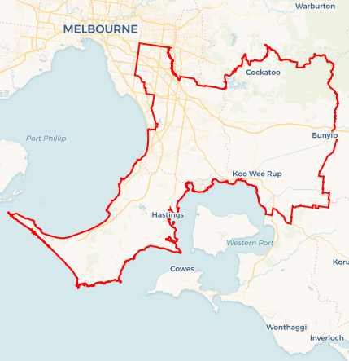Local Jobs Plan

South Eastern Melbourne and Peninsula | Victoria | June ****2024****

Workforce Australia Local Jobs (Local Jobs) is a program that supports tailored approaches to accelerate   
reskilling, upskilling and employment pathways in response to current and emerging local workforce needs.

## Local Jobs elements

### Local Jobs Plan

The Local Jobs Plan sets out the skills and employment challenges and priorities of the region, and associated strategies that will drive the design and implementation of activities to be implemented to address these challenges.

### Employment Facilitators

Employment Facilitators and Support Officers support the delivery of the program by bringing together key stakeholders including businesses, employment services providers, and higher education and training organisations.

### Local Jobs and Skills Taskforce

Each Employment Region has its own Taskforce. Representatives include local stakeholders who have demonstrated experience in upskilling, reskilling, and an ability to represent, connect and collaborate with others in the region to meet labour market needs.

### Local Recovery and National Priority Funds

The Local Recovery Fund supports projects that meet the priorities identified in the Local Jobs Plan. The National Priority Fund provides funding for innovative local solutions to address structural barriers to employment.

Explore labour market insights for the  
[South Eastern Melbourne and Peninsula](https://www.jobsandskills.gov.au/work/employment-region-dashboards-and-profiles/monthly-labour-market-dashboards) Employment Region

## Local labour market challenges in the region

* Youth unemployment: The youth unemployment rate consistently exceeds the State average.
* Diversity integration: Integrating a culturally and linguistically diverse workforce into the local job market.
* Diverse industry demands: High employment demand in health care, construction, retail, manufacturing and accommodation/food Services.

## Local jobs and skills priorities and strategies in the region

### Priority 1 – Maximising existing employment and skills initiatives and funding opportunities to create career pathways in the region

#### What are our challenges and opportunities?

#### Navigating the large number of stakeholders and local initiatives across the region.

#### How are we responding?

* Connecting with all levels of government, employment service providers, and community groups to align actions and resources.
* Utilising Skills and Jobs Networks to identify and address sub-regional priorities and implement collaborative solutions.
* Maximising the use of government and community funding and resources to enhance the impact on community programs.

### Priority 2 – Understanding local workforce needs to develop industry led training and employment initiatives

#### What are our challenges and opportunities?

Understanding and responding to future industry workforce planning needs, including Net Zero alignment, and meeting demands accordingly.

#### How are we responding?

* Engaging with key industries for workforce insights.
* Developing industry led employment programs for skills in demand and identified skills gaps.
* Fostering market understanding for participants and providers.
* Working in collaboration with the Regional Workforce Transition Officer to support and advise on government Net Zero policies and industry workforce changes required.

### Priority 3 – Generating opportunities for youth skills development

#### What are our challenges and opportunities?

#### Regional youth unemployment rate in the South East region continues to be well above the State average while Mornington Peninsula remains close to the State average.

#### How are we responding?

* Partnering with education providers and industry to create job readiness programs and industry pathways.
* Developing youth focused career pathway programs.
* Addressing challenges to youth unemployment.

### Priority 4 – Local opportunities for local individuals

#### What are our challenges and opportunities?

A large number of the local workforce travels outside of the region to secure employment and training opportunities.

#### How are we responding?

* Enhancing industry engagement with local Workforce Australia Employment Services Providers.
* Promoting local employment and training opportunities for providers.
* Developing industry led programs for upskilling local participants to fill in demand roles.
* Working with local education providers, including TAFE, Registered Training Organisations and Learn Local Providers, to deliver vocational pathway and training programs within the region for easier accessibility.

### Priority 5 – Support for challenged groups including Culturally and Linguistically Diverse, young people, women, ex-offenders and Aboriginal and Torres Strait Islander people

#### What are our challenges and opportunities?

Minority groups are disproportionately represented within Workforce Australia caseloads and face multiple unique challenges to employment.

#### How are we responding?

* Establishing Impact Working Groups for African, Afghan, Pacifica youth and ex-offenders to better understand the challenges they face when seeking employment.
* Organising employer events and targeted initiatives to increase awareness, education and knowledge for successful engagement.
* Accessing available funding streams to support targeted opportunities and initiatives.

### Priority 6 – Reskilling and transition support

#### What are our challenges and opportunities?

Increased operating and production costs resulting in rationalisation of employers across a range of industries, resulting in employee redundancies.

#### How are we responding?

* Promoting Self Employment Assistance and other Workforce Australia programs.
* Providing immediate support for displaced workers through workshops and connections to available services and assistance.

**Want to know more?**

Contact: Sean Teer, South Eastern Melbourne and Peninsula Employment Facilitator: Sean.Teer@employmentfacilitator.com.au

Visit: [Local Jobs](https://www.dewr.gov.au/local-jobs) or [Workforce Australia](https://www.workforceaustralia.gov.au/)