

Local Jobs Plan

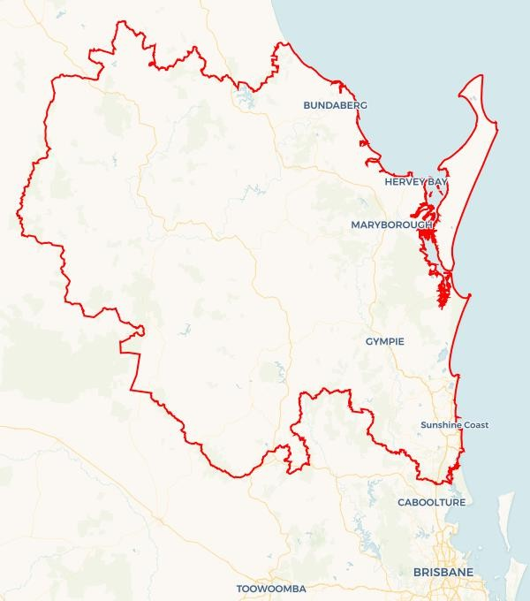

Wide Bay and Sunshine Coast | Queensland | ****October 2024****

Workforce Australia Local Jobs (Local Jobs) is a program that supports tailored approaches to accelerate   
reskilling, upskilling and employment pathways in response to current and emerging local workforce needs.

## Local Jobs elements

### Local Jobs Plan

The Local Jobs Plan sets out the skills and employment challenges and priorities of the region, and associated strategies that will drive the design and implementation of activities to be implemented to address these challenges.

### Employment Facilitators

Employment Facilitators and Support Officers support the delivery of the program by bringing together key stakeholders including businesses, employment services providers, higher education and training organisations.

### Local Jobs and Skills Taskforce

Each Employment Region has its own Taskforce. Representatives include local stakeholders who have demonstrated experience in upskilling, reskilling, and an ability to represent, connect and collaborate with others in the region to meet labour market needs.

### Local Recovery and National Priority Funds

The Local Recovery Fund supports projects that meet the priorities identified in the Local Jobs Plan. The National Priority Fund provides funding for innovative local solutions to address structural barriers to employment.

Explore labour market insights for   
[Wide Bay and Sunshine Coast](https://www.jobsandskills.gov.au/data/employment-region-dashboards-and-profiles/monthly-labour-market-dashboards) Employment Region

## Local labour market challenges in the region

* On-going demand for entry-level workers in the hospitality, aged care and disability sectors.
* Long term unemployed, mature-aged residents, youth and   
  First Nations cohorts require on-going targeted support towards training and employment opportunities.
* Significant gaps between current business needs and available skills in the region.
* A large geographical area with diverse labour markets. Employer ability to attract and retain workers is impacted by limited access to transport.
* Large infrastructure projects such as the Queensland Train Manufacturing Program may be impacted by skills gaps and a level of labour supply that is currently difficult to access.
* The Wide Bay and Sunshine Coast Employment Region is currently experiencing record low unemployment rates resulting in a limited supply of suitable candidates for businesses seeking labour.
* A low level of awareness regarding the spectrum of career and employment opportunities in current and emerging industries.

## Local jobs and skills priorities and strategies in the region

### Priority 1 – Health and social services sector

#### What are our challenges and opportunities?

The health and social services sector are the largest employers across the Wide Bay and Sunshine Coast Employment Region. The industry has a growing demand for a suitably skilled workforce. The industry is predicted to grow exponentially and demand is currently exceeding labour supply in the region.



#### How are we responding?

* Connecting, coordinating, and leveraging existing programs and aligning efforts to upskill and reskill participants to meet employer needs and maximise employment pathways.
* Targeting promotional activities to relevant cohorts such as the mature aged who currently constitute a large component of the industry workforce. Another relevant cohort is young people who are interested in a career in the sector.
* Consulting with industry representatives, employers and associations to develop and refine strategies to assist in recruitment for the sector.
* Delivering industry and career forums to assist in promoting the sector and enhancing professional networks between employers and Workforce Australia Employment Services Providers.
* Using social media to promote employment opportunities to unemployed people across the region who are currently not being assisted by providers.

### Priority 2 – Promotion of apprenticeships and traineeships

#### What are our challenges and opportunities?

With the current cost of living, attracting and retaining apprentices and trainees is challenging. It requires on-going advocacy of the long-term career opportunities and benefits that a trade can offer in terms of employment stability and flexibility.

#### How are we responding?

* Engaging with local businesses and industry to identify their requirements and specifications for employment opportunities.
* Promoting to Apprenticeship Connect Australia Providers the employment opportunities within current and emerging infrastructure projects across the region.
* Developing a targeted promotional strategy to inform potential apprentices and employers of current wage subsidy programs available through state and federal government funded initiatives.
* Hosting forums to promote current and emerging projects in the region that offer employment and career opportunities with an emphasis on career pathways via apprenticeships and traineeships.
* Working with the local Chambers of Commerce to assist in promoting the benefits of apprenticeships and traineeships.
* Interfacing with local Registered Training Organisations (RTO) that offer the delivery of skills and certified training required by current and future demand industries across the employment region.

### Priority 3 – Tourism and hospitality industry

#### What are our challenges and opportunities?

The tourism and hospitality industry is currently facing a significant demand for labour. Waiters, commercial cooks, chefs and room attendants are required to meet current and future workforce needs for the sector. The current housing and affordable accommodation crisis in the region is suppressing labour supply for the sector. This is impacting employers in areas such as Noosaville and Hervey Bay.

#### How are we responding?

* Engaging with employers, RTOs and providers of other pre-employment programs to promote vacancies in the sector.
* Coordinating with local stakeholders to develop and deliver a range of training options including full qualifications, short courses and micro-credentials to link the available workforce with industry demand in the region.
* Supporting and encouraging employers to consider a variety of recruitment strategies to identify and attract suitable candidates for the industry.
* Conducting career forums to empower and educate local people and other relevant stakeholders regarding employment opportunities across the sector.
* Hosting monthly 'Community of Practice' forums with other Local Jobs Employment Facilitators and Support Officers across the country to develop placed based strategies to support the sector.

### Priority 4 – Agriculture, manufacturing and the renewable energy sectors

#### What are our challenges and opportunities?

The region will see emerging energy-based projects being implemented over the immediate and long-term future. These projects will require a skilled workforce to meet project implementation timelines. Several large manufacturing firms across the region are seeking to expand and increase their employment composition. The agriculture sector continues to face challenges in attracting and retaining staff for entry level positions in harvesting, seeding and other labour-based roles. The forestry and timber sectors are also facing challenges with an unprecedented demand for product whilst negotiating supply chain delays and on-going labour shortages.

#### How are we responding?

* Identifying new employment opportunities, including those in the renewable energy sectors such as wind, solar, pumped hydro and hydrogen and other major infrastructure projects including supply chains.
* Delivering forums and coordinating presentations from employers regarding skills and roles/career options and pathways. Working with Workforce Australia Services Providers, training organisations and other stakeholders to promote the emerging energy-based industries in the region.
* Coordinating with manufacturing employers across the region to support them in developing targeted strategies to identify, attract and retain employees.
* Collaborating with key stakeholders in the agricultural sector to develop advocacy initiatives to incentivise suitable candidates to consider employment and career opportunities.
* Developing and delivering career forums that highlight sectors and the expansive employment pathways they offer.
* Assisting local small to medium enterprises and large businesses that are strategically aspiring towards a Net Zero policy. Consulting and engaging in the advocacy of skills and strategies required to meet a Net Zero policy framework.
* Consulting with local RTOs to understand and promote new skill sets that may be required under a Net Zero industry framework.

### Priority 5 – Mature age, youth, culturally and linguistically diverse (CALD) and First Nations peoples

#### What are our challenges and opportunities?

The Wide Bay and Sunshine Coast Employment Region embodies four cohorts that are an area of focus for additional support: mature-age, youth, First Nations and CALD. Additional challenges may be experienced by these cohorts in securing appropriate support and training pathways that result in sustainable and meaningful employment outcomes.

#### How are we responding?

* Engaging with organisations who specialise in youth support services such as Transition to Work Providers and Police Community Youth Clubs to ascertain training and development needs of participants.
* Collaborating with regional jobs committees in Bundaberg, Fraser Coast and the Sunshine Coast to develop strategies and promote pre-employment programs and entry level job opportunities.
* Consulting with providers, schools and other stakeholders to raise awareness of the employment pathways that align with current and future labour market demands.
* Consulting with employers in retail, hospitality and other sectors that have a high youth employee composition to identify and promote entry level roles to encourage youth participation into the labour market.
* Working with the specialist providers and First Nations organisations to develop culturally appropriate and relevant training and employment strategies to assist in Closing the Gap.
* Developing culturally relevant and tangible strategies with providers and cultural and community centres to assist the CALD community in engaging with the local labour market.
* The Wide Bay and Sunshine Coast Taskforce includes a dedicated First Nations representative to provide guidance, advice and support in developing and delivering suitable strategies.
* Seeking and provide advice from Career Transition Assistance Providers regarding relevant and appropriate initiatives to support the mature-age cohort in meaningful and sustainable employment.
* Engaging with organisations that deliver Skilling Queenslanders for Work pre-employment programs for the identified cohorts in the region by connecting program coordinators with employers who are offering entry level vacancies.

## Want to know more?

* Contact: Austin Ryann, Wide Bay and Sunshine Coast Employment Facilitator: [austin@ljpemploymentfacilitator.com.au](mailto:austin@ljpemploymentfacilitator.com.au)
* Visit: [Local Jobs](https://www.dewr.gov.au/local-jobs) or [Workforce Australia](https://www.workforceaustralia.gov.au/)