

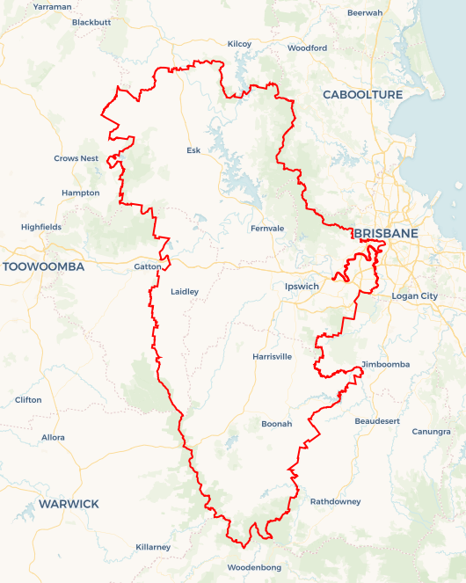Local Jobs Plan

Wivenhoe Employment Region | QLD |October 2024

Workforce Australia Local Jobs (Local Jobs) is a program that supports tailored approaches to accelerate   
reskilling, upskilling and employment pathways in response to current and emerging local workforce needs.

## Local Jobs elements

### Local Jobs Plan

The Local Jobs Plan sets out the skills and employment challenges and priorities of the region, and associated strategies that will drive the design and implementation of activities to be implemented to address these challenges.

### Employment Facilitators

Employment Facilitators and Support Officers support the delivery of the program by bringing together key stakeholders including businesses, employment services providers, higher education, and training organisations.

### Local Jobs and Skills Taskforce

Each Employment Region has its own Taskforce. Representatives include local stakeholders who have demonstrated experience in upskilling, reskilling, and an ability to represent, connect and collaborate with others in the region to meet labour market needs.

### Local Recovery and National Priority Funds

The Local Recovery Fund supports projects that meet the priorities identified in the Local Jobs Plan. The National Priority Fund provides funding for innovative local solutions to address structural barriers to employment.

Explore labour market insights for the  
[Wivenhoe](https://www.jobsandskills.gov.au/data/employment-region-dashboards-and-profiles/monthly-labour-market-dashboards) Employment Region

## Local labour market challenges in the region

* The Wivenhoe Employment Region has many entry level job vacancies across all industries. The major challenge in filling these roles is the extent of long-term unemployed people on Workforce Australia Provider caseloads who require support to develop the confidence, motivation, resilience and physical fitness required to return to employment.
* Youth, culturally and linguistically diverse (CALD) and First Nations unemployed people face significant challenges in securing work. They require targeted solutions and programs to elevate their potential to capitalise on training and job opportunities.
* The proportion of the Wivenhoe CALD caseload (including refugees) is marginally higher than the same figure Queensland wide. A challenge for this group, and the labour market, is underutilisation and under employment when matched against their skills, experience and ability acquired overseas.
* The Wivenhoe caseload figures show the region has a larger share of unemployed young people on the provider caseloads than its share at the national level. The caseload share for First Nations people is similar to that at the national level.
* The mismatch between the skills and experience required by employers, industry and the available workforce is also a significant challenge. This mismatch applies in most industries within the Employment Region.
* There is a significant shortage of labour in the health and community care sectors which needs to be addressed by pre-employment programs negotiated with industry, funded by existing programs and which include vocational and soft skills training. There is also a need for the industry to promote the full range and variety of career opportunities that exist.
* Transport within and across the Employment Region is a challenge. The local unemployed workforce in the agricultural areas, such as the Scenic Rim and the Lockyer Valley, is insufficient to meet demand and there are transport barriers to enabling the potential workforce to travel from the major population centre of Ipswich to these jobs.
* The agriculture sector is also becoming more digitised and looking toward ‘smart’ supply chains to minimise future disruptions due to major events. This will likely see future changes in the skills needed for this sector.
* There is a shortage of skilled labour and tradespeople for the manufacturing and construction industries in the Employment Region. Some employers are now prepared to look at trades assistants and labourers but there is still a need for job specific pre-employment preparation.
* The current labour market conditions of industry has expanded their view on ways of connecting unemployed people to their job opportunities, including greater support for initiatives such as job expos.

## Local jobs and skills priorities and strategies in the region

### Priority 1 – Better prepare Wivenhoe Employment Region’s long term unemployed caseload to meet entry level job requirements of industries

#### What are our challenges and opportunities?

Long term unemployed people in Wivenhoe represent the largest share of the caseload with the majority of this cohort experiencing at least 2 years without work. This presents a significant challenge with their confidence, motivation, resilience and physical fitness to obtain and retain work. Evidence shows that once soft skills and physical fitness improve, long term unemployed people can meet industry entry level job requirements and obtain work.

#### How are we responding?

* Negotiating and co-designing pre-employment programs with stakeholders to improve the required soft skills and physical fitness in long term unemployed people.
* Designing and delivering soft skills programs for long term unemployed people to directly enter suitable jobs or fully participate in accredited skills-based qualifications or programs required by industry.

### Priority 2 – Address the mismatch between the skills of the available workforce and employer/industry requirements

#### What are our challenges and opportunities?

The mismatch between the skills and experience required by employers and industry and the available workforce is a significant challenge. This mismatch applies in most industries within the Employment Region.

#### How are we responding?

* Negotiating and co-designing pre-employment preparation programs with industry and other stakeholders to address the mismatch of the skillsets, experience and work behaviours of participants on the Workforce Australia Provider caseloads.
* Approaches to address this mismatch may also include changes to job design, the use of micro-credential training to fast track the pathway to productivity and exploring the use of various Australian and Queensland government supports and incentives to expand working hours, particularly in small business and make jobs more viable to those looking for work.

### Priority 3 – Collaborate with industry and Workforce Australia Employment Services Providers to enhance the potential of youth, CALD and First Nations peoples to maximise opportunities available in the current labour market

#### What are our challenges and opportunities?

Youth representation within caseloads is higher than that at the national level. First Nations, culturally diverse and refugee cohorts are at similar representation levels in the caseloads to that at the national level. The challenge is in preparing people to maximise opportunities that exist in the current labour market.

#### How are we responding?

* Developing appropriate programs to address the challenges experienced by youth, CALD and First Nations peoples relevant to their labour market challenges.
* Negotiating programs with, and to be delivered by, First Nations organisations that include community mentoring and suitable accredited and soft skills training.
* Increasing the participation of CALD people and refugees in industry focused programs and pre-pre-employment programs for the long term unemployed.
* Developing strategies with Workforce Australia Employment Services Providers to ensure that people with skills, experience and abilities acquired overseas are matched and referred to available jobs that minimise underutilisation of their experience and maximise their potential.
* Developing focused programs for young people with industry and organisations in the local youth sector
* Mobilising the provider network and other stakeholders, including schools and community organisations, to develop effective employment pathways that align with the needs of these people.
* Developing various ‘job expos’ to better connect people with job opportunities in local industries.
* Sourcing funding for pre-employment programs through the Employment and Participation Fund as well as other funding sources through Queensland and Australian government programs including the Local Recovery Fund.

### Priority 4 – Address transport barriers

#### What are our challenges and opportunities?

There is a need for better public transport options within and across the Employment Region to meet some industry locations and shift work hours. The majority of the population reside in the Ipswich local government area and south west Brisbane suburbs. There is little or no reliable public transport to access jobs in the agricultural sector to the south and west of Ipswich and local ‘job dense’ industrial areas such as Wacol.

#### How are we responding?

* Collaborating with key regional stakeholders, including the three levels of government, to address barriers to employment resulting from lack of viable ‘transport to work’ options within the Employment Region.
* Engaging with the transport and driver training industry to develop solutions to transport issues.

### Priority 5 – Promote the engagement and retention of apprenticeships and traineeships

#### What are our challenges and opportunities?

There is a shortage of skilled labour and tradespeople for the manufacturing and construction industries in the Employment Region. Some employers are now prepared to look at trades assistants and labourers but there will still be a need for job specific pre-employment preparation.

#### How are we responding?

* Promoting the engagement and retention of Australian apprenticeships and traineeships to align with projected skills shortages, including areas of future demand in the region.
* Connecting appropriate candidates from Workforce Australia Employment Services Providers and local high schools to engage with the Australian Apprenticeship Support Network and Group Training Companies to leverage existing approaches and programs to increase apprenticeship and traineeship opportunities.

**Want to know more?**

* Contact: John Perry, Wivenhoe Employment Facilitator: [john.perry@localjobsprogram.org.au](mailto:john.perry@localjobsprogram.org.au) or 0418 719 795
* Visit: [Local Jobs](https://www.dewr.gov.au/local-jobs) or [Workforce Australia](https://www.workforceaustralia.gov.au/)