

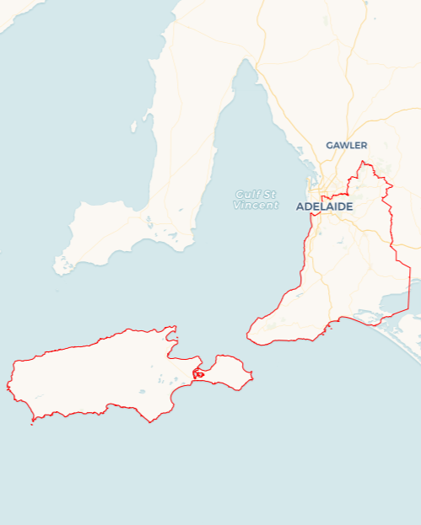Local Jobs Plan

****Adelaide South Employment Region**** | South Australia | ****August 2024****

Workforce Australia Local Jobs (Local Jobs) is a program that supports tailored approaches to accelerate   
reskilling, upskilling and employment pathways in response to current and emerging local workforce needs.

## Local Jobs elements

### Local Jobs Plan

The Local Jobs Plan sets out the skills and employment challenges and priorities of the region, and associated strategies that will drive the design and implementation of activities to be implemented to address these challenges.

### Employment Facilitators

Employment Facilitators and Support Officers support the delivery of the program by bringing together key stakeholders including businesses, employment services providers, higher education and training organisations.

### Local Jobs and Skills Taskforce

Each Employment Region has its own Taskforce. Representatives include local stakeholders who have demonstrated experience in upskilling, reskilling, and an ability to represent, connect and collaborate with others in the region to meet labour market needs.

### Local Recovery and National Priority Funds

The Local Recovery Fund supports projects that meet the priorities identified in the Local Jobs Plan. The National Priority Fund provides funding for innovative local solutions to address structural barriers to employment.

Explore labour market insights for the  
[Adelaide South](https://www.jobsandskills.gov.au/work/employment-region-dashboards-and-profiles/monthly-labour-market-dashboards) Employment Region

Explore labour market insights for   
Adelaide South Employment Region

## Local labour market challenges in the region

* Projected high demand for workers with many major projects scheduled to commence across the region all requiring similar workforces.
* Employers seeking dynamic workforce strategies for recruitment, upskilling and retention across numerous sectors. Employers competing to attract and retain skilled workforce – particularly those with an ageing employee base.
* Cost of living concerns coupled with a tight housing market has seen many of those outside the workforce struggling to manage competing priorities.
* Youth cohort keen to increase workforce readiness by gaining appropriate licences and trying alternate pathways with employers who can give them support and mentoring.

## Local jobs and skills priorities and strategies in the region

### Priority 1 – Support and empower small to medium businesses to encourage inclusive hiring

#### What are our challenges and opportunities?

Businesses in the region acknowledge workforce attraction and retention are key challenges. By increasing awareness of support, challenging attitudes and assisting them to link with these supports, we are able to assist them with pipeline pathways and workforce development.

#### How are we responding?

* Local Jobs is a trusted partner with business associations and local government across the region to highlight appropriate resources and programs.
* Local Jobs is organising and supporting workforce focussed activities to build employer knowledge ensuring collaboration as appropriate with agencies that support those seeking work.
* Local Jobs is showcasing opportunities for employment to agencies and individuals at events and expos across the region.

### Priority 2 – Address growth areas, skills shortages and unique challenges

#### What are our challenges and opportunities?

Creating pipeline opportunities for individuals to find appropriate training, mentoring and employment prospects, allowing those with significant challenges to tap into suitable local solutions.

#### How are we responding?

* Fostering existing, and forming new partnerships with training organisations and apprenticeship networks to enhance trainee and apprentice experiences.
* Showcasing and promoting career pathways in growth sectors.
* Supporting localised solutions for the care and support sector by continuing connections with existing collaborative partnerships.
* Collaborating with councils and other key stakeholders on events that connect individuals with employers.

### Priority 3 – Develop and showcase employers and training organisations that support individuals on their employment pathways

#### What are our challenges and opportunities?

Building connections between support services and the employment services sector to ensure those who are most challenged have links to supports that suit their unique needs.

#### How are we responding?

* Strengthening connections between youth focussed networks and programs.
* Leveraging government programs and stakeholder partnerships for employment and pre-employment support.
* Promoting, in collaboration with Workforce Australia Employment Services Providers, resources that provide non-vocational support and investigate alternative solutions for challenges.
* Increasing partnerships with local governments to showcase and expand awareness of community resources.

### Priority 4 – Foster collaborative economic growth and development

#### What are our challenges and opportunities?

#### Ensuring a seamless employment pathway through effective collaboration with government programs and stakeholders to enhance job access and economic growth.

#### How are we responding?

* Engaging with our Local Jobs and Skills Taskforce members outside of regular scheduled meetings to deepen understanding of needs and opportunities across the region.
* Showcasing innovative workforce solutions across employer networks to allow employers to learn from each other.
* Facilitating opportunities for employers to meet with training organisations and employment providers to discuss workplace solutions.

## Want to know more?

* Contact: Leanne Hill, Adelaide South Employment Facilitator: [leanne.hill@employmentfacilitator.com.au](mailto:leanne.hill@employmentfacilitator.com.au)
* Visit: [Local Jobs](https://www.dewr.gov.au/local-jobs) or [Workforce Australia](https://www.workforceaustralia.gov.au/)