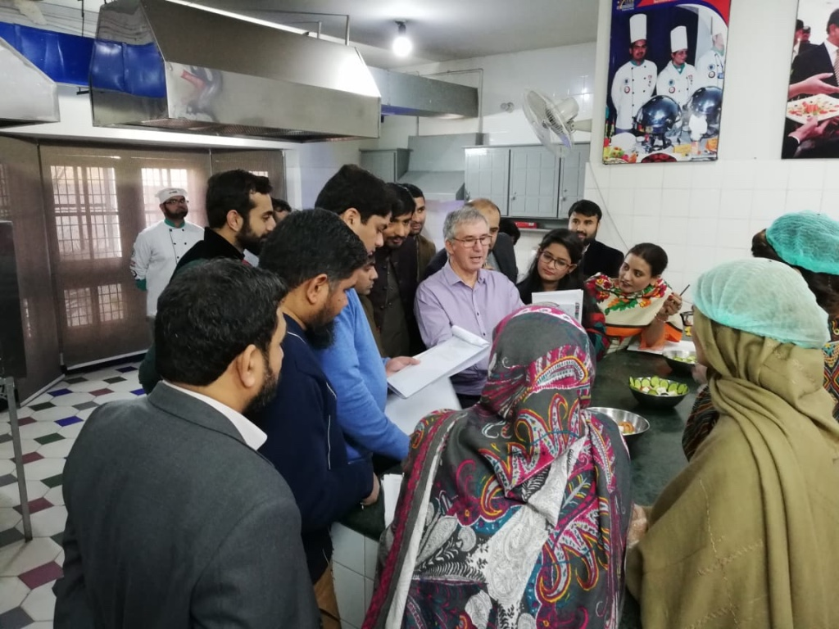

Delivering Training and Assessment Programmes in Pakistan with Melbourne Polytechnic

From January to April 2019, Melbourne Polytechnic supported the Pakistan government in the first phase of their TVET Sector Support Programme (TVETSSP.) The project was implemented in partnership with the German development agency GIZ, with the goal of supporting capacity development and reform in the Pakistan TVET system.

**When:** January – April 2019   
**Where:** Pakistan   
**Who:** German Development Agency (GIZ)  
**Learners:** 145  
**Courses:** TVETC001, TVETC002 and TVETC003

Melbourne Polytechnic successfully delivered the IST suite to 145 vocational trainers, including 35 who completed all three courses and qualified as ‘chief master trainers.’ Competency-based training and assessment and a cascading model of training for capacity development are key components of the Pakistan TVETSSP. The IST suite was thus particularly suited for this endeavour. Feedback from the program was very positive, from both participants and stakeholders. The trainers expressed appreciation for the concept of competency and a willingness to incorporate competency-based training and assessment into their teaching practice.

A number of participants in the program have since been in contact, including some who completed all three courses. They note that they have successfully adapted training materials that were introduced to them by our trainers, and that they carry out validation and moderation of assessment consistent with competency-based training.

The training was delivered in person in Faisalabad. Phase 2 of the TVETSSP has been disrupted by the COVID-19 pandemic, but Melbourne Polytechnic has been invited to tender for further IST training in a blended model of delivery.