

Using Payroll Prints as Wage Evidence

When completing a Claim Application through the Apprenticeships Data Management System (ADMS), you will need to upload evidence of wages paid to the Apprentice during the Claim Period. This resource shows you how to use payroll prints as Wage Evidence for your claim.

# Payroll Prints (from a payroll system)

A Payroll Print (also known as a Payroll Extract or a Timesheet Summary) is a single document listing separate amounts for each pay event (weekly, fortnightly or monthly) covering a whole Claim Period. Some payroll prints will include a total amount, but others will require the Employer to add up the total amount to enter in the Claim Application.

## Determining the extract dates

When extracting Payroll Prints from your payroll system, make sure the Payroll Print includes all days your Apprentice worked in the Claim Period, not just the pay events within the Claim Period. This can include dates outside of the Claim Period. Below is an example of a correctly extracted Payroll Print for the Claim Period 1 April 2022 to 30 June 2022. 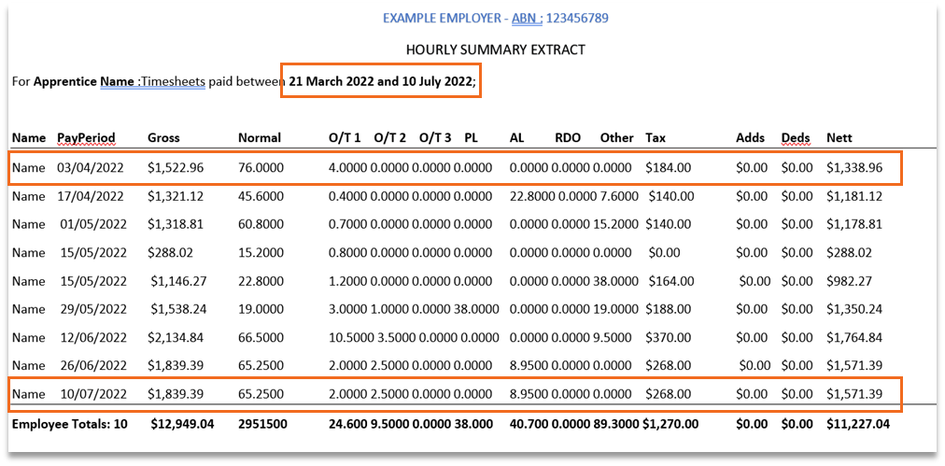

In this payroll print extract, the first pay period covers 21 March 2022 to 3 April 2022. ADMS will exclude dates before the first day of the claim period (in this case, 21 March 2022 to 31 March 2022) so that the claim amount is accurate. This also applies to the last pay event where ADMS will exclude dates after the last day of the claim period (in this case, 1 July 2022 to 10 July 2022) so that the claim amount is accurate.

## Dates

When uploading and entering details for the Payroll Print, you should record the ‘Date from’ and ‘Date to’ as it appears in the Payroll Print extract. Using the example provided above, the ‘Date from’ and ‘Date to’ reflect the period of the extract, as below.

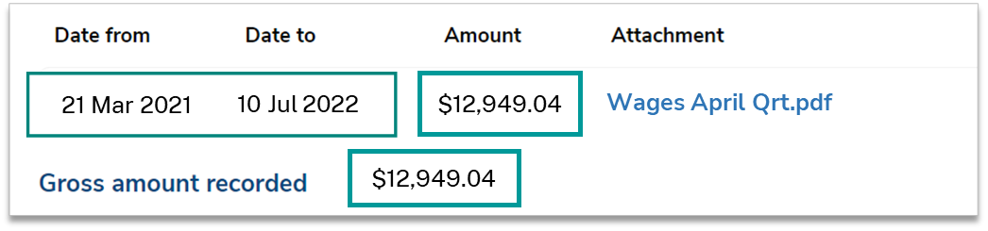

## Amount

When uploading and entering details for the Payroll Print, you should record the ‘Amount’ ensuring you enter the **gross wage amount** from your wage evidence. Be careful not to confuse this with the ‘nett amount’ or ‘net amount’ as this may impact your claim amount.

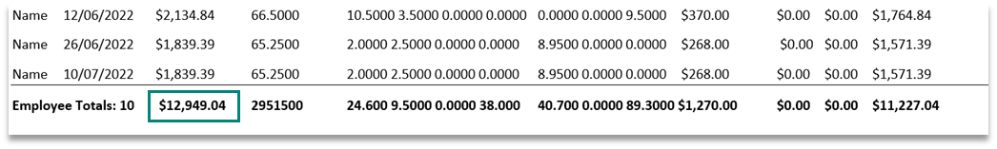

ADMS will perform the calculations required to exclude dates outside of the Claim Period when calculating your payment amount.

|  |
| --- |
| Tip: An incorrectly extracted Payroll Print that excludes days worked in the Claim Period with incorrectly recorded dates and amounts will result in an incorrect payment. |

## Gross Amount Recorded

The ‘Gross amount recorded’ is calculated based on the ‘Amount’ recorded in the wage evidence document uploaded. The Gross amount recorded is used to determine your wage subsidy entitlements.

## Claim Amounts Payable

The ‘Claim amounts payable’ will be calculated based on the ‘Gross amount recorded’. This is the subsidy amount you will receive if you submit your claim. It is not an estimate.

Submission of this Claim Application confirms your acceptance of the amount payable.

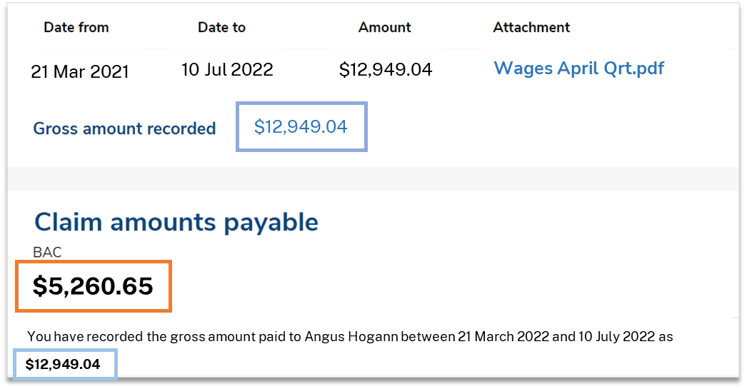

## Commencements and Cancellations

Ifthere was a commencement, cancellation, withdrawal or completion during the Claim Period, ADMS will use the dates recorded in the relevant fields within the Claim Application to determine the ‘Claim amounts payable’.

# Support

For assistance with completing Claim Applications or submitting Wage Evidence in ADMS, contact **1800 719 706**.

For assistance with ADMS, contact the National Customer Service Line (NCSL) on **1800 020 108**.

For feedback on this Knowledge Article, contact [ADMSEngagement@dese.gov.au](mailto:ADMSEngagement@dese.gov.au).