Summary of Outcomes - Piloting of Draft Revised Standards for RTOs: Outcome Standards

# Piloting Activities

The Department of Employment and Workplace Relations (DEWR) has undertaken piloting of the draft Outcome Standards for Registered Training Organisations (RTOs) (draft Outcome Standards) in collaboration with the Australian Skills Quality Authority (ASQA) and the Training Accreditation Council (TAC) in Western Australia. Piloting activities were designed to ensure the draft Outcome Standards:

* enable consistent understanding of requirements across RTOs and regulators
* enable RTOs of different types, sizes and focus to demonstrate compliance in different ways
* enable regulators to effectively identify risk, and
* allow for sufficient flexibility to enable excellence and innovation.

As well as informing refinements to the draft revised Standards, piloting activities aimed to inform ongoing work around the development of guidance material to support implementation of the revised Standards, including types of evidence that providers of different types and sizes could use to demonstrate conformance with the Standards.

## Survey

In October-November 2023, DEWR conducted an online public survey seeking input on how different RTOs would demonstrate conformance with the draft Outcome Standards within their operational context and areas where guidance would be most valuable. Respondents were invited to provide examples of how delivering quality services could be evidenced, drawing on their existing practices. 177 full submissions were received, with 2% of responding organisations identifying as First Nations owned or run. A breakdown of respondents by stakeholder type is included below:

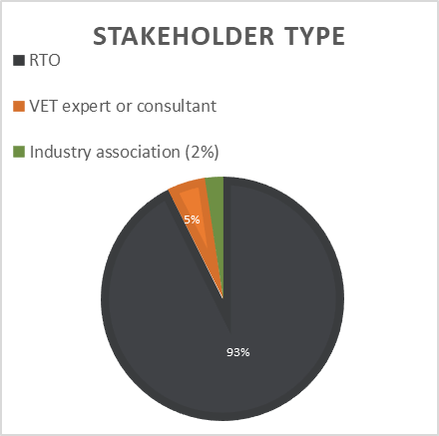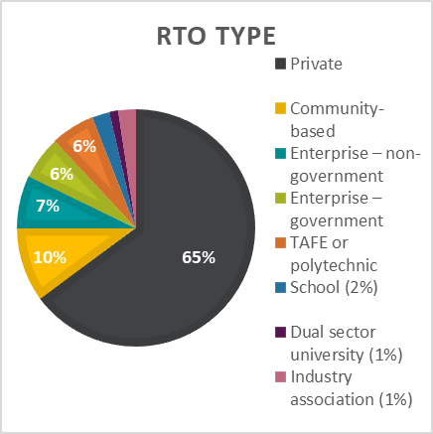

# RTO Focus Groups

Piloting activities also included a series of focus groups with RTOs which were designed to test the practical functionality of a small selection of newer standards across a diverse range of RTO settings. Participants in the focus groups discussed the evidence they would provide to demonstrate conformance with the draft Outcome Standards, and any challenges with understanding and evidencing the indicators under the Outcome Standards. The format of the focus groups allowed in-depth exploration of how these newer requirements may work across a wide range of providers. 74 RTOs of varying type, size, scope, and location were involved in the focus groups, 5% of which identified as First nations owned or run. The below table includes a breakdown of participants by RTO type:

**Regulators**

As part of the pilot, ASQA facilitated internal focus groups with ASQA auditors and compliance staff in October 2023. The focus groups provided a forum for in-depth discussion on the draft Outcome Standards and an opportunity to explore expectations of conformance with the Outcome Standards and supporting evidence.

TAC similarly undertook piloting activities with RTOs and auditors in October-December 2023 including an information session, RTO self-assessment tool and one-on-one evaluations to discuss the outcomes of the self-assessment, RTO evidence requirements and interpretation.

# Outcomes of Piloting

Overall stakeholders supported the draft Outcome Standards, including their revised structure and the inclusion of indicators. Survey respondents noted that the introduction of performance indicators in the draft Outcome Standards struck a good balance between offering direction and maintaining flexibility. The indicators provide clarity around the expectations of RTOs which will help to simplify their compliance processes.

No significant issues were identified with the applicability of the draft Outcome Standards. Most RTOs expressed confidence that they would be able to evidence the requirements in the Outcome Standards. Where they were less confident, this related more to the wording of the standard or indicator than the intent or the outcome sought. This feedback helped to inform refinements to the draft Outcome Standards and key areas of focus in the development of guidance material.

A common theme raised through the focus groups was an appreciation for the shift that the revised Standards are trying to drive. Many participants noted that the Outcome Standards should drive strong, quality and future-focused organisations that self-reflect and can identify issues and continuously improve. Stakeholders supported the emphasis on integrity, creating a positive learning environment and the delivery of quality VET.

Another common theme emerging from the piloting activities was the importance of a flexible approach to enable RTOs to demonstrate conformance in different ways. For example, there was a desire for small RTOs to continue to be able to use genuine processes that support high performance without having to create documents or implement systems for the sake of evidence at audit when outcomes are otherwise being achieved. It was evident that it will be important to accommodate different ways in which an RTO might demonstrate conformance where this does not always rely on documentation.

Positive feedback was also received about the focus groups providing an opportunity to foster a shared understanding of expectations, and this will inform further engagement with the sector once the Outcome Standards are finalised to ensure consistent understanding of the changes.

Specific areas raised for further consideration in terms of refinements to the draft Outcome Standards and development of guidance are described below.

# Training and Assessment

With regard to training requirements, there were diverse views about the concept of ‘motivation’ in the context of training delivery engaging and motivating learners, as this was interpreted as learner’s internal motivation, which RTOs may find difficult to influence.

Some stakeholders sought more detail about the extent of expectations in relation to validation. There was general agreement that guidance would be helpful in this area.

Stakeholders also sought further clarification of their responsibilities for risk management in relation to work placements. There was general agreement that guidance on this would be helpful.

It was suggested that recognition of prior learning be incorporated into the assessment requirements rather than being grouped with credit transfer. Some RTOs expressed concern that RPL requirements were not applicable to all types of RTO and that further clarification of expectations would be useful in guidance.

# Learner Support

There was some suggestion that there was potential duplication of concepts within this quality area and with some requirements in the governance quality area. Stakeholders identified potential opportunities to streamline and consolidate requirements relating to wellbeing and protection from harassment and discrimination. While stakeholders were supportive of the focus on diversity and inclusion in this quality area, some suggested that the relevant requirements could be framed more clearly to better differentiate the concepts of ‘diversity and inclusion’ and ‘wellbeing’.

There was general acknowledgement that for terms that are context-dependent, such as ‘reasonable access’ and ‘timely responses’, further explanation in guidance would be helpful rather than trying to provide a ‘one size fits all’ definition of these terms.

# VET Workforce

Some RTOs were unsure about evidencing requirements relating to monitoring the conduct of staff. There was general discussion that this standard should focus holistically on workforce management rather than be limited to workforce planning.

# Governance

RTOs were interested in discussing this new quality area and provided useful feedback. There was general support for the policy intent of the governance requirements, however some held the view that some standards attempted to cover too many concepts or could be more clearly structured to better support conformance. It was suggested that some requirements could be streamlined to focus on the key factors underpinning good governance.

Some RTOs expressed concern about possible overlap with other standards, particularly those relating to wellbeing. This quality area includes some newer concepts that RTOs were less confident with – such as cultural safety, leadership, inclusion and diversity and learner wellbeing. There was general agreement that clear guidance around new or different concepts and requirements will be important.

# Next Steps

DEWR and regulators appreciate the feedback received from RTOs during these piloting activities. In response to feedback received from pilot activities, the draft Outcome Standards were refined to ensure the language is clear and consistent, requirements are streamlined so that related concepts are located together, and the Outcome Standards meet the needs of the sector.

Feedback and examples from stakeholders have also provided a solid basis from which to develop guidance to support the implementation of the Outcome Standards. Initial policy guidance has been designed with the intention of ensuring there is clear and consistent understanding of the policy intent underlying the revised Standards and reflecting the diverse operating contexts of RTOs. Guidance aims to support RTOs to understand, self-assure and continuously improve their performance against the Outcome Standards. Guidance will continue to be refined and expanded in line with feedback received.