

# Reconciliation Action Plan

2018–2020

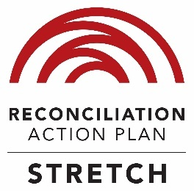

Opportunity   
through learning

Disclaimer: The Department of Education and Training acknowledges diversity and respectfully uses both terms ‘Indigenous’ and ‘Aboriginal and Torres Strait Islander peoples’ interchangeably throughout this document.

ISBN  
978-1-76051-508-9 [PRINT]  
978-1-76051-509-6 [PDF]  
978-1-76051-510-2 [DOCX]



With the exception of the Commonwealth Coat of Arms, the department’s logo, any material protected by a trade mark and where otherwise noted all material presented in this document is provided under a Creative Commons Attribution 4.0 International (https://creativecommons.org/licenses/by/4.0/) licence.

The details of the relevant licence conditions are available on the Creative Commons website (accessible using the links provided) as is the full legal code for the CC BY 4.0 International (http://creativecommons.org/licenses/by/4.0/legalcode).

The document must be attributed as the *Reconciliation Action Plan 2018–2020.*

## Decorative elementAcknowledgement of Country

The Department of Education and Training acknowledges the traditional owners and custodians of country throughout Australia and their continuing connection to land, waters and community. We pay our respect to them and their cultures, and elders past, present and future.

## Decorative elementContents

Secretary’s foreword 4

Message from our Indigenous Leader 6

Message from Reconciliation Australia 8

Who we are 10

Strategic intent 10

Governance and accountability 12

Our continuing commitment to reconciliation 14

What we’ve learnt 16

Commitment to action 18

Innovation 27

Opportunities 29

Respectful relationships 35

Accountability 38

Artist Information 40

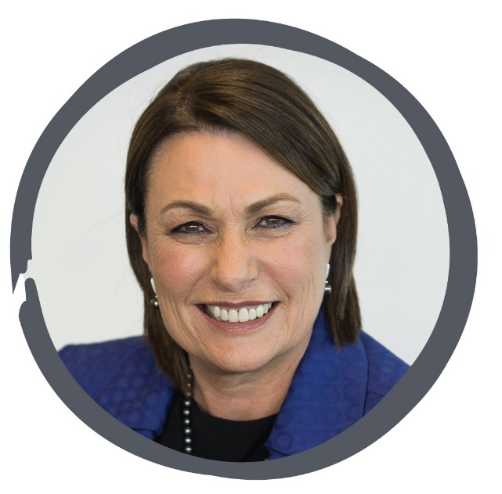

## Decorative elementSecretary’s foreword

At the foundation of reconciliation is a spirit of willingness to participate through recognition and understanding of how our past has shaped the life experiences of our First Australians, and through respect for one another in our everyday interactions.

While the symbolism behind reconciliation is extremely powerful, it must also be backed up by practical and deliberate actions that contribute to improved quality of life for Aboriginal and Torres Strait Islander peoples—both within our organisation and in the broader community.

Over the span of our past four Reconciliation Action Plans, celebrating NAIDOC and National Reconciliation Week have become part of the fabric of life in the department and our commitment to Indigenous business being everyone’sbusiness has been embraced.

Now it is time for us to build on this robust footing, and commit to new, ambitious actions. This practical Department of Education and Training Reconciliation Action Plan 2018–2020 will provide a guide for us to do just that; as individuals, as team members and as an organisation.

Significant internal and external consultation highlighted five key action areas for us to continue to strengthen our relationships and to create and foster opportunities for Aboriginal and Torres Strait Islander peoples.

We will strengthen our partnership approaches with Indigenous organisations to advance Indigenous policy and programs—and to develop and design innovative approaches. We will actively seek to increase opportunities to contribute to reconciliation in a broader remit than our ‘business as usual’, including strengthening our mentoring role in the Reconciliation Action Planning community.

Delivering a strong, ambitious Reconciliation Action Plan (RAP) by committing to significant new initiatives was one of my key priorities for the department this year. Alongside this commitment, this Plan—our fifth RAP—outlines stronger accountabilities so we can make sure our actions are making a real difference.

By continuing to work together—within the department, across the Australian Public Service (APS) and with Aboriginal and Torres Strait Islander peoples and organisations in a collaborative way—we can make a real and continued positive impact within our department and to reconciliation in Australia.

Dr Michele Bruniges AM

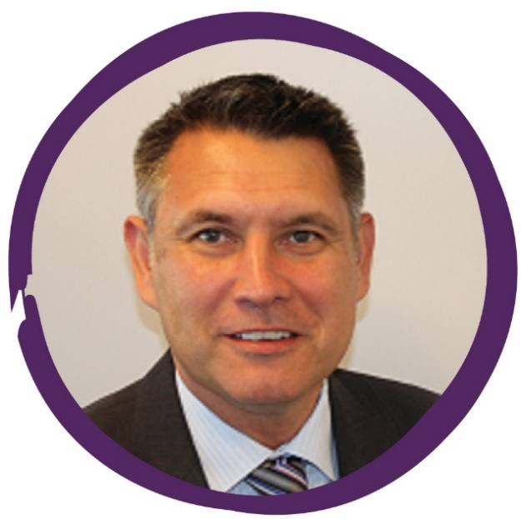

## Decorative elementMessage from our Indigenous Leader

My vision for reconciliation is respect between Aboriginal and Torres Strait Islanders and non‑Indigenous Australians and the celebration of Indigenous heritage and cultures—because these principles underpin true opportunity and justice for *all* Australians.

Reconciliation is ambitious—all ongoing and significant cultural change is just that. It is also the most rewarding.

Our organisation stands as a leader in the Indigenous field across the APS. We have a proud history of engaging with Indigenous organisations, and a longstanding commitment to celebrating landmark events, developing our Indigenous staff and supporting Indigenous procurement. For our new RAP, we have committed to do more.

The department’s Reconciliation Action Plan 2018–2020(RAP) encapsulates and translates these ambitious reconciliation principles into tangible, achievable strategies for change. It shows us how we can all contribute to the pursuit for a reconciled, just and equitable Australia—in our work *and* in our workplaces: together and individually.

Our new RAP is ambitious, aspirational and articulates our shared determination to advance reconciliation in our workplace and community. It follows more than six months of consultations and development. I would like to thank those who contributed—your engagement was valued and a crucial part of the journey. I would particularly like to acknowledge the contribution of our outgoing Indigenous Champion, Dr Subho Banerjee, for his commitment and leadership in developing this RAP.

The RAP’s five key initiatives build on our particular experience and expertise as the national leader of education and training policy. Our new Indigenous education ‘think tank’ will contribute to a meaningful dialogue on the ‘big ideas’ that can drive real change in education and training outcomes for Aboriginal and Torres Strait Islander peoples. It will also build our capacity to engage effectively with Aboriginal and Torres Strait Islander peoples and, in so doing, strengthen the links between Indigenous communities and the policy‑making process.

We have committed to extending our cultural capability framework by creating greater and more flexible opportunities for our employees to take part in community-based secondments and experiential learning. This builds on a strong foundation of cultural awareness training and engagement in the Jawun Corporate Leaders Program. We have also committed to an ambitious target to buy more of the goods and services we need from Indigenous owned businesses and strengthening career support for our Aboriginal and Torres Strait Islander employees.

We will create an ongoing conversation about reconciliation within our organisation and with others by introducing a new approach to accountability and reporting built on storytelling and ongoing reflection. This will ensure we remain engaged and committed throughout the life of the RAP, including maintaining ongoing engagement with Aboriginal and Torres Strait Islander communities.

Collectively, our new RAP initiatives are designed to inject more vitality into transforming our department’s culture, building our capability and going the next step in advancing reconciliation.

Importantly, and in support of a Stretch status, these initiatives demonstrate a significant, broader contribution to reconciliation in Australia that reflects our distinctive position as the Commonwealth Government agency with primary responsibility for education and training.

The success of the plan is up to us. It has the potential to make a substantial difference to the lives of Aboriginal and Torres Strait Islander peoples and advance reconciliation, but only if we put it into practice.

As your Indigenous Leader, I will play a central role in implementing and promoting the RAP. I look forward to working with you all as we embark on the next stage of our reconciliation journey. Please join me as we work toward reconciliation.

Kevin Brahim



## Decorative elementMessage from Reconciliation Australia

Reconciliation Australia congratulates the Department of Education and Training on its past successes and ongoing commitment to advancing reconciliation as it implements its fifth Reconciliation Action Plan (RAP).

As an early adopter of the RAP framework, the department has led the way, influencing other federal departments and educational bodies to join the reconciliation movement. This leadership has supported the exponential growth of the RAP program across businesses, government agencies and community organisations throughout Australia.

The department’s commitment to promoting and practicing sound approaches to policy and program development in Aboriginal and Torres Strait Islander education is to be commended. Consistent with the recommendations of Reconciliation Australia’s State of Reconciliation Report, 2016, it is only through respectful and sustained engagement with Aboriginal and Torres Strait Islander peoples, their representative bodies and community organisations that effective policy can be achieved.

Over the lifetime of the department’s engagement with the RAP program, many practices and behaviours have been embedded in the   
day-to-day business of the organisation. Cultural awareness, acknowledgement of Country protocols, procurement practices and Aboriginal and Torres Strait Islander cultural celebrations are now ‘the norm’.

I am pleased to see the department continue to extend itself, and push for greater change through this 2018–2020 Stretch RAP.

Innovative approaches, such as the proposed ‘think tank’, and commitment to deeper engagement with Aboriginal and Torres Strait Islander peoples will contribute to achieving positive outcomes in Aboriginal and Torres Strait education. As will ongoing review and assessment, conducted in collaboration with First Nations stakeholders.

On behalf of Reconciliation Australia, I commend the Department of Education and Training on its 10‑year RAP journey, the renewed commitments made in this Stretch RAP, and look forward to following its future achievements on the ongoing reconciliation journey.

Karen Mundine   
CEO   
Reconciliation Australia



“It is important to me to be working in a department where Indigenous business is everyone’s business. Where National Reconciliation Week and NAIDOC week are recognised and celebrated. Where meetings start with an Acknowledgement of Country and I am encouraged and supported in developing my cultural capability through ongoing learning.”

Kylie: Finance, Technology and Business Services Group.

## Decorative elementWho we are

The Department of Education and Training, formed in December 2014, provides national leadership on education and training policy. The department leads the Australian Government’s efforts to strengthen social wellbeing and economic growth through better access to child care and quality early learning and schooling through to higher education and research, skills and training, and international education.

As at 31 December 2017, the department comprised a total of 1848 employees including 227 employees located across offices in each state and territory. At this date, 72 employees identified as being of Aboriginal and/or Torres Strait Islander descent which equated to 3.9 per cent of the department’s workforce.

## Decorative elementStrategic intent

We support the Australian Government’s priority to improve the wellbeing and opportunities of Indigenous peoples through everything that we do. The department’s overarching purpose is maximising opportunity and prosperity through national leadership on education and training.

We operate on the principle that Indigenous business is everyone’s business, to ensure that opportunity and prosperity for Indigenous peoples is at the heart of our work. The department has in place an Indigenous Business is Everyone’s Business Framework that guides our employees and work areas.

It also outlines to our stakeholders how we embed this philosophy into everything we do. The three elements of this framework are:

* the right people
* the right capabilities
* the right policies and programs.

We develop and deliver education and training policies and programs by working with Indigenous peoples, respecting cultures and building our cultural capability. We recognise the unique skills, experience and contributions of our Indigenous employees and we support them to reach their potential. Each of us works to strengthen our understanding and appreciation of Indigenous peoples’ cultures, history and diversity.

Our RAP provides the framework to commit to practical actions that build respectful relationships and create opportunities with Indigenous peoples—inside and outside our organisation.



## Decorative elementGovernance and accountability

The department has established a robust set of formal reporting and monitoring practices; particularly through the Indigenous Business is Everyone’s Business Committee, accountability to the Executive Board and inclusion in our Corporate Plan.

The Indigenous Business is Everyone’s Business Committee champions the RAP and continues to oversee the implementation and reporting progress of actions and measurable targets outlined in the RAP, as well as strategies to embed the department’s principle of Indigenous business is everyone’s business across all aspects of the department’s work. The Committee is chaired by our Indigenous Champion. Professor Tom Calma AO, Chancellor of the University of Canberra and Co-chair of Reconciliation Australia, participates in the committee as an advisor. The Indigenous Business is Everyone’s Business Committee reports directly to the department’s Executive Board.

Progress against the actions outlined in the RAP will be reported to the Indigenous Business is Everyone’s Business Committee quarterly and six monthly to the Executive Board. All actions will be implemented and targets achieved by 31 December 2020.

Every employee in the department will be accountable for ensuring the success of the RAP by including a personal commitment to cultural capability in individual performance agreements.

All departmental business plans will include actions that contribute to meeting the RAP targets and other planning and performance documents will include commitments towards achieving the RAP and embedding the principle of Indigenous business is everyone’s business.

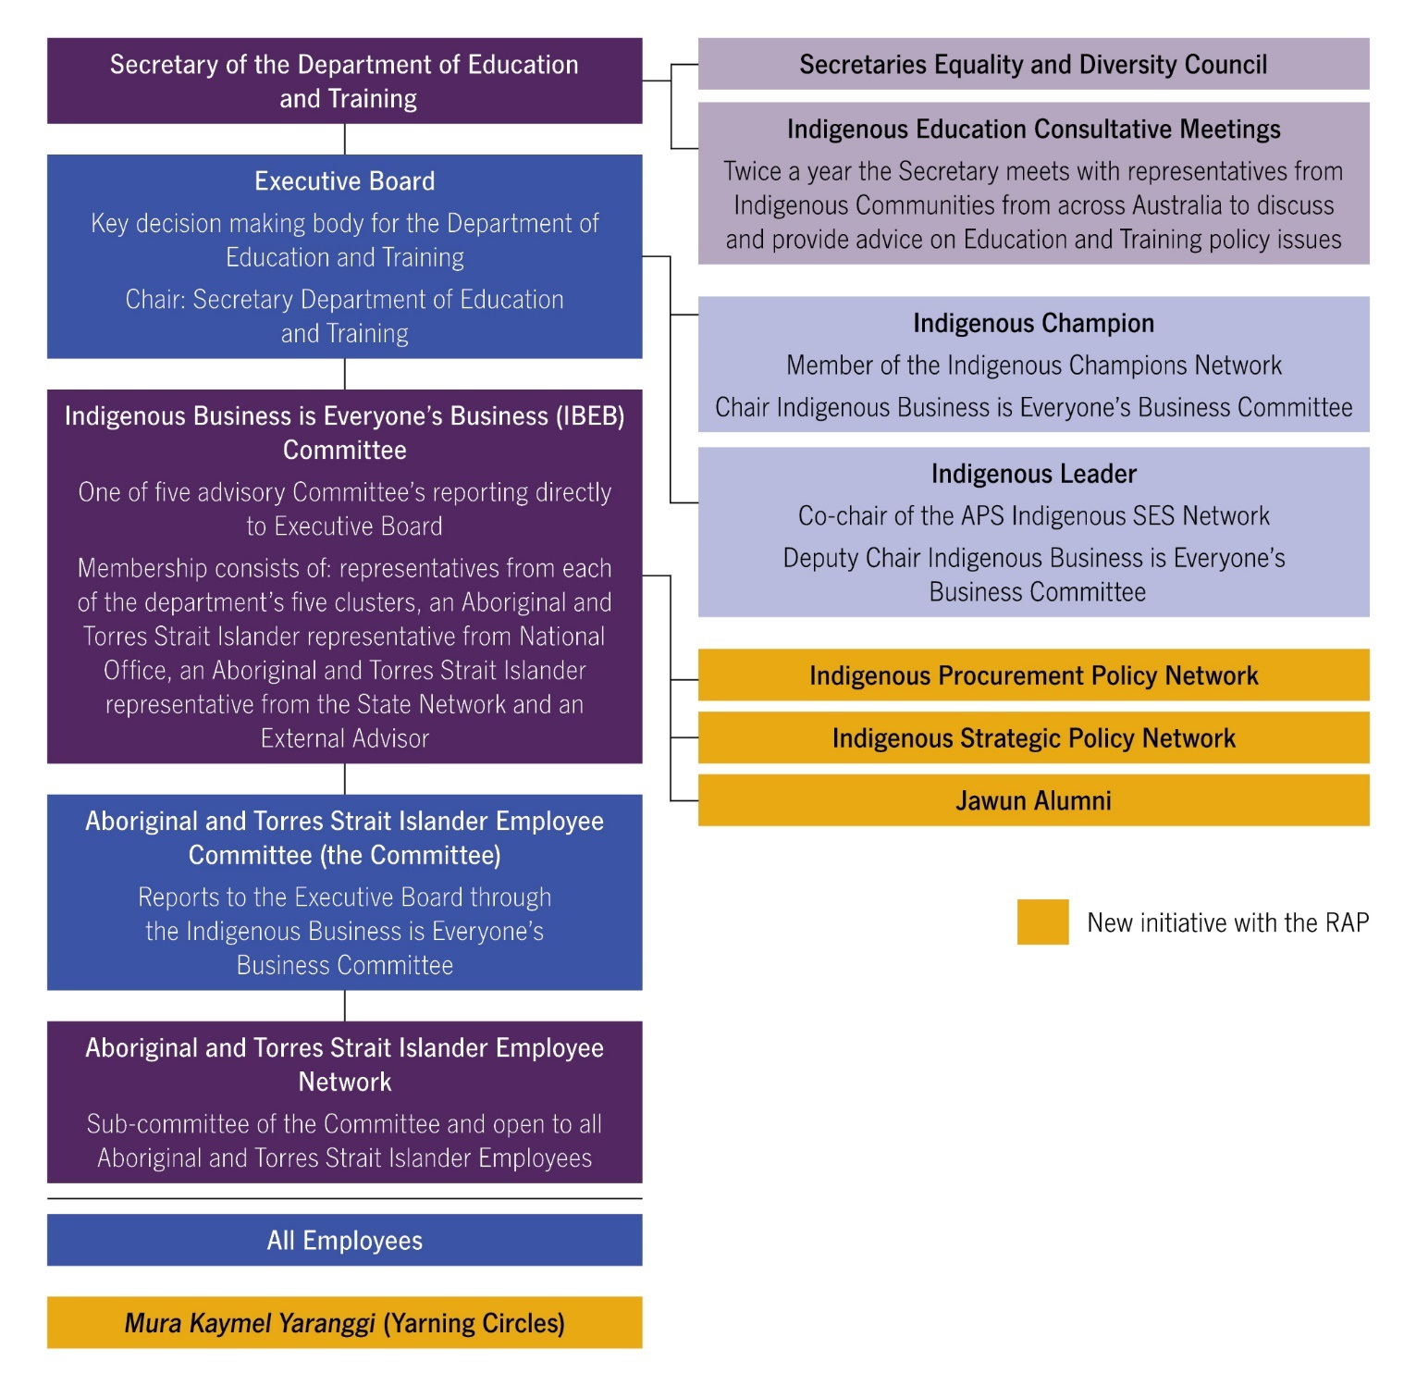

## Decorative elementOur continuing commitment to reconciliation

Since 2008, the department has successfully delivered four RAPs. Over this period, while a series of Machinery of Government changes have adjusted our composition and some areas of work, our commitment to reconciliation has never wavered. Our key achievements and ongoing commitments are highlighted below.



| **Supporting our people  and cultural capability** | **Connecting with community  and respectful relationships** | **Leadership and governance** |
| --- | --- | --- |
| * Active Aboriginal and Torres Strait Islander Employee Network * Indigenous Liaison Officer (identified position) to support our Aboriginal and Torres Strait Islander employees * 25 Indigenous Australian Government Development Program graduates since 2014 * Aboriginal and Torres Strait Islander employees annual workshop since 2012 and job shadowing/ mentoring opportunities * Over 500 employees completed an online cultural awareness program between 2016 and 2017 * NEW Secretary’s Award for Excellence in Commitment to Reconciliation from 2017 | * Established protocols for respecting country, peoples and culture * Hosted the 2017 Jawun Emerging Leaders Workshop * 22 Jawun secondees since 2011 * Secretary meets with Indigenous Consultative Group twice a year to discuss education and training  policy issues * Celebrate NAIDOC Week annually * Sponsor annual ACT NAIDOC Ball 2014–2017 * Key role in organising NAIDOC Touch Football Carnival since 2003 * Celebrate National Reconciliation Week annually * 135 contracts with Indigenous businesses since 2015  (worth over $7 million) | * *Indigenous Business is Everyone’s Business Framework* * Implementation Plan to support the  Commonwealth Aboriginal and Torres Strait Islander Employment Strategy * Stretch RAP since 2014 * Secretary participates in Secretaries Equality and Diversity Council * Indigenous Champion participates in APS Indigenous Champions Network * Indigenous Leader is co-chair of the APS Indigenous SES Network * IBEB Committee meets at least four times per year; reports to our Executive Board * External advisor on our  IBEB committee |

## Decorative elementDecorative elementWhat we’ve learnt

Extensive consultation, both internally and externally, recognised our achievements to date, while highlighting key areas where the department needs to improve and focus our attention. Feedback received acknowledged the challenges of developing and implementing   
an innovative Stretch RAP, however, there was overwhelming support for an ambitious Indigenous agenda moving forward.

| Issue | Machinery of Government changes impact on our ability to deliver on our actions. |
| --- | --- |
| Solution | Actions will be transferrable and applicable no matter what structure the department takes and are not dependent on the delivery of a particular program. |

| Issue | Too many actions mean we lose sight of what we are trying to achieve. |
| --- | --- |
| Solution | A streamlined RAP which acknowledges the continuing initiatives now embedded in the department with a focus on five signature initiatives that will establish the department as a leader in reconciliation. |

| Issue | Gaps in our focus. |
| --- | --- |
| Solution | Focus and improve our attention to:   * Drive significant advances and innovation in Indigenous policy and programs in partnership with Indigenous organisations. * Improve mentoring and problem solving in the RAP community. * Increase our contributions to reconciliation beyond our organisation’s business as usual activities. * Increase internal and external accountability requirements. |

| Issue | Some employees have lost sight of the true meaning of Indigenous business is everyone’s business. |
| --- | --- |
| Solution | Development of the new RAP provides us with an opportunity to rejuvenate our commitment to Indigenous business is everyone’s business. |

| Issue | Employee engagement with the RAP. |
| --- | --- |
| Solution | Explore new ways to connect and engage with our employees to promote the RAP. |

**“**Reconciliation covers all aspects of my life. It is not just a concept but a process of continuous learning. There is so much diversity in Aboriginal and Torres Strait Islander cultures to be celebrated and shared. This can start from a simple conversation where I share my Noongar language with a non-Aboriginal colleague, to instilling, in my daughter, the importance of aiming high with her education so she can take advantage of opportunities our ancestors before us did not have. A major driver in my working life is to increase awareness of the importance of engaging with Aboriginal and Torres Strait Islander peoples and communities in policy development. We can achieve great things working together.**”**

Corrina: Western Australia State Office

**

## Decorative elementCommitment to action

Building on our strong commitment to reconciliation, the department produced and delivered its first Stretch RAP in 2014. The department’s Stretch RAP was a formal commitment and call to action for all our employees to ensure Indigenous business is part of day-to-day business.

As a result of this demonstrated achievement, our 2018 RAP does not attempt to identify everything we will do to advance the reconciliation agenda—instead our RAP will focus on what we will do differently. Outlined below are five initiatives we believe will ensure our efforts result in the greatest impact on reconciliation in Australia.

These initiatives are underpinned by our commitment to provide increased opportunities for Indigenous peoples within our organisation and in the broader community, support our employees to develop respectful relationships with Indigenous peoples and communities, to lead and mentor the public service in the reconciliation movement and enhance the level of accountability for our commitments under the RAP. The five initiatives are:

1. Drive innovation in Indigenous education and training policy
2. Be an employer of choice through innovative Indigenous recruitment and career development
3. Increase our engagement with Indigenous owned businesses
4. Build our organisation’s cultural responsiveness
5. Share our results through storytelling and reflection.

### 1. Drive innovation in Indigenous education and training policy

**We will establish a high-level ‘think tank’ that engages in discussion and debate around the ‘big ideas’ that will drive policy innovation and achieve better educational outcomes for Aboriginal and Torres Strait Islander peoples and communities. The department provides national leadership on education and training policy, including influencing significant mainstream funding levers from early childhood to tertiary education. It is essential that we be at the forefront of innovative solutions and engagement.**

The ‘think tank’ initiative will be led by the department’s Indigenous Strategic Policy Network (ISPN). The ISPN is responsible for driving a whole-of-department strategic approach to Indigenous education policy and engagement. As part of the department’s Stretch RAP, the ISPN will actively partner with expert bodies, industry, government, and leading Indigenous organisations and individuals.

This collaborative approach will focus on or implement four ‘big ideas’ each year that will deliver innovative approaches to engagement and innovative policy solutions, with the potential to impact both mainstream and Indigenous targeted programs and better meet the needs of Aboriginal and Torres Strait Islander students, families and communities.

We acknowledge that we need to adopt innovative and integrated approaches to engagement, idea generation and sharing. Our new ‘think tank’ initiative moves beyond the standard processes governments use for policy development and adopts an innovative approach to engaging internally and with external stakeholders.

Our collaborative approach will include sharing our ‘big ideas’ and innovative approaches with stakeholders, including internally through the department’s new yarning circles (see Initiative No. 5) and community through the Secretary’s twice yearly Indigenous Education Consultative Meetings (IECM). The IECM is composed of members from Indigenous education consultative arrangements from each Australian state and territory.

**“**For me, in the department, reconciliation means coming together, from different cultures, identities and with diverse histories to work with and not ‘for’ or ‘to’ all Aboriginal and   
Torres Strait Islander peoples to achieve common goals.**”**

Alice: Improving Student Outcomes Group

### 2. Be an employer of choice through innovative Indigenous recruitment and career development

**We will lead the way with innovative career development, progression and retention initiatives to support the aspirations and needs of our Aboriginal and Torres Strait Islander employees, including extending support in entry level programs. By moving beyond employment targets to a focus on career and leadership development, we aim to be an employer of choice for Aboriginal and Torres Strait Islander peoples in the APS. We will share our success stories and mentor our portfolio entities.**

Our commitment is to foster a **diverse and inclusive workforce** that reflects the diversity of the Australian community. This includes strategies to increase the representation of Indigenous employees across the various functions and levels of our department. We will enhance our recruitment practices and engagement with Indigenous employees by providing integrated, career‑long professional support.

We will evaluate our existing **entry level** programs to ensure we attract the best applicants, reduce barriers to work in our organisation and provide the best information about our work to applicants. We will share our findings with other government departments.

We will introduce an additional 12-month induction support for all our entry level participants to ensure our retention rates are amongst the highest in the public service.

Our support for our **middle managers** will ensure we remain an attractive workplace for Indigenous peoples. Career interval options will be offered to broaden the professional experience-base of our employees and assist with retention. This initiative will be available for employees who remain in the same function for three years and/or have not secured a promotion for five years. Mobility, short term secondments, ‘reconnecting with community placements’, (co)mentoring, coaching, skill development and leadership programs will be among the opportunities available.

We are committed to promoting more Indigenous peoples into the most senior positions in our organisation and across the public service.   
We will support our **senior managers’** aspirations to move into the Senior Executive Service (SES) by co-owning and co-developing talent management agreements. These agreements provide a means for the department to commit to the professional empowerment of employees and will involve specific responsibilities for both direct managers and senior leadership.

**“**Reconciliation to me means Togetherness, Unity and Respect between Aboriginal and Torres Strait Islanders and non-Indigenous Australians. It is about respecting us, our people’s heritage and culture and embracing it now and in the future, so that our children and their children will carry what and who we are as Indigenous Australians.**”**

Mersane: Higher Education Group

|  |
| --- |
| **International Scholarship for department’s Andrea Kelly** |
| In September 2017 Andrea Kelly, Director Indigenous Strategy Team, won a prestigious INSEAD Scholarship. The scholarship program aims to support and provide talented Aboriginal and Torres Strait Islander women with the opportunity to build their leadership skills, enrich their experiences and advance their careers.  Of the experience Andrea said “I embraced the experience studying at INSEAD in Singapore, such a prestigious business school. I am grateful for the future opportunities the scholarship will provide in further developing my education and career and I will use the learnings and experience gained to continue to work hard in the interests of Aboriginal and Torres Strait Islander peoples. I appreciate the confidence that Chief Executive Women and the Roberta Sykes Indigenous Foundation placed in me by awarding me the scholarship, and I am also grateful to our Indigenous Champion in sponsoring my application”. |



**“**I test our work through a cultural lens as part of my day to day work with questions such as: How would this policy impact on Torres Strait Islander families? How do I engage with remote Aboriginal communities? How do I apply the Indigenous Procurement Policy in this contract? What do my Indigenous colleagues think about this issue? What can we do to contribute to Closing the Gap?**”**

Jason: Programs and Network Group

### 3. Increase our engagement with Indigenous owned businesses

**By setting an ambitious target and establishing a dedicated internal network to champion our commitment to, and involvement with, Indigenous owned businesses, we will exceed the APS target of awarding three per cent of our procurement contracts to Indigenous enterprises.**

We aim to exceed the APS target of awarding three per cent of procurement contracts to Indigenous businesses. We have set ourselves a target to award a total value of $3.5 million in new contracts each year. This is $1.5 million higher than a target based on three per cent and almost double our achievement in 2017–18.

Setting this target demonstrates our commitment to the Indigenous Procurement Policy (IPP) and achieving it will establish the department as a public sector leader in supplier diversity. We are also committed to growing our engagement with **Indigenous businesses**, including diversifying the range of goods and services and increasing the number of unique Indigenous businesses.

An internal IPP network will be established to champion the purchase of more goods and services from Indigenous owned businesses. The network will facilitate training and events where suppliers and buyers can meet. This network builds on our existing initiatives, which includes an online learning solution that was itself delivered by an Indigenous business and is available to all employees to learn about the IPP.



### 4. Build our organisation’s cultural responsiveness

**Cultural capability is an ongoing learning journey for our people. We will build on our existing initiatives by providing a greater range of opportunities, including through partnerships with other organisations and building on our relationships with Aboriginal and Torres Strait Islander communities. We will share our success stories and strategies with other public service entities.**

We aim to transition from a culturally aware and capable organisation to a culturally responsive organisation, which uses its capability to drive innovation and positive change. We will work in partnership with the Australian Institute for Aboriginal and Torres Strait Islander Studies (AIATSIS) and other organisations to develop a structured and three-tiered cultural capability development program. We will continue to use existing programs, while also developing innovative and flexible options, to bridge the gap between foundational cultural awareness and intensive cultural immersion programs. This will ensure our employees can access, maintain and grow through experiential knowledge and cultural capability.

**Tier One:** The foundation level will provide initial learnings for all our employees, delivered through our existing cultural awareness training program. This will establish a high cultural capability baseline for the organisation. The online course will undergo regular evaluation,   
with feedback provided to AIATSIS.

**Tier Two:** An intermediate level that will provide community-centred opportunities for employees to build on their foundation skills and knowledge through experiential learning. Community-based opportunities will be developed in partnership with local Indigenous organisations to provide flexible options for engagement, including short term and longer term intermittent secondments.

Employees who participate in the intermediate level will have access to structured support from the department, including a pre-placement briefing from an external broker, matching of an internal Indigenous mentor and a post-placement debrief.

**Tier Three:** This leadership level will drive cultural responsiveness of leaders, allowing them to create working environments that meet the needs of Indigenous employees and embed Indigenous business is everyone’s business into everyday work. Initiatives such as the Jawun Corporate Leaders Program will underpin the Leadership tier. SES participants will have access to structured support, including pre-visit briefings, post-visit debrief and an internal or external Indigenous mentor.

The department will share the learnings from the program each year with other public service entities through the Indigenous HR forums.

**“**As a result of my recent Jawun Secondment, I now have a greater understanding, awareness and appreciation for Aboriginal and Torres Strait Islander peoples. The secondment provided me with a great opportunity to contribute towards Reconciliation. The Jawun experience has given me the motivation to become more involved with ongoing Aboriginal and Torres Strait Islander affairs both within the department and externally.**”**

Shiona: Industry, Skills and Quality Group



### 5. Share our results through storytelling and reflection

**We will create and implement a culturally innovative yarning circle approach for reporting on our RAP. This initiative will not only extend our accountability and reporting framework beyond the standard requirements, it will also help build and sustain an ongoing conversation about reconciliation. In so doing, this initiative will further lift our cultural responsiveness and policy capability as an organisation.**

We will work with an Indigenous owned and managed business to design the yarning circle approach and evaluation tools, including a community engagement strategy. Our Aboriginal and Torres Strait Islander employees will be provided with training to lead and facilitate yarning circles.

Our approach will be called Mura Kaymel Yaranggi. Mura Kaymel—meaning ‘all or everyone together’—from Kala Lagaw Ya language from the Western Islands of the Torres Strait and Yaranggi—meaning ‘belonging to us’ from Bunuban language from the Fitzroy Crossing area in the Kimberley Region of Western Australia. We will engage all areas of the department and community stakeholders to participate and report on challenges, achievements and key learnings from delivering initiatives which impact on Aboriginal and Torres Strait Islander peoples and their communities. We will share the key learnings with other public service entities.

This initiative will establish a series of sustained engagement activities to transform the RAP from a passive written record to **an ongoing conversation about reconciliation**. This is a reorientation of the way we connect to the RAP, to embed its underlying ideals into the everyday culture of our department. This initiative will refresh and breathe new life into our existing commitment to Indigenous business is everyone’s business.

This initiative will supplement, rather than replace, our existing robust set of **formal reporting and monitoring practices**. This includes reporting through the Indigenous Business is Everyone’s Business Committee, accountability to the Executive Board and inclusion in our Corporate Plan. As the department implements this new RAP, we will strengthen these formal accountability measures, including through greater transparency of cultural engagement and IPP performance metrics.

**“**Our RAP generates the conversations that expand individual and collective awareness of Aboriginal and Torres Strait Islander cultures, peoples and their communities. Its strategies aim to produce innovative solutions and create the opportunities for Aboriginal and Torres Strait Islander peoples to learn, grow and succeed.**”**

Shane: Queensland State Office.

|  |
| --- |
| **Supporting Indigenous emerging leaders** |
| In September 2017 participants in the Jawun Emerging Leaders program visited Canberra for a ‘Working with Government’ workshop, which was designed and run by the Department of Education and Training. Outstanding leaders from communities from West Kimberley to Hope Vale, from the Central Coast of NSW to the Lower River Murray area of South Australia, came to hear insiders’ tips on how to navigate Government and the policy-making process.  The Jawun Emerging Leaders program looks to connect emerging Indigenous leaders from across Australia with each other and develop their leadership skills, specifically their understanding of how to make change happen and how to implement reform through effective leadership. |





## Decorative elementInnovation

**Key Initiative 1: Drive innovation in Indigenous education and training policy**

| **Action** | **Leader/ Champion** | **Action owner/ responsibility** | **Timeline** | **Indigenous Business is Everyone’s Business Framework** | **RA Dimension** |
| --- | --- | --- | --- | --- | --- |
| Use the newly established Indigenous Strategic Policy Network to drive a high-level ‘think tank’, including:   * identifying four ‘big ideas’ each year * engaging with communities by identify and partnering with expert bodies, industry, leading Indigenous organisations and individuals * convening the Indigenous Education Policy Forum series and other collaborative activities with a focus on overcoming policy challenges and developing innovative solutions * sharing the outcomes with relevant internal and external stakeholders. | Branch Manager, Student Participation Branch | Indigenous Strategic Policy Network | Implement and achieve from  mid 2018 | The Right Policies  and Programs | Race Relations, Equality and Equity, Unity, Institutional Integrity, Historical Acceptance |
| Report and seek community feedback on our approach through the Secretary’s twice yearly Indigenous Education Consultative Meetings. | Branch Manager, Student Participation Branch | Secretary, Indigenous Strategic Policy Network | Implement from mid 2018 | The Right Policies  and Programs | Race Relations, Equality and Equity, Unity, Institutional Integrity, Historical Acceptance |

## Decorative elementOpportunities

**Key Initiative 2: Be an employer of choice through innovative Indigenous recruitment and career development**

2.1 Increase our retention rates and capability development for our entry level participants:

|  |  |  |  |  |  |
| --- | --- | --- | --- | --- | --- |
| **Action** | **Leader/ Champion** | **Action owner/ responsibility** | **Timeline** | **Indigenous Business is Everyone’s Business Framework** | **RA Dimension** |
| Our existing entry level recruitment programs are evaluated and a best practice induction is developed and implemented. | Branch Manager People, Culture and Capability | People, Culture and Capability Branch | Evaluate late 2018 Implement from mid 2019 | The Right People | Race Relations, Equality and Equity |
| An additional year of support is provided to Indigenous Apprenticeship Program participants, including:  mentoring from culturally-capable employees  focusing on retention and career planning. | Branch Manager People, Culture and Capability | Line area SES, Supervisors, People, Culture and Capability Branch | Implement and achieve from early 2019, starting with the first cohort in the new program | The Right People,  The Right Capabilities | Equality and Equity |
| Our learnings are shared with other government agencies. | Branch Manager People, Culture and Capability | People, Culture and Capability Branch | Achieve from late 2018 | The Right People | Unity, Institutional, Integrity, Historical Acceptance |

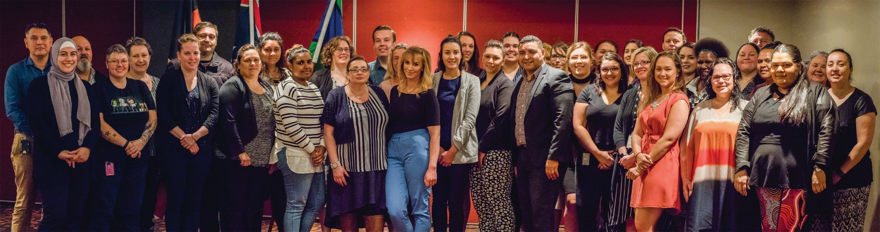

Photo caption: 2017 Aboriginal and Torres Strait Islander Employee Workshop

2.2 Support the career development of Aboriginal and Torres Strait Islander employees (APS levels 1-6), with a focus on those who have remained in the same function for three years and/or have not secured a promotion for five years:

| **Action** | **Leader/ Champion** | **Action owner/ responsibility** | **Timeline** | **Indigenous Business is Everyone’s Business Framework** | **RA Dimension** |
| --- | --- | --- | --- | --- | --- |
| At least 50 per cent of eligible employees are supported to develop career interval plans.  Note: Participation will be actively supported for all eligible employees, but not compulsory, recognising each employee’s choice. | Branch Manager People, Culture and Capability | Aboriginal and Torres Strait Islander Employees, Supervisors, Line area SES | Implement and support from late 2018; Achieve by late 2020 | The Right People | Equality and Equity |
| Eligible employees are supported to participate in career interval options, such as:   * mobility or secondments * ‘reconnecting with community’ placements * (co) mentoring or coaching * skill development programs; or * external leadership programs  (e.g. through the APSC talent development program). | Branch Manager People, Culture and Capability | Aboriginal and Torres Strait Islander Employees, Supervisors, Line area SES | Implement and achieve from  mid 2018 | The Right People,  The Right Capabilities | Race Relations, Equality and Equity |

2.3 Increase the number of Aboriginal and Torres Strait Islander employees in Executive Level and Senior Executive Service (SES) positions:

| **Action** | **Leader/ Champion** | **Action owner/ responsibility** | **Timeline** | **Indigenous Business is Everyone’s Business Framework** | **RA Dimension** |
| --- | --- | --- | --- | --- | --- |
| All Executive Level employees:   * co-design and co-own career development agreements with their line area SES * have an internal mentor at the Deputy Secretary level or higher * have access to an external career coach (EL2 only). | Branch Manager People, Culture and Capability | Aboriginal and Torres Strait Islander Employees, Line  area SES, Deputy Secretaries | Implement from  mid 2018 | The Right People | Equality and Equity |
| Minimum two employees per year are supported to participate in an external development program, such as the Indigenous Talent Program, the Atlantic Fellows for Social Equity Program and/or the Australia and New Zealand School of Government (ANZSOG). | Branch Manager People, Culture and Capability | Aboriginal and Torres Strait Islander Employees, Line area SES | Implement from late 2018 | The Right People,  The Right Capabilities | Equality and Equity |



2.4 For all Aboriginal and Torres Strait Islander employees:

|  |  |  |  |  |  |
| --- | --- | --- | --- | --- | --- |
| **Action** | **Leader/ Champion** | **Action owner/ responsibility** | **Timeline** | **Indigenous Business is Everyone’s Business Framework** | **RA Dimension** |
| Employees are invited to participate in an annual two-day internal leadership development workshop. | Branch Manager People, Culture and Capability | People, Culture and Capability Branch, Line area SES, Supervisors of Aboriginal and Torres Strait Islander employees | Implement and support from 2018 | The Right People,  The Right Capabilities | Race Relations, Equality and Equity, Unity, Historical Acceptance |
| Each employee is supported to participate in an annual SES shadowing day, which helps them to learn more about the daily activities of an SES officer. | Branch Manager People, Culture and Capability | Aboriginal and Torres Strait Islander employees, all SES | Implement and support from 2018 | The Right People | Race Relations, Equality and Equity, Unity, Historical Acceptance |
| Aboriginal and Torres Strait Islander employees are matched with SES officers in a new co-mentoring program that fosters two-way learning. | Branch Manager People, Culture and Capability | Aboriginal and Torres Strait Islander employees, all SES | Establish in late 2018 and support from early 2019 | The Right People,  The Right Capabilities | Race Relations, Equality and Equity, Unity, Historical Acceptance |

**Key Initiative 3: Increase our engagement with Indigenous-owned businesses**

| **Action** | **Leader/ Champion** | **Action owner/ responsibility** | **Timeline** | **Indigenous Business is Everyone’s Business Framework** | **RA Dimension** |
| --- | --- | --- | --- | --- | --- |
| An internal Indigenous Procurement Policy network champions purchasing more of the goods and services we need from Aboriginal and Torres Strait Islander owned businesses. The network of 15-20 employees participates in at least four organised activities per year, including training or meet the supplier events. | Chief Financial Officer | Budget, Planning and Performance Branch | Implement and support from early 2018 | The Right Capabilities | Unity, Institutional Integrity |
| 300 employees complete our new Indigenous Procurement Policy online learning course over three years. | Chief Financial Officer | All employees | Achieve by  late 2020 | The Right Capabilities | Race Relations, Unity, Historical Acceptance |
| A total value of $3.5 million is awarded in new contracts to Indigenous owned enterprises each year. | Chief Financial Officer | All employees undertaking or approving procurements | Achieve from 2018 | The Right Policies and Programs | Race Relations, Institutional Integrity |



## Decorative elementRespectful relationships

**Key Initiative 4: Build our organisation’s cultural responsiveness**

4.1 Continue to offer online cultural awareness training to all levels and ensure:

| **Action** | **Leader/ Champion** | **Action owner/ responsibility** | **Timeline** | **Indigenous Business is Everyone’s Business Framework** | **RA Dimension** |
| --- | --- | --- | --- | --- | --- |
| All new starters complete the training package within three months of commencement. | Branch Manager People, Culture and Capability | All new starters, supervisors of new starters | Achieve from  late 2018 | The Right Capabilities | Race Relations, Equality and Equity, Unity, Historical Acceptance |
| All employees complete the training package, with:   * 50 per cent complete within the first year * 75 per cent complete by the end of the second year * 95 per cent by the end of the third year. | Branch Manager People, Culture and Capability | All employees | Achieve from  late 2018 | The Right Capabilities | Race Relations, Equality and Equity, Unity, Historical Acceptance |
| All employees who nominate to participate in an Indigenous community-based secondment program have completed the training package to be eligible. | Branch Manager People, Culture and Capability | Employees wishing to participate in an Indigenous community based secondment program | Implement from early 2018 | The Right Capabilities | Race Relations, Equality and Equity, Unity, Historical Acceptance |
| 100 per cent completion rate of the training package for the following groups:   * Indigenous Business is Everyone’s Business Committee members * All Senior Executive Service (SES) level employees. | Branch Manager People, Culture and Capability | Indigenous Business is Everyone’s Business Committee, all SES | Achieve by  early 2020 | The Right Capabilities | Race Relations, Equality and Equity, Unity, Historical Acceptance |
| The department regularly evaluates the take-up and impact of the training package in collaboration with the Australian Institute of Aboriginal and Torres Strait Islander Studies (AIATSIS). | Branch Manager People, Culture and Capability | People, Culture and Capability Branch | Evaluate by  mid 2020 | The Right Capabilities | Race Relations, Equality and Equity, Unity, Institutional Integrity, Historical Acceptance |

4.2 Expand our cultural learning opportunities to enable employees to progress from on-line learning to experiential learning:

| **Action** | **Leader/ Champion** | **Action owner/ responsibility** | **Timeline** | **Indigenous Business is Everyone’s Business Framework** | **RA Dimension** |
| --- | --- | --- | --- | --- | --- |
| 10 employees per year participate in local Indigenous community-based secondment programs. | Branch Manager People, Culture and Capability | People, Culture and Capability Branch, all SES | Implement and achieve from  late 2018 | The Right Capabilities | Race Relations, Equality and Equity, Unity, Historical Acceptance |
| The number of participants on the Jawun secondment program increases to nine per year, including a minimum of one SES officer to participate in the Jawun Leadership program per year. | Branch Manager People, Culture and Capability | People, Culture and Capability Branch, all SES | Achieve from  late 2018 | The Right Capabilities | Race Relations, Equality and Equity, Unity, Historical Acceptance |
| Establish a Jawun Alumni group to help promote the secondment program internally and across the Australian Public Service (APS). | Branch Manager People, Culture and Capability | People, Culture and Capability Branch, all SES, Jawun Alumni | Implement and support from  early 2018 | The Right Capabilities | Race Relations, Equality and Equity, Unity, Historical Acceptance |
| Partner with the Atlantic Fellows for Social Equity to establish an Atlantic Fellows inward placement to allow Atlantic Fellows to work in our department. | Branch Manager People, Culture and Capability | All SES | Establish in  late 2018 | The Right Capabilities | Race Relations, Equality and Equity, Unity, Institutional Integrity, Historical Acceptance |
| Establish an employee exchange program with AIATSIS. | Branch Manager People, Culture and Capability | People, Culture and Capability Branch | Establish in  late 2018 | The Right Capabilities | Race Relations, Equality and Equity, Unity, Historical Acceptance |

 Accountability

**Key Initiative 5: Share our results through storytelling and reflection**

| **Action** | **Leader/ Champion** | **Action owner/ responsibility** | **Timeline** | **Indigenous Business is Everyone’s Business Framework** | **RA Dimension** |
| --- | --- | --- | --- | --- | --- |
| Engage an Aboriginal and Torres Strait Islander-owned and managed  business to:   * design a culturally innovative yarning circle approach, evaluation tools and community engagement strategy * conduct training to develop our Aboriginal and Torres Strait Islander employees to lead and facilitate yarning circles * develop resources to support all employees to understand and engage in the yarning circle process. | Branch Manager, Budget, Planning and Performance Branch | Indigenous Business is Everyone’s Business Committee | Implement in  mid 2018 | The Right Capabilities, The Right Policies and Programs | Race Relations, Equality and Equity, Unity, Historical Acceptance |
| Support Aboriginal and Torres Strait Islander community stakeholders  (who are service providers and program beneficiaries) to participate and provide feedback through the yarning  circle process. | Branch Manager, Budget, Planning and Performance Branch | Indigenous Business is Everyone’s Business Committee | Implement and support from  mid 2018 | The Right Capabilities, The Right Policies and Programs | Race Relations, Equality and Equity, Unity, Institutional Integrity, Historical Acceptance |

|  |  |  |  |  |  |
| --- | --- | --- | --- | --- | --- |
| **Action** | **Leader/ Champion** | **Action owner/ responsibility** | **Timeline** | **Indigenous Business is Everyone’s Business Framework** | **RA Dimension** |
| Employees actively participate in the department’s culturally innovative yarning circle and by rotating hosting responsibilities, each area of the department will lead at least one yarning circle session per year. | Branch Manager, Budget, Planning and Performance Branch | All SES, all employees | Implement and support from  mid 2018 | The Right Capabilities, The Right Policies and Programs | Race Relations, Equality and Equity, Unity, Historical Acceptance |
| Develop and implement systems to track, measure and report on the outcomes from yarning circle sessions. | Branch Manager, Budget, Planning and Performance Branch | Indigenous Business is Everyone’s Business Committee | Implement in  mid 2018 | The Right Capabilities | Race Relations, Unity, Historical Acceptance |



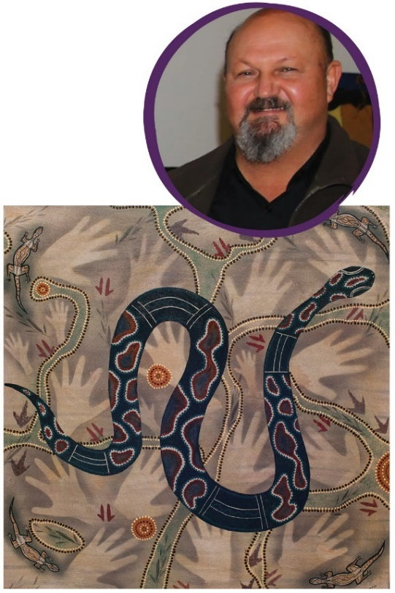

## Artist Information

### Artist statement

I am what I’d call an ‘accidental artist’. My art came to me through my Aboriginality and the opportunity to try art. I spoke with an elder of my mob (Bidjara People) and asked permission to paint in our traditional style of stencil art using ochres back in 2013, before that I’d never done any paintings.

That’s how it all happened for me and it is as simple as that. I let my thoughts, dreams and my connection to my country bring the art out of me.

This painting of the Rainbow Serpent is contemporary in style and not intended to be anything else out of respect for Indigenous culture. I’ve tried to include Aboriginal and Torres Strait Islander peoples across the country through the story of the Rainbow Serpent using different styles and techniques.

### The Rainbow Serpent

The serpent as a ‘Creation Being’ is perhaps the oldest continuing religious belief in the world. The Rainbow Serpent dreaming story is told by many Aboriginal nations and is always associated with waterways, rivers, creeks and billabongs. The Rainbow Serpent is the protector of the land, its people, and the source of all life.

One such version of the Rainbow Serpent story tells that in the Dreaming, the world was flat, bare and cold. The Rainbow Serpent slept under the ground with all the animal tribes in her belly waiting to be born. When it was time, she pushed up, calling to the animals to come from their sleep. She threw the land out, making mountains and hills and spilled water over the land, making rivers and lakes. She made the sun,   
the fire and all the colours.

### Cultural Responsibilities

Our dreaming stories are important. The knowledge and cultural stories are handed down to each generation in the same way that our songs, dances, paintings and stories express our cultural history.

Aboriginal and Torres Strait Islander peoples have the longest continuous cultural history of any people in the world. Dating back between 50,000 and 65,000 years before European settlement.

### Biography

My name is Dennis Anderson. I am a Bidjara man from Charleville Queensland. Our traditional lands are north and south of Charleville and Augathella and down to the Carnarvon Gorge region. My great great grandmother was born on country near Augathella before the first settlers came to the region. Our people were almost wiped out and have struggled from one generation to the next. But we survived. I am   
a survivor of the Government policy of removing Aboriginal Children from their families during the 1960s.

As an adult I completed an apprenticeship in French Polishing. I worked for myself in this trade for 18 years. I also served in the RAAF from 1991–1999. I came into the Department as part of the Indigenous Australian Government Development Program in 2012. I am particularly interested in the RAP initiative and working with Reconciliation Australia to improve the lives of Aboriginal and Torres Strait Islander peoples.

Reconciliation to me will only be achieved when Aboriginal and Torres Strait Islander people have regained pride in their identity without being treated as second class or made to feel they’re not worthy. Reconciliation must also offer Indigenous Australians the same opportunities as other Australians, but with the support needed with respect to what was taken. Only then will there be equality between Indigenous and   
non-indigenous peoples of this country. Achieving this will contribute greatly to closing the gap.

**Dennis Anderson**Queensland State Office

**“**It is important for us to publicly articulate our deep   
and enduring commitment to reconciliation to   
signpost our leadership in both the education  
 sector and the Australian Public Service.**”**

Jason: Programs and Network Group



Opportunity through learning