

COMMON FEATURES OF LABOUR MARKETS WITH A PROMINENT RESOURCES SECTOR

The Department of Education, Employment and Workplace Relations conducts Surveys of Employers’ Recruitment Experiences in regions across Australia. In these surveys, employers from all sectors of the local economy tell us about their experiences recruiting and retaining workers.

Over the past two years surveys have been conducted in four regions which are heavily reliant on the resources sector (Kimberley, Capricornia, Gladstone and Mt Isa). Findings from these surveys have highlighted some features common to these four regions which differentiate them from labour market conditions reported by employers in other regions across Australia[1].

# Recruitment activity and staff turnover higher

Employers in regions with high levels of employment in the resources sector were two to three times more likely to report that staff retention was a significant problem for their business than was the case in other surveyed regions.

Staff retention problems were also reflected in higher measures of recruitment activity. The recruitment rate, which identifies the annual number of vacancies reported in surveyed businesses per 100 staff, was much higher in resources intensive areas than in other regions surveyed (see Table 1).

**Table 1. Recruitment Activity Levels and Staff Retention Problems: Resources Areas vs All Regions**

|  |  |  |  |  |  |
| --- | --- | --- | --- | --- | --- |
|  | Mt Isa  (Jun 2011) | Gladstone (Nov 2011) | Capricornia (Mar 2012) | Kimberley (Nov 2012) | All Regions (Mar 2013) |
| **Recruitment rate** (annual vacancies per 100 staff) | 38 | 26 | 32 | 66 | 17 |
| **Staff retention problems** (past 12 months) | 25% | 32% | 27% | 24% | 9% |

# Vacancies more difficult to fill

A far higher proportion of vacancies remained unfilled and employers more commonly said that it was ‘difficult’ to fill vacancies in regions with large resources sectors than was the case for all regions surveyed (see Table 2).

Employers in resources intensive areas were far more likely to say that recruitment was ‘difficult’ because of the location of the job. This reflects the additional challenge of remoteness in many resources intensive regions which contributed to the average number of job applicants per vacancy in these regions (4.2) being less than half that for all surveyed regions (8.8).

**Table 2. Recruitment difficulty: Resources Areas vs All Regions**

|  |  |  |  |  |  |
| --- | --- | --- | --- | --- | --- |
|  | Mt Isa  (Jun 2011) | Gladstone (Nov 2011) | Capricornia (Mar 2012) | Kimberley (Nov 2012) | All Regions (Mar 2013) |
| **Recruitment difficult** (% of recruiting employers) | 70% | 70% | 64% | 60% | 49% |
| **Vacancies unfilled** (% of recent vacancies) | 14.6% | 16.9% | 12.7% | 7.8% | 4.3% |

# Many vacancies for Trades Workers and Machinery Operators and Drivers Unfilled

In general, employers in resources intensive industries had particular difficulty filling vacancies for Technicians and Trades Workers and Machinery Operators and Drivers.

More than one quarter of recent vacancies for Technicians and Trades workers remained unfilled in three of the regions (Mount Isa, Gladstone and Capricornia), well above the all-region average of 7.3 per cent (Figure 1). The unfill rate for Machinery Operators and Drivers vacancies was also more than three times the all-region average in Gladstone, Capricornia and the Kimberley (Figure 2).

**Figure 1. % of Unfilled Vacancies:   
Technicians and Trades Workers**

**Figure 2. % of Unfilled Vacancies:  
Machinery Operators and Drivers**

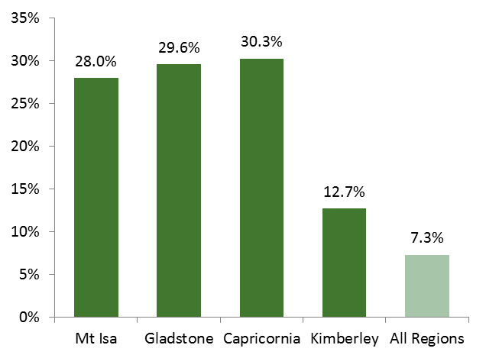

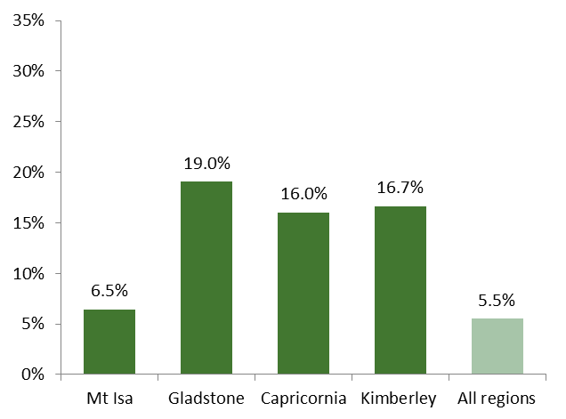

**FOR FURTHER INFORMATION ON EMPLOYER SURVEYS:**

**Survey of Employers’ Recruitment Experiences**: www.deewr.gov.au/regionalreports

Or contact the **Regional and Industry Employer Surveys Section** on 1800 059 439 or email recruitmentsurveys@deewr.gov.au.

1. In the 12 months to March 2013, 26 regions were surveyed. The majority of regions surveyed were Priority Employment Areas so the data for this period may be more representative of disadvantaged labour markets than of the Australian labour market in general.