

Labour Market Conditions in Tasmania

* In the last two years Tasmania has experienced softening labour market conditions, with:

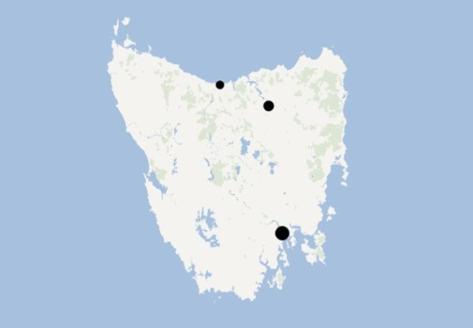

**Hobart**

Launceston

Devonport

* + declining employment and internet job vacancies; and
  + an increasing unemployment rate.

|  |  |  |  |  |
| --- | --- | --- | --- | --- |
|  | Employment(a) | Unemployment rate(a) | Participation rate(a) | Internet job vacancies(b) |
| Tasmania | 230,200 | 8.9% | 60.8% | 1475 |
| 2 yearly change | -2.2% | 3.7% pts | 0.6% pts | -30% |
| Australia | 11,668,500 | 5.7% | 65.3% | 158,565 |
| 2 yearly change | 2.3% | 0.8% pts | -0.2% pts | -34% |
| 1. ABS, Labour Force, Australia, June 2013 (cat.no. 6202.0), seasonally adjusted data. 2. DEEWR, Vacancy Report, May 2013, trend data. | | | | |

* The largest employing industry is Health Care and Social Assistance, which grew by 8 per cent over the last two years. By contrast, employment in Agriculture, Forestry and Fishing fell by 22 per cent.[1]

# What employers are telling us[2]

* Recruitment activity in Tasmania was subdued, with 14 vacancies per 100 staff in the last 12 months.
  + Recruitment had slowed noticeably in Hobart (11 vacancies per 100 staff).
* There were few vacancies that remained unfilled (2.9 per cent in the most recent recruitment round).
* Fewer employers reported recruitment difficulty compared with previous years.
  + However, recruitment difficulty was still commonly reported when recruiting for Community and Personal Service Workers, Managers, and Technicians and Trades Workers.

* In the 12 months to March 2013.

* Just over half (52 per cent) of all employers surveyed reported that demand for their products or services or overall economic conditions was the single greatest future concern to their business.

**Where are the opportunities?**

* The Education and Training and Health Care and Social Assistance industries have recorded strong jobs growth over the last two years. There has also been strong recruitment in industries with traditionally high staff turnover, such as Accommodation and Food Services.
  + In the next 12 months, employers anticipate recruiting for Registered Nurses, Aged and Disabled Carers, Waiters, Bar Attendants and Baristas, Sales Assistants (General) and Truck Drivers.

1. ABS, Labour Force, Australia, Detailed – Quarterly, May 2013 (cat. no. 6291.0.55.003), four-quarter averages of *original* estimates.
2. Based on a Survey of Employers’ Recruitment Experiences undertaken by DEEWR in March 2013.