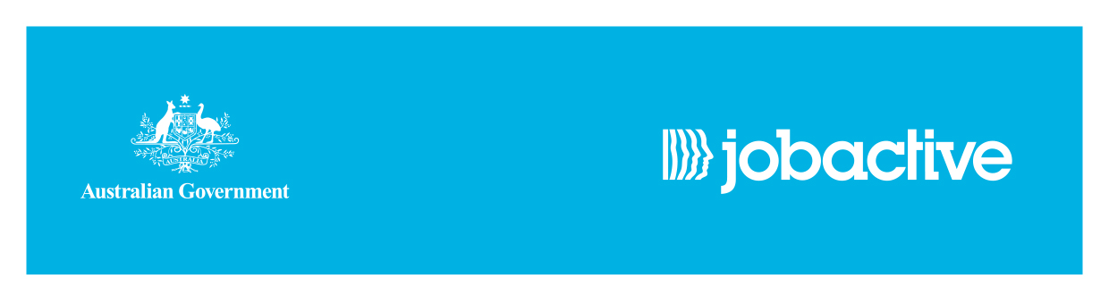
jobactive services on Norfolk Island

Asuria provides jobactive services on Norfolk Island.

What is jobactive?
jobactive is the Australian Government’s way to get Australians into work. It connects job seekers with employers.
Asuria provides jobactive services to both employers and job seekers on Norfolk Island.
Employers can get help from the jobactive provider to source and recruit employees who meet their business needs.
Job seekers can get help from the jobactive provider to find and keep a job.
Services for employers
The jobactive provider will work closely with employers to understand their recruitment needs.
They can tailor their services to ensure employers get the help they need to find suitable staff.
The jobactive provider can help employers by:
- pre-screening job seekers to meet the needs of the employer and referring job-ready employees who are ready for a real work environment
- providing support after their new employee starts work as they settle into the job
Services for job seekers
Services for job seekers from the jobactive provider include:
- help to look for work, write a résumé and prepare for interviews
- referrals to jobs
- developing a Job Plan that outlines what the job seeker will do to become more job ready and satisfy their mutual obligation requirements
- help to become job-ready, including targeted training that is suited to the skills that local employers need
- individualised support so they are ready to take up and keep a job
- support to complete Work for the Dole, or other approved activities, that provide work-like experiences, help for job seekers to learn new skills and improve the job seeker’s chances to find a job
- help to start a new small business through the New Enterprise Incentive Scheme (NEIS).
Job seeker eligibility for jobactive
Job seekers who receive income support payments, such as JobSeeker Payments, Youth Allowance (Other), or Parenting Payment, and have mutual obligation requirements will generally receive the full range of jobactive services.
Some people can also get help under jobactive as a Volunteer job seeker and the type of support they receive will depend on their circumstances.
Job seekers may be eligible to volunteer for jobactive services if they:
- are not on income support, or
- are on income support and have no mutual obligation requirements
- are not working or studying full time, and
- have the right to work in Australia.
Support to suit a job seeker’s needs
Most new job seekers on income support will have their first contact with a Services Australia agent on Norfolk Island, who will assess their eligibility for jobactive services.
The level of support a job seeker will receive from the jobactive provider will depend on their assessed readiness for work.
Job seeker obligations
To ensure job seekers remain active and engaged while looking for work, they may need to meet certain requirements to keep receiving income support. These are called Mutual Obligation Requirements.
Mutual Obligation Requirements apply to people on JobSeeker Payments or Youth Allowance (Other), or Parenting Payment recipients whose youngest child is at least six years of age). A job seeker’s Mutual Obligation Requirements vary according to their age and other personal circumstances.
From 4 July 2022, job seekers will have more choice and flexibility in how they manage their obligations. Find out more about Points Based Activation or talk to the provider about options.
Interested in starting a new small business through the New Enterprise Incentive Scheme (NEIS)?
Job seekers who want to start and run a new small business may be eligible to participate in NEIS, delivered as part of jobactive. NEIS provides individualised help for eligible job seekers to become self-employed business owners.
Generally, to be eligible for NEIS, a job seeker must be on income support and meet other personal and business eligibility requirements.
Job seekers who are interested in starting and running a new business should contact Asuria for more information.
What is Work for the Dole?
Work for the Dole places job seekers in activities where they can gain skills and experience that give back to the community while they are looking for work.
Work for the Dole activities can be hosted by not-for-profit organisations such as charities, community organisations and government agencies.
Work for the Dole hosts provide work-like activities for Work for the Dole participants and gain an extra set of hands to undertake activities that would normally not be done.
Depending on the Work for the Dole activity being undertaken, job seekers may be required to undergo police checks or work, health and safety training as a prerequisite.
Who can do Work for the Dole?
Job seekers who have mutual obligation requirements may participating in Work for the Dole.
Want more information?

Asuria
112a Taylors Road, Burnt Pine
Norfolk Island
Ph 1800 773 338

Employers
Employers can talk to Norfolk Island’s jobactive provider, Asuria, about their needs or manage their vacancies through the Workforce Australia website.
Visit www.WorkforceAustralia.gov.au for more information.
Alternately, contact the Employer Hotline on 13 17 15*.
Job seekers
  - Call the Employment Services Information Line on 13 62 68*, if they are not registered with jobactive or Disability Employment Services, or
  - Call the National Customer Service Line on 1800 805 260*, if they are registered with jobactive
If you need an interpreter, please call the Translating and Interpreting Service (TIS) on 131 450* and ask for the Employment Services Information Line on 13 62 68* or the Employer Hotline on 13 17 15*.
If you are deaf, or have a hearing or speech impairment, you can use the National Relay Service. For more information, visit www.relayservice.com.au.
* Note that call charges apply for calls to ‘13’ and ‘1800’ numbers from Norfolk Island and also from mobile phones.

