­

Review of the   
Australian Apprenticeships National Skills Needs List

Summary of Online Submission Forms

On 29 August 2019, the Department released the Review of the Australian Apprenticeships National Skills Needs List – Issues Paper, which outlined six proposed principles for the design of a new methodology for identifying occupations in skills shortage for the purpose of targeting apprenticeship incentives. Stakeholder groups were invited to provide feedback on the Issues Paper via an online submission form or by emailing their submissions. Submissions closed on 27 September 2019.

The six design principles are:

1. There should be a single coherent approach to identifying occupational skills shortages
2. The methodology should be forward looking
3. The methodology should be responsive to changes in skills shortages
4. The methodology should be transparent yet flexible
5. The methodology should support informed decision making
6. The methodology should prioritise outcomes that deliver the greatest social and economic benefit.

The National Skills Needs List (NSNL) Issues Paper is the first of two consultation papers seeking stakeholder input on the new methodology for identifying occupations in skills shortage for the purpose of targeting apprenticeship incentives**.** The focus of the Issues Paper was to get the fundamental design principles for a revised skills shortage methodology right.

# Summary of responses

The Department received a total of 48 completed submissions – 20 via the online submission form and 28 via free form email submissions. This report is based on responses from the 20 completed online submissions forms.

## Demographic questions

### Stakeholder groups represented

Of the eight employer respondents, seven reported they currently have one or more apprentices.

Figure : Stakeholder groups represented in responses to online submission forms

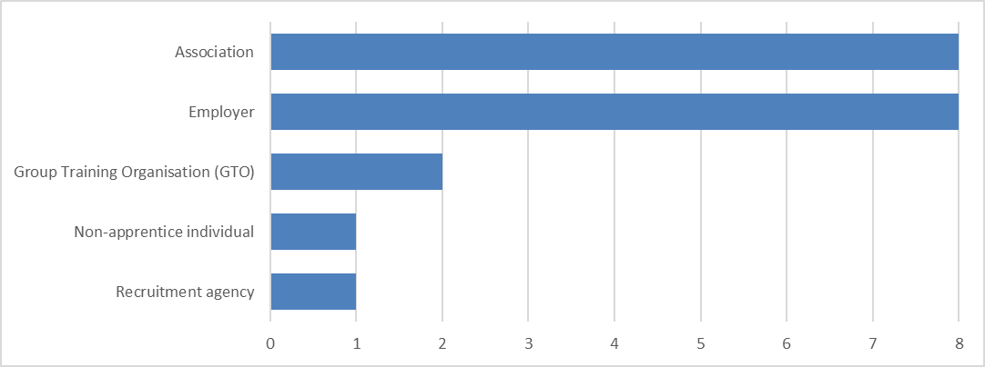

### Occupations represented

#### Occupations represented in responses to online submission forms

* Floor covering trades
* Technology
* Building & Construction
* Small goods Manufacturing
* Mine Operator
* Telecommunications
* Childcare Workers
* Arborist
* Boiler Maker Welder
* Mechanical Services Plumbers, Refrigeration and Air Conditioning Technicians, Mechanical Draftspersons
* Vehicle Spray Painting
* Printing and all visual graphic related activities
* Shearing
* Panel Beating
* Butcher or Small goods Maker
* Carpenter
* Child Care Educators
* Harvesting & Haulage
* Electrical
* Mobile plant operators
* Heavy Duty Mechanic
* Composites Technician
* Harvesting & Haulage
* Wall & Ceiling Liners
* Light Vehicle Mechanic
* Welding
* Plumbing and gas fitting
* General mechanical engineering
* Meat industry

### Location of main business activity

Figure : Location of main business activity for responses to online submission forms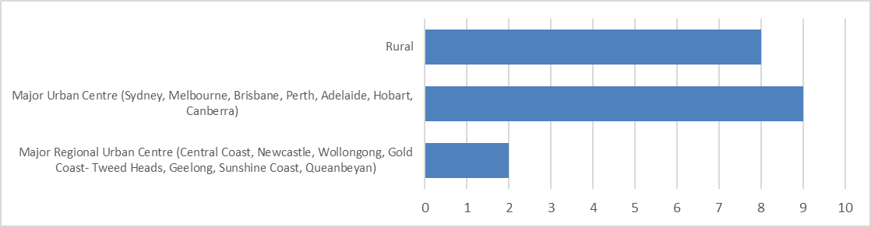

## Overall sentiment towards the NSNL review

### Level of agreement with NSNL issues raised in Issues Paper

Figure : Level of agreement with NSNL issues raised in Issues Paper

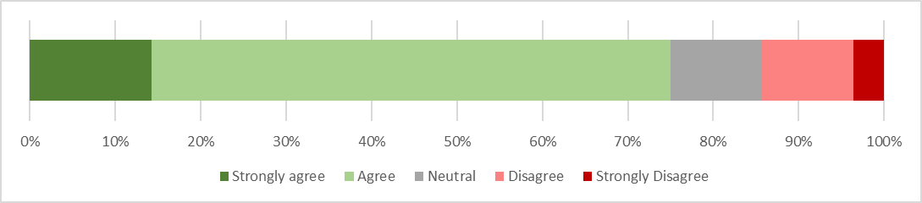

#### Other issues with NSNL raised by respondents

* Increased feedback from employers is needed.
* Skills demand arising from major technology change is not reflected in the composition of the NSNL.
* The NSNL is too focused on traditional trade occupations.
* There needs to be greater consideration of re-skilling older workers to fill skills shortage occupations.
* There are issues with the skills shortage data used by the Department.
* Occupations listed on NSNL still haven’t seen a significant reduction in skills shortage- may not be having a major impact on skill supply.
* Apprenticeship qualifications are not always well aligned to skills required in the workplace.

### Level of agreement with the design principles

Figure : Level of agreement with the design principles

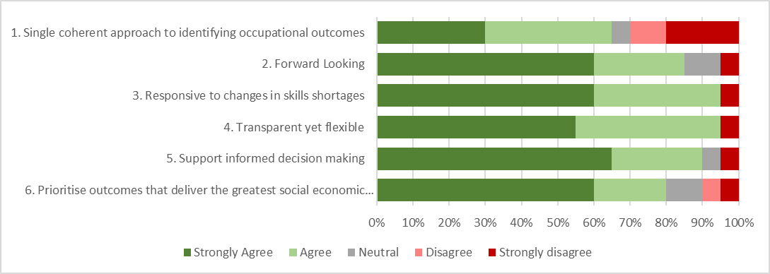

#### Other design principles raised by respondents

* Increased industry consultation.
* Increased understanding of skills shortages by region/ state/ locality.
* Increased flexibility in targeting ‘skills’ rather than occupations/ qualifications.
* Support apprenticeship diversity.
* Local skills development where skills are being sourced overseas.

### Ranking of design principles (Top 3)

Figure : Ranking of design principles (Top 3)

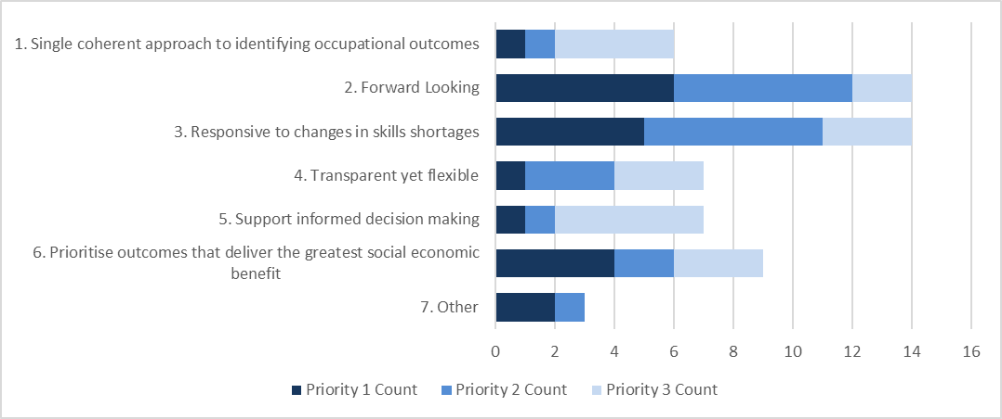

## Sentiment towards each design principle

### Design principle 1: A single coherent approach

Figure : Level of agreement with a single coherent approach to underpin the identification of skills shortages

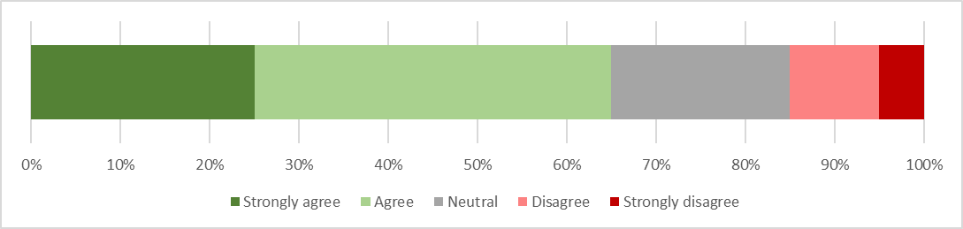

### Design principle 2: Forward looking methodology

Figure : Preferred timeframe for forecasting occupational skills shortages raised by respondents

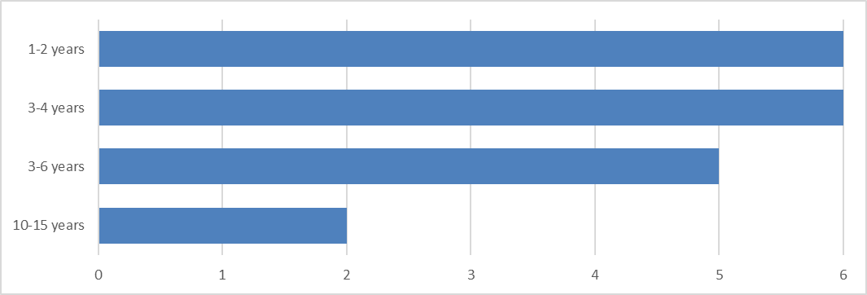

#### Limitations of a forward looking methodology and solutions raised by respondents

##### Limitations

• The methodology must not be over-reliant on labour market data due to increasing volatility and rapid changes in skills need.

• Skills shortages for many industries are dictated by economic cycles, which are difficult to forecast far into the future.

• The methodology must not ignore the immediate skills shortage needs of industry.

##### Solutions

• Industry engagement must be a central feature of a forward looking methodology.

• Government could consider conscripting industry associations to conduct surveys for their members.

• Develop more nuanced analysis methods for understanding the skills pipeline in related sectors that can have an impact on skills availability for other sectors.

Figure : Level of agreement with the proposed core components of a forward looking methodology

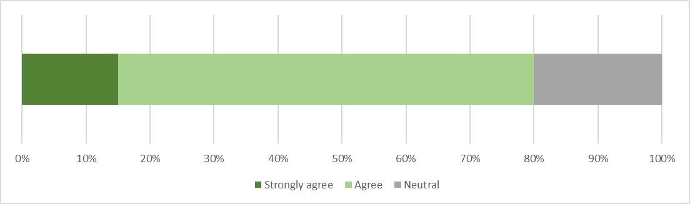

### Design principle 3: Responsive to changes in skills shortages

Figure : Level of agreement with an annual update of the occupational skills shortage list

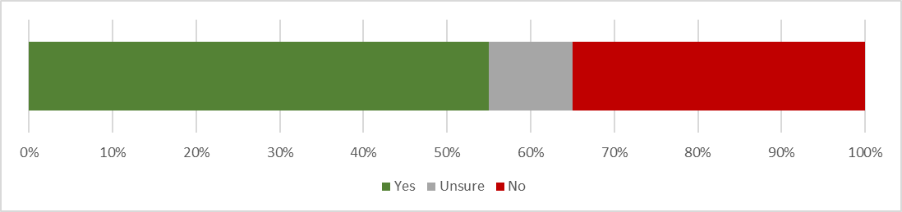

#### Concerns raised by respondents regarding annual update of the occupational skills shortage list

* Annual updates may place excessive administrative burden on industry and employer stakeholders.
* Skills shortages may not be uniform across a 12 month period.
* Annual updates may disrupt employer workforce planning.
* The methodology should remain in place for a number of years, but the data that feeds into the methodology should be reviewed annually.

### Design principle 4: Transparent yet flexible

Figure : Distribution of respondents favouring transparency or flexibility

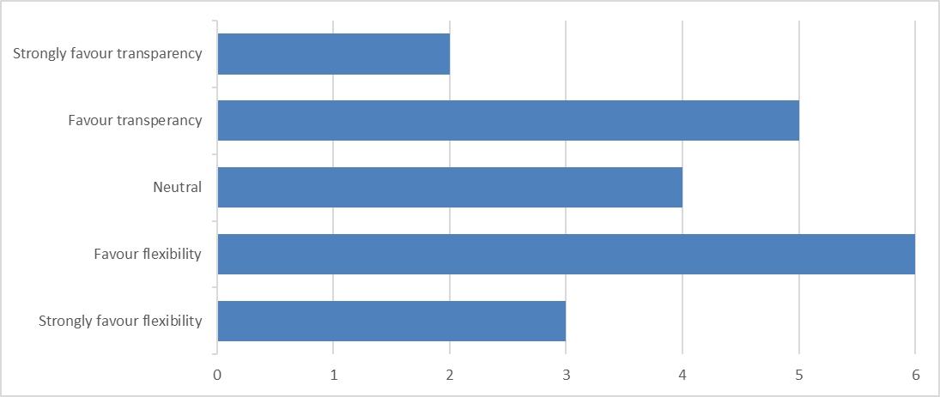

#### Respondent comments on balancing flexibility and transparency

* Use an environmental scan approach that combines local industry, global trends, demographic trends and apprenticeship uptake trends.
* Use a more flexible approach in targeting baseline skills in need that feed into multiple occupations.
* Use increased levels of ongoing industry engagement.

### Design principle 5: Support informed decision making

Figure : Level of agreement with determining skills shortage incentives at commencement of an apprenticeship

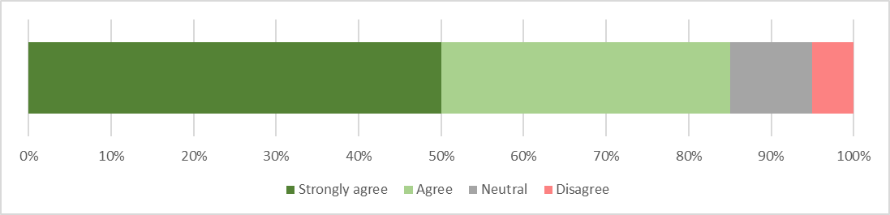

Figure : Level of agreement that volatility accessing skills shortage incentives will impede their effectiveness

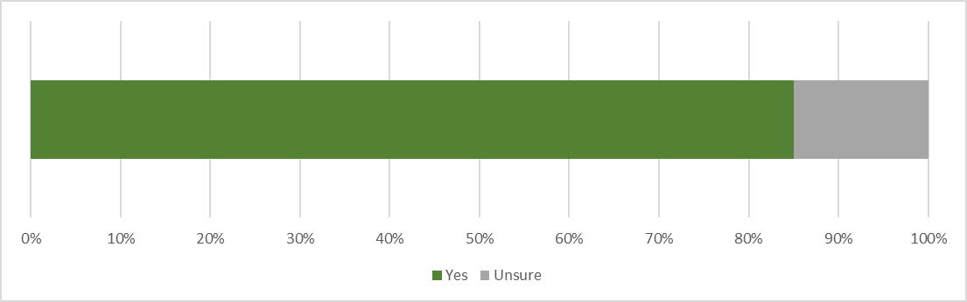

#### Stabilising mechanisms discussed by respondents

* Any changes to the NSNL should have an inbuilt lead time for any changes to take effect.

Figure : Period of notice before changes in the skills shortage list take effect raised by respondents

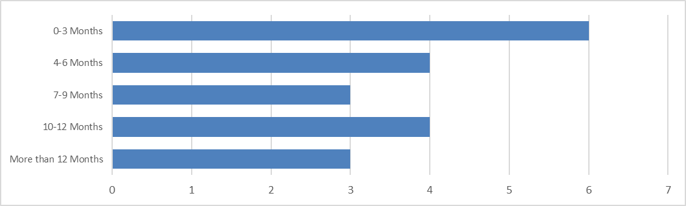

#### Reasons provided by respondents regarding period of notice

* Respondents favouring shorter notice periods discussed the need to quickly respond to urgent skills shortages and to reassure employers that the methodology is responsive.
* Respondents favouring longer notice periods primarily focused on the need for employers to be given adequate time to conduct workforce and budget planning, which could be for one to six years into the future.

### Design principle 6: Prioritise outcomes delivering the greatest benefit

Figure : Level of agreement with proposed prioritisation criteria

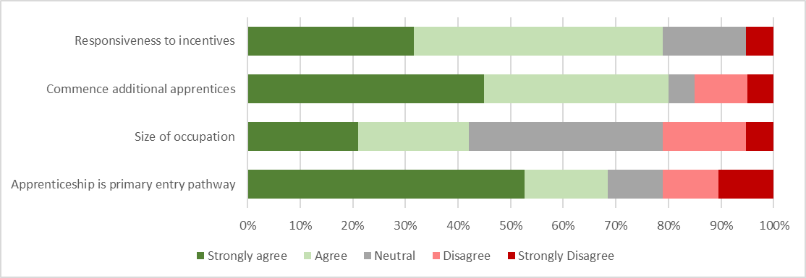

#### Alternative criteria provided by respondents

* Target small businesses.
* Target apprenticeships that can be tailored to entry level and mid-career roles, recognising prior experience and skills that can be transitioned.
* Target industries that have high levels of non-qualified people operating in the specific trade.
* Target industries that require increased levels of diversity.
* The rate of growth of the occupation.
* Target industries/ occupations where there is likely to be a high replacement demand due to an ageing workforce.
* Target occupations where a skills shortage will impact the most other occupations in the supply chain.

#### Skills shortage occupational analysis suggested by respondents

* Employment rates at completion of the apprenticeship.
* Cross-government (Federal and State/ Territory) skills shortage analysis.
* Increased Industry engagement.
* Sentiment analysis of attitudes towards VET and apprenticeships as a career pathway.