

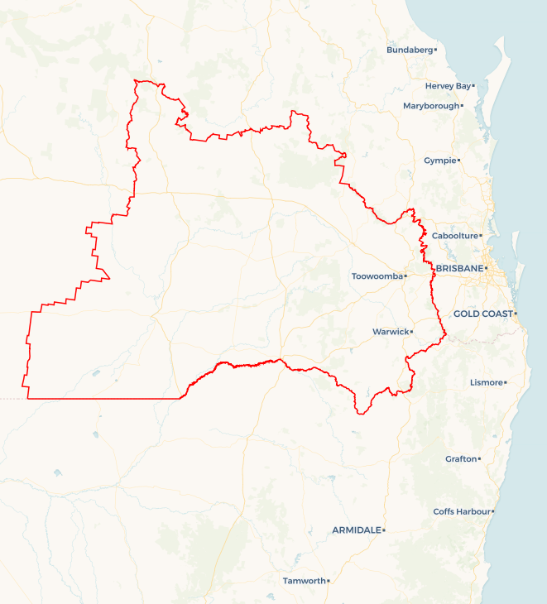Local Jobs Plan

Darling Downs Employment Region | QLD | ****April 2024****

Workforce Australia Local Jobs (Local Jobs) is a program that supports tailored approaches to accelerate   
reskilling, upskilling and employment pathways in response to current and emerging local workforce needs.

## Local Jobs elements

### Local Jobs Plan

The Local Jobs Plan sets out the skills and employment challenges and priorities of the region, and associated strategies that will drive the design and implementation of activities to be implemented to address these challenges.

### Employment Facilitators

Employment Facilitators and Support Officers support the delivery of the program by bringing together key stakeholders including businesses, employment services providers, higher education and training organisations.

### Local Jobs and Skills Taskforce

Each Employment Region has its own Taskforce. Representatives include local stakeholders who have demonstrated experience in upskilling, reskilling, and an ability to represent, connect and collaborate with others in the region to meet labour market needs.

### Local Recovery and National Priority Funds

The Local Recovery Fund supports projects that meet the priorities identified in the Local Jobs Plan. The National Priority Fund provides funding for innovative local solutions to address structural barriers to employment.

Explore labour market insights for   
[Darling Downs](https://www.jobsandskills.gov.au/data/employment-region-dashboards-and-profiles/monthly-labour-market-dashboards) Employment Region

## Local labour market challenges in the region

* The Darling Downs region is geographically one of Australia’s largest Employment Regions, encompassing a variety of regional and rural communities each facing different labour market challenges. Urban Toowoomba in particular, contrasts sharply with rural areas in this regard.
* The region is experiencing high levels of unmet demand for suitably skilled workers in key sectors including health and social care, agriculture, retail, and hospitality. In addition, there is a high demand for construction workforce that is underpinning major infrastructure including renewable energy projects, hospital upgrades and Inland Rail.
* There are significant issues with disengagement, below average workforce participation, and labour market challenges for several cohorts in the region including Indigenous, mature aged, and young people.
* As a major refugee and humanitarian settlement area, the Toowoomba region has a significant Culturally and Linguistically Diverse (CaLD) population who require specialised, tailored assistance to facilitate a smooth transition into Australian society and the local workforce.
* In the region’s rural towns, workforce participation is hampered by   
  below-average school completion rates combined with a lack of diversity of training options available to support language, literacy, numeracy and digital skills. Lack of adequate access to childcare is a significant contributing factor.

## Local jobs and skills priorities and strategies in the region

### Priority 1 – Shortage of suitably skilled workforce in key industry sectors

#### What are our challenges and opportunities?

#### There are high levels of unmet demand for both entry-level and skilled workers in key regional industry sectors including but not limited to: health and social care, agriculture, construction, retail, and hospitality.

#### How are we responding?

* We are working closely with businesses and training providers in the region to ensure local training is aligned with current and future workforce needs.
* We are liaising with business and industry representatives to identify shortages of suitably skilled workers and their specific occupational requirements, so that innovative employment and skilling, up-skilling and re-skilling pathways can be designed and implemented particularly targeting vulnerable and   
  over-represented cohorts on employment services provider caseloads.
* We are engaging with business and industry representatives to develop and refine strategies to assist in recruitment and retention, help develop their knowledge of available workforce and connect them to relevant programs, services, and funding from all levels of government.
* We are fostering relationships between employment services providers and local industry, training, and community stakeholders to ensure Workforce Australia participants have knowledge of, and access to a broad range of opportunities.
* We are working with employment services providers and relevant stakeholders to increase the engagement and retention of trainees and apprentices in alignment with current and projected skills shortages in key industry sectors and assisting with connecting participants for these opportunities.
* We are engaging with both existing and emerging renewable energy industry to develop an understanding of their workforce requirements and facilitate engagement with employment services providers and other relevant regional stakeholders.

### Priority 2 – Indigenous Australians

#### What are our challenges and opportunities?

Indigenous Australians are significantly over-represented on the region’s Workforce Australia caseload. Opportunities exist to support greater inclusion of participants within the local labour market and provide more equitable access to skilling and employment pathways.

#### How are we responding?

* We are working collaboratively with community, Indigenous organisations, and local industry to identify suitable, sustainable employment opportunities for Indigenous participants, and building awareness between stakeholders of the existing suite of programs and services to support Indigenous people.
* We have created an Indigenous Workforce Action Group in collaboration with the National Indigenous Australians Agency and the Queensland Government Department of Treaty, Aboriginal and Torres Strait Islander Partnerships, Communities and the Arts, the purpose of which is to collaborate, design and support delivery of projects that improve employment outcomes for Indigenous Australians.
* We are working with industry and relevant stakeholders to develop and implement strategies and programs that will build businesses cultural competence and to increase recruitment and improve retention of Indigenous Australians, by creating culturally safe workplaces.

### Priority 3 – Mature-Age Australians

#### What are our challenges and opportunities?

Mature age workers (45 years+) make up a significant proportion of Workforce Australia participants in the Darling Downs Employment Region and they are more likely to remain unemployed longer. In addition, successfully encouraging mature age Australians to re-enter the labour force will assist in improving the region’s below-average workforce participation.

#### How are we responding?

* We will work with stakeholders to facilitate pathways for mature age Australians to participate in skilling, re-skilling and upskilling pathways that will improve labour mobility, and further opportunities to re-enter the workforce.
* We are engaging with business and industry to assist in identifying roles that might be suitable for retired, semi-retired, underemployed, volunteer and mature age Australians not participating in the workforce, whilst promoting the benefits of recruiting from this cohort, including utilisation of job carving.
* We will support and develop events and networking opportunities for employment and training suitable for mature age workers, including a focus for women looking to re-enter the workforce.
* We are engaging stakeholders to build awareness of relevant government supports for mature age workers including the Career Transition Assistance and Skills Checkpoint for Older Workers programs.

### Priority 4 – Culturally and Linguistically Diverse (CaLD) people

#### What are our challenges and opportunities?

CaLD communities face extra challenges in securing work due to lower language, literacy, numeracy, and digital skills. Additionally, our region is a major humanitarian settlement area, where recent arrivals of predominantly Yazidi people from Iraq and Syria has resulted in Kurdish Kurmanji being the second most common language spoken in Toowoomba. This community is vulnerable due to lower levels of educability, experiences of torture and trauma, and other challenges in adjusting to the Australian workplace.

#### How are we responding?

* We will conduct Migrant and Refugee Employment Roundtables with participation from migrants and refugees, community leaders, employment and training stakeholders, community-based organisations, and all levels of government, with a focus on identifying gaps, sharing best practice, and collaborating to enhance delivery of employment and skilling pathways targeting our migrant communities.
* We are creating stronger links between businesses, employment services providers, training organisations and migrant and refugee community leaders to foster better understanding of challenges, promote the benefits of workforce diversity, improve recruitment and retention, and build awareness of relevant programs and services.

### Priority 5 – People with a Disability

#### What are our challenges and opportunities?

People with disabilities make a valuable contribution to our workforce. However, they often face significant challenges to employment, including discriminatory recruitment practices, inflexible working arrangements, and limited access to transport. A significant proportion of Workforce Australia participants identify as individuals with a disability, and many remain unemployed longer. Supporting greater inclusion of people with disabilities in the labour market has economic and social benefits, including a more diverse workforce and increased participation.

#### How are we responding?

* We are establishing a Disability Employment Taskforce to investigate and develop place-based initiatives to reduce labour market challenges for people with disabilities.
* We will facilitate collaboration between businesses, training providers, and other stakeholders including Workforce Australia Provider Services, Disability Employment Services, and other relevant government programs and supports. This collaboration will encourage them to work together to improve training and employment outcomes for people with a disability.
* We will engage with local businesses to identify and increase suitable employment opportunities for individuals with disabilities, share best practices for creating inclusive workplaces, and advocate for flexible work arrangements and workplace adjustments where appropriate.

## Want to know more?

* Contact: David New, Darling Downs Employment Region Employment Facilitator: facilitator@ddlocaljobs.com.au
* Visit: [Local Jobs](https://www.dewr.gov.au/local-jobs) or [Workforce Australia](https://www.workforceaustralia.gov.au/)