

Department of Employment and Workplace Relations Data Strategy

2024-2027

Creative Commons

With the exception of the Commonwealth Coat of Arms, the Department’s logo, any material protected by a trade mark and where otherwise noted all material presented in this document is provided under a [Creative Commons Attribution 4.0 International](https://creativecommons.org/licenses/by/4.0/) (https://creativecommons.org/licenses/by/4.0/) licence.

The details of the relevant licence conditions are available on the Creative Commons website (accessible using the links provided) as is the full legal code for the [CC BY 4.0 International](https://creativecommons.org/licenses/by/4.0/legalcode) (https://creativecommons.org/licenses/by/4.0/legalcode)

The document must be attributed as the (Department of Employment and Workplace Relations Data Strategy).

Contents

Acknowledgement of country 4

Message from the Chief Data Officer 5

Purpose of the Strategy 6

Approach to Decision Making 7

Approach to Data Analytics 9

Approach to Data Sharing 10

Approach to Data Capability 11

Data Organisational Model 12

Building on our Data Governance Foundations 14

Enhancing our Data Capability 15

Driving our Data Technology Ethically 16

Transforming our Data Analytics, Evaluation & Integration 17

Implementation Roadmap 18

Data Governance Framework 18

More information 18

# Acknowledgement of country

The Department respectively acknowledges the traditional owners and custodians of country throughout Australia. We acknowledge all traditional custodians, their Elders past, present and emerging and we pay our respects to their continuing connection to their culture, community, land, sea, and rivers.

# Message from the Chief Data Officer

I am excited to be the Department of Employment and Workplace Relations (DEWR) first Chief Data Officer (CDO). It is a new data leadership role for the Department, and in collaboration with my colleagues, I look forward to leading the effective and efficient use of data and data-related activities across the Department and the wider government landscape.

Data[1] facilitates us to make informed decisions in all aspects of our business, from understanding our clients, enhancing our services, and improving our operations. Insights gained from data needs to be at the forefront of policy development and evaluation. Therefore, we need to set clear goals for how we prioritise, govern and use data. Our Data Strategy outlines the future state for how we want to collect, manage, and use data, enabling us to answer new and complex questions, while expanding our knowledge, and informing decisions.

The Data Strategy alone does not deliver the necessary improvements in how we use and adopt data in support of the Department’s objectives. These changes require the support and contribution from everyone within the Department—from APS staff to our senior executives. A Data Strategy Implementation Roadmap, developed in consultation with key stakeholders, complements the Data Strategy. The Roadmap sets timelines, resourcing, allocates roles and responsibilities for each element of the Data Strategy. It provides the overarching structure for the implementation of the Data strategy initiatives and measure its success.

As the department’s CDO, I will actively promote and champion the implementation of the Data Strategy.

Jenny Humphrys

Chief Data Officer

# Purpose of the Strategy

The Department of Employment and Workplace Relation Data Strategy outlines the framework in which we will direct and manage our resources to achieve our vision for data.

The Strategy sets the strategic direction for the Department’s data governance, capability, and technology to transform our data analysis, evaluation, and integration.

The Strategy aligns with the [Data and Digital Government Strategy](https://www.dataanddigital.gov.au/strategy) and the Australian Government APS reform agenda, and compliments our Department’s Corporate, People and Digital Business Strategies.

The Strategy enhances our data sharing approaches and expands on our data analysis capability beyond descriptive statistics, while maintaining the public’s trust in our use and storage of their personal information.

The Strategy supports the Department’s use of our data assets enabling data empowered policy development, program management and evaluation.

This strategy ensures our department empowers and values data now and into the future, with trusted and efficient data processes, enabling our staff can confidently use data to influence policy and decisions.

# Approach to Decision Making

The amount of data collected and released is growing exponentially, with 90% of the worlds data generated in the past two years. The sheer volume of data the department encounters can make decision-making more complicated – DEWR holds data on over 350 thousand apprentices, over 500 thousand people assisted by Workforce Australia, and 7.5 thousand enterprise agreements covering 1.3 million employees. With an abundance of information at our fingertips, we can find ourselves inundated and paralysed by data overload. It is not about producing more data points or publishing more datasets. This strategy aims to reduce duplication while adhering to our legal and ethical obligations.

It is not about producing more data points, or publishing more datasets, this Strategy focuses us to make sure we are using appropriate data that has right level of quality for the purpose.

This approach is consistent with the DEWR Digital Business Strategy which outlines the future state of being Data Driven – having the relevant information relevant at the right time.

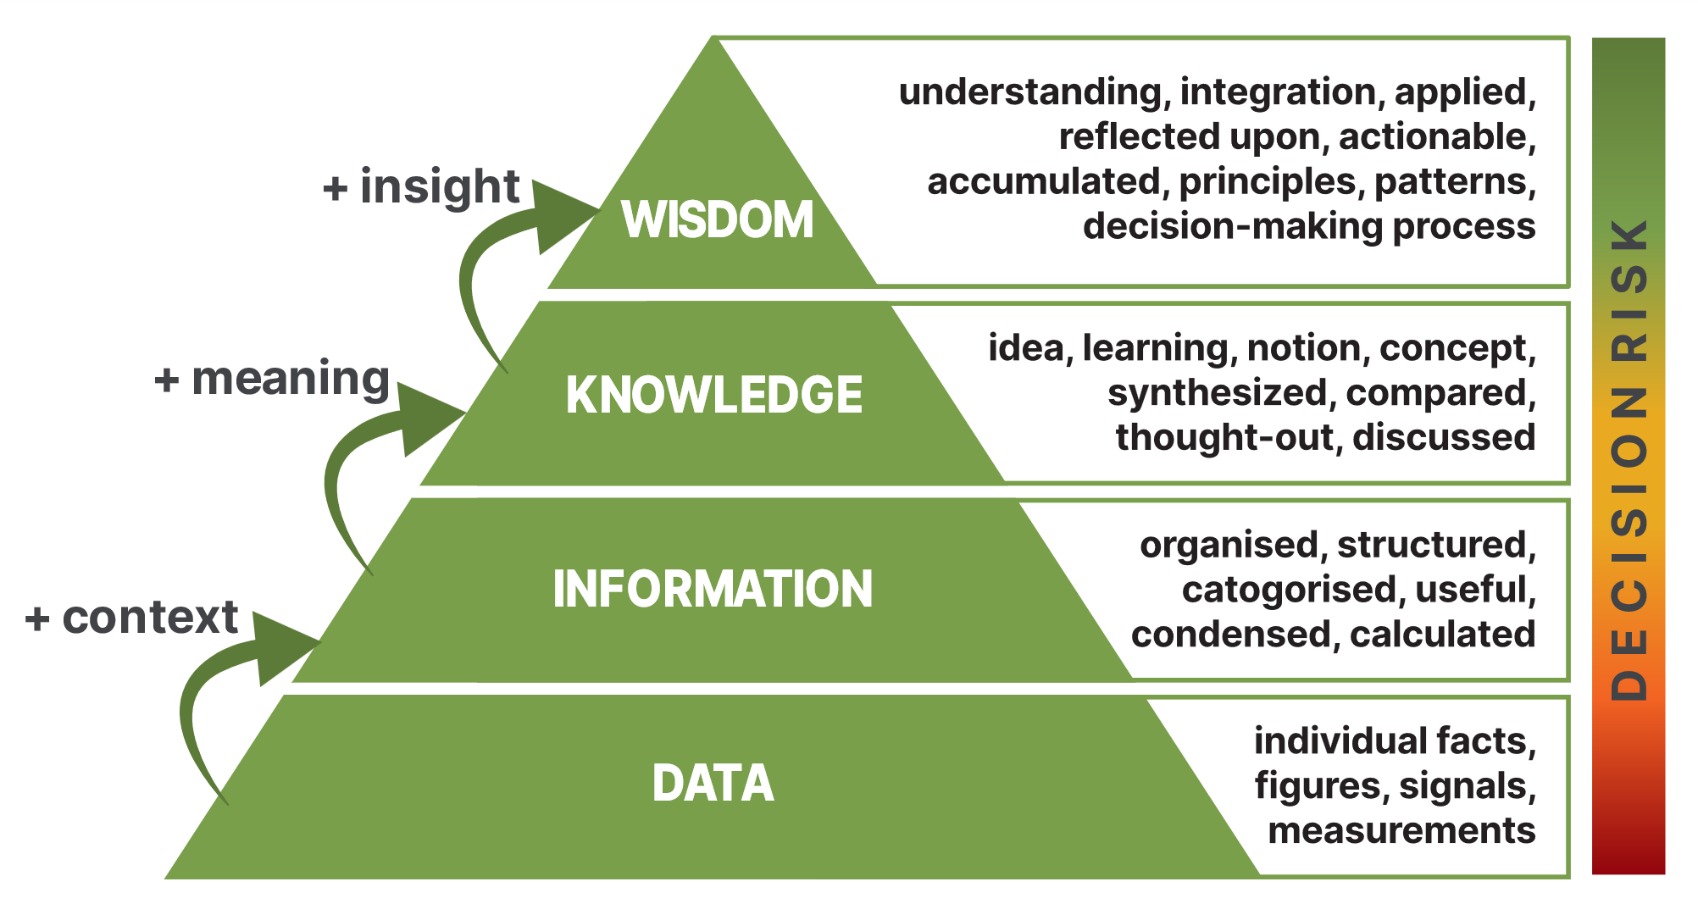

Low

High

The Department is taking a strategic approach to collecting and using data to support   
decision-making by:

* **Defining clear objectives**: Before delving into data analysis, we need to clearly define our decision-making objectives, enabling us to focus on the relevant data points and avoid getting lost in the sea of information.
* **Understanding the data**: When using data to make decisions we understand the data content and metadata. We consider the strengths and weaknesses of our data assets and ensure the data is appropriate for the purpose.
* **Embracing automation and Artificial Intelligence[2]**: We leverage automation and AI technologies to streamline data analysis. Automated processes can help identify patterns, trends, and anomalies, enabling us to make data-backed decisions in a more-timely manner. We will use tools and technologies that enable efficient data organisation, categorisation, and visualisation to enhance decision-making processes.

We have developed this data strategy to help us manage the influx of data efficiently and effectively. The data strategy aims to lift our decision-making maturity from using data and information, to drawing on knowledge and wisdom.

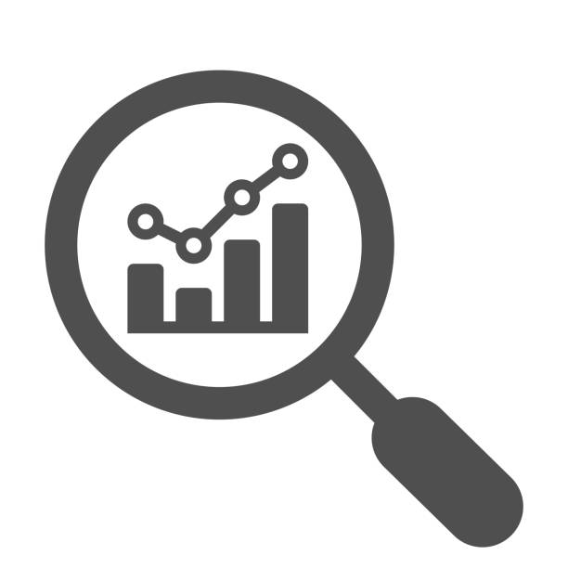**Our commitment**

We will avoid data overload by focusing on the right data, at the right time, to make the right decisions.

# Approach to Data Analytics

When analysing data there are four common approaches to analytics:

* **Descriptive**, which answers the question, “What happened?”

Descriptive analytics is the process of using current and historical data to identify trends and relationships. It’s sometimes called the simplest form of data analysis because it describes trends and relationships but doesn’t dig deeper.

* **Diagnostic**, which answers the question, “Why did this happen?”

Diagnostic analytics is the process of using data to determine the causes of trends and correlations between variables. It can be viewed as a logical next step after using descriptive analytics to identify trends.

* **Prescriptive**, which answers the question, “What should we do next?”

Prescriptive analytics is the process of using data to determine an optimal course of action. By considering all relevant factors, this type of analysis yields recommendations for next steps. Because of this, prescriptive analytics is a valuable tool for data empowered decision-making.

* **Predictive**, which answers the question, “What might happen in the future?”

The ability to predict future events and trends is crucial across labour market. Predictive analytics is the use of data to predict future trends and events. It uses historical data to forecast potential scenarios that can help drive strategic decisions.

Our data strategy aims to move us from descriptive analysis to diagnostic and prescriptive analysis with a goal of predictive analysis. However, we recognise the purpose of the analysis will underpin the type of analytics undertaken, and that descriptive analysis will always be valid.

**Our commitment**

Descriptive analysis is valued - but diagnostic, prescriptive, and predictive analysis is our data future.

# Approach to Data Sharing

Sharing and releasing data is critical to enhance the value of the data that we and our partners hold.

*The Government’s APS reform agenda outlines its commitment to use data better – ensuring the APS has the right capability, tools, and processes to securely use, share and understand data and other sources of information for better policy advice, regulation, and services*.[3]

By making our data safely, legally, and ethically available, we will build the capacity of all our partners and external stakeholders to understand, improve and optimise the use of data and evidence to support Australians to have safe, secure, and well-paid work with the skills for a sustainable future.

The data may be available through direct source or through other channels such as the ABS Person Level Integrated Data Asset (PLIDA) and Australian National Data Integration Infrastructure (ANDII).

A culture that supports data sharing, with appropriate guardrails[4], will build momentum towards linking data across the life journey to better understand how the labour market is performing and where we can make improvements.

By having trusted and efficient policies and processes in place, our staff can confidently make data available to others to influence policy and decisions, whilst maintaining privacy and confidentiality.

**Our commitment**

We will say yes to data release, sharing and use, unless there is a good reason to say no.

# Approach to Data Capability

Working with the APS Data Capability Framework and in alignment with the APS Data Professional Stream Strategy[5], we will uplift our staff’s data capabilities by clearly defining our required data capabilities, increasing diversity and mobility of people in data roles, and creating career pathways and development opportunities.

We aim to attract, develop, and retain the data capabilities required to harness the unprecedented growth in the availability and value of data.

*Ensuring the Australian Public Service (APS) has the right capabilities to use data is a key enabler to government leveraging the benefits of data and delivering quality services and outcomes to Australians.[6]*

This approach emphasises our responsibility for all DEWR Senior Executive Service (SES) to *encourage and motivate people to engage in continuous learning to increase baseline data skills.[7]*

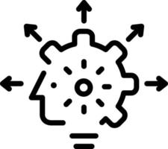**Our commitment**

It is our expectation that everyone in the Department has some data literacy and data confidence.

# Data Organisational Model

The Department has committed to data as a priority by establishing a Chief Data Officer. This role will be further supported by the implementation of a Data Hub and Spoke organisational model to implement the data strategy.

The data hub-and-spoke model enables a centralized “data hub” to promote data best practices, the development of data strategies and policies, and managing strategic data projects. The “data spokes” are teams located with the business streams, focusing on producing data services within their data specialty consistent with the data priorities and policies.

The data hub and spoke model is a wheel, we are only as strong as our weakest link. The data organisational model supports all staff to do more with data, where everyone one has a part to play in using data efficiently and effectively to deliver on our data vision.

Picture 1: DEWR’s Hub and Spoke Model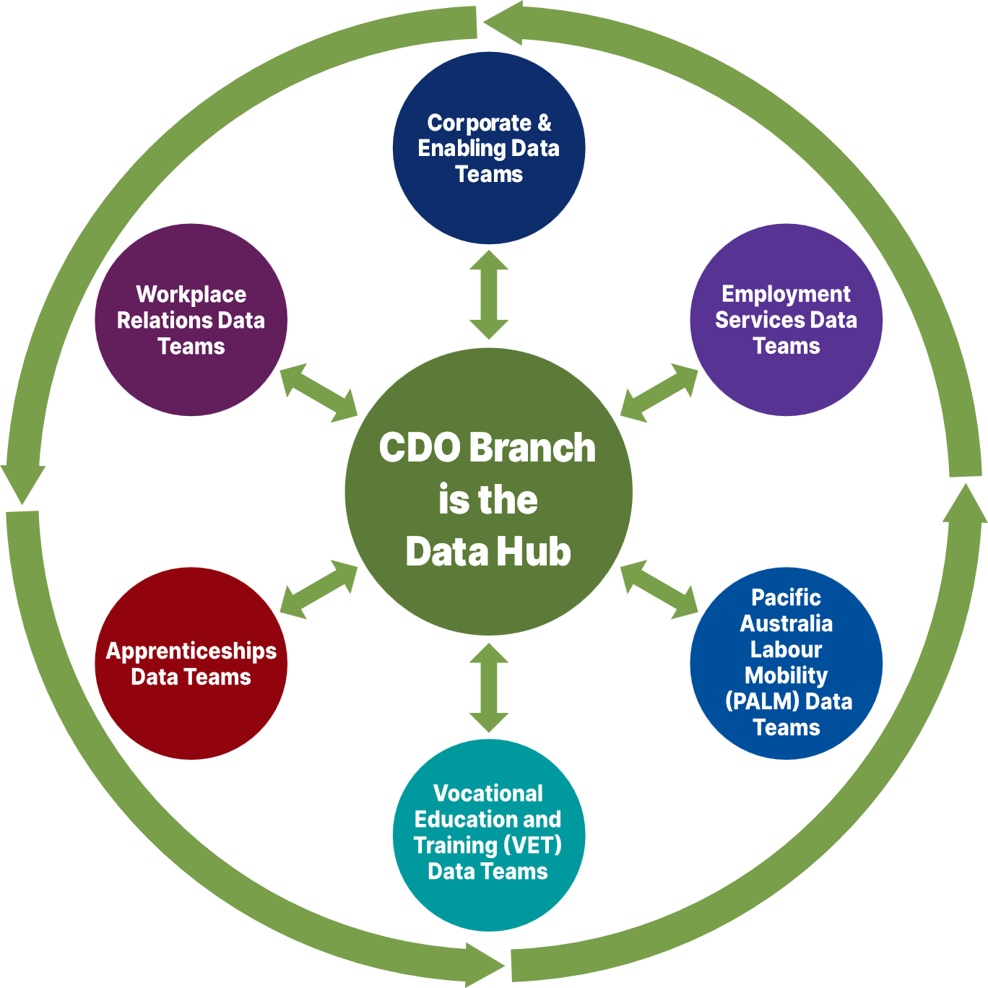Diagram describing DEWR data priorities to deliver on Data Vision and Data culture with four components. Refer to body text.


|  |  |  |  |  |  |
| --- | --- | --- | --- | --- | --- |
| Building on our Data Governance Foundations To fully realise the value of our data, and the insights our data can provide, we need to sure up our *Data Foundations*.  **Aims:**   * Transparent accountability and oversight of our data management practices. * Clear articulation of our data policies, procedures and standards used to manage our data assets. * Documentation of data capture, management, and quality, ensuring trust in our use and storage of data. * All staff understand their privacy responsibilities and how they relate to data. | **DEWR’s future state**   * All staff understand their data roles, responsibilities of our data management practice, including an understanding privacy obligations and ethical data use. * Data policies, procedures, and standards, are developed, clearly articulated, shared, and used by all to manage our data assets. * The Department is prepared for the Data Availability and Transparency Act, becoming an accredited user, and using the Office of the National Data Commissioner’s (ONDC) DataPlace. * The Department actively contributes to Whole of Government data initiatives, such as Closing the Gap Priority Reform 4, gender statistics and disability data in a coordinated and considered way.   **Implementation priorities**   | **Delivery in 2024** | **Delivery in 2025+** | | --- | --- | | * Data Governance Framework * Data Governance Committee * Data Policies and Procedures * Data Standards * DAT Act preparations * Data Assets * Data Maturity Assessment * Data Sharing | * Data Policies and Procedures * Data Standards * Metadata * Data Sharing * Data Maturity Assessment * Data Assets * DAT Act | |

|  |  |  |  |  |  |
| --- | --- | --- | --- | --- | --- |
| Enhancing our Data Capability Create staff capability enabling an embedded culture of data curiosity.  **Aims:**   * Contributing to APS Data Profession initiatives. * Promotion of a *Data Capability week.* * Supporting staff to undertake data‑centric training. * Proactively attract and retain staff with highly sought after data skills. | **DEWR’s future state**   * All staff have confidence and capability to data to support their day-to-day decision making, including policy development, program management and service delivery. * Data and insights are readily accessible, easy to find and used by all staff. * The Department have staff with the appropriate skills to fully use integrated data assets enabling data empowered decision making. * Collaborating with, and influencing other agencies, streamline access to integrated data, enabling more timely analysis to inform policy development and program management. * The Department continues to attract highly skilled staff, including data specialists. * The Department continues to invest in and encourage staff to further their data capabilities, from Communities of Practice and presentations through the Data Analytics Network through to university courses such as a Masters in Analytics or Data Science. * Staff can safely and securely use data, while protecting and respecting the privacy of individuals. * Effective leadership inspires and promotes the responsible and ethical use of data.   **Implementation priorities**   | **Delivery in 2024** | **Delivery in 2025+** | | --- | --- | | * Data Capability Week * Data Graduate Training * Data Leaders/Data specialist training * Non-data staff – data training * Data Analyst Network | * Data Workforce Strategy * Data Capability Week * Data Graduate Training * Data Leaders/Data specialist training * Non-data staff – data training * Data Professions | |
| Driving our Data  Technology Ethically Data holdings are secure, while enabling staff to safely and securely access the tools and infrastructure needed to maximise the value of our data.  **Aims:**   * Optimising our data platforms for  efficient multiple use. * Keeping pace with best practice data storage, processing, and analytical systems. * Our approaches to data technology influence APS policies and practices. * Ongoing commitment to the security/protection of our data. | **DEWR’s future state**   * Ensure the Department’s technology and systems support all aspects of the data lifecycle. * Engage in the use of cutting-edge data analytics, infrastructure, and tools, enhancing the use of data for real-time decision making within the Department and the broader community. * Curate, and share the Department’s data externally, enhancing public benefit, where it is safe, legal, and ethical to do so, while protecting the privacy of individuals. * Explore the transparent use of Artificial Intelligence to aid government decision making. * Work in conjunction with the Department’s ICT strategy 2020-2023 (or future iteration) and the Joint Cyber Security Strategy 2023-2026.   **Implementation priorities**   | **Delivery in 2024** | **Delivery in 2025+** | | --- | --- | | * Data Platform Strategy * Data, Digital and AI Ethics Policy * Data Retention & Disposal Policy * Data Quality Improvement * Data Stewardship Program * Artificial Intelligence Trial | * Data Asset technology Assessment * Data Quality Improvement * Data Stewardship Program * Artificial Intelligence Trial | |

# 

|  |  |  |  |  |  |
| --- | --- | --- | --- | --- | --- |
| Transforming our  Data Analytics, Evaluation  & Integration Maximise the safe, legal, and ethical release, sharing and use of our data.  **Aims**:   * Making greater use of our data assets. * Open and consistent data sharing to deliver outcomes for government. * The Department is an active leader in whole of government data initiatives. | **DEWR’s future state**   * Expand discoverability, accessibility, and useability of our quality data products, enabling timely and effective analytics, and evidence-based insights through the redevelopment of the data intranet page. * Working collaboratively across the Department, enhancing our range of data products, analytics, and insights to readily answer questions from the Minister’s offices and other interested parties, influencing decisions. * Empower change through responsible data use, fostering innovation and inclusivity, creating a resilient labour market. * Expand our use of integrated data assets to influence program evaluation and design, feeding into actionable insights. * Increase our contributions of data to Whole-of-Government integrated data assets, such as Personal Level Integrated Data Asset (PLIDA) or the National Disability Data Asset (NDDA). * Work across Government, including the Centre for Evaluation, influencing, and sharing program evaluation experiences and techniques, for the benefit of the Australian public.   **Implementing priorities**   | **Delivery in 2024** | **Delivery in 2025+** | | --- | --- | | * Dashboards * Closing the Gap Implementation Plan * Disability Data Improvement Plan * Gender Statistics Improvement Plan * Data Publication Plan * Location Data Standardisation * Managers Dashboard | * Data Analytics Framework * Dashboards * Closing the Gap Implementation Plan * Disability Data Improvement Plan * Gender Statistics Improvement Plan * Location Data Standardisation * Managers Dashboard | |

# Implementation Roadmap

The Data Strategy Implementation Roadmap outlines the detailed work required to implement the Department’s Data Strategy.

The roadmap incorporates key focus areas and related activities that support how we manage and use data, while providing a baseline of priorities and indicative timeframes of work, subject to resource availability, strategic planning and whole of government priorities.

The Data Governance Committee will receive regular updates on progress, with an annual refresh of the roadmap.

# Data Governance Framework

The Data Governance Framework supports the Department’s Data Strategy by articulating our data governance structures, roles and responsibilities, supporting everyone within the Department to implement data management policies and processes, working collaboratively to implement the Data Strategy.

# More information

For more information on the data strategy and the roadmap, please contact us at [data@dewr.gov.au](mailto:data@dewr.gov.au).

1. Data: any information in a form capable of being communicated, analysed or processed (whether by an individual or by computer or other automated means).
2. For example, Parlihelper which summarises Senate Estimates discussions, or the expansion of the use of interactive dashboards, enabling faster decision making.
3. Commonwealth of Australia, Department of the Prime Minister and Cabinet, Delivering for Australians, 2019.
4. [Data sharing factsheets | Department of Finance](https://www.finance.gov.au/government/public-data/data-sharing-factsheets)
5. [APS Data Professional Stream Strategy (apsc.gov.au)](https://www.apsc.gov.au/sites/default/files/2020-12/aps_data_professional_strategy_0.pdf)
6. [APS Data Capability Framework – User Guide | Australian Public Service Commission (apsc.gov.au)](https://www.apsc.gov.au/publication/aps-data-capability-framework/aps-data-capability-framework-user-guide)
7. Building Strong SES Accountability for Data (PM&C Deputy Secretaries Data Group Project)