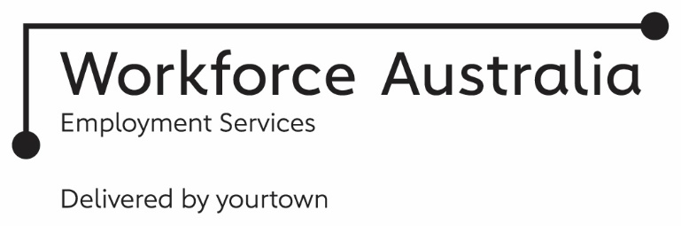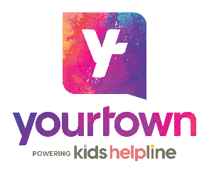
TRANSITION TO WORK
Service Delivery Plan – Members
At yourtown, we understand everyone is unique and so is your journey to finding work.
It’s why we put you at the centre of what we do. We are more than just an Employment Service.
As specialists in youth employment, we will listen to you and provide a personalised and flexible service that is based around your needs. Our youth-friendly Transition to Work teams work alongside young people aged 15 to 24 and provide practical support to secure a job, complemented by education or training. We respond to your needs by building your employability skills and developing your strengths to achieve your aspirations.
Access to Practical Support
Building on our linkages with local employers, we aim to match you with your preferred employment pathway. Our flexible support fund can ease the financial pressure of looking for and starting work, including specific work-related costs.
Create your own experience
It’s all about personalising your journey around you from choosing your Job Placement Coach, through to how you’d like to connect with us.
Unlock your potential
Opportunities to upskill through training; develop your employability and life skills through workshops; and participate in ‘on the job’ tasters through work experience.
Have your say
Your opinion is important to us! We take the time to listen to issues that matter to you through our youth participation opportunities which can inform our decision making and influence change.
Increase your skillset
Education pathways to increase your readiness for work by equipping you with skills for now and into your future!
Boost your work readiness
We strive to match you with the right tools and support relevant to where you are at on your job search journey. Within a month you’ll have a resume you’ll be proud of!
Accessible
- Our full-time sites* are also open Thursday nights to allow you to choose how & when you engage
- Easy to access as we’re close to public transport
- Help for you to connect; free WiFi access, device charging stations & fully stocked kitchens
- Quiet zones & study spaces for when you need some time to yourself
- Priority access to a Kids Helpline counsellor through the yourtown 24/7 helpline
- There’s no wrong door at yourtown. Connecting you seamlessly with other yourtown services, creating a network of support
- Opportunity to engage in supportive youth-led conversations about employment and wellbeing on the free, safe and confidential social platform, My Circle
*check the website for your local site opening hours
Safe
- Whether you connect in person or virtually, your privacy and safety is important to us
- Every yourtown site is a safe place where you can be yourself
- We treat all young people with dignity, compassion and respect
Empowering
- Belief in your potential and support to map your own future
- Respect and elevate your unique strengths
- Work alongside you to initiate change and cultivate self-confidence
- Ongoing trust and encouragement to achieve your vision
YOUTH PARTICIPATION
MENTAL HEALTH & WELLBEING SUPPORT
SOCIAL ACTIVITIES
Unlocking your Potential
- We take the time to get to know you & your story
- Recognise your strengths & vision for the future
- Discover your local education & employment pathways
- A job plan personalised to your goals, & support for any challenges
Employability & Life Skills
- Career exploration sessions with our experienced Job Coaches
- Culturally responsive support from Indigenous Employment Coaches
- Interactive workshops delivered virtually & face-to-face
Upskilling Opportunities
- Training courses aligned to your career aspirations
- Explore options to achieve Year 12 or equivalent
- Regular check-ins, mentoring & support while you study
- Develop ‘on the job’ skills through work experience opportunities
Overcoming Life Challenges
- On-site mental health & wellbeing support from counsellors & youth workers
- Referrals to appropriate yourtown & local services
- A peer support social platform about wellbeing & employment
- Prioritised telehealth & online support from yourtown 24/7
Achieving your Employment Goals
- Specialised resume services, career advice & supported jobsearch
- Flexible support fund to equip you for study, interviews & work
- Matching you with the right employer
- Interview guidance & practice
Member Care
- In-work mentoring & support when you gain work
- Help to navigate the world of work
- Practical support to help you succeed in the workplace
- Relevant training to boost skills & confidence for your new role
Our Community is Your Community
We work alongside & connect with…
- Employers
- Schools, Education Providers & RTOs
- Specialised Supports
- Mental Health Services
- Elders and Cultural Networks
- Local Community Organisations
- Other Employment Services providers & Government Initiatives
Our Locations
Wide Bay
Bundaberg
Childers
Kingaroy
Pialba
Brisbane South East
Browns Plains
Kingston
Upper Mt Gravatt
yourtown acknowledges the Traditional Custodians of Country of the lands on which we work, the Yuggera/Jagera/Yugarabul, Yugambeh regions and throughout Australia. We recognise their continuing connection to the land and their waterways. We pay our respects to them, their culture and their Elders; past, present and emerging.
Connect With Us
1300 001 015
yourtown.com.au/member
ttw@yourtown.com.au

