

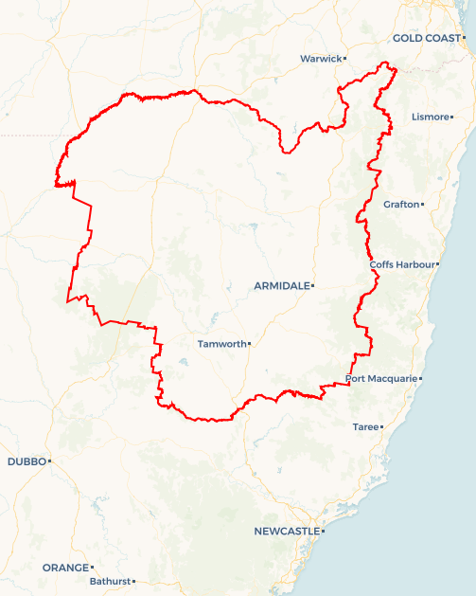Local Jobs Plan

New England and North West | NSW | ****January 2024****

Workforce Australia Local Jobs (Local Jobs) is a program that supports tailored approaches to accelerate   
reskilling, upskilling and employment pathways in response to current and emerging local workforce needs.

## Local Jobs elements

### Local Jobs Plan

The Local Jobs Plan sets out the skills and employment challenges and priorities of the region, and associated strategies that will drive the design and implementation of activities to be implemented to address these challenges.

### Employment Facilitators

Employment Facilitators and Support Officers support the delivery of the program by bringing together key stakeholders including businesses, employment services providers, higher education, and training organisations.

### Local Jobs and Skills Taskforce

Each Employment Region has its own Taskforce. Representatives include local stakeholders who have demonstrated experience in upskilling, reskilling, and an ability to represent, connect and collaborate with others in the region to meet labour market needs.

### Local Recovery and National Priority Funds

The Local Recovery Fund supports projects that meet the priorities identified in the Local Jobs Plan. The National Priority Fund provides funding for innovative local solutions to address structural barriers to employment.

Explore labour market insights for the   
[New England and North West](https://www.jobsandskills.gov.au/data/employment-region-dashboards-and-profiles/monthly-labour-market-dashboards) Employment Region

## Local labour market challenges in the region

* Limited public transport in most towns across the region, with very few reliable and/or frequent public transport options available for individuals residing outside of the major centres of Tamworth and Armidale.
* The region relies heavily on seasonal work due to the predominance of agricultural businesses. Agricultural employment in the region has been impacted by unpredictable weather events such as drought, bushfires, floods, and pests, as well as seasonal workforce challenges. When industries which usually employ seasonally are affected by drought or other natural disasters, workers for these roles find it difficult to transition to other industries.
* There are limited vocational training opportunities in the region which contribute to a discrepancy between the skills businesses are seeking and the skills local people have.
* The region has a disproportionately high number of Indigenous Australians, with many of these individuals in the 16-24 years age range.
* Sectors including construction, meat processing, IT, childcare, aged care, and disability services report difficulties in finding suitably skilled and qualified staff with training delivery limited in some localities.
* Further constraints include access to housing, transport and childcare across the region, exacerbated by the proximity of major projects including mining, gas, and infrastructure.

## Local jobs and skills priorities and strategies in the region

### Priority 1 – Indigenous Australians

#### What are our challenges and opportunities?

There are a limited range of culturally appropriate, sustainable programs and employment models to address the systemic inequity faced by Indigenous Australians in the region. The connection of multiple stakeholders continues to be challenging in addressing this need and will require stronger engagement with the Indigenous community through elders, cultural consultants, and Local Aboriginal Lands Councils to develop strategies to address.

#### How are we responding?

* Supporting equitable access to the local labour market for Indigenous Australians by building clearer pathways to employment and training opportunities.
* Providing culturally appropriate integrated supports to individuals over the longer term.
* Ensuring Indigenous Australians are included in the design of activities developed to meet Local Jobs priorities.

### Priority 2 – Youth

#### What are our challenges and opportunities?

There is a disconnect between schools, businesses, and training organisations, which prevents specific employment and training opportunities being communicated to participants in a timely manner. We have an opportunity to create pathways to employment and training for young people, which includes more visibility of, and streamlined access to, local employment and training options.

#### How are we responding?

* Maximising local workforce participation and employment for youth, by developing strategies to enhance access of participants to employment and training opportunities.
* Aligning local transport solutions.
* Focusing on broader participant needs to further generate opportunities for skills development, better aligning local labour market needs including apprenticeships, traineeships, and skills training in partnership with local skills brokers, tertiary education providers and businesses.
* Ensuring young people are included in the design of activities developed to meet Local Jobs priorities.

### Priority 3 – Health Care and Social Assistance

#### What are our challenges and opportunities?

The region requires stronger pathways to meet employer needs in healthcare, aged care, individual support, and child care. This includes the development of tools that provide more visibility and streamlined access to local employment and training opportunities, including introduction to micro-credentialling and traineeships.

#### How are we responding?

* Continuing to promote Australian Government initiatives, connecting with NSW Skills Brokers and local businesses to leverage key partnerships facilitating reskilling and upskilling of participants into healthcare and support sectors.
* Continuing to collaborate with healthcare and social assistance businesses, organisations, and stakeholders to develop campaigns raising awareness of employment opportunities.
* Building a job-ready workforce through observational work experience, pre-employment training and job readiness programs to support the aged, disability, community and childcare sectors.
* Generating awareness of career pathways available in the sector (particularly for youth) and linking employment with traineeships and apprenticeships opportunities to showcase the variety of jobs and careers on offer.
* Ensuring consumers, participants and industry stakeholders are included in the design of activities developed to meet Local Jobs priorities.

### Priority 4 – Manufacturing and Construction

#### What are our challenges and opportunities?

Build a job-ready and skilled workforce to capitalise on the manufacturing and construction sector growth, including infrastructure projects. The region requires stronger business connections to the available workforce to address the challenging labour and skills shortages.

#### How are we responding?

* Collaborate with businesses to build stronger pathways to employment in the region’s construction projects. This includes the development of tools that provide more visibility and streamlined access to local employment and training opportunities and development of pre-employment programs leading to sustainable employment.
* Work with businesses and training providers to ensure future workforce needs are aligned with courses and training available through Workforce Australia.
* Explore opportunities for integrating manufacturing and construction businesses with localised infrastructure projects.

**Priority 5 – Net Zero Transition**

**What are our challenges and opportunities?**

Meeting Net Zero targets will change the nature of jobs across a broad range of sectors. There will be opportunities for high quality work in renewables, electricity networks and energy performance across utilities, agriculture, mining and transport. Waste reduction and circular economy initiatives that are tailored to the opportunities and challenges faced in managing waste and creating economic and employment opportunities at regional scales will also be crucial in meeting Net Zero targets.

**How are we responding?**

* Co-designing with business groups and industry on specific pre-employment and pre-vocational training.
* Focus on strong collaboration with businesses to build these pathways.
* Enable place-based regional initiatives through strong linkages with regional associations and regional industries and sectors.
* Investing in local initiatives to generate new job opportunities through economic diversification and emergent markets.

**Priority 6 – Art, Culture and Tourism**

**What are our challenges and opportunities?**

Creative industries are an input to many, if not all industries. Arts and cultural programs drive many regional tourism strategies, with many Local Government Areas in the region identifying tourism as a key aspect of drought proofing local economies. Creative roles are often more accessible for people with complex barriers and can provide opportunity for self-employment.

**How are we responding?**

* Co-designing with business groups and industry on specific pre-employment and pre-vocational training.
* Create career development opportunities and explore partnerships.
* Establish partnerships to enhance professional skills and career development.

#### Want to know more?

* Contact: Kate McGrath, New England and North West Employment Facilitator: kate@nenwfacilitator.com.au
* Visit: [Local Jobs](https://www.dewr.gov.au/local-jobs) or [Workforce Australia](https://www.workforceaustralia.gov.au/)