

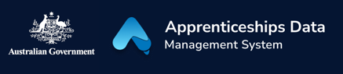Fact Sheet: Checking the Status of a BAC or CAC Claim Application

This fact sheet will show you how you can check the status of your Boosting Apprenticeship Commencements (BAC) or Completing Apprenticeship Commencements (CAC) wage subsidy claim application. It will also explain what each status means.

# Checking statuses in ADMS

To check on the status of a BAC or CAC wage subsidy claim application, you will first need to log in to ADMS. For help with logging into ADMS, visit [australianapprenticeships.gov.au/about-adms](https://www.australianapprenticeships.gov.au/about-adms).

After you have logged in to ADMS, you will see the ADMS home page. From the home page, click the large button labelled “Process BAC/CAC applications” in the Actions section of the home screen.

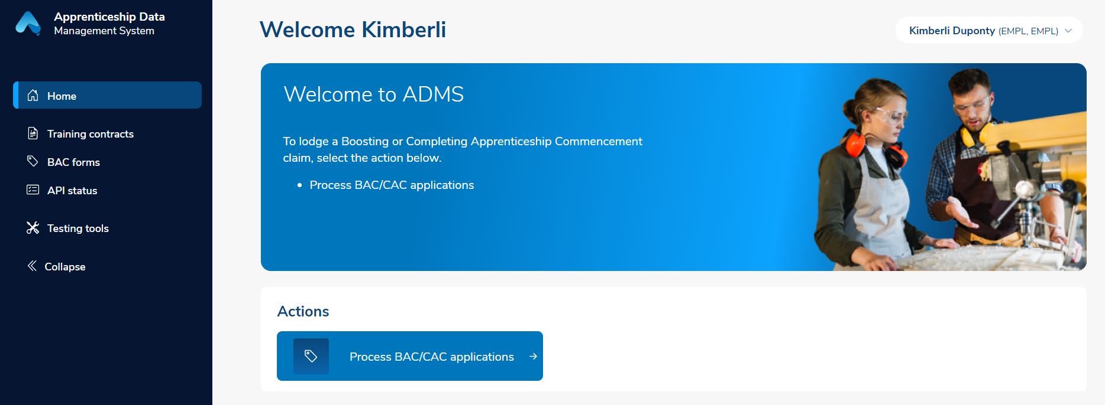

# BAC/CAC claim application list

The BAC/CAC claim application list displays all available claims for your business. For each claim you can check the status column to see how the claim is progressing.

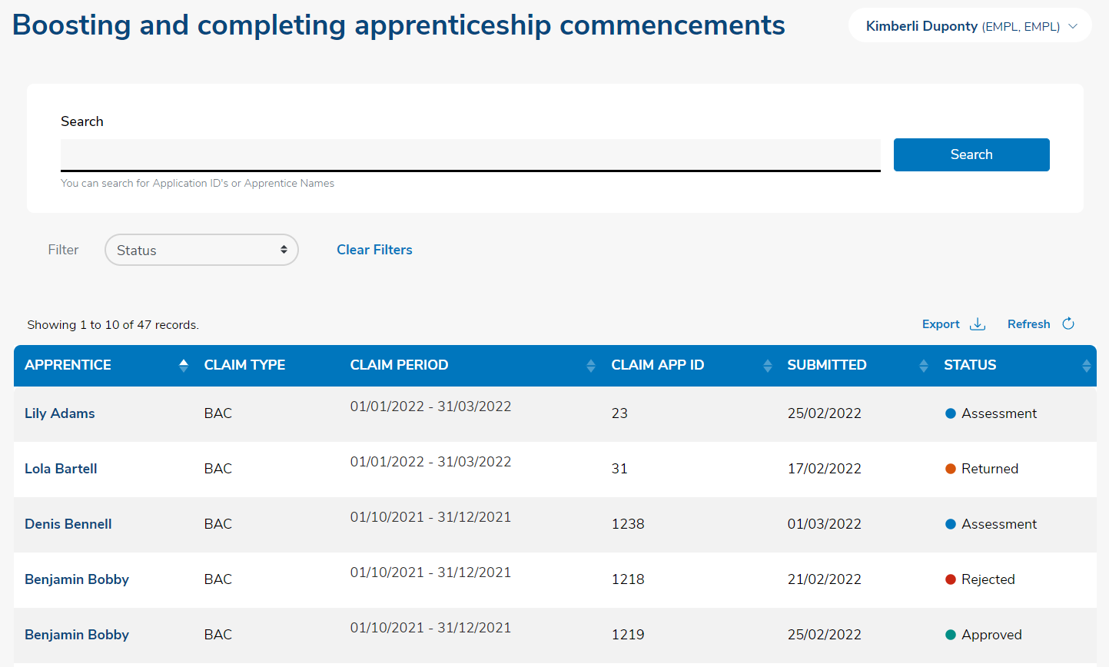

The status of your claim may show as one of the following:

|  |  |
| --- | --- |
| Status | Description |
| Ready | A claim application is available for you to begin. The claim will remain in Ready status until you save the information you have entered. |
| Draft | A claim application will change to Draft status when you have saved the information you have entered but haven’t submitted the claim. |
| Submitted | Once you have entered all required information and attached your evidence you will be able to submit the claim. The status will then change to Submitted. |
| Assessment | If ADMS cannot automatically verify your claim, it will move to a manual assessment process. Once assessment is complete the claim will move to Approved, Rejected, or Returned status. |
| Verified | Your application has been assessed as valid and is awaiting final approval. |
| Approved | Your application has been approved. |
| Rejected | Your application has been rejected. |
| Returned | Your application has been returned to you as it requires further information. |

# Support

For assistance with ADMS, contact the National Customer Service Line (NCSL) on **1800 020 108**.

For feedback on this quick reference guide, contact [ADMSEngagement@dese.gov.au](mailto:ADMSEngagement@dese.gov.au).