New Energy Apprenticeships Program
New Energy Apprentices are eligible to receive up to $10,000 during their apprenticeship and work with an industry mentor.
The New Energy Apprenticeships Program is available to Australian Apprentices working in the clean energy sector. There are 40 occupations listed as clean energy on the Australian Apprenticeships Priority List.

Apprentices
To be eligible for the New Energy Apprenticeships Program, you must:
- meet all primary eligibility requirements.
- be training towards a clean energy occupation on the Priority List.
- undertaking a Cert III, IV, Diploma or Advanced Diploma level qualification for an occupation on the Priority List.
- employed by an organisation who can provide meaningful exposure, experience, and work in the clean energy sector.
To become a New Energy Apprentice, contact your Apprentice Connect Australia Provider. By starting a New Energy Apprenticeship your employer may be eligible for the Priority Hiring Incentive.

Case study
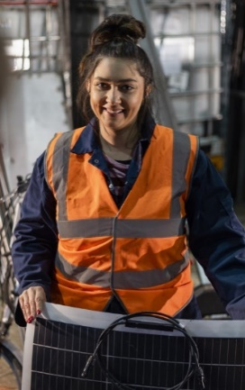 | Rachel has started a 4-year apprenticeship to become an Electrician. Rachel is studying towards a Certificate III in Electrotechnology Electrician and working full-time in rooftop solar installation.  As a New Energy Apprentice, Rachel is eligible for:  - Up to $10,000 ($2,000 for each study year and when she finishes her apprenticeship).  - Personalised non-financial support services (peer-support, networking).  - An income contingent loan, as part of the Australian Apprenticeship Support Loan program.  Rachel’s employer is eligible to receive a Priority Hiring Incentive of up to $5,000.
The New Energy Apprenticeships Program is part of the Australian Government’s commitment to invest in the clean energy sector and create the next generation of talent to deliver Australia’s clean energy infrastructure.

