

Post Program Monitoring Survey Methodology

## Purpose

Post Program Monitoring (PPM) surveys assess the experiences and outcomes of participants who are engaged with or were engaged with various elements of employment services.

* The Labour Force Survey provides information on the employment and education status of participants.
* The Quality and Progress Survey provides information on participant satisfaction with their service provider and their progress to employment.

## Population

Each survey has a different target population of Workforce Australia participants, depending on its purpose. The Labour Force Survey collects employment information for participants in Workforce Australia Online, Workforce Australia Services and Transition to Work. The Quality and Progress Survey collects information about participant satisfaction with services received and their progress to employment in Workforce Australia Services and Transition to Work.

## Sampling

PPM surveys use stratified random sampling. The survey population is first divided into groups defined by certain attributes during sample selection and then a random sample of participants are invited to participate in the survey. The number of people invited to participate is calculated to ensure that the number of responses received is reliable for reporting purposes. This includes oversampling – sending more invitations to cohorts that have lower response rates. Stratification and oversampling allows the sample and subsequent results to be more representative of the survey population, while random sampling ensures participants are fairly chosen to participate.

Different surveys have different strata. These can include, but are not limited to, the employment services program participants are participating in, the licence of the service provider participants are working with, and whether participants have exited their employment service program.

Participants are excluded from the sample if they meet any of the following conditions:

* They have been selected for a PPM survey or similar research activity in the past 91 days.
* They have responded to the same PPM survey in the past 365 days.
* They have a permanent exclusion; for example, they have asked to be excluded from surveys.
* They have an administration exclusion; for example, they are currently overseas.
* They were located in a contingency area with paused mutual obligations during the survey sample selection.
* They have an invalid point of contact; for example, they don’t have a valid or deliverable email address.

## Weighting

Weighting is a statistical technique where contributions from individual groups are relative to their representativeness of the entire survey population. This ensures that the sample of participants surveyed and the overall results accurately represent the target population. In PPM surveys, weightings are applied according to survey-specific selection strata during sample selection and result calculation. For example, for an employment services program stratum, the sample of participants and their responses are weighted by this stratum during calculation, according to their representativeness of the overall survey population.

## Contact Methods and Timing

Surveys are delivered on either a monthly, quarterly or one-off basis. Surveys are mainly completed online – participants with a valid email address are sent an email invitation with a personalised link. Participants who received an email invitation are also eligible to receive a combination of email and SMS reminders if they haven’t completed the survey. For the Labour Force Survey and the Quality and Progress Survey a multimodal approach is used. Paper surveys are also sent to those without valid email addresses, followed by SMS reminders. Then, a selection of participants who haven't responded after reminders are contacted via computer assisted telephone interviews (CATI) to complete the survey. See Figure 1 for an overview of the PPM survey contact cycle.

Figure 1. The PPM Survey Contact Cycle.

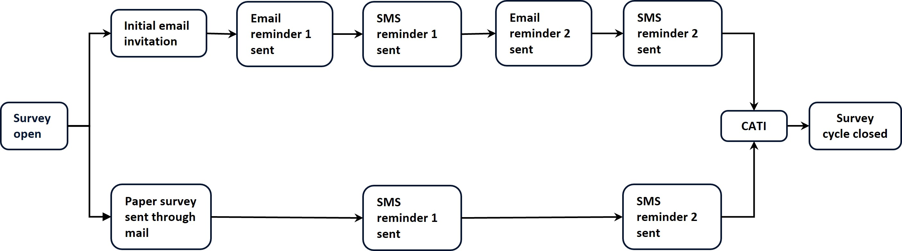

Results are provided on a rolling quarterly basis, based on 12 months of collected data. This accommodates potential seasonality effects and allows time for enough responses to be collected. Due to the length of the survey process, and additional quality assurance requirements, results are available publicly around six months after the end of the reference period.

## Reliability of Results

All results are produced through surveys answered by a select sample from the relevant population of Workforce Australia participants. Due to this, there may be differences between reported results and the true value that would be obtained if the entire relevant Workforce Australia population were surveyed. This is known as sampling error.

To account for this sampling error, the margin of error (MoE), at the 90% confidence level, is calculated and then used to determine the robustness of results. When the MoE is greater than 5.0 percentage points, at the 90% confidence level, results are not published (n.p). See Figure 2.

Figure 2. Acceptable MoEs for a reported resultDiagram showing a dot on a horizontal line as the reported result and the range of acceptable margin of error as -5.0 and +5.0 percentage points around the reported result dot on the line. 