Australian Government Department of Employment logo

Slide 1 Labour market conditions in East Gippsland Local Government Area (LGA).

Presentation given by Chris Sainsbury, Director, Labour Market Research and Analysis Branch in October 2013

# Slide 2 Map of East Gippsland ESA

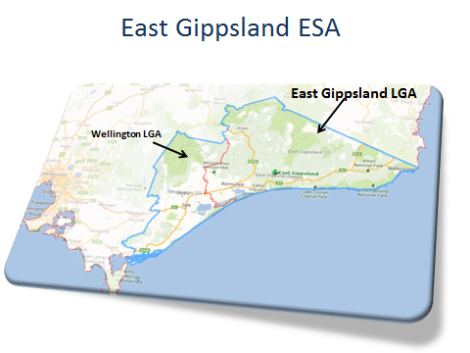

# Slide 3 Population profile

|  |  |  |  |
| --- | --- | --- | --- |
| Region | Adult Population  (15+ years) 2012 | Growth 2007 to 2012 | Median Age 2011 |
| Wellington | 34,400 | 5% | 41 |
| East Gippsland | 35,700 | 6% | 47 |
| Victoria | 4,599,000 | 10% | 37 |

*Source: ABS, Estimated Resident Population, 2007 and 2012*

# Slide 4 Ageing population with young adults leaving the area

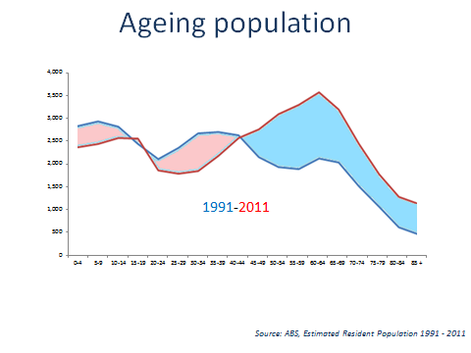

*Source: ABS, Estimated Resident Population 1991 – 2011*

This graph illustrates the change in the age distribution of the population in East Gippsland from 1991 to 2011. The change reflects a marked growth in population aged 45+ years and a decline in young adults, particularly those aged between 20 and 44 years.

Similar demographic patterns exist in some other regional areas and are due in part to young adults moving to major urban centres while those of retirement age being more likely to remain within the region.

People moving from East Gippsland over five years to 2011

4,090 15 yrs+ people moved away from East Gippsland over the 5 years to 2011.

Age breakup of the people that moved away

* 15 – 24 year olds 33%
* 25 – 34 year olds 17%
* 35 – 44 year olds 12%
* 45 – 54 year olds 11%
* 55 – 64 year olds 11%
* 65+ year olds 16%

Where did they go?

* 1210 moved interstate
* 1570 moved to Melbourne
* 1310 moved elsewhere in Victoria

29% or almost 1 in 3 persons aged 15-24 in 2011 who had resided in East Gippsland LGA in 2006 lived elsewhere in 2011.

15 to 24 year olds who have moved away between 2006 and 2011 to:

|  |  |  |
| --- | --- | --- |
|  | Number | % studying |
| Melbourne | 660 | 60% |
| Anywhere in Australia | 1,050 | 60% |

# Slide 5 Gippsland Internet Vacancies continue to grow (12 months to September 2013)

|  |  |  |
| --- | --- | --- |
| Region | Yearly %  change | Number of vacancies (September 2013) |
| Gippsland | 1.7% | 1,060 |
| Victoria | -7.1% | 41,550 |

*Source: DEEWR Vacancy Report, September 2013 (three month moving average)*

# Slide 6 Unemployment defying state and national trends

|  |  |  |  |
| --- | --- | --- | --- |
| Region | Unemployment Rate | | Annual Change |
| June 2012 | June 2013 |
| Bairnsdale SLA | 5.2% | 4.7% | -0.5% pts |
| Orbost SLA | 6.6% | 6.0% | -0.6% pts |
| South-West SLA | 5.3% | 4.7% | -0.6% pts |
| East Gippsland LGA | 5.4% | 4.9% | -0.5% pts |
| Victoria  (September, seasonally adjusted) | 5.4% | 5.7% | 0.3% pts |
| Australia  (September, seasonally adjusted) | 5.2% | 5.6% | 0.4% pts |

*Source: Department of Education Small Area Labour Markets, June 2013 (smoothed); ABS Labour Force, September 2013 (seasonally adjusted)*

# Slide 7 Long-term Unemployment All Gippsland LFR

|  |  |  |  |
| --- | --- | --- | --- |
| Region | Long-term unemployed  (52 weeks or more) | | Average duration of unemployment |
| Persons | Per cent  of all unemployed |
| All Gippsland LFR | 1,230 | 19.9% | 47 weeks |
| Victoria | 30,400 | 17.5% | 34 weeks |

*Source: ABS Labour Force Data September 2013, 12 month averages of original data*

# Slide 8 People moving to East Gippsland

Age break up of those that moved in to East Gippsland

15-24 years 11%
25-35 years 17%
35-44 years 18%
45-54 years 15%
55-64 years 20%
65+ years 18%

Further described below

*Source: ABS Census of Population and Housing, 2011; Department of Immigration http://www.immi.gov.au/settlementn and Citizenship. Settlement reporting, October 2008 to October 2013*

5,700 people (aged 15 + years in 2011) had moved to East Gippsland between (2006 and 2011).*

3,800 came from elsewhere in Victoria

1,500 people had moved into East Gippsland from Interstate

* NSW 590
* Queensland 420
* South Australia 60
* Western Australia 200
* Tasmania 70
* Northern Territory 110
* ACT 80

400 came from overseas

*\*Note: 2,100 people (aged 15 + years) living in East Gippsland did not report or adequately define where they lived in 2006 in the 2011 Census so where excluded from these figures.*

Employed persons who moved to East Gippsland between 2006 and 2011, proportion employed in each major occupation category:

* Managers 15%
* Professionals 22%
* Technicians and Trades Workers 14%
* Community and Personal Service Workers 13%
* Clerical and Administrative Workers 11%
* Sales Workers 9%
* Machinery Operators and Drivers 4%
* Labourers 12%

# Slide 9 Recent arrivals more likely to be unemployed

|  |  |  |
| --- | --- | --- |
| Lived in 2006 | Unemployment Rate | Participation Rate |
| East Gippsland | 4.3% | 54.2% |
| Elsewhere | 10.2% | 56.6% |
| * Overseas | 8.1% | 68.0% |
| * Melbourne | 10.4% | 55.0% |
| * Elsewhere in Victoria | 9.4% | 56.9% |
| * Interstate | 10.8% | 55.4% |

*Source: ABS Census of Population and Housing, 2011*

Highest educational attainment for working age population (15-64 years in 2011) who had moved to LGA in the 5 years between 2006 and 2011

|  |  |  |  |
| --- | --- | --- | --- |
|  | Bachelor or higher | Unemployment rate | Participation rate |
| 15-24 | 11% | 5.8% | 88.1% |
| 25-34 | 33% | 6.0% | 92.9% |
| 35-44 | 26% | 1.4% | 82.5% |
| 45-54 | 16% | 0.0% | 81.3% |
| 55-64 | 18% | 9.7% | 58.9% |
| Total | 21% | 4.5% | 81.4% |

|  |  |  |  |
| --- | --- | --- | --- |
|  | Advanced Diploma, Diploma or Certificate III and IV | Unemployment rate | Participation rate |
| 15-24 | 18% | 19.8% | 79.4% |
| 25-34 | 33% | 7.2% | 78.0% |
| 35-44 | 35% | 6.2% | 79.9% |
| 45-54 | 40% | 9.6% | 81.1% |
| 55-64 | 29% | 6.3% | 48.5% |
| Total | 32% | 8.5% | 72.8% |

|  |  |  |  |
| --- | --- | --- | --- |
|  | Year 12 | Unemployment Rate | Participation Rate |
| 15-24 | 15% | 6.7% | 64.5% |
| 25-34 | 14% | 8.9% | 70.6% |
| 35-44 | 12% | 4.8% | 69.4% |
| 45-54 | 5% | 17.9% | 84.8% |
| 55-64 | 10% | 25.0% | 42.3% |
| Total | 11% | 10.7% | 64.7% |

|  |  |  |  |
| --- | --- | --- | --- |
|  | Below Year 12 | Unemployment Rate | Participation Rate |
| 15-24 | 51% | 21.5% | 48.5% |
| 25-34 | 14% | 24.7% | 61.6% |
| 35-44 | 23% | 18.4% | 69.4% |
| 45-54 | 34% | 12.3% | 69.6% |
| 55-64 | 40% | 12.0% | 34.7% |
| Total | 31% | 16.8% | 53.3% |

Almost 1/3 of new arrivals did not complete year 12.

# Slide 10 What are youth doing

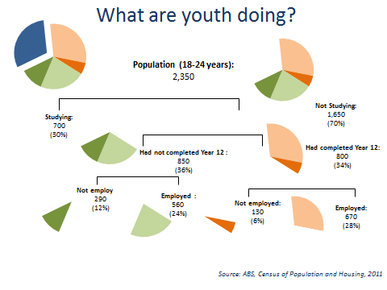

*Source: ABS, Census of Population and Housing, 2011*

There are 2,350, 18 to 24 year olds in the East Gippsland area. Of these 700 or 30 per cent are studying.

Of the remaining 70 per cent (1,650) 850 (or 36 per cent of the cohort) had not completed year 12.

Of these 290 (or 12 per cent of the cohort) were not employed.

Of the 800 (or 34 per cent of the cohort) who had completed year 12, 103 (6 per cent of the cohort where not employed).

# Slide 11 Young adults less likely to be working or studying

In East Gippsland males aged 20-24 years not studying and:
Not in the labour force 10%
Looking for work 7%

In East Gippsland females aged 20-24 years not studying and:
Not in the labour force 21%
Looking for work 4%

In Wellington males aged 20-24 years not studying and:
Not in the labour force 6%
Looking for work 7%

In Wellington females aged 20-24 years not studying and:
Not in the labour force 18%
Looking for work 6%

In Victoria males aged 20-24 years not studying and:
Not in the labour force 5%
Looking for work 5%

In Victoria females aged 20-24 years not studying and:
Not in the labour force 8%
Looking for work 4%

*Source: ABS Census of Population and Housing, 2011;*

# Slide 12 Educational attainment

Persons aged 25 – 34 years

|  |  |  |  |  |
| --- | --- | --- | --- | --- |
| Region | Completed Year 12 | | Highest Non-School Qualification | |
| 2011 | 2006 | Advanced Diploma, Diploma or Certificate III & IV | Bachelor Degree or Higher |
| Bairnsdale | 57% | 53% | 40% | 16% |
| Orbost | 57% | 52% | 33% | 18% |
| South-West | 54% | 51% | 43% | 18% |
| East Gippsland | 57% | 53% | 39% | 17% |
| Victoria | 79% | 73% | 29% | 40% |
| Australia | 75% | 69% | 30% | 35% |

*Source: ABS Census of Population and Housing, 2011*

Year 12 completion for persons aged 24 – 34 increased by 4 percentage points to 57 per cent in the 5 years to 2011.

# Slide 13 Ongoing shift to higher skilled jobs in the Australian labour market

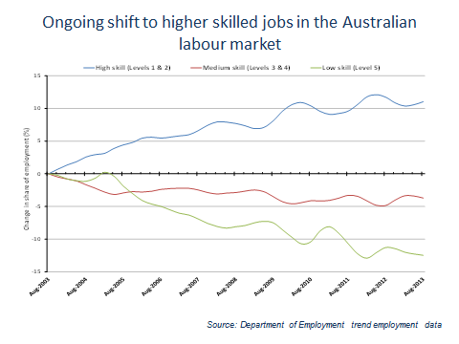

*Source: Department of Employment trend employment data*

The attainment of educational qualifications remains important given the strong past and projected growth of higher skilled occupations, as well as the lower unemployment rates recorded for people with higher qualifications.

Looking over the 10 year period from August 2003 to August 2013, it is clear that jobs at the higher skill levels (Skill Level 1, commensurate with a Bachelor degree or higher qualification and Skill Level 2, commensurate with an Associate Degree, Advanced Diploma or Diploma)) are increasing as a proportion of overall employment – up from 37.0 per cent to 41.1 per cent. At the same time, jobs at the lowest skill level (Skill Level 5, commensurate with compulsory secondary education or a Certificate I) are diminishing as a proportion of total employment from 19.9 per cent to 17.5 per cent.

**What this means for school leavers** is that yes, you may get a job when you leave school, **BUT** you may not experience the same employment stability or earn as much as those students whose education choices set them up for a career, rather than a series of low skilled jobs.

The key technical and trade group at skill level 3, corresponding to a Certificate IV or a formal apprenticeship, is declining as a share of employment, but growth rates vary considerably within this category.

Note: This chart plots the percentage change in the percentage shares of employment from August 2003 onward. Source: ABS Labour Force Survey data to August 2013, seasonally adjusted and trended by the Department of Employment.

# Slide 14 Educational attainment and labour market outcomes

Slide looks at persons aged 25-34 years in East Gippsland comparing unemployment rate to participation rate for different levels of education

Bachelor degree or higher 2.7%/88.2%
Advanced diploma and diploma level 8.0%/84.2%
Certificate III and IV level 4.7%/86.6%
Year 12 or equivqlent 4.8%/73.9%
Certificate I and II level 13.8%/66.0%
Below year 12 16.9%/62.8%

*Source: ABS Census of Population and Housing, 2011*

# Slide 15 Employment by industry

Employment by indusrty as a % of total employment
East Gippsland compared to Victoria

Health Care and Social Assistance 14%/12%
Retail Trade 12%/11%
Construction 10%/9%
Education and Training 9%/8%
Accommodation and Food Services 9%/6%
Manufacturing 9%/11%
Agriculture, Forestry and Fishing 8%/2%
Public Administration and Safety 5%/5%




*Source: ABS Census of Population and Housing, 2011*

Industry employment demonstrates the relative importance of agriculture and tourism

Industry change 2001-2011

|  |  |  |
| --- | --- | --- |
| % of total employment | 2001 | 011 |
| Health Care and Social Assistance | 12% | 14% |
| Retail Trade | 17% | 12% |
| Construction | 7% | 10% |
| Education and Training | 9% | 9% |
| Accommodation and Food Services | 8% | 9% |
| Manufacturing | 10% | 9% |
| Agriculture, Forestry and Fishing | 13% | 8% |
| Public Administration and Safety | 3% | 5% |

# Slide 16 Employment growth by Industry

Employment growth by industry between 2006-2011

Health Care and Social Assistance +360
Construction +190
Education and Training +190
Public Administration and Safety +140
Manufacturing +130
Accommodation and Food Services +110
Retail Trade -70
Agriculture, Forestry and Fishing -170



*Source: ABS Census of Population and Housing, 2011 and 2006; Source: Department of Education Industry Projections, five years to 2016/17*

TOTAL GROWTH = 1,200 jobs in the 5 years to 2011

# Slide 17 Recruitment difficulty

Resaons some possitions were difficult to fill

Higher skilled jobs 
Technical skills required for the job 55%
Soft skills required 27%
Location 36%

Lower skilled jobs
Technical skills required for the job 34%
Soft skills required 21%
Location 38%


*Source: Department of Employment, Survey of Employers’ Recruitment Experiences, East Gippsland ESA, June 2012*

Occupations most commonly reported by employers as being difficult to fill vacancies for in the Gippsland ESA include:

Bachelor Degree or higher Vet Qualifications

* Chef
* Advertising and Marketing Professionals
* Electricians
* Motor Mechanics
* Architectural, Building and Surveying Technicians

Lower Skilled

* Cooks
* Gaming Workers

# Slide 18 Many employers recruited informally

56% of employers used formal recruitment methods. These employers  had 9.5 applicants per vacancy and 10% of applicants were successful.

44% of employers used only informal methods. These employers had 1.6 applicants per vacancy and 59% of applicants where successful.

*Source: Department of Employment, Survey of Employers’ Recruitment Experiences, East Gippsland ESA, June 2012*

# Slide 19 Basic employability skills

*Source: Department of Education, Survey of Employers’ Recruitment Experiences, All regions surveyed in the 12 months to December 2010*

Most importance placed on:

* 30 per cent personal traits and qualities only
* 28 per cent technical skills only
* 41 per cent both equally important

Personal traits and qualities applicants lacked:

* Enthusiasm
* Motivation
* Communication
* Confidence
* Teamwork

# Slide 20 Conclusion

* Region outperforming Victoria overall
* Disadvantaged groups
  + Long-term unemployed, youth, less educated
* Ongoing structural shifts
  + Ageing population
  + Growing market of higher skilled jobs
  + Growth in Health sector
* Job seekers need to be job ready
  + Employability skills a must
* Stakeholders need to work together

# Slide 21 Further Information

If you have any questions about the presentation please contact the Employer Surveys Section or Recruitment Analysis Section on:

Tel: 1800 059 439 or

[Email](mailto:recruitmentsurveys@employment.gov.au): recruitmentsurveys@employment.gov.au

More information on labour market conditions and other research on small areas can be found on these web sites

[LMIP](http://www.employment.gov.au/LMIP): www.employment.gov.au/LMIP

[Skills Shortages](http://www.employment.gov.au/SkillShortages): www.employment.gov.au/SkillShortages

[Regional Reports](http://www.employment.gov.au/RegionalReports): www.employment.gov.au/RegionalReports

[Australian Jobs](http://www.employment.gov.au/australianjobs): www.employment.gov.au/australianjobs

[Job Outlook](http://www.joboutlook.gov.au/): www.joboutlook.gov.au

