Slide 1: University of Canberra: Preparing for the jobs market


Slide 2: Conditions are strengthening
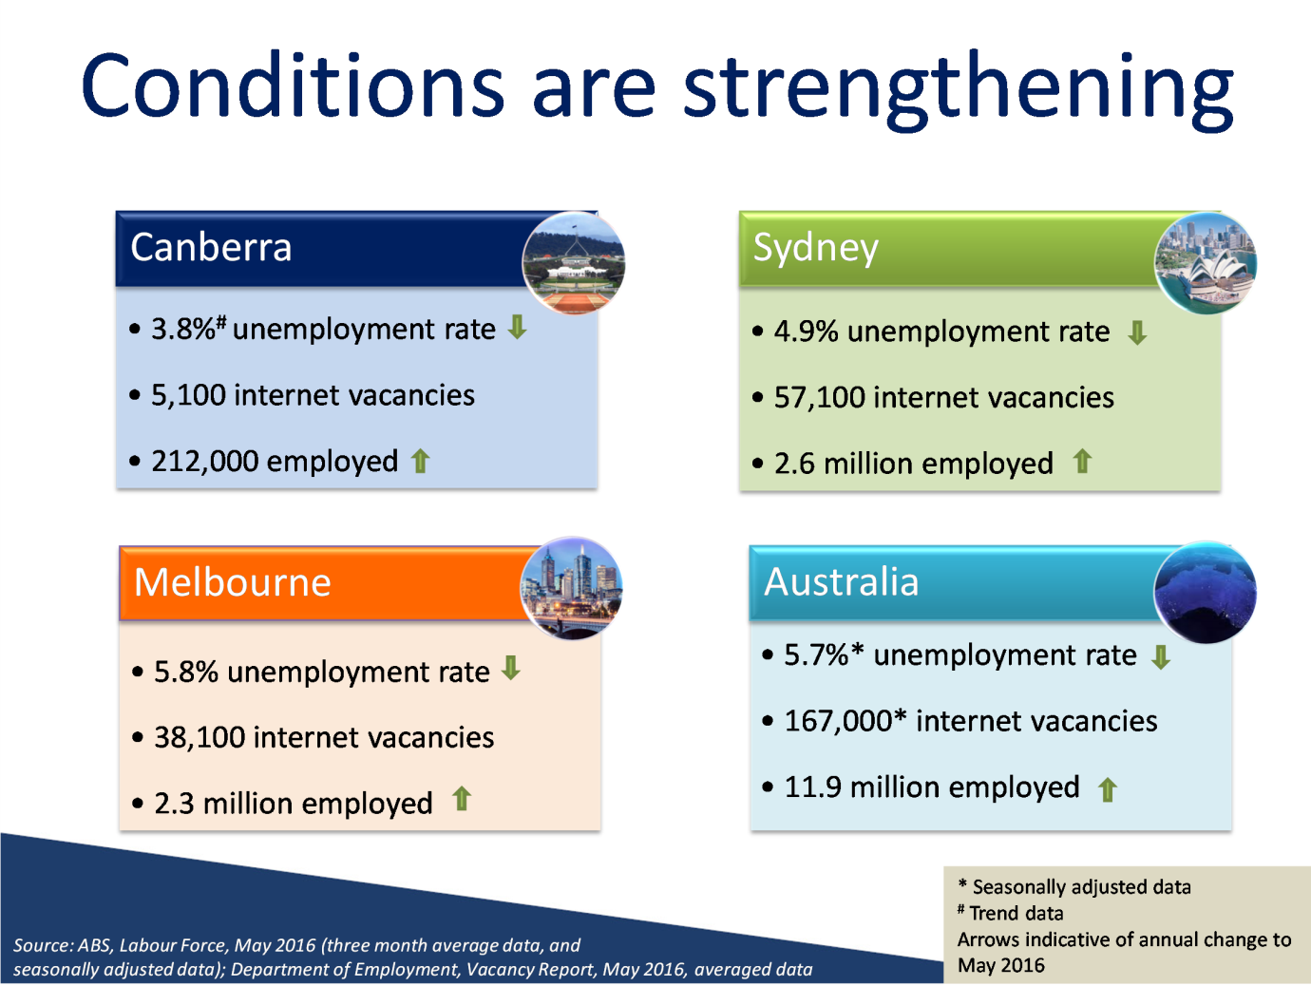

Notes
Source: ABS, Labour Force, May 2016 (three month average data, and seasonally adjusted data); Department of Employment, Vacancy Report, May 2016, averaged data

Slide 3: Where are the jobs?
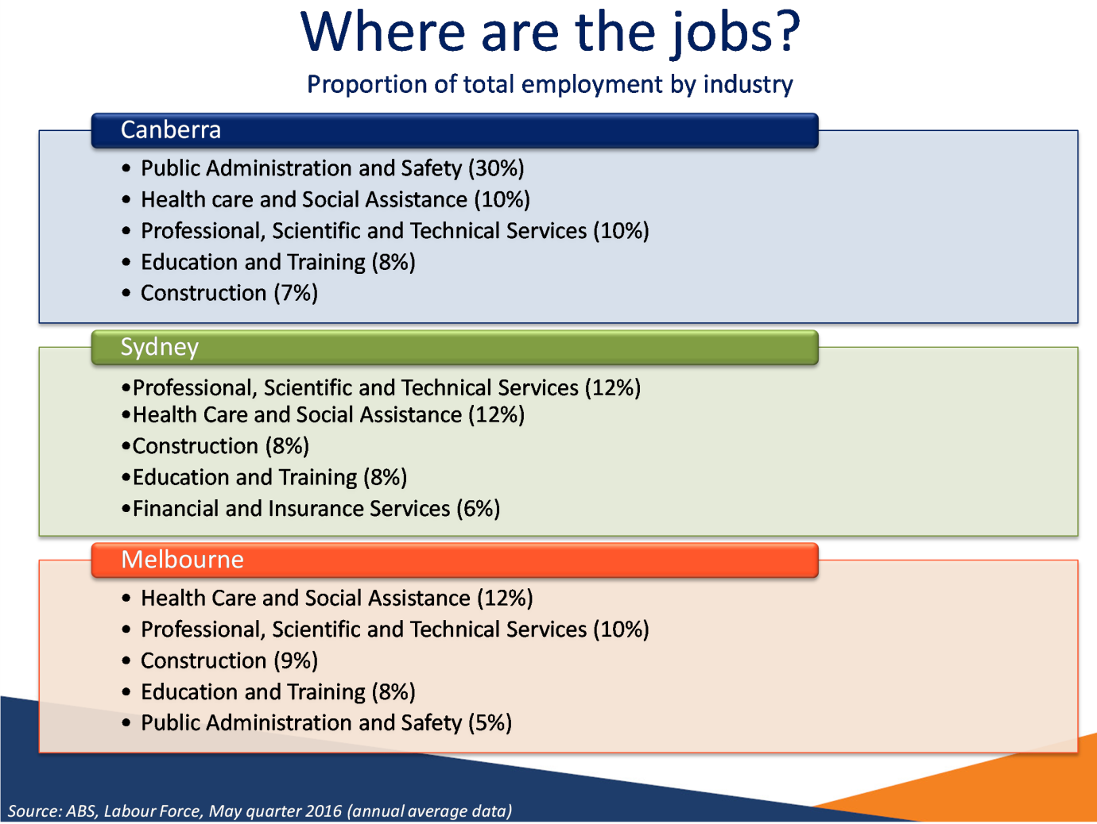

Notes
Source: ABS, Labour Force, May quarter 2016 (annual average data)

Slide 4: 92% of new jobs will be in the services…
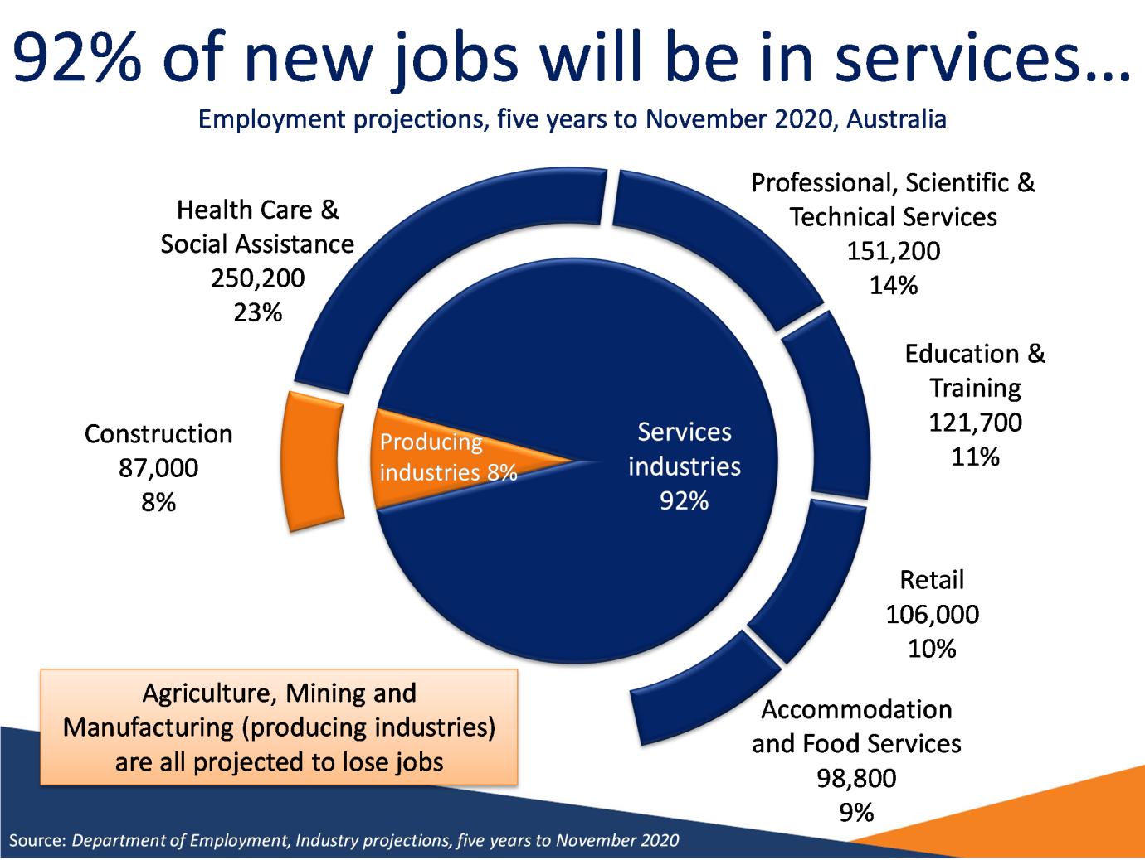

Notes
Source: Department of Employment, Industry projections, five years to November 2020

Slide 5: …flowing on to the ACT jobs market
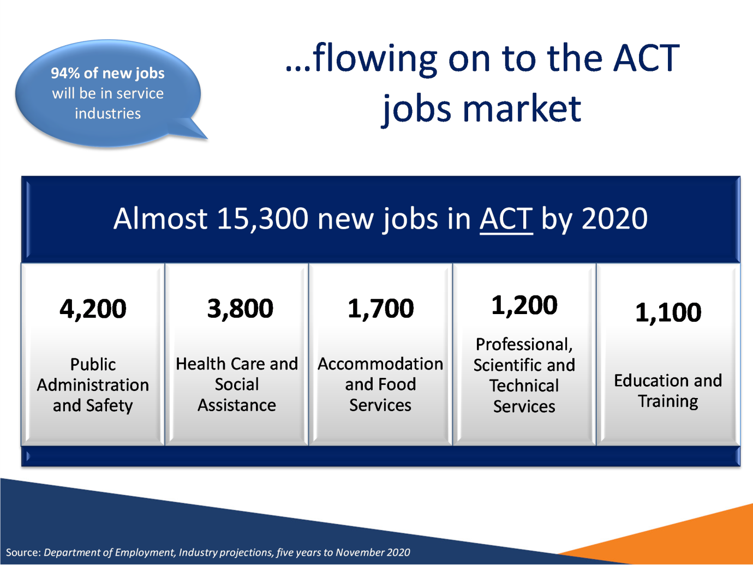

Notes
Source: Department of Employment, Industry projections, five years to November 2020

Slide 6: You will have many choices
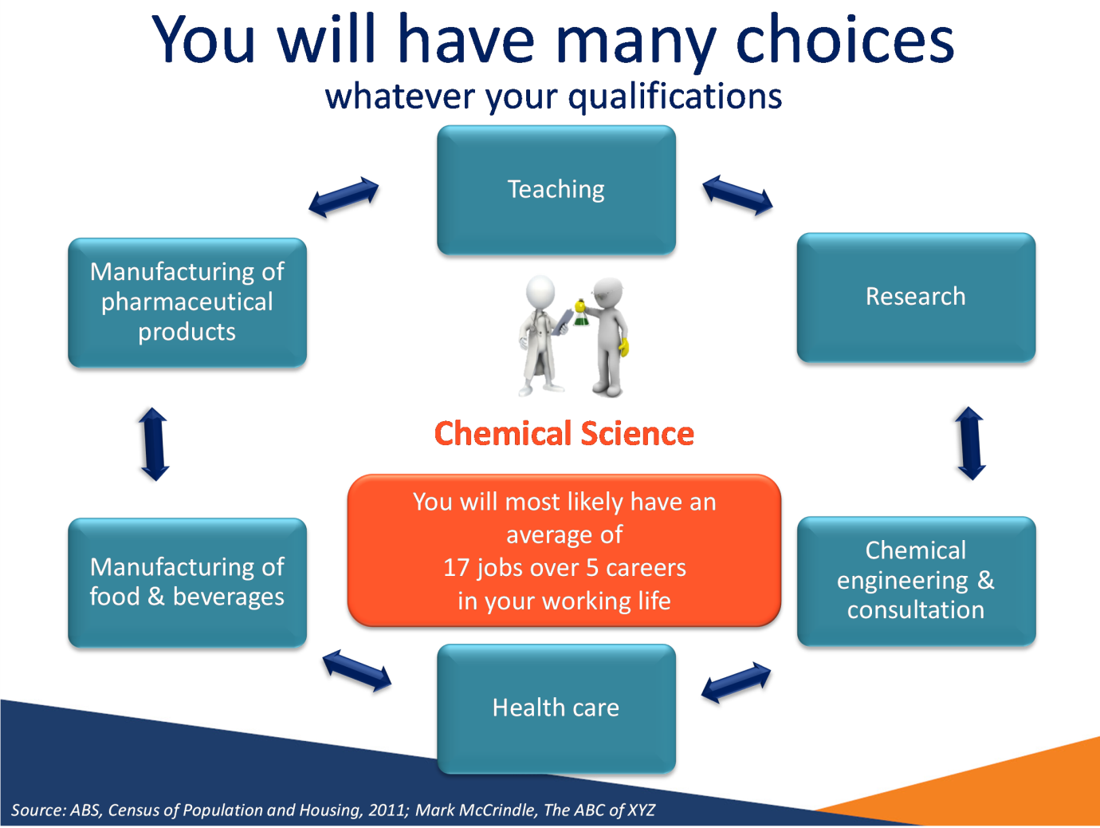

Notes
Source: ABS, Census of Population and Housing, 2011; Mark McCrindle, The ABC of XYZ

Slide 7: However, the jobs market can be tough
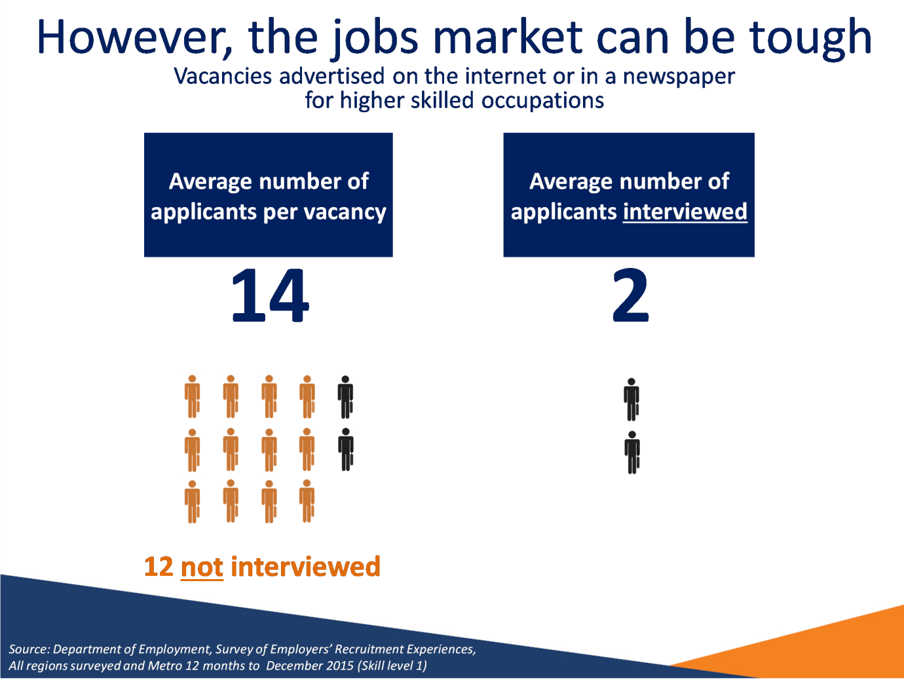

Notes
Source: Department of Employment, Survey of Employers’ Recruitment Experiences, All regions surveyed and Metro 12 months to December 2015 (Skill level 1)

Slide 8: Competition for graduate roles is increasing…
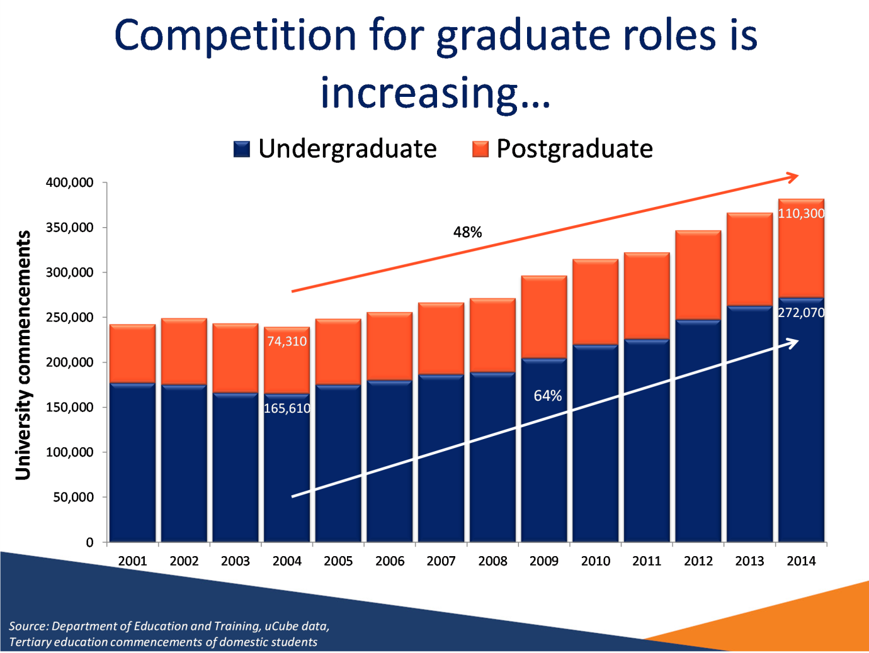

Notes
Source: Department of Education and Training, uCube data, Tertiary education commencements of domestic students

Slide 9: …so graduates are finding it more difficult to get a job…
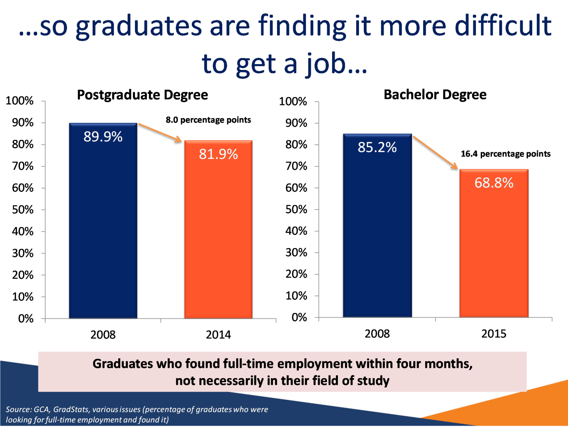

Notes
Source: GCA, GradStats, various issues (percentage of graduates who were looking for full-time employment and found it)

Slide 10: …but you are on the right track
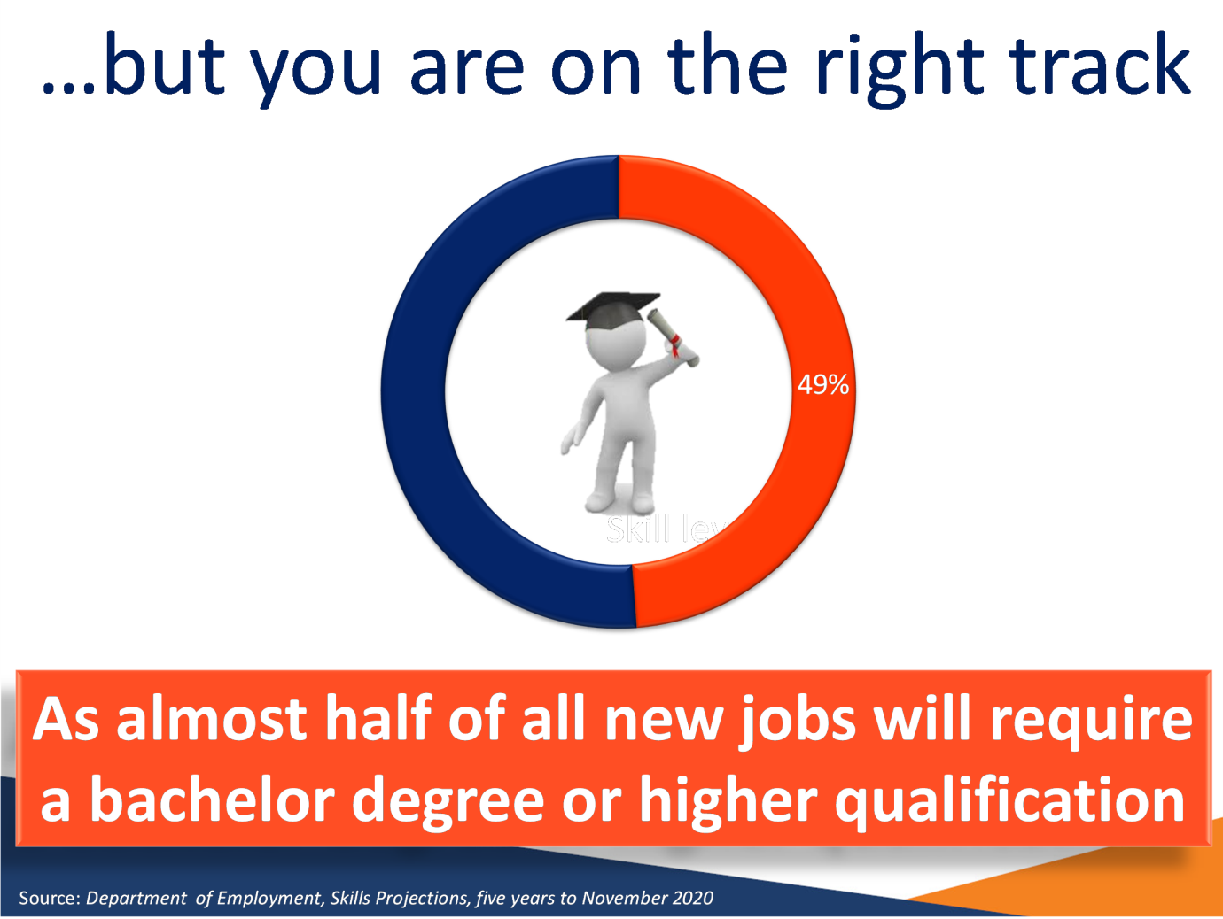

Notes
Source: Department of Employment, Skills Projections, five years to November 2020

Slide 11: How do you stand out from all the other graduates?


Slide 12: Finishing your degree is still the next step
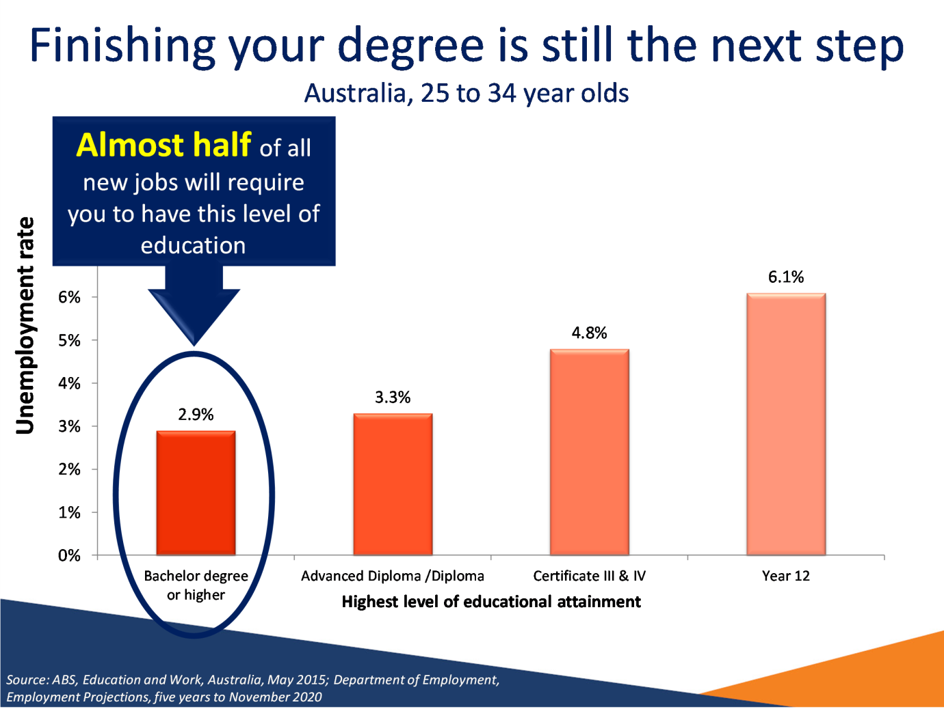

Notes
Source: ABS, Education and Work, Australia, May 2015; Department of Employment,
Employment Projections, five years to November 2020

Slide 13: Relevant experience is vital
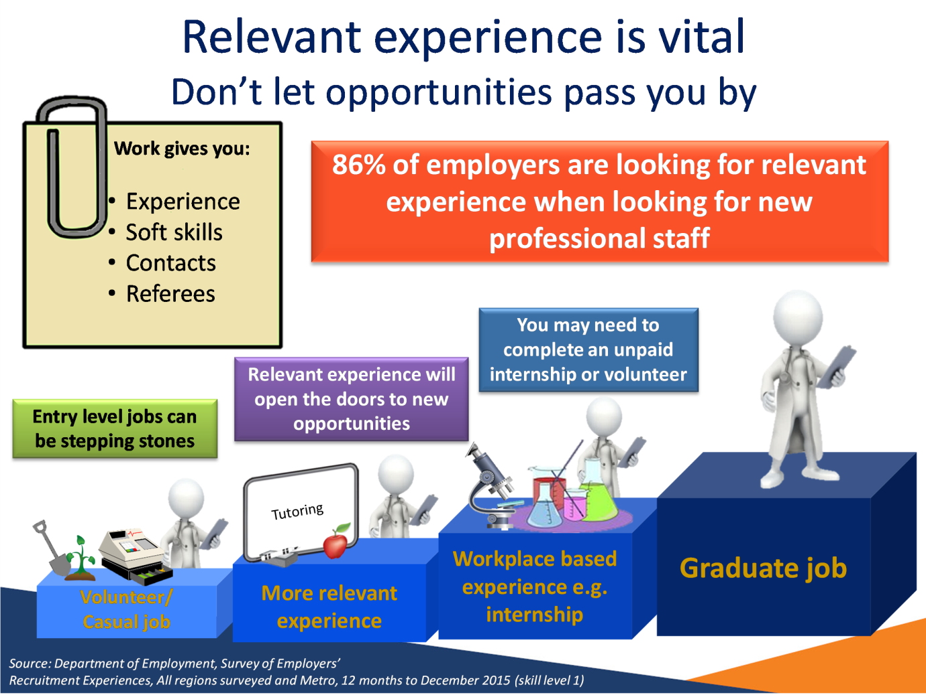

Notes
Source: Department of Employment, Survey of Employers’ Recruitment Experiences, All regions surveyed and Metro, 12 months to December 2015 (skill level 1)

Slide 14: Experience versus further study?
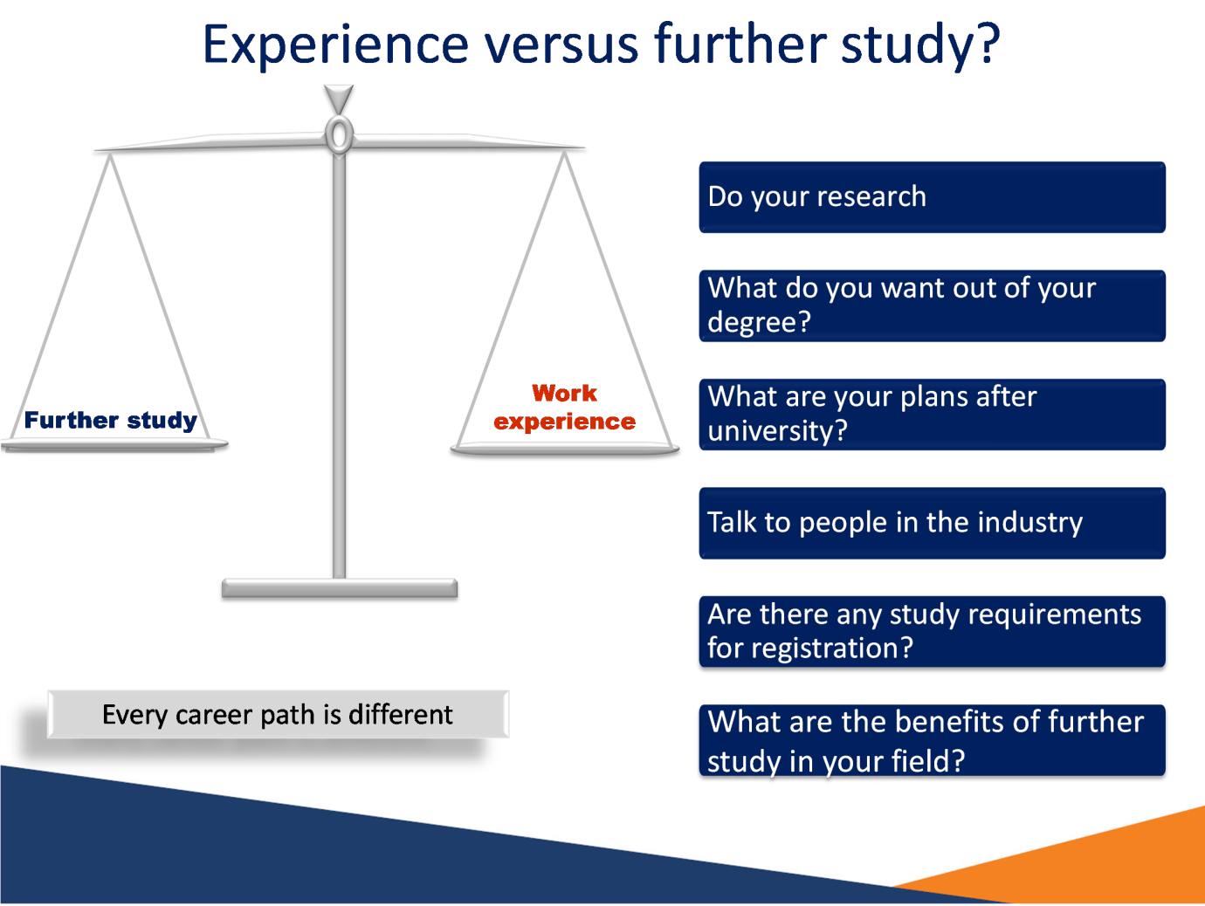

Slide 15: How are graduates finding employment?
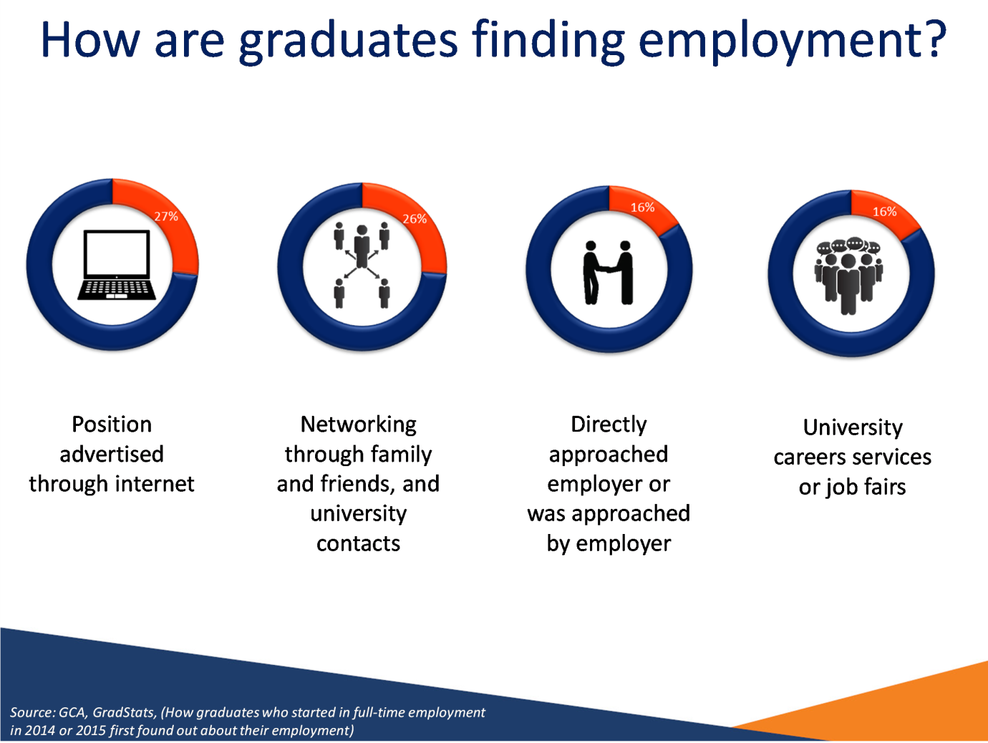

Notes
Source: GCA, GradStats, (How graduates who started in full-time employment in 2014 or 2015 first found out about their employment)

Slide 16: Networking is a powerful tool for professionals…


Notes
Source: Department of Employment, Survey of Employers’ Recruitment Experiences, All regions surveyed and Metro, 12 months to December 2015

Slide 17: Don’t underestimate the importance of a good application
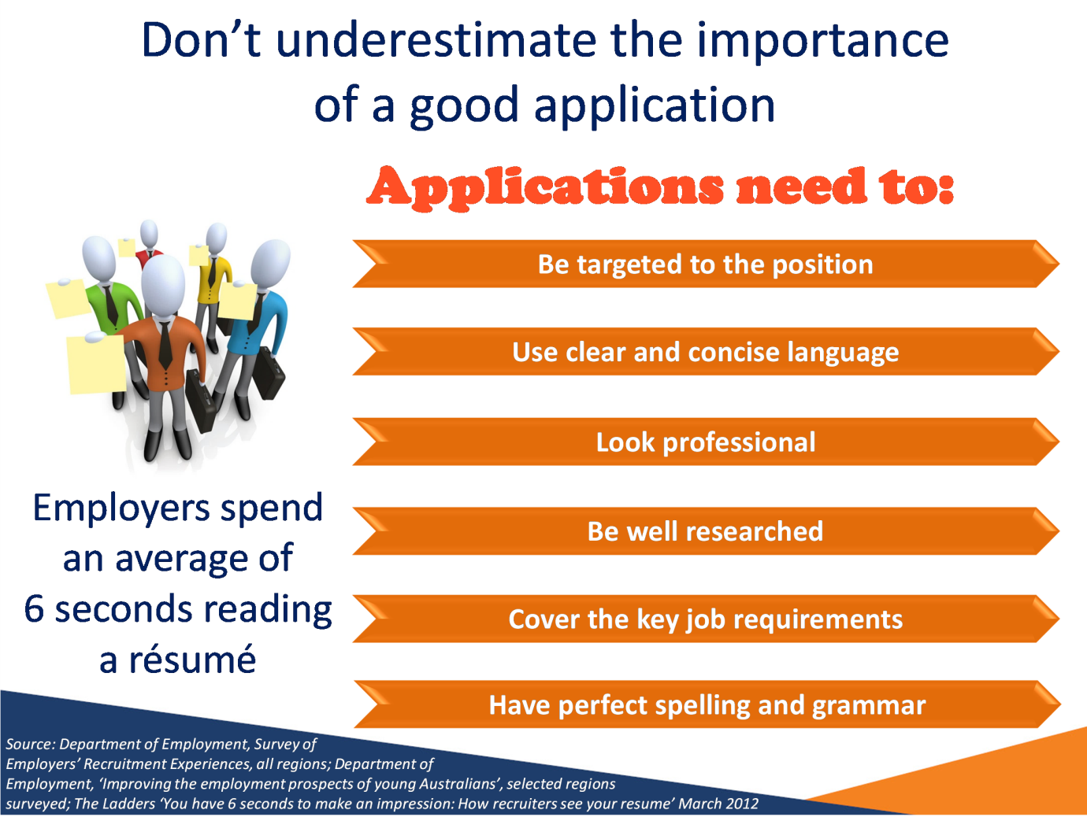

Notes
Source: Department of Employment, Survey of Employers’ Recruitment Experiences, all regions; Department of Employment, ‘Improving the employment prospects of young Australians’, selected regions surveyed; The Ladders ‘You have 6 seconds to make an impression: How recruiters see your resume’ March 2012

Slide 18: First impressions are important
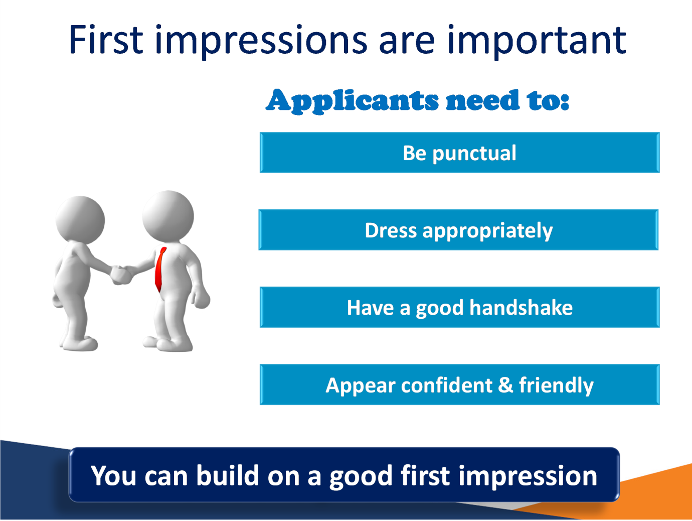

Slide 19: People skills and communication skills are essential for a graduate in today’s job market
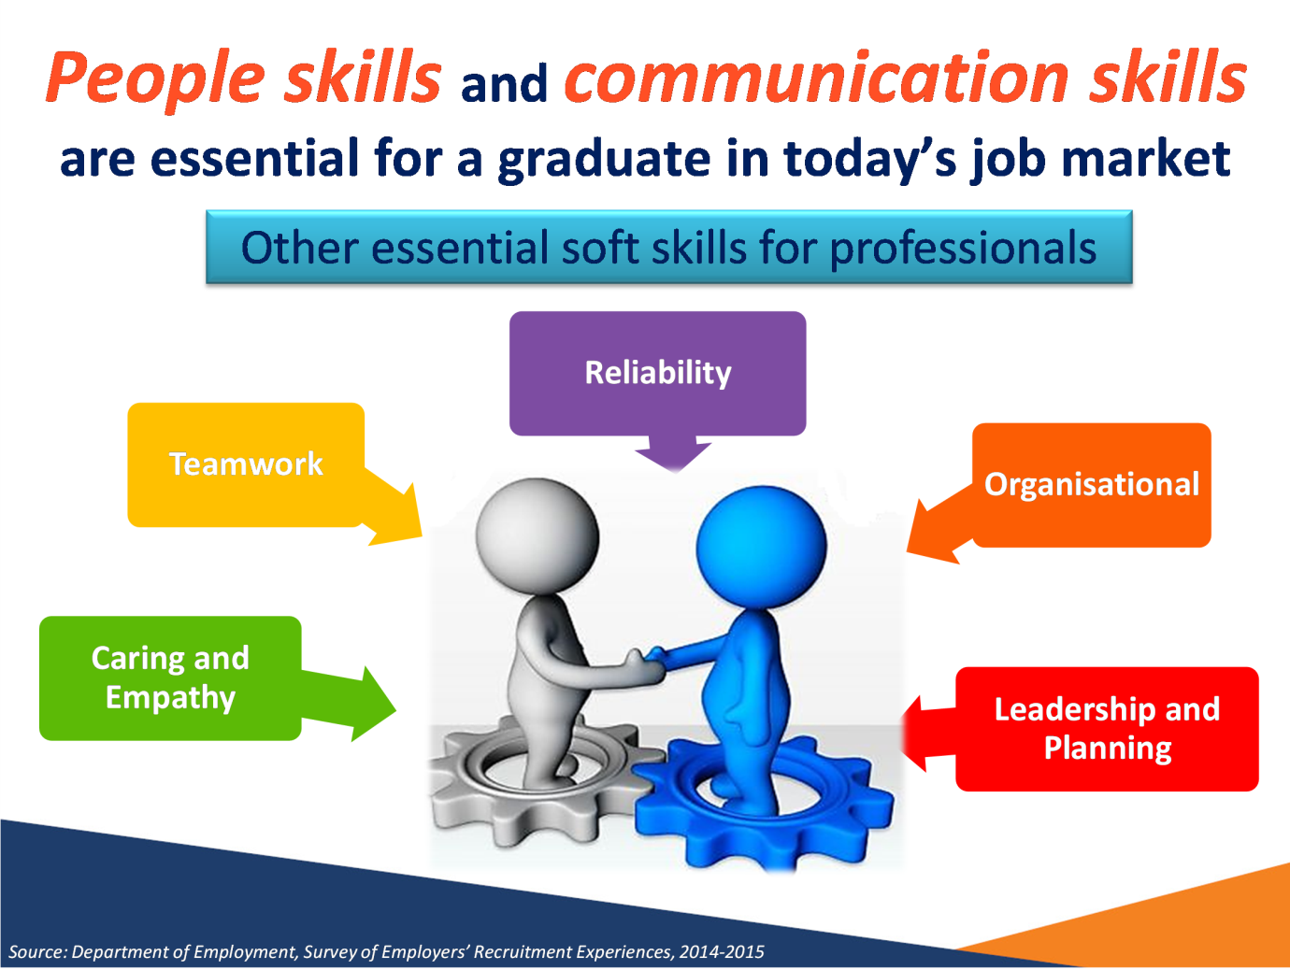

Notes
Source: Department of Employment, Survey of Employers’ Recruitment Experiences, 2014-2015

Slide 20: …and employers are also increasingly seeking workers with these transferable skills
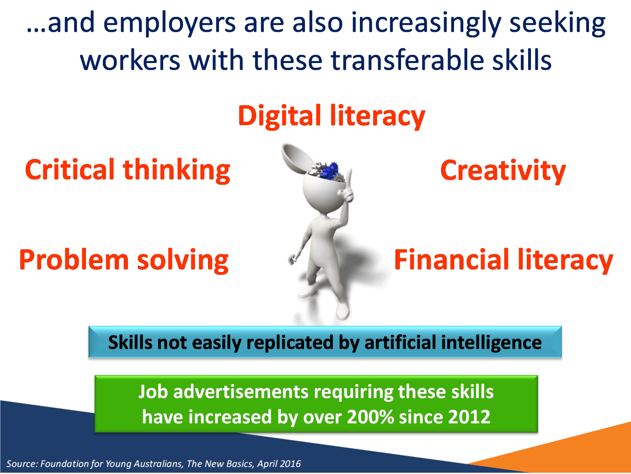

Notes
Source: Foundation for Young Australians, The New Basics, April 2016

Slide 21: As a graduate, employers will initially expect you to demonstrate
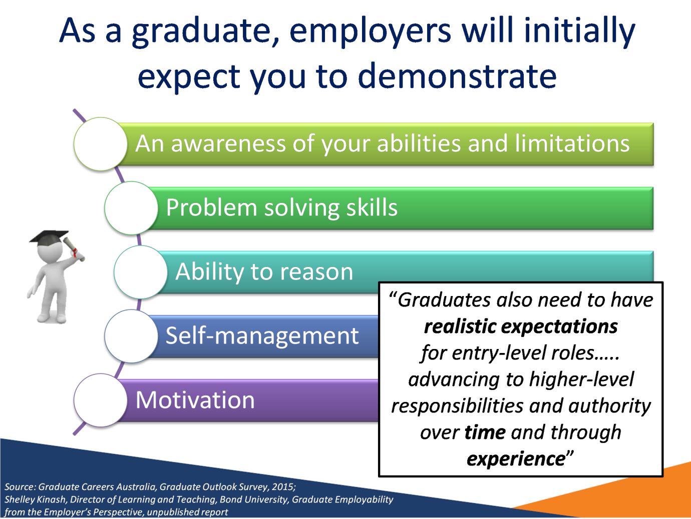

Notes:
Source: Graduate Careers Australia, Graduate Outlook Survey, 2015; Shelley Kinash, Director of Learning and Teaching, Bond University, Graduate Employability from the Employer’s Perspective, unpublished report

Slide 22: The jobs market is changing
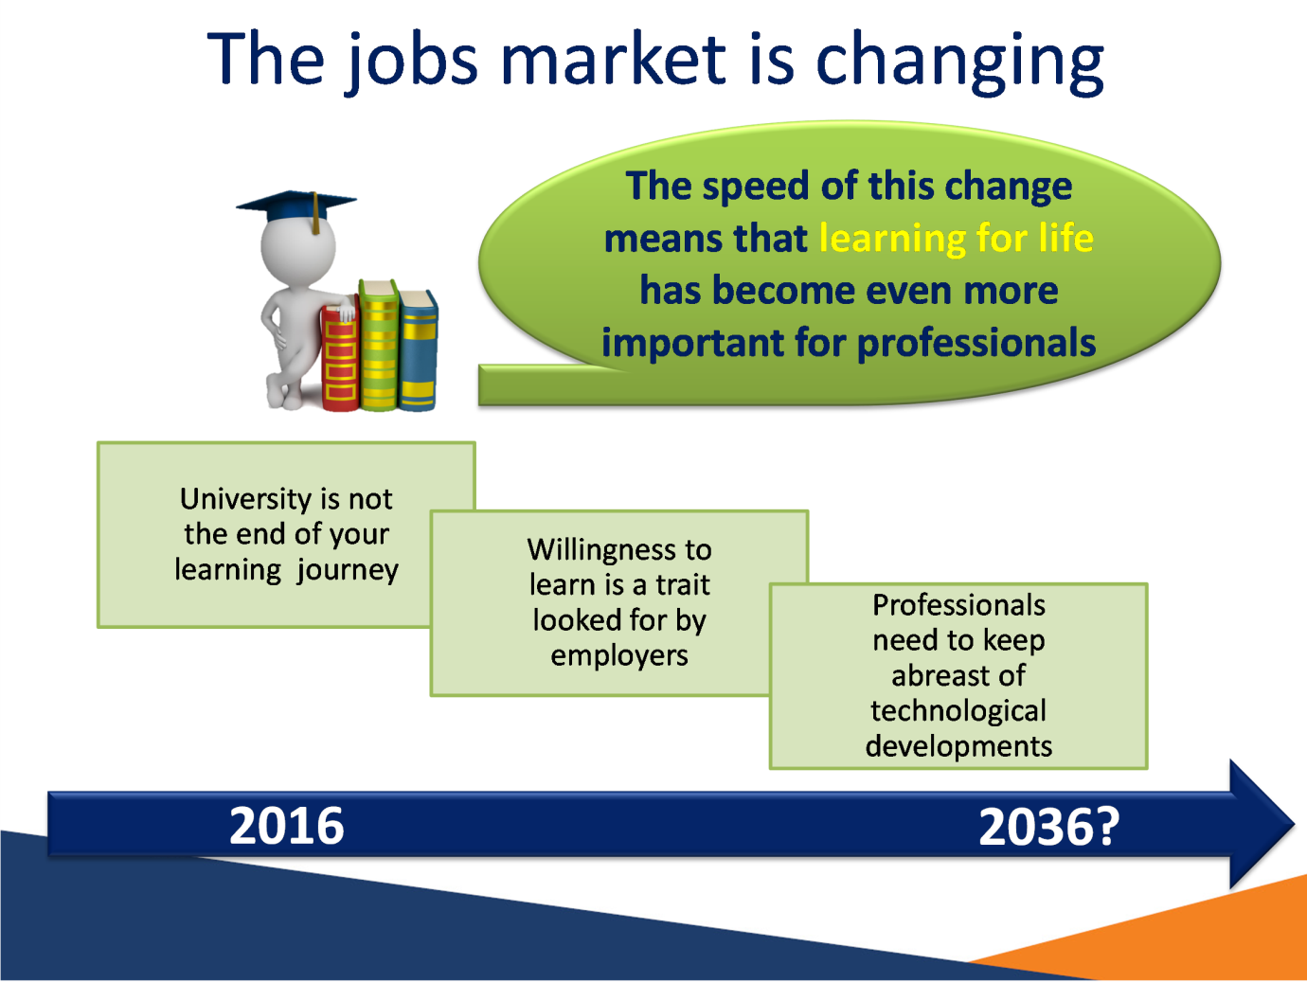

Slide 23: Every application is a learning experience
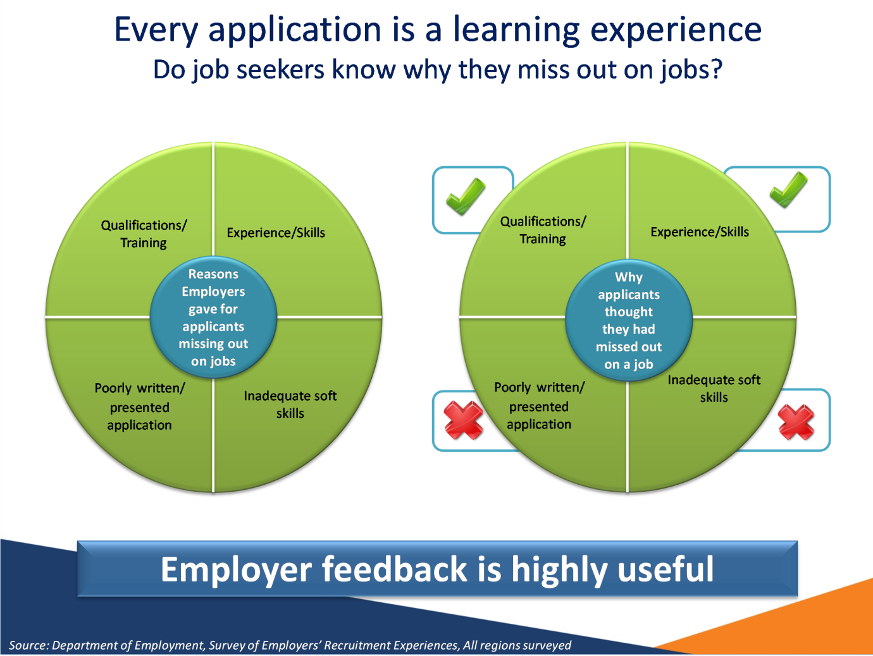

Notes
Source: Department of Employment, Survey of Employers’ Recruitment Experiences, All regions surveyed

Slide 24: Tips for improving your odds


Slide 25
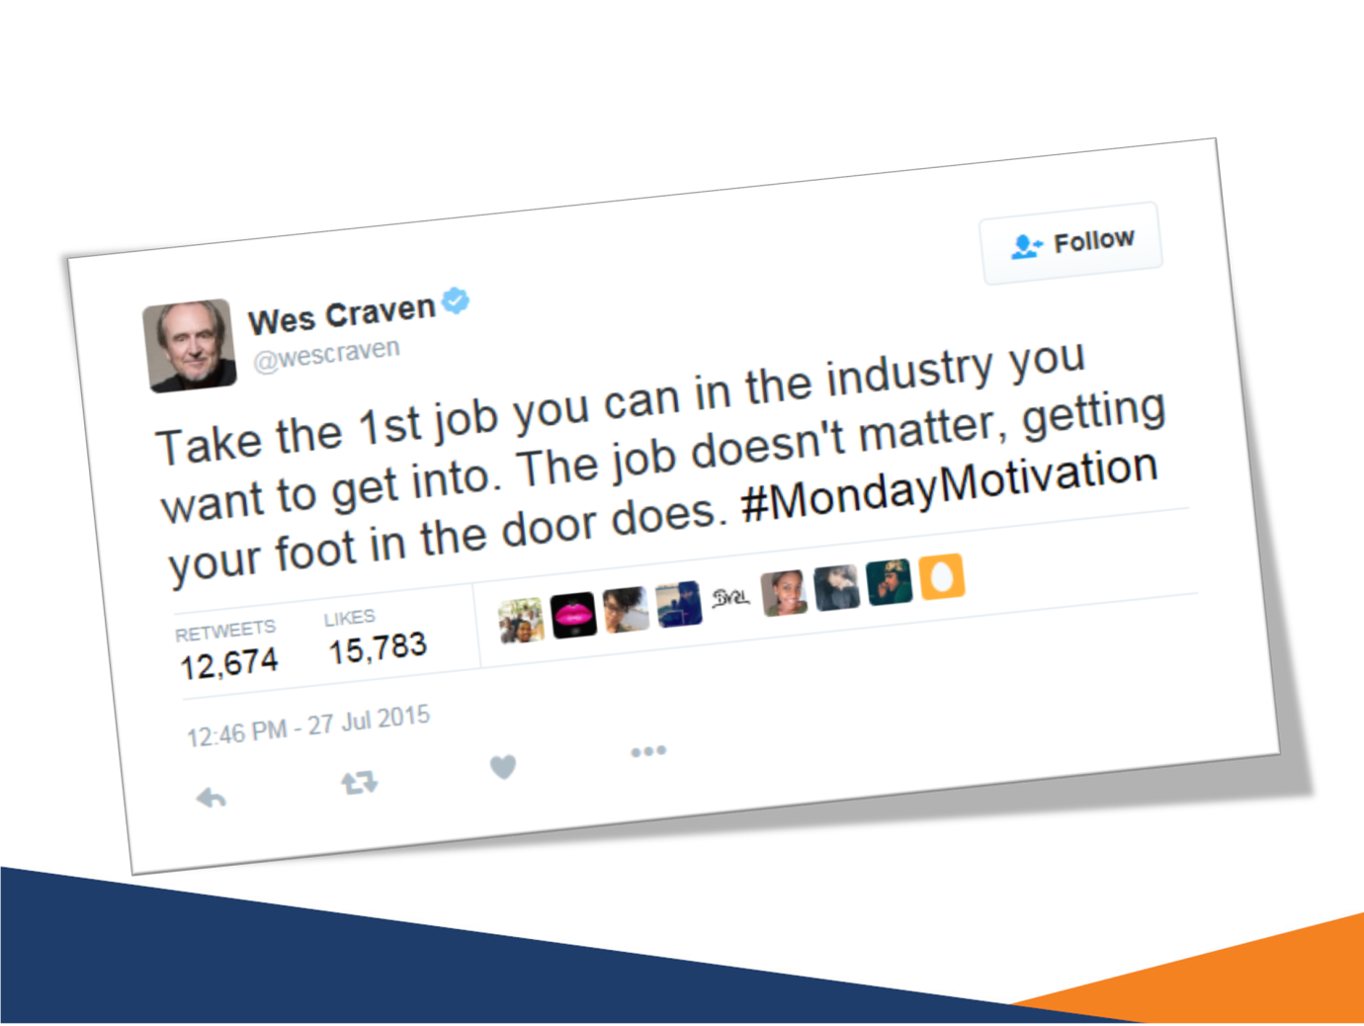

Slide 26: Tools to assist with job search
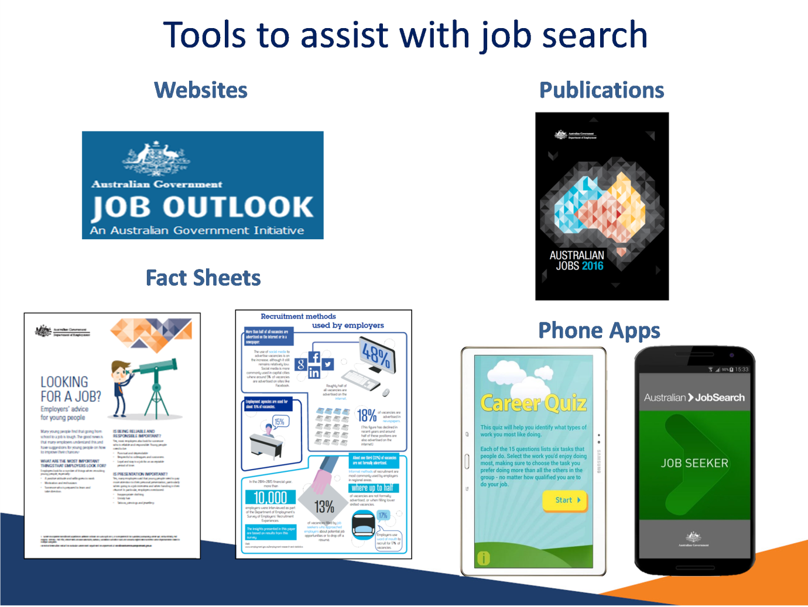

Slide 27


