# Slide 1: Preparing VET students for the jobs market

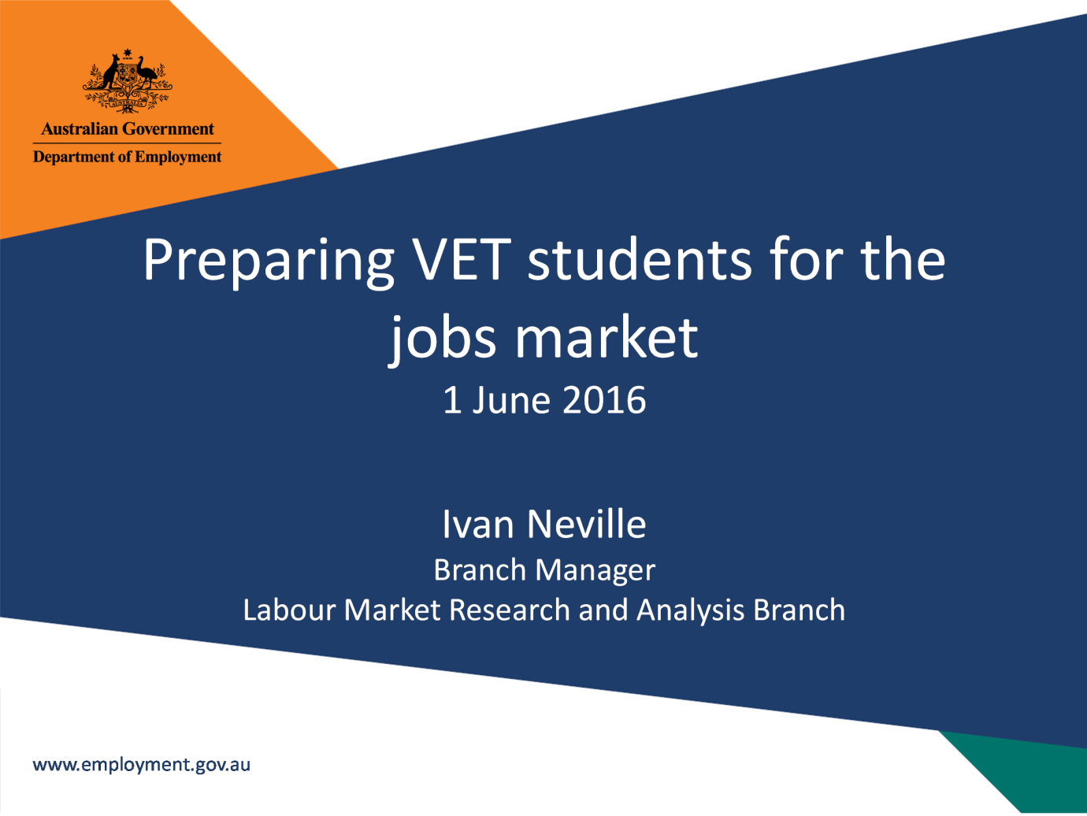

# Slide 2: What we know

Arrows refer to change over twelve months to June 2016
Unemployment rate:
NSW: 5.3% (down)
Vic: 5.7% (down)
Qld: 6.5% (up)
SA: 7.0% (down)
WA: 5.7% (down)
Tas: 6.6% (up)
NT: 3.7% (down)
ACT: 3.6% (down)
Youth unemployment rate:
NSW: 11.7% (down)
Vic: 13.2% (down)
Qld: 12.9% (down)
SA: 15.2% (steady)
WA: 11.1%(up)
Tas: 15.3% (down)
NT: 8.0% (down)
ACT: 11.4 % (up)
Internet Vacancies:
NSW: 66,400 (up)
Vic: 43,200 (up)
Qld: 29,700 (up)
SA: 7,200 (down)
WA: 13,200 (up)
Tas: 1,600 (up)
NT: 2,100 (up)
ACT: 5,300 (up)



## Notes

Source: ABS, Labour Force, June 2016 (seasonally adjusted, trend and annual average data);   
Department of Employment, Vacancy report, June 2016 (trend data)

# Slide 3: Youth unemployment a concern

15-24 years Australia
15+ Australia
Steadily on the rise


## Notes

Source: ABS, Labour Force, June 2016 (annual average and seasonally adjusted data

# Slide 4: Youth disengagement is very high in some areas

18 to 24 year olds
Not studying and: Not looking for work/Looking for work
NSW: 7.9%/4.9%
VIC: 6.7%/4.3%
QLD: 8.8%/6.3%
SA: 8.1%/5.5%
WA: 8.1%/4.6%
TAS:10.3%/6.5%
NT: 20.7%/6.2%
ACT: 4.2%/2.3%
Australia: 7.9%/5.0%

## Notes

Source: ABS, Census of Population and Housing, 2011

# Slide 5: Some young people face additional barriers

Migrants (non-English speaking* 15 - 24 years):
Victoria 17%
NSW 15%
ACT 15%
Western Australia 13%
Australia 13%
Jobless families (with children under the age of 15):
Northern Territory 20%
Tasmania 18%
South Australia 15%
NSW 15%
Australia 14%
Indigenous (15 to 24 years):
Northern Territory 38%
Tasmania 6%
Queensland 5%
Western Australia 5%
Australia 4%
*Born in a non-English speaking country

## Notes

Source: ABS, Census of Population and Housing, 2011

# Slide 6: Where are the jobs?

Largest employing industries as a proportion of total employment:
Health Care and Social Assistance 13%
Retail Trade: 11%
Construction: 9%
Professional, Scientific and Technical Services: 8%
Education and Training: 8%
Manufacturing: 7%
Accommodation and Food Services: 7%
Public, Administration and Safety: 6%
Transport, Postal and Warehousing: 5%
Other Services: 4%
Financial and Insurance Services: 4%
Administrative and Support Services: 4%
Wholesale Trade: 3%
Agriculture, Forestry and Fishing: 3%
Mining: 2%
Arts and Recreation Services: 2%
Rental, Hiring and Real Estate Services: 2%
Information Media and Telecommunications: 2%
Electricity, Gas, Water and Waste Services: 1%


## Notes

Source: ABS, Labour Force, May quarter 2016 (annual average data)

# Slide 7: There will be opportunities

92% of new jobs will be in service industries
989,700 new jobs across Australia by 2020
Health Care and Social Assistance 250,200
Professional, Scientific and Technical Services 151,200
Education and Training 121,700
Retail Trade 106,000
Accommodation and Food Services 98,800
Agriculture, Mining and Manufacturing are projected to decline

## Notes

Source: Department of Employment, Industry projections, five years to November 2020

# Slide 8: Know your region

Know the strengths and the jobs that will be needed:
Health and Disability care: is it a retirement hub?
Hospitality and Retail: is tourism strong?
Agriculture: a large industry in the region?
Construction: are there large projects or developments in the pipeline?
For more information about your region visit: lmip.gov.au/

# Slide 9: What do students need to do to increase their odds if employment?

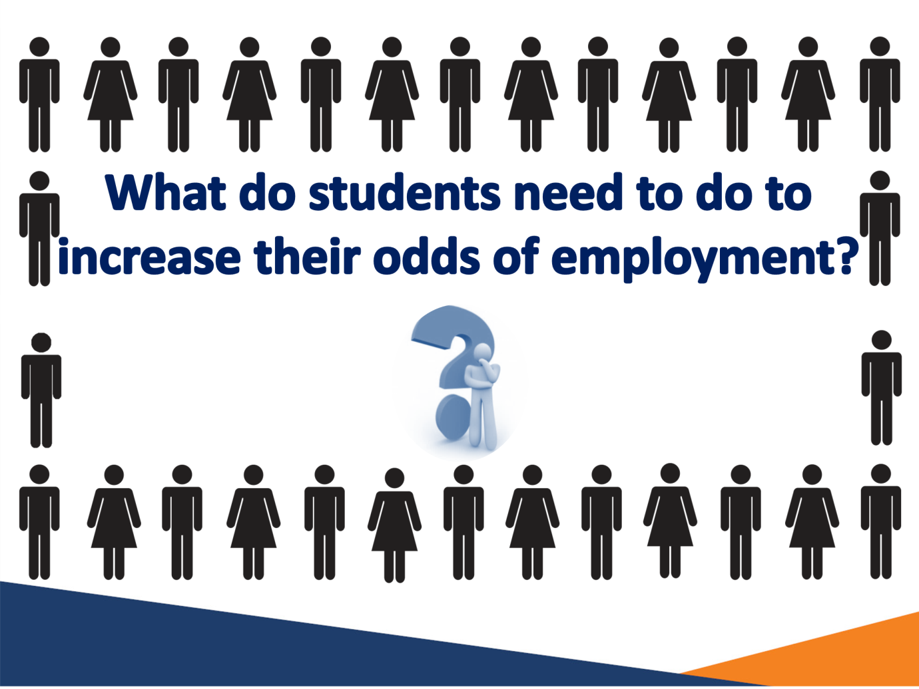

# Slide 10: Further education and training is vital

Unemployment rate by highest level of educational attainment, Australia, 25 to 34 year olds
Bachelor Degree and Higher: 3.6%
Advanced Diploma and Diploma Level: 4.1%
Certificate III & IV Level: 4.1%
Aim to be here: 93% of new jobs may need applicants to have the above three level of education
Year 12: 6.0%
Certificate I & II Level: 14.4%
Below Year 12: 12.5%

## Notes

Source: ABS, Census of Population and Housing, 2011; Department of Employment,   
Employment Projections, five years to November 2020

# Slide 11: VET outcomes are holding up

Apprentice and trainee, and VET graduates who found employment within six months
Apprentice and Trainee Graduates:
2008: 89.2%
2015: 84.1% (down 5.1% since 2008)
All VET Graduates:
2008: 82.4%
2015: 74.2% (down 8.2% since 2008)
Bachelor degree graduates who found full-time employment within four months
2008: 85.2%
2015: 68.8% (down 16.4% since 2008)

## Notes

Source: GCA, GradStats, various issues NCVER, Student outcomes, various issues

# Slide 12: Apprentice and trainee numbers have declined

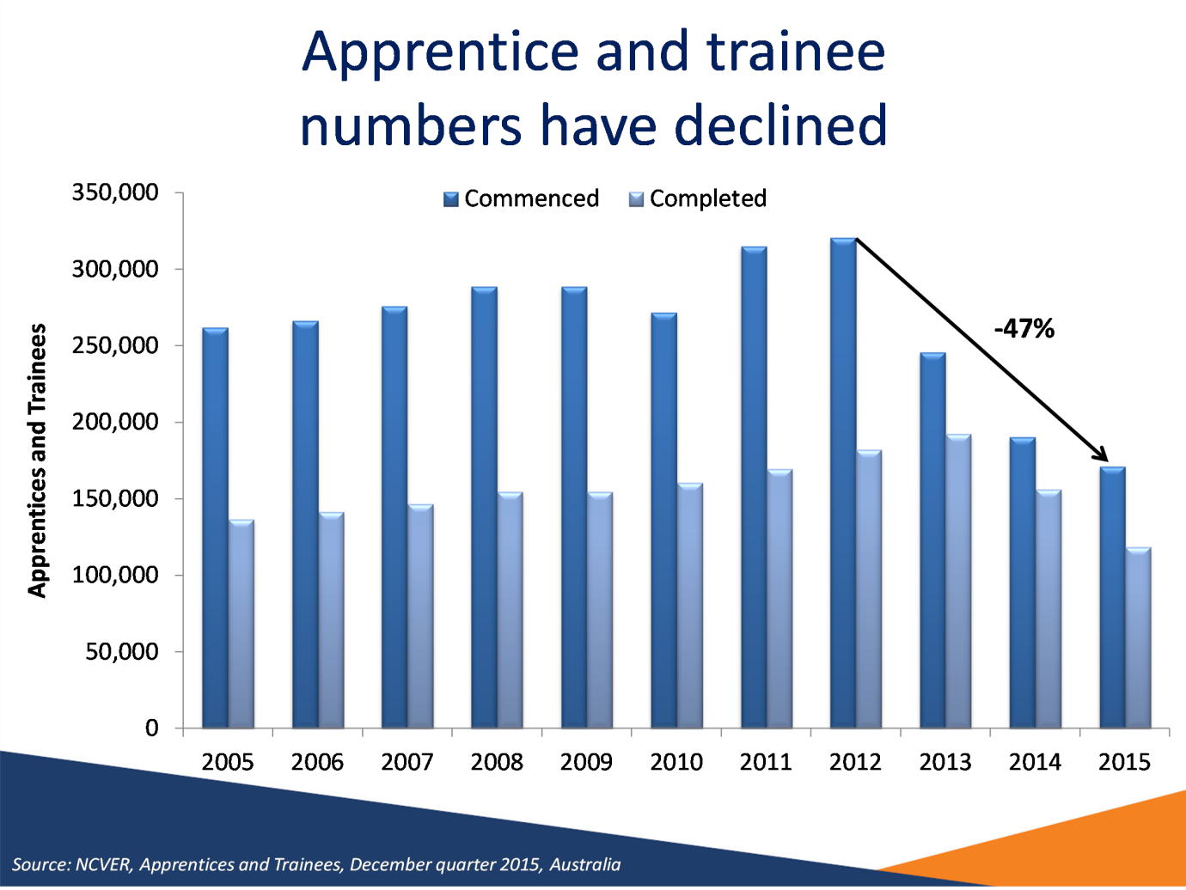

## Notes

Source: NCVER, Apprentices and Trainees, December quarter 2015, Australia

# Slide 13: Students need to ensure they complete a qualification

New apprentices and trainees: Almost one third (30%) of all new apprentices and trainees don't finish
Common reasons why trade apprenticeships are not completed:
Not satisfied with the employment experience
Low wages
Redundancy

## Notes

Source: NCVER, Completion and attrition rates for apprentices and trainees, 2014

# Slide 14: There are opportunities for new apprentices, but competition can be strong

Apprentice vacancies filled: 62%
Average number of applicants per apprentice vacancy: 22.3
Average number of suitable applicants per apprentice vacancy: 2.4
Most applicants do not match employers' expectations
From the employers' perspective:
Easiest (Electrician Apprentices): Greatest applicant competition for vacancies
Hardest (Construction Trades Apprentices): Half of vacancies filled smallest pool of applicants
No Applicants: 6% of employers had no applicants for their apprenticeship, mainly in food and automotive trades

## Notes

Source: Department of Employment, Labour Market for Apprentices, 2014-15, Australia

# Slide 15: Employers have difficulty finding apprentice due to

Attitude:
Lack of interest
Lack of commitment
Poor work ethic
Skill sets:
Insufficient trade skills
Inadequate experience
Poor aptitude
Not enough students undertaking VETiS

## Notes

Source: Department of Employment, Labour Market for Apprentices, 2014-15, Australia

# Slide 16: Relevant experience is vital

Students shouldn't let opportunities pass them by:
72% of employers looking for Technicians and Trades workers required relevant experience
Volunteer/Casual job
Workplace based experience
Apprenticeship
Goal

## Notes

Source: Department of Employment, Survey of Employers’ Recruitment Experiences, All regions surveyed and Metro, 12 months to December 2015 (Technicians and Trade workers for Australia)

# Slide 17: The ideal apprentice demonstrates

The ideal apprentice demonstrates the following people skills and communication skills:
Mature attitude
Reliable
Positive attitude
Strong work ethic
Good presentation
Genuine interest
Desire/passion
Commitment


## Notes

Source: Department of Employment, Survey of Employers’ Recruitment Experiences, 2014-2015; Department of Employment, Labour Market for Apprentices, 2014-15

# Slide 18: Employers also increasingly seeking these transferable skills…

Digital literacy
Creativity
Problem solving
Financial literacy
Critical thinking
Job advertisements requiring these have increased by over 200% since 2012

## Notes

Source: Foundation for Young Australians, The New Basics, April 2016

# Slide 19: …because jobs are evolving

2016:
App developer
Mobile Groomer
Financial Broker
Drone Pilot
3D Print Professional
2036?
What we know:
Emerging technologies
Ageing Population
Globalisation
Learning for life is essential

# Slide 20: Every application is a learning experience

Do job seekers know why they miss out on jobs?
Reasons employers gave for applicants missing out on jobs:
Qualifications/Training
Experience/Skills
Inadequate soft skills
Poorly written/presented application
Why applicants thought they had missed out on a job:
Qualifications/Training (correct)
Experience/Skills (correct)
Poorly written/presented application (incorrrect)
Inadequate soft skills (incorrect)
Employer feedback is highly useful


## Notes

Source: Department of Employment, Survey of Employers’ Recruitment Experiences, All regions surveyed

# Slide 21: Students shouldn’t forget to approach employers directly

1 in 3 jobs in Australia are not advertised
Formally advertised: 66%
Informally advertised: 34% (includes word of mouth, approaced by job seeker, social media and networking)

## Notes

Source: Department of Employment, Survey of Employers’ Recruitment Experiences, All regions surveyed and Metro, 12 months to December 2015

# Slide 22: Tools to assist

Websites:
lmip.gov.au
joboutlook.gov.au
Phone apps:
Australian Jobsearch
Career Quiz (http://joboutlook.gov.au/careerquiz.aspx)
Publications:
Australian Jobs (www.employment.gov.au/australianjobs)
Fact Sheets
Looking for a Job - Employer Advice for Young People (lmip.gov.au)
Recruitment Methods Used by Employers - Infographic

# Slide 23

