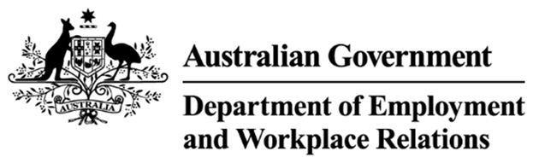

# Workplace Agreement Database – Data Request

Instructions: Please complete the form, sign and return via email to [EBTrends@dewr.gov.au](mailto:EBTrends@dewr.gov.au). Should you have any problems please contact the Economic and Workplace Agreements Analysis Team via Department of Employment and Workplace Relations’ [online contact form](https://www.dewr.gov.au/about-department/contact-us/online-contact-form).

## Details of requester

| **Field** | **Response** |
| --- | --- |
| Name: |  |
| Organisation: |  |
| Position/title: |  |
| Work area in organisation: |  |
| Mailing address: |  |
| Email address: |  |
| Daytime telephone: |  |

## Details of data requested

| **Question** | **Response** |
| --- | --- |
| Provide a short description of, and date range for, the data you are interested in: |  |
| By what date do you require the data? |  |
| Provide a short description of the intended use of the data: |  |
| What (if any) is the dissemination plan (i.e. public report/ conference/presentation/ journal article) for your research/findings? |  |
| Will the data provided by the Department be made public (either in the form provided or in a modified form)? |  |
| How did you hear of the database? |  |
| Signature: |  |
| Date: |  |

* Please ensure that the intended use of the data is correctly reflected.

The Department will review every request it receives, then can approve or decline data requests.

While the Department will not make available fields that can potentially identify individuals, users must make reasonable efforts to ensure that they do not disclose (including by publishing) any information that could potentially identify individuals covered by an agreement when combining the data from the WAD with other data sources.

Users must provide the Department with any material containing information drawn from the data that the user intends to make publicly available, prior to making that material publicly available.

Please note that for reference purposes, the user must attribute the Department as the source of the data, but must not present the data in such a way as to suggest that the Department endorses the material in which the data appears. The data source is to be referred to as “Department of Employment and Workplace Relations, Workplace Agreements Database”.

By signing this form, you acknowledge that you are aware that giving false or misleading information is a serious offence under section 137.1 of the Schedule to the Criminal Code Act 1995.

### Privacy Notice

The personal information collected from you on this form is protected by law, including the *Privacy Act 1988* (Cth) (Privacy Act), and is collected by the Department for the purpose of making the requested data available to you. The consequence for not providing some or all of your personal information is that the Department may not be able to provide the requested data to you.

Your personal information will not be used for any other purpose or disclosed to any other person or organisation unless such use or disclosure is permitted under the Privacy Act.

The Department’s APP Privacy Policy contains more information about the way in which the Department will manage your personal information, including information about how you may access your personal information held by the Department and seek correction of such information. This APP Privacy Policy also contains information on how you can complain about a breach of the Australian Privacy Principles (APPs) and how the Department will deal with such a complaint. A copy of the Department’s APP Privacy Policy can be found at dewr.gov.au/using-site/privacy or by requesting a copy from the Department at privacy@dewr.gov.au.