

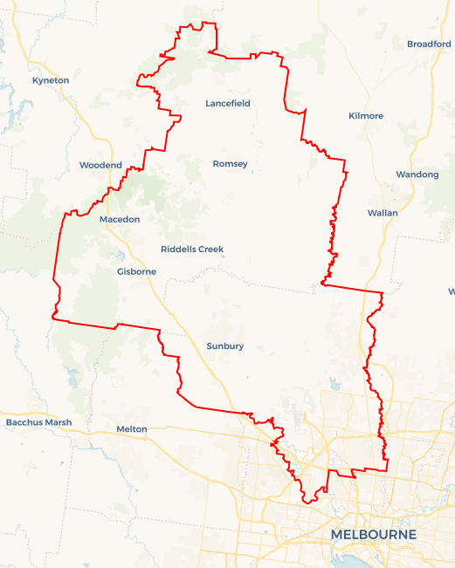Local Jobs Plan

North Western Melbourne ****Employment Region**** | VIC | ****January 2023****

Workforce Australia Local Jobs (Local Jobs) is a program that supports tailored approaches to accelerate   
reskilling, upskilling and employment pathways in response to current and emerging local workforce needs.

## Local Jobs elements

### Local Jobs Plan

The Local Jobs Plan sets out the skills and employment challenges and priorities of the region, and associated strategies that will drive the design and implementation of activities to be implemented to address these challenges.

### Employment Facilitators

Employment Facilitators and Support Officers support the delivery of the program by bringing together key stakeholders including businesses, employment services providers, and higher education and training organisations.

### Local Jobs and Skills Taskforce

Each Employment Region has its own Taskforce. Representatives include local stakeholders who have demonstrated experience in upskilling, reskilling, and an ability to represent, connect and collaborate with others in the region to meet labour market needs.

### Local Recovery and National Priority Funds

The Local Recovery Fund supports projects that meet the priorities identified in the Local Jobs Plan. The National Priority Fund provides funding for innovative local solutions to address structural barriers to employment.

Explore labour market insights for the   
[North Western Melbourne](https://www.jobsandskills.gov.au/work/employment-region-dashboards-and-profiles/monthly-labour-market-dashboards) Employment Region

## Local labour market challenges in the region

* The North Western Melbourne unemployment rate is one of the highest of any region in Victoria and is the second highest nationally.
* North Western Melbourne has the highest youth unemployment rate in Victoria coupled with a low participation rate.
* Within North Western Melbourne there are pockets of low socio-economic disadvantage, limited access to the labour market and disparity in unemployment across the region.
* North Western Melbourne has a high proportion of Culturally and Linguistically Diverse (CALD) and refugees with low education and/or unrecognised qualifications where English is a second language.
* Cultural and generational factors affecting long term unemployed including the participation rates of women in the workforce.
* Labour demand and skill shortages exist for the region’s major employing sectors including health care and social assistance, construction, manufacturing, and warehousing and distribution.
* Lack of employers and businesses willing to apply flexible recruitment practices to uncover the hidden labour market.

## Local jobs and skills priorities and strategies in the region

### Priority 1 – Employment and learning pathways into growth industries

#### What are our challenges and opportunities?

The contraction of the manufacturing sector over the last decade had a significant impact on the region’s traditional labour market. Whilst manufacturing is still a key industry, other industries are emerging with significant employment opportunities. Reskilling and upskilling of job seekers in these industries will be required to meet this demand.

#### How are we responding?

* Maximising the benefits of existing Australian, Victorian and local government programs, to create pathways into growth industries, particularly for major labour shortage industries as outlined above.
* Collaborating with local government and State Economic Development representatives across the region to align and identify emerging employment opportunities related to investment and infrastructure advancement in growth industries.
* Engaging and working with employers and industry to understand current and future workforce requirements.
* Working proactively with local employers to educate and assist them in becoming fit for purpose when employing individuals from priority cohorts (including non-English speaking).

### Priority 2 - Skills development

#### What are our challenges and opportunities?

North Western Melbourne’s diverse labour market covers a broad range of industry sectors and presents opportunities for employment growth to meet the ongoing high demand for workers in the region. Focusing on skills development of local people including those with a higher level of disadvantage will enhance access to employment and support the skills required by employers and industry.

#### How are we responding?

* Engaging with key industry and employers to identify, connect and develop local programs that support opportunities for skills development and pathways to current and emerging workforce demand.
* Generating opportunities for skills development aligned with the needs of the local labour market, including through apprenticeships, traineeships and skills training.
* Leveraging already established approaches that are designed to assist those with low English literacy levels and limited labour market experience in Australia, in particular recent migrants who held an overseas qualification before arriving in Australia.

### Priority 3 – Maximising workforce engagement opportunities for local disadvantaged groups

#### What are our challenges and opportunities?

There is a disparity of the employment rate across North Western Melbourne Employment Region where the unemployment and labour market disengagement rates in locations such as Broadmeadows, Meadow Heights, Campbellfield and Coolaroo are significantly higher than the regional average.

#### How are we responding?

* Mapping caseloads using a geographical and existing skills cohort profile to develop demand led strategies for participants experiencing disadvantage entering the workforce. Including: CALD, Long Term Unemployed, Youth, Parents and Women.
* Developing a comprehensive understanding of the drivers and disincentives to engagement and participation and develop inclusive place-based approaches, including through education and training.
* Establishing a strong collaborative employment and related service network to develop solutions and share best practice approaches to regional issues.
* Support the development of industry led training and employment initiatives that increase opportunities and outcomes for local participants with a focus on initiatives that align to the current labour market conditions.

### Priority 4 – Reducing the market disadvantage of local people, including youth, people from culturally and linguistically diverse and refugee backgrounds.

#### What are our challenges and opportunities?

The youth unemployment rate for North Western Melbourne is the fourth highest in Australia, a proportion of this cohort is also highly disengaged from support services whilst minority groups are disproportionately represented on the Workforce Australia Employment Services caseload.

#### How are we responding?

* Supporting engagement/re engagement programs and activities for local youth in the region.
* Identifying and connecting with local programs to support opportunities for skill development and pathways to current and emerging workforce requirements.
* Developing targeted industry programs that support the employment of youth and females in particular for the apprenticeships/traineeships sector.
* Developing job readiness programs that address barriers to gaining employment and create industry pathway alignment.
* Delivering information sessions describing the options that exist for this cohort in relation to skill development and learning and employment pathways.

### Priority 5 – Facilitate and support individuals looking to explore entrepreneurship/transition to self-employment.

#### What are our challenges and opportunities?

Post-COVID-19, our working lives have changed with individuals and employers/industry now open to exploring more flexible working arrangements. While this is encouraging, many individuals require advice, support and mentoring to have the confidence to explore these possibilities. This is particularly relevant to new migrant and CALD/refugee participants who can be experienced entrepreneurs - however are not familiar with opportunities in the local market.

#### How are we responding?

* Identifying opportunities and creating skills development pathways that can align self-employment opportunities with growth economies and industries.
* Promoting the Entrepreneurship Facilitators program through collaboration of providers and networks
* Collaborating with Victorian and local government to promote careers and self-employment expos.
* Promoting the Self Employment Assistance program through collaboration with providers to encourage, advise, support and mentor individuals to confidently explore the possibilities and opportunities.

## Want to know more?

* Contact: North Western Melbourne Employment Facilitator Mike Barker: mike.barker@employmentfacilitator.com.au
* Visit: [Local Jobs](https://www.dewr.gov.au/local-jobs) or [Workforce Australia](https://www.workforceaustralia.gov.au/)