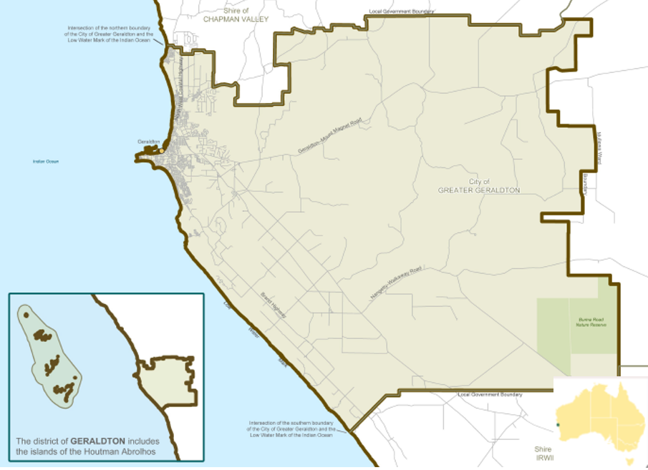

Local Jobs Plan

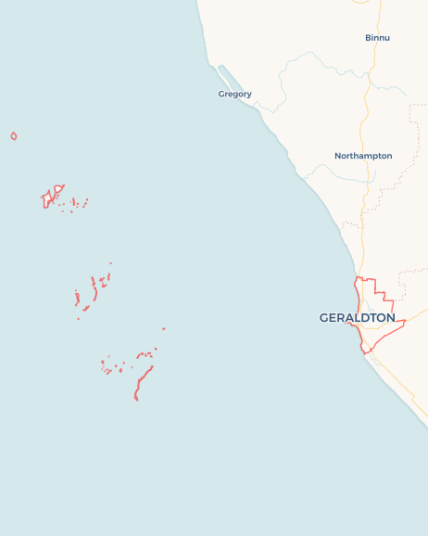Geraldton ****Employment Region**** | WA | ****March 2024****

Workforce Australia Local Jobs (Local Jobs) is a program that supports tailored approaches to accelerate   
reskilling, upskilling and employment pathways in response to current and emerging local workforce needs.

## Local Jobs elements

### Local Jobs Plan

The Local Jobs Plan sets out the skills and employment challenges and priorities of the region, and associated strategies that will drive the design and implementation of activities to be implemented to address these challenges.

### Employment Facilitators

Employment Facilitators support the delivery of the program by bringing together key stakeholders including businesses, employment services providers, higher education, and training organisations.

### Local Jobs and Skills Taskforce

Each Employment Region has its own Taskforce. Representatives include local stakeholders who have demonstrated experience in upskilling, reskilling, and an ability to represent, connect and collaborate with others in the region to meet labour market needs.

### Local Recovery and National Priority Funds

The Local Recovery Fund supports projects that meet the priorities identified in the Local Jobs Plan. The National Priority Fund provides funding for innovative local solutions to address structural barriers to employment.

Explore labour market insights for the  
[Geraldton](https://www.jobsandskills.gov.au/work/employment-region-dashboards-and-profiles/monthly-labour-market-dashboards) Employment Region

## Local labour market challenges in the region

* Ongoing staff shortages experienced across all industry sectors with a noticeable effect on the mining and resource sector, building industry, health sector, tourism and hospitality and critical labour shortages experienced by the aged care and childcare sector.
* A lack of driver’s licenses and/or transport, compounded with the shortage of accommodation is a challenge for people seeking employment and for retaining staff with regular rental rises.
* First Nations people unemployment is significant in Geraldton.
* Opportunities for apprenticeships and traineeships can be impacted by low levels of literacy and numeracy skills which is a challenge for youth.
* A lack of childcare availability is restricting the opportunities for people to enter or return to the workforce.

## Local jobs and skills priorities and strategies in the region

### Priority 1 – Engage with business and industry

#### What are our challenges and opportunities?

Minimal level collaboration between business and employment service providers.

#### How are we responding?

* The Employment Facilitator is liaising directly with key local business operators to gain understanding of current employment needs.
* We are facilitating round tables for businesses to identify industry workforce requirements and develop collaborative approaches to bridge current gaps between workforce requirements and job readiness of individuals.
* We are collaborating with recognised training organisations to develop and implement targeted, fast-tracked training solutions to meet local industry requirements.

### Priority 2 – Promote positions for individuals including apprenticeships and traineeships opportunities that represent regional employment opportunities

#### What are our challenges and opportunities?

The ongoing tightness of the labour market has resulted in individuals securing ongoing employment without being required to have accredited skills sets, leading to a potential overall reduction in the skill level and productivity of the workforce.

#### How are we responding?

* We are facilitating industry workshops with key businesses, employment service providers, peak industry bodies and relevant community support services to develop industry specific initiatives to bridge gaps between workforce requirements and job readiness of individuals.
* We are facilitating events and industry specific information sessions for businesses to inform them of existing services and supports while encouraging a collegial and collaborative approach to finding solutions to workforce issues.
* We are developing a communication strategy utilising professional networks, online and local media to raise awareness of services and information sessions among businesses.

#### Priority 3 – First Nations people, participation and pathways to employment

**What are our challenges and opportunities?**

Promote opportunities and increase awareness for First Nations individuals of programs, upskilling and pre-employment training available.

#### How are we responding?

* Work collaboratively with First Nations people by listening and identifying culturally appropriate approaches to maximise suitable training and needs, in a comfortable and safe place.
* Identify employment opportunities by working with businesses and providers across all industry sectors to develop effective approaches to inspire individuals to seek gainful employment with support and knowledge from key Indigenous organisations and councils.
* Promote networks between businesses and First Nations people to create a stronger community with the focus on ‘closing the gap’ priorities.
* Develop cross cultural awareness and training to build cohesive and empowered communities.
* Support and develop collaborative employment pathways for people re-entering community from correctional services.

#### Priority 4 – Women in the workforce

**What are our challenges and opportunities?**

Challenges facing women to re-enter the workforce relate to lack of confidence with advances in technology, meaning women need to rethink career choices - financial constraints include training, daycare, clothing, transport.

#### How are we responding?

* Empower women entering or returning to work with support programs, upskilling, training and mentors to enable them to gain employment.
* Work with businesses and organisations to encourage flexibility to enable women to work.
* Seek programs and training to upskill women to equip them for a confident transition into the workforce.
* Explore creative approaches to enable women to work where childcare may not be available.
* Develop mentors in the workplace to encourage a positive culture for all women.

#### Priority 5 – Youth, excite, empower and achieve

**What are our challenges and opportunities?**

To encourage youth participation whilst increasing knowledge of programs and pathways to employment.

#### How are we responding?

* Facilitate a collaborative approach with the Department of Education, providers and industry to build a supportive network for our youth via pathways into fulfilling and purposeful employment, utilising the diverse services available across our community.
* Facilitate opportunities for our youth to visit workplaces and meet local champions in the workforce to inspire them on their journey to employment.
* Showcase Science, Technology, Engineering and Maths (STEM) based careers and employment options for our future workforce from space technologies to hydrogen, solar, wind and other renewables - the pathway of employment for tomorrow.

## Want to know more?

* Contact: Barbara Thompson, Geraldton Employment Facilitator: [Barbara.Thompson@dewr.gov.au](mailto:Barbara.Thompson@dewr.gov.au)
* Visit: [Local Jobs](https://www.dewr.gov.au/local-jobs) or [Workforce Australia](https://www.workforceaustralia.gov.au/)