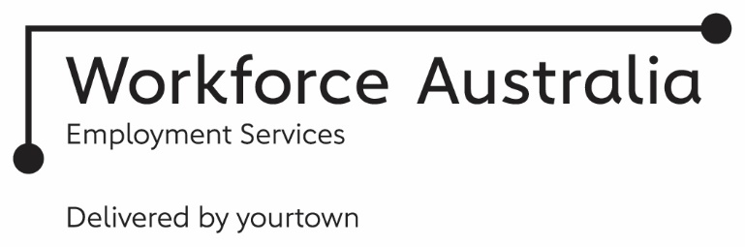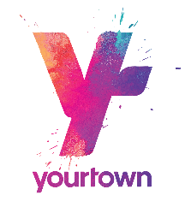
TRANSITION TO WORK
Service Delivery Plan – Employer
yourtown Employment Services connect you with work-ready young people saving you time and money to meet your recruitment needs.
Our youth-friendly Transition to Work teams work alongside young people aged 15 to 24 to support them on their individual journey to employment.
Transition to Work is a voluntary youth-specialist employment service that helps young people in the program to develop practical skills to get a job.
- you get the right people for your business
- we do the work for you at NO COST!
- we know and can help secure financial incentives
- you’re helping young people
- you’re strengthening your community
Our dedicated teams take the time to get to know your business first hand, learn what is most important to you, and identify your recruitment needs. With the ability to choose the type and level of service you require, we can customise a tailored regional or local approach to advertising, screening and matching the right employee/s to fill your position. We will find, train and develop the right young people for your available roles.
Work experience opportunities are available for employers to trial young people in a role before committing to an offer of employment. This provides the young person with valuable connection to the workforce, the opportunity to demonstrate their interest in a role and provides you as the employer a chance to see if they are a right fit for your business, before you hire.
We understand that the initial and ongoing costs of recruitment, including training and wages can be significant. Our commitment is to offer a wage subsidy of up to $10,000 to every Employer who hires one of our young people into ongoing employment*.
(*eligibility criteria applies)
To us, it’s not just about filling the job – it’s about finding the right fit. We work with you before and after the placement to ensure a successful outcome.
We listen to the voices of employers and know that recruitment does not take a ‘one size fits all’ approach. No two employers are the same and therefore we adapt and tailor our services to be what you want and need. In addition to our dedicated account management approach, we provide you with choice from being able to lodge job vacancies online, to being able to easily calculate relevant financial incentives, through to varying levels of support at the interview.

Our Community is Your Community
We invest in initiatives such as Community Investment Committees which bring together leaders from industry, employers, skills and training bodies, all levels of government, young people, schools and community organisations to create meaningful employment pathways for young people. We have strong involvement and linkages with the Local Jobs Program to source opportunities including apprenticeship and traineeships that align with skills shortages.
To maintain our local labour market knowledge, and gain a strong understanding of our employer’s needs and perspectives, yourtown commits to our staff having regular work immersion opportunities through visiting workplaces across various industries.
We work alongside & connect with…
- Employers
- Schools, Education Providers & RTOs
- Specialised Supports
- Mental Health Services
- Elders and Cultural Networks
- Local Community Organisations
- Other Employment Services providers & Government Initiatives
Our Locations
Wide Bay
Bundaberg
Childers
Kingaroy
Pialba
Brisbane South East
Browns Plains
Kingston
Upper Mt Gravatt
yourtown acknowledges the Traditional Custodians of Country of the lands on which we work, the Taribelang Bunda, Batjala/ Butchulla, Gubbi Gubbi/Kabi Kabi, Wakka Wakka regions and throughout Australia. We recognise their continuing connection to the land and their waterways. We pay our respects to them, their culture and their Elders; past, present and emerging.
Check out our website or scan the below QR code to list a vacancy
1300 001 015
yourtown.com.au/employers
jobs@yourtown.com.au

