

# Ensuring Job Crafting Success

## Job Crafting Enablers

While job crafting is driven by the individual, the performance environment must be geared toward safety, experimentation and trust to encourage and support individuals to experiment with their roles.

The five areas outlined below are critical to promote job crafting behaviours.

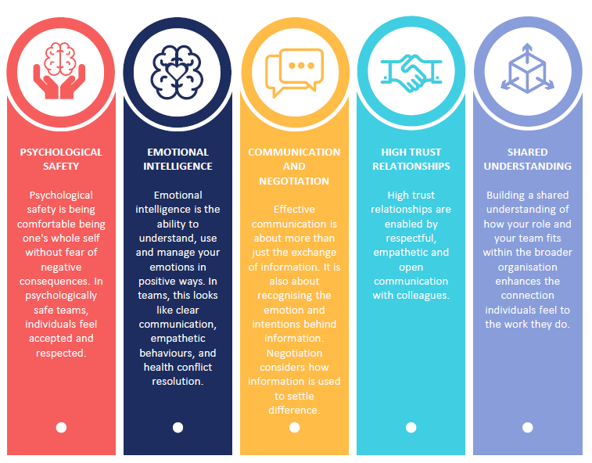

By utilising the above “crafting supplies”, organisations can foster job crafting behaviours. Individuals need to feel comfortable and confident to experiment and ask questions or talk through challenges as they arise. Without these workplace characteristics, job crafting can occur in isolation, impacting the experience of the individual at work and how the organisation achieves its goals.

## Set Yourself Up to Job Craft Successfully

Take a moment to answer the questions below. If answers are positive, the more likely your job crafting journey is to be supported by leaders and team members.

If you identify gaps in your team, consider talking to your manager or leadership group about how to enhance these areas.

|  |
| --- |
| ENABLING JOB CRAFTING CHECKLIST |
| PSYCHOLOGICAL SAFETY |
| * Are your unique skills and talents valued and utilised in this team? |
| * Is it safe to take a risk in this team? |
| * Are members of this team able to bring up problems and tough issues? |
| EMOTIONAL INTELLIGENCE |
| * Do your team members and manager display professional actions and behaviours during stressful periods of work? |
| * Does your manager take time to teach you and contribute to your professional development? |
| * Do you receive recognition and appreciation for the work you do? |
| HIGH TRUST RELATIONSHIPS |
| * Is it difficult to ask other members or the manager of this team for help? |
| * Do you feel comfortable sharing stories from your personal life with your team? |
| * Are you trusted to carry out your day-to-day role autonomously? |
| COMMUNICATION AND NEGOTIATION |
| * Do you have access to the information you need to complete your work? |
| * Do you feel comfortable when discussing your performance with your manager? |
| * Is team communication and discussion respectful? |
| SHARED UNDERSTANDING |
| * Do you know how your team’s function contributes to the organisation as a whole? |
| * Think about what values are important to you. Do they align with the values of your organisation? |
| * Are you proud to tell people where you work and why? |

## A warning about Job Crafting

It is worth a reminder that job crafting will not magically fix issues related to engagement at work. Without the right conditions, individuals and organisations can experience poor job crafting outcomes.

Being aware of the limitations of job crafting can help you plan for and mitigate any barriers you may come across.

|  |  |
| --- | --- |
|  |  |
| Job crafting may lead to inefficiencies in a team.  If job crafting starts to incorporate tasks or activities that overlap with or contradict those that are already occurring within the team, this can lead to frustration, decreased productivity and poor team culture. | If an individual leaves the organisation, the role that they have crafted for themselves may not suit their replacement.  Job crafting is driven by individual values, motivations and strengths, which may not align to those held by others. Roles which have been crafted to suit the individual may need to be crafted again for an incoming employee, changing the way the work is completed and how the rest of the team view the role. |
|  |  |
| Job crafting may result in individuals working beyond their agreed remuneration point or Enterprise Agreement.  An employee may craft their role into one which goes beyond their agreed salary or conditions. This can have legal implications and introduce tension between the employee and organisation. | Job crafting, particularly task crafting, may result in a higher-than-anticipated workload.  Sustained overwork can lead to burnout, fatigue, stress, and other health impacts for the individual. |
|  |  |
| When individual and organisation goals are not in alignment, both the individual and organisation can have a poor experience of job crafting.  In some cases, individuals may be more interested in fulfilling personal goals, rather than engaging with organisational goals. This misalignment will lead to conflict and have a direct impact on the relationship the individual has with the organisation. | |
|  | |