Portfolio Supplementary  
Additional Estimates Statements  
2017–18

Appropriation Bill (No. 5) 2017–2018   
and   
Appropriation Bill (No. 6) 2017–2018

Education and Training Portfolio

This document has been produced as an aid to accessing the information contained in [the Education and Training Portfolio Supplementary Additional Estimates Statements 2017–18](https://www.docs.education.gov.au/node/50551). Whilst the information contained is the same, it differs in format from the document tabled in Parliament at Budget (8 May 2018). Footnotes, page references and the presentation of tables may not exactly match the print friendly edition. [The financial tables are also available in excel format from data.gov.au](http://data.gov.au/).

Explanations of Supplementary Additional Estimates 2017–18

© Commonwealth of Australia 2018

ISBN 978-1-76051-459-4 [PRINT]

978-1-76051-457-0 [PDF]

978-1-76051-458-7 [DOCX]

Creative Commons logo

With the exception of the Commonwealth Coat of Arms, the department’s logo, any material protected by a trade mark and where otherwise noted all material presented in this document is provided under a [Creative Commons Attribution 4.0 International (https://creativecommons.org/licenses/by/4.0/) licence](https://creativecommons.org/licenses/by/4.0/).

The details of the relevant licence conditions are available on the Creative Commons website (accessible using the links provided) as is [the full legal code for the CC BY 4.0 International (https://creativecommons.org/licenses/by/4.0/legalcode)](https://creativecommons.org/licenses/by/4.0/legalcode).

The document must be attributed as the *Portfolio Supplementary Additional Estimates Statements 2017–18 Education and Training Portfolio*.

**Derivative material**

If you have modified or transformed Department of Education and Training material, or derived new material from those of the Department of Education and Training in any way, then Department of Education and Training prefers the following attribution: *Based on the Australian Government Department of Education and Training data.*

**Use of the Coat of Arms**

[The terms under which the Coat of Arms can be used are set out on the It’s an Honour website (see www.dpmc.gov.au/government/its-honour).](http://www.dpmc.gov.au/government/its-honour)

**Other Uses**

Inquiries regarding this licence and any other use of this document should be directed to the Department of Education and Training on 1300 566 046.



**Senator the Hon Simon Birmingham**

Minister for Education and Training

Manager of Government Business in the Senate

Senator for South Australia

Senator the Hon Scott Ryan  
President of the Senate  
Australian Senate  
Parliament House  
CANBERRA ACT 2600

The Hon Tony Smith MP  
Speaker  
House of Representatives  
Parliament House  
CANBERRA ACT 2600

Dear Mr President

Dear Mr Speaker

I hereby submit these Portfolio Supplementary Additional Estimates Statements in support of the additional appropriations sought for the Education and Training Portfolio, through Appropriation Bill (No. 5) 2017–2018 and Appropriation Bill (No. 6) 2017–2018.

These statements have been developed, and are submitted to the Parliament, as a statement on the funding requirements being sought for the Portfolio.

I present these statements by virtue of my ministerial responsibility for accountability to the Parliament and, through it, the public.

Yours sincerely

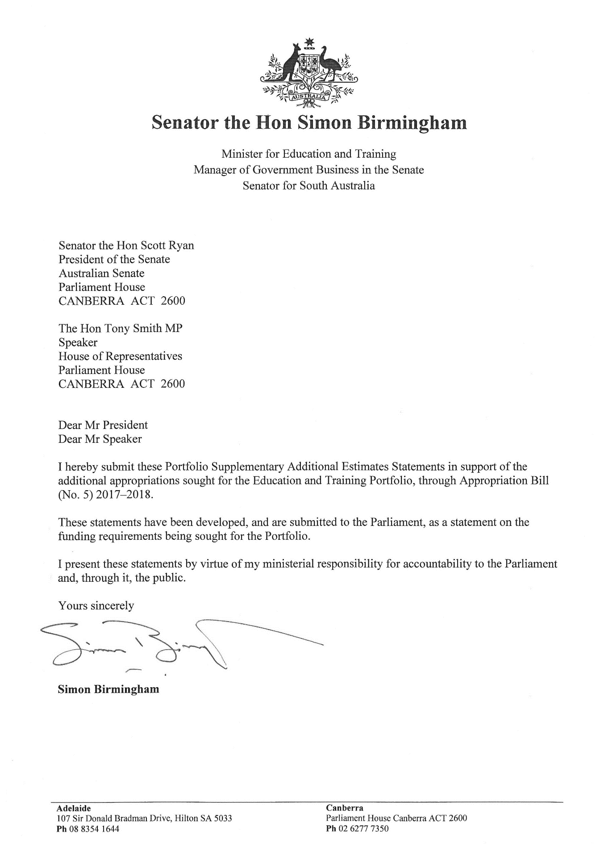

**Simon Birmingham**

| **Adelaide** | **Canberra** |
| --- | --- |
| 107 Sir Donald Bradman Drive, Hilton SA 5033 | Parliament House Canberra ACT 2600 |
| **Ph** 08 8354 1644 | **Ph** 02 6277 7350 |

Abbreviations and conventions

The following notation may be used:

NEC/nec not elsewhere classified

- nil

.. not zero, but rounded to zero

n/a not applicable (unless otherwise specified)

nfp not for publication

$m $ million

$b $ billion

tbc to be confirmed

Figures in tables and in the text may be rounded. Figures in text are generally rounded to one decimal place, whereas figures in tables are generally rounded to the nearest thousand. Discrepancies in tables between totals and sums of components are due to rounding.

Enquiries

Should you have any enquiries regarding this publication please contact the Chief Financial Officer, Department of Education and Training on 1300 566 046.

Links to this document can be located on [the Australian Government Budget website at: www.budget.gov.au](http://www.budget.gov.au).

User Guide  
to the  
Portfolio Supplementary Additional Estimates   
Statements

# User guide

The purpose of the 2017–18 Portfolio Supplementary Additional Estimates Statements (PSAES) is to inform Senators, Members of Parliament and the public of the proposed allocation of additional resources to government outcomes by entities within the portfolio.

The PSAES facilitate understanding of the proposed appropriations in Appropriation Bill (No. 5) 2017–2018 and Appropriation Bill (No. 6) 2017–2018. In this sense the PSAES is declared by the Appropriation Acts to be a ‘relevant document’ to the interpretation of the Acts according to section 15AB of the *Acts Interpretation Act 1901*.

Appropriation Bill (No. 5) 2017–2018, which follows on from *Appropriation Act (No. 1)* tabled at Budget and Appropriation Bill (No. 3) tabled at Additional Estimates, will provide additional expenditure authority for the ordinary annual services of government in respect of the 2017–18 financial year.

Appropriation Bill (No. 6) 2017–2018, which follows on from *Appropriation Act (No. 2)* tabled at Budget and Appropriation Bill (No. 4) tabled at Additional Estimates, will provide additional expenditure authority in respect of the 2017–18 financial year for capital works and services, payments to or for the states, territories and local government authorities, and new administered outcomes not authorised in specific legislation.

Contents

User guide ii

Entity Supplementary Additional Estimates Statements 2

Department of Education and Training 2

Department of Education and Training

Overview of additional appropriations 2

Entity measures table 2

Additional estimates and variations 2

Breakdown of additional estimates by Appropriation Bill 2

# Department of Education And Training

## Overview of additional appropriations

Overall, the Department of Education and Training is receiving a net increase in funding in 2017–18. This increase is the effect of additional funding to support measures in *Table 1.1 Entity 2017–18 supplementary additional estimates measures* and other variations as demonstrated in *Table 1.2 Supplementary estimates and variations to outcomes from measures and other variations*.

### Entity measures table

Table 1.1 summarises new Government measures taken since the 2017–18 Additional Estimates. The table is split into revenue, expense and capital measures, with the affected program identified.

Table 1.1 Entity 2017–18 supplementary additional estimates measures

|  |  |  |  |  |  |
| --- | --- | --- | --- | --- | --- |
|  | Program | 2017–18 $'000 | 2018–19 $'000 | 2019–20 $'000 | 2020–21 $'000 |
| **Expense measures** |  |  |  |  |  |
| Non-Government Reform Support Fund — additional funding (a) | 1.7 |  |  |  |  |
| Administered expenses |  | (1,000) | - | - | - |
| Departmental expenses |  | - | - | - | - |
| **Total** |  | **(1,000)** | **-** | **-** | **-** |
| Quality Schools — communication campaign (a) | 1.7 |  |  |  |  |
| Administered expenses |  | 3,650 | - | - | - |
| Departmental expenses |  | - | - | - | - |
| **Total** |  | **3,650** | **-** | **-** | **-** |
| National Research Infrastructure Investment Plan — implementation of Government response (a) | 2.6 |  |  |  |  |
| Administered expenses |  | 199,217 | - | - | - |
| Departmental expenses |  | - | - | - | - |
| **Total** |  | **199,217** | **-** | **-** | **-** |
| **Total expense measures** |  |  |  |  |  |
| Administered |  | 201,867 | - | - | - |
| Departmental |  | - | - | - | - |
| **Total** |  | **201,867** | **-** | **-** | **-** |

Prepared on a Government Financial Statistics (fiscal) basis. Figures displayed in brackets are negative and represent a decrease in funds. Non-bracketed figures are positive and represent an increase in funds.

(a) Refer to the Education and Training 2018–19 Portfolio Budget Statements: *Table 1.2 Department of Education and Training 2018–19 Budget Measures* for the 2018–19 and forward years financial impacts and to the 2018–19 Budget Paper No. 2 for the full measure impact.

### Additional estimates and variations

The following table details the changes to the resourcing for the Department of Education and Training at Supplementary Additional Estimates, by outcome. The table details the supplementary estimates and variations resulting from new measures and any other variations since the 2017–18 Additional Estimates in Appropriation Bills (No. 5 and No. 6).

Table 1.2 Supplementary estimates and variations to outcomes from measures and other variations

|  |  |  |  |  |  |
| --- | --- | --- | --- | --- | --- |
|  | Program impacted | 2017–18 $'000 | 2018–19 $'000 | 2019–20 $'000 | 2020–21 $'000 |
| **Outcome 1** |  |  |  |  |  |
| **Administered** |  |  |  |  |  |
| **Annual appropriations** |  |  |  |  |  |
| Non-Government Reform Support Fund — additional funding | 1.7 | (1,000) | - | - | - |
| Quality Schools — communication campaign | 1.7 | 3,650 | - | - | - |
| **Movement of Funds** |  |  |  |  |  |
| Child Care Services Support | 1.1 | (1,200) | 1,200 | - | - |
| **Other Variations** |  |  |  |  |  |
| Jobs Education and Training, Child Care Fee Assistance (JETCCFA) | 1.1 | (634) | - | - | - |
| **Net impact on appropriations for Outcome 1 (administered)** |  | **816** | **1,200** | **-** | **-** |
| **Total net impact on appropriations for Outcome 1** |  | **816** | **1,200** | **-** | **-** |
| **Outcome 2** |  |  |  |  |  |
| **Administered** |  |  |  |  |  |
| **Annual appropriations** |  |  |  |  |  |
| National Research Infrastructure Investment Plan — Implementation of Government response | 2.6 | 199,217 | - | - | - |
| **Movement of Funds** |  |  |  |  |  |
| Growth Fund Skills and Training | 2.8 | (7,751) | 3,951 | 3,800 | - |
| **Other Variations** |  |  |  |  |  |
| Adult Migrant English Program | 2.8 | (25,000) | - | - | - |
| **Net impact on appropriations for Outcome 2 (administered)** |  | **166,466** | **3,951** | **3,800** | **-** |
| **Total net impact on appropriations for Outcome 2** |  | **166,466** | **3,951** | **3,800** | **-** |
| **Total Decisions taken but not yet announced for all Outcomes** |  | **-** | **-** | **-** | **-** |

### Breakdown of additional estimates by appropriation bill

The following tables detail the Additional Estimates sought for the Department of Education and Training through Appropriation Bills (No. 5 and No. 6).

Table 1.3: Appropriation Bill (No. 5) 2017–2018

|  |  |  |  |  |
| --- | --- | --- | --- | --- |
|  | *2016–17 Available   $'000* | 2017–18 Budget and Additional Estimates $'000 | 2017–18 Revised   $'000 | Supplementary Additional Estimates  $'000 |
| **Administered items** |  |  |  |  |
| **Outcome 1 - Improved early learning, schooling, student educational outcomes and transitions to and from school through access to quality child care, support, parent engagement, quality teaching and learning environments.** | *515,866* | 479,002 | 479,818 | 816 |
| **Outcome 2 - Promote growth in economic productivity and social wellbeing through access to quality higher education, international education, and international quality research, skills and training.** | *1,353,361* | 1,431,822 | 1,598,288 | 166,466 |
| **Total administered** | ***1,869,227*** | **1,910,824** | **2,078,106** | **167,282** |
| **Total departmental** | ***-*** | **-** | **-** | **-** |
| **Total administered and departmental** | ***1,869,227*** | **1,910,824** | **2,078,106** | **167,282** |

Table 1.4: Appropriation Bill (No. 6) 2017–2018

The Department of Education and Training has no measures in Appropriation Bill (No. 6) 2017–2018 and so Table 1.4 is not presented.