# J:\Desktop\Test.pngLabour Market Conditions in the

# Port Augusta-Whyalla-Port Pirie PEA

* Labour market conditions in the Port Augusta-Whyalla-Port Pirie Priority Employment Area (PEA) have softened over the past year, with the unemployment rate increasing by 0.9 percentage points to stand at 7.8 per cent in the December quarter 2013.[1]

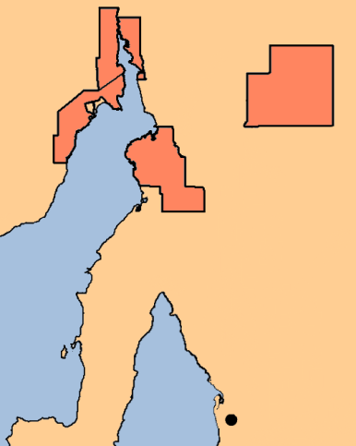

**Adelaide**

Port Augusta

Whyalla

Port Pirie

* Labour market participation and the level of educational attainment in the PEA are both well below the national average.[2]
* *Manufacturing* and *Health Care and Social Assistance* are the two largest industries in the PEA, both employing 15 per cent of the workforce.[3]
  + Over the five years to 2011, however, employment in *Health Care and Social* increased by 12 per cent, while in *Manufacturing* employment remained relatively stable over the same period.

## Feedback from employers

The survey results suggest that recruitment conditions have softened since the PEA was last surveyed in 2012.

* Employers reported 17 vacancies per 100 staff, which is in line with the 18 vacancies per 100 staff in 2012.
* Fewer employers reported recruitment difficulty compared with the previous survey (38 per cent in 2013 compared with 48 per cent in 2012).
  + Businesses received more applicants (an average of 7.3 applicants per vacancy) compared with the previous survey (5.0 applicants per vacancy).
* Only 1.1 per cent of recent vacancies remained unfilled, well below the unfilled vacancy rate of 7.5 per cent in 2012.
* In general, recruitment conditions in the Port Pirie City and Districts LGA were slightly weaker than the remainder of the PEA, with lower recruitment activity, applicant numbers and recruitment difficulty.
* Employers appeared cautious about recruitment in the 12 months following the survey, with only 12 per cent of businesses surveyed expecting to increase staff numbers, compared with 19 per cent for all regions surveyed.

|  |  |  |  |
| --- | --- | --- | --- |
|  | PEA December 2013 | PEA December 2012 | All regions surveyed(c) |
| Average annual vacancies per 100 staff(a) | 17 | 18 | 16 |
| Unfilled vacancy rate(b) | 1.1% | 7.5% | 3.8% |
| Applicants per vacancy(b) | 7.3 | 5.0 | 10.1 |
| Experienced difficulty recruiting(b) | 38% | 48% | 36% |

### (a) Based on the 12 months preceding the survey.

### (b) Based on employers’ most recent recruitment round.

### (c) Department of Employment, Survey of Employers’ Recruitment Experiences, All regions surveyed in the nine months to November 2013.

### Where are the opportunities?

* *Health Care and Social Assistance* is expected to continue to contribute strongly to employment growth across the PEA, with 21 per cent of employers anticipating increasing staff in the 12 months following the survey. Recruitment expectations for occupations such as *Registered Nurses* and *Nursing Support and Personal Care Workers* were particularly strong.
* Despite the softening labour market, employers still had difficulty filling vacancies for occupations such as *Bar Attendants and Baristas*, *Cooks* and *Health and Welfare Support Workers*.
  + Employers also intended to recruit for a number of other occupations in the 12 months following the survey, including *Motor Mechanics*, *Sales Assistants* and *Checkout Operators and Office Cashiers*.

1. Department of Employment, *Small Area Labour Markets,* December quarter 2013.
2. ABS, *Census of Population and Housing*, 2011.
3. ABS, *Census of Population and Housing*, 2006 and 2011.